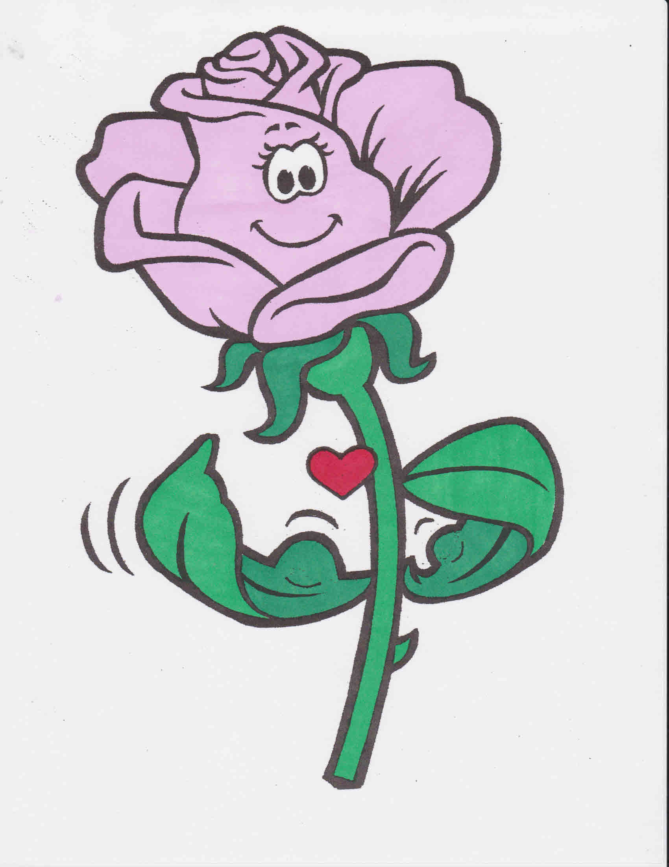  South Valley Rose Society invites you to their SECOND  - rose show  Theme: Roses Strong  In memory of the victims of 1 October, 2017  Saturday, November 10, 2018 University of Nevada Cooperative Extension 8050 Paradise Rd., Classroom B & C Las Vegas (215 Freeway & Windmill Lane) Call 702 257-5555 for information  Accepting rose entries: 6:30am to 9:45am Open to the public 1:00pm to 4:00pm  - Silent Rose Auction & Raffles  - ARS Consulting Rosarians are available to answer your rose questions.  - Rose & Botanical Garden Tours | We greatly acknowledge our Sponsors & Donors:  University of Nevada  Cooperative Extension www.unce.unr.edu  Star Nursery various locations www.starnursery.com  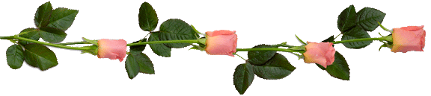  Gardener’s Supply Co Website www.gardeners.com  For Love of Roses, LLC Website: www.forloveofroses.com  Burlington Roses www.burlingtonroses.com  Subway 8790 So. Maryland Pkwy Las Vegas, NV 89123  Grouchy John’s 8520 So. Maryland Pkwy Las Vegas, NV 89123  South Valley Rose Society  Meets the 4th Thursday of each month from September to June. Time: 6:30pm to 8:30pm Location: 8050 Paradise Rd. (215 freeway & Windmill Lane)  Website: southvalleyrosesociety.com

