Admiral Pearls LLC
Oyster Opening Instructions
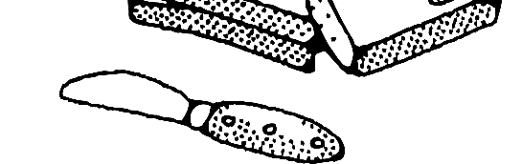
Please read and follow these instructions for a safe and successful oyster experience!
Required Items

Butter Knife (or similar flat tool)

Small bowl of water

Table Salt
Rubber/latex gloves Towel
Step 1: Carefully remove oyster from vacuum sealed plastic. Once removed from plastic, oyster should be opened within 24 hrs.
Step 2: Allow the oyster to soak in water for 30 to 40 minutes, then place on a flat surface.
Step 3: While wearing rubber/latex gloves, secure oyster on surface with one hand
Step 4: With the other hand use a butter knife, or similar tool, to open the oyster through the lip of the shell. (Some oysters open easier than others, shell chipping or breaking may occur.)
Step 5: Use your tool to expose the pearl within the meat. Be careful that the pearl does not roll away.
Step 6: Once pearl is removed from the oyster, rinse pearl off in dish of water.
Step 7: Place small amount of salt in palm of gloved hand. Vigorously rub pearl in salt to clean and polish.
Step 8: Dispose of oyster, its meat inside, and gloves immediately and remove from home, as oyster contents can become foul.
*Dispose of oyster and contents immediately. Not for human or animal consumption*

