**WHY HIRE CORNERSTONE BUSINESS COACHING?**

*Operating a business is tricky, which is why nearly 50% of all businesses fail within the first five years.(U.S. Bureau of Labor Statistics)*

Let's face it. Running a successful business is a bit like an airline mechanic being plopped into the cockpit of a flying jet and asked to bring it safely to its destination. Without knowing how to navigate the plane or read the instrument panel or operate the controls, the odds are you will crash at some point. For new business startups, you can add the challenge of essentially getting that airplane delivered in a box that requires assembly before even trying to fly it.

**HOW DOES IT WORK?**

Cornerstone Business Coaching is a service for business owners that realize having an instruction manual, a flight mechanic and a seasoned co-pilot are invaluable to getting to their destination predictably and profitably. Utilizing over 20 years of successful service business experience, we assess your goals, vision and mission along with your business model, practices and financial situation regularly in personalized, one to one meetings or video chat sessions to provide insight, direction and accountability for improved business success.

**WHAT IS COVERED?**

The scope of coaching includes regular accountability, goal setting, key performance indicators tracking, training, and business health assessments and wellness plan, along with optional team code creation and sales training. The coaching process is driven by you and often involves a bit of therapy, a bit of detective work, good, clear communication and of course, accountability.

**BENEFITS OF CORNERSTONE BUSINESS COACHING:**

* **Heightened optimism** as clear plans are developed to achieve desired goals
* **Reduced risk** through KPI identification and regular tracking
* **Increased profitability** as improvements to efficiency, costs and income are implemented
* **Reduced employee turnover** through improved business vision, mission and culture
* **Reduced stress** as predictable systems are developed for sales, admin and operations
* **Greater productivity** and results through accountability-driven, prioritized tasks
* **More free time, less aggravation, happier employees...and happier business owners!**

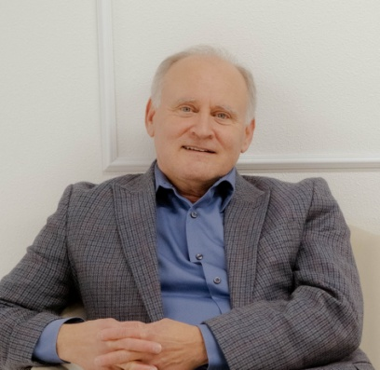While the results depend on your implementation, Cornerstone Business Coaching provides the tools, concepts, encouragement and support needed to help you get from where you are to where you want to be, often for an ROI of two to five times the coaching investment - sometimes more.

For a **FREE initial consultation**, call or text **775-220-1727**

or email: **stephen@coachnv.com** with code: FREE1