Holy Trinity Lutheran Church
Fourth Sunday after Epiphany
Sunday, January 30th, 2022
8:30 A.M.

Gathering
The Holy Spirit calls us together as the people of God.

PRELUDE Rise, Shine, You People! by Benjamin Culli

Welcome and Announcements

Thanksgiving FOR BAPTISM
In the name of the Father,
and of the ☩ Son,
and of the Holy Spirit.
Amen.

Joined to Christ in the waters of baptism,
we are clothed with God's mercy and forgiveness.
Let us give thanks for the gift of baptism.
We give you thanks, O God,
for in the beginning your Spirit moved over the waters
and by your Word you created the world,
calling forth life in which you took delight.

Through the waters of the flood you delivered Noah and his family.
Through the sea you led your people Israel from slavery into freedom.
At the river your Son was baptized by John and anointed with the Holy Spirit.
By water and your Word you claim us as daughters and sons,
making us heirs of your promise and servants of all.

We praise you for the gift of water that sustains life,
and above all we praise you for the gift of new life in Jesus Christ.
Shower us with your Spirit,
and renew our lives with your forgiveness, grace, and love.

To you be given honor and praise
through Jesus Christ our Lord
in the unity of the Holy Spirit, now and forever.
Amen.

Gathering Song Rise, Shine, You People! ELW 665

Greeting
The grace of our Lord Jesus Christ, the love of God,
and the communion of the Holy Spirit be with you all.
And also with you.

Kyrie

Prayer of the Day
Let us pray.
Almighty and ever-living God, increase in us the gifts of faith, hope, and love; and that we may obtain what you promise, make us love what you command, through your Son, Jesus Christ, our Savior and Lord.
Amen.

Childrens message

Word
God speaks to us in scripture reading, preaching, and song.

FIRST READING: Jeremiah 1:4-10
A reading from Jeremiah.
⁴Now the word of the Lord came to me saying,
⁵“Before I formed you in the womb I knew you,
and before you were born I consecrated you;
I appointed you a prophet to the nations.”
⁶Then I said, “Ah, Lord God! Truly I do not know how to speak, for I am only a boy.” ⁷But the Lord said to me,
“Do not say, ‘I am only a boy’;
for you shall go to all to whom I send you,
and you shall speak whatever I command you.
⁸Do not be afraid of them,
for I am with you to deliver you,
says the Lord.”
⁹Then the Lord put out his hand and touched my mouth; and the Lord said to me,
“Now I have put my words in your mouth.
¹⁰See, today I appoint you over nations and over kingdoms,
to pluck up and to pull down,
to destroy and to overthrow,
to build and to plant.”
Word of God, word of life.
Thanks be to God.

PSALM: Psalm 71:1-6
¹In you, O Lord, have I taken refuge;
let me never be put to shame.
²In your righteousness, deliver me and set me free;
incline your ear to me and save me.
³Be my strong rock, a castle to keep me safe;
you are my crag and my stronghold.
⁴Deliver me, my God, from the hand of the wicked,
from the clutches of the evildoer and | the oppressor.
⁵For you are my hope, O Lord God,
my confidence since I was young.
⁶I have been sustained by you ever since I was born; from my mother’s womb you have been my strength;
my praise shall be always of you.

SECOND READING: 1 Corinthians 13:1-13
A reading from 1 Corinthians.
¹If I speak in the tongues of mortals and of angels, but do not have love, I am a noisy gong or a clanging cymbal. ²And if I have prophetic powers, and understand all mysteries and all knowledge, and if I have all faith, so as to remove mountains, but do not have love, I am nothing. ³If I give away all my possessions, and if I hand over my body so that I may boast, but do not have love, I gain nothing.
⁴Love is patient; love is kind; love is not envious or boastful or arrogant ⁵or rude. It does not insist on its own way; it is not irritable or resentful; ⁶it does not rejoice in wrongdoing, but rejoices in the truth. ⁷It bears all things, believes all things, hopes all things, endures all things.
⁸Love never ends. But as for prophecies, they will come to an end; as for tongues, they will cease; as for knowledge, it will come to an end. ⁹For we know only in part, and we prophesy only in part; ¹⁰but when the complete comes, the partial will come to an end. ¹¹When I was a child, I spoke like a child, I thought like a child, I reasoned like a child; when I became an adult, I put an end to childish ways. ¹²For now we see in a mirror, dimly, but then we will see face to face. Now I know only in part; then I will know fully, even as I have been fully known. ¹³And now faith, hope, and love abide, these three; and the greatest of these is love.
Word of God, word of life.
Thanks be to God.

GOSPEL: Luke 4:21-30
The holy gospel according to Luke.
Glory to you, O Lord.

²¹Then [Jesus] began to say to [all in the synagogue in Nazareth,] “Today this scripture has been fulfilled in your hearing.” ²²All spoke well of him and were amazed at the gracious words that came from his mouth. They said, “Is not this Joseph’s son?” ²³He said to them, “Doubtless you will quote to me this proverb, ‘Doctor, cure yourself!’ And you will say, ‘Do here also in your hometown the things that we have heard you did at Capernaum.’ ” ²⁴And he said, “Truly I tell you, no prophet is accepted in the prophet’s hometown. ²⁵But the truth is, there were many widows in Israel in the time of Elijah, when the heaven was shut up three years and six months, and there was a severe famine over all the land; ²⁶yet Elijah was sent to none of them except to a widow at Zarephath in Sidon. ²⁷There were also many lepers in Israel in the time of the prophet Elisha, and none of them was cleansed except Naaman the Syrian.” ²⁸When they heard this, all in the synagogue were filled with rage. ²⁹They got up, drove him out of the town, and led him to the brow of the hill on which their town was built, so that they might hurl him off the cliff. ³⁰But he passed through the midst of them and went on his way.
The gospel of the Lord.
Praise to you, O Christ.

Sermon Pastor Josh Martyn

Hymn of the Day This Is My Fathers World ELW 824

Apostles Creed

I believe in God, the Father almighty,
creator of heaven and earth.
I believe in Jesus Christ, God’s only Son, our Lord,
who was conceived by the Holy Spirit,
born of the virgin Mary,
suffered under Pontius Pilate,
was crucified, died, and was buried;
he descended to the dead.*
On the third day he rose again;
he ascended into heaven,
he is seated at the right hand of the Father,
and he will come to judge the living and the dead.
I believe in the Holy Spirit,
the holy catholic church,
the communion of saints,
the forgiveness of sins,
the resurrection of the body,
and the life everlasting. Amen.

Prayers of Intercession
At the end of each petition, the reader will say “God of grace” please respond with “hear our prayer”.

The Spirit of the Lord is poured out upon us in abundance; so we are bold to pray for the church, the world, and all that God has made.

Guide your church in the ways of faith, hope, and love…..

Since we have such great hope in your promises, O God, we lift these and all of our prayers to you in confidence and faith; through Jesus Christ our Savior.
Amen.

Peace
The peace of Christ be with you always.
And also with you.

SHARING THE PEACE
In the midst of the pandemic, please greet one another with a sign of God’s peace from a distance.

Offering In the Bleak Midwinter ELW 294

Offeratory Response

Offering Prayer
Let us pray.
Good and loving God, we rejoice in the birth of Jesus, who came among the poor to bring the riches of your grace. As you have blessed us with your gifts, let them be blessing for others. With the trees of the field, with all earth and heaven, we shout for joy at the coming of your Son, Jesus Christ our Lord.
Amen.

Meal
God feeds us with the presence of Jesus Christ.

Great Thanksgiving
It is indeed right, our duty and our joy,
that we should at all times and in all places
give thanks and praise to you, ………we praise your name and join their unending hymn:

Thanksgiving at the Table

Lord’s Prayer
Lord, remember us in your love and teach us to pray.
Our Father, who art in heaven,
hallowed be thy name,
thy kingdom come,
thy will be done,
on earth as it is in heaven.
Give us this day our daily bread;
and forgive us our trespasses,
as we forgive those
who trespass against us;
and lead us not into temptation,
but deliver us from evil.
For thine is the kingdom,
and the power, and the glory,
forever and ever. Amen.

Invitation to Communion
Taste and see that the Lord is good.
Please be seated.

Communion
All are welcome to commune at Christ’s Holy Supper. We are now communing two ways, coming forward or remaining in your pew. Participate as you feel comfortable.
For those coming forward:
Come to the altar by the center aisle and return by the outside aisle. Please stay masked until you return to your pews with the elements. You will receive the elements in the prepackaged form and hear the words of distribution after which you are asked to take them back into your pews to partake of them. If you cannot come forward to receive communion but would like to receive it directly from the pastor, please let a greeter know and the pastor will bring communion to you. Gluten-free wafers are available as well. Children and adults who do not receive communion are invited to come forward as they wish to receive a blessing.

For those who wish to commune in their pew: Please take a pre-filled communion cup located in the basket in your pew. When instructed to do so, please first remove the bottom film of your cup to access the wafer. Set the wafer aside and remove the top film from the cup to access the grape juice. You may put your empty communion cups into the empty basket in your pew.

LAMB OF GOD
communion Song He Comes to Us as One Unknown ELW 737

POST-COMMUNION BLESSING
Please stand.
The body and blood of our Lord Jesus Christ strengthen you and keep you in God’s grace.
Amen

Post- Communion Prayer
Let us pray.
Radiant God, with our eyes we have seen your salvation, and in this meal we have feasted on your grace. May your Word take flesh in us, that we may be your holy people, revealing your glory made known to us in Jesus Christ, our Savior and Lord.
Amen.

Sending
God blesses us and sends us in mission to the world.

Blessing
The Lord bless you and keep you.
The Lord’s face shine on you with grace and mercy.
The Lord look upon you with favor and ☩ give you peace.
Amen.

Sending Song Go, My Children, with My Blessing ELW 543

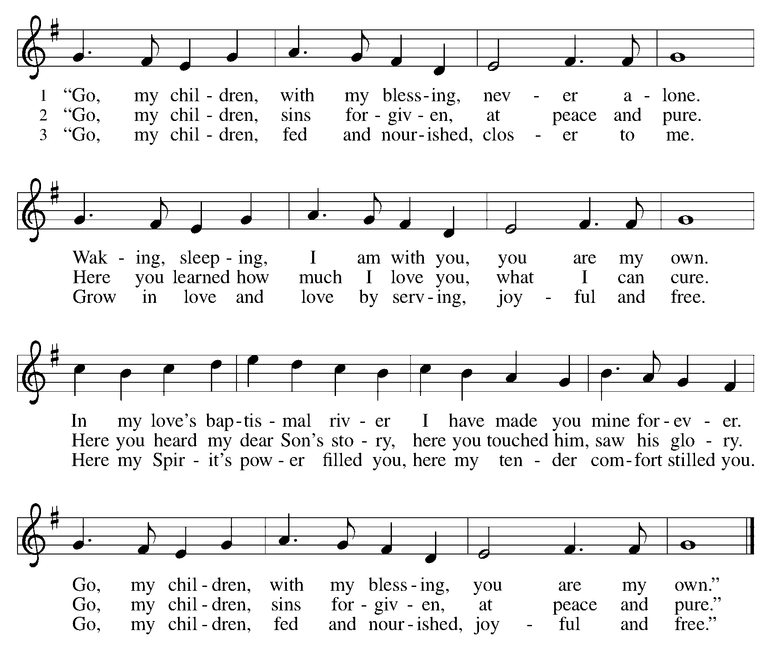

Dismissal
Go in peace. Serve the Lord.
Thanks be to God.
POSTLUDE Sortie by Richard Knight

TODAY
ANNUAL MEETING
Chili Lunch 12:00-1:00 in the LFC
Annual Meeting 1:00 P.M.in the Sanctuary

Welcome To Worship
We are happy you are here!

All who enter the church building, no matter your vaccination status, are
are strongly recommended to mask for the health and safety of us all.

Greeters are here to help! If you have questions, need directions, or just want to know why Holy Trinity is a great place to be, just ask a greeter.

The sanctuary is equipped with Hearing Loop, an assistive listening device. To hear the worship service through your hearing aid, switch your hearing aid to the T-coil setting. Portable receivers and headsets are available for check out. Just ask a greeter to check one out.

We love having children in worship! If you find you or your child needs a break, head on over to the nursery. You will find books, toys, and a changing table. It is just down the hall from the sanctuary.

Restrooms are just down the hall, past the nursery. At the end of the hall turn left!

Be sure to pick up your copy of the Sunday News for all the News & Announcements

ACKNOWLEDGMENTS:
From Sundays and Seasons.com. Copyright 2015 Augsburg Fortress. All rights reserved. Reprinted by permission under Augsburg Fortress Liturgies Annual License # SAS003592. New Revised Standard Version Bible, Copyright © 1989, Division of Christian Education of the National Council of the Churches of Christ in the United States of America. Used by permission. All rights reserved. Revised Common Lectionary, Copyright © 1992 Consultation on Common Texts, admin Augsburg Fortress.God Is Here Text © 1979 and music © 1942, Ren. 1970 Hope Publishing Company, Carol Stream, IL 60188. All rights reserved. Used by permission.Rise, Shine, You People! Text and music © 1974 Augsburg Publishing House, admin. Augsburg Fortress Used with permission under ONE LICENSE #A-708252.This Is My Fathers World Public DomainIn the Bleak Midwinter Public DomainHe Comes to Us as One Unknown Text © 1984 Hope Publishing Company, Carol Stream, IL 60188. All rights reserved. Used by ermission. Music public Domain Used with permission under ONE LICENSE #A-708252.Go, My Children, with My Blessing Text © 1983 Concordia Publishing HouseOutside USA: Arr. from The English Hymnal, © Oxford University Press 1906 music public domain Used with permission under ONE LICENSE #A-708252.Rise, Shine, You People! By Benjamin Culli © 2008 Concordia Publishing House. Performed with permission under ONE LICENSE #A-708252.Sortie by Richard Knight © 1995 Kevin Mayhew, Ltd. Performed with permission under ONE LICENSE #A-708252.

