**HOLY TRINITY LUTHERAN CHURCH**

**SUMMER CONNECTION SERIES**

**JUNE 15 – AUGUST 3, 2025 10:00 AM**

1755 Delhi Street, Dubuque, IA 52001

Service streamed live on YouTube at htlcdbq.com

**GATHER**

*We come together as the Body of Christ for praise, forgiveness, and renewal.*

**Announcements**

**Opening Song**

### **Thanksgiving for Baptism**

### Thanksgiving for Baptism

### Blessed be the holy Trinity, + one God,

### who creates, saves, and sends us

### with love that lives forever. **Amen.**

### Joined to Christ in the waters of baptism,

### we give thanks for the Great Exchange,

### the mercy and forgiveness that wrap

### our true selves in sacred belonging and purpose.

### **Thanks be to God. Alleluia!**

### For a word at the dawn of creation,

### which spoke water and life into being.

### **Thanks be to God. Alleluia!**

### For the great flood that revealed nature’s power

### and God’s commitment to life after death.

### **Thanks be to God. Alleluia!**

### For the river that carried Moses safely,

### building a bridge between mothers and nations.

### **Thanks be to God. Alleluia!**

### For the rock split open in the desert,

### spilling water for those thirsting for freedom.

### **Thanks be to God. Alleluia!**

### For the One who turned water to wine

### and met a woman at the well with living water.

### **Thanks be to God. Alleluia!**

### For the gift of holy baptism,

### which declares there are no more godforsaken places,

### and nothing can separate us from the love of God in Jesus.

### For Christ is risen!

### **Christ is risen, indeed. Alleluia!**

### God of life, we rejoice with the waters that cover creation;

### our songs of praise echo their dancing tides and streams.

### Pour out your Holy Spirit on this community and all of creation.

### Cleanse our fears. Drown our divisions.

### Give us mercy and grace to drink so that our whole lives

### are signs of death defeated and thirst quenched

### thanks to the risen Jesus, the Son of God.

### **Amen.**

### 

P: *(gestures to assembly)*

**C: Thanks be to God! Alleluia.**

P: For Christ is Risen!

C: **Christ is Risen, indeed! Alleluia!**

**Now the Feast**  *ELW 167*

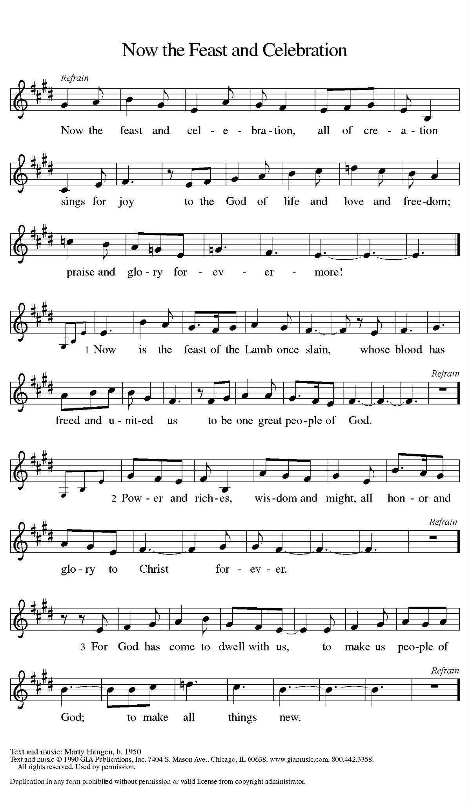

### **Prayer of the Day**

**Children’s Message**

**WORD**

*Together we receive God’s Word through Scripture, Song, and Liturgy.*

### **Scripture Reading**

### 

Word of God, Word of Life. **Thanks be to God.**

*Please rise.****Alleluia Now the Feast***

### **Gospel:**

The Gospel according to… **Glory to you, O Lord.**

The gospel of the Lord. **Praise to you, O Christ.**

*Please be seated.*

**MESSAGE**

### 

### 

### 

### 

### 

### 

### 

### 

### 

### 

### 

*Please rise.***SONG OF THE DAY**

## 

## **Apostles’ Creed**

With the whole church, let us confess our faith.

**I believe in God, the Father almighty,**

**creator of heaven and earth.**

**I believe in Jesus Christ, God’s only Son, our Lord,**

**who was conceived by the Holy Spirit,**

**born of the virgin Mary,**

**suffered under Pontius Pilate,**

**was crucified, died, and was buried;**

**he descended to the dead.\***

**On the third day he rose again;**

**he ascended into heaven,**

**he is seated at the right hand of the Father,**

**and he will come to judge the living and the dead.**

**I believe in the Holy Spirit,**

**the holy catholic church,**

**the communion of saints,**

**the forgiveness of sins,**

**the resurrection of the body,**

**and the life everlasting. Amen.**

## **Prayers of Intercession**

P:God of grace.. **C: hear our prayer.**

### **Sharing of the Peace**

The peace of Christ be with you always. **And also with you.**

*The congregation is invited to share the peace of Christ by greeting your neighbors.*

### **Offering Music** *Instrumental*

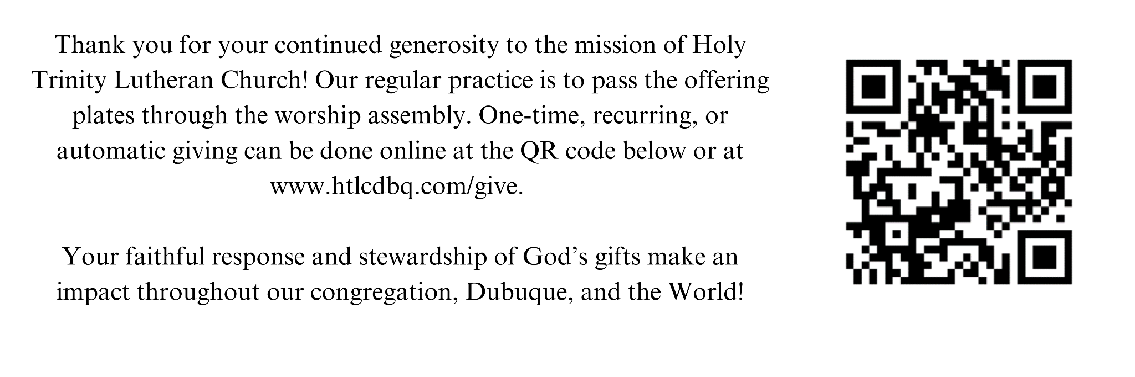

*Please rise*

**OFFERING PRAYER**

Let us join our voices together in our offering prayer…

Creator God,

**in your wisdom you bring forth all that is good**

**and the harvest is plentiful.**

**Strengthen us at your table with these gifts of the earth**

**and our labor,**

**that we may work for the good of all;**

**through Jesus Christ, our Savior.**

# **MEAL**

God feeds us with the presence of Jesus Christ.

**THANKSGIVING AT THE TABLE**

The Lord be with you.

**And also with you.**

Lift up your hearts.

**We lift them to the Lord.**

Let us give thanks to the Lord our God.

**It is right to give our thanks and praise.**

**HOLY, HOLY, HOLY**

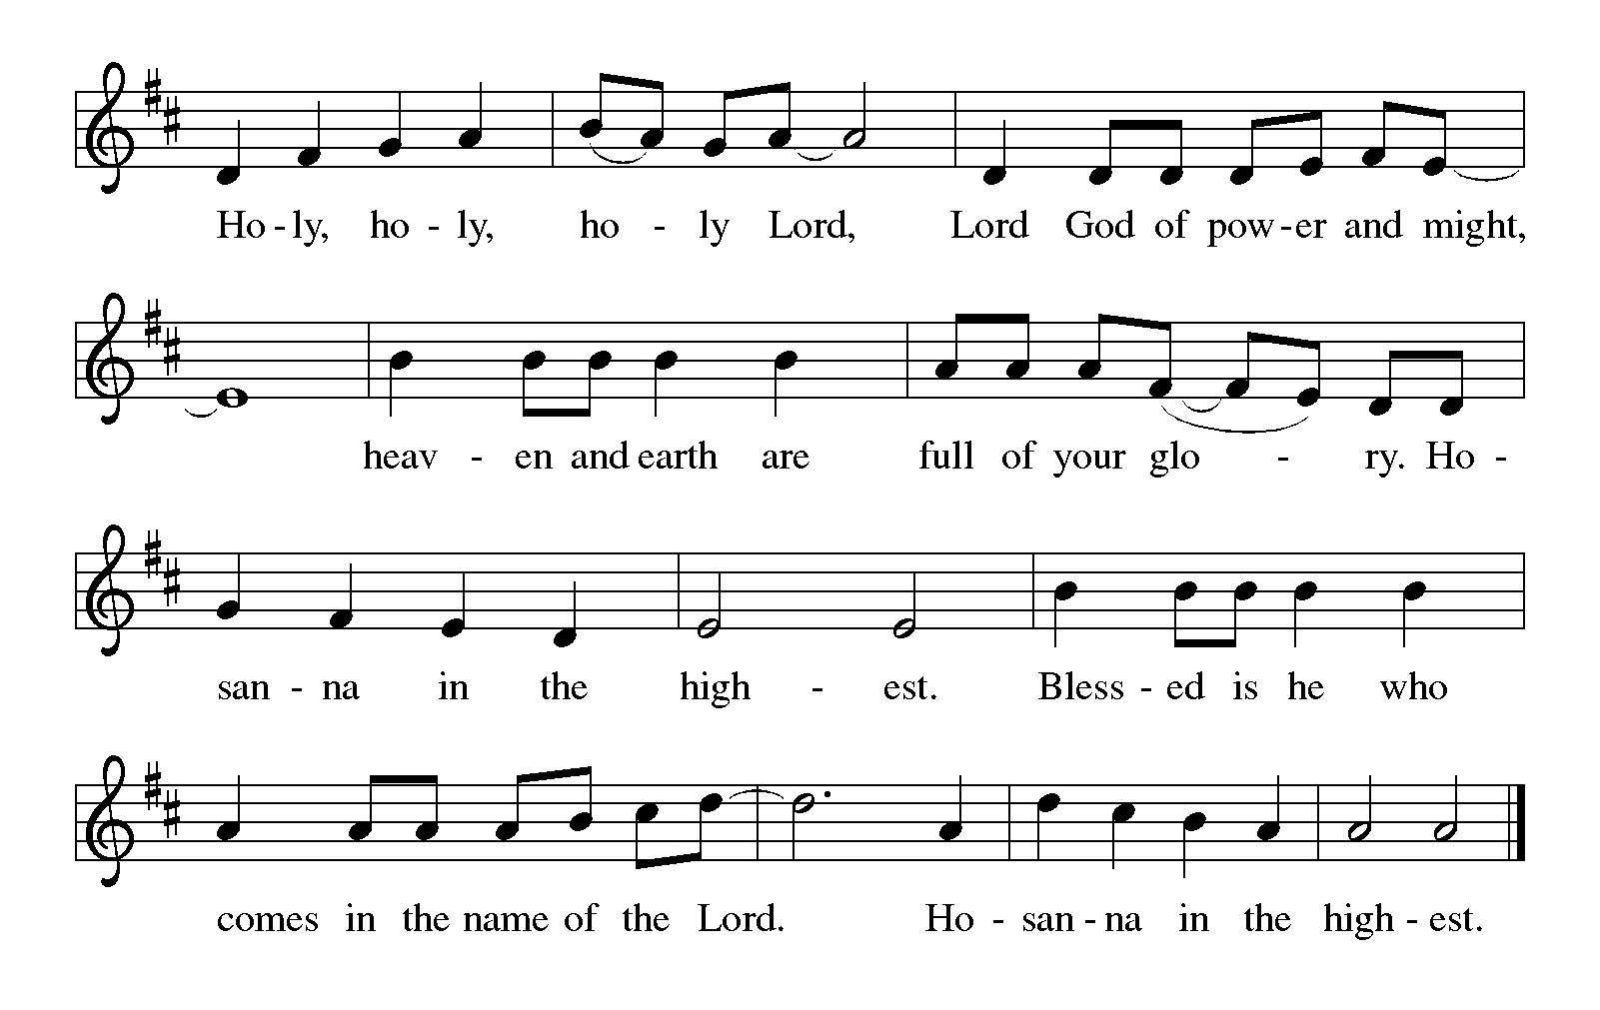

In the night in which he was betrayed…

With this bread and cup

we remember our Lord’s Passover from death to life

as we proclaim the mystery of faith:

**Christ has died.**

**Christ is risen.**

**Christ will come again.**

**LORD’S PRAYER**

Lord remember us in your love and teach us to pray,

**Our Father in heaven,**

**hallowed be your name,**

**your kingdom come,**

**your will be done,**

**on earth as in heaven.**

**Give us today our daily bread.**

**Forgive us our sins**

**as we forgive those**

**who sin against us.**

**Save us from the time of trial**

**and deliver us from evil.**

**For the kingdom, the power,**

**and the glory are yours,**

**now and forever. Amen.**

**Invitation to Communion**

This is Christ’s table…

P: These are the the gifts of God for the people of God… **C: Thanks be to God.**

## **COMMUNION**

*All are welcome to commune at Christ’s Holy Supper. We invite everyone to come forward to the altar to receive the Body and Blood of Christ. Come forward by way of the center aisle to receive the elements and return by the outside aisle.* ***If you cannot come forward*** *to receive communion but would like to receive it directly from the pastor, please let a greeter know and the pastor will bring communion to you. Gluten-free wafers and grape juice are available as well. Children and adults who do not receive communion are invited to come forward as they wish to receive a blessing.*

**LAMB OF GOD Now the Feast**

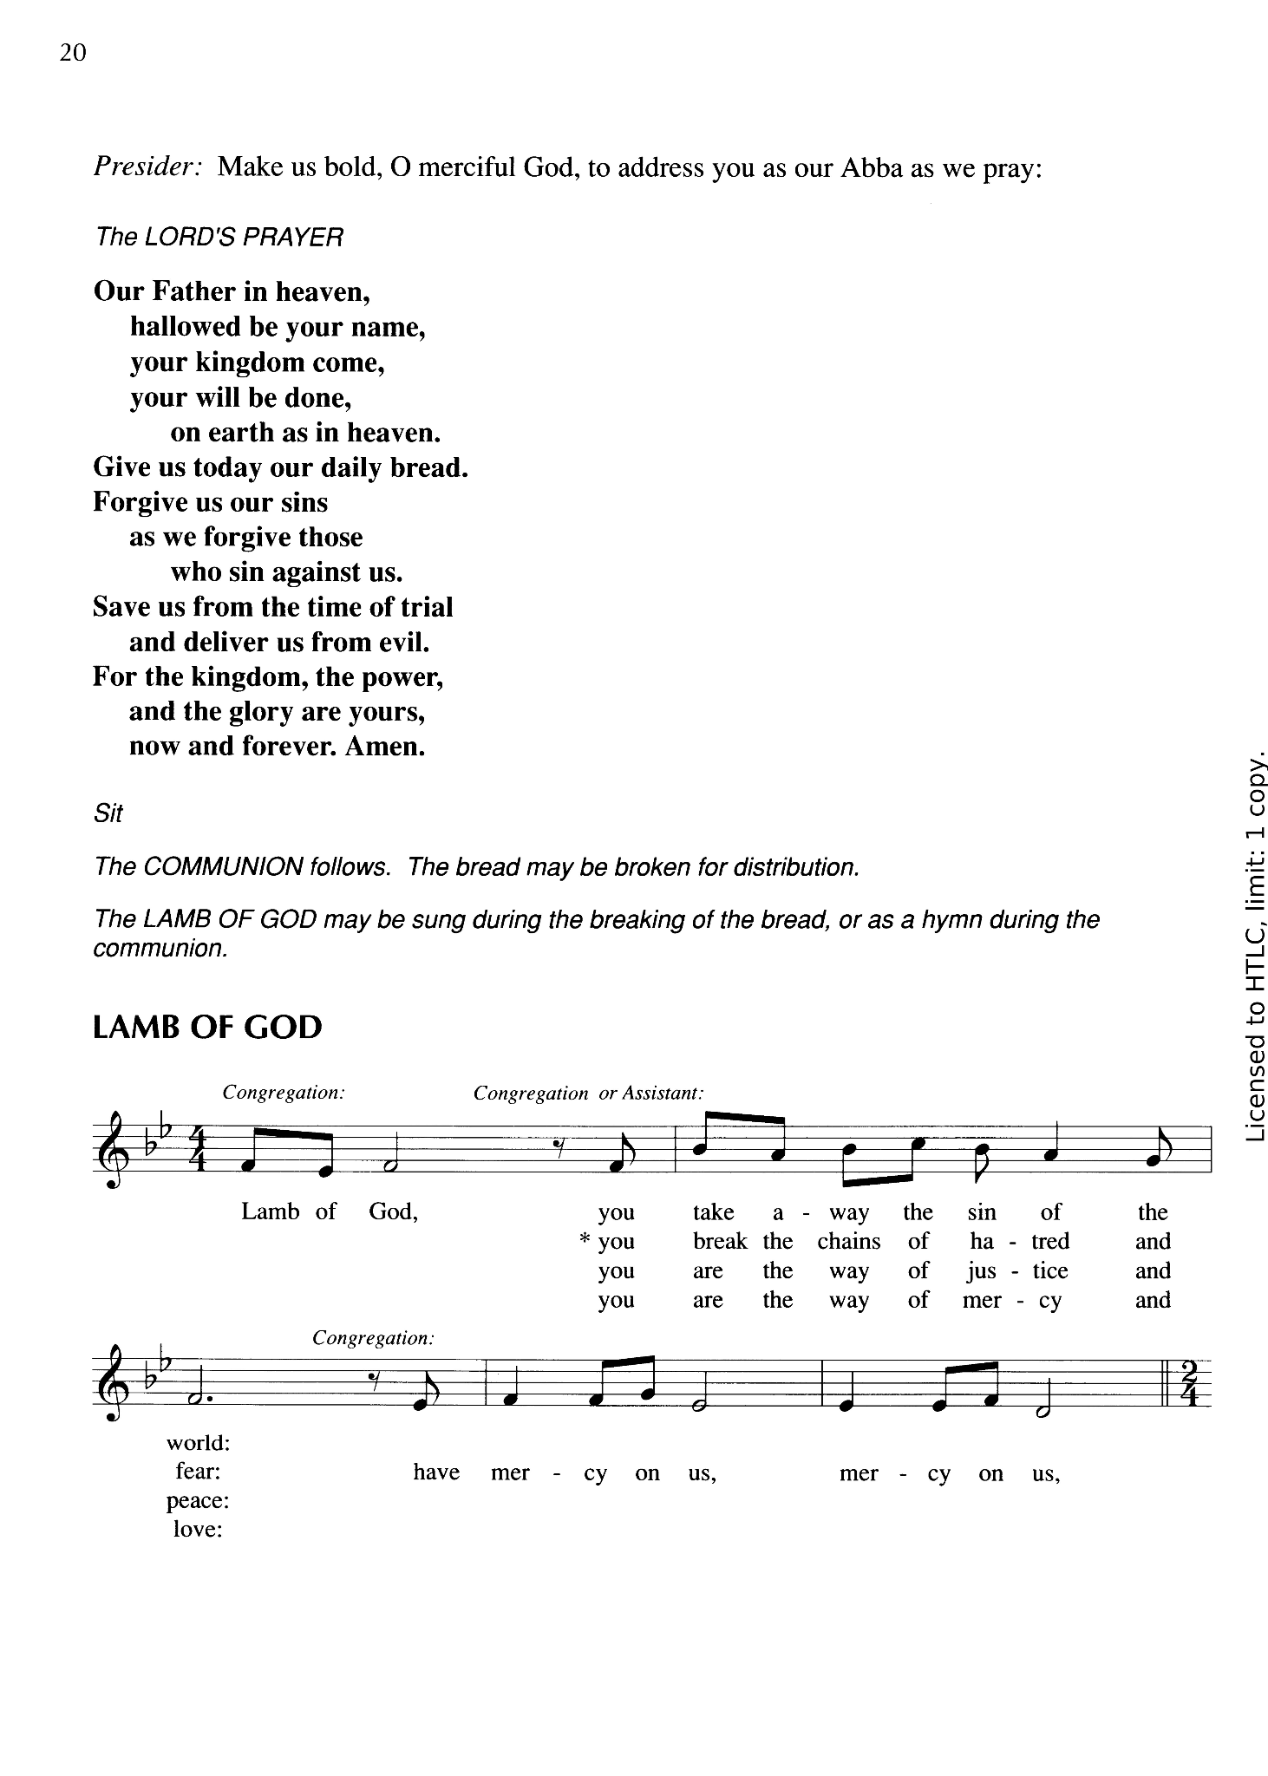

**Communion Song** *Soloist/Instrumental*

**Table Blessing**

The Body and Blood of our Lord Jesus Christ, strengthen and keep you in his grace. **Amen**

**Post Communion Prayer**

Let us pray…

Mothering God,

you gathered us to your table

and we drank deeply of your grace.

Send us out by your Spirit

to love our neighbors as ourselves

and proclaim your love in Jesus’ name.

**Amen.**

**SENDING**

*The Holy Spirit leads us out into the world.*

**BLESSING**

**The love of God abound in you;**

**the grace of our Savior Jesus Christ fill your hearts;**

**and the life of the Spirit**

**bless you and give you peace.**

**In the name of the father, and of the son, and of the Holy Spirit. Amen.**

**SENDING SONG** *Thanks Be to You*

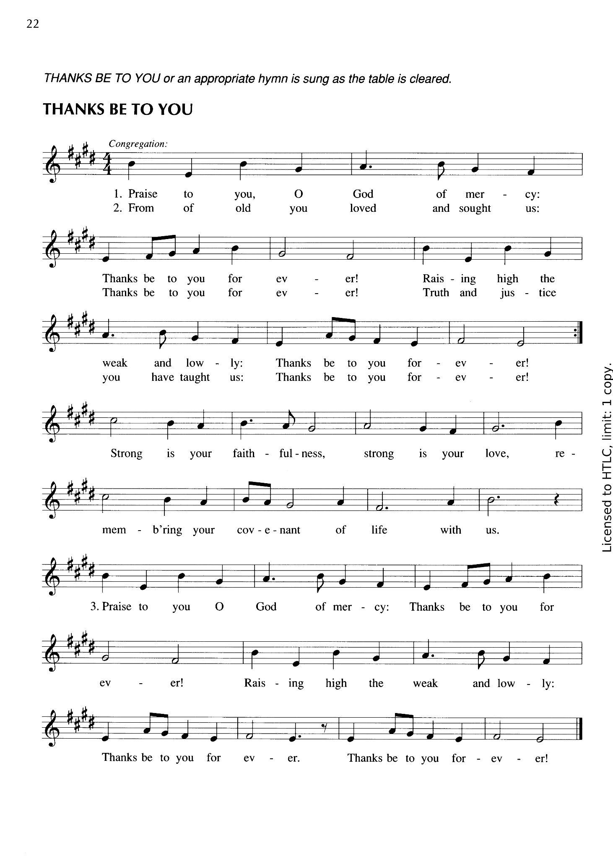

### **Dismissal**

**Go in peace. Live by the Spirit.**

**Thanks be to God.**

**ACKNOWLEDGEMENTS**

From Sundays and Seasons.com. Copyright 2015 Augsburg Fortress. All rights reserved. Reprinted by permission under Augsburg Fortress Liturgies Annual License # SAS003592. New Revised Standard Version Bible, Copyright © 1989, Division of Christian Education of the National Council of the Churches of Christ in the United States of America. Used by permission. All rights reserved. Revised Common Lectionary, Copyright © 1992 Consultation on Common Texts, admin Augsburg Fortress. ONE LICENSE #A-708252

**Now the Feast and Celebration: Now the Feas**

Type: Words and Music; First Line: Now the feast and celebration

Language: English

Contributors: Marty Haugen

Tune: © 1990, GIA Publications, Inc. Text: © 1990, GIA Publications, Inc.

Performed with permission under ONE LICENSE #A-708252.

**Thanks Be To You**

Type: Words and Music; First Line: Praise to you, O God of mercy

Language: English

© 1990, GIA Publications, Inc.

Contributors: Marty Haugen

Performed with permission under ONE LICENSE #A-708252.

