**HOLY TRINITY LUTHERAN CHURCH**

Twelveth Sunday of Pentecost

August 31, 2024

10:30 a.m.

*Services streamed live on YouTube at htlcdbq.com*

**GATHER**

*We come together as the Body of Christ for praise, forgiveness, and renewal.*

**PRELUDE**

**WELCOME AND ANNOUNCEMENTS**

### **Opening Song** Gather Us In

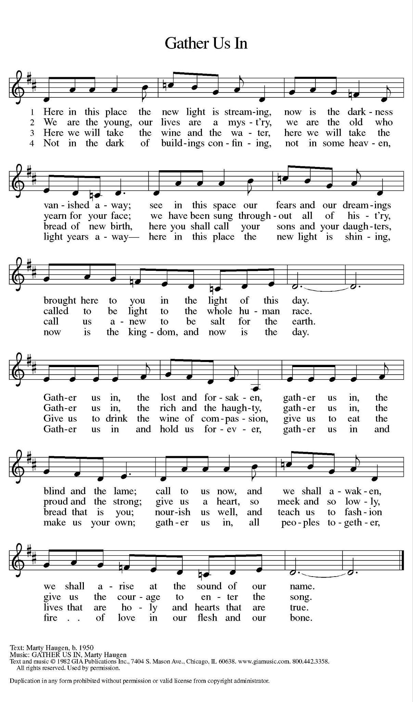

### **Confession and Forgiveness**

*All may make the sign of the cross, the sign that is marked at baptism, as the presiding minister begins.*

In the name of the Father,

and of the ☩ Son,

and of the Holy Spirit.

**Amen.**

Baptized into Christ, let us confess our sin.

*Silence is kept for reflection.*

Merciful God,

**you free us to love others,**

**but we neglect our neighbors and follow our own way.**

**You lead us by the Spirit of joy and peace,**

**but we turn away from the abundant life you offer.**

**You surround us with patience, kindness,**

**and generosity,**

**but we grow weary in doing what is right.**

**In your mercy, forgive us.**

**Do not give up on us.**

**Heal us, break our bonds,**

**and show us the path of life.**

**Amen.**

You belong to Christ Jesus

and you are God’s children through faith.

In the cross of ☩ Christ,

and through the power of the Holy Spirit,

your sins are forgiven.

Clothed with Christ, you are a new creation.

**Amen.**

### 

### 

### 

### 

**Prayer of the Day**

Almighty God, you sent your Holy Spirit to be the life and light of your church. Open our hearts to the riches of your grace, that we may be ready to receive you wherever you appear, through Jesus Christ, our Savior and Lord. **Amen.**

**Children’s Message**

**WORD**

*Together we receive God’s Word through Scripture, Song, and Liturgy*

### **Scripture Reading: Hebrews 13:1-8, 15-16**

1 Let mutual affection continue. 2 Do not neglect to show hospitality to strangers, for by doing that some have entertained angels without knowing it. 3 Remember those who are in prison, as though you were in prison with them, those who are being tortured, as though you yourselves were being tortured. 4 Let marriage be held in honor by all, and let the marriage bed be kept undefiled, for God will judge the sexually immoral and adulterers. 5 Keep your lives free from the love of money, and be content with what you have, for he himself has said, “I will never leave you or forsake you.” 6 So we can say with confidence,

 “The Lord is my helper;

  I will not be afraid.

 What can anyone do to me?”

  7 Remember your leaders, those who spoke the word of God to you; consider the outcome of their way of life, and imitate their faith. 8 Jesus Christ is the same yesterday and today and forever. 15 Through him, then, let us continually offer a sacrifice of praise to God, that is, the fruit of lips that confess his name. 16 Do not neglect to do good and to share what you have, for such sacrifices are pleasing to God.

### Word of God, Word of Life. **Thanks be to God.**

### 

### 

### 

### 

*Please rise.*

**GOSPEL ACCLAMATION**

**Gospel: Luke 14:1, 7-14**

The Gospel according to Luke the 14th Chapter.

**Glory to you, O Lord.**

### 1 On one occasion when Jesus was going to the house of a leader of the Pharisees to eat a meal on the Sabbath, they were watching him closely.

### 7 When he noticed how the guests chose the places of honor, he told them a parable. 8 “When you are invited by someone to a wedding banquet, do not sit down at the place of honor, in case someone more distinguished than you has been invited by your host, 9 and the host who invited both of you may come and say to you, ‘Give this person your place,’ and then in disgrace you would start to take the lowest place. 10 But when you are invited, go and sit down at the lowest place, so that when your host comes, he may say to you, ‘Friend, move up higher’; then you will be honored in the presence of all who sit at the table with you. 11 For all who exalt themselves will be humbled, and those who humble themselves will be exalted.”

### 12 He said also to the one who had invited him, “When you give a luncheon or a dinner, do not invite your friends or your brothers and sisters or your relatives or rich neighbors, in case they may invite you in return, and you would be repaid. 13 But when you give a banquet, invite the poor, the crippled, the lame, and the blind. 14 And you will be blessed because they cannot repay you, for you will be repaid at the resurrection of the righteous.”

### 

The gospel of the Lord. **Praise to you, O Christ.**

*Please be seated.*

### **MESSAGE** *Pastor Jason R. Davis*

**SONG OF THE DAY** *Blessed Assurance*

## **Apostles’ Creed**

## With the whole church, let us confess our faith.

## **I believe in God, the Father almighty,**

## **creator of heaven and earth.**

## **I believe in Jesus Christ, God’s only Son, our Lord,**

## **who was conceived by the Holy Spirit,**

## **born of the virgin Mary,**

## **suffered under Pontius Pilate,**

## **was crucified, died, and was buried;**

## **he descended to the dead.\***

## **On the third day he rose again;**

## **he ascended into heaven,**

## **he is seated at the right hand of the Father,**

## **and he will come to judge the living and the dead.**

## **I believe in the Holy Spirit,**

## **the holy catholic church,**

## **the communion of saints,**

## **the forgiveness of sins,**

## **the resurrection of the body,**

## **and the life everlasting. Amen.**

## 

### **Prayers of Intercession**

## Let us pray for the church, the creation, and the whole people of God, for God is near.

## *A brief silence.*

## After each prayer:

## Hear us, O God.

## **Your mercy is great.**

## 

## Confident in God’s presence and promise, we entrust our prayers to the one who always receives them; through Jesus Christ, our wisdom and companion.

## **Amen.**

### **Sharing of the Peace**

The peace of Christ be with you always. **And also with you.**

*The congregation is invited to share the peace of Christ by greeting your neighbors.*

### **Offering Music**

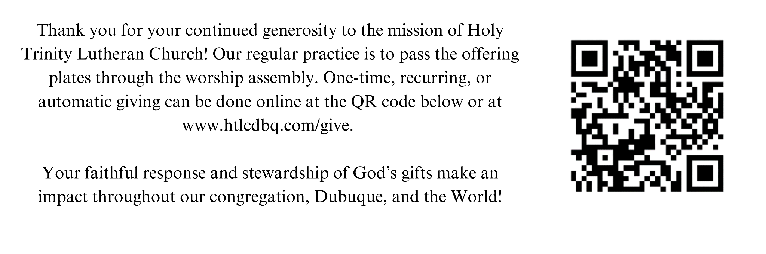

*Please rise*

**OFFERING PRAYER**

Let us join our voices together in our offering prayer…

Creator God,

**in your wisdom you bring forth all that is good**

**and the harvest is plentiful.**

**Strengthen us at your table with these gifts of the earth**

**and our labor,**

**that we may work for the good of all;**

**through Jesus Christ, our Savior.**

**Amen**

**MEAL**

God feeds us with the presence of Jesus Christ.

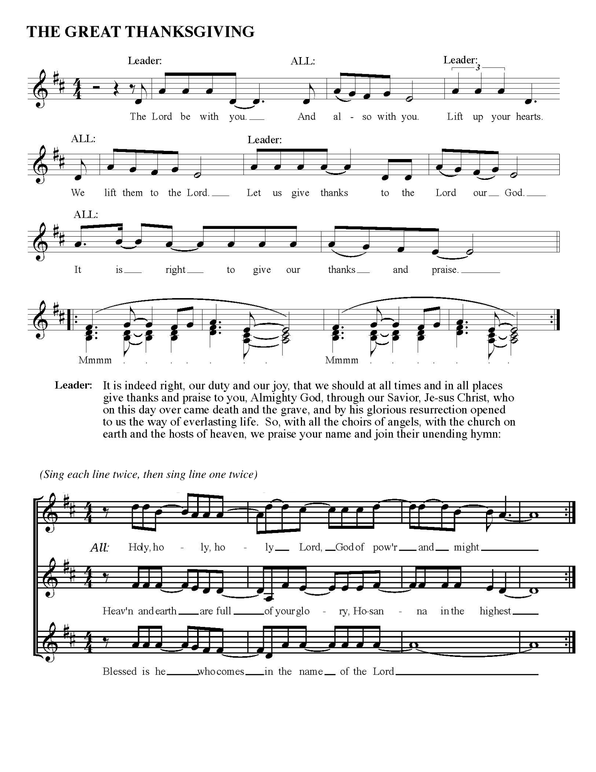

**THANKSGIVING AT THE TABLE**

In the night in which he was betrayed,

our Lord Jesus took bread, and gave thanks; broke it, and gave it to his disciples, saying: Take and eat; this is my body, given for you. Do this for the remembrance of me.

Again, after supper, he took the cup, gave thanks, and gave it for all to drink, saying:

This cup is the new covenant in my blood,

shed for you and for all people for the forgiveness of sin. Do this for the remembrance of me.

With this bread and cup

we remember our Lord’s Passover from death to life

as we proclaim the mystery of faith:

**Christ has died.**

**Christ is risen.**

**Christ will come again.**

**LORD’S PRAYER**

Lord remember us in your love and teach us to pray,

**Our Father in heaven,**

**hallowed be your name,**

**your kingdom come,**

**your will be done,**

**on earth as in heaven.**

**Give us today our daily bread.**

**Forgive us our sins**

**as we forgive those**

**who sin against us.**

**Save us from the time of trial**

**and deliver us from evil.**

**For the kingdom, the power,**

**and the glory are yours,**

**now and forever. Amen.**

**Invitation to Communion**

This is Christ’s table. It's a table of love and welcome. It's a table of fellowship with the poor and communion with the Earth.

So come: Those of you with great faith and those of you who wish you had more.

Come, those of you who have tried to follow Jesus and those of you who believe you have somehow failed.

Come. Those of you who depend on this meal for your life and for those of you who feel this is a strange thing.

P: These are the the gifts of God for the people of God… **C: Thanks be to God.**

## **COMMUNION**

*All are welcome to commune at Christ’s Holy Supper. We invite everyone to come forward to the altar to receive the Body and Blood of Christ. Come forward by way of the center aisle to receive the elements and return by the outside aisle.* ***If you cannot come forward*** *to receive communion but would like to receive it directly from the pastor, please let a greeter know and the pastor will bring communion to you. Gluten-free wafers and grape juice are available as well. Children and adults who do not receive communion are invited to come forward as they wish to receive a blessing.*

**LAMB OF GOD**

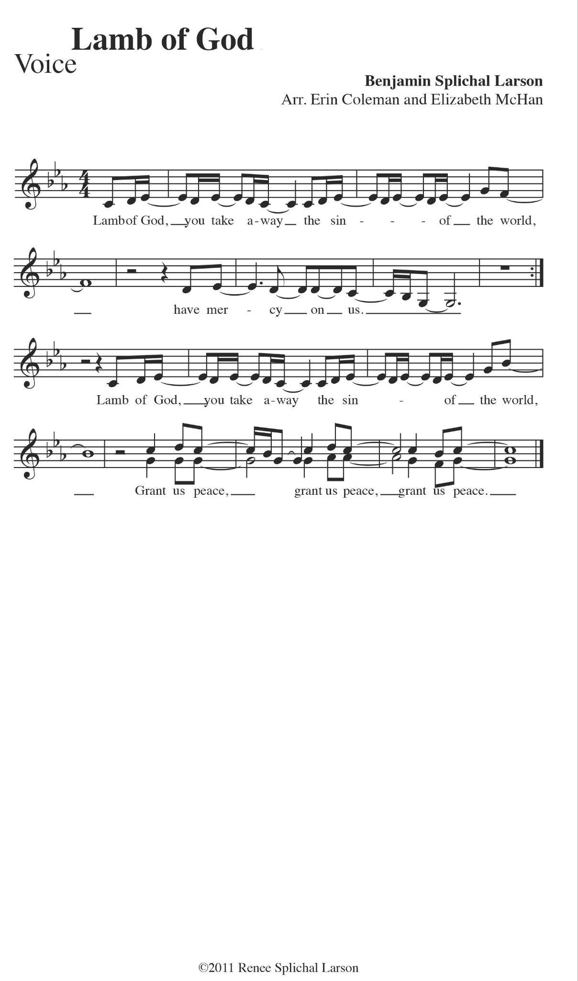

*Please be seated*

***Communion Song*** *Welcome Table ELW 969*

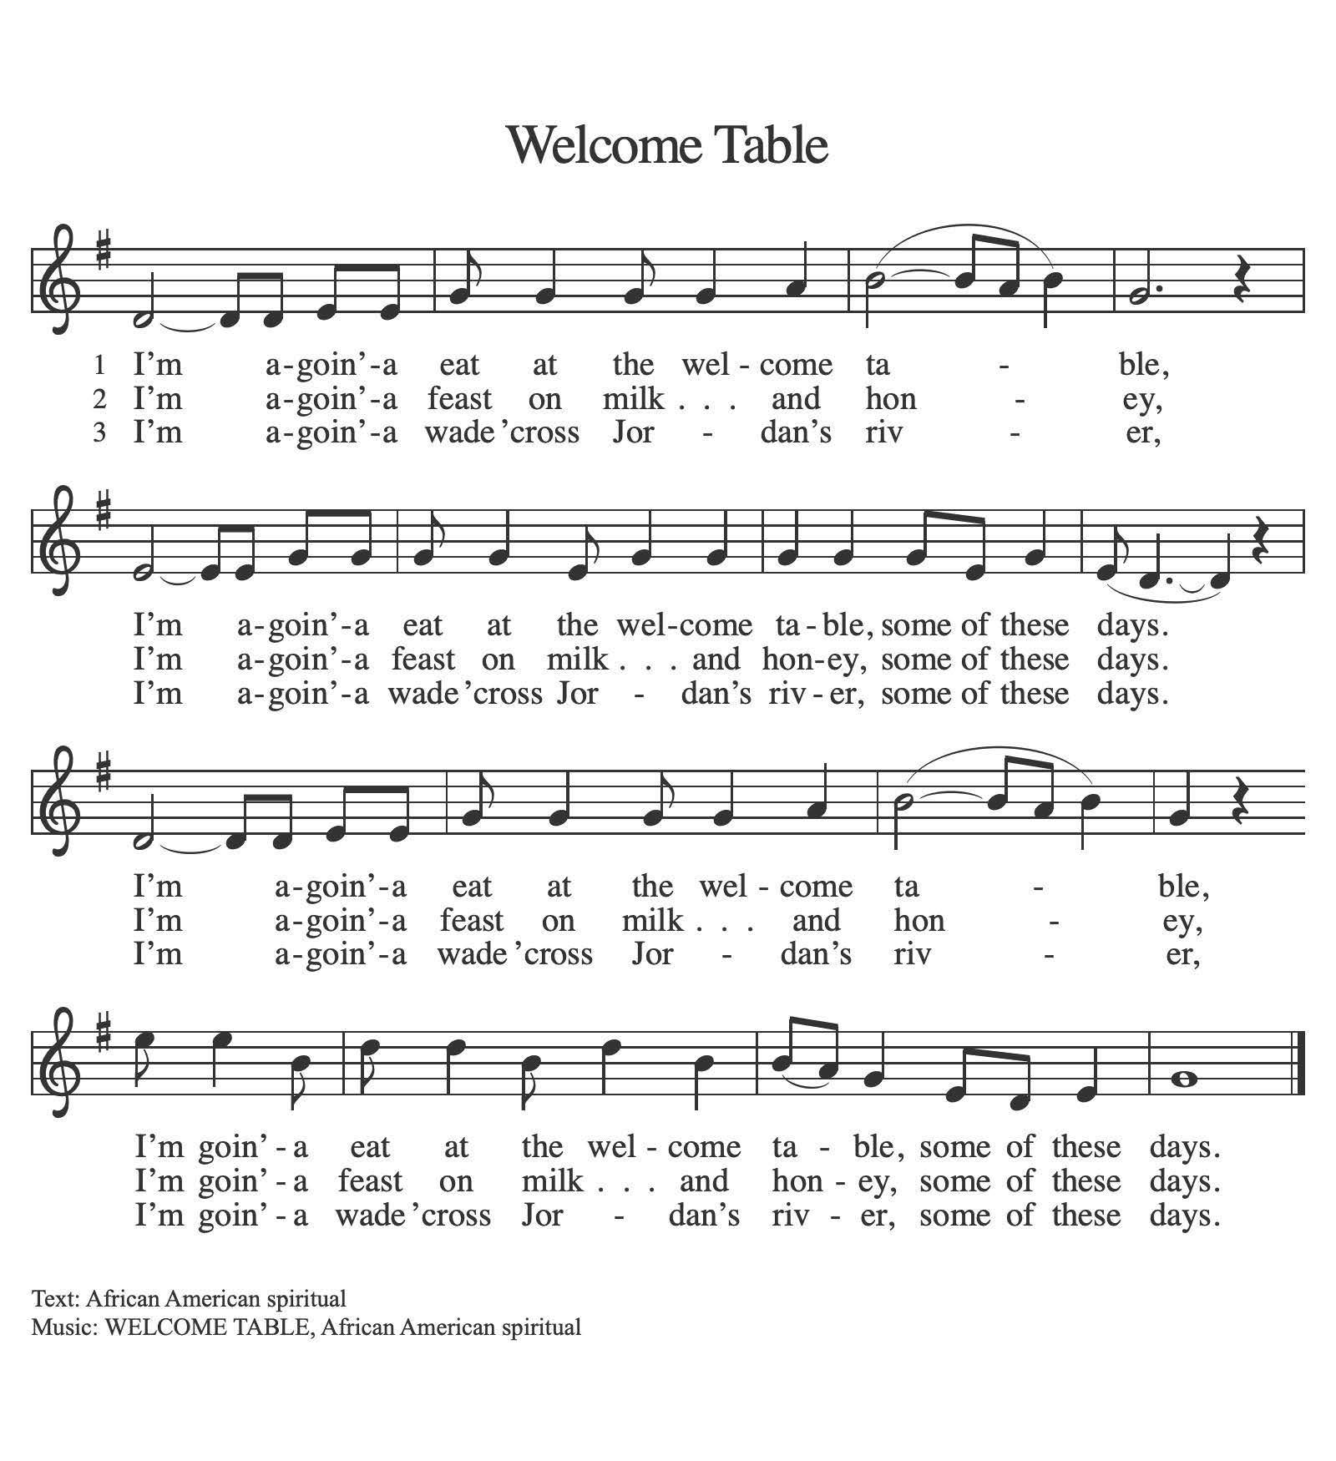

### **Table Blessing…**

The Body and Blood of our Lord Jesus Christ, strengthen and keep you in his grace. **Amen**.

### **Prayer after Communion** Let us pray…

Mothering God,

**you gathered us to your table**

**and we drank deeply of your grace.**

**Send us out by your Spirit**

**to love our neighbors as ourselves**

**and proclaim your love in Jesus’ name. Amen.**

**SENDING**

*The Holy Spirit leads us out into the world.*

**BLESSING**

The love of God abound in you;

the grace of our Savior Jesus Christ fill your hearts;

and the life of the Spirit

☩ bless you and give you peace.

**Amen.**

**SENDING SONG** *The Lord Now Sends Us Forth ELW 538*

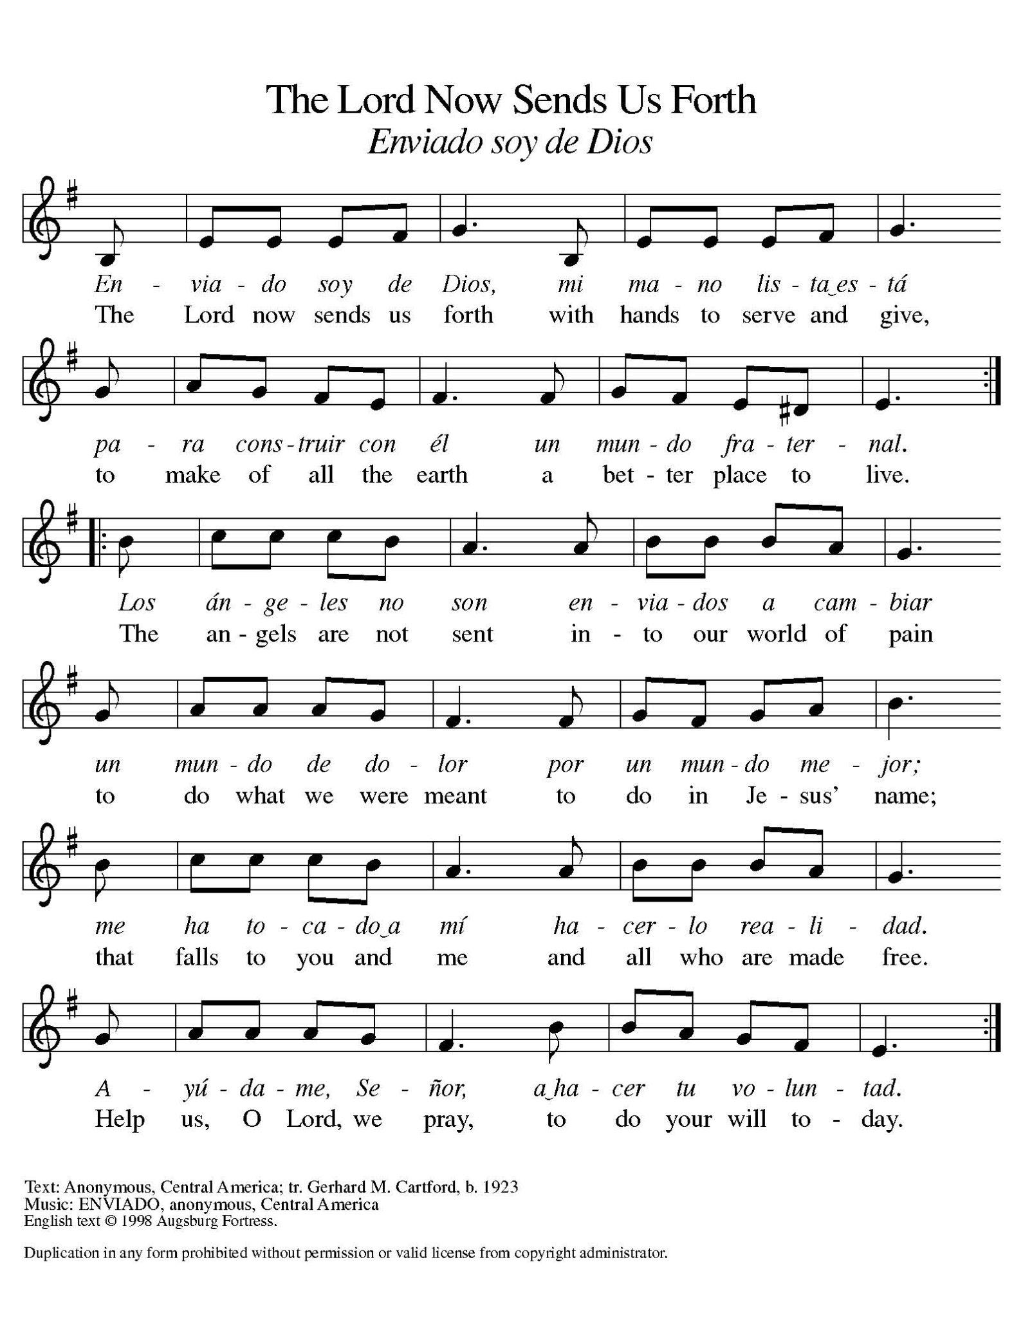

## **DISMISSAL**

Go in peace. Live by the Spirit. **Thanks be to God.**

**ACKNOWLEDGEMENTS**

From Sundays and Seasons.com. Copyright 2015 Augsburg Fortress. All rights reserved. Reprinted by permission under Augsburg Fortress Liturgies Annual License # SAS003592. New Revised Standard Version Bible, Copyright © 1989, Division of Christian Education of the National Council of the Churches of Christ in the United States of America. Used by permission. All rights reserved. Revised Common Lectionary, Copyright © 1992 Consultation on Common Texts, admin Augsburg Fortress.



