**Holy Trinity Lutheran Church**

Fifth Sunday of Easter

Sunday, May 2, 2021 | 9:00 A.M.



1755 Delhi Street, Dubuque, IA 52001

56.-582-3228

www.HTLCDBQ.COM

**Gathering**

The Holy Spirit calls us together as the people of God.

**Prelude**

**Welcome and Announcements**

*Please rise.*

**Thanksgiving for Baptism**

In the name of the Father,

and of the ☩ Son,

and of the Holy Spirit.

**Amen.**

Joined to Christ in the waters of baptism,

we are clothed with God's mercy and forgiveness.

Let us give thanks for the gift of baptism.

We give you thanks, O God,

for in the beginning your Spirit moved over the waters

and by your Word you created the world,

calling forth life in which you took delight.

Through the waters of the flood you delivered Noah and his family.

Through the sea you led your people Israel from slavery into freedom.

At the river your Son was baptized by John and anointed with the Holy Spirit.

By water and your Word you claim us as daughters and sons,

making us heirs of your promise and servants of all.

We praise you for the gift of water that sustains life,

and above all we praise you for the gift of new life in Jesus Christ.

Shower us with your Spirit,

and renew our lives with your forgiveness, grace, and love.

To you be given honor and praise

through Jesus Christ our Lord

in the unity of the Holy Spirit, now and forever.

**Amen.**

Please be seated

**Gathering Hymn***Now the Green Blade Rises*  ELW 379



**Greeting**

The grace of our Lord Jesus Christ, the love of God,

and the communion of the Holy Spirit be with you all.

**And also with you.**

**Prayer of the Day**

Let us pray.

O God, you give us your Son as the vine apart from whom we cannot live. Nourish our life in his resurrection, that we may bear the fruit of love and know the fullness of your joy, through Jesus Christ, our Savior and Lord, who lives and reigns with you and the Holy Spirit, one God, now and forever.

**Amen.**

**Word**

God speaks to us in scripture reading, preaching, and song.

**First Reading: Acts 8:26-40**

A reading from Acts.

26An angel of the Lord said to Philip, “Get up and go toward the south to the road that goes down from Jerusalem to Gaza.” (This is a wilderness road.) 27So he got up and went. Now there was an Ethiopian eunuch, a court official of the Candace, queen of the Ethiopians, in charge of her entire treasury. He had come to Jerusalem to worship 28and was returning home; seated in his chariot, he was reading the prophet Isaiah. 29Then the Spirit said to Philip, “Go over to this chariot and join it.” 30So Philip ran up to it and heard him reading the prophet Isaiah. He asked, “Do you understand what you are reading?” 31He replied, “How can I, unless someone guides me?” And he invited Philip to get in and sit beside him. 32Now the passage of the scripture that he was reading was this:   
 “Like a sheep he was led to the slaughter,  
  and like a lamb silent before its shearer,  
   so he does not open his mouth.  
 33In his humiliation justice was denied him.  
  Who can describe his generation?  
   For his life is taken away from the earth.”  
34The eunuch asked Philip, “About whom, may I ask you, does the prophet say this, about himself or about someone else?” 35Then Philip began to speak, and starting with this scripture, he proclaimed to him the good news about Jesus. 36As they were going along the road, they came to some water; and the eunuch said, “Look, here is water! What is to prevent me from being baptized?” 38He commanded the chariot to stop, and both of them, Philip and the eunuch, went down into the water, and Philip baptized him. 39When they came up out of the water, the Spirit of the Lord snatched Philip away; the eunuch saw him no more, and went on his way rejoicing. 40But Philip found himself at Azotus, and as he was passing through the region, he proclaimed the good news to all the towns until he came to Caesarea.

Word of God, word of life. **Thanks be to God.**

**Psalm: Psalm 22:25-31**

25From you comes my praise in the great assembly;  
  I will perform my vows in the sight of those who fear the Lord.  
 26**The poor shall eat and be satisfied,**  
  **Let those who seek the Lord give praise! May your hearts live forever!**  
 27All the ends of the earth shall remember and turn to the Lord;  
  all the families of nations shall bow before God.  
 28**For dominion belongs to the Lord, who rules over the nations.**   
 29Indeed, all who sleep in the earth shall bow down in worship; all who go down to the dust, though they be dead, shall kneel before the Lord.  
 30**Their descendants shall serve the Lord,**  
  **whom they shall proclaim to generations to come.**  
 31They shall proclaim God’s deliverance to a people yet unborn,  
  saying to them, “The Lord has acted!”

**Second Reading: 1 John 4:7-21**

A reading from 1 John.

7Beloved, let us love one another, because love is from God; everyone who loves is born of God and knows God. 8Whoever does not love does not know God, for God is love. 9God’s love was revealed among us in this way: God sent his only Son into the world so that we might live through him. 10In this is love, not that we loved God but that he loved us and sent his Son to be the atoning sacrifice for our sins. 11Beloved, since God loved us so much, we also ought to love one another. 12No one has ever seen God; if we love one another, God lives in us, and his love is perfected in us.  
  13By this we know that we abide in him and he in us, because he has given us of his Spirit. 14And we have seen and do testify that the Father has sent his Son as the Savior of the world. 15God abides in those who confess that Jesus is the Son of God, and they abide in God. 16So we have known and believe the love that God has for us.   
  God is love, and those who abide in love abide in God, and God abides in them. 17Love has been perfected among us in this: that we may have boldness on the day of judgment, because as he is, so are we in this world. 18There is no fear in love, but perfect love casts out fear; for fear has to do with punishment, and whoever fears has not reached perfection in love. 19We love because he first loved us. 20Those who say, “I love God,” and hate their brothers or sisters, are liars; for those who do not love a brother or sister whom they have seen, cannot love God whom

they have not seen. 21The commandment we have from him is this: those who love God must love their brothers and sisters also.

Word of God, word of life.

**Thanks be to God.**

**Gospel Acclamation**

*Please rise.*



**Gospel: John 15:1-8**

The holy gospel according to John.

**Glory to you, O Lord.**

[Jesus said:] 1“I am the true vine, and my Father is the vine grower. 2He removes every branch in me that bears no fruit. Every branch that bears fruit he prunes to make it bear more fruit. 3You have already been cleansed by the word that I have spoken to you. 4Abide in me as I abide in you. Just as the branch cannot bear fruit by itself unless it abides in the vine, neither can you unless you abide in me. 5I am the vine, you are the branches. Those who abide in me and I in them bear much fruit, because apart from me you can do nothing. 6Whoever does not abide in me is thrown away like a branch and withers; such branches are gathered, thrown into the fire, and burned. 7If you abide in me, and my words abide in you, ask for whatever you wish, and it will be done for you. 8My Father is glorified by this, that you bear much fruit and become my disciples.”

The gospel of the Lord.

**Praise to you, O Christ.**

***Please be seated.***

**Sermon** Pastor Josh Martyn

**Hymn of the Day***Love Divine, All Loves Excelling*  ELW 631



*Please rise*

**Creed**

**We believe in one God,**

**the Father, the Almighty,**

**maker of heaven and earth,**

**of all that is, seen and unseen.**

**We believe in one Lord, Jesus Christ,**

**the only Son of God,**

**eternally begotten of the Father,**

**God from God, Light from Light,**

**true God from true God,**

**begotten, not made,**

**of one Being with the Father;**

**through him all things were made.**

**For us and for our salvation**

**he came down from heaven,**

**was incarnate of the Holy Spirit and the virgin Mary**

**and became truly human.**

**For our sake he was crucified under Pontius Pilate;**

**he suffered death and was buried.**

**On the third day he rose again**

**in accordance with the scriptures;**

**he ascended into heaven**

**and is seated at the right hand of the Father.**

**He will come again in glory to judge the living and the dead,**

**and his kingdom will have no end.**

**We believe in the Holy Spirit, the Lord, the giver of life,**

**who proceeds from the Father and the Son,**

**who with the Father and the Son is worshiped and glorified,**

**who has spoken through the prophets.**

**We believe in one holy catholic and apostolic church.**

**We acknowledge one baptism for the forgiveness of sins.**

**We look for the resurrection of the dead,**

**and the life of the world to come. Amen.**

**Prayers of Intercession**

*At the end of each petition, the reader will say “Hear us, O God”, please respond with****“Your mercy is great.”***

Alive in the risen Christ by the power of the Holy Spirit, we bring our prayers before God who promises to hear us and answer in steadfast love.

God of all fruitfulness…….

In the hope of new life in Christ, we raise our prayers to you, trusting in your never-ending goodness and mercy; through Jesus Christ our Lord. **Amen.**

**Peace**

The peace of Christ be with you always.

**And also with you.**

*Please be seated*

**Offering**

**Offering Prayer**

Let us pray.

Blessed are you, O God, ruler of heaven and earth. Day by day you shower us with blessings. As you have raised us to new life in Christ, give us glad and generous hearts, ready to praise you and to respond to those in need, through Jesus Christ, our Savior and Lord.

**Amen.**

**Meal**

God feeds us with the presence of Jesus Christ.

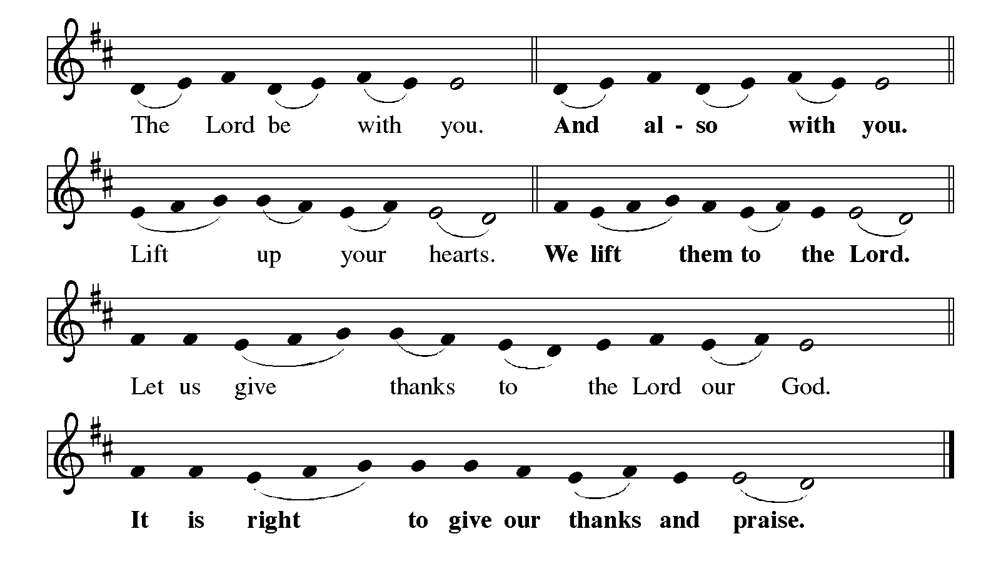**Great Thanksgiving**

It is indeed right, our duty and our joy, that we should at all times and in all places give thanks and praise to you...and with angels and archangels, cherubim and seraphim, we praise your name and join their unending hymn:

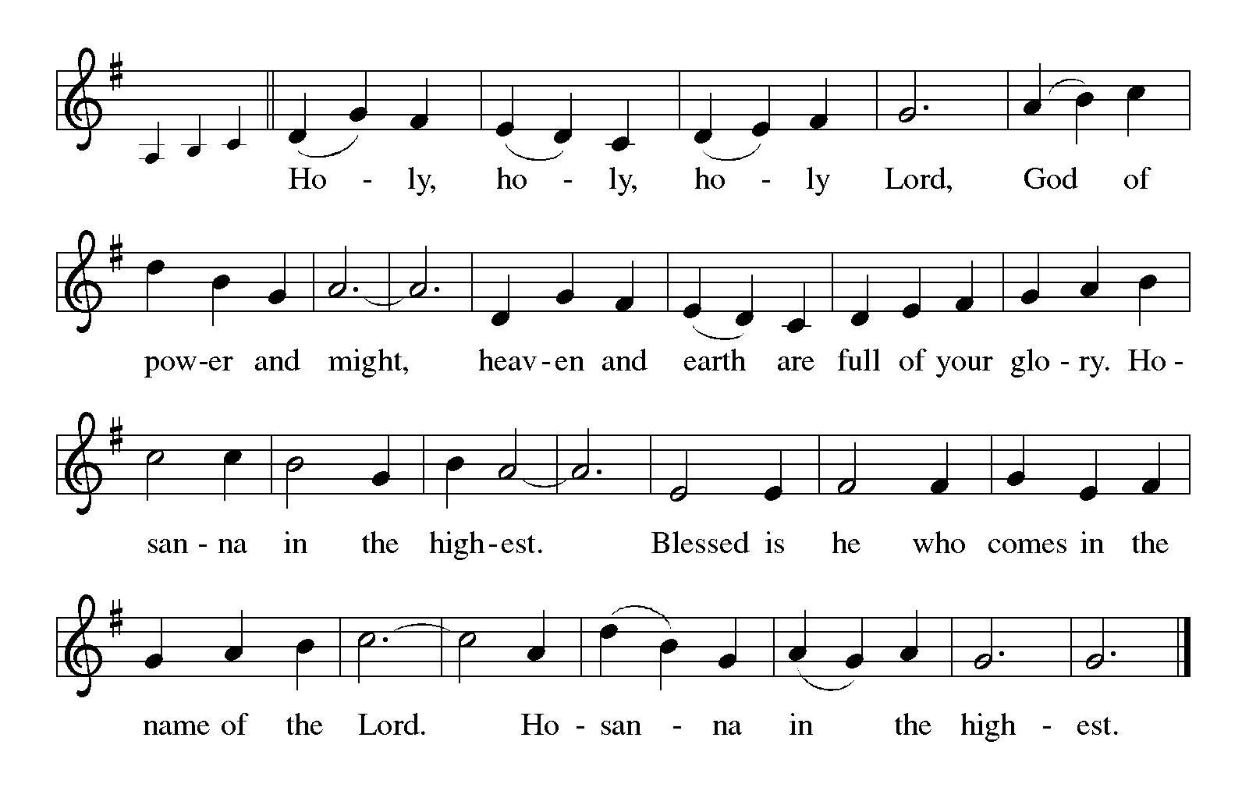

**Eucharistic Prayer**

Holy, mighty, and merciful Lord, heaven and earth are full of your glory…

Pour out upon us the Spirit of your love, O Lord, and unite the wills of all who share this heavenly food, the body and blood of Jesus Christ, our Lord; to whom, with you and the Holy Spirit, be all honor and glory, now and forever.

**Amen.**

**Lord’s Prayer**

Lord, remember us in your kingdom and teach us to pray.

**Our Father, who art in heaven,**

**hallowed be thy name,**

**thy kingdom come,**

**thy will be done,**

**on earth as it is in heaven.**

**Give us this day our daily bread;**

**and forgive us our trespasses,**

**as we forgive those**

**who trespass against us;**

**and lead us not into temptation,**

**but deliver us from evil.**

**For thine is the kingdom,**

**and the power, and the glory,**

**forever and ever. Amen.**

All are welcome to commune at Christ’s Holy Supper.  Please grab a pre-filled communion cup located in the basket in your pew.  When instructed to do so, please first remove the bottom film of your cup to access the wafer.  Set the wafer aside and remove the top film from the cup to access the grape juice.  You may put your empty communion cups into the empty basket in your pew.

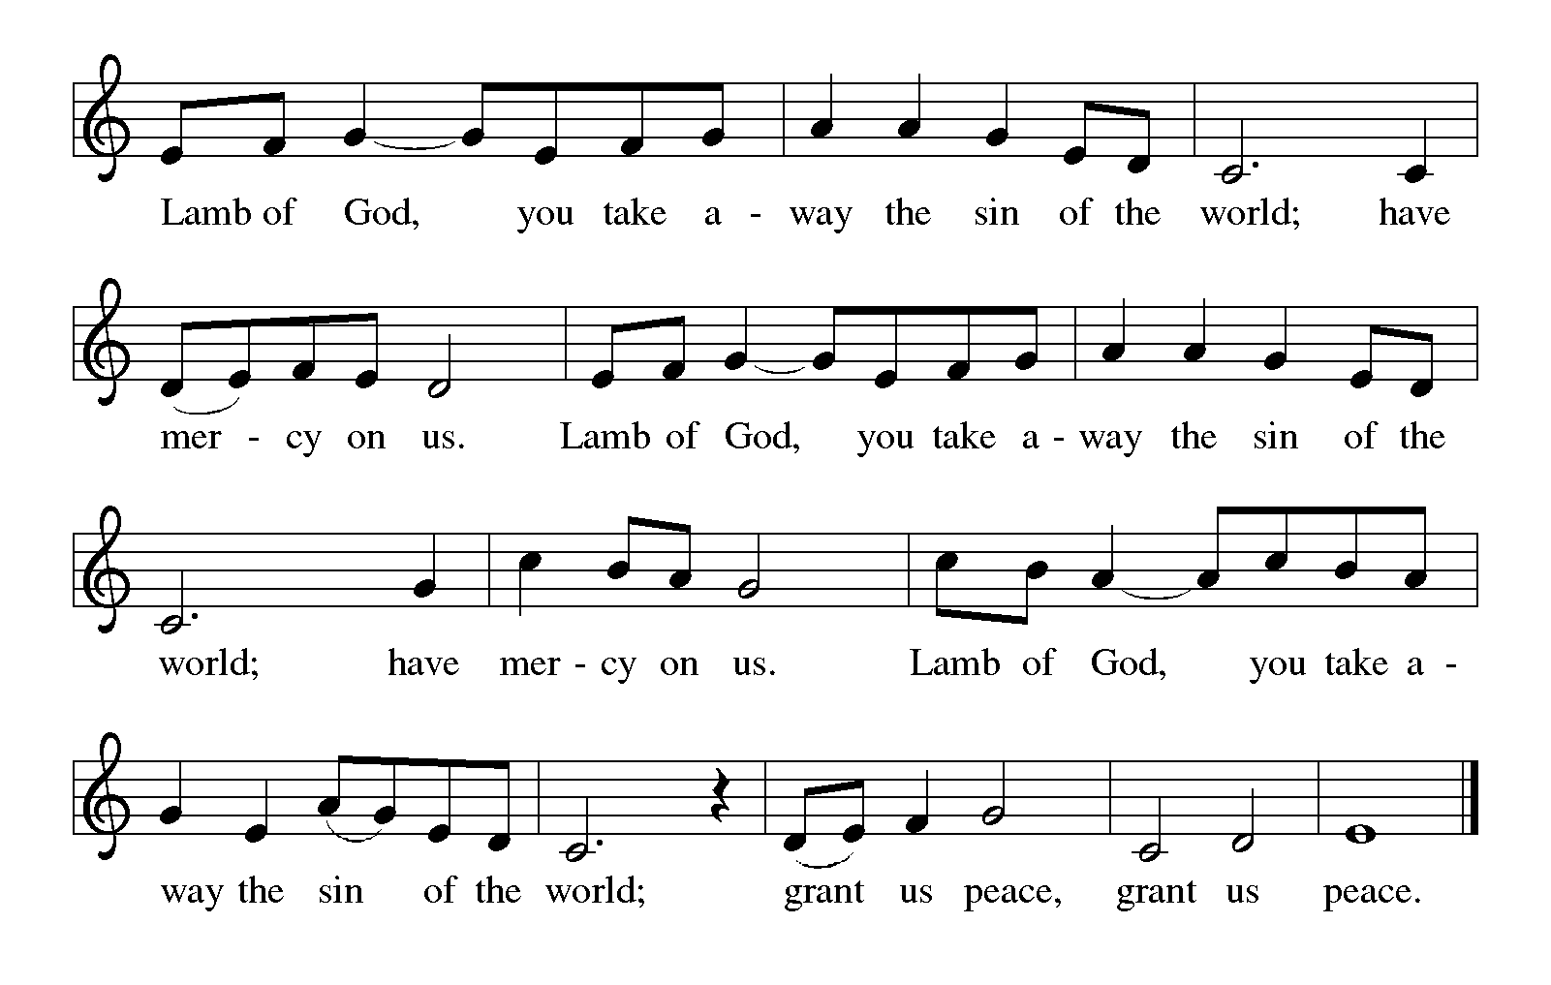**Lamb of God**

**Communion Hymn** *I Received the Living God* ELW 477



**Communion**

*Please rise.*

**POST-COMMUNION BLESSING**

The body and blood of our Lord Jesus Christ strengthen you and keep you in his grace.

**Amen.**

**Post-Communion Prayer**

Let us pray. Living God, you have greeted us in our brokenness and nourished us with the body of Christ, broken for us. Risen to new life with you, send us now to bear your healing love into the wounded world, in the name of our risen Savior and Lord. **Amen.**

**Sending**

God blesses us and sends us in mission to the world.

**Blessing**

The Lord bless you and keep you.

The Lord’s face shine on you with grace and mercy.

The Lord look upon you with favor and ☩ give you peace.

**Amen.**

**Sending Hymn***Christ Is Alive! Let Christians Sing*ELW 389



**Dismissal**

Go in peace. Christ is with you.

**Thanks be to God.**

**Postlude**

**Acknowledgements**

**I Received the Living God, Text and Tune, Public Domain, Arrangement** Augsburg Fortress Reprinted with permission under ONE LICENSE #A-708252. All rights reserved.

**Now the Green Blade Rises,** Text from *Oxford Book of Carols*, © Oxford University Press 1928. All rights reserved.

Tune, Public Domain. Arrangement Reprinted with permission under ONE LICENSE #A-708252. All rights reserved.

**Love Divine, All Loves Excelling,**

**Let the Vineyards Be Fruitful (Capers)** Text © 1978 Lutheran Book of Worship, admin. Augsburg Fortress and music © 1993 Augsburg Fortress Reprinted with permission under ONE LICENSE #A-708252. All rights reserved.

**Christ Is Alive! Let Christians Sing,** Music Public Domain, Text © 1975, rev. 1995 Hope Publishing Company, Carol Stream, IL 60188. All rights reserved. Used by permission. Reprinted with permission under ONE LICENSE #A-708252. All rights reserved.

From Sundays and Seasons.com. Copyright 2015 Augsburg Fortress. All rights reserved. Reprinted by permission under Augsburg Fortress Liturgies Annual License # SAS003592.

New Revised Standard Version Bible, Copyright © 1989, Division of Christian Education of the National Council of the Churches of Christ in the United States of America. Used by permission. All rights reserved. Revised Common Lectionary, Copyright © 1992 Consultation on Common Texts, admin Augsburg Fortress. Used by permission.