**Holy Trinity Lutheran Church**

Twelfth Sunday of Pentecost

August 31, 2025

8:30 A.M.

1755 Delhi Street, Dubuque, IA 52001

Service streamed live on YouTube at htlcdbq.com

**GATHER**

*We come together as the Body of Christ for praise, forgiveness, and renewal.*

**PRELUDE**

**WELCOME AND ANNOUNCEMENTS**

### **Confession and Forgiveness**

*All may make the sign of the cross, the sign that is marked at baptism, as the presiding minister begins.*

In the name of the Father,

and of the ☩ Son,

and of the Holy Spirit.

**Amen.**

Baptized into Christ, let us confess our sin.

*Silence is kept for reflection.*

Merciful God,

**We have sinned against you.**

**You free us to love others,**

**but we neglect our neighbors and follow our own way.**

**You lead us by the Spirit of joy and peace,**

**but we turn away from the abundant life you offer.**

**You surround us with patience, kindness,**

**and generosity,**

**but we grow weary in doing what is right.**

**In your mercy, forgive us.**

**Do not give up on us.**

**Heal us, break our bonds,**

**and show us the path of life.**

**Amen.**

You belong to Christ Jesus

and you are God’s children through faith.

In the cross of ☩ Christ,

and through the power of the Holy Spirit,

your sins are forgiven.

Clothed with Christ, you are a new creation.

**Amen.**

**GATHERING SONG**  *Gather Us in ELW 532*

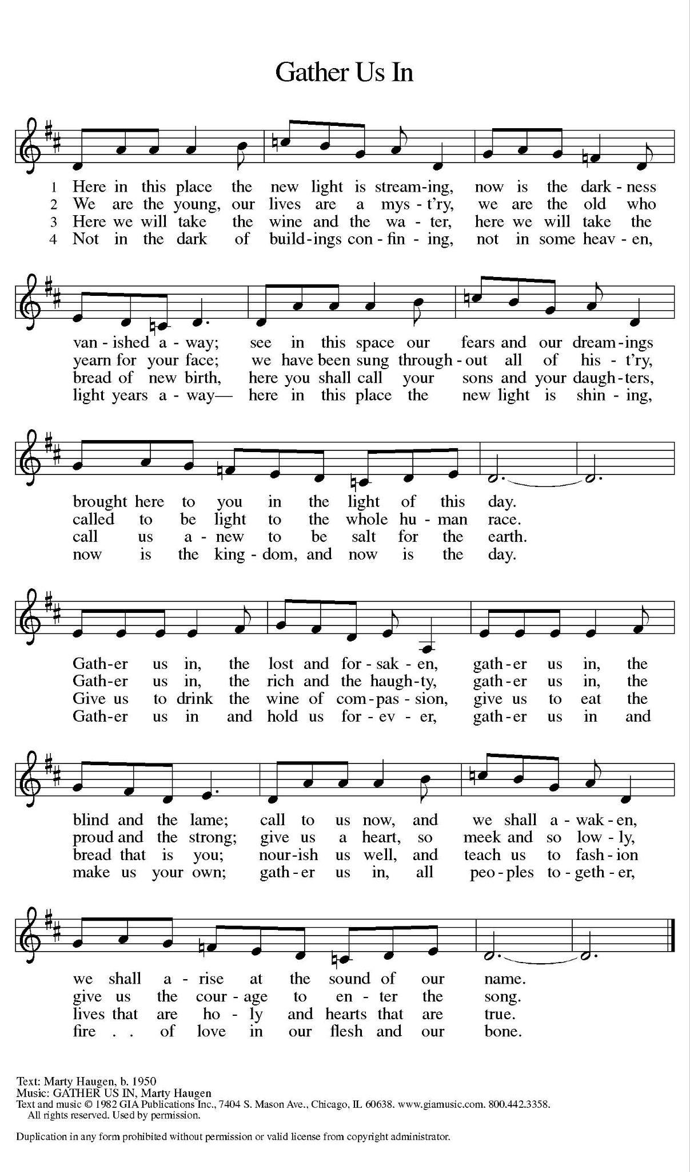

## **GREETING**

The grace of our Lord Jesus Christ, the love of God, and the communion of the Holy Spirit be with you all. **And also with you.**

**This is the Feast**

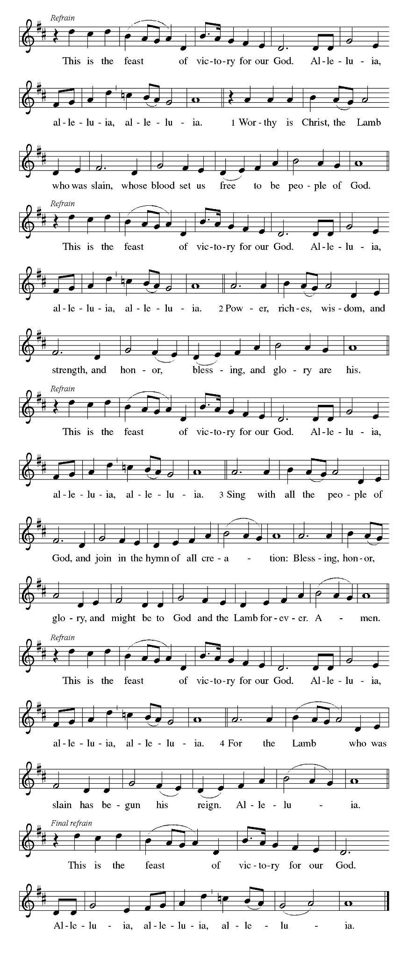

### 

### **Prayer of the Day**

Almighty God, you sent your Holy Spirit to be the life and light of your church. Open our hearts to the riches of your grace, that we may be ready to receive you wherever you appear, through Jesus Christ, our Savior and Lord. **Amen.**

*Please be seated.*

**CHILDREN’S MESSAGE**

**WORD**

*Together we receive God’s Word through Scripture, Song, and Liturgy.*

**First Reading: Proverbs 25:6-7a**

 6 Do not put yourself forward in the king’s presence

  or stand in the place of the great,

 7a for it is better to be told, “Come up here,”

  than to be put lower in the presence of a noble.

Word of God, Word of Life. **Thanks be to God.**

### **Second Reading: Hebrews 13:1-8, 15-16**

1 Let mutual affection continue. 2 Do not neglect to show hospitality to strangers, for by doing that some have entertained angels without knowing it. 3 Remember those who are in prison, as though you were in prison with them, those who are being tortured, as though you yourselves were being tortured. 4 Let marriage be held in honor by all, and let the marriage bed be kept undefiled, for God will judge the sexually immoral and adulterers. 5 Keep your lives free from the love of money, and be content with what you have, for he himself has said, “I will never leave you or forsake you.” 6 So we can say with confidence,

 “The Lord is my helper;

  I will not be afraid.

 What can anyone do to me?”

  7 Remember your leaders, those who spoke the word of God to you; consider the outcome of their way of life, and imitate their faith. 8 Jesus Christ is the same yesterday and today and forever. 15 Through him, then, let us continually offer a sacrifice of praise to God, that is, the fruit of lips that confess his name. 16 Do not neglect to do good and to share what you have, for such sacrifices are pleasing to God.

### Word of God, Word of Life. **Thanks be to God.**

*Please rise*

## **GOSPEL ACCLAMATION**

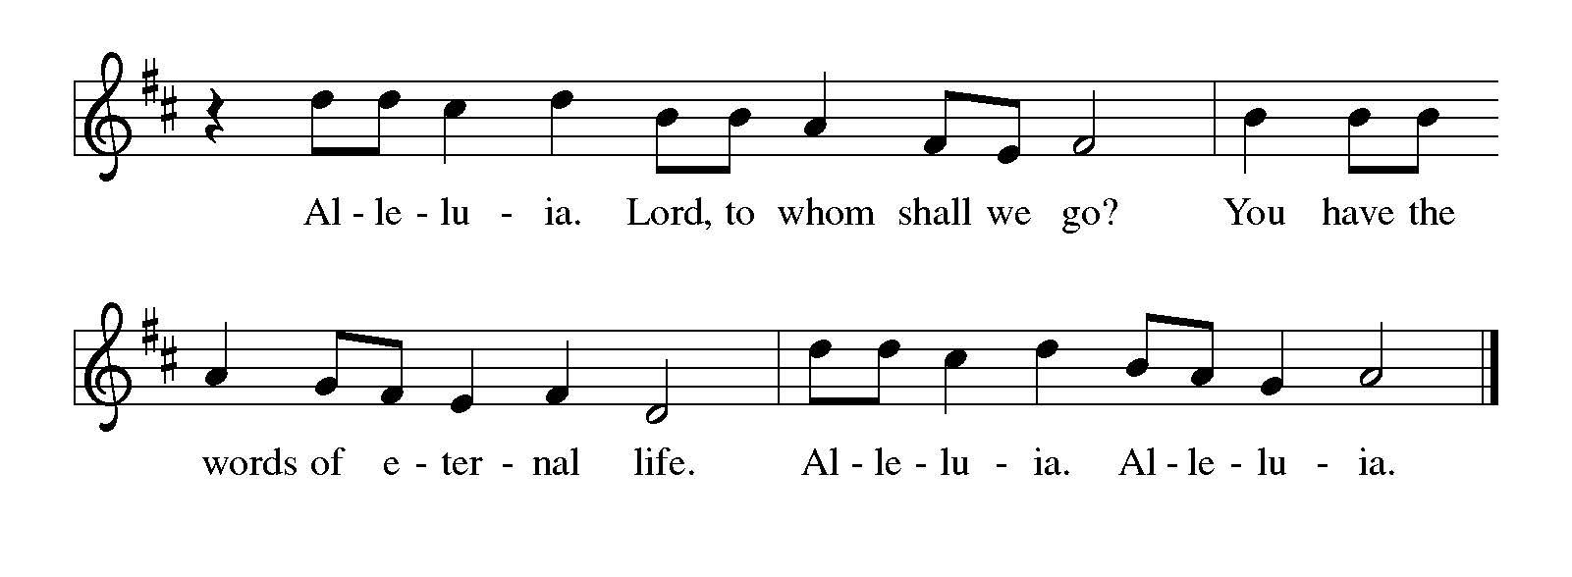**Gospel: Luke 14:1, 7-14**

The Gospel according to Luke the 14th Chapter.

**Glory to you, O Lord.**

### 1 On one occasion when Jesus was going to the house of a leader of the Pharisees to eat a meal on the Sabbath, they were watching him closely.

### 7 When he noticed how the guests chose the places of honor, he told them a parable. 8 “When you are invited by someone to a wedding banquet, do not sit down at the place of honor, in case someone more distinguished than you has been invited by your host, 9 and the host who invited both of you may come and say to you, ‘Give this person your place,’ and then in disgrace you would start to take the lowest place. 10 But when you are invited, go and sit down at the lowest place, so that when your host comes, he may say to you, ‘Friend, move up higher’; then you will be honored in the presence of all who sit at the table with you. 11 For all who exalt themselves will be humbled, and those who humble themselves will be exalted.”

### 12 He said also to the one who had invited him, “When you give a luncheon or a dinner, do not invite your friends or your brothers and sisters or your relatives or rich neighbors, in case they may invite you in return, and you would be repaid. 13 But when you give a banquet, invite the poor, the crippled, the lame, and the blind. 14 And you will be blessed because they cannot repay you, for you will be repaid at the resurrection of the righteous.”

### 

The gospel of the Lord. **Praise to you, O Christ.**

*Please be seated.*

**MESSAGE** *Pastor Jason R. Davis*

*Please Rise*

**HYMN OF THE DAY** *Look Who Gathers at Christ's Table ACS 977*

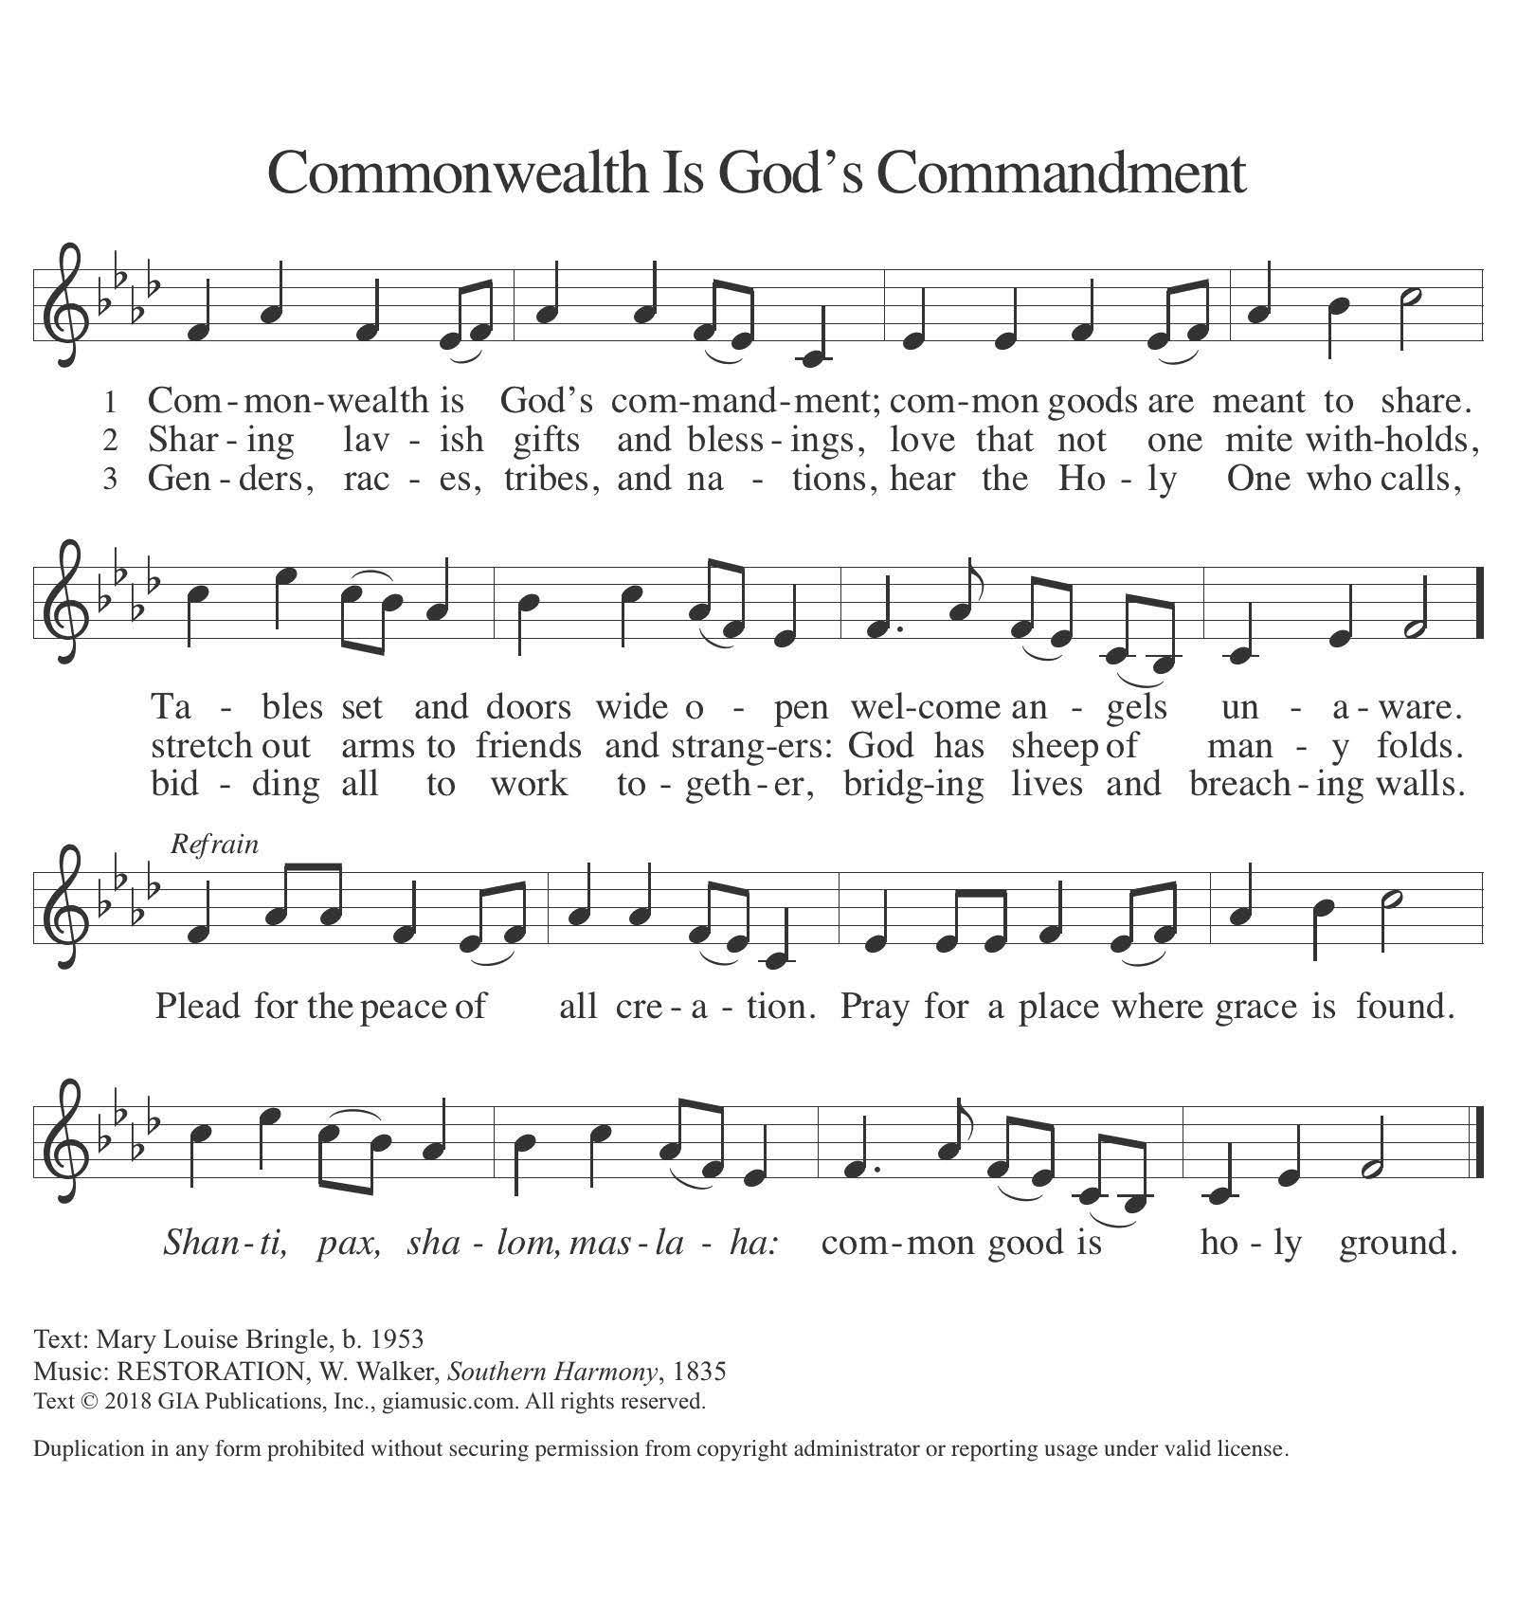

## **APOSTLES’ CREED**

## With the whole church on Earth, we proclaim our faith with the words of the Apostles Creed.

**I believe in God, the Father almighty,**

**creator of heaven and earth.**

**I believe in Jesus Christ, God’s only Son, our Lord,**

**who was conceived by the Holy Spirit,**

**born of the virgin Mary,**

**suffered under Pontius Pilate,**

**was crucified, died, and was buried;**

**he descended to the dead.**

**On the third day he rose again;**

**he ascended into heaven,**

**he is seated at the right hand of the Father,**

**and he will come to judge the living and the dead.**

**I believe in the Holy Spirit,**

**the holy catholic church,**

**the communion of saints,**

**the forgiveness of sins,**

**the resurrection of the body,**

**and the life everlasting. Amen.**

### **Prayers of Intercession**

## Let us pray for the church, the creation, and the whole people of God, for God is near.

## *A brief silence.*

## After each prayer:

## Hear us, O God.

## **Your mercy is great.**

## 

## Confident in God’s presence and promise, we entrust our prayers to the one who always receives them; through Jesus Christ, our wisdom and companion.

## **Amen.**

**SHARING OF THE PEACE**

The peace of Christ be with you always. **And also with you.**

*The congregation is invited to share the peace of Christ by greeting your neighbors.*

*Please be seated.*

***OFFERING***

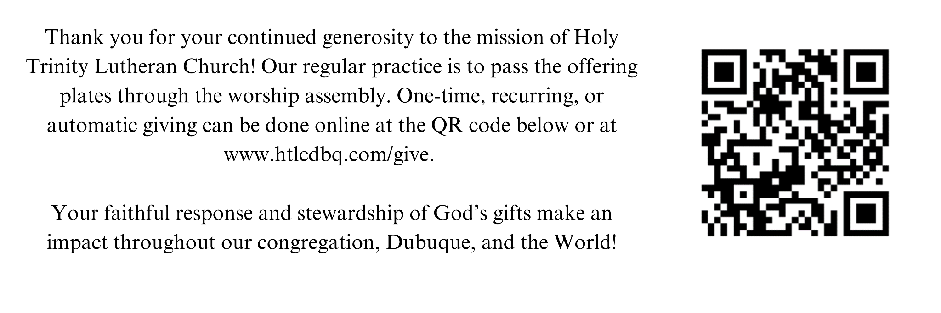

*Please be seated.*

**OFFERING SONG**

*Please rise*

**OFFERING PRAYER**Let us join our voices together in our offering prayer…

Creator God,

**in your wisdom you bring forth all that is good**

**and the harvest is plentiful.**

**Strengthen us at your table with these gifts of the earth**

**and our labor,**

**that we may work for the good of all;**

**through Jesus Christ, our Savior.**

**Amen.**

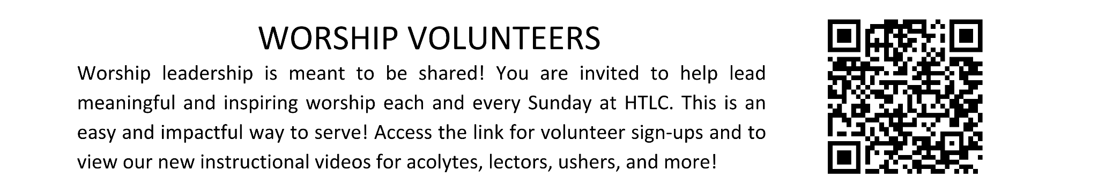

# **MEAL**

God feeds us with the presence of Jesus Christ.

## **GREAT THANKSGIVING**

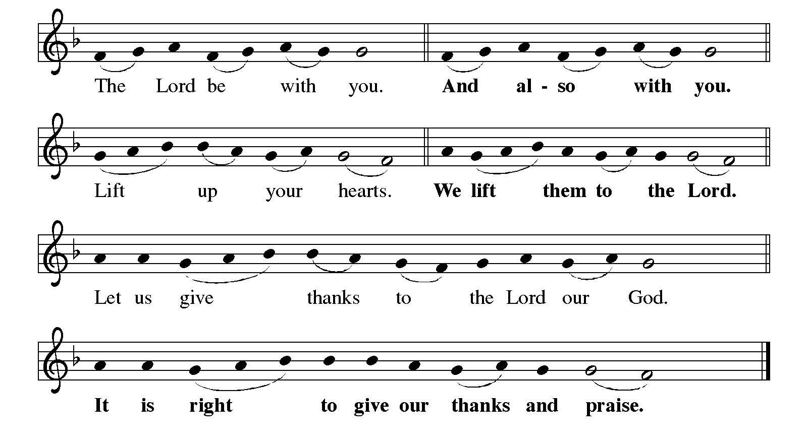

It is indeed right, our duty and our joy..

**HOLY, HOLY, HOLY**

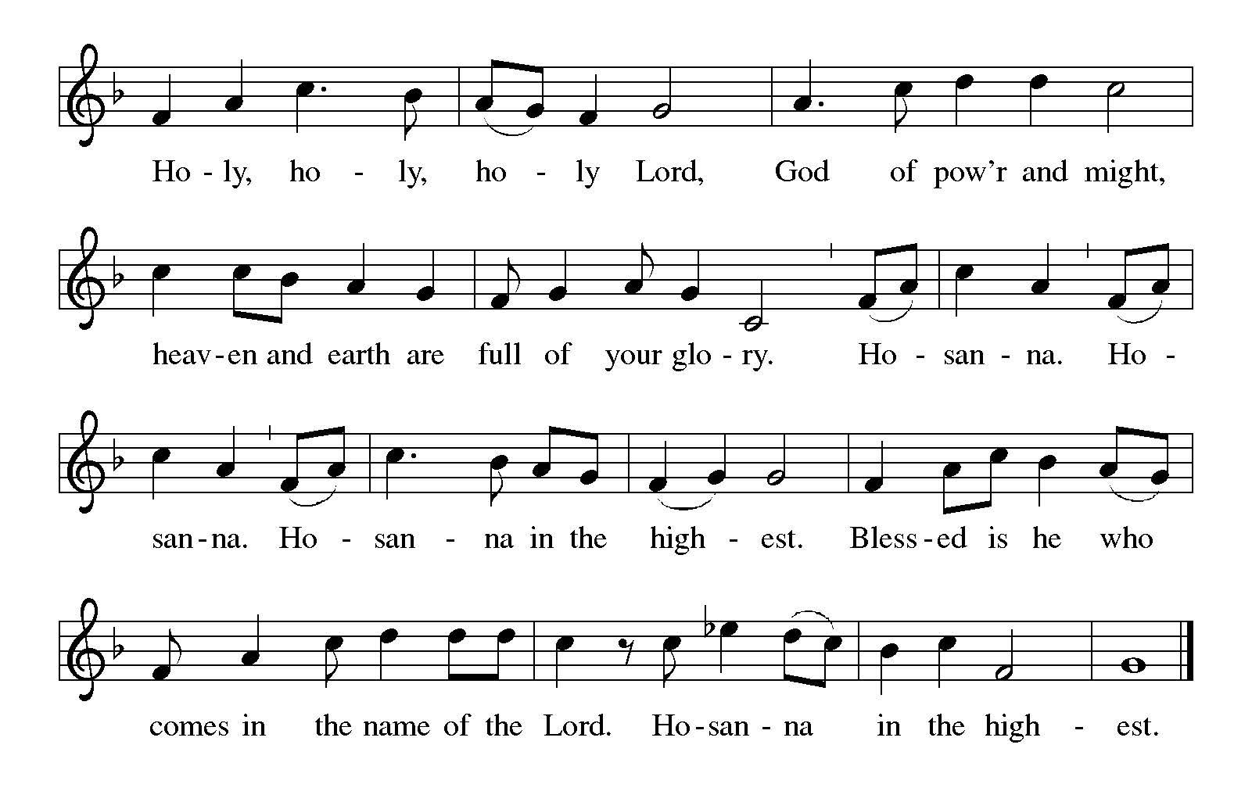

## **THANKSGIVING AT THE TABLE**

## In the night in which he was betrayed,

our Lord Jesus took bread, and gave thanks; broke it, and gave it to his disciples, saying: Take and eat; this is my body, given for you. Do this for the remembrance of me.

Again, after supper, he took the cup, gave thanks, and gave it for all to drink, saying:

This cup is the new covenant in my blood,

shed for you and for all people for the forgiveness of sin. Do this for the remembrance of me.

With this bread and cup

we remember our Lord’s Passover from death to life

as we proclaim the mystery of faith:

**Christ has died.**

**Christ is risen.**

**Christ will come again**

**Lord’s Prayer**

Gathered into one by the Holy Spirit, let us pray as Jesus taught us.

**Our Father, who art in heaven,**

**hallowed be thy name,**

**thy kingdom come,**

**thy will be done,**

**on earth as it is in heaven.**

**Give us this day our daily bread;**

**and forgive us our trespasses,**

**as we forgive those**

**who trespass against us;**

**and lead us not into temptation,**

**but deliver us from evil.**

**For thine is the kingdom,**

**and the power, and the glory,**

**forever and ever. Amen.**

## **INVITATION TO COMMUNION**

## The kingdom of God is set before you.

## Eat and rejoice.

*Please be seated.*

## **COMMUNION**

*All are welcome to commune at Christ’s Holy Supper. We invite everyone to come forward to the altar to receive the Body and Blood of Christ. Come forward by way of the center aisle to receive the elements and return by the outside aisle.* ***If you cannot come forward*** *to receive communion but would like to receive it directly from the pastor, please let a greeter know and the pastor will bring communion to you. Gluten-free wafers and grape juice are available as well. Children and adults who do not receive communion are invited to come forward as they wish to receive a blessing.*

## **LAMB OF GOD**

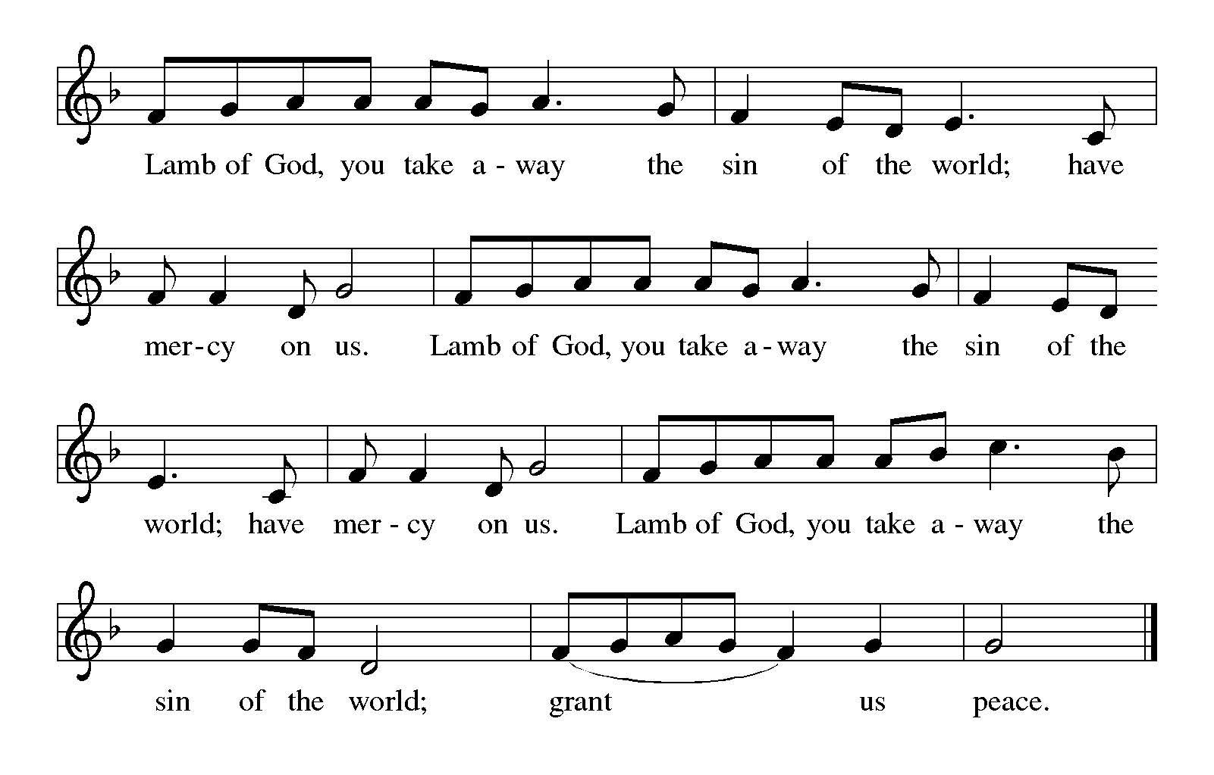

**COMMUNION**  *In the Singing ELW 466*

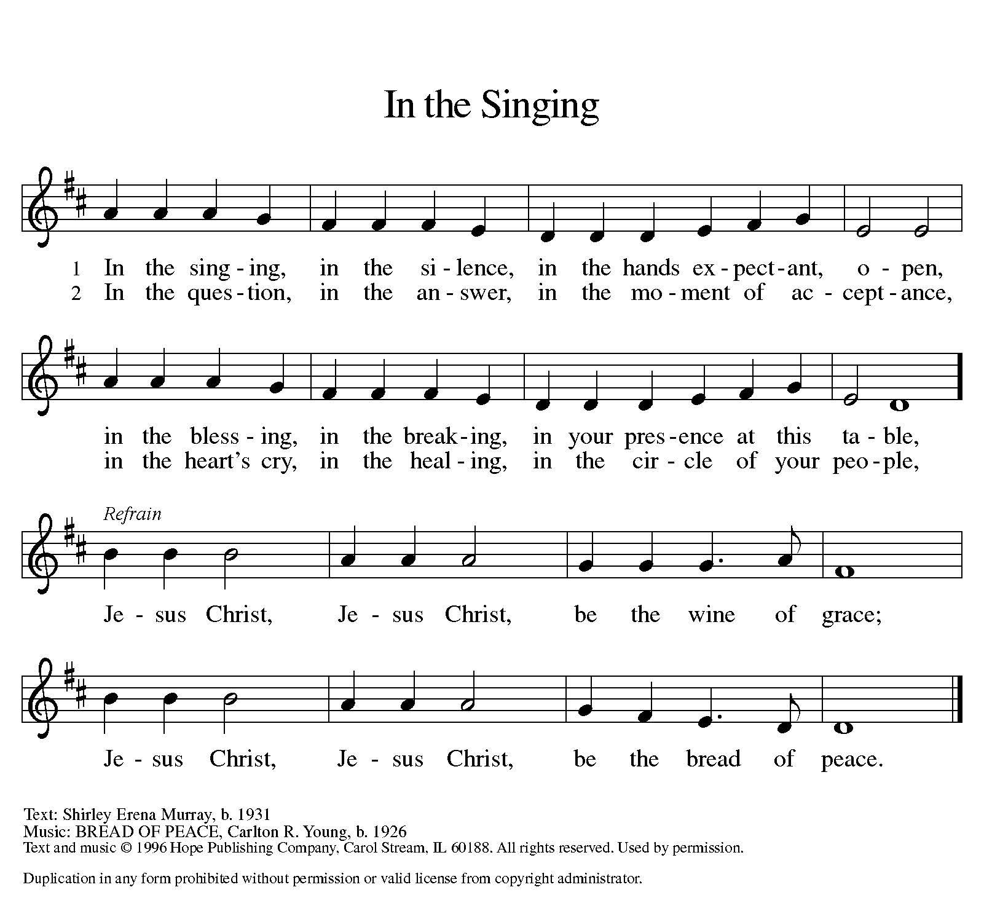

*Please rise*

## **POST-COMMUNION BLESSING**

## The body and blood of our Lord Jesus Christ strengthen you and keep you in his grace.

**Amen.**

## **POST-COMMUNION PRAYER**

Let us pray…

Mothering God,

**you gathered us to your table**

**and we drank deeply of your grace.**

**Send us out by your Spirit**

**to love our neighbors as ourselves**

**and proclaim your love in Jesus’ name.**

**Amen.**

*Please rise*

## **POST-COMMUNION BLESSING**

## The body and blood of our Lord Jesus Christ strengthen you and keep you in his grace.

**Amen.**

## **POST-COMMUNION PRAYER**

Let us pray…

Mothering God,

**you gathered us to your table**

**and we drank deeply of your grace.**

**Send us out by your Spirit**

**to love our neighbors as ourselves**

**and proclaim your love in Jesus’ name.**

**Amen.**

# **SENDING**

*God blesses us and sends us in mission to the world.*

**BLESSING**

The love of God abound in you;

the grace of our Savior Jesus Christ fill your hearts;

and the life of the Spirit

☩ bless you and give you peace.

**Amen.**

**SENDING SONG** *Welcome Table ACS 969*

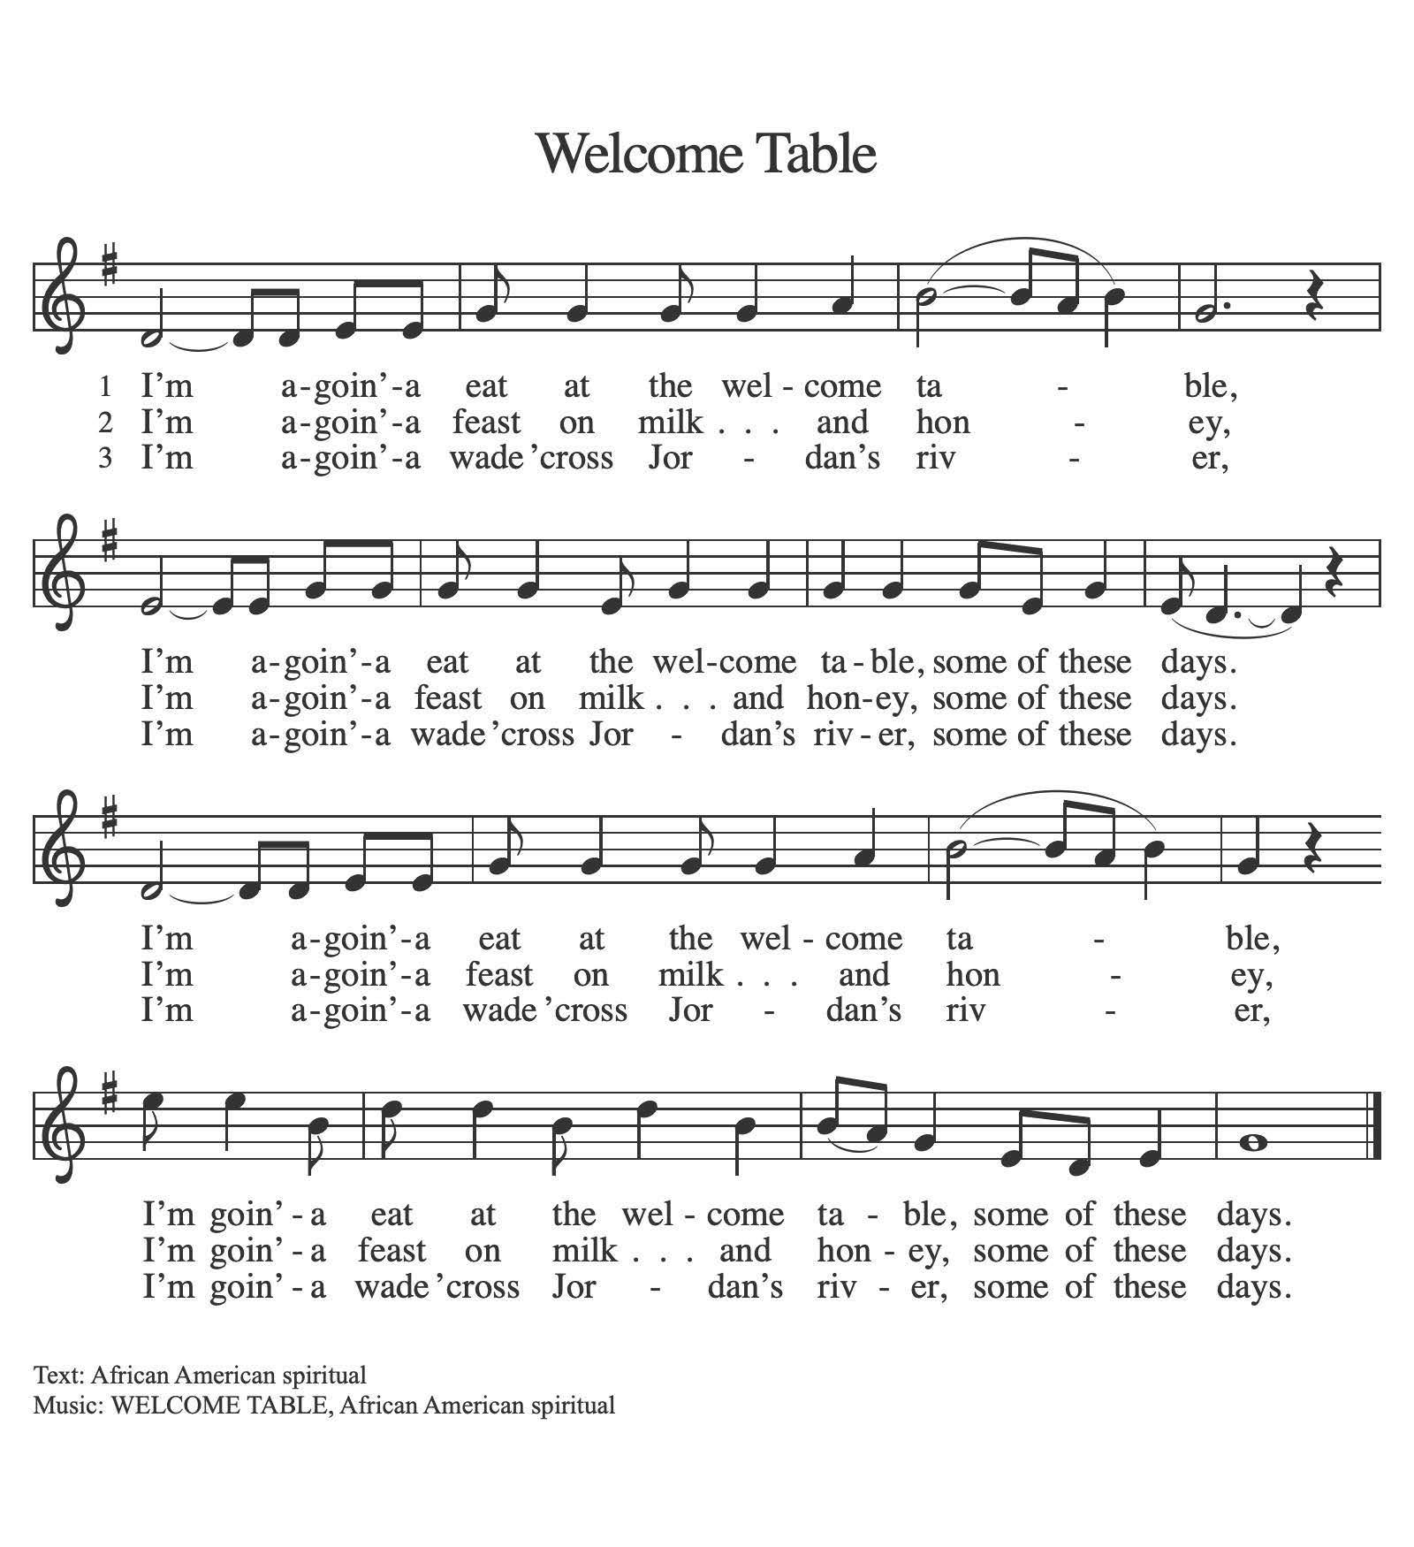

## **DISMISSAL**

Holy Trinity, go in peace. Live by the Spirit. **Thanks be to God.**

**POSTLUDE**

**ACKNOWLEDGEMENTS**

From Sundays and Seasons.com. Copyright 2015 Augsburg Fortress. All rights reserved. Reprinted by permission under Augsburg Fortress Liturgies Annual License # SAS003592. New Revised Standard Version Bible, Copyright © 1989, Division of Christian Education of the National Council of the Churches of Christ in the United States of America. Used by permission. All rights reserved. Revised Common Lectionary, Copyright © 1992 Consultation on Common Texts, admin Augsburg Fortress. Oh, Praise the Gracious Power by Text: Thomas H. Troeger, b. 1945.Music: Carol Doran, b. 1936 Text and music from New Hymns for the Lectionary, © 1984 Oxford University Press, Inc. Performed with permission under ONE LICENSE #A-708252. Music reprinted with permission under OneLicense #A-708252 and CCLI License #2627014. All rights reserved.

*Let the Whole Creation Cry – Text: Stopford A. Brooke, alt., public domain. Music: Jakob Hintze; arr. J. S. Bach, public domain.  
 Come, Let Us Eat – Text: Billema Kwillia, © Lutheran World Federation; st. 4 Gilbert E. Doan, © 1972 Contemporary Worship 4, admin. Augsburg Fortress. Music: Billema Kwillia, adapt. Gilbert E. Doan, © 1972 Contemporary Worship 4, admin. Augsburg Fortress.  
 God, Be the Love to Search and Keep Me – Text and music: Richard Bruxvoort Colligan, © 2004 This Here Music, admin. Augsburg Fortress.  
 I Want to Walk as a Child of the Light – Text and music: Kathleen Thomerson, © 1970, 1975 Celebration, admin. The Copyright Company.*

*All rights reserved. Reprinted under OneLicense #A-708252 and CCLI License #2627014.*

