**Holy Trinity Lutheran Church**

Sixth Sunday of Easter

May 25, 2025

8:30 A.M.

1755 Delhi Street, Dubuque, IA 52001

Service streamed live on YouTube at htlcdbq.com

**GATHER**

*We come together as the Body of Christ for praise, forgiveness, and renewal.*

**PRELUDE**

**WELCOME AND ANNOUNCEMENTS**

### **Thanksgiving for Baptism**

Alleluia! Christ is risen. **Christ is risen, indeed. Alleluia!**

In the name of ☩ the One

who was, who is, and who is to come. **Amen.**

Baptized into Christ’s death and resurrection,

and called to live the baptized life,

let us give thanks for the gifts of baptism.

*Water may be poured before or during the thanksgiving.*

Holy Triune God,

we give you thanks for the waters of baptism,

waters that make a people your own,

that restore to wholeness,

and empower us to be witnesses in your name.

Baptized into you, O Living One, **make us one as you are one.**

We give you thanks for the waters of baptism,

waters that strengthen believers

and give new life to beloved servants of your church;

waters that extend your boundless love

and cross barriers of our own making.

Baptized into you, O Living One, **make us one as you are one.**

We give you thanks for the waters of baptism,

waters that open the hearts of believers

and give a voice in the night to those in captivity;

waters that set your people on a new path,

rejoicing in the Spirit’s power.

Baptized into you, O Living One, **make us one as you are one.**

Grant us grace, love, and life, O Living One,

that our every day is shaped by these waters

that give us our very lives in you.

We ask this in the name of Jesus, the Crucified and Risen One.

**Amen.**

**GATHERING SONG**  *Drawn to the Light ELW 593*

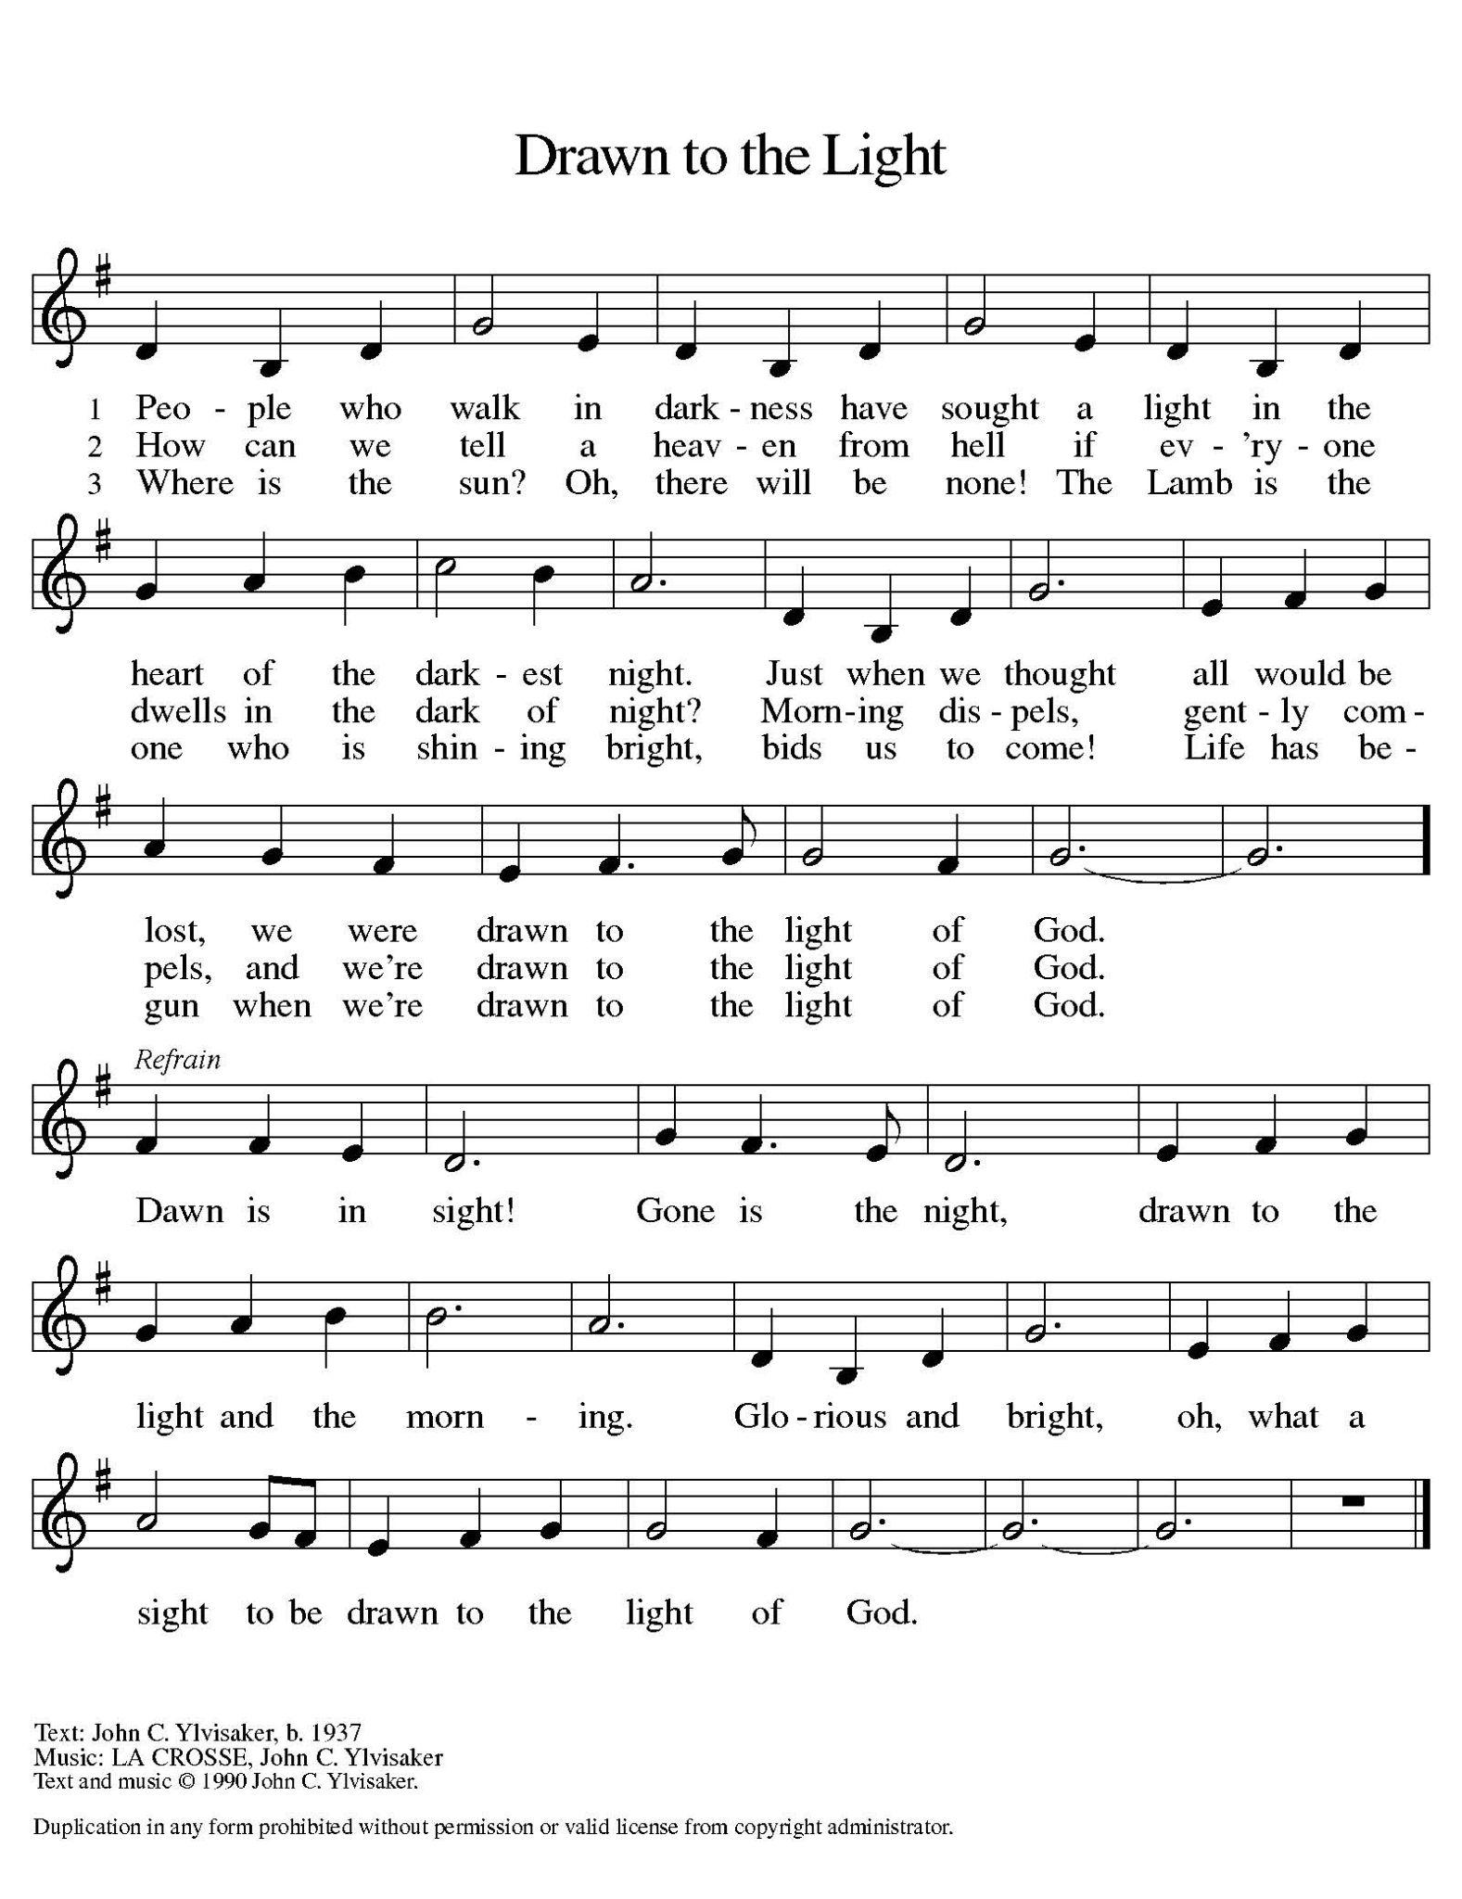

## **GREETING**

The grace of our Lord Jesus Christ, the love of God, and the communion of the Holy Spirit be with you all. **And also with you.**

**This is the Feast**

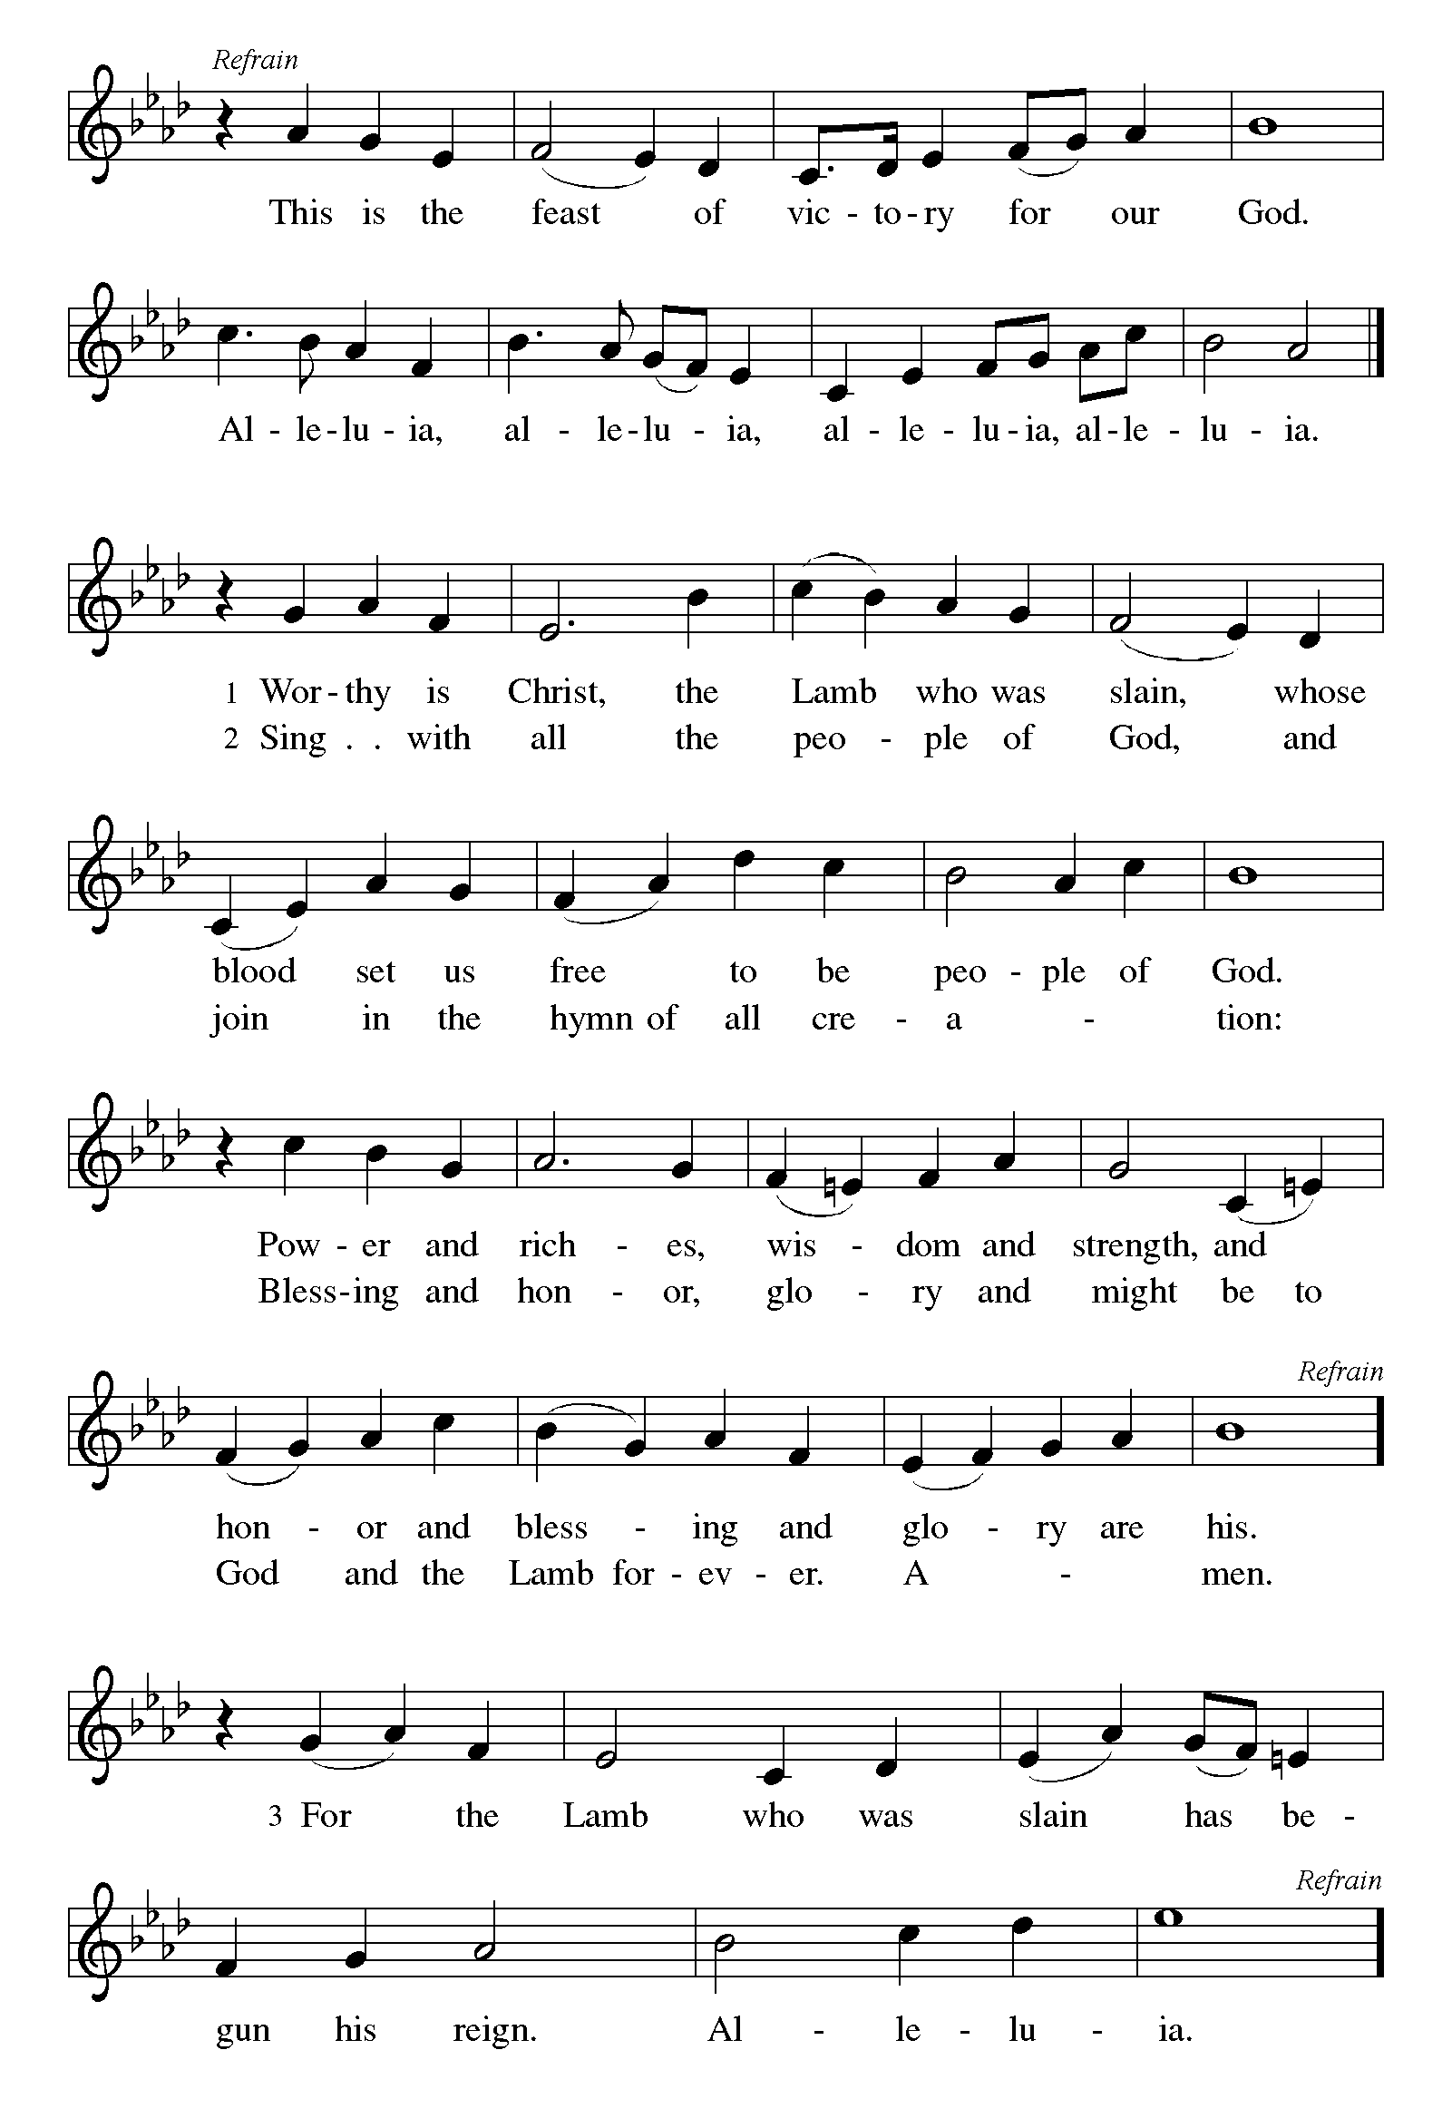

### **Prayer of the Day**

Bountiful God, you gather your people into your realm, and you promise us food from your tree of life. Nourish us with your word, that empowered by your Spirit we may love one another and the world you have made, through Jesus Christ, our Savior and Lord, who lives and reigns with you and the Holy Spirit, one God, now and forever.

**Amen.**

*Please be seated.*

**CHILDREN’S MESSAGE**

**WORD**

*Together we receive God’s Word through Scripture, Song, and Liturgy.*

### **First Reading: Acts 16:9-15**

### 9 During the night Paul had a vision: there stood a man of Macedonia pleading with him and saying, “Come over to Macedonia and help us.” 10 When he had seen the vision, we immediately tried to cross over to Macedonia, being convinced that God had called us to proclaim the good news to them.

### 

### 11 We set sail from Troas and took a straight course to Samothrace, the following day to Neapolis, 12 and from there to Philippi, which is a leading city of the district of Macedonia and a Roman colony. We remained in this city for some days. 13 On the sabbath day we went outside the gate by the river, where we supposed there was a place of prayer; and we sat down and spoke to the women who had gathered there. 14 A certain woman named Lydia, a worshiper of God, was listening to us; she was from the city of Thyatira and a dealer in purple cloth. The Lord opened her heart to listen eagerly to what was said by Paul. 15 When she and her household were baptized, she urged us, saying, “If you have judged me to be faithful to the Lord, come and stay at my home.” And she prevailed upon us.

### 

Word of God, Word of Life. **Thanks be to God.**

### **Second Reading: Revelation 21:10, 22—22:5**

10 And in the spirit [one of the angels] carried me away to a great, high mountain and showed me the holy city Jerusalem coming down out of heaven from God.

  22 I saw no temple in the city, for its temple is the Lord God the Almighty and the Lamb. 23 And the city has no need of sun or moon to shine on it, for the glory of God is its light, and its lamp is the Lamb. 24 The nations will walk by its light, and the kings of the earth will bring their glory into it. 25 Its gates will never be shut by day—and there will be no night there. 26 People will bring into it the glory and the honor of the nations. 27 But nothing unclean will enter it, nor anyone who practices abomination or falsehood, but only those who are written in the Lamb’s book of life.

 22:1 Then the angel showed me the river of the water of life, bright as crystal, flowing from the throne of God and of the Lamb 2 through the middle of the street of the city. On either side of the river is the tree of life with its twelve kinds of fruit, producing its fruit each month; and the leaves of the tree are for the healing of the nations. 3 Nothing accursed will be found there any more. But the throne of God and of the Lamb will be in it, and his servants will worship him; 4 they will see his face, and his name will be on their foreheads. 5 And there will be no more night; they need no light of lamp or sun, for the Lord God will be their light, and they will reign forever and ever.

### Word of God, Word of Life. **Thanks be to God.**

*Please rise*

## **GOSPEL ACCLAMATION**

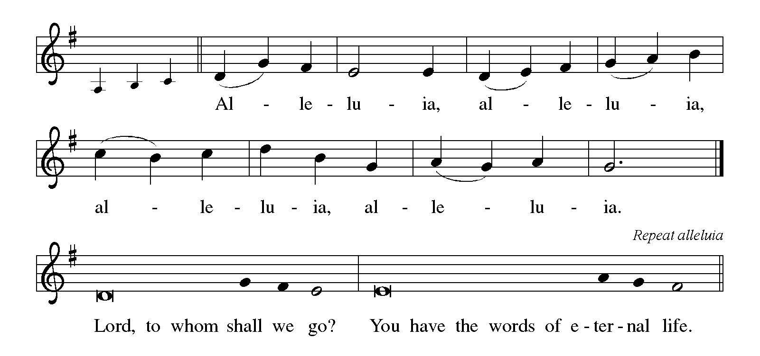

### **Gospel: John 14:23-29**

The Gospel according to John the 14th Chapter

**Glory to you, O Lord.**

### 23 Jesus answered [Judas (not Iscariot),] “Those who love me will keep my word, and my Father will love them, and we will come to them and make our home with them. 24 Whoever does not love me does not keep my words; and the word that you hear is not mine, but is from the Father who sent me.

### 25 “I have said these things to you while I am still with you. 26 But the Advocate, the Holy Spirit, whom the Father will send in my name, will teach you everything, and remind you of all that I have said to you. 27 Peace I leave with you; my peace I give to you. I do not give to you as the world gives. Do not let your hearts be troubled, and do not let them be afraid. 28 You heard me say to you, ‘I am going away, and I am coming to you.’ If you loved me, you would rejoice that I am going to the Father, because the Father is greater than I. 29 And now I have told you this before it occurs, so that when it does occur, you may believe.”

### 

The gospel of the Lord. **Praise to you, O Christ.**

*Please be seated.*

**MESSAGE** *Pastor Jeanette M. Perrault*

*Please Rise*

**HYMN OF THE DAY** *Lift Up Your Heads ACS 1032*

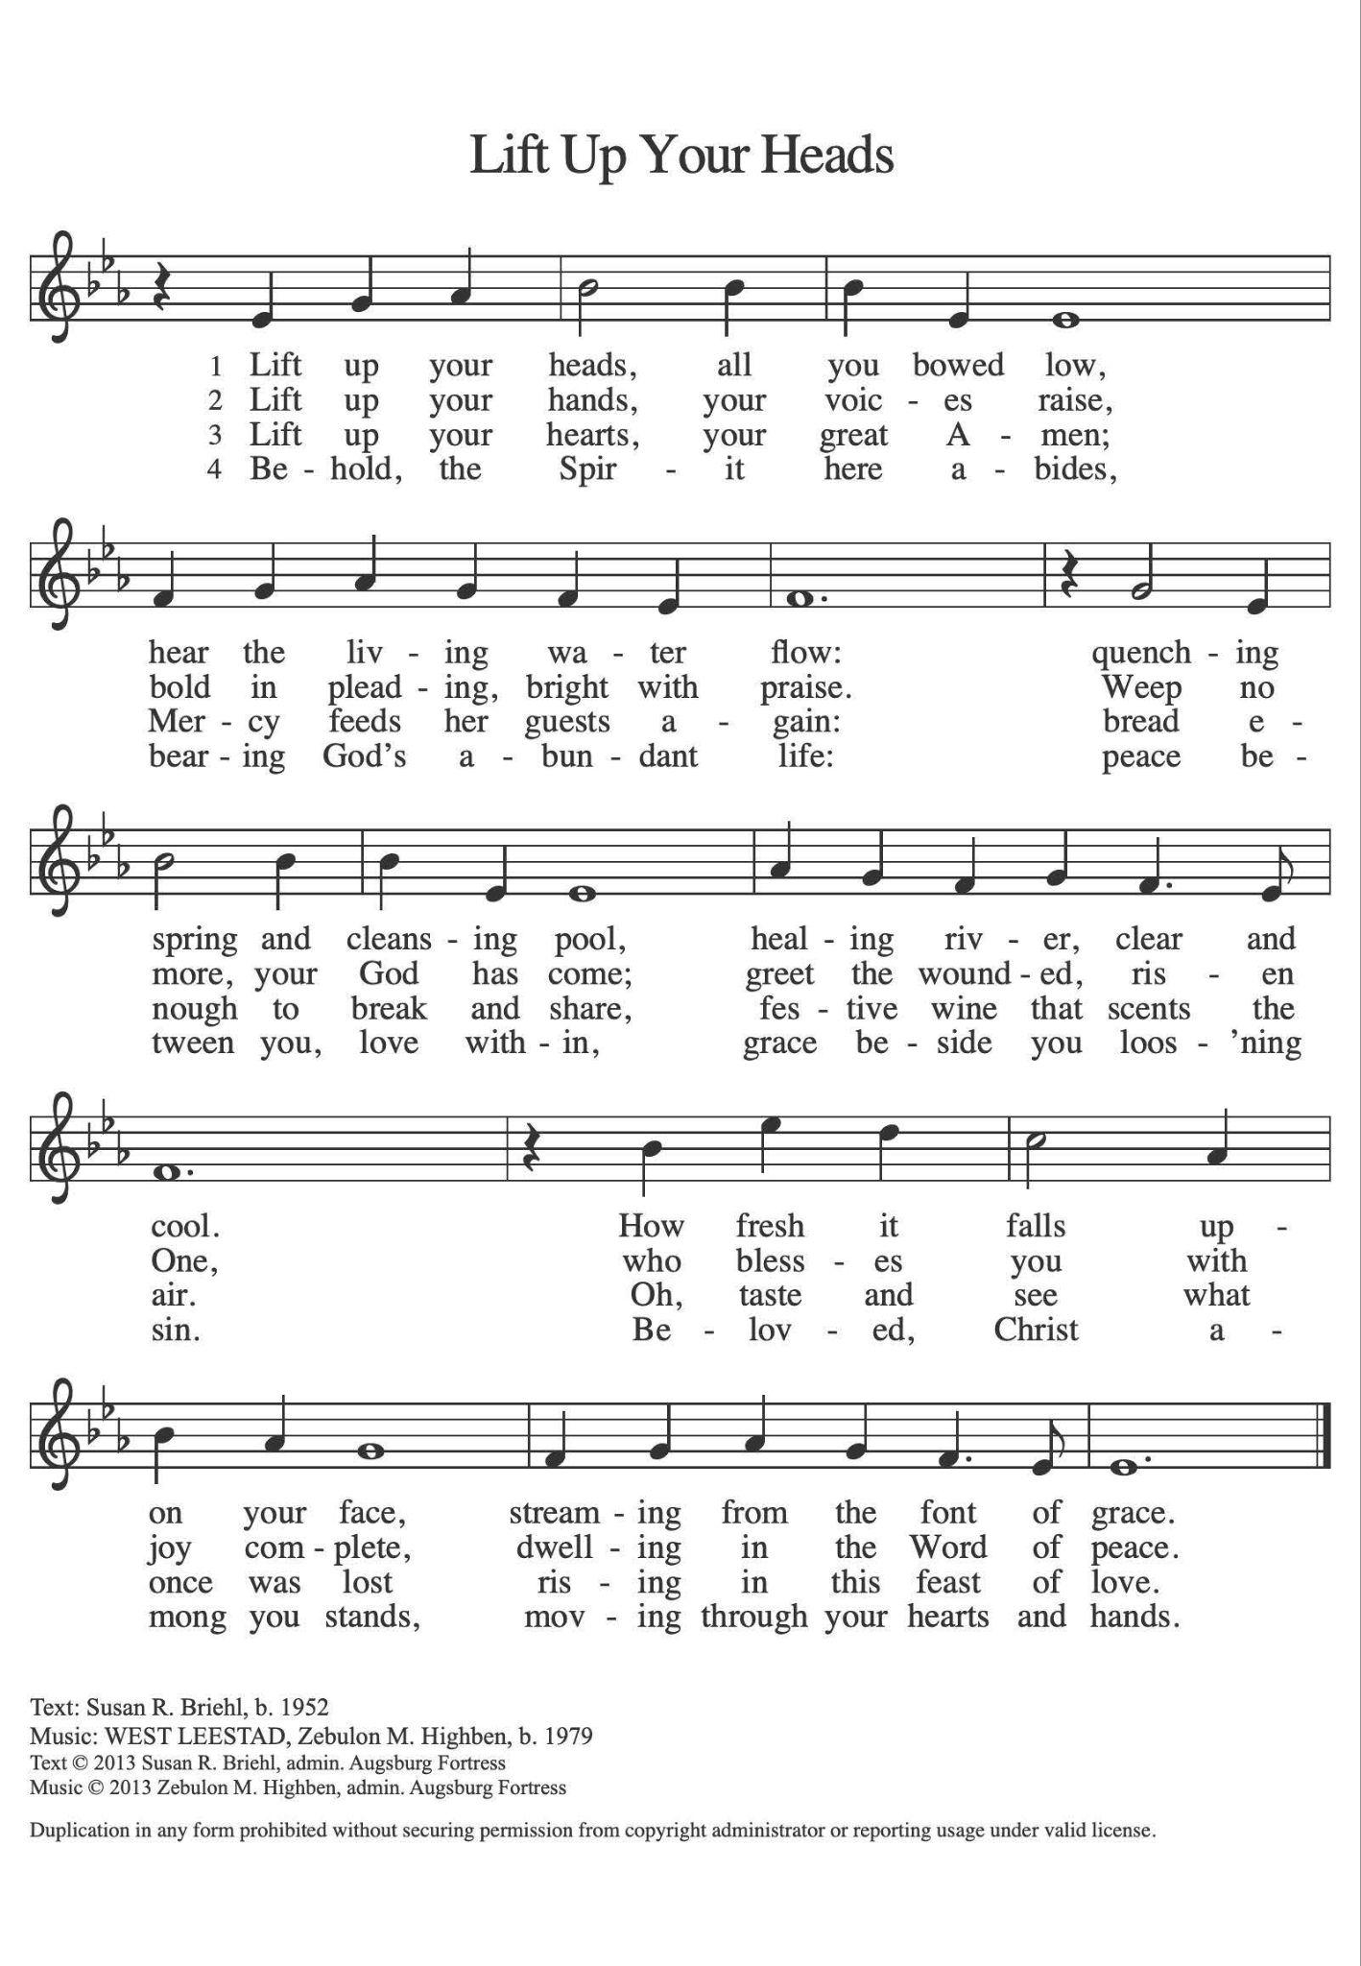

## **Nicene Creed**

## With the whole church, let us confess our faith with the words of the Nicene Creed

## **We believe in one God,**

## **the Father, the Almighty,**

## **maker of heaven and earth,**

## **of all that is, seen and unseen.**

## **We believe in one Lord, Jesus Christ,**

## **the only Son of God,**

## **eternally begotten of the Father,**

## **God from God, Light from Light,**

## **true God from true God,**

## **begotten, not made,**

## **of one Being with the Father;**

## **through him all things were made.**

## **For us and for our salvation**

## **he came down from heaven,**

## **was incarnate of the Holy Spirit and the virgin Mary**

## **and became truly human.**

## **For our sake he was crucified under Pontius Pilate;**

## **he suffered death and was buried.**

## **On the third day he rose again**

## **in accordance with the scriptures;**

## **he ascended into heaven**

## **and is seated at the right hand of the Father.**

## **He will come again in glory to judge the living and the dead,**

## **and his kingdom will have no end.**

## **We believe in the Holy Spirit, the Lord, the giver of life,**

## **who proceeds from the Father and the Son,\***

## **who with the Father and the Son is worshiped and glorified,**

## **who has spoken through the prophets.**

## **We believe in one holy catholic and apostolic church.**

## **We acknowledge one baptism for the forgiveness of sins.**

## **We look for the resurrection of the dead,**

## **and the life of the world to come. Amen.**

## 

## 

### **Prayers of Intercession**

God of resurrection and new life, we come before you in prayer for the church, the world, and all who are in need.

*A brief silence.*

*After each prayer:*

Hear us, O God.

**Your mercy is great.**

We commend these and all our prayers to you, O God, trusting that you are always with us; in the name of Jesus Christ, our risen Savior.

**Amen.**

**SHARING OF THE PEACE**

The peace of Christ be with you always.

**And also with you.**

*The congregation is invited to share the peace of Christ by greeting your neighbors.*

*Please be seated.*

***OFFERING***

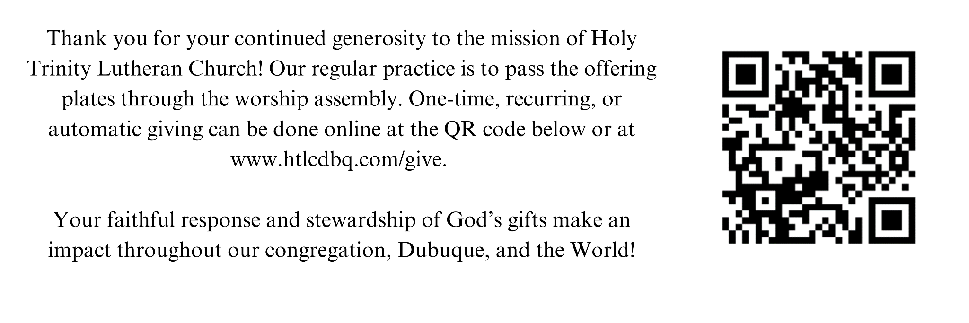

*Please be seated.*

**OFFERING SONG**

*Please rise*

**OFFERING PRAYER**Let us join our voices together in our offering prayer…

Risen One,

**you have gathered us around your table of grace**

**along with these gifts we bring.**

**Come among us again,**

**breathe your life into us,**

**and enliven us with this meal,**

**that we may live as your risen body in the world.**

**Amen.**

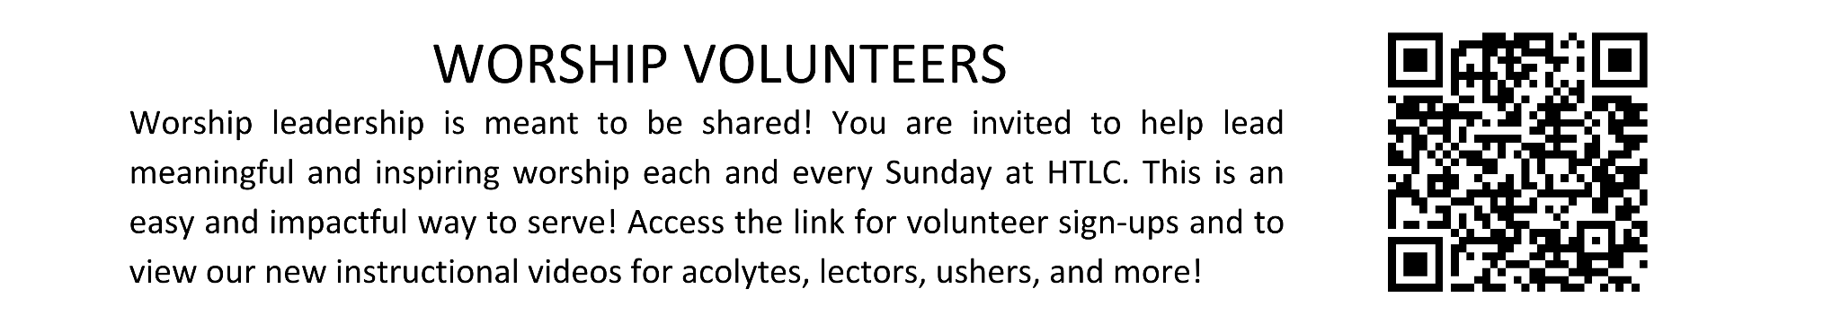

# **MEAL**

God feeds us with the presence of Jesus Christ.

## **GREAT THANKSGIVING**

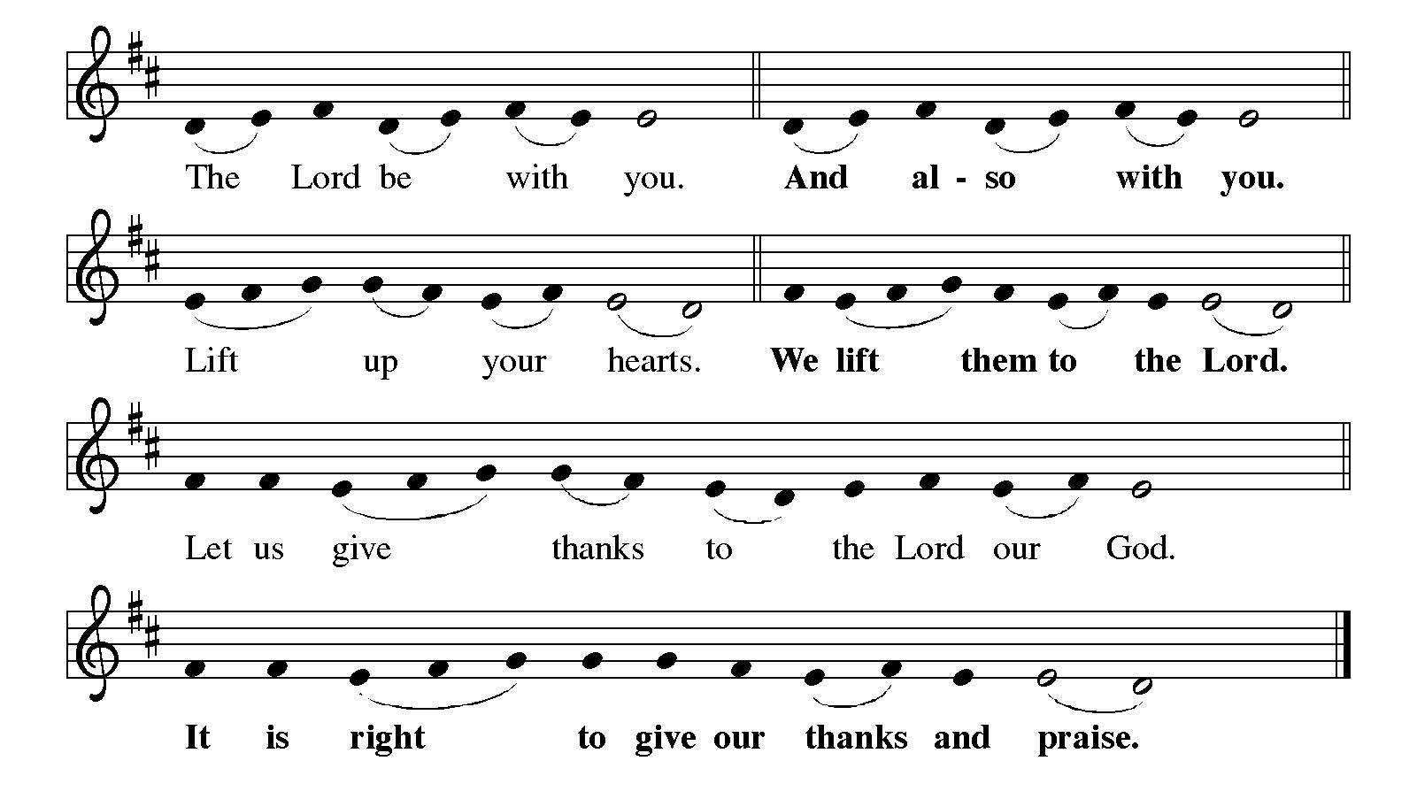

It is indeed right, our duty and our joy…

**HOLY, HOLY, HOLY**

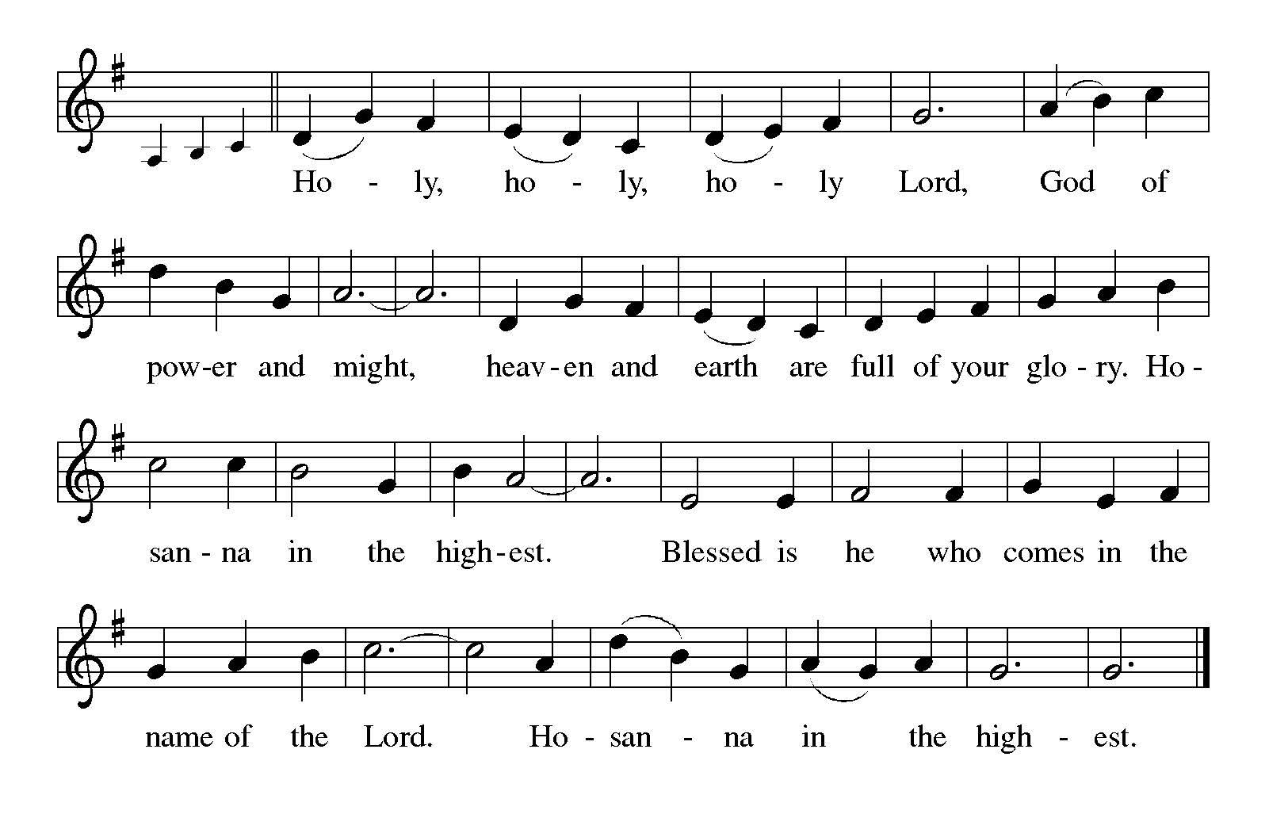

## **THANKSGIVING AT THE TABLE**

## In the night in which he was betrayed,

our Lord Jesus took bread, and gave thanks; broke it, and gave it to his disciples, saying: Take and eat; this is my body, given for you. Do this for the remembrance of me.

Again, after supper, he took the cup, gave thanks, and gave it for all to drink, saying:

This cup is the new covenant in my blood,

shed for you and for all people for the forgiveness of sin. Do this for the remembrance of me.

With this bread and cup

we remember our Lord’s Passover from death to life

as we proclaim the mystery of faith:

**Christ has died.**

**Christ is risen.**

**Christ will come again.**

**Lord’s Prayer**

Gathered into one by the Holy Spirit, let us pray as Jesus taught us.

**Our Father, who art in heaven,**

**hallowed be thy name,**

**thy kingdom come,**

**thy will be done,**

**on earth as it is in heaven.**

**Give us this day our daily bread;**

**and forgive us our trespasses,**

**as we forgive those**

**who trespass against us;**

**and lead us not into temptation,**

**but deliver us from evil.**

**For thine is the kingdom,**

**and the power, and the glory,**

**forever and ever. Amen.**

## **INVITATION TO COMMUNION**

Come to the table of grace. Receive the gift of new life.

*Please be seated.*

## **COMMUNION**

*All are welcome to commune at Christ’s Holy Supper. We invite everyone to come forward to the altar to receive the Body and Blood of Christ. Come forward by way of the center aisle to receive the elements and return by the outside aisle.* ***If you cannot come forward*** *to receive communion but would like to receive it directly from the pastor, please let a greeter know and the pastor will bring communion to you. Gluten-free wafers and grape juice are available as well. Children and adults who do not receive communion are invited to come forward as they wish to receive a blessing.*

## **LAMB OF GOD**

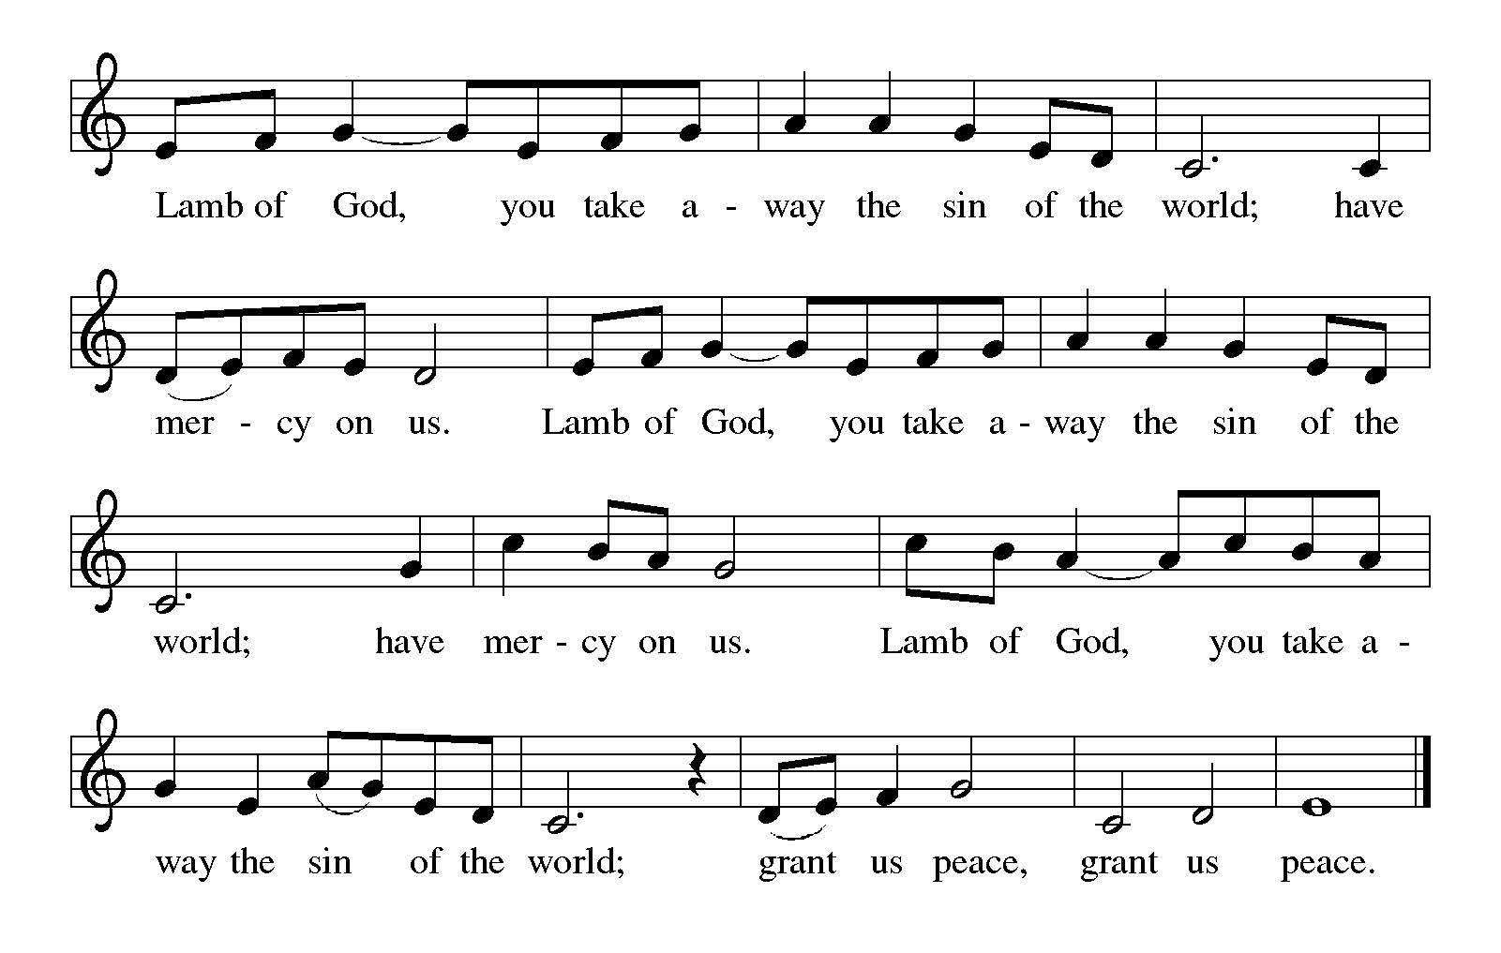

**COMMUNION** *Anointing Fall on Me ACS 1013*

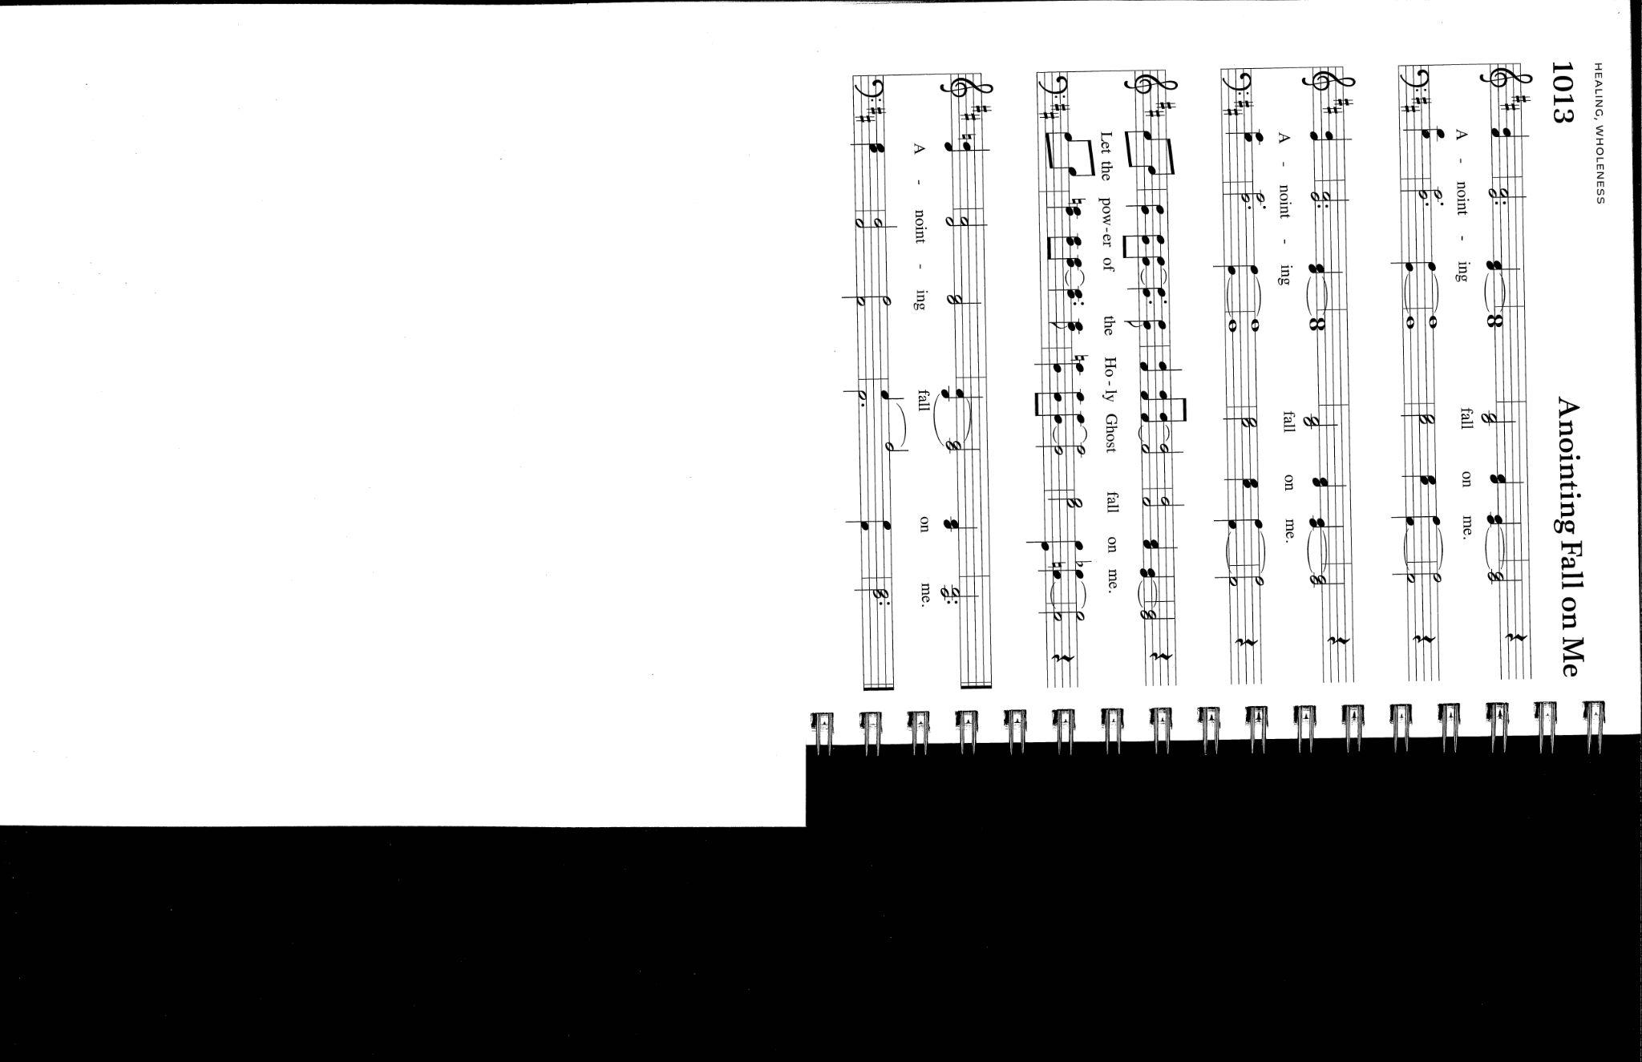

*Please rise*

## **POST-COMMUNION BLESSING**

## The body and blood of our Lord Jesus Christ strengthen you and keep you in his grace.

**Amen.**

## **POST-COMMUNION PRAYER**

Let us pray…

Living One,

**in this feast you have made yourself known to us.**

**Send us now to tell of your wonders,**

**sing of your glory,**

**and proclaim your risen life**

**to a wounded and weary world.**

**Amen.**

# **SENDING**

*God blesses us and sends us in mission to the world.*

**BLESSING**

The Triune God,

who was, who is, and who is to come,

Sovereign, ☩ Savior, and Spirit,

light your way with resurrection dawn,

now and always.

**Amen.**

**SENDING SONG** *I Want to Walk as a Child of the Light ELW 815*

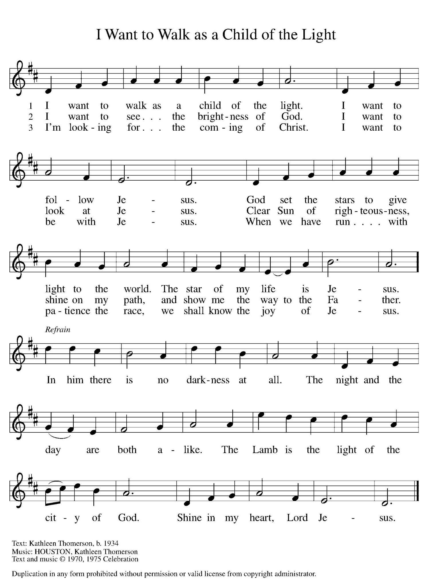

## **DISMISSAL**

Alleluia! Christ is risen.

**Christ is risen indeed. Alleluia!**

Go in peace. In Christ you are made new. Alleluia! Alleluia!

**Thanks be to God. Alleluia! Alleluia!**

**POSTLUDE**

**ACKNOWLEDGEMENTS**

From Sundays and Seasons.com. Copyright 2015 Augsburg Fortress. All rights reserved. Reprinted by permission under Augsburg Fortress Liturgies Annual License # SAS003592. New Revised Standard Version Bible, Copyright © 1989, Division of Christian Education of the National Council of the Churches of Christ in the United States of America. Used by permission. All rights reserved. Revised Common Lectionary, Copyright © 1992 Consultation on Common Texts, admin Augsburg Fortress. Oh, Praise the Gracious Power by Text: Thomas H. Troeger, b. 1945.Music: Carol Doran, b. 1936 Text and music from New Hymns for the Lectionary, © 1984 Oxford University Press, Inc. Performed with permission under ONE LICENSE #A-708252.



