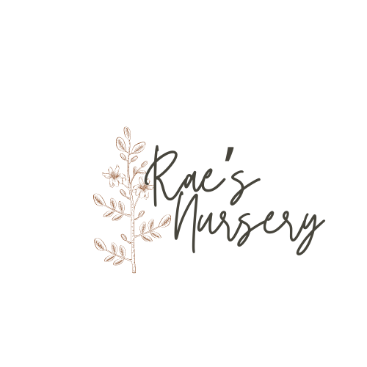

Couple: Event Date:

Venue: City:

*Denomination: Color/Palette:*

*Guest Count: Feel/Vibe:*

*Ceremony Start: Flower Likes:*

*Reception Start: Flower Dislikes:*

| **Personals** | **Qty** |
| --- | --- |
| Bouquets |  |
| *Bridal* |  |
| *Toss* |  |
| *Bridesmaid* |  |
| Boutonnieres |  |
| *Groom* |  |
| *Groomsmen* |  |
| *Family* |  |
| *Other:* |  |
|  |  |

| **Ceremony** | **Qty** |
| --- | --- |
| *Altar Installation* |  |
| *Back-of-Aisle Arrangements* |  |
| *Aisle Florals* |  |
| *Welcome Arrangements* |  |
| *Signage Accent* |  |
| *Other:* |  |
|  |  |

| **Cocktail Hour** | **Qty** |
| --- | --- |
| *Highboy Accents* |  |
| *Bar Arrangements* |  |
| *Escort Display* |  |
| *Lounge Florals* |  |
| *Restroom Florals* |  |
| *Other:* |  |
|  |  |

| **Reception** | **Qty** |
| --- | --- |
| Dining Tables |  |
| *Sweetheart / Head* |  |
| *Rectangulars* |  |
| *Rounds* |  |
| Bar Arrangement |  |
| Lounge Florals |  |
| Buffet Table |  |
| Dessert Table |  |
| Favor Table |  |
| Cake Flowers |  |
| Other: |  |
|  |  |

| **Rentals** | **Qty** |
| --- | --- |
| Vase & Vessel |  |
| *Centerpiece* |  |
| *Accent* |  |
| *Bud Vase* |  |
| Candles |  |
| *Pillars* |  |
| *Tapers* |  |
| *Votives* |  |
| Other: |  |
|  |  |

**Budget:**