JOYcabulary

Title: A Shell is Cozy | Author: Diane Hutts Aston
Genre/Unit: narrative nonfiction | Shared Reading: The Wave  Gussie Osborne

Objective: Using a poetic voice to communicate information; altering font to write different types of information.

Standards: LS1

Knowledge Building: Enter the fascinating world of shells to learn how they eat, move, and protect themselves. How humans use shells.

Vocabulary
Word | Page | Student Friendly Definition
cozy | Cover, 3, 27 | Comfortably warm and snug, often by being small in size
delicate | 3 | Easy to break or hurt; fragile
hinge | 4 | A device that connects two pieces so they can open, close, or swing like on a door or a shell
shelter | 3 | A place that provides protection from danger
cling | 8,15 | To stick or attach
locate | 12 | To find a place or thing

Siphon is a Tier 3 word, but it is used repeatedly in this book. It may be worthwhile to explicitly teach this word: a tube that sticks out and used to take in sea water and push it back out.

Warm Up Poem:

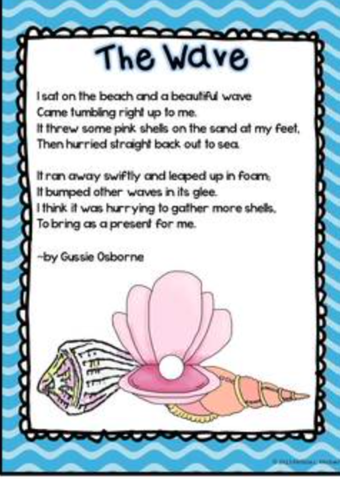

Reading:
This book can be read aloud in different ways depending on your grade level. In Kindergarten, you may choose to just read the enlarged text and script while discussing the illustrations. As you move up grade levels, you may decide to just read certain sections. For example, pages 6-7 depict the life cycle of a queen conch. Children will be amazed that shells (the animals within them) actually hatch from eggs! With older students, you may use the book to demonstrate how you can use text structure to take notes – pages 14-15 would be a good place to do this work. Children can act out certain pages to deepen their understanding – see pages 12-13. Pages 16-17 can inspire a list of adjectives to describe different types of shells. Finally – pages 18-19 and 22-23 may spark further research and reading.

Extensions:
Hyphenated Words:
Razor-sharp lid-like
Shell-building slip-sliding
See-through meal-chasing
Talon-like strand-like
Shell-shaped

Writing
- Text structure
- Text features
- Ellipsis
- Diagram
- sequence
- Unusual adjectives
- Appositive
- Twin sentences
- Comparison
- Varied font
- Definitions provided within the sentence
- Circular ending

Science
- Classification
- Survival
- Man’s use of nature

Next Steps:
Create a Shell Museum equipped with magnifying glasses. Children can observe closely to notice (and perhaps chart) color, shape, size, pattern, etc. This hands-on experience will encourage the use of the Tier 3 vocabulary in this book (especially if students are provided with a tool like a teacher-created Word Bank or a Pictionary)

Read other books in this award-winning series: A Seed is Sleepy, A Rock is Lively, A Butterfly is Patient, A Nest is Noisy, and A Beetle is Shy.

- Linda
cozy  Comfortably warm and snug | delicate  easy to break or hurt
hinge  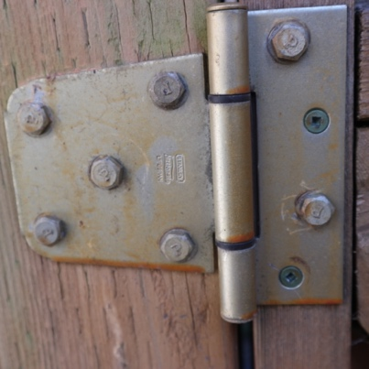  A device that connects two pieces so they can open, close, or swing | shelter  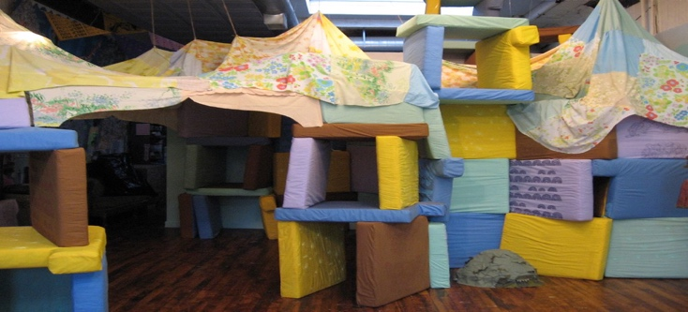  A place that provides protection from danger
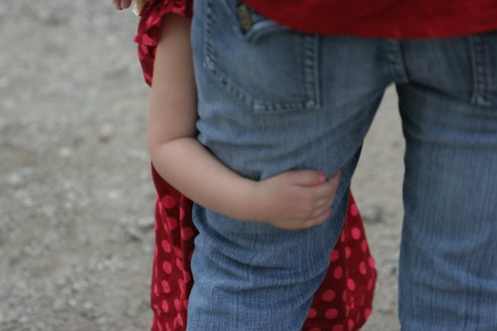  cling  To stick or attach; hold tight | locate  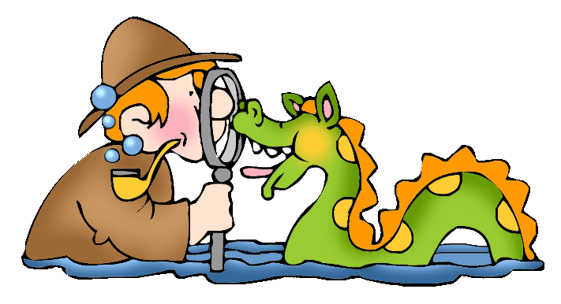  To find a place or thing

