JOYcabulary

Title: Bicycle Book | Author: Gail Gibbons
Genre/Unit: informational | Shared Reading: Bicycle, Bicycle  Kenn Nesbitt c2011

Objective: to build knowledge about how a bike works

Standards:

Knowledge Building: machines; safety; inventions

Vocabulary
Word | Page | Student Friendly Definition
similar | 2 | almost alike; having some things the same
rear | 5 | the back part of something
design | 6, 20, 26,30 | the way something has been planned and made; a decorative pattern
attach | 8 | to join or stick together
connect | 8,12 | to join together

Warm Up Poem:
Bicycle, Bicycle

Bicycle, bicycle
Ride me around
Up on the seat with
My feet off the ground.
All through the country and
All through the town
Bicycle, bicycle
Ride me around.

Kenn Nesbitt c2011 poetry4kids.com

Reading:
Page # | Accountable Talk | JOYcabulary
Before Reading | Begin a KWL chart: What do we already know about bicycles and how they work? What do we want to learn?
 | Let’s look at how this book is organized. It doesn’t have a Table of Contents, so let’s name out the parts as we read.
P. 1 - 7 | Let’s think of what this part was mostly about – yes, about how bikes have changed over time. Let’s bullet some notes about this to make a trail map of this book. What were some important things we learned? | Maybe you had a ‘hobbyhorse’ when you were little. How is the first bicycle like a Hot Wheels tricycle? Are the designs similar in any ways? How is the design different?
P. 8 - 12 | So… this part seems to be about how bikes move. Wow! There are a lot of tricky words in this part. Let’s look at P 8 & 9 again and see if we can act out how a bike moves. We’ll try to use those tricky words as we explain so we sound like experts. | These Tier 3 words are not ones we necessarily want kids to learn, but using content-specific language is good practice for when they are writing informational pieces.
P 13 - 15 | Oh, right away I can tell we are starting a new part about the different kinds of bikes. Why do you suppose we have so many different kinds of bikes? | Encourage the use of the words, similar, design, attach and connect.
P 16 - 25 | Another new part: how we use bikes. We have to care for our bike so they stay safe to ride. We also need to ride safely. How many of these tips did you already know? What new tips did you learn? | Why do bike designs keep changing?
P 26 - 28 | Wow! There are a lot of cool things about bikes! Turn and talk to your partner about which ones stood out for you.

Extensions:
Writing:
- Make posters to put around the school to help everyone to be safe when riding a bike.
- Write a How-To on caring for a bike.
- Make a bike diagram and label the parts.
Art
- Design a new type of bicycle.
Music
- Rewrite the words to The Wheels on the Bus to write a song called The Wheels on the Bike. How will it be similar? Different?
Science
- There is a lot of science used to make bikes go. Maybe you’d like to learn more about how gears work.

Next Steps:
There are YouTube song videos that a young child might enjoy learning.

- Linda

similar  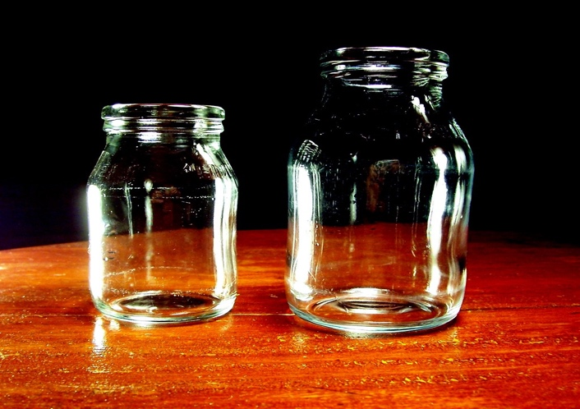  This Photo by Unknown Author is licensed under CC BY-NC-ND  almost alike; having some things the same | 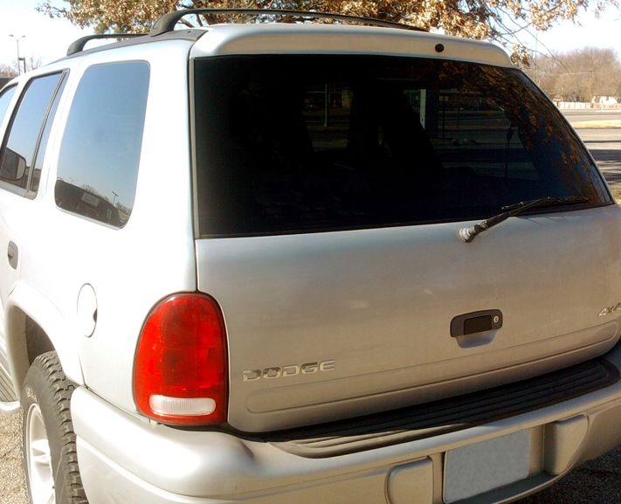  rear  the back part of something
design  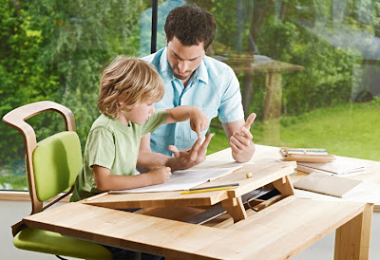  The way something has been planned and made; a decorative pattern | attach / connect  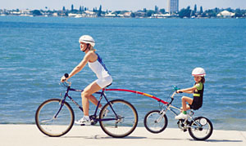  to join or stick together

