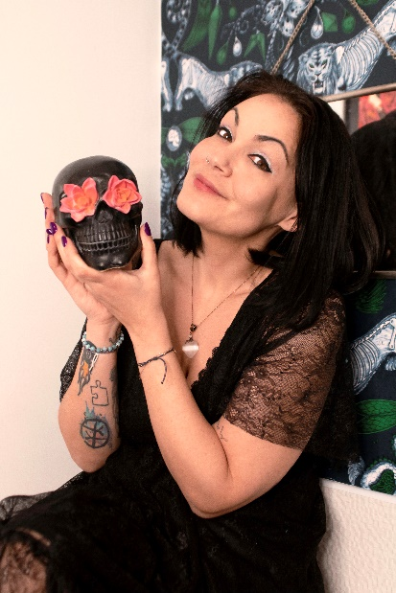
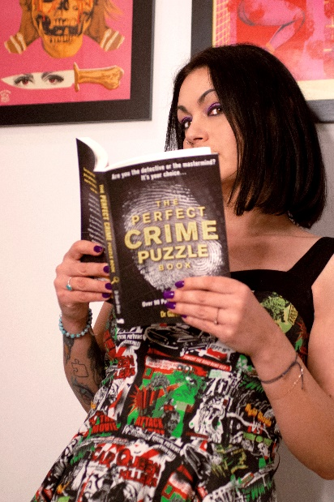
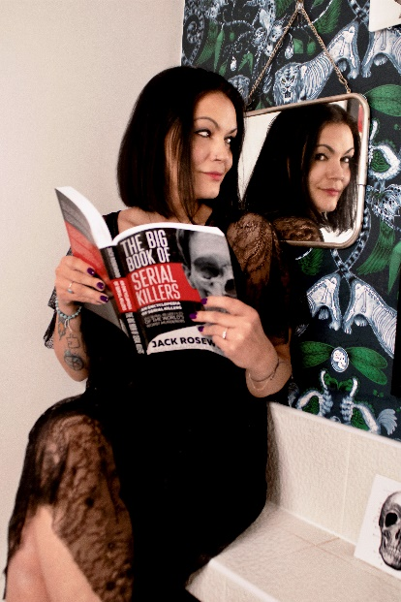
Diana Safieh
www.dianasafieh.com
diana.safieh@gmail.com
Instagram

Switchblade Sisters Social Club True Crime Podcast – top 30 true crime podcast in the UK
www.switchbladesisterssocialclub.com
switchbladesisterssocialclub@gmail.com
Instagram

Britain Palestine Project Podcast - #1 podcast on Palestine
https://britainpalestineproject.org/
Instagram

Loves: True crime podcasts
Dislikes: Spiders

Diana Safieh is a journalist and the host of the UK's Top 30 true crime podcast Switchblade Sisters Social Club, alongside co-host Isla Coole, owner of Criminally Good Books in York. She is also the host of globally ranked number one podcast on Palestine, Britain Palestine Project. Drawing on years of experience in storytelling, she writes crime fiction that balances compelling mysteries with emotionally complex characters and the intricate relationships that bind and betray them.
A selection of her writing can be found here.

Diana’s background is in events and fundraising in the charity sector, which she has now been doing for nearly 20 years. Her passion is working on and development projects in her homeland of Palestine. She was honoured to have been invested as a member of the Order of St John for her efforts, just like her father and great uncle before her.

