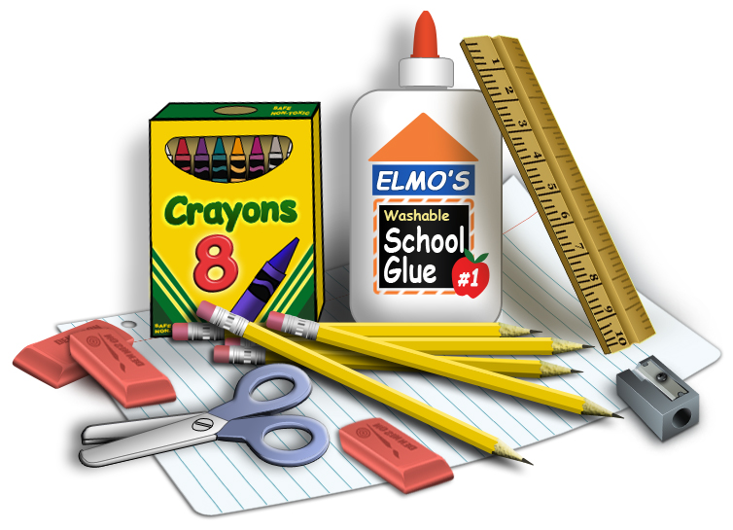
First Grade
School Supply List

Dear Families,
Please send your child to school with the following school supplies by 9-13-2021
I am sending this list home now because many times during the summer months stores will have good quality school supplies on sale. If you wait until September to purchase these items, the prices are often very high.
Thank you,
First Grade Teacher
- 5 Marble notebooks- Wide ruled
- 5 Plastic Folders ( 5 different colors)
- 2 boxes of sharpened pencils
- 4 large glue sticks
- 3 pink erasers
- 2 boxes of 24 crayons in a box
- 1 pack of dry erase markers and eraser
- 1 pack of Post It Notes
- 3 boxes of Ziploc bags: 1-quart size and 2-gallon size
- 1 roll of Paper Towels
- 2 boxes of Kleenex Tissues
- 1 container of baby wipes
- 2 Purell Hand Sanitizers
- 1 children’s size scissors
- Headphones in a ziplock bag with your name on it.
- A school bag large enough to fit folders, notebooks, and text books
Please label all supplies with your child’s name and class number!!

