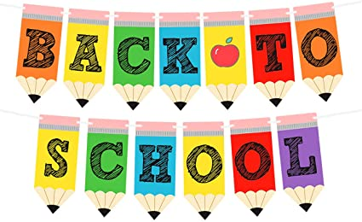

MS. WATERS’ CLASS-301 SUPPLIES LIST

- 24 sharpened “Dixon Ticonderoga” #2 pencils
- 2 Marble Composition notebooks with 100 sheets
- 1 pack of 12 pencil cap erasers
- 1 soft pink eraser
- 1 soft pencil case (no plastic or metal cases please)
- 4 large solid glue sticks- 0.77 oz. (not liquid please)
- Soft schoolbag that will fit folders, notebooks, workbooks, and binder (no backpacks with wheels please)
- Five plastic 2 pocket folders (red, green, blue, black, and yellow please)
- 1 box of baby wipes
- 1 container of hand sanitizer
- 2 rolls of “Bounty” paper towels
- 1 “Clorox” Disinfecting Wipes Container
- 1 box of “Kleenex” tissues
- 2 boxes of 24 “Crayola” crayons
- 1 box of gallon size “Ziploc” bags
- 1 box of quart size “Ziploc” bags
- 1 package of 4 different colored “Expo” chisel tip dry-erase markers
- 1 pair of headphones

Please label all school supplies with your child’s name.
Please send your child with their supplies on the first day of school, September 13, 2021.
Thank you for your cooperation!

