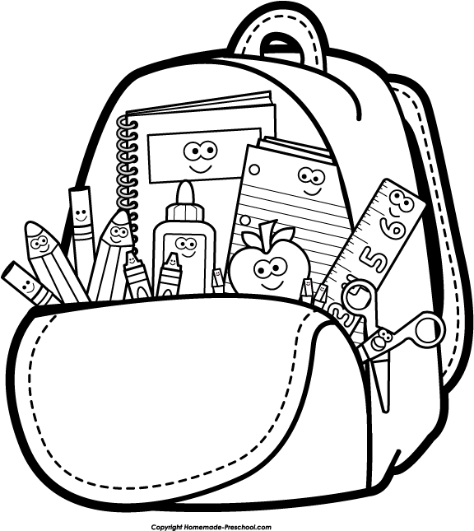
Kindergarten School Supply List
2021-2022

Dear Families,
Please send your child with the following school supplies
on the first day of school which is Monday, 9/13/20...

• 6 plastic folders “LABELED” (red-Math, blue-Reading, yellow-Writing, green-Science, purple-Social Studies, black-Homework)
• 3 Black & White Composition Notebook (Wide Ruled)
• 1 box of 24 Ticonderoga Pencils
• 2 boxes of 24 Crayola Crayons
• 1 container of Lysol Wipes
• 3 large Glue Sticks and 1 Elmer’s Glue Bottle
• 1 pack of pencil eraser caps
• 1 pack of Black Dry Erase Markers and an Eraser
• 2 boxes of Ziploc bags (1 quart size and 1 gallon size)
• 2 boxes of Kleenex tissues
• 2 rolls of Paper Towels
• 1 School Backpack (large enough to fit folders and books)
• 1 soft lunch box (if your child brings lunch)
• PLEASE LABEL ALL SCHOOL SUPPLIES with your child’s name and class number (remember to also add school subjects, listed at the top of this list, on matching colored folders).
• PLEASE KEEP A HOMEWORK BOX AT HOME with extra supplies such as: pencils, erasers, glue sticks, scissors and crayons.

All of your child’s school supplies will be kept at school. Thank you in advance and we look forward to having a great school year.

Sincerely,
Kindergarten Teachers

