Chapter 10
“A year in the life of a hive”
How to manage your new Bee-Habitat,

So the first year of beekeeping begins the year before.

But it’s not really a year in the life of a beehive, it’s “ the first two years of a beehive , then year on year after that.”
Getting your hive and putting it on a stable base, and building swarm poles, and swarm boxes. Or for the more squeamish people , let just call it a “bee colony capture boxes” and attracting poles.
And then baiting them.
Maybe even feeding with honey to see who is about? To do this you need a shallow thing a bottle cap or dish, the put some grass or straw in as a means for the bees that fall in to get out. The put some honey in, not so much that it will not get consumed in a day or two, els you will only end up with ants. But if you do this every now and then you will see if you get any number of bees.
So now you have been baiting, though the last few months, even winter. Spring has arrived and you are still baiting. You have planted loads of flowering plants, that should start coming up, but the first are normally established trees and bushes that flower first.it will now take a month or three for the bees to really start flying and for the queens to start laying. And then they will swarm.
So the first swarms are out. This is the lot you really want. They will be strong queens and loads of new workers.
If you get one great! Pop them in a hive and you’re in business. Keep your traps and stuff out, coz if you get another you could have two hives or you could give or sell your windfall.
If it staring to get to the end of mid-summer or later and you get a swarm! Great, pop them in your hive , but then put a 2.5kg block of fondent in one of the honey boxes remove a cork and pop that on. I am not an advocator of feeding, however some bees are so accustomed to feeding and if it is late in the swarming season feed this once. They will take a year or two to become more resilient, but they will.
Then when the fondant is finished remove the box and plug the hole again.
When it is staring to have daytime temperatures of about 8 Centigrade consider adding winter insulation, including plugging most of the bottom entrances but not all, the bees still need to get out to go poo.
Then there is nothing to do until the next spring.
Once day time temps are about 8 Centigrade remove all the bottom entrance plugs.

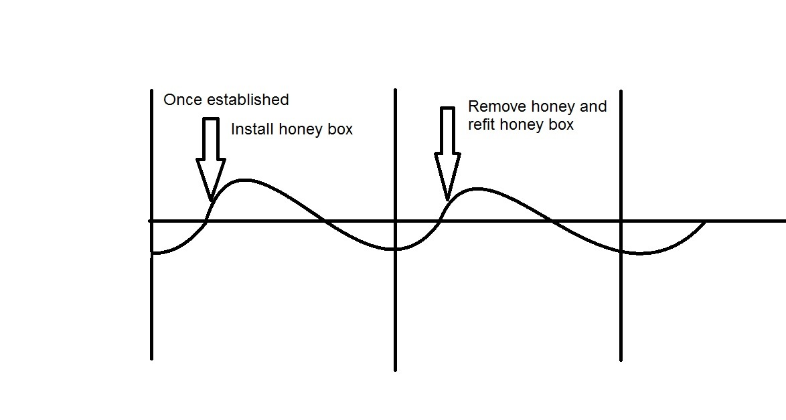
Once the bees really start flying in big numbers, the same as hot sunny days from the previous year, then you can remove the insulation and put on a honey box. Not more than one every two weeks. Remove the plug from the top and pop on a box. Do not put on more than three..
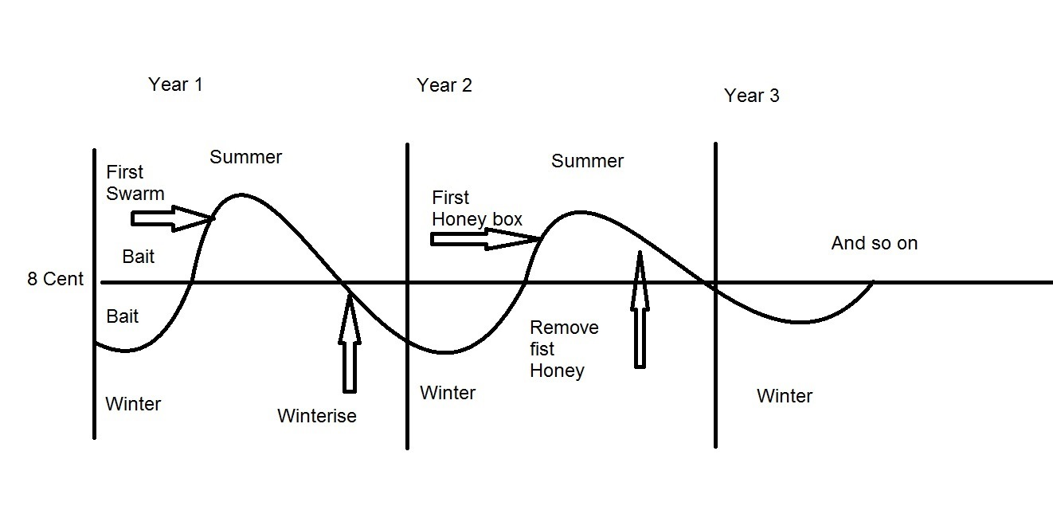
You don’t have to harvest honey, you can just let the bees do what bees do. And just enjoy them for them. So no honey boxes.

You can monitor the amount of comb in the boxes with an endoscope.
Hay presto you have honey. If you don’t, well there is always next year.
If you do, don’t be greedy and leave the boxes on into autumn. Remove then and block the holes. This way the bees will know there loss and compensate by making more stores in their box.
Year three will be the same as year two, but now you will have a better feel for the best time of the year to give the bees the best chance.
