- Lure Instructions

When the Gardeners’ Beehive arrived, you would have found a small bottle of lure inside. This is the magic! This lure will make the Gardeners’ Beehive smell like a habitat which has had honey bees living in it before. Therefore, when the scout bees are scouting for a new habitat, they will be attracted to your Gardeners’ Beehive since it is seen as a safe place to live. The lure and special wood chip is what makes the Gardeners’ Beehive a self- populating hive.

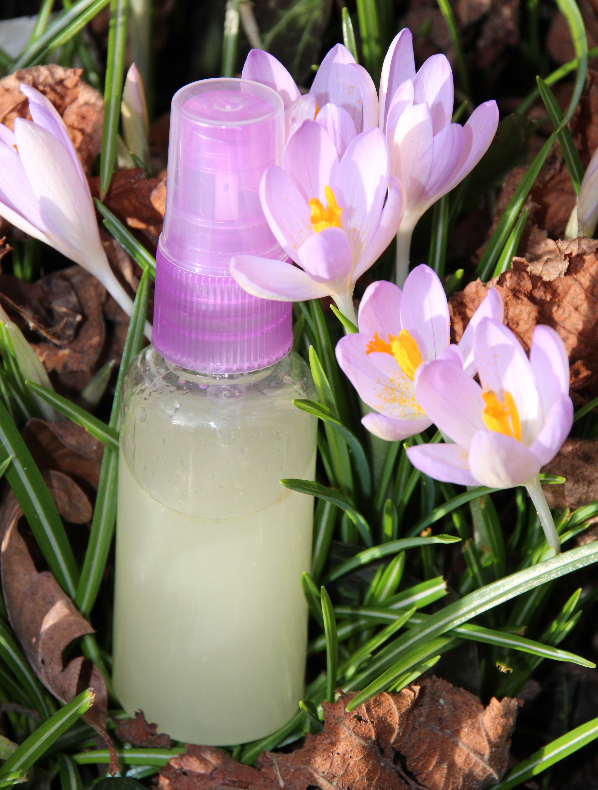
How to use the lure
Keep the spray bottle with lure in a sealed or zip lock bag.

First time:
Spray the inside of lid with 3 good squirts. This is only ever done once and then the lid should be put on the hive and not removed again.

Next
From mid-March to mid-April
Once a week spray one squirt on the entrance and one quirt in the air in front of the hive on sunny days.

Then from Mid-April till end of August
Spray one of the entrance holes with one good squirt.
(Be mindful not to get this in your eyes as it will burn).

If the above instructions are followed, the enclosed bottle of lure should last approximately 5 years.

Important Note: If at any time you see scout bees showing an interest in the hive, stop using the lure.
After a couple of days, if you are sure that no bees have moved in, continue the once a week spray. If honey bees are in the Gardeners Beehive, cease spraying.

Each bottle contains about
160 squirts; 3 to 5 years’ worth.
Shelf life is 5 years.

www.gardenersbeehive.com
This hive and all material are “copyright” and a “resisted design.”
We accept no responsibility or liability for any accidents or injury that might result from this product or the use thereof.
Copyright © 2016 [COPYRIGHT Mr K Hancock ]. All Rights Reserved.

