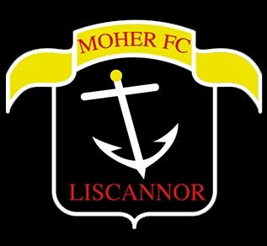

**Moher Celtic FC**

**Code of Behaviour for Officials and Coaches in our Club**

Ensuring the safety and welfare of children who are members of our club or who engage with our club through competition and participation in club events is our primary concern.

It is important that all club officials and coaches are fully aware of the behaviour our club expects from them. This code of conduct sets out those expectations. As an official or coach in our club, we expect you to:

* Consider the wellbeing and safety of children at all times
* Endeavour to make sure all activities are appropriate to the age, ability and the experience of those taking part.
* Promote the positive aspects of participation over winning and promote good sportsmanship and effort over results.
* Communicate with and provide feedback to children in a way that reflects respect and care.
* Encourage and guide children to accept responsibility for their own performance and behaviour.
* Do not condone rule violations, overly rough play or the use of prohibited substances.
* Lead by example when it comes to positive behaviour. Behave respectfully towards other coaches and officials
* Maintain appropriate boundaries and relationships with all participants and their parents or carers.
* Never use foul or inappropriate language
* Each team has two dedicated coaches. In so far as possible, both dedicated coaches should attend each training session and match. Where a coach cannot attend a match, they should notify the other dedicated coach for that team and arrange for another coach or failing that a club official to attend in their absence. Where a coach cannot attend a training session, they should notify the other dedicated coach for that team and arrange for another coach to attend in their absence. No coach should conduct a training sessions unless at least one other coach is present.
* Follow all guidelines laid down by the FAI and the club. Read, understand and put into practise all club policies and procedures.
* Ensure you are Garda Vetted at all times and have completed appropriate Child Safety Training
* Where a parent, club official or coach has a concern that a club official or coach has not conducted themselves in accordance with this Code of Behaviour they can raise a complaint/concern under the FAI Concern/Complaint Procedure.

I have fully read and understand the above code of conduct and will ensure that my conduct and practice reflects the above points.

Signed: ………………..……………… Name: ……………………………………….……………. Date: ………….………….