***Tender* *Hearts* *Home* *Care* *Agency***

|  |  |  |  |
| --- | --- | --- | --- |
| **Application for Employment** |  |  |  |
| Name ______________ | _________ | ______________ |  |
| Last First | MI | Date |  |
| Address ____________________________________________  Street | _ ____  City | ___  State/Province | ___________  ZIP/Postal Code |
|  |  |  |  |
| Telephone # _ ( _ ) Cell Phone # ( ) ______________ SSN_____________________    E-Mail address __________________________________ Referred to us by | | | |

Position(s) applied for Caregiver Nursing Other: ______________ Date available

Type of employment desired Full-Time

Part-Time Please Specify Days and Hours

Casual

If currently employed, may we contact your employer?

Yes

No

Rate of Pay Expected $_______________ per hour License/Certification Number ____________________

Is there a specific reason you are applying for employment at this company? Yes No If Yes, please briefly outline the reason:

________________________________________________________________________________________

________________________________________________________________________________________

______________________________________________________________________________________

Are you legally eligible for employment in the United States? Yes No

Do you have a Green Card or a Work Visa? __________

Are you available to work overtime if required? Yes No

Have you applied with this company before? Yes No

Have you been employed at this company before? Yes No

If yes, when? ____________________ and at what location? _________________________________

Do you have any friends or family employed at this location? Yes No

Have you been convicted of a crime in the last seven (7) years? Yes No

If yes, please explain

CONVICTION WILL NOT NECESSARILY BE A DISQUALIFICATION FOR EMPLOYMENT.

If considered for hire, will you agree to provide a criminal background check? Yes No

If considered for hire, will you agree to provide a drivers abstract? (Drivers Record) Yes No N.A.

Have you had the COVID-19 Vaccination? ______ If so, and upon hire please provide a copy.

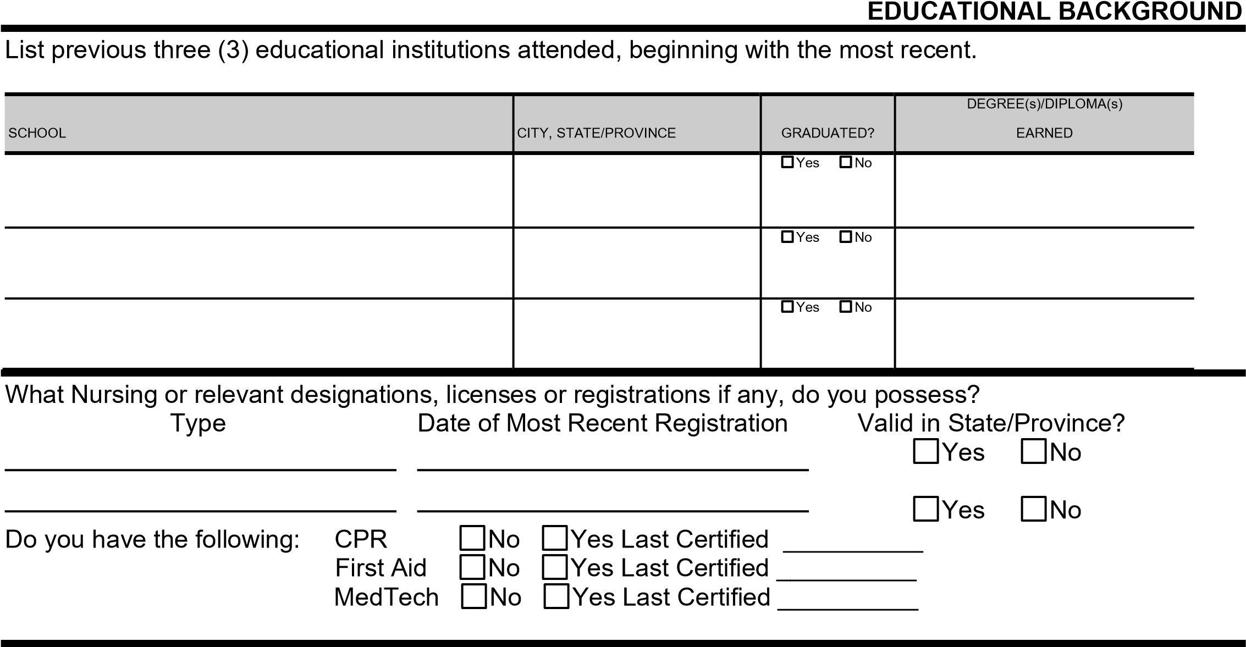

# PLEASE ANSWER THE FOLLOWING QUESTIONS

What do you think is the most difficult part of nursing or customer service work?

What was the best job you ever had and why?

What was your least favorite job and what did you dislike about it?

Think of the BEST supervisor you have ever had, what characteristics made that person a good manager?

Think of the WORST supervisor you have ever had, what characteristics made that person a poor manager?

How will you be able to contribute to providing seniors with high quality care?

Imagine you have been on your feet and working hard all day. A customer that you have been dealing with is rude and impatient, what do you do?

# EMPLOYMENT BACKGROUND

Provide the following information beginning with the most recent employer.

|  |  |  |  |  |  |
| --- | --- | --- | --- | --- | --- |
| EMPLOYER | TELEPHONE  ( ) |  | DATES EMPLOYED | | SUMMARIZE THE TYPE OF WORK PERFORMED AND JOB RESPONSIBILITIES |
|  | FROM | TO |
| ADDRESS |  |  |  |  |  |
| JOB TITLE |  |  | HOURLY RATE/SALARY | |  |
|  | STARTING | |
| IMMEDIATE SUPERVISOR AND TITLE AND PHONE NUMBER |  | $ |  | per |  |
| REASON FOR LEAVING |  |  | HOURLY RATE/SALARY | |  |
|  | FINAL | |
| MAY WE CONTACT FOR REFERENCE?  Yes No Later |  | $ |  | per |  |
| EMPLOYER | TELEPHONE  ( ) |  | DATES EMPLOYED | | SUMMARIZE THE TYPE OF WORK PERFORMED AND JOB RESPONSIBILITIES |
|  | FROM | TO |
| ADDRESS |  |  |  |  |  |
| JOB TITLE |  |  | HOURLY RATE/SALARY | |  |
|  | STARTING | |
| IMMEDIATE SUPERVISOR AND TITLE AND PHONE NUMBER |  | $ |  | per |  |
| REASON FOR LEAVING |  |  | HOURLY RATE/SALARY | |  |
|  | FINAL | |
| MAY WE CONTACT FOR REFERENCE?  Yes No Later |  | $ |  | per |  |
| EMPLOYER | TELEPHONE  ( ) |  | DATES EMPLOYED | | SUMMARIZE THE TYPE OF WORK PERFORMED AND JOB RESPONSIBILITIES |
|  | FROM | TO |
| ADDRESS |  |  |  |  |  |
| JOB TITLE |  |  | HOURLY RATE/SALARY | |  |
|  | STARTING | |
| IMMEDIATE SUPERVISOR AND TITLE AND PHONE NUMBER |  | $ |  | per |  |
| REASON FOR LEAVING |  |  | HOURLY RATE/SALARY | |  |
|  | FINAL | |
| MAY WE CONTACT FOR REFERENCE?  Yes No Later |  | $ |  | per |  |
| EMPLOYER | TELEPHONE  ( ) |  | DATES EMPLOYED | | SUMMARIZE THE TYPE OF WORK PERFORMED AND JOB RESPONSIBILITIES |
|  | FROM | TO |
| ADDRESS |  |  |  |  |  |
| JOB TITLE |  |  | HOURLY RATE/SALARY | |  |
|  | STARTING | |
| IMMEDIATE SUPERVISOR AND TITLE AND PHONE NUMBER |  | $ |  | per |  |
| REASON FOR LEAVING |  |  | HOURLY RATE/SALARY | |  |
|  | FINAL | |
| MAY WE CONTACT FOR REFERENCE?  Yes No Later |  | $ |  | per |  |

# REFERENCES

List the name, relationship, number of years acquainted, and phone number of three references. (No relatives please).

YEARS

PHONE

NAME

RELATIONSHIP

ACQUAINTED

NUMBER

(

)

)

(

(

)

*I certify that all the information I have provided is true, complete and correct.*

*The information contained within this application or any cover letter or resume attached is not shared with any third parties. The information is used by the employer only as an aid in the hiring decision making process. The applicant, by signing the application gives the employer consent to collect the information contained herein and use for the purpose specified.*

*I authorize this company to investigate all statements contained on this application. I understand that any misrepresentation or omission of facts called for is cause for immediate disqualification and/or if employed, immediate dismissal.*

*I understand that if I am hired, I will be required to provide criminal background check at my cost, proof of identity and legal authority to work in the United States, proof of certifications or educational qualifications, and a drivers abstract (if applicable).*

*Furthermore, I understand and agree that if employed, I am free to resign at any time, with or without cause and without prior notice, and the employer reserves the same rights to terminate my employment at any time, with or without prior notice, except as may be required by law. This application does not in any way constitute an agreement or contract for employment.*

# Applicant’s Signature: _____________________________________________ Date __________________

For office use only:

Date application received:

Date applicant contacted:

Note

___________________________________________________________

A 1 2 3 4 5 6 7 8 9 10 C 1 2 3 4 5 6 7 8 9 10 F 1 2 3 4 5 6 7 8 9 10