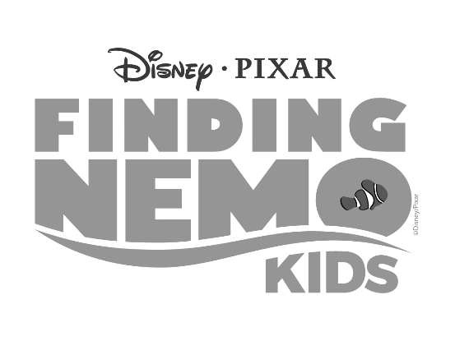
Audition Materials

Audition Song Lyrics:
In the big blue world, we’re gonna go explore. In the big blue world, we’ve never seen before. What’s waiting out there? We can never know…In the big blue world, we’re ready to go!

Audition Spoken Lines:
Welcome to Sydney Harbor! Sydney, Australia is famous for a few things. Our Opera House! Bondi Beach! And our stories!...And there’s one that we love to tell the most! The story of a clownfish who really loved his kid. We’ll start at the beginning, and soon enough you’ll know of Marlin’s great adventure. That’s one dedicated father…

