I am not good at this.

**GROWTH**

I’ll use some of the strategies I’ve learned.

I give up.

**FIXED?**

*CHANGE*

*YOUR*

*WORDS*

I don’t understand.

**CHANGE**

**YOUR**

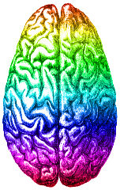

Think about the unhelpful things you may say to yourself and replace with HELPFUL.

Mistakes help me improve.

I made a mistake

I can always improve, I’ll keep trying.

I can’t make this any better.

I’m going to train my brain in singing.

I can’t sing!

This may take some time and effort.

This is too hard.

I’m going to figure out what he/she does and try it.

I’ll never be as smart as him/her!

Is this really my best work?

It’s good enough!

What am I missing?

I’m on the right track.

**MINDSET**