**IMAGINE That You Took A Selfie Of Your Anger, What Would That Look Like?**

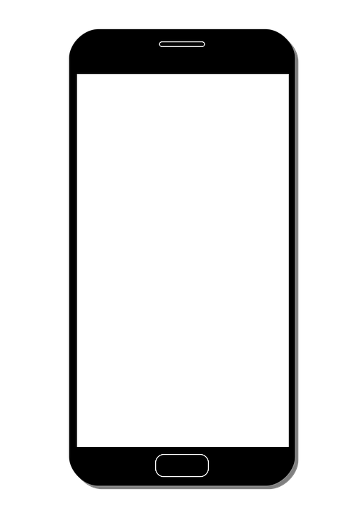

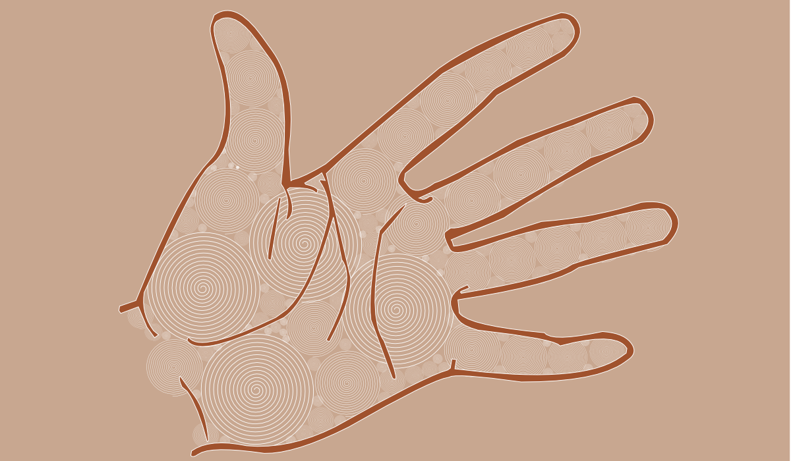



**Say Something BEAUTIFUL To The World In Your Own Unique Way.**