How They Died: Martyrdom of the Apostles
By Brad Miner
https://www.thecatholicthing.org/2026/01/10/how-they-died-martyrdom-of-the-apostles/

In The Cost of Discipleship (1937), Dietrich Bonhoeffer writes that Christ invited St. Peter “to the supreme followship of martyrdom for the Lord he had denied. . .thereby forgiving him all his sins. In the life of Peter, grace and discipleship are inseparable.” (p. 49)
In Bonhoeffer’s famous reckoning, this was a case of costly, as opposed to cheap, grace. Bonhoeffer, of course, would come to embody the former. On his way to be executed by the Nazis at the Flossenbürg concentration camp in 1945, Bonhoeffer told a fellow prisoner, “This is the end – but for me it is the beginning of Life!”
That’s the attitude of all true martyrs when their time comes.
Bonhoeffer was hanged. The deaths of the original Twelve Apostles were often more excruciating.
So: how, when, and where did the Twelve meet their deaths? And how have artists imagined each man’s martyrdom?
To begin, we know that Christ’s betrayer died by his own hand (cf. Matthew 27:3-5 and Acts 1:18-19). Judas was a suicide, not a martyr.
We also know John (December 27 is his feast day) was not martyred. And he is the only one, according to tradition, not killed for preaching the Gospel.
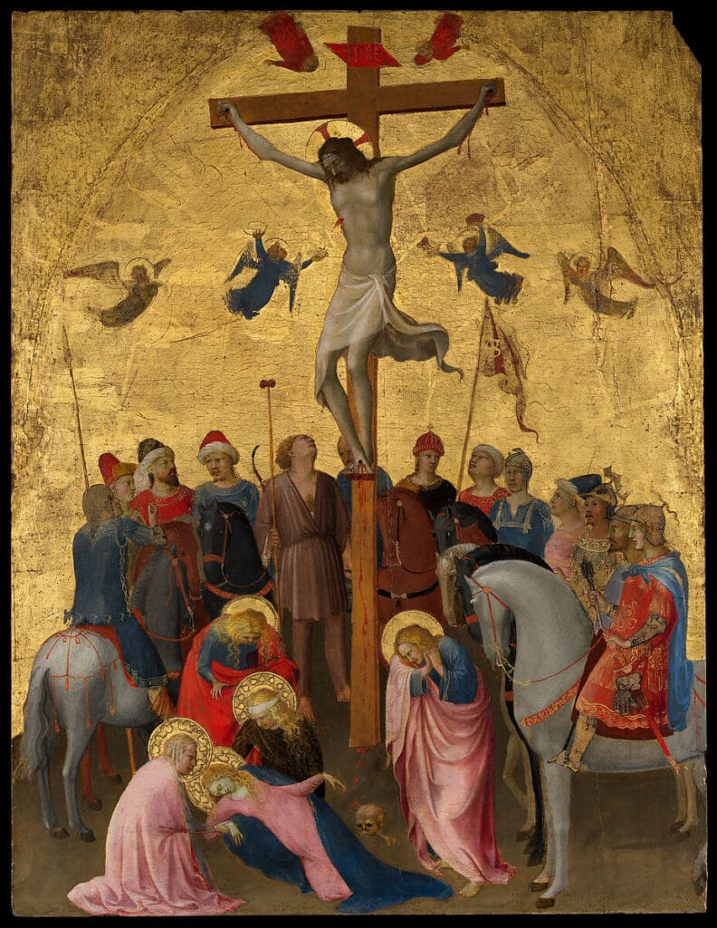
Christ would be the first martyr were He not our Savior: Crucifixion by Fra Angelico, c. 1420-23 [The MET, New York]
Scripture (Acts 12:1-2) tells us that John’s brother, James the Great (feast on July 25), was the first apostle-martyr, c. 44. He was “killed with the sword,” presumably in Jerusalem. Luke, the author of Acts, may have got the story from John himself, and the facts are corroborated by Irenaeus (c. 125 – 202), who knew Polycarp (c. 60 – 155), who knew John, whom we believe died as late as the end of the 1st century. Luke prefaces his account of James’ death by indicating it was King Herod Agrippa who gave the order, using the same method his uncle Antipas had chosen to murder John the Baptist. James’ body, they say, now resides in the Cathedral of Santiago de Compostela.

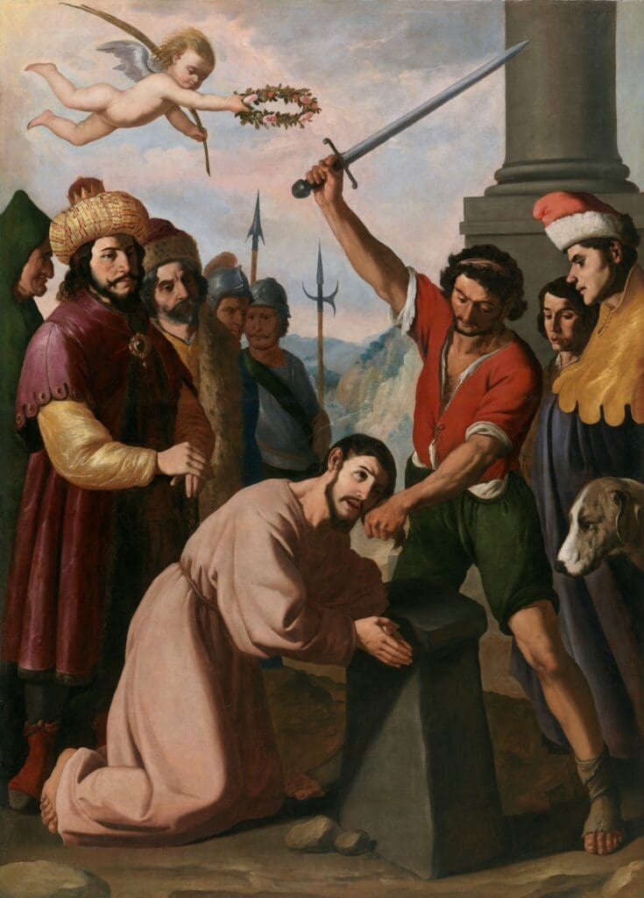
The Martyrdom of Saint James by Francisco de Zurbarán, c. 1640 [The Prado, Madrid]

The order of subsequent martyrdoms is largely unknown, but all (save John, of course) were likely gone by the year 80. What we know comes from early Church historians (Eusebius, Tertullian, the aforementioned Irenaeus and Polycarp, and others, including St. Jerome), some apocryphal “gospels,” and a scattering of ancient local traditions. Many of these were gathered in the 13th-century Golden Legend by Jacobus de Voragine. The dates given here are approximate, debatable, and by no means gospel. As to place, I have simply chosen the city that claims to be the site of martyrdom. (And I have included in parentheses, as in John and James above, the date of each saint’s feast.) I also note where relics are claimed to reside. Relics were often separated to be used in other altars. They still are.

Between 60 and 70:
Andrew (November 30) was crucified on an X-shaped cross, called a saltire (or crux decussata), in Patras, Greece. He was put to death because of the number of Greeks he converted, including the wife of the pagan governor. It took three days for him to die, and he never stopped preaching. Andrew’s remains, they say, reside in the Cattedrale di Sant’Andrea in Amalfi.
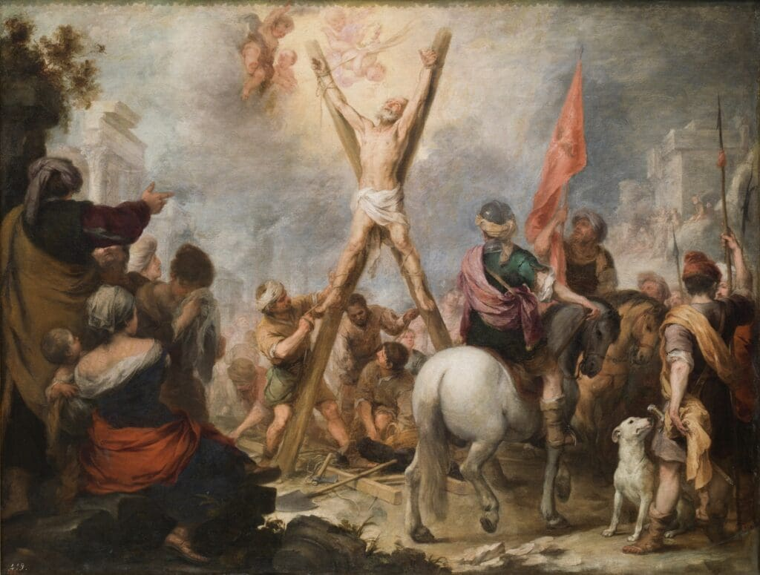The Martyrdom of St. Andrew by Bartolomé Esteban Murillo, 1675-1682 [The Prado, Madrid]

Bartholomew [Nathanael] (August 24) was flayed alive and beheaded in Albanopolis, Armenia. From that, we get a macabre association: he is the patron saint of tanners. And, again, his murder resulted from his conversion of the local Roman satrap. His relics reside at the Basilica di San Bartolomeo all’Isola, Tiber Island, Rome.

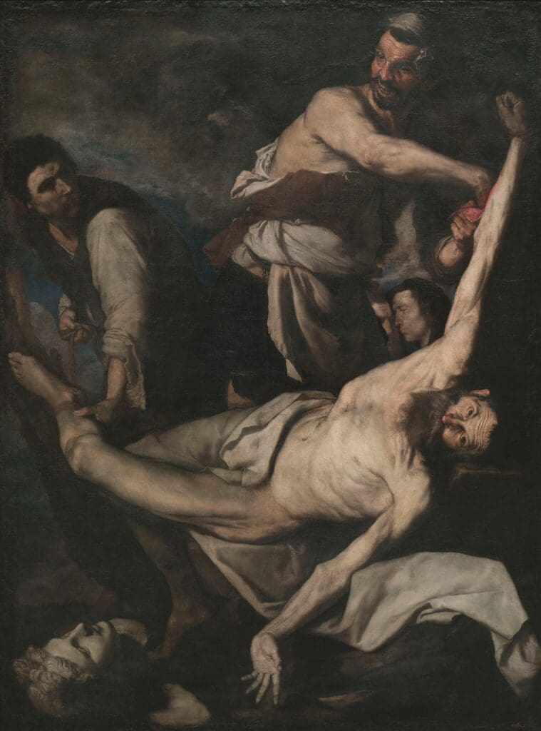
Martyrdom of Saint Bartholomew by Jusepe de Ribera, 1644 [Museu Nacional d’Art de Catalunya]

James the Less, known to the Early Church as “the Just” (May 11), was defenestrated, then stoned, and (perhaps) clubbed to death in Jerusalem. He was condemned by the Sanhedrin and thrown from the pinnacle of the Temple, survived, and began praying for his attackers. The coup de grâce was delivered by a laundryman with his clothes beater. His relics, they say, are in Santi Apostoli, Rome. That is, unless, as some say, they reside at the Cathedral of Saint James, Jerusalem. Maybe they’re in both places.

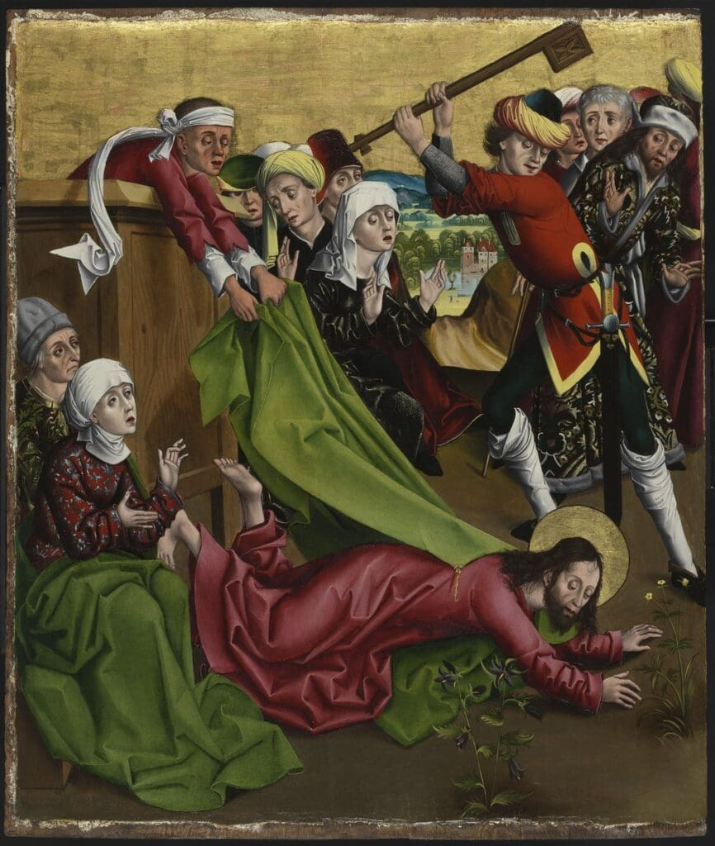
The Martyrdom of James the Lesser by [Master of the Winkler Epitaph], [Museum of Fine Arts Budapest]

Matthew took the Good News to North Africa and was martyred in Ethiopia. His preaching converted Ephigenia, daughter of King Egippus, but when he died and was succeeded by Hirtacus, the new king attended a Mass at Matthew’s invitation, then ordered the Apostle’s beheading. His remains are said to reside in the Cathedral in Salerno.

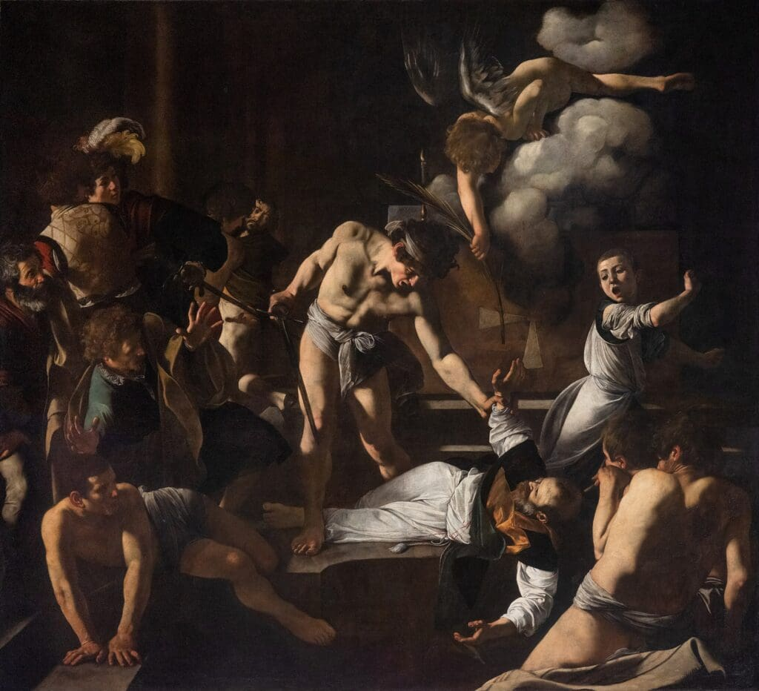
The Martyrdom of Saint Matthew by Caravaggio, c. 1600 [San Luigi dei Francesi, Rome]

Simon (the Zealot) & Thaddeus (Jude) (both October 28), who evangelized together, are thought to have been martyred in what is present-day Iran. In the image below, Thaddeus (in green) is about to be bludgeoned, as Simon is being sawn in half. Their relics are said to be under an altar at St. Peter’s Basilica.
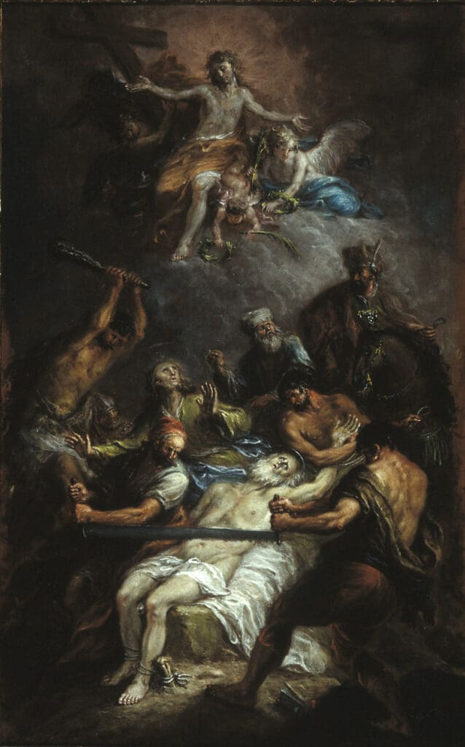
Martyrdom of Saint Simon Zelotes and Saint Judas Thaddeus by Martin Johan Schmidt, c. 1796 [Spencer Museum of Art, Lawrence, Kansas]

Peter and Paul died sometime after 60 AD – but more on that below.
After 70:
Philip (May 3) traveled and evangelized with Bartholomew, although they went different ways at some point, and Philip met his end in Hierapolis in Turkey. One aspect of Philip’s story is the suggestion that he was accompanied by Mary Magdalene. Tradition has it that Philip was crucified upside down, perhaps at his own request, because he knew Peter had died that way. Philip’s relics are thought to be with Little James’ at Santi Apostoli.

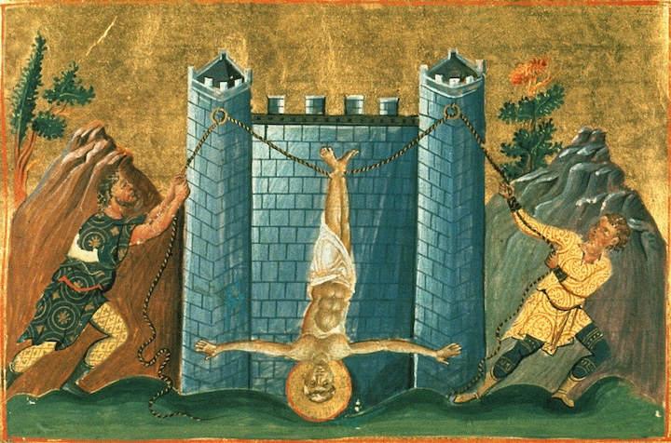Crucifixion of Philip by Georgios (in the Menologion of Basil II), c. 1000 [Vatican Library]

Matthias (May 14). There is a marker at the Gonio Fortress in the nation of Georgia that claims Matthias is buried there, killed for preaching the Gospel. As to the means of his death. . .well, Lochner’s painting below suggests the popular claim: an axe to the head, although the word “beheaded” is usually used. They say his relics (or some of them) were transported to St. Matthias Abbey in Trier, Germany. The Gonio Fortress is near the coast of the Black Sea, and relics are often well-traveled, so . . .
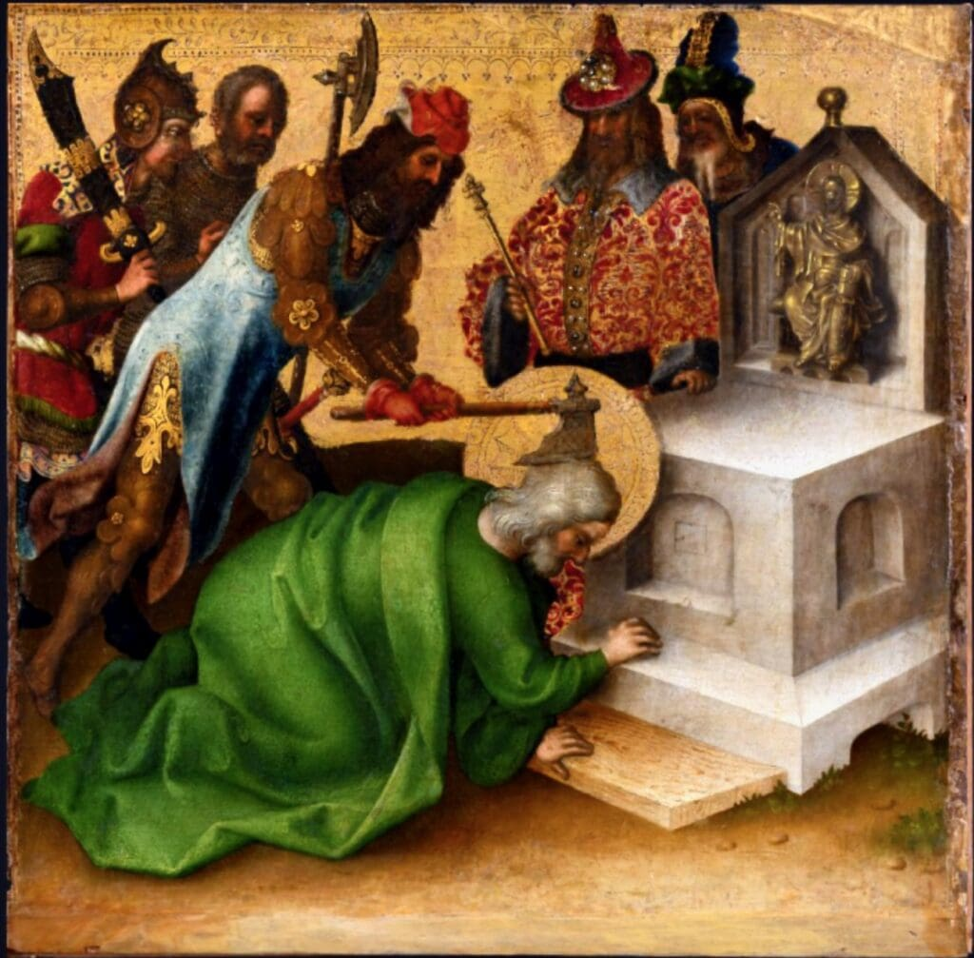Martyrdom of St Matthias by Stefan Lochner, after 1435 [Städel Museum, Frankfurt, Germany]

Thomas (July 3) was martyred in India. His was the case – true of many other Apostles (if not, in fact, most of them) – of converting the family of a king, Misdaeus (so named in the apocryphal Acts of Thomas), who ordered Thomas to be run through with a spear. Caesar famously divided Gaul into three parts, and Thomas may also have been: His relics are claimed in India (San Thome Basilica in Chennai), Turkey (maybe just a transit point), and Italy (Basilica of San Tommaso Apostolo, Ortona).
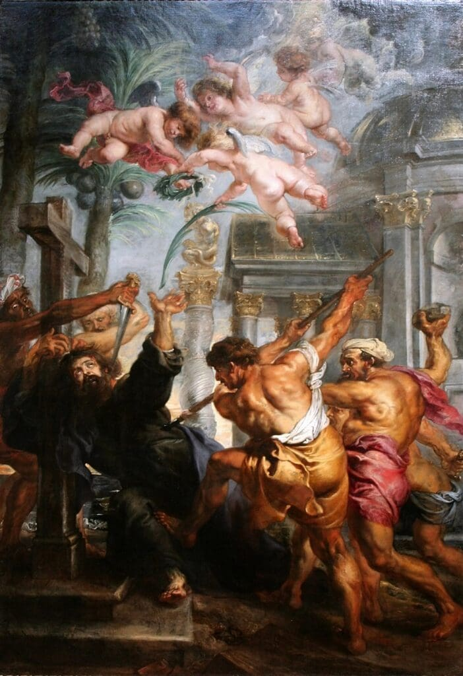
Martyrdom of St. Thomas by Peter Paul Rubens [National Gallery, Prague]

And, finally, the fates of Peter and Paul (June 29). We celebrate the Feast of Saints Peter and Paul on the same day because there is a tradition that they were martyred at the same time, although in different places. They surely did die in Rome: Peter crucified upside down, and Paul beheaded. And we have the authority of St. Jerome’s On Illustrious Men, in his précis on Paul, that “in the fourteenth year of Nero on the same day with Peter, he was beheaded at Rome for Christ’s sake and was buried in the Ostian way, the twenty-seventh year after our Lord’s passion.” That would make it 60 AD, although other sources say 64. Their remains rest beneath the churches that bear their names: St. Peter’s Basilica and the Basilica of St. Paul Outside the Walls.

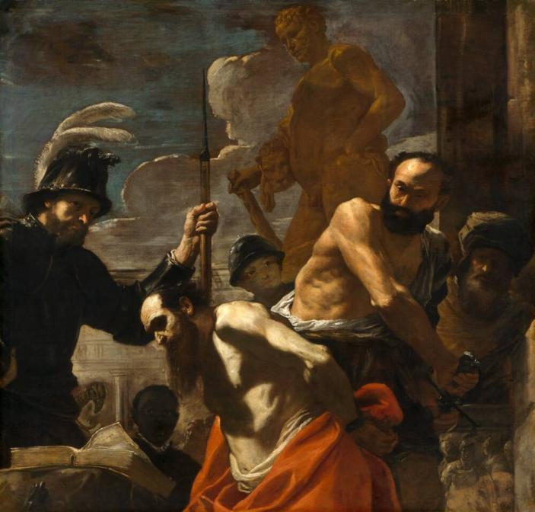The Martyrdom of Saint Paul by Mattia Preti, c. 1656–1659 [Museum of Fine Arts Houston]

It’s no surprise that tradition is stronger regarding these two great men. They were the leaders of the Early Church and brought the Faith to its enduring home. It has become redundant to state the reasons why they were killed, and it simply remains to be said that:

Truly, the cost of discipleship can be high!

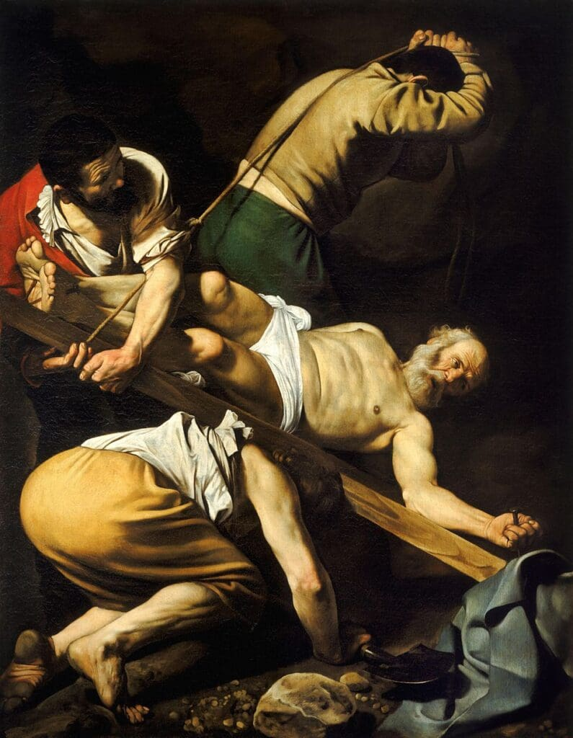
Crucifixion of Saint Peter by Caravaggio, 1601 [Santa Maria del Popolo, Rome]

