Did Mary Have Other Children?
I have probably addressed this somewhere before on this blog, but I was asked about this question recently: didn't Mary have other children? That seems to throw a kink into the whole perpetual Virginity thing, doesn't it? After all, the people Jesus grew up with doubted His claim to be the Messiah on the grounds that He was just a hometown Boy made good:
Is not this the carpenter, the son of Mary, the brother of James, and Joses, and of Juda, and Simon? and are not his sisters here with us? And they were offended at him.
(Mark 6:3; see also Matthew 13:55-56).
That sure sounds like Mary had other kids. Turns out, though, She didn't. We know this in two ways: first, because of the difference between what a first-century Jew and a modern English reader calls a "brother," and second, because we know the parents of two of the men listed as Jesus' "brothers."
I. Brothers from Another Mother

The people called His "brothers" and "sisters" in Matthew 13 and Mark 6 are probably Jesus' cousins. Ancient Hebrew and Aramaic didn't have a lot of words for relatives, and the words that they did have often meant more than one thing (for example, the word that can mean "nephew" also meant "son's son"). As a result, distant ancestors are generally called "fathers" and "mothers," like "Father Abraham," and descendants, even distant ones, are described as a person's sons and daughters. If you were any other kind of relative (sibling, half-sibling, cousin, in-law, aunt, uncle, niece, nephew, etc.), they were usually called your "brother" or "sister."
There's an explicit example of this in the Bible. From Genesis 11:27, Gen. 12:5, and Gen. 14:12, we know that Lot is Abraham's nephew - the son of Abraham's brother, Terah. Yet Genesis 14:14 and Gen. 14:16 refer to Lot as Abraham's "brother." In English, this would be wrong - they're not brothers, they're uncle/nephew. In Hebrew and Aramaic, it's right. They're relatives who aren't direct ancestors/descendants.
It's in this Biblical sense that Jesus and James, Joses, and the rest were "brothers."
II. The Family Tree of James and Joses

Let's look at two of the "brothers" - James and Joses - to show what I mean. Matthew 27 relates the Crucifixion account. One of the interesting details is from v. 56-57, relating some of the women who were there:
And many women were there beholding afar off, which followed Jesus from Galilee, ministering unto him:
Among which was Mary Magdalene, and Mary the mother of James and Joses, and the mother of Zebedee's children.
So Matthew mentions three women: (1) Mary Magdalene, (2) the mother of Zebedee's children, and (3) Mary the Mother of James and Joses. That Mary is not the Virgin Mary. If she were, Matthew would have said, "Mary, the mother of Jesus," instead of "James and Joses." But just to eliminate any doubts, look at the parallel accounts. Here's Mark 15:40,
There were also women looking on afar off: among whom was Mary Magdalene, and Mary the mother of James the less and of Joses, and Salome;
Mark uses the same description: that this Mary is the mother of Joses and James (Mark specifies it's James the Younger, instead of James the son of Zebedee). He also tells us that Salome is the name of the woman described as Zebedee's wife. This Salome is mother of James and John (Matthew 4:21). Finally, we get to John 19:25-26, which distinguishes between that Mary and the Virgin Mary:
Now there stood by the cross of Jesus his mother, and his mother's sister, Mary the wife of Cleophas, and Mary Magdalene.
When Jesus therefore saw his mother, and the disciple standing by, whom he loved, he saith unto his mother, Woman, behold thy son!
John's list varies slightly from Matthew and Mark's, and for good reason. From John 19:26-27, we know that the Virgin Mary was at the foot of the Cross, within earshot. The other women were apparently further away, as Matthew 27:56, Mark 15:40, and Luke 23:49 all specify. Since the three Synoptic Gospels are describing the women watching "from a distance" or "from afar," their lists don't include the Virgin Mary.
But John's given us a number of clues. First, this other Mary -- the one described as the mother of James the Younger and Joses -- isn't the Virgin Mary. Second, she's the wife of someone else, Cleophas. And third, she's described as Jesus' "Mother's sister."
This final clue is bigger than it appears, for a few reasons. Obviously, it shows once more that we're not dealing with siblings: Mary doesn't literally have a sister named Mary - this isn't a George Foreman situation. Instead, Mary, Cleophas' wife, was almost certainly Mary's sister-in-law. Tradition holds that Cleophas is St. Joseph's brother, and both sons married women named Mary, but Scripture never explains the exact relationship between these two Marys. Suffice to say, they're somehow related by blood or marriage.
Finally, this key unlocks the whole question of why James and Joses are called Jesus' "brothers." Their mothers are described as "sisters," so it's sensible that the sons are desribed as "brothers." We're probably looking at something like this:
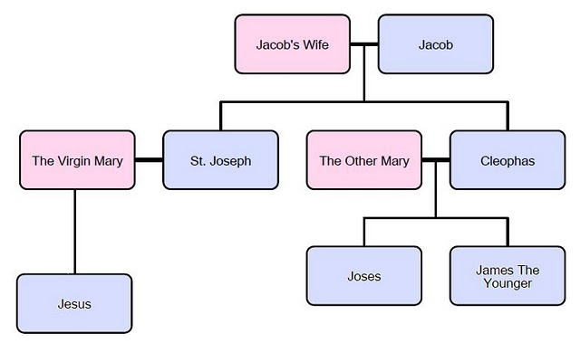

III. The Two Final Clues
There are two final clues that these men aren't Jesus' brothers. Some translations give Joses' name as Joseph. If that's right, it's more evidence against this being Mary's son. Just as it's supremely unlikely that the Virgin Mary would have a sister named Mary, it's unlikely that St. Joseph would have a son named Joseph. Although that sort of thing is done these days, I can't find a single case in the Bible were someone was given the exact same name as their father.
Finally, look at what Jesus does on the Cross:
When Jesus saw his mother there, and the disciple whom he loved standing nearby, he said to her, “Woman, here is your son,” and to the disciple, “Here is your mother.” From that time on, this disciple took her into his home. (John 19:26-27).
By this time, the Virgin Mary is apparently a widow. Typically, in Jewish culture, She'd be placed in the care of Her Son or sons. Jesus acts here as if Mary has no other sons, and places Her in the care of a non-relative, the Apostle John. But those who claim that Mary had numerous children (James, Joses, Juda, Simon, and multiple daughters) have to claim that Jesus skipped over them to entrust Her to a non-relative. That's no small insult, particularly since one of His "brothers" is James the Younger, another one of the Twelve Apostles. From Galatians 1:19, we know that St. James the Younger was an Apostle, and was alive and well in Jerusalem well after the Death and Resurrection of Christ. It's unthinkable that he would have actually been Jesus' brother, and yet overlooked for the task of caring for his own mother.

