**Healthy Iftar Beverages**

Here is a list of healthy beverages with a low glycemic index (GI) suitable for breaking the fast during Ramadan:

1. Fresh fruit juices made with low-GI fruits**.**

* **Fresh juices are generally healthier than packed juices because** they contain more vitamins, minerals, enzymes, and flavonoids than packed juices. They are full of antioxidants that support the body's immune system
* **Packaged juices** often contain **added sugars, preservatives, artificial flavours,** and colours. They often lack fibre because it is stripped during processing.

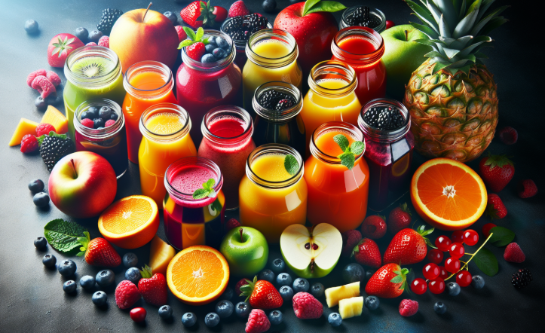

1. 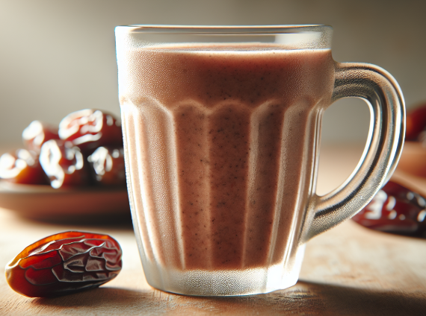Date Smoothie is ideal for sahur and easy to prepare and quick to consume in the early hours of the morning. Made with 1 cup of oats, 1 cup of fresh milk, 3 dates and 1 cup of water. It is a great drink to have sustainable energy for long time along with nutritious fibers and antioxidants.
2. Avocado, Celery, Cucumber and Lemon Juice-Celery and cucumber are high in water content while lemons are high in Vitamin C. Combining these ingredients with the avocado superfood helps to stay hydrated, strong, and satiated throughout the fasting day.

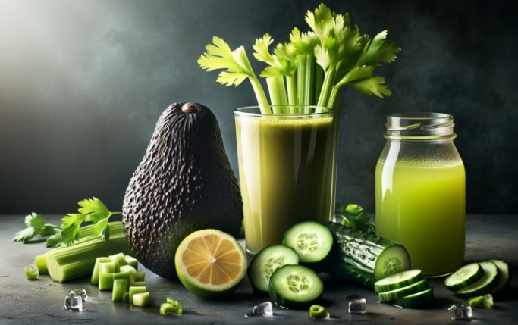

1. Starfruit & Strawberry Juice- This drink is highly packed in Vitamins B and C and is an immunity-boosting anti-oxidant. It is a refreshing and thirst-quenching combination to keep hydrated and enhance wellness throughout Ramadan.



1. Spinach, Lettuce Juice- The iron components of spinach aid in blood production to improve the transfer of oxygen from the lungs to the cell body.

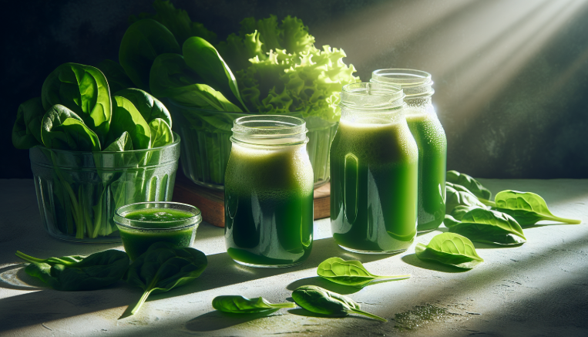

1. Apple, Spinach, Celery, Cucumber Juice-Juicing leafy vegetables such as spinach and parsley help to detoxify the liver. These vegetables are also loaded with vitamins A, B, C, K, niacin, and folate.

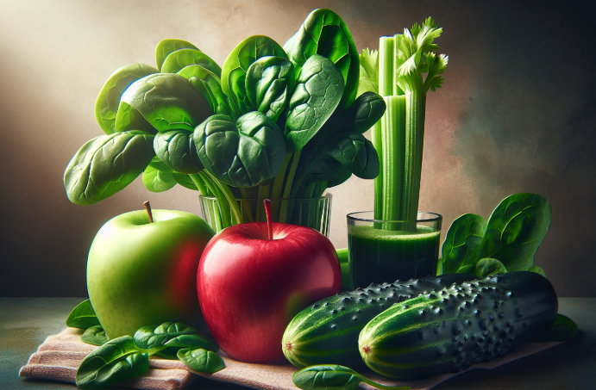

1. Buttermilk- It has a low glycemic index of 35, making it an ideal drink for people with diabetes. It is low in fat and calories and contains moderate protein.

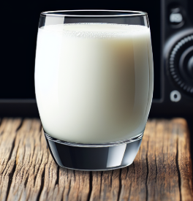

1. Herbal teas- Can help improve digestion, boost the immune system, and reduce inflammation



1. **Water with chia seeds-** it is a hydrating drink that can be consumed during Ramadan. Chia seeds are high in fiber, protein, and healthy fats, and they can absorb up to 10 times their weight in water. This makes them a good source of hydration and nutrients during fasting. Whisk one tablespoon of chia seeds into half a litre of water and leave it for 15 minutes for the chia seeds to turn the water into a gel-like consistency.

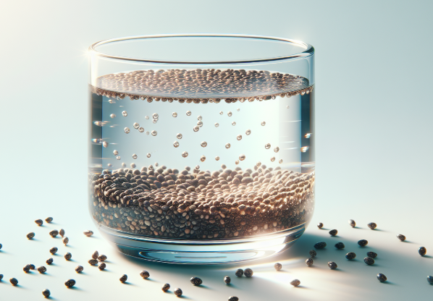

1. **Kokum juice**- this is a low-GI drink that causes the stomach to feel full and reduces the chances of overeating. It is advisable to avoid adding sugar.

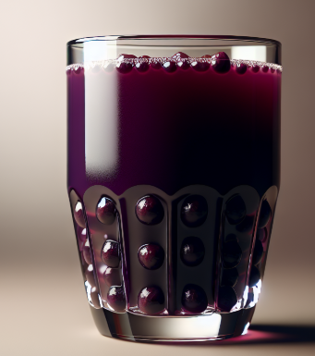

**Drink to avoid:**

* Caffeinated drinks can increase thirst.
* Sugary beverages can change blood sugar levels.
* Fizzy drinks are diuretics that can cause dehydration.
* High GI fruit Juices can raise blood sugar.
* Packed juices