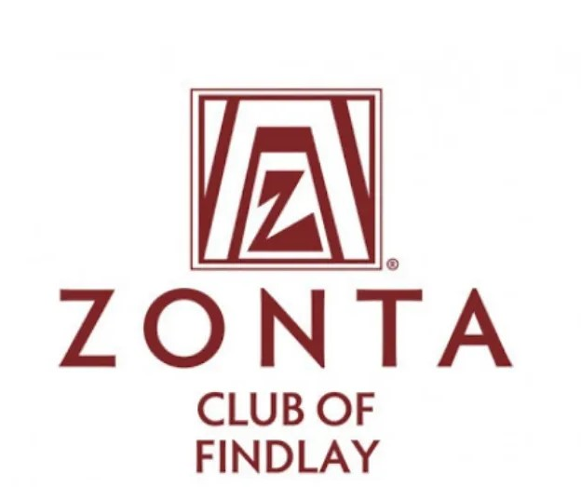

2025 General Scholarship Description

APPLICATION DUE BY FRIDAY, FEBRUARY 28, 2025

Zonta Club of Findlay offers a general scholarship to female, high school seniors, who are pursuing further education.

The following criteria must be completed in order to be considered for a General Scholarship.

Applicants must:

* Be a female in their Senior Year of High School
* Possess a high school diploma prior to August of the granting year
* Reside or go to school in Findlay/Hancock County
* **Complete a typed, electronic application**
* Provide high school transcript
* Provide a letter of recommendation from a teacher or someone not related to you
* Email application, letter of recommendation, and transcript (in one PDF) to [**FindlayZontaScholarship@gmail.com**](mailto:FindlayZontaScholarship@gmail.com)by the deadline listed on the application.
* This is a Non-Renewable Scholarship

The criteria for selection of the scholarship recipients will include:

* Academic Achievements
* School Activities
* Community Service
* Demonstrated Leadership
* Clearly formulated career goals
* Financial Need

The number and amount of scholarships is determined annually by the Scholarship Committee and availability of funds.