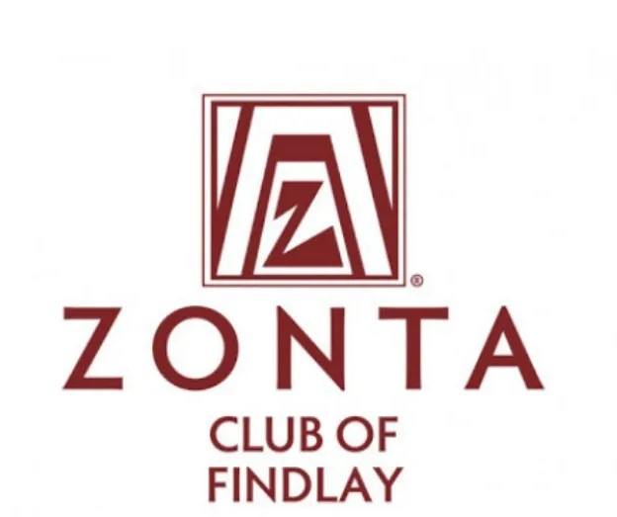
2026 General Scholarship Description
APPLICATION DUE BY FRIDAY, FEBRUARY 27, 2026
Zonta Club of Findlay offers a general scholarship to female, high school seniors, who are pursuing further education.
The following criteria must be completed in order to be considered for a General Scholarship.
Applicants must:
- Be a female in their Senior Year of High School
- Possess a high school diploma prior to August of the granting year
- Reside or go to school in Findlay/Hancock County
- Complete a typed, electronic application
- Provide high school transcript
- Provide a letter of recommendation from a teacher or someone not related to you
- Email application, letter of recommendation, and transcript (in one PDF) to FindlayZontaScholarship@gmail.com by the deadline listed on the application.
- This is a Non-Renewable Scholarship
The criteria for selection of the scholarship recipients will include:
- Academic Achievements
- School Activities
- Community Service
- Demonstrated Leadership
- Clearly formulated career goals
- Financial Need

The number and amount of scholarships is determined annually by the Scholarship Committee and availability of funds.

