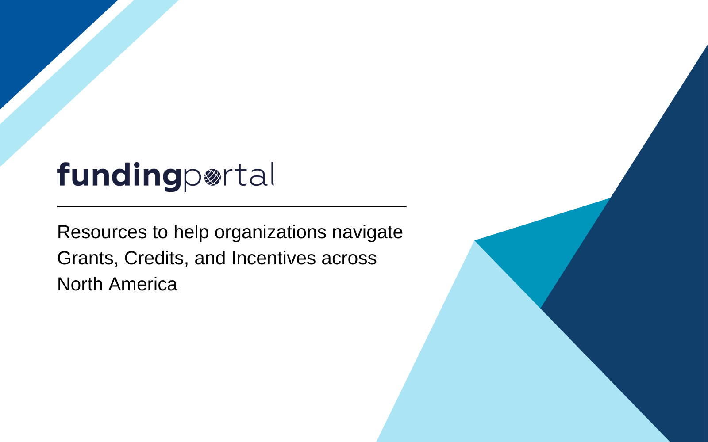

Glossary of Funding Terms and Frequently Asked Questions
Understanding Key Terms in Government Funding for Pork Producers and Processors

This document provides an essential reference guide for pork producers and processors, helping to demystify common terms and frequently asked questions related to government funding programs. It covers key concepts such as grants, tax credits, cost-share models, project eligibility, and more. Additionally, it includes answers to the most commonly asked questions about the Fundsearch™ Tool, its use, and available funding options to support your business's growth and sustainability.

Glossary of Funding Terms
Allotment
A designated portion of a budget for a funding program, allowing a specified maximum amount to be spent within a set period.
Application
The specific set of forms, documents, and attachments submitted to apply for funding from federal, provincial, or regional programs.
Application Package Template
A reusable collection of forms and documents that can be used across multiple funding applications.
Award
Financial assistance provided to support a public purpose, including grants, loans, and other forms of funding from government bodies.
Awarding Agency
The government agency providing financial support directly to an entity. This may include provincial or federal governments.
Biosecurity
Measures to protect farms from diseases or pests, often supported by funding for disease prevention infrastructure.
Budget
The financial plan for a project that details costs, typically approved by the funding agency.
Call for Proposals
An invitation to submit funding applications within a specified time frame.
Contribution Agreement
A formal agreement outlining the terms of financial contributions, including monitoring and potential repayment conditions.
Cost-Share
A funding model where the applicant contributes a percentage of project costs, with the rest covered by the funder.
Eligible Applicant
A business or individual that meets the specific criteria to apply for and receive funding.
Eligible Costs
Expenses deemed appropriate for funding by a program, such as infrastructure or sustainability-related costs.
Fiscal Year
An accounting period of 12 months used for budgeting and financial reporting, often running from April 1 to March 31 for Canadian governments.
Funder
The organization or government body providing financial support through grants, tax credits, or other contributions.
Funding Opportunity Announcement (FOA)
A public announcement detailing available funding, eligibility, and deadlines, inviting applications from potential recipients.
Grant
A non-repayable contribution from the government that supports specific projects, with no repayment obligation if terms are met.
Infrastructure
Physical structures or equipment essential to farm operations, such as barns or energy-efficient systems, often eligible for funding.
Incorporation
Most funding programs require applicants to be incorporated at a provincial or federal level, demonstrating they are well-established businesses.
Intake Period
The specific time during which applications for a particular funding program are accepted.
Local Government
Any unit of government within a province, such as a municipality or town, eligible for certain funding programs.
Matching Funds
Funds required by the applicant to match or partially match the contribution provided by the funding program.
Maximum Funding Amount
The highest dollar amount that a program will fund for an eligible project.
Nonprofit Organization
An organization that operates for public interest purposes and reinvests profits into its operations rather than distributing them.
Ongoing Deadline
A program that accepts applications throughout the year, without a fixed closing date, until funds are depleted or the program is closed.
Optional Forms
Forms that are not mandatory but can be included in an application to provide additional support or information.
Program Intake
The period when applications are accepted for a specific funding program.
Program Objective
The primary goals of a funding program, such as promoting sustainability or improving biosecurity.
Project
The set of activities required to meet specific goals for which funding is sought.
Project Cost
The total allowable costs associated with a project, including funded expenses and required cost-sharing contributions.
Project Period
The official start and end dates of a project as determined by the funding agency.
Recipient
A non-governmental entity that receives funding directly from a government awarding agency, typically to carry out a specific project.
Regional Funding
Programs designed to address specific funding needs in certain geographic areas or provinces.
Repayable Contribution
Funding provided with the expectation of full repayment, based on terms outlined in the contribution agreement, often without interest.
Research and Development (R&D)
Activities aimed at increasing knowledge in a given field, including both basic and applied research to create new products, systems, or technologies.
SCAP (Sustainable Canadian Agricultural Partnership)
A federal-provincial program supporting sustainability, biosecurity, and innovation initiatives in Canadian agriculture.
Stacking
The practice of using multiple sources of funding (federal, provincial, or regional) to cover the costs of a single project, provided the programs allow it.
Third-Party In-Kind Contributions
Non-cash contributions of property or services provided by external parties that benefit a project without direct payment by the project recipient.

Frequently Asked Questions (FAQ)
Q1: What is the Fundsearch™ Tool?
The Fundsearch™ Tool is a resource that connects pork producers and processors with government funding programs tailored to their business needs.

Q2: Who can use the Fundsearch™ Tool?
The tool is available to pork producers and processors across Canada, regardless of their size, to help them find relevant funding opportunities.

Q3: How does the Fundsearch™ Tool work?
The tool generates a list of funding programs based on information entered about your business, such as location, sector, and project goals.

Q4: What types of funding can I find through the Fundsearch™ Tool?
You can find various funding options, including grants, tax credits, and loans, covering a wide range of projects, from biosecurity improvements to infrastructure upgrades.

Q5: Is there a cost to use the Fundsearch™ Tool?
No, the tool is free for all pork producers and processors through the Canadian Pork Council website.

Q6: Can the tool help with funding applications?
Yes, users can request grant writing services through Ryan Government Grants and Incentives Services for support with applications.

Q7: What if I don't find any suitable funding programs?
You can refine your search criteria, or check back periodically, as new programs are regularly added and updated.

Q8: Can I apply to multiple funding programs?
Yes, many businesses apply to several programs simultaneously, provided they meet the eligibility criteria.

Q9: What types of projects are eligible for funding?
Eligible projects include biosecurity upgrades, sustainability initiatives, infrastructure improvements, and innovation in production.

Q10: What key federal funding programs are available?
Key programs include:
- SCAP: Supporting sustainability, biosecurity, and innovation projects.
- AgriAssurance: Helping small- and medium-sized producers meet market requirements.
- AgriInnovate: Encouraging the adoption of innovative technologies and processes.

