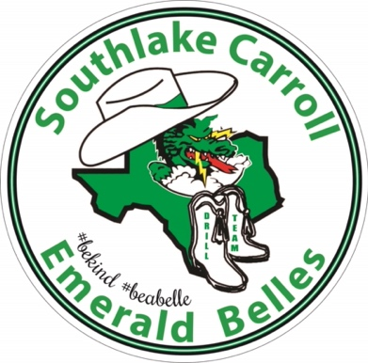

**Booster Club Board Meeting**

September 3, 2024

7 pm

**Minutes:**

* Agenda emailed prior.
* MP – Additional dates to calendar. Mavs date 3/7 (TBD). DCC rehearsal there 12/19. DCC game 12/22.
* KD discussed cruise payment procedures. Greenlight added payment dates of 9/2 and 10/2. The 10/2 date is strict – as they will drop you if not current. Make all payments on Greenlight website. If you want to use Belle bucks, turn in MVF - ahead of cruise payment due date. Calendar dates added for MVF turn-in ahead of time for this purpose. (If you are not using Belle bucks, you do not need to do MVF for cruise payments.)
* There will be a DCC try-out. 11/4.
* 2/22 competition – Crowd Pleasers at Independence, Frisco. 2/28-3/2 – Showmakers at Texas State (TBD).
* 9/9 – First Dragon card $ turn-in date. KD would prefer 1 check or Zelle. Must submit MVF. 10/21 - 2nd turn-in date.
* 9/23 – fall fee payment #1 due.
* FYI/reminder - Belle bucks can be used for banquet, tea, competition fees, bowling, fall/spring fees, etc. Basically, anytime $ is collected.

Committee Updates:

* Brooke/Cindy – Sponsor update. $124,419 in-kind & cash (93k of it cash). Big thanks!
* CC Maggie on committee emails esp for in-kind donation tracking.
* Belle Dads update – Alan Schnake. Becoming Belle Dads from Water Dads. Encouraging community, tailgate, etc. among the dads. There is a WhatsApp group – email/text him to be added. Every Wed night at Cork & Pig at 6:30. Also doing tailgates. Michael Hall made a belle dad website - Ebdads.com & it has a calendar.
* Belle cards – Beatriz. All sold. 2035. Thanks to this committee for their great card! Mr. Wilson request for Belles for helping with traffic for curriculum night on 9/11.
* Belle buttons raised $3000. Thanks to Gina Parks! Also, shadowing need to learn from her this year (next chance at Jr Belle clinic).
* HaeJung Belle care - FYI. Reach out to this committee for any needs.
* Chick-fil-a update. Homecoming is next. Reminder to Venmo right after order.
* Jr Belle Clinic. 50 registered so far. PR underway. Looking for more committee members for photography and security/check-in on game day. Meetings will be happening soon.
* Letterman jackets/patches. Today is last day for extra patches. (Email reminder sent that night.)
* Spirit Wear – Julie. Remaining brought to mtg to hand out. FYI – Showed flare sweatpants & hoody – grey, black, off white to be offered in a 2nd launch. 1 size fits all. Can be blank. Volunteer shirts (demo) should be ready this week. Distributed thru line officers.
* Belle tea – Belle & Co theme (like Tiffany’s). 12/8 3-5. Set up the day before.
* Banquet. Wed 4/30 (TBD). Bowden.
* Raffle for Skybox for Belle families. $25/ticket – get it for 15 friends and family. QR code/link for raffle. (Info came out in Belle mail.)
* Pink out. 10/10. Doing some extra things at tailgate for survivors. Goal is support and building awareness. (Possibly merch?)
* Bowling. Alley Cats in Hurst. Dads dress up. Costume contest. 10/18. $ due 10/7 (in calendar). $40/ticket.

Board introductions.

Meeting adjourned.