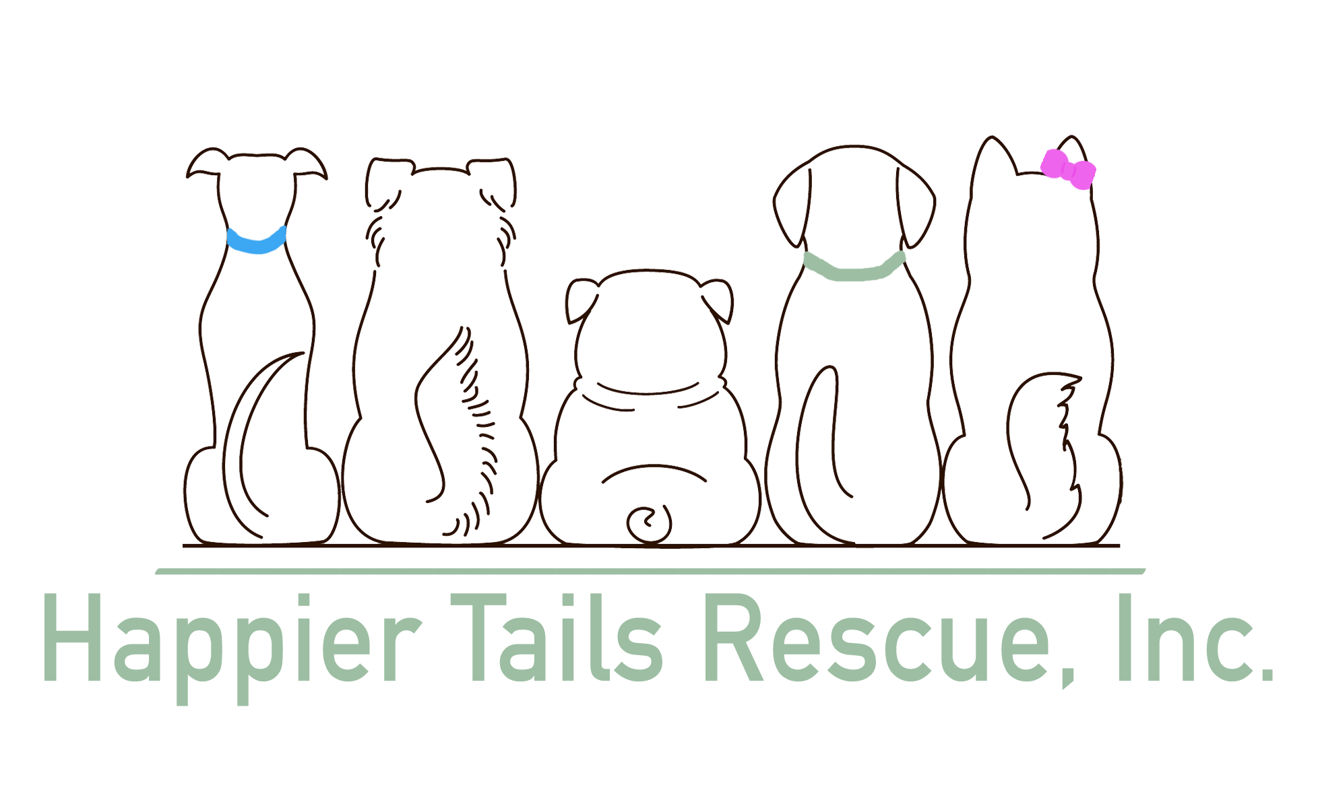HTR Volunteers Rules of Conduct
Please read the following carefully. This form MUST be signed by the volunteer

As a volunteer, I am expected to:
- Attend training classes when appropriate
- Conduct myself in a professional manner at all times when involved in HTR activities
- Perform my tasks under the guidelines established wihin the job description for the task
- Adhere to al estblished policies and procedures
- Wear a volunteer badge at all times when working at any public event

As a volunteer, I understand and agree that:
- I am providing my services in a volunteer capacity without any expressed or implied promise of salary or employment benefits
- Using or being under the influence of alcohol or drugs is prohibited while volunteering
- My volunteer involvement may be terminated if I do not meet my commitment in an appropriate manner, or otherwise fail to adhere to the guidelines outlined on this form.

As a volunteer working with the dogs, I am expected to:
- Treat the animals with respect and kindness
- Immediately report animal injuries, illness or behavior concenrs to a HTR representative
- Never handle an animal that makes me feel uncomfortable. I will not put myself, the animal or others at risk
- Follow all posted instruction in animal care areas. Do not enter any restricted areas without permission.
I understand that s a volunteer I am responsible for understanding and abiding by the information conttained within this Volunteer Rules of Conduct form and any subsequent form given to me by HTR

Signature: _________________________________________ Date: ________________________

If under 18 years old, parent or gardian signature is necessary:

__________________________________________________

