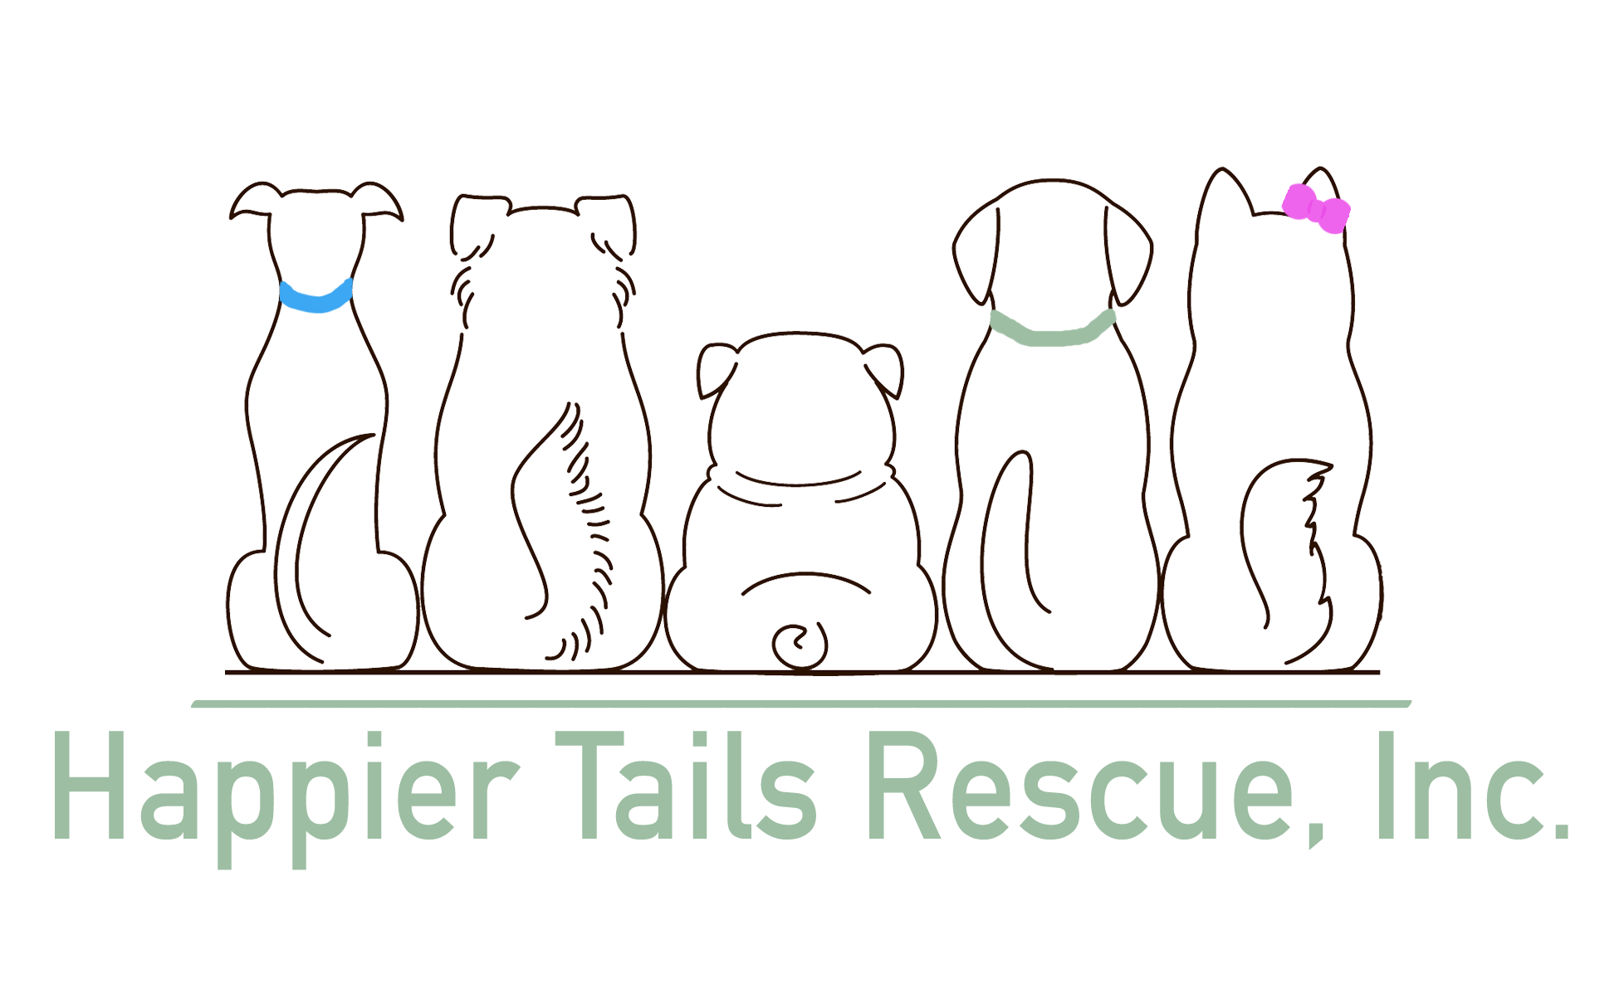 HTR Volunteer Waiver
Please read the following carefully. This waiver MUST be signed by the volunteer

Dress Code:
While volunteering, for our safety, you should wear closed-toe, non-slip shoes. Please do not wear any dangling jewelry or clothing with offensive words or pictures. Please accept that your clothing and shoes may become damaged and or dirty while volunteering.

Property:
Anything donated on behalf of Happier Tails Rescue (HTR) becomes the property of HTR. No compensation should be expeced by any volunteer. A donation receipt will be provided upon request.

Injury & Illness:
Working with animals may be dangerous and lead to serious injury, illness or even death. As a volunteer you understand and agree to personally assume any and all of the liability and risk associated with volunteering for Happier Tails Rescue. Further, each volunteer agrees to hold harmless HTR, its directors, officers, agents, and other volunteers from any responsibility or liabiity for any and all illness, injuries, or death which may occur aas direct or proximate results of their involvement with HTR.

Tetanus Shot:
A volunteer must be current on their tetanus shot. Alternatively, the volunteer acknoledges that failur to acquire & remain current on a Tetanus vaccination may put the volunteer at risk & hereby agrees to hold harmless HTR, its directors, officers, agents, & other volunteers from any responsibiliy or liability for any and all illness, injuries, or death as a result.

Signature: _________________________________________ Date: ________________________

If under 18 years old, parent or gardian signature is necessary:

__________________________________________________

