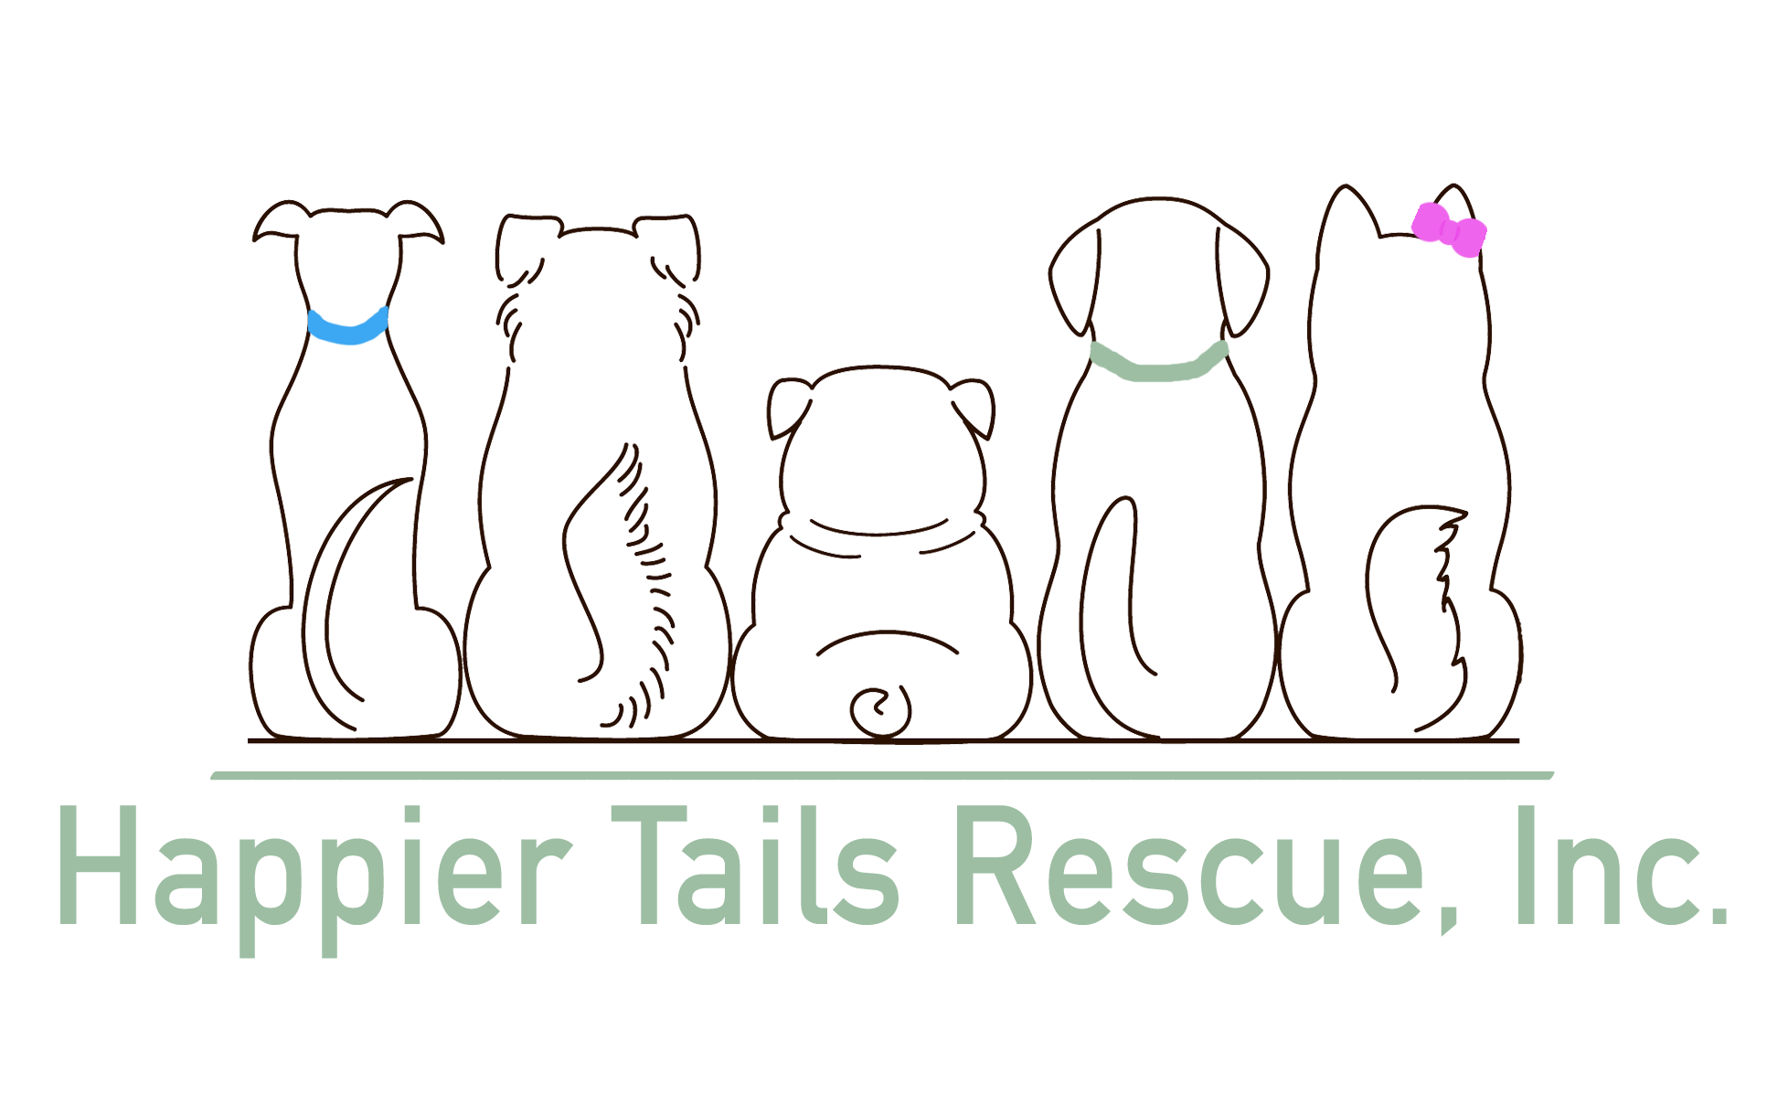 **HTR Volunteer Information**

**Please keep this page for your records and reference as needed**

Welcome and THANK YOU for volunteering with Happier Tails Rescue (HTR)! We hope you find your volunteer experience rewarding, educational, exciting and fun. You can have a HUGE impace on the lives of homeless animals. The happy wagging tails from our dogs is sure to touch your heart and bring you back for more! Because of volunteers like you, our dogs are provided with the highest level of care as they make the jourey towrd fining their forever homes. Thank you again for your time and commitment!

**Here is an abbreviated summary of the Waiver you signed:**

As a volunteer, I understand that:

* I should wear close toed / non silp shoes not wear offensive t-shirts or dangling jewelry
* My clothes & shoes may become dirty or damaged while volunteering
* All donations given to HTR are the property of HTR
* Volunteers do not receive compensation for donations but will be provided a donation receipt, if requested
* Volunteering with HTR to work with animals may lead to injury, illness or death & I assume all liability & risk associated with volunteering.
* I should be up to date on my Tetanu Shot, just to be safe.

**Here is an abbreviated summary of the Code of Conduct you signed:**

As a volunteer, I am expected to:

* Conduct myself in a professional manner at all times when involved in HTR activities
* Attend training classes when appropriate
* Perform my tasks under the guidelines established wihin the job description for the task
* Adhere to al estblished policies and procedures
* Wear a volunteer badge at all times when working at any public event

As a volunteer, I understand and agree that**:**

* I am providing my services in a volunteer capacity without any expressed or implied promise of salary or employment benefits
* Using or being under the influence of alcohol or drugs is prohibited while volunteering
* My volunteer involvement may be terminated if I do not meet my commitment in an appropriate manner, or otherwise fail to adhere to the guidelines outlined on this form.

As a volunteer working with the dogs, I am expected to:

* Treat the animals with respect and kindness
* Immediately report animal injuries, illness or behavior concenrs to a HTR representative
* Never handle an animal that makes me feel afraid or uncomforable
* Follow all posted instruction in animal care areas