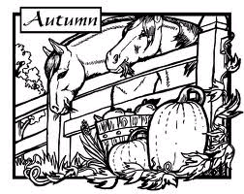
4STEPS Therapeutic Riding Program

5367A Sixty Foot Road Parsonsburg Maryland 21849 (410)835-8814

email giddyup4steps@aol.com website www.4stepstrp.org

September 2020
Dear Riders, Parents, and Caregivers and Volunteers,

It’s time to start planning for our Fall 2020 riding season. All your 2-legged and 4-legged friends at 4STEPS look forward to cooler temperatures and lots of fun on the trail. I hope you will help us make this year’s Annual Halloween Spooktacular See the attached flyer! The Early Fall Session begins the week of October 6th.

Please complete the attached registration form and send it back to the office. A 2020 Fall Program Calendar is also attached. Please keep for your scheduling.
All participants should update their application and physicians referral form.
Go to our website at www.4stepstrp.org and print one out.
PLEASE MAKE SURE IT IS ON FILE BEFORE THE BEGINNING OF THE SESSION. THANKYOU!

.
SESSION POLICIES: The Participant’s manual can be found online at www.4stepstrp.org

Lessons take place on Tuesdays, Wednesdays, Thursdays, and Saturdays mornings and afternoons. Call the office, email or message on FB to reserve your special time with our AMAZING horses and staff.

Recreational Riding (mounted) – Our goal is to place all students in a group-lesson atmosphere so that the participants can develop peer groups and friendships at the farm. Our program offers skill-based instruction in which students learn progressively, at their own pace ultimately obtaining the goal of independence in the saddle.
Fee - The cost of a regular 6-week riding session is $240. Because we know that it is a hardship for families to pay for multiple participants, we offer siblings a reduced rate. PLEASE call the Program Director (PD) for family rates and to discuss agency group rates.

Equine Assisted Learning Activities (unmounted) - Offered for those individuals who are unable or unwilling to horseback ride but still enjoy spending time with the horses and learning about horsemanship. Program includes grooming, feeding, learning natural horsemanship and spending quality time with the animals and staff. Fee - The cost is $180 for a regular 6-week session.

HORSEPLAY Adaptive Summer Camp (Offered when grant funding is available) - HORSEPLAY offers a safe and integrated horse experience for children with disabilities and their families. Horseplay camp varies depending on availability of funding. The immersion in nature with horses is a unique experience and allows for families to be together in an tribe of other families and caregivers. Please contact the PD for more information.

MAKE ARRANGEMENT FOR PAYMENT IN ADVANCE. All services require registration and payment up front to reserve spots. Riders unable to pay the session fee should contact our PD for assistance in obtaining tuition assistance. If you are working with an agency to provide for funds, we will give you an invoice upon request.

Inclement Weather and Adverse Conditions - If the weather is adverse for conducting lessons on your scheduled lesson date or time the instructor may cancel the lesson. However, the weather on the Eastern Shore is often different in one place than in another. Lessons may be cancelled if the conditions at the farm are adverse, therefore if the weather where you are is inclement do not assume the lesson will be cancelled.

Make-up Lessons. Makeup classes must be scheduled during the current session or arranged otherwise with the instructor. Makeup classes will be offered subject to availability of the instructor, horses and staff.

Participant’s Name___________________________________ Phone_______________________________
Email address__________________________________________ Early Fall ____ Late Fall _____
Please designate preferred day and time. We will try to accommodate your preference. If you have a problem scheduling during these times call to discuss other possibilities.
PAYMENT INCLUDED WITH REGISTRATION FORM: $___________

Military Monday (for Veterans only) _____
Tuesday AM ____ Tuesday afternoon (after school/work) ____
Wednesday AM ____ Wednesday afternoon (after school/work) ____
Thursday AM ____ Thursday afternoon (after school/work) ____
Saturday AM ____ Saturday afternoon ____

SCHOLARSHIP REQUESTED Yes___ No____
If you would like to be considered for a tuition assistance, please provide the information below.

Describe your need for assistance:

Describe how the participant will benefit from equine assisted activities:

4STEPS THERAPEUTIC RIDING PROGRAM
REGISTRATION FORM 2020

Mail to

4STEPS Therapeutic Riding Program

5367 Sixty Foot Rd

Parsonsburg, MD 21849

4STEPS Program and Administrative Calendar

Fall 2020

Back to school Recess and Fall Planning Aug 31 – Oct 5 No Lessons
New Participant and New Volunteer Orientation Sat. Sept 26th 11AM – 1PM
Volunteer Training October 4th Sunday 1:00 – 4:00pm
Planned activities include safety procedures, role playing, and ride rewards
Early Fall | Oct 6 –Nov 16
Halloween Fundraiser Walk-Ride-a-thon October 27-31
Late Fall | Nov 17 – Dec 31 | No classes Thanksgiving and Christmas

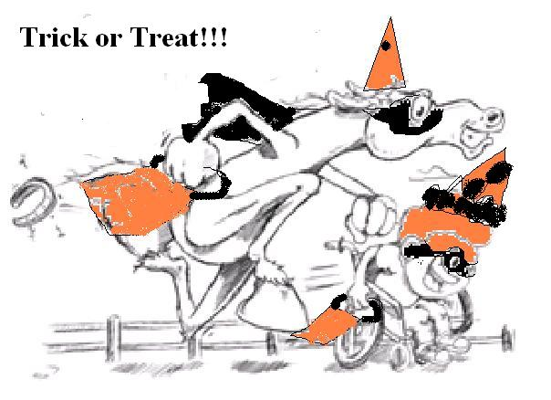
SPONSORS WANTED!!!
4STEPS
Therapeutic Riding Program
Halloween
Trick and Treat Walk/Ride-A-Thon October 26th – 31st

Join in the fun to help put a ‘giddy-up’ in a kid's step!

Costumed horseback riders and volunteers will Trick-and-Treat on a specially-adapted haunted holiday trail to raise scholarship funds for special riders at 4STEPS Therapeutic Horseback Riding and Equine Partnership Programs.
The objectives of this event are to
- to enrich the lives of individuals with disabilities by participation in a fun fall event
- to raise money for scholarships and operating expenses
- to raise awareness of the benefits of therapeutic riding and equine partnership programs in our community.

This event is open to program participants, volunteers and their families and friends. In order to achieve our objectives, we are reaching out to our community for help with this event. You can help in the following ways:

- Monetary donations from organizations and businesses
- $25 and up Gift cards for raffle fundraiser
- Volunteer as a zombies during the event!!!

Any donation amount is appreciated and will be acknowledged in our Annual ‘4STEPS Express Newsletter’ and a vinyl banner will be displayed showing your business’ support!

To learn more about 4STEPS, please visit www.4stepstrp.org or call 410-835-8814. You can make checks payable to 4STEPS Therapeutic Riding Program.
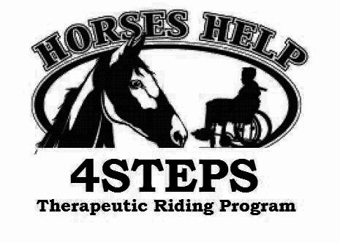
4STEPS Therapeutic Riding Program
5367A Sixty Foot Road Parsonsburg, Maryland 21849 410-835-8814
www.4stepstrp.org giddyup4steps@aol.com

4STEPS Therapeutic Riding Program is a 501c3 nonprofit organization (#71-0959202)

