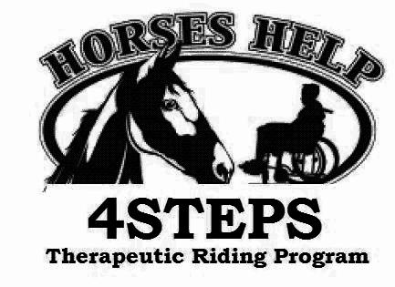
4STEPS Therapeutic Riding Program

5367 Sixty Foot Road Parsonsburg Maryland 21849

(410)835-8814 giddyup4steps@aol.com www.4stepstrp.org

January 15, 2025
Dear Riders, Parents, Caregivers, Resource Coordinators and Volunteers,

It’s time to start planning for our 2025 riding season. We look forward to serving with you and fulfilling the needs for recreational riding and equine-assisted activities in the coming year. The Early Spring Session begins the week of March 4th.

Help us plan our 2025 sessions by completing the attached registration form and sending it back to us. A Program Calendar is attached, please keep for scheduling.

All participants should update their application and physicians referral form. Go to our website at www.4stepstrp.org and print one out. PLEASE MAKE SURE IT IS UPDATED AND ON FILE BEFORE THE BEGINNING OF THE SESSION. THANKYOU!

SESSION POLICIES: The Participant’s manual can be found online at www.4stepstrp.org
Lessons take place on Tuesdays, Wednesdays, Fridays, and Saturdays mornings and afternoons. Contact us to reserve your special time with our AMAZING horses and staff.

Adaptive Riding (mounted) – Our program offers skill-based instruction in which students learn progressively at their own pace ultimately obtaining independence in the saddle.
Fee-The cost of a 6-week riding session is $240; 4 week abbreviated summer session $160.
We know that it is a hardship for families to pay for siblings we offer a reduced rate. Call for family rates and to discuss agency group rates.

Equine Assisted Learning Experiences (unmounted) – This program is unmounted where the participant is guided through activities with horses. There are different kinds of equine programs and they have different goals for the people involved. Fee - The cost is $180 for a regular 6-week session; $120 for 4 week abbreviated summer session.
HORSEPLAY Adaptive Summer Camp (offered when grant funding is available) - A safe and integrated horse experience for 4STEPS families. HORSEPLAY varies depending on availability of funding. The immersion in nature with horses is a unique experience and allows for families to be together in a tribe of other families and caregivers. The cost for summer camp will be determined based on grant funding.

MAKE ARRANGEMENT FOR PAYMENT IN ADVANCE. All services require registration and payment up front to reserve spots. Riders unable to pay the session fee should apply for scholarship (see registration form on next page). If you are working with an agency for funding we will provide you an invoice upon request.

Inclement Weather and Adverse Conditions - If the weather is adverse for conducting lessons on your scheduled lesson time the instructor may cancel the lesson. However, the weather on the Eastern Shore is often different one place than another. Lessons may be cancelled if the conditions at the farm are adverse, therefore call to make sure.

Make-up Lessons. Makeup classes must be scheduled during the current session or arranged otherwise with the instructor. Makeup classes will be offered subject to availability of the instructor, horses and staff. Please call the office to make arrangements.

4STEPS THERAPEUTIC RIDING PROGRAM
REGISTRATION FORM 2025

Participant’s Name_________________________________________________________

Phone_______________________ email _______________________________________

Please designate preferred day and time. We will try to accommodate your preference. If you have a problem scheduling during these times call to discuss other possibilities.

Early Spring ____ Late Spring ____

PAYMENT INCLUDED WITH REGISTRATION FORM: $___________

Tuesday AM ____ Tuesday afternoon (after school/work) ____
Wednesday AM ____ Wednesday afternoon (after school/work) ____
Friday AM ____ Friday afternoon (after school/work) ____
Saturday AM ____ Saturday afternoon_____

SCHOLARSHIP REQUESTED Yes___ No____

To be considered for tuition assistance please provide the information below.

Describe your need for assistance

Describe how the participant will benefit from equine assisted activities

Mail to:

4STEPS Therapeutic Riding Program, 5367 Sixty Foot Rd, Parsonsburg, MD 21849

4STEPS Program Calendar 2025
Please keep for planning

Winter Break and Program Planning Jan 1 – Mar 4 No Lessons
New Participant and New Volunteer Orientation Saturday February 22 11AM–1PM
Volunteer Training Sunday March 23 1PM– 4PM
Planned activities include safety procedures, role playing, and ride rewards

Early Spring | Mar 4 – Apr 12 | 6 weekly lessons
Late Spring | April 15 – May 24 | 6 weekly lessons
Saturday May 3rd Kentucky Derby Day Open House
Celebrating our Donors
Saturday May 10th Mother’s Day Open House
Tribute to our Moms, our Friends, and our Families
May 25 – June 2 Memorial Day Recess No Classes
Early Summer | June 3 –June 28 | 4 weekly lessons
July 1- Jul 7 Summer Recess No lessons
Late Summer | Jul 8 - Aug 2 | 4 weekly lessons
HORSEPLAY Summer Camp 1 (August 12 – 14)
HORSEPLAY Summer Camp 2 (August 19 - 21)
Volunteer Appreciation Thanks to our Volunteers Sunday Aug 3
Please help make this a special day for our hard working and dedicated volunteers!

Back to school Recess and Fall Planning (Aug 24–Sept 29) No Lessons
New Participant and New Volunteer Orientation
(Saturday Sept 27thnd 11AM – 1PM)

Volunteer Training Sunday, September 28th (1:00 – 4:00pm)
Planned activities include safety procedures, role playing, and ride rewards

Early Fall | Oct 7–Nov 15 | 6 weekly lessons
Halloween Walk-Ride-a-thon Fundraiser (October 25-31)
Late Fall  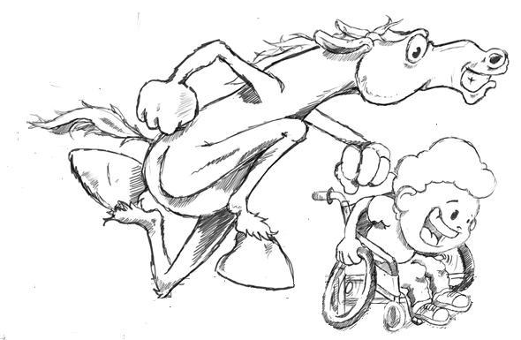 | Nov 18 – Dec 31 | 6 weekly lessons  No Lessons on Thanksgiving and Christmas Days

