- Billing Information Tab
  - Leave Company Name Blank
  - Enter your First Name, Last Name, Email Address, and Telephone # (xxx-xxx-xxxx)
  - Enter Address linked to your checking account
  - Click Continue
  - 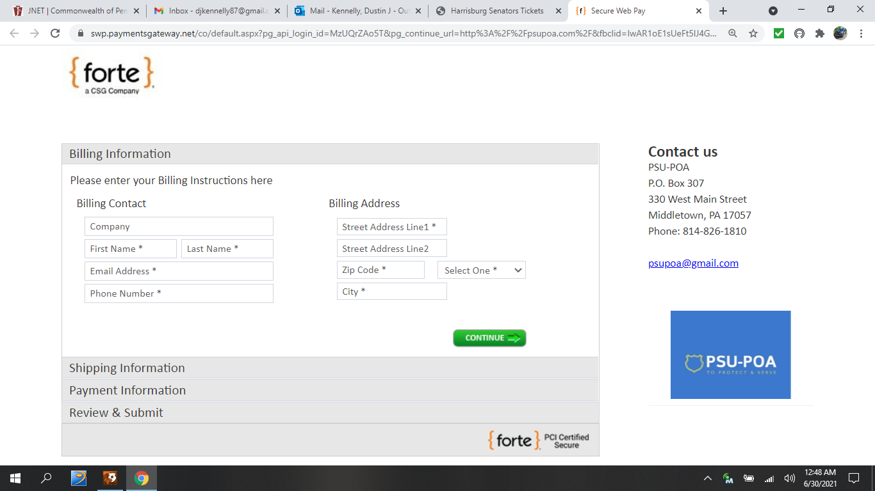
4
3
2
1
4
3
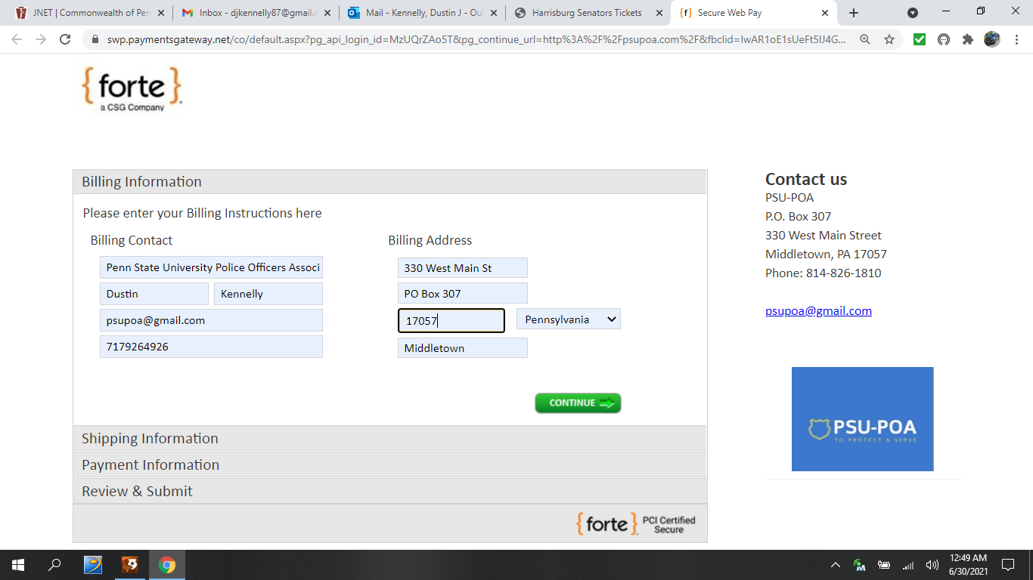
- Shipping Information Tab
  - Check the Same as Billing check box
  - Click Continue
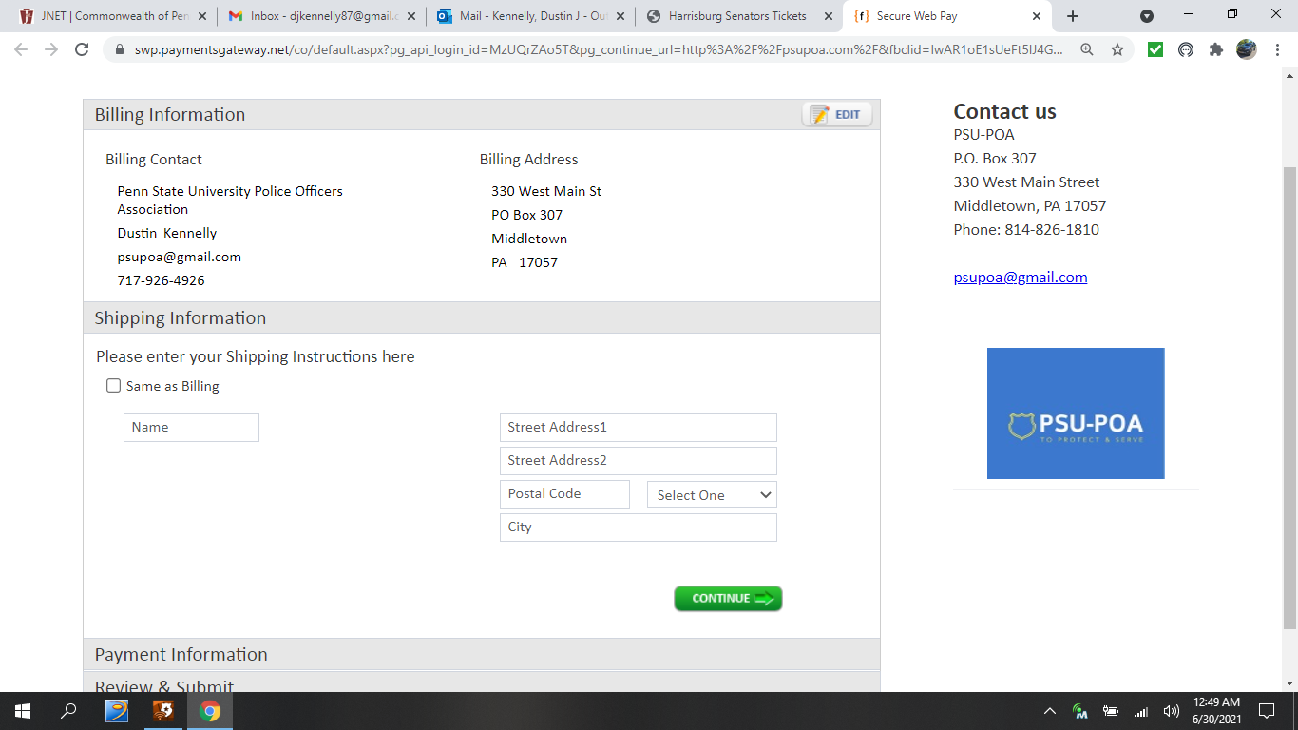
1
2
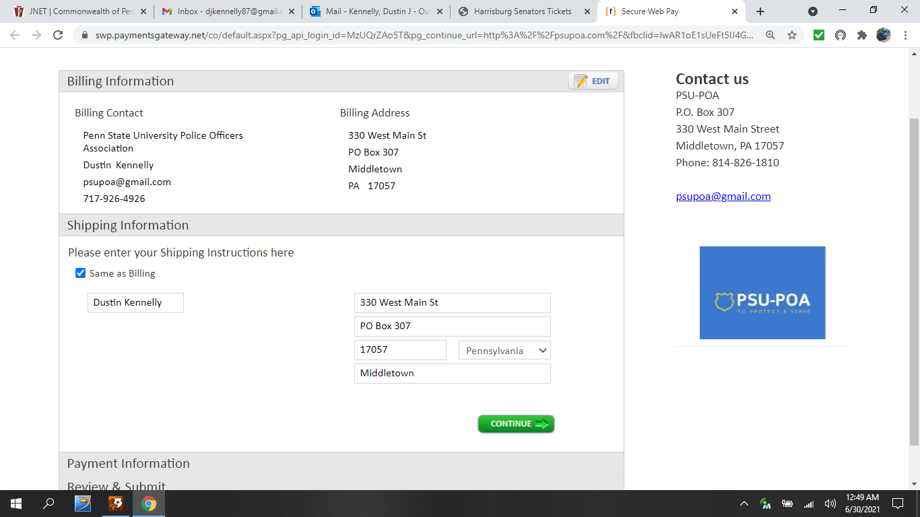

- Payment Information
  - Enter your Bank Routing #
  - Enter your Checking Account #
  - You can leave the Check # Blank
  - Re-Enter your Checking Account Number
  - Select Account Type (Savings or Checking)
  - Select Multiple Payments
  - Enter your Payment Start date (this will be the processing date every month)
  - In the Frequency tab select Monthly
  - Check the Continuous check box
  - Enter $85.00 in the Payment Amount
  - Click Continue
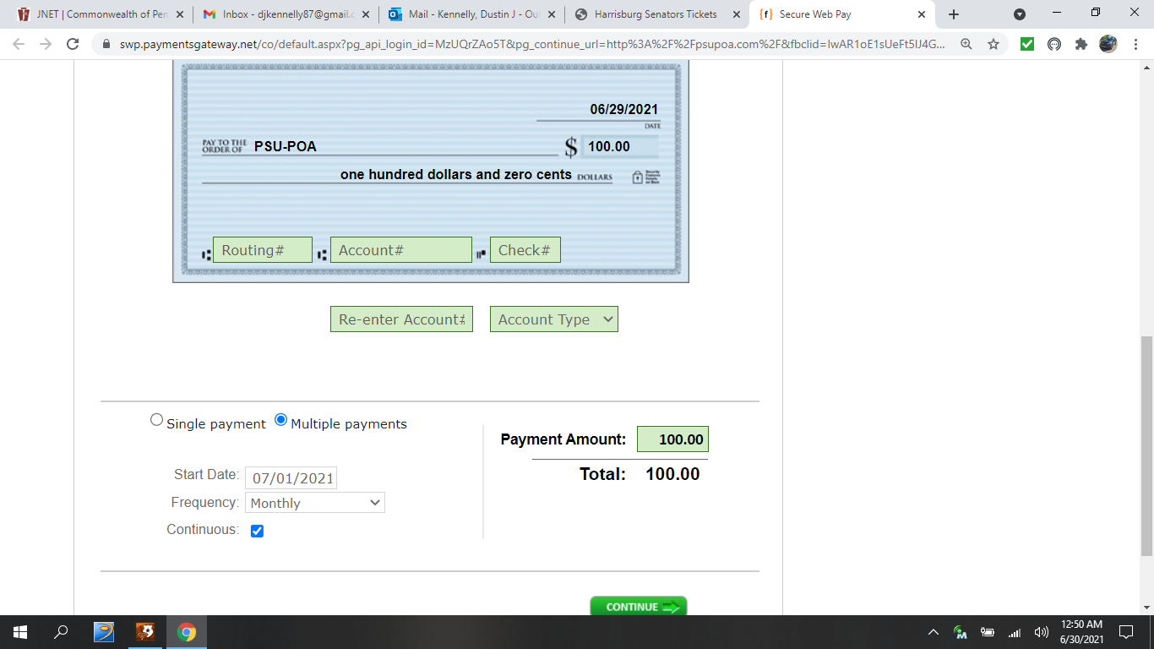
1
11
10
2
3
4
5
6
7
8
9
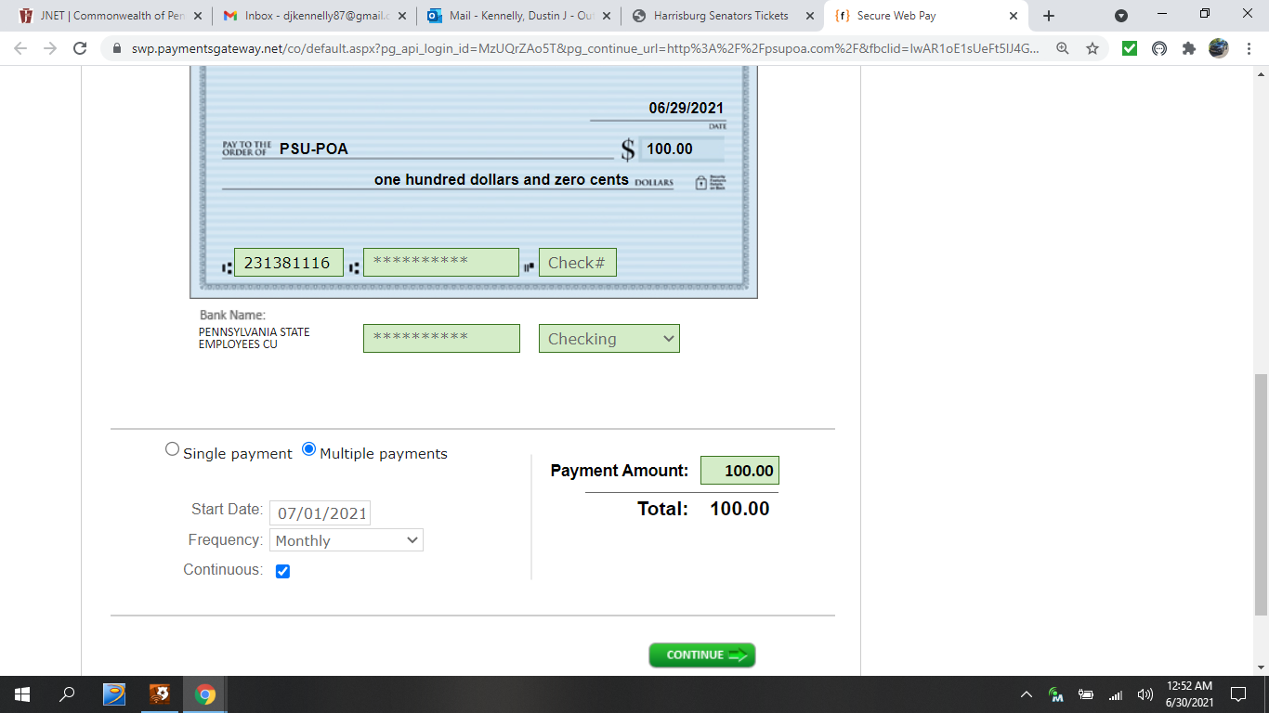
- Review Payment Information
  - Review all the information (if a correction is necessary select Edit)
  - Check the check box for agreeing to the Terms and Conditions
  - Check the check box for saying you are not a robot
  - Select Submit Payment
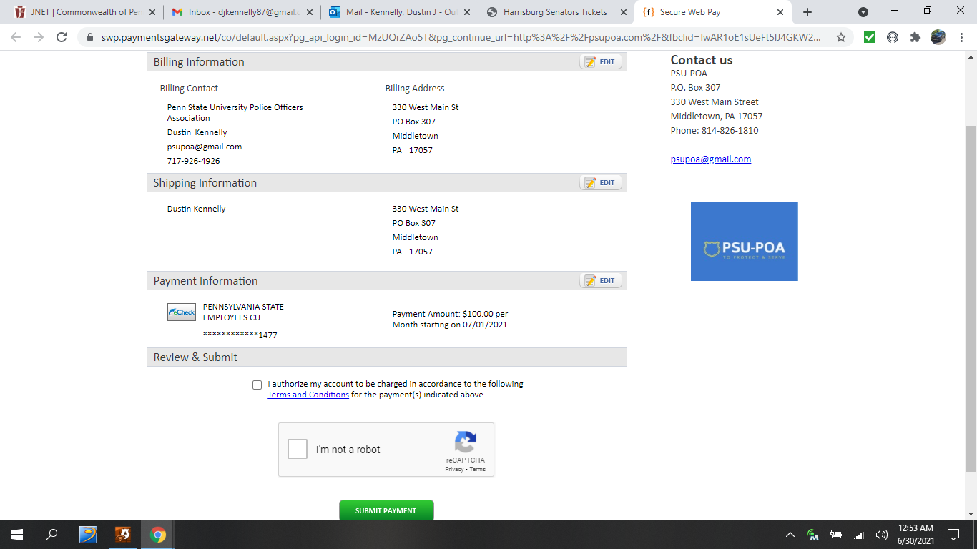
3
2
4
1

