CANCER INTELLIGENCE SYSTEM  Clarity in Cancer. Confidence in Decisions.  A free, global, multilingual cancer education and decision-support system that helps people understand medical information, prepare for doctor conversations, and avoid misinformation. |  |  |  | 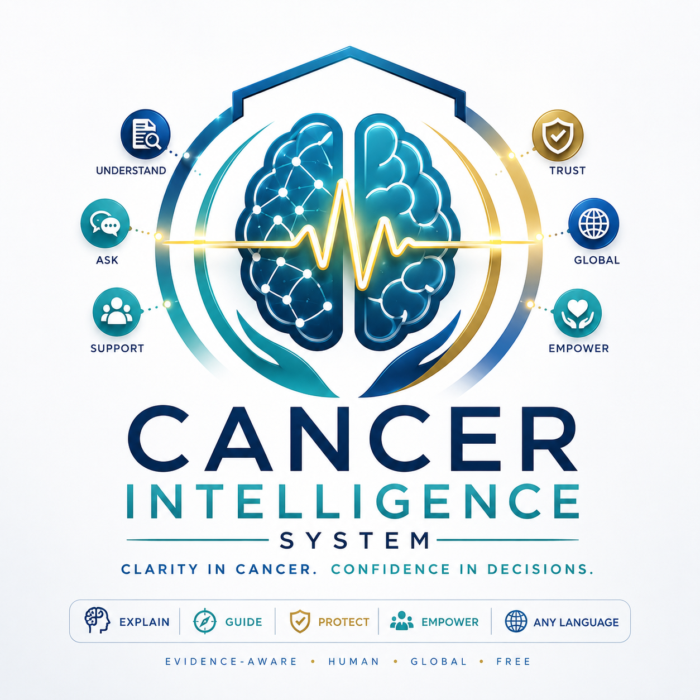
EXPLAIN | GUIDE | PROTECT |  | SUPPORT | GLOBAL
WHAT IT IS  Cancer Intelligence System is a purpose-built AI clarity layer for patients, families, and caregivers facing cancer questions. It translates complexity into understandable, actionable language while staying within safe medical boundaries.  WHAT IT DOES  • Translates medical documents: Pathology, imaging, labs, genomics and treatment notes into plain English, Spanish, French, and other languages.  • Explains cancer clearly: Diagnosis, stage, grade, biomarkers, treatment options, side effects, recurrence, survivorship and next steps.  • Prepares doctor conversations: Turns confusion into focused questions, visit agendas, scripts, and decision discussion points.  • Detects misinformation: Checks miracle cures, social media claims, unsafe supplement advice, and anti-treatment narratives. |  |  | WHO IT IS FOR  WHY IT IS DIFFERENT  | Cancer-only focus: Designed to stay on-topic and never drift into unrelated chatbot behavior.  | Safety-first architecture: Built with guardrails for urgent symptoms, medication boundaries, and treatment-risk language.  | Human + evidence-aware: Warm enough for fear, structured enough for decisions, careful enough for medicine.  | No ads in answers: Sponsor-friendly model without polluting user responses or undermining trust.
  Not a doctor. Not a replacement for care. A trusted explanation and preparation system that helps users ask better questions and avoid dangerous misinformation.
  PATIENTS  Understand reports, treatment terms, side effects and follow-up. | FAMILIES  Get clear language for hard conversations and support.
  CAREGIVERS  Prepare appointments, track concerns and know what to ask. | GLOBAL USERS  Access plain-language guidance in the language they are comfortable using.
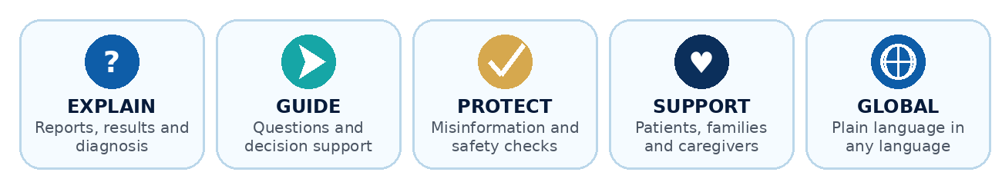
MISSION Reduce fear by making cancer information understandable. | PROMISE Guided support - never diagnosis, prescribing or treatment replacement. | ACCESS Built for patients and families worldwide, in any language.
Designed to support informed conversations with qualified medical professionals. Medical decisions should always be made with the appropriate care team.

