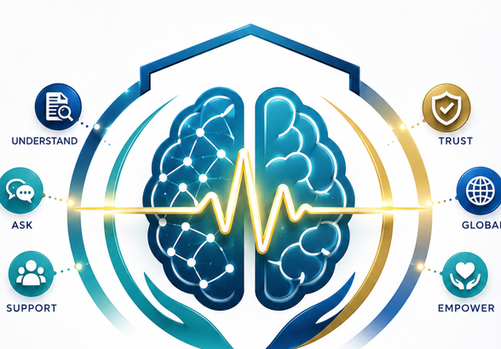 | CANCER INTELLIGENCE SYSTEM  User Guide: Understand cancer. Ask better questions. Avoid misinformation. |  |  | 01
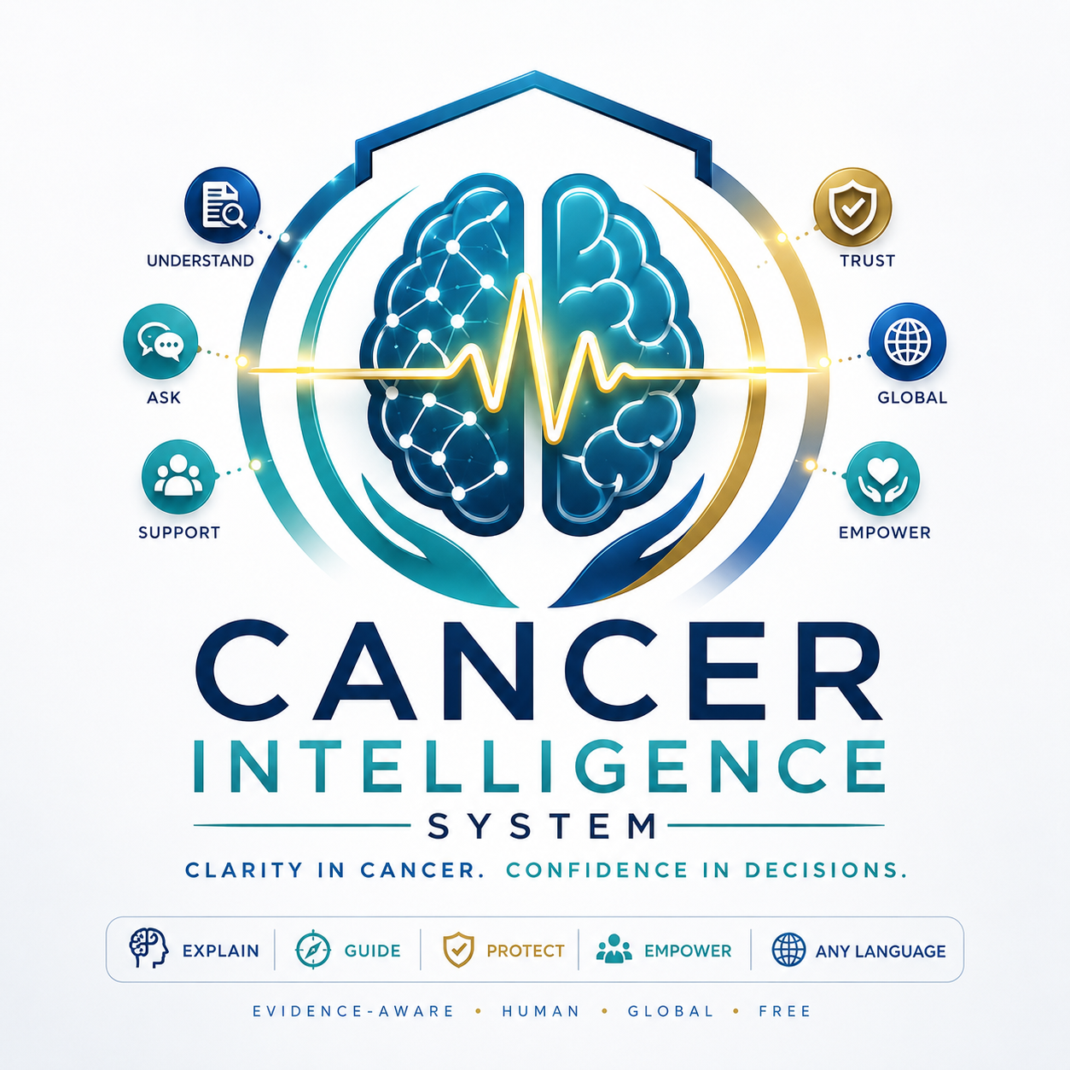 |  | Clarity in Cancer. Confidence in Decisions.  A warm, global, multilingual cancer education and decision-support system for patients, families and caregivers.  Cancer information can be technical, frightening and hard to translate into real-life decisions. This system helps users understand medical language, organize questions, check claims and prepare for safer conversations with their oncology team.  What users can bring to the system  • Reports: pathology, imaging, labs, genomics and doctor notes  • Questions: diagnosis, treatment, side effects, risk, recurrence or survivorship  • Claims: social media posts, supplement claims, diet cures and online misinformation
  The promise: clear explanations, safer questions, multilingual support and no miracle-cure nonsense.
EXPLAIN  Translate complex cancer language. | GUIDE  Prepare questions and next steps. |  | PROTECT  Check misinformation and unsafe claims. | GLOBAL  Support users in any language.
Educational support only. The system does not diagnose, prescribe or replace licensed medical care.

 | WHAT THE SYSTEM CAN DO FOR YOU  A practical map of capabilities users can start using immediately. | 02
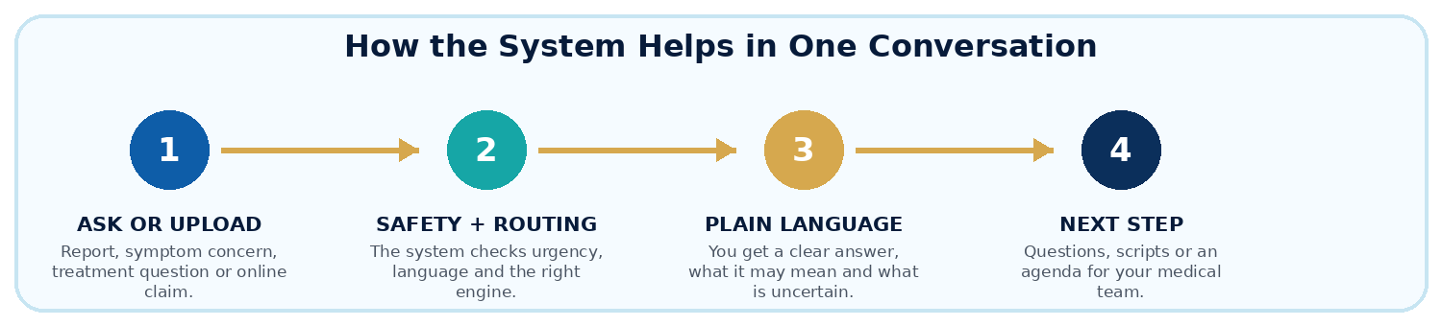
Core Uses  • Translate documents: turn reports and results into plain language.  • Explain diagnosis: understand stage, grade, biomarkers and next questions.  • Prepare visits: create agendas, scripts and portal messages.  • Compare options: organize trade-offs without choosing treatment.  • Check claims: reality-check online posts and miracle-cure claims.  • Support caregivers: explain what to say, ask and watch for. | 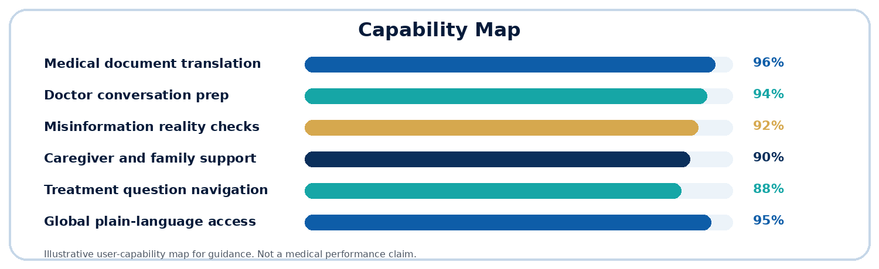
Best use: bring the system your actual question, report text, treatment concern or claim you want checked.

 | HOW TO USE IT: DOCUMENTS, TRANSLATION AND QUESTIONS  Turn reports into plain language and doctor-ready next steps. | 03
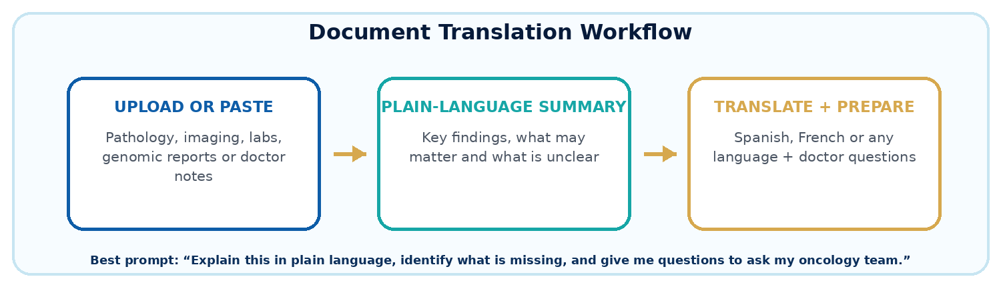
Supported Document Types  • Pathology: diagnosis, grade, margins, lymph nodes, receptors and biomarkers.  • Imaging: CT, MRI, PET, mammogram, ultrasound, X-ray and comparison language.  • Labs: blood counts, liver/kidney markers, electrolytes and tumor marker trends.  • Genomics: BRCA, HER2, PD-L1, MSI/MMR, KRAS, EGFR and other concepts.  • Doctor notes: visit summaries, treatment plans and unclear next steps. | Copy/Paste Prompts
  Plain English: Explain this report in plain language and list the top doctor questions.
  Translation: Explain this diagnosis in Spanish for my family, accurately and simply.
  Missing Info: What information is missing from this report?
  Visit Prep: Create an appointment agenda from this report.
Tip: remove names, addresses, account numbers and full birthdates before uploading when possible.

 | LIFESTYLE, MENUS AND MISINFORMATION SUPPORT  Practical support without pretending food or supplements cure cancer. | 04
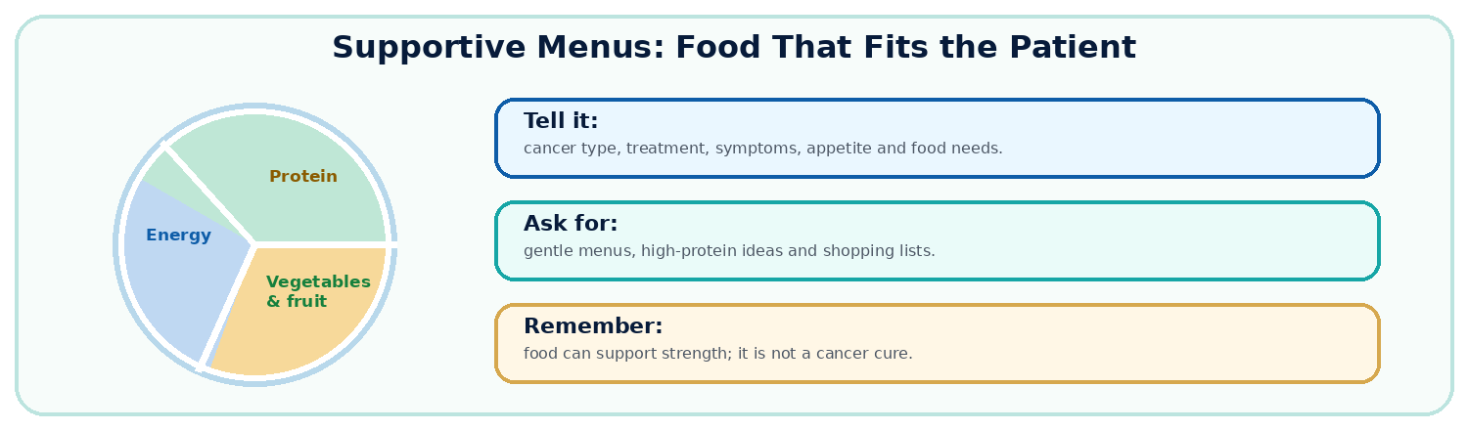
Healthy Menu Support  The system can create supportive meal ideas for cancer patients and caregivers when appetite, nausea, mouth sores, fatigue, diabetes, kidney issues, weight loss, culture, language or budget matter.  • Nausea-friendly menus: small meals, bland options and hydration ideas.  • High-protein support: gentle ideas to support strength when eating is difficult.  • Caregiver meal planning: simple menus, shopping lists and prep ideas.  • Cultural adaptation: food suggestions built around normal foods and access. | Misinformation Checks  Users can paste a social media post or claim and ask whether it is true, misleading, unsupported or potentially unsafe. The system explains the claim, evidence confidence, why it matters and what to ask the doctor.
  Menu prompt: Create a simple 3-day nausea-friendly menu and list what the oncology dietitian should confirm.
  Claim prompt: A post says sugar feeds cancer and must be eliminated. Is this true, misleading or unsafe?
Food, movement and lifestyle can support strength and quality of life. They are not guaranteed cancer cures.

 | TRUST, SAFETY AND QUICK START  Use the system with confidence and clear boundaries. | 05
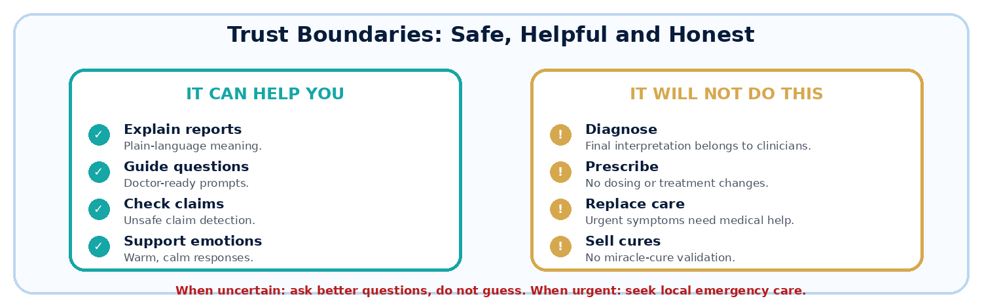
Start Here  • New diagnosis: “Explain what this diagnosis means in plain language.”  • Report upload: “Summarize this report and list missing questions.”  • Treatment concern: “Explain this treatment and what I should ask.” | Use It When  • Overwhelmed: ask for a simple explanation and one next step.  • Need translation: ask for Spanish, French or another language.  • Saw a claim: ask for a reality check and safety concerns. | Urgent Safety  For chest pain, severe shortness of breath, stroke-like symptoms, uncontrolled bleeding, severe allergic reaction, confusion, fainting, fever during chemotherapy, suicidal thoughts or other emergency symptoms: contact local emergency services or go to the nearest emergency department.
Cancer Intelligence System helps users become better prepared, better informed and less vulnerable to misinformation - while keeping final medical decisions with qualified healthcare professionals.
Free • Global • Multilingual • Evidence-aware • Human-centered • Cancer-focused

