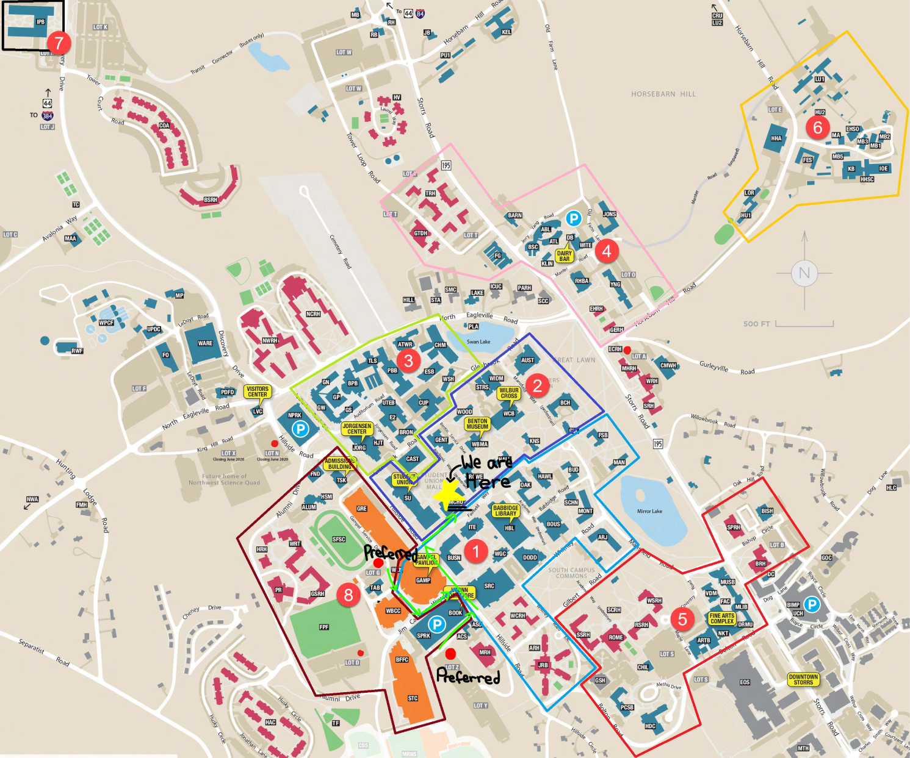

Free Parking Lots:

Lot Z(Preferred)

Lot G(Preferred)

Lot D

Lot A

Lot N

***NOTE: SOUTH GARAGE IS PAID PARKING!***

Directions:

From Lot Z:

* Turn right along the South Garage until you reach Hillside Road.
* Turn Left on Hillside Road, and walk until you reach the North Entrance of Gampel Pavilion
* Cross the street and walk down Fairfield Way. The Student union will be on your left.
* McHugh Hall is the second building to the left.

From Lot G:

* Turn Right along Gampel Service Drive.
* Turn left along Jim Calhoun Way until Hillside Road.
* Turn right on Hillside Road, and walk until you reach the North Entrance of Gampel Pavilion
* Cross the street and walk down Fairfield Way. The Student union will be on your left.
* McHugh Hall is the second building to the left.