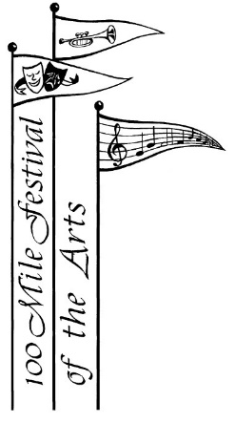

100 Mile Festival of the Arts

Calendar of Events for 2019 - 2020

Committee Meeting September 13th, 2019

Committee Meeting October 11th, 2019

Committee Meeting November 8th, 2019

Christmas Luncheon December 6, 2019 Dinner

Committee Meeting January 10th, 2020

Student Recital January 19, 2020

Festival Registration Day February 8th, 2020 from 10 am – 3 pm

Committee Meeting February 14th, 2020

Workshop & Recital **TBA**

Committee Meeting March 13th, 2020

Committee Meeting April 3rd, 2020

Festival Dates: April 14th – 24th, 2020

***Showcase Concert*** ** ***Saturday, April 25th, 2020***

PABC June 2-6, 2020 in Cranbrook

Committee Meeting May 8th, 2020

Committee Meeting June 12th, 2020

AGM June 15th, 2020

Committee Meetings are usually the 2nd Friday of the month at 10:00 a.m.

Location: 100 Mile Regional Library meeting room

**\*\* Date Revised as of February 14, 2020**