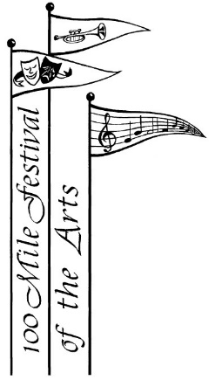
100 Mile Festival of the Arts
Calendar of Events for 2019 - 2020

Committee Meeting September 13th, 2019
Committee Meeting October 11th, 2019
Committee Meeting November 8th, 2019
Christmas Luncheon TBA
Committee Meeting January 10th, 2020
Student Recital January 19th, 2020
Festival Registration Day February 8th, 2020 from 10 am – 3 pm
Committee Meeting February 14th, 2020
Workshop & Recital TBA
Committee Meeting March 13th, 2020
Committee Meeting April 3rd, 2020
Festival Dates April 14th – 24th, 2020
Showcase Concert Sunday, April 26th, 2020
PABC June 2-6th, 2020 in Cranbrook
Committee Meeting May 8th, 2020
Committee Meeting June 12th, 2020
AGM June 15th, 2020

Committee Meetings are usually the 2nd Friday of the month at 10:00 a.m.
Location: 100 Mile Regional Library meeting room

Dates Revised October 22nd, 2020

