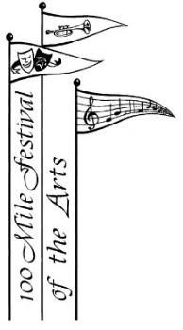
100 Mile Festival of the Arts
Calendar of Events for 2020-2021

Revised November 13, 2020

Committee Meeting |  | September 11th, 2020
Committee Meeting |  | October 16th, 2020
Committee Meeting |  | November 13th, 2020
Christmas Meeting/Dinner |  | December 11th, 2020 CANCELLED
Committee Meeting |  | January 15th, 2021
Student Recital |  | January 24th, 2021 CANCELLED
Festival Registration |  | February 6th, 2021 – 10 am – 3 pm @ 100 Mile Community Hall CANCELLED
Committee Meeting |  | February 19th, 2021 CANCELLED
Spring Workshop/Recital |  | TBA CANCELLED
Committee Meeting |  | March 12th, 2021 CANCELLED
Committee Meeting |  | April 9th, 2021CANCELLED
Festival Dates |  | April 26th – May 7th, 2021 CANCELLED
Showcase Concert |  | Saturday, May 8th, 2021 CANCELLED
Committee Meeting |  | May 14th, 2021
Provincial Dates |  | June 1st – 5th, 2021 in Cranbrook
Committee Meeting |  | June 11th, 2021
AGM |  | June 14th, 2021
Committee Meetings are usually the 2nd Friday of the month at 10:00 a.m. at Parkside Centre, downstairs meeting room. Dates may change due to long weekend holidays and/or school holidays. ALL MEETINGS CANCELLED DUE TO COVID19

