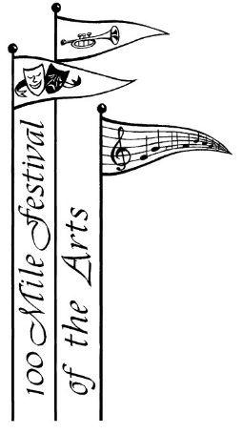

**Spring Recital**

**Chase the Winter Blues Away**



March 2nd, 2019 - 4:00 p.m.

100 Mile House United Church

Admission by donation

**Inviting students of all ages and disciplines.**

**Come and perform your Festival pieces as a trial run.**

**Audience is guaranteed to be friendly, encouraging and enthusiastic!**

No fee for performing, but please register with Ginny-Lou Alexander 250-395-3555 by February 27th so that an interesting, balanced program can be prepared.

