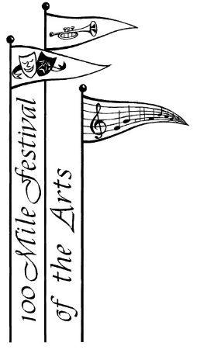

**Chase the Winter Blues Away**

**100 Mile Festival of the Arts**

**Recital**

January 22nd, 2023 – 2:00 p.m.

Martin Exeter Hall

Admission by donation



Call Ginny-Lou Alexander at 250-395-3555 to register.

No fee for performing.

**Inviting students of all ages and disciplines.**

**Come and perform in front of an**

**audience that is guaranteed to be friendly, encouraging and enthusiastic!**

