7th Annual Discover Hope Golf Scramble Registration Form
The Nightmare Golf Course
Wednesday July 28th
Registration: 8:30 am – Shotgun start: 9:00 am
18 holes with cart, lunch provided afterward.
Prizes for 1st, 2^{nd,} and last place
Raffles, Drawings and Games throughout day
“Including chance to win a Car for a Hole in one”!!!
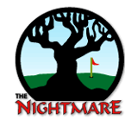
$80- per person
$320 per team
Register as a team, partial team, or as a single player

Golfer 1 ____________________________ Phone # ____________________
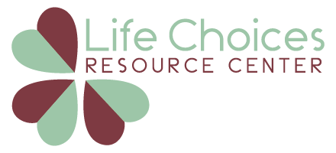
Golfer 2 ____________________________
Golfer 3 ____________________________
Golfer 4 ____________________________
Please return the completed form by June 21st
Drop it off at the Life Choices Resource Center or
Mail it to us at 575 Court St. West Branch, MI 48661
Scan and email your form to Director@LCRC-WB.org
Payment Options:
Golfer 1 is responsible for the payment of the entire group
Please send payment with this form or go online to chooselifeconnection.org

