Mark Andeson, Compliance Consultant

647.300.1711 or mark@compliance-assurance.ca


This Photo by Unknown Author is licensed under CC BY-NC-ND

FINTRAC Case Study
  - Canadian Real Estate Sector
  - Updated - March, 2026
The Financial Transaction and Reports Analysis Centre of Canada (FINTRAC) ensures the compliance
of businesses subject to the Proceeds of Crime (Money Laundering) and Terrorist Financing Act (PCMLTFA).

This case study focuses specifically on Notices of Violation and Administrative Penalties issued by FINTRAC to businesses in the real estate sector. Participants in the sector subject to FINTRAC
supervision include Real Estate Brokers, Sales Representatives and Developers; Mortgage Lenders; Financial Institutions; Mortgage Brokers and Administrators; and Title Insurers.

FINTRAC has supervised businesses subject to the PCMLTFA since 2008 and has published the names
of businesses assessed administrative penalties since 2020. Since 2020, FINTRAC has posted @ Public notice of administrative monetary penalties the names and penalties for 80 businesses, 25 being in the real estate sector. Although FINTRAC publishes the details of violation notices issued, there are no specific details available regarding total reviews and outcomes in the real estate sector. This means the delta between reviews where no further actions were taken vs. reviews resulting in notices of violation is not known.

Over the last five years, 25 real estate brokerages were issued with 111 notices of violation and
combined administrative penalties of $2.8M, or an average penalty of $113K per brokerage. No
other businesses in the sector were issued notices or fines during this period. As previously
mentioned, this does not mean FINTRAC has not been engaging with other sector players it supervises, and it should be noted that FINTRAC has up to two years to issue a notice of violation following the completion of a review.
During the same period, 12 banks and credit unions were issued with administrative penalties,
averaging $1.9M per institution; it is not clear if any of these violations were real estate specific.

Mortgage Brokers and Administrators, and Title Insurers have been under supervision for less than
2 years, and are in an adjustment period, as noted in FINTRAC’s 2024-25 Annual Report.

The chart below illustrates violations by type, volume, and as a percentage of the 25 brokerages
reviewed. For example, 22 or 88% of brokers had deficient policies and/or procedures.
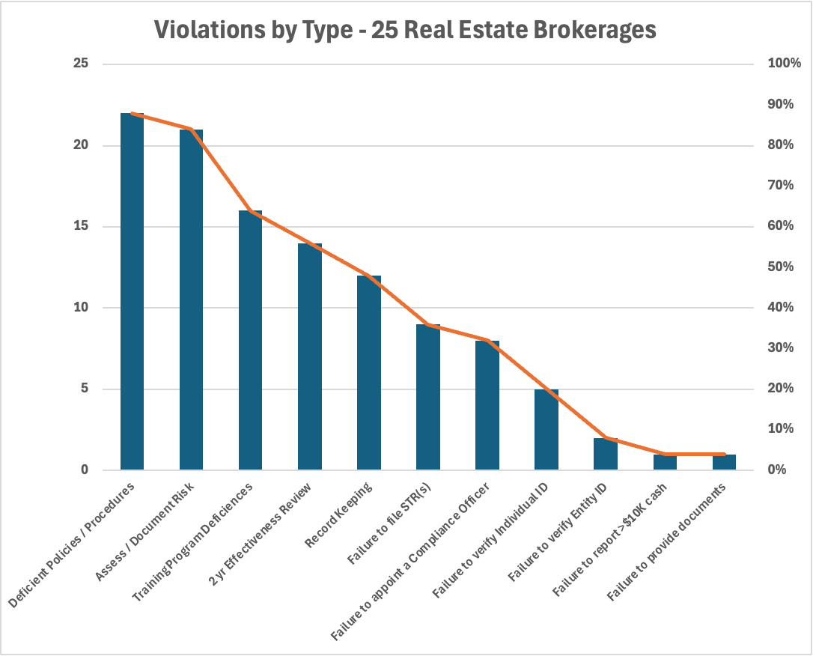
Data Source: FINTRAC Public notice of administrative monetary penalties

A FINTRAC review evaluates over 200 possible violations under the PCMLTFA, with deficiencies
grouped into approximately 20 different violation types. As noted above, the three most typical violations concern Policies and Procedures, Assessment of Risk, and AML training. Although the
specifics vary, each violation typically shares the same violation wording as described below:

- Policies and Procedures: “Failure to develop and apply written compliance policies and procedures that are kept up to date and, in the case of an entity, are approved by a
- senior officer”, meaning P&Ps are either incomplete or missing; or evidence shows P&Ps
- are not followed; or there is missing evidence that P&Ps have been reviewed and approved by a senior or compliance officer.

- Assessment of Risk: “Failure of a person or entity to assess and document the risk referred. to in subsection 9.6(2) of the Act”, meaning the broker has failed in its assessment of risk to fully take into consideration the prescribed factors of its products and delivery channels, its geographic location and its clients and business relationships.

- Training: “Failure to develop and maintain a written ongoing compliance training program”, meaning the ongoing compliance training program was not fully documented or was missing key training components; or there is no evidence confirming that training was effectively delivered to agents and employees.
How do Real Estate violations compare to those in other FINTRAC-regulated sectors?
Sector | Businesses Reviewed | Average Violations per Business | Average  Penalty ($ Can)
Real Estate | 25 | 5 | $113,235
MSBs & Currency exchanges | 23 | 4 | $152,912
Banks & Credit Unions | 12 | 3 | $1,964,579
Gaming & Casinos | 4 | 3 | $649,000
Investments & Wealth Management | 5 | 3 | $170,478
Precious Metals and Stones (& Jewelers) | 8 | 4 | $139,764
Crypto Exchanges | 3 | 4 | $67,504,730
Data Source: FINTRAC Public notice of administrative monetary penalties; analysis by compliance-assurance.ca

The table above shows the number of players in each sector, average violations and average fine within each sector. As the chart clearly shows, the number of violations has little to do with the penalty size.

How FINTRAC calculates Administrative Monetary Penalties?
Following the completion of an assessment activity, and depending on the extent of the non-compliance identified, FINTRAC may decide to:
- Take no further action
- Conduct follow-up assessment activities
- Issue an administrative monetary penalty and publish the Notice of Violation on FINTRAC’s website; and
- Disclose relevant information to law enforcement for investigation and prosecution of non-compliance offences under the Act and associated Regulations.

Administrative monetary penalties are classified three ways as the table below illustrates.
Degree of importance | Penalty range
Minor violation | $1 to $1,000 per violation
Serious violation | $1 to $100,000 per violation
Very serious violation | $1 to $100,000 per violation for an individual  $1 to $500,000 per violation for an entity

A review of the violations issued to real estate brokers indicates almost all were classified as Serious but none as Very Serious. By contrast, the largest single administrative penalty levied in FINTRAC history was to Cryptomus (a crypto exchange) for $176M for two violations: for failing to file multiple STRs and failing to comply with a Ministerial Directive on multiple occasions. Both violations were considered Very Serious.

What’s in store for 2026?

FINTRAC’s last annual report (April 2024-March 2025) revealed it had prioritized Money Service
Businesses (MSBs), Dealers in Precious Metals dealers (including Jewelers), and Credit Unions for review during the period. There was no sector specific clarity provided for 2025-2026, other than to state that FINTRAC has...

“...shifted to enhanced, risk-based supervision...allowing the Centre to screen businesses based on their risk profiles, vulnerability to money laundering...and potential non-compliance; assess businesses more quickly; and provide earlier corrective actions aligned with the severity of the deficiencies.”

As part of Bill C-12 (Strengthening Canada's Immigration System and Borders Act), the PCMLTFA will be amended to increase administrative penalties by a factor of 40, meaning the maximum administrative penalty per occurrence for a business will increase from $500K to $20M; Bill C-12 was passed by the House of Commons and has completed 3rd reading in the Senate of Canada in March 2026.
What can I do to ensure my business is FINTRAC compliant?

If you are a Senior Officer or Compliance Officer of an entity under FINTRAC supervision you should consider the following if you have compliance concerns:

- Review the findings of your last 2-year effectiveness review and the follow-up action plan; were all deficiencies remediated, do you have evidence to show remediation is complete? If not, document your plan to complete all outstanding remediation activities, including reasonable timelines for completion, and ensure management sign-off on the plan.
- If you have never conducted a 2-year review, familiarize yourself with the requirements available on the FINTRAC website, appoint an internal or external auditor, (internal auditors should not who works directly in the line of business) and start your review.

For more information on FINTRAC compliance, contact Mark Anderson: 647.300.1711 or mark@compliance-assurance.ca

