

Online Registration opens January 10

<http://goo.gl/forms/riCGfCNA2e>

Deadline for online registration of student projects

February 6

Please complete our campus [participation survey](https://docs.google.com/forms/d/e/1FAIpQLSc2B_v9erbztjV91r5Ql_4Ii5ZJvt1xa2BjQQ6iTbfxnJVEkw/viewform?usp=sf_link) and register

your campus for a Starter Pack of Materials.

Limited Quantity!

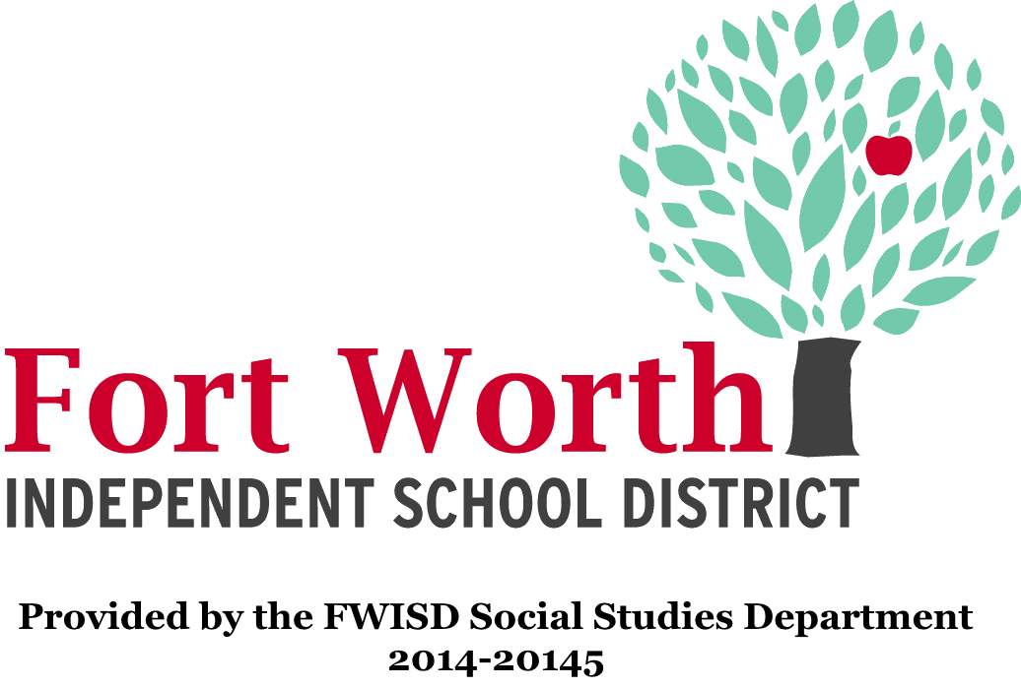

FWISD Elementary History Fair

Frequently Asked Questions

Updated 10/21/2019

**Table of Contents**

1. **Elementary History Fair Timeline of Important Dates**
2. **Elementary History Fair Frequently Asked Questions**
3. **History Day Competition Materials and Resources**
4. **Required Written Materials for All Entries** 
   1. **Annotated bibliography and process paper**
5. **Elementary History Fair Campus Coordinator Checklist**
6. **2019 Theme Narrative**
7. **2019 Theme Topic List**

## Elementary History Fair Timeline of Important Dates

**When should my school host the campus History Fair?**

The FWISD Elementary History Fair competition is scheduled for February 11 . The campus **History Fair competition** should occur at least 1-2 weeks prior to the district competition. This will provide enough time to inform parents about their child advancing to the district competition and to register projects for the district competition.

For questions please contact [John Fernandez](mailto:john.fernandez@fwisd.org) (john.fernandez@fwisd.org).

**Timeline of Important Dates**

October 10

Elementary Campus Representative Meeting

February 6

Deadline for online registration of student projects

February 10

On-site registration and delivery of projects

3:00 P.M. – 5:00 P.M.

View a [map of the specific location](https://drive.google.com/open?id=1p9xXO-6e9H4o4xbneMLN7H7pY9c&usp=sharing) for project delivery and awards ceremony parking.

February 11

District Competition

8:00 A.M. – 3:00 P.M. – Project judging, campuses with winners will be notified between 3:00 p.m. and 4:00 p.m.

Riley Center

1701 West Boyce Avenue

Fort Worth, Texas 76115

Project viewing begins at 5:00 p.m.

Awards Ceremony begins at 6:15 p.m.

View a [map of the specific location](https://drive.google.com/open?id=1p9xXO-6e9H4o4xbneMLN7H7pY9c&usp=sharing) for project delivery and awards ceremony parking.

IMPORTANT NOTE: With the new venue, ***it is imperative that History Fair Projects be picked up after the awards ceremony.*** The social studies department is not responsible for any projects that are left behind. Please make arrangements with parents or a campus representative to insure projects are retrieved.

>>>>>>>>>>>>>>>>>>>>>>>>>>>>>>>>>>>>>>>>>>>>>>>>>>>>>>>>>>>>>>>>>>>>>>>>>.

## Elementary History Fair Frequently Asked Questions

**Where should my school host the campus History Fair?**

The amount of space needed will depend upon the number of student projects. The library and auditorium are great places to display projects for judging. Collaborate with your principal, librarian and/or custodial staff to assist with setting up a space to accommodate the competition.

**What kinds of awards do we give to students?**

Certificates of participation are an excellent way to validate a student’s effort and accomplishment. Medals, ribbons, or prizes are different ways to reward those students who performed well in the competition. Rewarding student achievement does not have to stop at the competition rules. Some rewards may include most colorful, best layout, creative title, unique topic, and others. Giving students awards helps increase participation each year and make certain to recognize all students for participating in the History Fair.

Other ideas:

*Mrs. Naylor, Natha Howell ES – “The local library agreed to display the projects for one week. Parents and kids who delivered the projects to the library were given a library card.”

**How do I inform parents and the community about the History Fair?**

The campus History Fair competition is an opportunity for members of the school community to celebrate the accomplishments of the students. Use the school marquee to inform the community about the History Fair. Invite school leaders and members of the PTA to take a tour of the History Fair display. The teachers and students will appreciate the publicity. Please contact the FWISD Communications Department to assist with the dissemination of information regarding your campus History Fair competition.

Classroom tours are also a great way to get other students to see the accomplishments of their peers. Make a schedule for teachers to sign up at half-hour intervals or class periods to bring their class to visit the exhibits.

**How do I get started on History Fair?**

Inform teachers about the suggested activities listed in the modules of the curriculum frameworks (grades 1-5).

|  |  |
| --- | --- |
| First Grade - Unit 3  Second Grade - Unit 3 | Third Grade - Unit 4  Fourth Grade - Unit 4  Fifth Grade - Unit 7 |

Librarians are an excellent resource for training students on the research processes and use of resources.

**What are the rules for the History Fair competition?**

Adapted from the National History Day Program (www.nhd.org)

Your project must relate to the annual theme. You can only participate in ONE entry. An individual exhibit, individual performance, or individual documentary must be the work of one student. A group exhibit, group performance, or group documentary must be the work of a minimum of 2 students and no more than 5 students. Each member must participate. Your project must be your work. Your parents and teachers can only give you advice and guidance.

**Projects for Dual Language**

It is not necessary to submit an English translation of text for projects completed in a language other than English.

**Projects for Language Center**

Please contact John Fernandez for more information regarding options for Language Center projects at the district fair.

**What is the process for judging a History Fair project?**

The FWISD Elementary History Fair competition uses the judging sheets created by the National History Day organization. It is important that students and teachers are aware of the different categories of the judging process and the requirements for History Fair.

The judging process can be a very efficient and effective process. Often times teachers assist in the judging process by identifying projects that fulfill the requirements for History Fair. In essence, teachers host their own classroom History Fair, and the projects evaluated by the teacher using the judging criteria advance to the campus History Fair. This tiered process helps the history fair coordinator with the overall management of the campus fair.

Start recruiting judges as soon as possible. There are different resources at your discretion: fellow teachers, librarians, alumni, school administrators, and other community members.

Familiarize individuals selected to be judges with the different categories on the judging sheet. The National History Day organization provides explanations of the different categories used to evaluate a project. If the history fair coordinator is not available to work with the judges, provide a sheet with instructions, an explanation of the categories, and the judging sheets.

**How do I register student projects for the district competition?**

Once you have completed your campus History Fair, each of the winning entries will need to be registered.

Each school is limited to a certain number of entries per category.

Individual Exhibit – Grades 3, 4, and 5 – one entry per level

Group Exhibit – Grades 3, 4 and 5 – one entry per level

Documentaries – 1 entry per school

Performances (Video Taped) – 1 entry per school

Registration will open January 10. Please fill out the appropriate information for each of the entries you are submitting for your school. After entering all of the necessary information, please click submit to register the student projects for the Elementary History Fair. Visit the link on the title page of this document to begin the registration process.

**What if there is a tie for first place?**

Since only one project from each category advances to the district competition, it is recommended to facilitate an additional round of judging to break the tie.

## Required Written Materials for All Entries – 2 copies of each

1. Process paper

a. Cover page that contains:

i. Student name(s)

ii. Title of Project

iii. Grade Level

b. Written portion describes the process you used to create your project. The process paper will describe:

i. How you chose your topic

ii. How you conducted your research

iii. Why you chose the project category (exhibit, documentary, or performance)

iv. How your project relates to the contest theme

2. Annotated Bibliography

1. List of sources used to complete research
2. Contains annotation explaining how each source was used
3. For additional information about annotated bibliographies, please visit [NHD.org - Annotated Bibliographies](http://www.nhd.org/annotated-bibliography)
   1. [View](https://drive.google.com/file/d/0B859jArSzRy4ai1iZzNpTDByU1k/view?usp=sharing) a sample of an annotated bibliography with teacher notes.

Annotated Bibliography Sample:

Bates, Daisy. The Long Shadow of Little Rock. 1st ed. New York: David McKay Co. Inc., 1962.

Daisy Bates was the president of the Arkansas NAACP and the one who met and listened to the students each day. This first-hand account was very important to my paper because it made me more aware of the feelings of the people involved.

## History Day Competition Materials and Resources

Updated 10/5/2018

[History Fair Instructional Resources](https://docs.google.com/document/d/1ScZszNO3oVRMV-ueh9xU87BY4wiKW-a5ruifsiR8VKc/preview)

[Theme & Sample Topics](https://nhd.org/contest-affiliates/annual-theme/)- The information sheet provides teachers, students, and parents with an understanding the theme for this year’s History Fair competition. The list includes highlighted topics reviewed and recommended by our department. Download the NHD Theme Book and review pages 8 -13, or review the information starting on page 6 of this coordinator packet.

[Judging Sheets](https://drive.google.com/open?id=0B859jArSzRy4b29jQVRtUmFyUkk) - The judging sheets have been updated to combine all of the project category elements into one sheet.

[Sample projects](https://drive.google.com/open?id=0B859jArSzRy4dW83M2hUZjd1bG8) - Download History Fair Exhibit examples to share with your students.

[History Fair Activities](https://drive.google.com/open?id=0B859jArSzRy4SmgzWkVjOHZOR2M) - These activities can be used to introduce Elementary History Fair to your students.

[Exhibit Board Schematic](https://docs.google.com/drawings/d/13OYqtoXQa9lW8jyr_tsRFZfPmNWdAOtDnqWBuxJ-Rfs/edit?usp=sharing) - This schematic provides information related to the organization of an Exhibit Board. Added 12/5/2016

## [2019 Theme Narrative: Breaking Barriers in History](https://www.nhd.org/sites/default/files/NHD_2020ThemeBook_web%20version-pages-7-8.pdf)

## (Updated 8/19/2019)

[Historical Context Graphic Organizer](https://www.nhd.org/sites/default/files/SEARCH%20Graphic%20Organizer.pdf)

Recommendations for Selecting a Topic:

The ideal topic:

* is interesting to you and one you want to explore;
* has plenty of information to explore, including people to interview, firsthand;
* accounts, documents, pictures, diaries, objects, or secondary sources such as;
* electronic resources, magazines or newspapers; and
* is clearly related to this year’s theme.

The items below are recommended [**Texas Social Studies Standards**](http://ritter.tea.state.tx.us/rules/tac/chapter113/) based categories for investigation:

For any questions related to the topic selection process, please feel free to contact the [Social Studies Department](mailto:john.fernandez@fwisd.org).

|  |  |  |
| --- | --- | --- |
| **U.S. History**   * Presidents * Colonial America * Free Enterprise System * American Revolution * Declaration of Independence * U.S. Constitution * Bill of Rights * Industrial Revolution in America * Scientific Discoveries * Technological Innovations * American Indians * Women’s Rights * Roaring 20s * Civil War * Reconstruction * The Great Depression * Child Labor * Immigration * World War I * World War II * Cold War * Civil Rights | **Texas History**   * Culture Groups in Texas * American Indian * groups in Texas * Empresarios of Texas * Explorers of Texas * Texas Revolution * Republic of Texas * Texas Annexation * War with Mexico * Civil War in Texas * Reconstruction in Texas * Texas Cattle Kingdom * The Transcontinental * Railroad: Connecting * East and West * Texas Oil Boom * Inventors and * Scientists of Texas * Migration and Immigration | **Community History**   * Heroes * Transportation and Growth * Education * Pioneers / Trailblazers * The Growth of Suburban America |

## 2019 Theme Topic List - Coming soon from [NHD.org](https://www.nhd.org/)