GRAND GUARDIAN COUNCIL
WYOMING
JOB'S DAUGHTERS INTERNATIONAL

PROCEEDINGS
84th ANNUAL MEETING
2016
CASPER, WYOMING
GRAND GUARDIAN COUNCIL
OF WYOMING JOB'S DAUGHTERS
"CHOOSE TO MAKE A DIFFERENCE"

The Cowboy Up Session
Honesty, Courage and Pride

84th SESSION

AND

GRAND BETHEL
49TH ANNUAL SESSION

Casper, Wyoming
June 15-18, 2016
Cowboy Up
MOTTO
The Cowboy Ethics-Code of the West
SYMBOLS
Cross (Kayleen and Mike)
MASCOTS
Moose (Kayleen)
Mallard Drake and Taz (Mike)
COLORS
Orange and yellow (Kayleen)
Purple (Mike)
FLOWER
Tiger Lily (Kayleen)
Forget Me Not (Mike)
SONGS
“Amazing Grace” and “Old Rugged Cross” (Kayleen)
“On Eagle’s Wings” and “The Rose” (Mike)
SCRIPTURE
In all your ways acknowledge him, and he will direct thy path.
Proverbs 3:6(Kayleen)
In the beginning God created the heavens and the earth. And the earth was without form and void; and darkness was upon the face of the deep. And the Spirit of God moved upon the face of the waters. And God said, “Let there be light”: and there was light.
Genesis1:1-5(Mike)

PROJECT
HIKE

GRAND OFFICERS
2015-2016

GRAND GUARDIAN……………………………………………………. Kayleen Logan (13)
ASSOCIATE GRAND GUARDIAN………………………………… Mike James (1)
VICE GRAND GUARDIAN…………………………………………… Vickie Cooke (29)
VICE ASSOCIATE GRAND GUARDIAN……………………… Bill Biggs (28)
GRAND GUIDE…………………………………………………………… Erin Jespersen (20)
GRAND INNER GUARD……………………………………………… Regis Michelena (7)
GRAND MARSHAL……………………………………………………… Linda Cole (1)
GRAND OUTER GUARD……………………………………………… Paul Lincoln (50)
GRAND SECRETARY………………………………………………….. Kathy Wiekhorst (48)
GRAND TREASURER…………………………………………………. Joan Means (28)
GRAND CHAPLAIN……………………………………………………… Chelsea Laughlin (13)
GRAND DIRECTOR OF MUSIC…………………………………… Nan James (1)
GRAND LIBRARIAN .............................................. Susan Miner (7)
GRAND FIRST MESSENGER………………………………………… Jeri Crompton (19)
GRAND SECOND MESSENGER …………………………………… Tracey Malone (2)
GRAND THIRD MESSENGER ……………………………………… Jessica Blackman (3)
GRAND FOURTH MESSENGER …………………………………… Michelle Brooks (20)
GRAND FIFTH MESSENGER ……………………………………… Brooke Michelena (7)
GRAND SENIOR CUSTODIAN………………………………………..Eric Ramirez (50)

GRAND BETHEL TRUSTEES

GRAND BETHEL GUARDIAN…………………………………..Cindy Selvey (28)
GRAND BETHEL ASSOCIATE GUARDIAN………………Jim Duncan, PAGG (20)
TRUSTEE………………………………………………………………..Vacant
TRUSTEE………………………………………………………………..Craig Henderson, PAGG (22)
TRUSTEE………………………………………………………………..Kathy Shenefelt (50)
TRUSTEE………………………………………………………………..Don York, PAGG (1)
TRUSTEE (ex officio)……………………………………………..Monica Ramirez,PGG (50)
TRUSTEE (ex officio)……………………………………………..Ron Siekert, PAGG (33)

GRAND BETHEL HONORED QUEEN
WILLOW WALDOCK, PHQ #1
THEME
Dream until your dreams come true
MOTTO
“The question isn’t who is going to let me; it’s who is going to stop me.”

SYMBOL
Anchor and infinity sign
FLOWER
Colored Daisies

COLORS
Peach and Charcoal
MASCOT
Rubber Ducks

SCRIPTURE
She is clothed in strength and dignity, and she laughs without fear of the future.
Proverbs 31:25

SONG
“Unwritten” by Natasha Bedingfield
PROJECT
Cornelia DeLange Syndrome Foundation
GRAND BETHEL OFFICERS
2015-2016

HONORED QUEEN Willow Waldock (1)
SENIOR PRINCESS Hannah Shenefelt (50)
JUNIOR PRINCESS Kayla Swett (28)
GUIDE Kellie Johnson (20)
MARSHAL Sami Cole (1)
CHAPLAIN Alyssa Mc Daniel (19)
RECORDER Sydnee Grossman (50)
TREASURER Casi Cole (1)
LIBRARIAN Madison Clark (3)
PARLIAMENTARIAN open
1ST MESSENGER Catherine Mansfield (5)
2ND MESSENGER Autumn McKinney (48)
3RD MESSENGER Baileigh Hamaker (2)
4TH MESSENGER Bernadette Moore (3)
5TH MESSENGER Kylee Brooks (20)
INNER GUARD Savannah Jones (50)
OUTER GUARD Jessica Miner (7)
SR. CUSTODIAN Devin O’Harra (19)
JR. CUSTODIAN Katalina Crain (7)
FLAG BEARER Jada Timmons (5)
1st PAGE………………………………………………………………………………………Shelby McIntosh (19)
2nd PAGE………………………………………………………………………………………..Erin Henderson (19)
3rd PAGE……………………………………………………………………………………….Alex Henderson (19)

GRAND BETHEL REPRESENTATIVES

MONTANA/COLORADO Kinsey Hegy (5)
ARIZONA /ALBERTA……………………………………………………………………Joelene Ramirez (50)
IOWA/MISSOURI…………………………………………………………………………….Kendra Lewis (48)
OKLAHOMA/QUEENSLAND Brooke Malone (2)
BRITISH COLUMBIA…………………………………………………………… Zia Brown (5)
CALIFORNIA I Audree McIntosh (19)
CALIFORNIA II Indica Gallo (3)
CALIFORNIA III Makayla Waldock (1)
CALIFORNIA IV Erin Darlington (48)
PENNSYLVANIA/DELAWARE Josie Anderson (20)
KANSAS/FLORIDA Toni Prego (50)
IDAHO Madison Turney (3)
ILLINOIS Alexis Tew (5)
INDIANA Morgan Crompton (19)
KENTUCKY - SOUTH DAKOTA Siera Penrod (2)
SASKATCHEWAN/MARYLAND Avey Jesperson (20)
MICHIGAN Morgan O’Neill (50)
NEBRASKA Autumn Hoffman (20)
ONTARIO Rian Hallman (3)
NEVADA - UTAH Becky Padget (3)
NEW MEXICO - MINNESOTA Nicole Nolting (5)
OHIO Alexis Weekly (19)
PHILIPPINES-MANITOBA Haylie McGill (5)
VIRGINIA………………………………………………………………………………………..Isabel Polidora (2)
WASHINGTON…………………………………………………………………………………..Shara Aaron (19)
WISCONSIN………………………………………………………………………………..Natalee Ramirez (50)
BRAZIL I………………………………………………………………………………………..Mikhela Scovil (2)
BRAZIL II………………………………………………………………………………………….Kelsie Davis (19)
BRAZIL III………………………………………………………………………………………...Amber Tew (5)
BRAZIL IV………………………………………………………………………………………..Annie Cooke (5)

COMMITTEE CHAIRMEN
2015-2016

APPEALS & GRIEVANCES
Stephanie Means, PGG, Marilyn Olson, PGG, Terry Wiekhorst, PAGG

ARTS & CRAFTS
Jeri Crompton, PBG Miranda Twomey,PHQ

CAV ADMINISTRATOR
Margie George, PGG

CHOIR COMPETITION
Nan James, PHQ, Shelby Porter, PHQ

COURTESY
Mary Hill, PGG

CREDENTIALS
Margie George, PGG, Don York, PGAG

DEGREE OF ROYAL PURPLE
Grand Bethel Trustees

EDUCATIONAL LOANS
Vickie Cooke, VGG
Bill Biggs, VAGG

FINANCE
Marge Christiansen, PGG, Jim Duncan, PAGG

FORGET ME NOT
Kayleen Logan, GG

GRAND SESSION 2016
Marge Christiansen, PGG, Jessica Blackman, PHQ, Cindy Selvey, PHQ,PBG

HIKE FUND
Maria Criswell, PGG

HONOR BETHEL
Erin Jespersen, PBG, and
Regis Michelena

JOBIE TO BE
Stephanie Ludwig, PHQ, Aubree Jones,PGBHQ, Willow Waldock, GBHQ

JR. MISS WYOMING JOB'S DAUGHTER
Kathy Shenefelt PHQ, PBG, Beckie Arwood PBG, Erin Estes, PHQ, PMIJD

JURISPRUDENCE
Konne Rife, PHQ, PGG, Roger Means II, PAGG, Ron Siekert, PAGG

LIBRARIAN-SCRAPBOOK
Susie Miner, PHQ, BG

LOCATIONS
Erin Jespersen,PHQ, PBG, GGuide and Regis Michelena, GIG

LONG RANGE PLANNING
Grand Council

MEMBERSHIP
Stephanie Ludwig, PHQ, BG, Chelsea Porter, PHQ, BG

MISS WYOMING JOB'S DAUGHTER
Kerri Lewis, PHQ, PGBG, Michele Blume, PHQ, PBG, Aubree Jones, PHQ, PGBHQ

NECROLOGY
Chelsea Porter Laughlin, PHQ, PBG

PARLIAMENTARIAN
Terry Wiekhorst, PAGG

PERFORMING ARTS
Nan James, PHQ, PBG

PUBLICATIONS
Kathy Wiekhorst, PHQ, PGG, Marge Christiansen, PGG

RITUAL COMPETITION
Linda Cole, PHQ, PBG, Paul LIncoln, PABG

SEWING
Tracey Malone, PHQ, PBG, Shelby Porter, PHQ

SUMMER CAMP 2016
Erin Jespersen, PBG, and Regis Michelena

SUPREME TRAVEL 2016
Marilyn Olson, PSG

WEBSITE
Marge Christiansen, PGG

WEDNESDAY - JUNE 15, 2016

The 84th Annual Session of the Grand Guardian Council and 49th Annual Session of the Grand Bethel of Wyoming was held on June 15, 16, 17, & 18th, 2015 at the Centennial Junior High School in Casper, Wyoming.
Cheerleader tryouts were held in the afternoon. A delicious BBQ was prepared at the Shrine Club after which many attended the Rodeo at the Casper Events Center.

THURSDAY, JUNE 16, 2016

Registration continued throughout the day. Ritual Competition and Performing Arts Competition was held in the morning at Centennial Junior High. Miss Wyoming competition was held at the Casper Masonic Temple and the Jr. Miss Wyoming Job's Daughter competition was held at the Shrine Club.

THURSDAY AFTERNOON

The following luncheon was held: Honor Bethel luncheon was held. Practices for Honor Bethel for the Majority and Forget-me-not Ceremony were held, as well as formal opening practice.

FORMAL OPENING

Formal Opening was held at the Centennial Junior High School gym at 7:00 p.m. Past Grand Guardian Maria Criswell and Past Associate Grand Guardian Terry Wiekhorst welcomed everyone to Formal Opening and Grand Session.

ENTRANCE OF GRAND BETHEL REPRESENTATIVES, OFFICERS, GRAND BETHEL OFFICERS, HONOR BETHEL, GRAND GUARDIAN, ASSOCIATE GRAND GUARDIAN

The Grand Bethel Guide and Grand Bethel Marshal escorted the Grand Bethel Representatives into the Bethel Room. The Grand Bethel Representatives placed their flags in the north and south. The Grand Bethel Officers and the Grand Council officers entered the Bethel room per the ritual. The Grand Bethel Guide Grand Guide, Grand Bethel Marshal and Grand Marshal retired and escorted the Grand Guardian, Associate Grand Guardian, Grand Bethel Honored Queen and the Honor Bethel Honored Queen to the altar and then they were escorted to the East and were introduced.

PROCESSION OF DISTINGUISHED GUESTS

Miss Wyoming Job’s Daughter: Kayla Swett, PHQ, #28
Miss Wyoming Congeniality: Kendra Lewis, PHQ,#48
Junior Miss Wyoming Job’s Daughter: Indica Gallo, #3
Suprme Third Messenger: Willow Waldock, PHQ, #1
Supreme Representative to GOIS, Brazil: Shara Beth Aaron, #19

Past Grand Guardians and Past Associate Grand Guardians:
Sheila Cooper,
Sid Anderson,
Marilyn Olson,
Kathy Winders,
Margie George,
Joan Means,
Mike James,
Kathy Wiekhorst
Roger Means
Craig Henderson, Marge Christiansen

Other Masonic Dignitaries:
Mark Mickelson: Right Worshipful Deputy Grand Master
WY Grand Lodge AF and AM
Terry Wiekhorst,and Janel Couture: Worthy Grand Patron and Matron
WY Order of the Eastern Star
Ron Siekert: Personal Representative to John Farmer, SGIG
Scottish Rite Masons of Wyoming
Steve Shinkler: Royal Arch Masons of WY
Don York: Royal and select Masters
Harry Oberg: Grand Commandry of Wy
Bill Biggs:Korein Temple Oriental Shrine
Chris Means: Representative Order of Demolay of WY, Darius Chapter
Liz Becher: Assistant Manager of Casper

PRESENTATION OF THE HOLY BIBLE

The Holy Bible was brought into the Bethel room by the Grand Bethel Guide, Grand Guide, Grand Bethel Marshal, Grand Marshal, Grand Bethel Chaplain, Bailey Crompton and Grand Chaplain, Chelsea Porter-Laughlin. Amazing Grace was played on the bagpipes as the bible was presented.

PRESENTATION OF THE FLAGS

The American Flag was presented by the Grand Bethel Marshal, Sami Cole and presented west of the altar. The National Anthem was sung and the Pledge of Allegiance given. The Bethel Flag was presented by Jada Timmons and the song was sung.

The Grand Bethel Chaplain lead the body in the Lord's Prayer and Linda Cole, Grand Marshal made the Proclamation.

Grand Guardian Kayleen introduced Liz Becher, who welcomed all to Casper. She discussed how the community of Job’s Daughters extends to the whole community at large, from high school, to college into today’s world. There is an instant bond, and she is amazed at how interconnected Job’s Daughters are in society. She never was a Job’s Daughter but had many friends who were.
COMMUNICATIONS

There were no communications read.

DEGREE OF ROYAL PURPLE

The Honor Bethel Officers presented the Degree of Royal Purple to Stacey Hays #50 and Becky Hoffman #20

NECROLOGY CEREMONY

The Necrology Ceremony was held, as names were read, chaplains from all bethels, formed a cross inside the messengers semicircle with Gaelic amazing Grace was played and sung.

PRESENTATIONS
Laura Waldock presented Willow with her PGBHQ ring.
Kayleen and Mike presented Willow, Kayla, Kendra and Indica with bucking horse bracelets.
Hannah was presented with photos from the Shrine Bowl.

REMARKS

Remarks were given by Chris Means, Demolay, Bill Biggs,
Shrine, Harry Oberg III, Commandry, Don York, Royal and Select Masters, Steve Shinkler, Royal Arch Masons, Ron Siekert, Scottish Rite, Janel Couture, Eastern Star, Mark Mickelson, Grand Lodge of WY.

GRAND GUARDIAN FAREWELL
Kayleen Logan, PHQ, PBG

What a wonderful year I had this year! Memories galore! Daughters, each of you have Cowboyed Up and tried to do the best you could! You have embraced membership, attended to relationships, cared for each other, embraced the ritual and memorization, had fun and treated Mike and I like royalty! I love each of you and encourage you to Cowboy Up and follow the Cowboy Ethics!

Councils, I continue to be amazed by your love and dedication to the daughters! Each of you have touched my heart and I have appreciated your assistance, contribution and Cowboy Up attitude! A message on Face book, phone call or request was immediately responded to by adults and daughters! Thank all of you for the support and assistance! I appreciate the advice I was given at the beginning of the year to trust myself and follow my dreams and knowledge! Do not be afraid to ask question and to understand why things are done the way it is done. Listen to advice, explore, and continue to grow!

It has been a year of rethinking, exploring and implementing changes! Executive Council accepted the challenge and I thank you! As an organization we have grown, which will support financial solvency and membership! Adults, we have become more technologically knowledgeable and joined the technology age as councils! Our inner child if allowed to express thoughts and feelings that will guide the communication with the daughters! The individuals who chaired committees have been awesome. The daughters and I appreciate all your efforts. The Session Committee has prepared a wonderful Grand Session, thank you.

We witnessed the impact the daughters have when they are resolved to change the status quo to sustain membership growth at Supreme! Internationally opinions, comments, and responses occurred overnight from Jobies that astounded adults! It was exhilarating to listen to the daughters’ voices, witness electronic petitions which caused adults to reconsider a decision and to be a part of supporting the daughters desire to add sponsorship to expand membership! To witness the first petition signed by Mike sponsoring a youth to join Bethel 1 was thrilling. We talk at length of how we witness growth in the daughters from joining to majority, however the impact the daughters have on adults is just as impactful!

Cindy and Jim this trail ride was a success having you with us! The trustees stepped up, worked diligently, planned successful State events that were fun and provided education even for "experts"! I trust all of you to succeed! The support of the Masonic family is strong and empowering! Thank you and for your representation tonight!

Travel buddies, we have wonderful stories from driving through snow tunnels, who really wins the A, B, C game, who has the pleasure to be in charge of the Book of Doom, getting lost, and memories! It has been a lot of fun! Willow you have stepped upped, led and met each expectation and challenge while going to college out of State! You rock! Kayla your determination and commitment in spite of life obstacles is amazing! Kendra you just sparkle and make such a difference to others as the young person in the starfish story! Indica, your love of ritual work has been contagious this year! You are totally amazing and inspirational!
Kya, Nan and Chelsea thank you for everything. Love you!

A year ago I received a phone call asking "How can I sign up and join this trail drive you are leading?" I was so relieved and felt blessed! Mike, I thank you for volunteering to join me! I have learned from you, value your friendship and love you! Your love for the daughters of Job is astounding! So glad you were given the opportunities to be the Queen, Princess and a turkey. Daughters thank you for helping me fulfill his dream! We have enjoyed every moment and received so much!

I have been blessed beyond words and thank all of you! God, I thank you, my life has changed.

GRAND BETHEL HONORED QUEEN FAREWELL
Willow Waldock, PHQ

This year was an amazing adventure, I was able to see Job’s Daughters in a new way. Watching the daughters around the state execute meetings, was an experience I will never forget. I was able to witness amazing ritual work, meet a lot daughters, and see bethels grow. As I traveled this year I gain a new perspective and love for this amazing organization.

Over the past year I traveled 9,274 miles. I was able to attend almost every event. The events I missed were kick off, Bethel #2 Grand Visit, and the Shrine Bowl banquet and game. I was not able to attend kick off because of the distance and the date. I attempted to get to Laramie but the Wyoming weather just did not allow that, I made it to Cheyenne but that’s as far as I could get due to road closer. Finally the Shrine Bowl banquet and game were the same weekend as my sister’s wedding. I made 9 Grand Visits, 3 State Events, Supreme, Grand Lodge, and the Wyoming State Fair Parade.

Last year I raised $433.50, to help with expenses this year. I used the money to pay for my pins which were $267.00 and my bracelet fundraiser which cost. I charged $5.00 for my pins and $3.00 for 2 bracelets. The bracelets were purple and teal, one was a Job’s Daughters bracelet and the other one was Cornelia DeLange Syndrome. After finishing covering the cost of the bracelets I have raised $86.50 for Cornelia DeLange Syndrome Foundation from my fundraiser and from a coin march at Spring Fling. I hope to increase this amount at Grand, with my pins, bracelets, and homemade suckers.

There are somethings that need to be brought to attention. The adult award is something that has been in the works for two years and is still not done. There is a daughter committee, but there needs to be an adult on this committee to guide the girls. The girls want this award but don’t know where to start and how to begin, they need help. Monica Ramirez edited and updated the Grand Bethel Ritual, it was supposed to go out to the bethel before Grand and was not. This needs to be done. The Grand Bethel Ritual has not been updated in a long time and things are left out, like the Mothers’ Fathers’ and Guardians’ Prayer. The Grand Bethel has money to use, they daughters would like to use this money to help with membership and advertisement. There is a committee but once again no adult to help with this. Most of our member are young and need help and guidance to complete these tasks.

Being Grand Bethel Honored Queen was the greatest experience that I have been able to complete. This organization means the world to me and I am extremely grateful for it and this last year. I met so many girls and adults, made memories that are going to last me a life time. My dream was to be Grand Bethel Honor Queen. Words cannot express how blessed I am that my dream came true. As Grand quickly approaches, my dream is coming to an end, but the memories and lessons I have learned will last a life time.

ASSOCIATE GRAND GUARDIAN FAREWELL

Mike James, PGAGG

No formal report given.

CLOSING

The Grand Chaplain and Grand Bethel Chaplain gave the Closing Prayer and Grand Marshal Linda Cole gave the Proclamation. Grand Bethel Officers Honored Bethel Queen and Princesses formed the closing cross. The Grand Officers formed a line in the East to watch the closing cross.

FRIDAY MORNING - JUNE 17, 2016

The Grand Bethel Meeting was held at Centennial Junior High in the gym. The Grand Council Meeting was held in the Band room at Centennial Junior High.

BUSINESS SESSION
FRIDAY MORNING, JUNE 17, 2016
Centennial Junior High School

Grand Guardian Kayleen Logan and Associate Grand Guardian Mike James welcomed all present and called the meeting to order at 9:00 a.m.
The American Flag was presented by Grand Marshal, Linda Cole followed by the singing of the National Anthem and the Pledge of Allegiance.
Grand Chaplain Chelsea Laughlin gave the invocation and Grand Marshal Linda Cole made the proclamation to open the business meeting.

INTRODUCTIONS

GG Kayleen introduced:
PSG: Marilyn Olson
PGG: Sid Anderson, Roger Means, Terry Wiekhorst, Margie George, Joan Means, Kathy Wiekhorst, Evonne Rogers and Maria Criswell.
GRAND OFFICERS: Nan JamesmTracey Malone, Jessica Blackman, Bill Biggs, Vickie Cooke, Chelsea Laughlin, Jerri Crompton, Susan Miner, Michelle Brooks, Paul Lincoln, Regis Michelena, Erin Jespersen and Linda Cole.
BG AND ABG: Jo-Dee Duncan-Mendez, Stephanie Ludwig, Kya Gallo, Jenny Cooke, Laura Waldock, Stacey Hays
PBG/PABG: Karen Stapleton, Paula Henderson, Deidra Wilson, Jim Zulauf, Jane Zulauf, Marilyn Giffin, Becki Arwood, April Ott, and Tammy Timmons.
COUNCIL MEMEBERS: Missey Turney, Artha Smith, Becky Hoffman, Melanie Lincoln, Shelby Porter and Jesi Timmons

Grand Secretary Kathy Wiekhorst moved that the minutes of the 2015 Annual Session be approved as sent by email in the Proceedings to all Bethels and Individuals. Kayleen Logan moved to approve the minutes and Joan Means seconded the motion. Motion Passed.

CREDENTIALS REPORT
52 Voting Delgates

GRAND GUARDIAN'S REPORT
Kayleen Logan
Cowboy Up – Cowboy Ethics 2015-2016
The year started with Installation on June 20, 2015 in Evanston, Wyoming. I appreciated all the help of Bethel 19 and my Installing Officers. I have worn the Grand Guardian pin proudly over this past year since I received it. I was thrilled that Mike James volunteered and was voted in unanimously as Grand Associate Guardian. I have been honored to share this experience and respect Mikes opinions however his love for Jobs Daughters and the daughters is astounding. I loved how the daughters honored him by encouraging him to wear the Honored Queen or Princess crowns. However Bethel 20 challenge to gobble like a turkey was hilarious! My only regret was that we were not partners longer. However, we will always be friends and will hold a special place in each other’s hearts! Mike, you were the first person to sponsor a young daughter in Wyoming Jobs Daughters. Yippee!
The Grand Family consisted of Kayla Swett, Miss Wyoming, Willow Waldock, Grand Bethel Honor Queen, Kendra Lewis, Wyoming Miss Congeniality and Indica Gall, Junior Miss Wyoming. I enjoyed traveling with each of them. They represented Jobs Daughters admirably and protemed many positions. Indica’s love of ritual work is astounding and infectious.
I have been blessed to be surrounded with an exceptional Executive Council. Kathy Wiekhorst, PGG, GS and Joan Means, PGG, GT are incredible, knowledgeable, and work diligently for the good of Wyoming Jobs Daughters. Financially, we are doing better with many of the changes Kathy and Joan have incorporated. I am encouraged and feel optimistic about the future leadership of the Executive Guardian Council and the future of Wyoming Jobs Daughters. We have held quarterly meetings through teleconferencing to keep everyone up to date, improve communication, provide education and conduct business. I sent out quarterly emails to the Bethels and frequently made announcements and reminders on Face book. Facebook has been an asset in obtaining rapid and timely communication with adults and daughters. Actually, I have better response to Facebook messaging than emails.
The EGGC have explored various ways of incorporating technology and promoting WY JDI to become up to date with the technology age. We have made changes which have been beneficial. We have decided to maintain confidentiality of finances and daughters’ identity so will email all proceedings instead of publishing on the WY JDI web site. We actually have better security of our Facebook page and were not able to identify a way to protect information on our web site. I think moving the approval of warrants to an email system warrants continued exploration and would further reduce postage costs and time involved to mail information. I appreciate everyone’s willingness to explore the way we have been doing business and embracing changing to improve and reduce financial expenditures as well as the overall system. I encourage daughters and adults to ask questions, check rules and regulations and explore better options. It is easier to stay with the status quo however stagnation can weaken an organization.
I have appreciated the leadership of so many adults and daughters as well as those individuals who were willing to Cowboy Up and get the work done. So many individuals in spite of life hurdles accomplished tasks, met deadlines, cleaned up after events, made phone calls, drove extra miles, donated money and just made it happen. Unfortunately, Cara McDaniel resigned her position as second year Trustee for personal and health reasons. Daughters and adults came together and Shrine Bowl activities with the Grand Bethel Cheerleaders were a success. I appreciated all the help and support to have the Shrine Bowl events be such a success. For the first time the Grand Bethel Cheerleaders were invited by the Rock Springs Shrine Club President, Albert Shedden to the Picnic for the players and coaches. Unfortunately we were not able to attend due to the invitation being extended late.
Another concern of mine is the lack of responsiveness from a few adult leaders regarding deadlines, reports, payments and overall communication. Many adult leaders are very proactive. It is a concern that the daughters of the organization are being affected by this behavior. I believe the organization teaches leadership skills to the daughter(s) but it is appalling that daughter(s) are seeking CAV adults in other parts of the state to assist them in obtaining transportation, lodging and providing them the opportunities to attend state functions. I thank the adults, who are so willing to make extra phone calls, ensure registrations are made, and assist the daughters. I think it is time for adult leaders to hold each other accountable to follow through with responsibilities. It is time to Cowboy UP and be responsible leaders or encourage and train other adult leaders to take on the leadership roles.
Supreme Session was incredible this year and I felt honored to represent Wyoming Jobs Daughters as Grand Guardian. Witnessing the adults listen to the voices of the daughters was incredible. Emails and social media were utilized by the daughters to gather comments, develop petitions with hundreds of signature which were presented to SGC the next morning. As a result the adults reconsider the sponsorship decision and passed the amendment.
The Wyoming daughters in attendance were Kayla Swett as Miss Wyoming, Willow Waldock as Grand Bethel Honored Queen, Indica Gallo as Junior Miss Wyoming. The Wyoming Messenger Team were: Joelene Ramirez, Shara Beth Aaron, Willow Waldock, Hannah Shenefelt and Sami Cole. Natalee Ramirez also attended. The adults were Monica Ramirez, Stephanie Ludwig, Jessica Blackman, Kathy Wiekhorst, Chelsea Laughlin, Shelby Porter, Marilyn Olsen, Kya Gallo and Kayleen Logan. Dolly Maxwell and the Montana adults did attend the Wyoming dinner held at Benihana with the Wyoming delegation. The Supreme Messenger team was coached by Chelsea and Shelby Porter and Stephanie Ludwig. Thank you daughters and coaches for the Wyoming Messenger Team was 4 points from third place. Jessica Blackman coached Kayla Swett, Miss Wyoming and assisted her through the pageant. I really appreciated all the work and assistance Jessica. The ritual competition included the charge, initiation and proficiency work. Joelene Ramirez was awarded 2nd place Category C for first messenger, Hannah Shenefelt was awarded 1st place for 2nd messenger and Sami Cole was awarded 2 nd place for Guide. The messenger team competed in individual ritual competition, which they felt prepared them for the Messenger Team competition. Kathy Wiekhorst was busy as a Supreme Trustee, but was able to attend many events with the group. I really appreciated all the support, assistance and cooperation of those who traveled to Lombard, Michigan. Willow Waldock, PHQ, GBHQ is Supreme Third Messenger and Shara Beth is Supreme Bethel Rep to Goias Brazil! Kathy Wiekhorst continued as Supreme Trustee.
Mike James, Kendra Lewis and Marge Christiansen represented Wyoming Jobs Daughters at Eastern Star Grand Chapter, while the rest of the Grand Family were at Supreme. Casper and Gillette Jobs Daughters joined together to perform the closing cross at installation of Grand Officers for Wyoming Eastern Star. I was amazed by the presentations of the Grand Family at Grand Lodge in Casper, Wyoming on August 9th. Kayla talked about Masonic Heritage and the relationship to Jobs Daughter. Willow talked about Supreme passing sponsorship. Kendra talked about the benefits of the scholarships offered by the Masonic family. Indica talked about membership and importance to Wyoming Jobs Daughters. Many adults complimented the daughters for their pose, grace and topics presented. I was incredibly proud of them.
The only activity I missed was the State Fair Parade in Douglas, Wyoming that Mike organized. The float took first place in the parade.
Summer Camp and Supreme Visitation was held in Cody, Wyoming. Jeannie Johnson, SG, Maddi Iroz, Supreme Bethel Honor Queen and Sarah Leeper, Miss International attended and enjoyed all the activities planned with Wyoming Jobies. Everyone attending received a cosmetic travel bag. Thank you, Vickie Cooke and Jenny Cooke for hosting Summer Camp.
JDU was hosted by Bethel 3 in Rawlins. I was presented special barbequed meat that was cooked to a crispy blackened state; such a funny inside joke. Grand Bethel had a meeting where Mike and I challenged the members to have all parts memorized. Thank you Bethel 3 for the planning, organization and presentations. Touring the old State Penitentiary continues to an unforgettable experience. The food was yummy.
Winterfest was wonderful and was hosted by Bethel 28. Laser tag brought out the competitive side. Tubing was a lot of fun and the dinner and dance that evening was great. Thank you Bethel 28, for the planning and fun had by all.
Spring Fling was in Torrington with the Grand Bethel meeting. I was so amazed that 5 protems had their parts memorized. One new initiate from Bethel 28 asked me to help her memorize her part prior to the meeting. She did a very good job for working on her part 30 minutes before the meeting. Boot Camp was very educational and the paint and sip was a wonderful way to end the state event. Thank you, Bethel 20 for all your hard work.
The Grand Visits were amazing with wonderful food, Honorary Memberships, donations to HIKE, gifts but most important memorized ritual work. We really worked and emphasized the value and importance of memorized ritual work, having fun, inclusion of others at every meeting and the value of being kind to one another. We utilized the scoring sheets that Jessica Blackman made during Marge Christiansen’s year as Grand Guardian. I appreciated Chelsea Porter, Nan James and Kya Gallo, who scored all the memorization work. It was thrilling to bring Bethel 3 out of reorganization during the Grand Visit. Bethel 7 was very close to coming out of reorganization and I am sure it will happen this year. Bethel 2 continues to be under reorganization as well and is really struggling with adult leadership. Bethel 2 has not sent one item requested in on time and to date is the only Bethel that I have not received a Bethel report from. So the following information does not include Bethel 2 report.
The Number of Members on July 1 2015 were 113
Members Gained by Initiation 32
Members Gained by Reinstatement 0
Members Gained by Affiliation 0
Total members on May 31, 2016 126
Total Participating Members 88
Total Lost Members 23
There are 10 Wyoming Bethel and two continue to be under reorganization. Bethel #7 will be able to come out of reorganization this next year. The EGGC will need to explore options regarding Bethel #2 for the Bethel has been under reorganization for several years beyond the Supreme Rules and Regulations. All Bethels continue to work on increasing members of daughters as well as CAV adults.
Money making projects include: Dessert bar for Eastern Star, serve at potentates installation, crab crack, Shrine Club, Eastern Star. Other projects include: 50/50 raffles, popcorn fundraiser, babysitting at local church, walking bake sale, turkey basket raffle, chili feed, sold calendars, council projects of garments and nuts, dinner for Masons, clean the Bethel for the Masons, Santa’s Workshop selling baked goods, % of Arby’s sales for one day, May Baskets, Dessert Auctions, Cookies and Caroling, developed and sold cookbooks, and silent auctions.
Fun activities include: Bowling, donating money for the Wyoming High School Rodeo Association for buckets for promotion, attending state events, shopping day in Casper, serve at little league opening day BBQ, study ritual and have dinner, sleep overs, make pizza, go to movie, cookie decorating/delivery to service orgs, eating with informal meetings, play board games, canoe trip (insurance approved), Cowboy Days Parade float, Halloween party, Saint Patty’s Party, Proclamation signing (four Bethels did this), Masonic Family night, participation in “Ladies Night Out” for breast cancer, lay wreaths for Memorial Day, participate on assisting with a Cut-A—Thon with proceeds going toward Goshen County Search and Rescue, scavenger hunts, holiday parties, events with DeMolay, mystery trips, participating with other Bethels meetings/installation, ornament exchange at Christmas, pumpkin carving, attended Ft Fun in Ft Collins, Co, ice cream social, attended Frontier Days parade, hosted a Masonic Talent Show, went bowling in formal attire, picnic in the park, and Sweetheart Dance with the DeMolay.
Several Bethel Councils were in a position to talk with members regarding their use of Social Media. Unfortunately one daughter was removed from Jobs Daughter due to inappropriate behavior. The daughter had been before the council another time with a corrective action plan in place. It was a difficult decision for the Bethel Council. The Council is commended for the manner in which they handled the situation.
I traveled approximately 9543 miles and attended several local Shrine activities. I sent Maria $139.50 for my HIKE charity, however we will do a coin march at formal opening to raise money for HIKE as well. I spent the $500.00 given by Grand Lodge on travel organizers for the Honor Bethel members. I made charm bracelets for each new member that had the living cross charm, our charm, and a charm of a Jobie with the same hair color. We gave everyone attending our installation living cross charms or pins. For each Grand Visit, I made homemade Carmel Apples for the daughters and council. The Cowboy Ethic Cards and pens and our charms were distributed to all in attendance as well.
I had approached Charles Vranish to make fingernail Steamboat decals for the daughters and a Cowboy Up decal for the adults attending Grand Session. He agreed to do the decals for us, however when I received the box there was a note stating that he wanted to donate all the decals to us. He donated $694.00 to us.
This Grand Session was incredible. Marge Christiansen, Jessica Blackman and Cindy Selvey were relentless and succeeded with holding a marvelous Grand Session. Thank you so much. I heard Kathy Wiekhorst was involved in baking some special surprise cookies that I am looking forward to tasting. Cannot wait.
Thank you to each and every chairperson and committee members, council members, CAV adults, daughters and family members. The contribution that everyone makes completes the whole and I believe we had a very successful year starting with installation, Supreme, Grand Chapter of Eastern Star, Grand Lodge, State Rodeo Parade, Summer Camp/Supreme Visit, JDU, Winterfest, Spring Fling, Shrine Bowl Activities and then Grand Session. I appreciated the work the adults did in helping the daughters Cowboy Up and improve memorization of the ritual. Our goal this year was to have no read parts during Bethel, Grand Bethel and Honor Bethel meetings. We challenged the daughter to have the special ceremonies memorized as well. Rarely where parts read in Bethel meetings. Ritual work excelled to the point that we identified three Bethels, 19, 3 and 48 as the top three Bethels in ritual work as scored during Grand Visits.
I have been blessed with so many people, who when asked, would step up and do whatever was required to accomplish a goal, assist with an event, organize, etc. What a marvelous year! I cannot begin to express all the appreciation and love I have for Wyoming Jobs Daughters. God Bless! “May the LORD watch between you and me, when we are absent one from the other.”
ASSOCIATE GRAND GUARDIAN'S REPORT
No written report given.

GRAND SECRETARY’S REPORT
Kathy Wiekhorst, PGG

Grand Guardian Kayleen and Associate Grand Guardian Mike, and members of the Grand Guardian Council:

Wyoming started the year with 131 girls reported to Supreme as of January 1, 2015. We reported an increase of members by 53; 26 initiated and 27 affiliated. 33 members were suspended or resigned, 27 demitted (Bethel #33, and *39 to *50)and 6 took their majority. This sounds horrible! However, the closure of Bethel #14; as well as the merging of #33 and #39 into #50……accounts for some of the numbers. No matter what, we need to encourage others to join our wonderful Order. We have gained many girls this year with the Masonic sponsorship; we need to keep up our growth! The, also fabulous news is the growth in potential family members taking CAV classes in order to become Council Members. I taught the last CAV class with twelve members; they are all so excited to help out!

My financial books for the Grand Guardian Council general fund, Grand Guardian Council Money Market Account, Grand Bethel General Fund and Grand Bethel Money Market account along with the Cheerleading and Summer Camp accounts have been turned over to the Chairman of the Finance Committee, Marge Christiansen, PGG for audit.

I have only had to charge two late fees all year! YEA! You have been doing a great job, as our deadlines are in front of those required by Supreme so we appreciate your timeliness! Supreme orders must be placed before the 15th of the month. Annual reports will be sent out in email, as this year it took fourteen days to get from Green River to Moorcroft. The cost of postage to Grand Council was $7.66 per bethel.

The packets will be available for each Bethel on Saturday morning for your Bethel Guardian’s to pickup. Council certificates will be there for your Bethel Guardian Council installation. If you have appointed someone to a position that is not a CAV; they will not be able to be installed until the CAV clears. I will send your certificates as soon as I get the list from Supreme. Speaking of CAV, I have a couple of items which have come up when (wearing my other hat as a trainer). There are several requirements for an Honored Queen to receive her Past Honored Queen status. These are spelled out in the bylaws: a fundraiser, an initiation and a go to church Sunday. This religious celebration can take many forms, from Cowboy Church, to everyone bringing their favorite scripture, to going to a church service. Only bethels under reorganization can opt to have one meeting in robes and one meeting in street clothes. Just a little food for thought….

I would like to thank Maria Criswell, Margie George and Don York for helping me out at the credentials table; love catching up with you, and serving our Order. This being my 50th year as a Job’s Daughter has been a year of continued joy. Our Order is in great hands!! I appreciate all of you working hard to coordinate your bethel with the Grand Council. Thanks for your continued support of our efforts to provide for our daughters a common ground. A special thank you goes out to Joan Means, for her fantastic support and ideas!!

MEMBERSHIP REPORT
JANUARY 1, 2015 – December 31, 2015

NUMBER OF ACTIVE MEMBERS JANUARY 1, 2015 131

ADDITIONS:
INITIATED 26
REINSTATED 0
AFFILIATED……………………………….27

TOTAL ADDITIONS 53

TOTAL ACTIVE MEMBERS 184

DEDUCTIONS:

SUSPENDED, RESIGNED, EXPELLED ..... 33
DEMITTED………………………………………27
MAJORITY………………………………………6

TOTAL DEDUCTIONS…………………………… 66

TOTAL ACTIVE MEMBERS DECEMBER 31, 2015 118

NET LOSS 2015 66

GRAND TREASURER'S REPORT

Joan Means, PGG

This past year has been an interesting and challenging year for the finances of the Grand Guardian Council. We ended the year with a balance of $8,895.12 in our Checking Account which is $3,456.04 less than the prior year; however, it was still better than some of the recent past years.
At this time, all bills have been paid and the Grand Treasurer’s books agree with the Grand Secretary’s books.
After the books for the year ending 2016 was completed, a comparison report was run of all accounts between the years ending 2015 and 2016. I found that we had held our total expenses in 2016 to within $722 of 2015 expenses. The decrease in our checking account balance can simply be attributed to less income being received - $20,009 in 2015 to only $12,881 in 2016. This seemed to be the norm and the challenge for Wyoming businesses this past year.

There were several major contributors to this decrease. The most obvious was the income received from the Vice Grand Guardian’s Project. While the Vice Grand Guardian and Vice
Associate Grand Guardian worked very hard on the Project, the income from this year was only $764 compared to $3,924 the previous year. Once again, while we know there are several projects throughout the year, we ask for your support for this project.
There were two other contributors. One was Annual Report Income which decreased $635. Obviously fewer bethels and fewer daughters being carried on the bethels’ books had an impact on that account. Also we haven’t yet collected all Council Dues and there are fewer individual members of the Grand Guardian Council continuing to pay dues than there has been in past years.
There are two events that took place this year that I’d like to make the members of the Grand Guardian Council aware of.
The first is that we followed the recommendation of last year’s Finance Committee and have instituted a policy to void all checks written by the Grand Guardian Council over two years old that have not been negotiated. In August, we voided seven items totaling $622.70 and credited that amount to the checkbook balance. We will continue this procedure going forward. As a reminder, please negotiate any checks written to you or your bethels in a timely manner. If it’s your intend to donate the funds back to Grand Guardian Council, please let the Grand Secretary know so that the transaction can immediately be voided rather than carrying the check on our books for two years.
Secondly, after the first of the year, I did an analysis of the last two years of interest earned in our Brokerage Account with BancWest Investments and by our Certificate of Deposit at Platte Valley Bank. As of December 31, 2015, the Brokerage Account had a balance of $26,838.38 and the CD had a balance of $25,453.08. During that two-year time period the Certificate of Deposit outperformed the Brokerage Account. It earned $453.08. The Brokerage Account earned $2.78 in 2014 and $4.64 in 2015. I believed it would be fiscally responsible to make a change at that time.
The analysis was presented to the Executive Council with a recommendation to close the Brokerage Account and to move existing balance of$26,839.29 into a 20-month Certificate of Deposit at Platte Valley Bank at 1.30% APY. The recommendation was well received and unanimously approved. This transaction was completed May, 2016.
In closing, I’d like to thank Kayleen Logan, Mike James, Kathy Wiekhorst, the Executive Council and the Finance Committee for the support and assistance this past year. I believe we still have some challenges ahead but with everyone’s help we can continue to keep Wyoming Job’s Daughters finances on the right path.

 |  | GRAND GUARDIAN COUNCIL-WY
 |  | FINANCIAL SPREAD SHEET FOR PERIOD
 |  |  | 6/1/2015-5/31/2016
 | GEN. FUND | EDUC. FUND | EQUIP. FUND |  | PROMOTIONS | TOTAL
BALANCE 6/1/2015 | $ 3,670.59 | $ 7,458.87 | $ (855.45) |  | $ 2,107.15 | $ 12,381.16
RECEIPTS (1) | $ 12,211.81 | $ 475.94 | $ 340.00 |  | $ 475.97 | $ 13,503.72
WARRANTS | $(15,985.91) |  | $ - |  | $ (1,003.85) | $ (16,989.76)
5/31/2016 | $ (103.51) | $ 7,934.81 | $ (515.45) |  | $ 1,579.27 | $ 8,895.12
BANCWEST INVEST.(CLOSED 5/16) | $ 26,834.41 |  |  |  |  | $0.00
M.M. AT BANK OF THE WEST (OPENED 6/10) | $ 7,148.47 |  |  |  |  | $ 6,977.83
C.D/SAC 2004 PLATTE VALLEY (BAL A/O 12/15) | $ 25,000.00 |  |  |  |  | $ 25,453.08
C.D PLATTE VALLEY (OPENED 5/16) | $ - |  |  |  |  | $26,839.29
BALANCE 5/31/2016 | $ 58,879.37 | $ 7,934.81 | $ (515.45) |  | $ 1,579.27 | $ 68,165.32
THIS REPORT SUBMITTED BY:
JOAN MEANS, PGG
GRAND TREASURER - WYO
5/31/2016
(1) General Fund Receipts includes 7 stale dated items that were voided in July, 2015 and returned to the
Checkbook Balance as recommended by the 2014-2015 Finance Committee. These items totalled $622.70.
Total Receipts in the General Fund are actually $12,881.02

Marilyn Olson moved that the money we would have given for the Supreme Team be given to the equipment fund. Much discussion ensued. Motion failed.

CREDENTIALS REPORT
CREDENTIAL COMMITTEE PARTIAL REPORT

Grand Guardian | 1
Associate Grand Guardian | 1
Other Grand Officers | 15
Past Grand Guardians | 8
Past Associate Grand Guardians | 7
Bethel Guardians | 6
Associate Bethel Guardians | 0
Past Bethel Guardians | 8
Past Associate Bethel Guardians | 1
Guardian Secretaries | 3
Guardian Treasurers | 4
Guardian Directors of Music | 0
Guardian Directors of Epochs | 0
TOTAL VOTING DELEGATES | 54
TOTAL NON VOTING DELEGATES | 5
TOTAL BETHELS REPRESENTED | 10
PARTIAL TOTAL REGISTERED AT THE 84th GRAND SESSION - JUNE 2016 Casper, WY
 | 59

CREDENTIAL COMMITTEE: Maria Criswell, Margie George, Don York

CAV COORDINATORS REPORT
MARGIE GEORGE
2015-2016

Three Certified Adult Volunteer classes were held this year. The first class was held on November 23, 2015 in Rock Springs with Kathy Wiekhorst as leader. Four persons were trained with three of them receiving their CAV certification. The next class was held on December 13, 2015 in Rawlins with Ron Siekert leading the class. Seven people were trained in this class and only one actually received their CAV certification. The last class was held in Casper on May 21, 2016 led by Kathy Wiekhorst. Twelve people attended this class. It is too soon for them to have received their certification at the time of this report.

Once again I will report that we have only three trainers in Wyoming. They are Terry and Kathy Wiekhorst and Ron Siekert. All are very busy with their other obligations but are very generous with their time to travel the state doing the training. Since we are relying on just these three trainers we ask the cooperation of the Bethel adults requesting the training. Please get commitments from those who wish to be trained and make sure there is a sufficient number requesting training to make the trip worthwhile for our trainers. They cannot go to each Bethel and train just a couple of people. They donate their time and gas to go to each training. Also, it is our policy not to hold training for just one or two people. Part of the training is the interaction between participants and we feel that is lacking with only two people.

I continue to send out at least two reminders for your renewal. Some renewal dates that fall at the first or end of the month will get three notices. I can’t send you a renewal notice if I don’t have a correct email address. If you change your email address and don’t notify me the notice may go to an address you are not checking, so it is important to notify me of any changes. If you have any questions about your CAV status you have to contact the Supreme Office yourself. Their privacy rules do not allow me to call with questions on anyone’s CAV status except my own. I can give you your CAV number if you forget and I can also give you your renewal date. I can’t however fix it if you forget or are late getting your renewal in to the Supreme office. The Supreme office will do a renewal 90 days in advance. If you do not provide an email address I will mail you a reminder and a copy of the renewal form but that will be the only reminder you will receive.

If you have any questions about whether or not an adult can participate in Bethel activities without a CAV card please speak with the Grand Guardian, one of the Trainers or myself. A good rule of thumb is that if someone is in any way chaperoning or working with Job’s Daughters in any capacity they must be a CAV. Please remember that the purpose of Certified Adult Volunteers is to protect our Daughters and our adults. The JDI insurance requires this certification to cover us for all activities.

Again I want to thank our three trainers Kathy, Terry and Ron. From your input and the evaluation forms we receive they do an excellent job. If we didn’t have trainers in Wyoming we would probably only be able to have one class a year from an out of state trainer and we would have to pay all their expenses. So when you see these three people please give them an “appropriate” hug and thanks!

LONG RANGE PLANNING:
Kayleen Logan
The EGGC has focused on trying to improve communication and move the state of Wyoming Jobs Daughters into the technology age. Kathy Wiekhorst and Marge Christiansen emailed all the proceedings for Grand Session 2015. The plan was to have all the proceedings posted on the web site but after thoughtfully assessing that decision it was decided to send out the reports via email due keep financial situation private and to allow the use of daughters’ full names in reports.

One area that might be helpful is to develop a system to email warrants and scan receipts for signature with email receipts. Email is recognized as legal correspondence now so this maybe a solution to Pony Express Mail across Wyoming and the difficulties faced this year with timely submissions. Facebook continues to be a very effective means of communication and I would encouraged continued announcements on the WY JDI Facebook page. Reports were asked to be sent to Kathy Wiekhorst prior to Grand Session 2016 to send via email for individuals to read prior to the Grand Council meeting. Some reports will not be available until after the Grand event. It is the hopes to reduce the amount of time it takes to present reports at the Grand Council meeting by emailing prior to Grand Session. Grand Session Proceedings will be emailed this year thus eliminating the extra fees to the Bethels.

Erin Jesperson presented an idea to shorten Grand Session by a day in an attempt to increase attendance by daughters and adults. The EGGC decided to try her idea and worked with the Grand Session committee to develop a schedule. It has presented challenges which everyone has been willing to problem solve and resolve. There will be hidden glitches that will need to be address in the future if this change in scheduling seems to be mutually accepted.

Marge continues to do an excellent job of keeping the web site up to date. It will be important submit information in a timely manner so that individuals can be dependent upon it for information. I was surprised at the number of people that did not know that the web site existed, therefore continued education is warranted. The Supreme Council is also using the Supreme Website as a primary tool of communication, so it will be important to frequently check the website for deadlines and communication. I missed the announcement on the Supreme Website regarding Youth Protection. The one and only section of the Supreme Website I was not frequently on over the past year.

The EGGC has been meeting via teleconferencing on a quarterly basis which seems to work well and allows the EGGC members to participate in State events without interfering with state event scheduling and allowing EGGC member to fully participate. My hope was to enhance communication amongst EGGC and provide education to new members of the EGGC over the year.

Mike and I wanted to focus on ritual memorization this year so challenged the daughters during Grand Session last year. We were both amazed at the Cowboy Up attitude of the daughters and adults. We appreciated the work demonstrated by the daughters and adults. This is an area that warrants continued emphasis to regain the beauty of memorized ritual work.

Membership of the daughters and CAV adult council members continued to be another area of focus. Several Bethels continue to struggle the having CAV adult involvement. There were three CAV trainings with 23 adults trained. Out of the 11 adults trained 4 became CAV certified. The last class of 12 adults trained occurred on May 21st and the numbers certified in this group is unknown at this time. It is a concern that a third of the adults trained became certified. Daughter membership continued to be a focus with 36 daughter initiated over the past year. Wyoming had one daughter initiated through sponsorship. Daughter membership and CAV training of adults will continue to be a priority for next year to strengthen the current Bethels and assist the three Bethel under reorganization.

Another concern of mine is the lack of responsiveness from adult leaders regarding deadlines, reports, payments and overall communication. Many adult leaders are very proactive. It is a concern that the daughters of the organizations are being affected by this behavior. I believe the organization teaches leadership skills to the daughter(s) but it is appalling that daughter(s) are seeking CAV adults in other parts of the state to assist them in obtaining transportation, lodging and providing them the opportunities to attend state functions. I thank the adults who are so willing to make extra phone calls, ensure registrations are made, and assist the daughters. It is time to Cowboy UP and be responsible leaders.

LOCATIONS
Erin Jespersen and Regis Michelena
Two proposals were received for the 2018 Grand Session. Cheyenne #50 presented their bid as did Torrington #20. A vote was taken and Torrington was selected.

EDUCATIONAL LOAN COMMITTEE
Vickie Cooke

One application was asked for but has not been turned back in to date. Therefore, educational loans were given this year, and we have a proposed amendment to allocate the money in a different manner.

CHAPLAIN’S REPORT
Chelsea Porter Laughlin

Thank you for allowing me to serve as your Grand Chaplain this year. It has been such an honor to serve in this position.
This year as Grand Chaplain I was able to travel to 9 out of the 10 Grand Visits, JDU, Winter Fest, Spring Fling, Shrine Hospital, Shrine Bowl, and Grand in Casper. I sent 9 cards to people who had family members pass away, 2 cards for babies being born, and 1 get well card.
This year I choose to inform the adults and daughters by use the Wyoming Job’s Daughter’s page on Facebook. I did send out an e-mail in May asking for names for the Necrology ceremony and I only received 1 e-mail in return. I then used the Facebook page and had names within hours. I would suggest that the next Grand Chaplain use the Facebook page to communicate with the adults and daughters.
I did buy a roll of stamps and used only 12 so they are plenty of stamps for the next Grand Chaplain. I know that Wyoming Job’s Daughter’s is trying to move into the technological stage, but I feel that getting a card through snail mail means a lot to people; whether it is a get well card, a card for the loss of a loved one, or a congratulations card for a baby.
I did buy more sympathy cards for the card box because all of the sympathy cards were gone. I spent a total of $12.16 on cards and $31.01 on printing of the names for the Necrology Ceremony. There is also a bag of cash totaling $10.16. This cash was in the card box when I received it at Grand in Evanston. The card box lid was also broken when I received it so I donated a new box for the cards.
This year, I changed the way we did Necrology based on the feedback received from the daughters and adults. I talked with GG Kayleen and AGG Mike to discuss with them ways we could make Necrology different. We decided to have Necrology during Formal Opening. I had the Chaplains and Honored Queens make a cross in the middle of the Bethel floor, I read the names aloud, and then we play “Amazing Grace” that was sung in Gaelic.
VGG and VAGG Project
Vickie Cooke, Bill Biggs
A total of $500.00 was netted from the sweatshirts and pants, and nut sales.

Summer Camp 2016
Erin Jespersen, Regis Michelena
2016 Job’s Daughters Summer Camp
August 26-28, 2016
Camp Story, Wyoming
11 Presbyterian RD., Story, WY.82842
Tentative Schedule
Friday Night, August 26
5:00pm (approx.): Check-in, get team assignments, dinner, Opening Ceremonies, camp songs
Saturday, August 27
Morning: Breakfast, Olympic events, crafts
Lunch
Afternoon: Hike, water games, Olympic events, crafts
Dinner
Evening: Campfire, Re-dedication ceremony, camp songs
Sunday, August 28
Breakfast
Worship Service
Closing Ceremonies
Things to Bring to Camp

_____ Sleeping Bag
_____ Pillow
_____ Towel/Washcloth
_____ Toiletries
_____ Sunscreen
_____ Bug Repellent
_____ Medications/Tylenol/Ibuprofen
_____ Good running/walking shoes
_____ Pajamas
_____ Sweatshirt/Light Jacket
_____ Extra Clothes
_____ Flashlight
_____ Jobie Excitement
HONOR BETHEL
Erin Jespersen, Regis Michelena

Honor Bethel performed the Majority Ceremony and the Forget Me Not Ceremony on Thursday Afternoon. Majority recipients were Casey Miller#1, Johanna Swisher #20,Carlie Rea #33. The Forget Me Not recipients were Bailey Crompton #19, Shelby Porter, #48.

HONOR BETHEL 2015-2016
Honored Queen: Indica Gallo #3
Senior Princess: Jessyka Smith #48
Junior Princess: Morgan Crompton #19
Guide: Joelene Ramirez #50
Marshal: Hannah Shenefelt #50
Chaplain: Madison Turney #3
Recorder: Morgan O’Neill #50
Treasurer: Annie Cooke #5
Librarian: Sylvia Mc Clure #7
1st Messenger: Brenda Ransom #20
2nd Messenger: Shara Aaron #19
3rd Messenger: Willow Waldock #1
4th Messenger: Gianna Sirois #48
5th Messenger: Shilia Hallman #3
Senior Custodian: Kendra Lewis #48
Junior Custodian: Aris Shank #50
Inner Guard: Kendall Colllins #28
Outer Guard: Nicole Nolting #5

Alternates-Serving as Choir
Honored Queen: Natalee Ramirez #50
Senior Princess: Jessica Miner #7
Junior Princess: Paige Grossman #50
Guide: Sami Cole #1
Marshal and Chaplain: Kayla Swett #28
Librarian: Becky Padget #3
1st Messenger: Katalina Crain #7
2nd Messenger: Avey Jespersen #20
3rd Messenger: Katelyn Ott #20
4th Messenger: Morgan O’Neill #50
5th Messenger: Alysa McDaniel #19
Senior Custodian: T.J. Benish #50
Junior Custodian: Zia Brown #5

Honor Bethel Council
Grand Guardian: Kayleen Logan
Associate Grand Guardian: Mike James, PAGG
Honor Bethel Guardian: Erin Jespersen, Grand Guide
Honor Bethel Associate Guardian: Regis Michelena Grand Inner Guard
Director of Music: Nan James, PBG
Director of Epochs:Margie George, PGG
Guardian Secretary: Kathy Wiekhorst, PGG, GGS

JURISPRUDENCE
Konne Rife, PGG Chairman
Roger Means II, PAGG
Ron Siekert, PAGG

The members of the Jurisprudence Committee would like to thank Grand Guardian Kayleen and Associate Grand Guardian Mike for the opportunity to work and serve the Grand Guardian Council the past year.

The following proposed amendments to the Wyoming Grand Guardian Council Manual of Rules and Regulations and Bylaw changes were submitted in proper form to the Jurisprudence Committee:

Amendment to WY-Bylaws-GGC
Article VIII
Educational and Promotion Funds.
Section 3
Add Section 4
- There will be (2) $500 scholarships selected annually by June 1st and given to 2 Job’s Daughters with the following criteria:
- The scholarship shall be granted for professional, vocational or academic educational purposes.
- Scholarship shall be made only to a girl who is recommended by the BGC of which she is an active or majority member, and who is in good standing in the Order and clear on the books. If the daughter does not complete the term of school for which the scholarship is made, she must immediately contact a member of the Educational Scholarship Committee informing of her intentions.
- Each scholarship recipient shall provide the Grand Secretary with verification of school attendance for each term she is attending school. This may include any one of the following: a transcript of grades, a letter from the college registrar, a letter from the financial office of any trade or vocational school.
- An application will be developed by the committee.
- The monetary award for the scholarship shall be given after the semester grades are turned in reflecting at least a 2.5 grade point average achieved.
Rationale:
The reason for the change is the Education fund continues to grow with the term projects and the daughters should have a chance to use that money in helping with the education of Wyoming Job’s Daughters.
Submitted by Marge Christiansen, PGG
Joan Means, PGG, Grand Treasurer
Kathleen E. Wiekhorst, PGG, Grand Secretary

ARTICLE IV
COMMITTEES
WY-B-GGC-3c
Section 4: Other committees
- See (c) The Grand Guardian Council Session Arrangement Committee

(2) Receiving the registration fee for session and ten dollars($10.00) shall be paid to the Grand Guardian Council by all those attending the Annual Session, except those under the age of ten (10). This fee shall be collected as part of the Session registration and remitted to the Grand Guardian Council within thirty (30) days of the close of the Session;
ARTICLE VI
FINANCES
WY-B-GGC-4
Section 4: Receipts
- Registration of three ($3.00) shall be paid to the Grand Guardian Council by all those attending the Annual Session except those under the age of ten (10). This fee shall be collected as part of the Session registration fee and remitted to the Grand Guardian Council within thirty (30) days of the close of Session.
Amend to Read:
ARTICLE IV
COMMITTEES
WY-B-GGC-3c
Section 4: Other committees
- See (c) The Grand Guardian Council Session Arrangement Committee

(2) Receiving the registration fee for session and ten dollars($10.00) shall be paid to the Grand Guardian Council by all those attending the Annual Session, except those under the age of ten (10). This fee shall be collected as part of the Session registration and remitted to the Grand Guardian Council within thirty (30) days of the close of the Session;
ARTICLE VI
FINANCES
WY-B-GGC-4
Section 4: Receipts
- Registration of three ($3.00) shall be paid to the Grand Guardian Council by all those attending the Annual Session except those under the age of ten (10). This fee shall be collected as part of the Session registration fee and remitted to the Grand Guardian Council within thirty (30) days of the close of Session.

Rationale:
Change to only have the $10.00 fee. Instead of having two separate fee’s in two different places in the bylaws As such the session committee also is responsible to pay the GGC $500 for the Supreme Team, $500 for Miss Wyoming Job’s Daughter’s Pageant: and $250 for the Jr. Miss Wyoming Job’s Daughter Pageant.

Submitted by:
Marge Christiansen, PGG
Joan Means, PGG, Grand Treasurer
Kathleen Wiekhorst, PGG, Grand Secretary

HIKE
Maria Criswell, PGG
This year’s donations to HIKE before Grand Session included donations from 5 Bethels, the Grand Guardian and one individual. These donations came to a total of $1135.37.
No information was received for High Plains HIKE again this year.
A silent auction was held at Grand Session again this year. Bethels 3, 7, 19 and 48, Beckie Arwood, PGBG, Sarah Dike, PMWJD and I donated baskets and items for the silent auction. Formals were also donated from Jette Brownlee, Sheila Cooper, Kerri Lewis, Kya Gallo and others. $914 was collected which included the silent auction, formals, some sales from miscellaneous items and donations. Thank you to those who donated, bid on the different items and bought formals. The Daughters had a great time trying on formals. A coin march was held during Formal Opening which brought in $287.20.
Thank you Kayleen and Mike for the appointment as HIKE chair this year. It was an honor and privilege to be able to do this. If anyone knows of a child that is in need of help with hearing devices please let me know. Total funds sent to HIKE from Wyoming for this year after Grand Session was $2702.57 as of June, 30, 2016. Thank you everyone for your generous donations.

MEMBERSHIP-JOBIE TO BE
Stephanie Ludwig, PHQ, BG
Our Membership Committee this year, which consisted of Willow Waldock, Aubree Jones and myself, put our heads together and came up with a new and different idea to promote membership and focus mainly on the girls who are doing the work of bringing in new members. We wanted to highlight “giving the gift of Job’s Daughters” in the form of a petition and decided to have Willow present girls who sign petitions with a gift at their Grand Visit for everyone to witness. If an initiation occurred that wasn’t a Grand Visit, the girls were mailed a gift to be presented during a meeting or presented with one at their Grand Visit if it occurred closely thereafter.
It is with GREAT pleasure that I tell you Wyoming initiated 34 girls into Job’s daughters from Grand 2015 to this past Sunday. Last year during the same span of time, Wyoming initiated 26 girls. What’s more, after doing all the math involved with subtracting the amount of girls lost to Majority, Demittal, etc., Wyoming still GAINED SEVENTEEN girls, going from 88 active members in the state to 105!!! Whatever is being done by the councils and their girls, PLEASE keep up the good work!!! I can truthfully say I am more at ease about membership in Job’s Daughters than I have been since joining this committee three years ago. EVERYONE should be very proud of our success!!!
We gave out a total of 24 prizes for 34 petitions signed. Each are named as they deserve the recognition. One signing member was a PHQ and MM, Erin Logan. The girls who signed one petition were Shilia Hallman, Indica Gallo, Ruby Ringrose, Treasure , Josie Andersen, Madison Turney, Rian Hallman, Cassi Cole, Alexis Tew, Erin Henderson, Kyla Beasley (who joined Jobies in February) and TJ Benison. There were three sets of two girls co-signing one petition was Jolene and Natalie Ramiez, and Autumn Hime and Brooke Malone, and cosigning three petitions were Kayla Swett and Rebecca Triplett. Girls signing two petitions included Jessyca Smith, Morgan O’Neill, Rhiannon Allison (who joined Jobies in October), and Rebecca Triplett. The girl who signed three petitions was Kylynn Derringer (who joined Jobies in the Fall). And the girl who individually signed the most petitions and was the winner of our Membership Award for Most Petitions signed was Jessica Miner, who signed four petitions.
We also sent out one progress letter in December, highlighting our success to that point, acknowledging the girls who signed and encouraging all of them to give the gift of Jobies as well as spotlighting a Majority Member “who owes it all” to Jobies.
Awards were given to every individual girl who signed a petition as I mentioned previously and also were given for membership this year were given in three different categories: the Bethel with the greatest per capita increase (State Membership Award), the Bethel who initiated the most girls, and the girl who signed the most petitions.
The awards were given as follows:
- State Membership Award: Bethel #50 Cheyenne with a 71% increase-they were presented with the traveling plaque, engraved with their Bethel number and the year.
- Bethel #50 Cheyenne also initiated the most girls (8)-they were given a $25 Visa gift card for a promotional event in their Bethel.
- Jessica Miner from Bethel #7 signed the most petitions (4) and she was given a $50 Visa gift card.
Awards were presented at the Honor Bethel Luncheon on June 16, 2016. I spent approximately $350 on all the awards, postage and plaque plates.
For me personally, attending Supreme for the first time this year was an amazing and eye-opening experience. I was able to see how big Jobies is outside of Wyoming. I saw girls from all over the world who are impacted by Jobies and whose passion is as great as mine. I also realized once again, the lifelong friends and relationships you make in Job’s and, as always, it has me wishing every girl could have the opportunity to experience the love and benefits of our beautiful organization. This certain Supreme Session was also a rather momentous one, as it is the Session where they changed the necessity of having a Masonic Relation to join Jobies. I am curious as to whether this has been some of the reason for the amazing influx of our numbers this past year. Four girls, to my knowledge, became Jobies in Wyoming by Sponsorship. There were three girls initiated in the Fall Term that went on to sign one, two and even three petitions in the Spring Term; a prime example of how important giving the gift of Jobies can be to just one girl.
Although I am somewhat preaching to the choir, I feel the need to emphasize the necessity of a strong, supportive Council and adults. The girls cannot do it alone, they are still girls after all. They need strong, positive role models and they need council who will have their backs and are willing to go out of their way for these girls. If we don’t provide that for them, their foundation is not as strong and they are not able to achieve all that they could. We are raising up amazing, beautiful girls into young women, let’s not be the cause of their falling short of success.
Plans for 2016-2017 include: I will be working closely with the Membership and Promotion Committee- Hannah Shenefelt, (Indica Gallo?) and Bailey Crompton. I hope to continue to recognize those who sign petitions and also keep encouraging the girls to sign and share the gift of Jobies with those around them! I hope to keep in better communication with the Bethels for ideas as well as look to the Supreme website as they continue their promotion page for ideas. Here at Grand, I have wrapped petitions as gifts for the daughters to take and give, and also put out poster boards for girls to share their thoughts and ideas about Membership and “what Jobies means to me.” As always, I am open to suggestions and ideas from each of you.
Finally, I would like to thank you for your prompt responses to my various texts and emails. And yes, you can expect that in the coming year, so I thank you in advance.
NEW BUSINESS
The first Amendment for the $10.00 change was presented. Motion to approve was made by Susan Miner and seconded by Paul Lincoln. Motion carried in the affirmative.
The Scholarship Amendment, changing from Educational Loan to a scholarship. Questions arose about what if the girl decides to not go, will she have to pay it back. Yes, the scholarship will be given after the first semester grades are handed into the Grand Secretary. Motion was made by Paul Lincoln and seconded by Vickie Cooke to approve the amendment. Motion carried in the affirmative. The amendments were voted upon favorably and will be submitted to Supreme Jurisprudence. Sid Anderson proposed a change in the amendment to insert, if funds are available. Sid moved, Erin Jespersen seconded the motion and the change was allowed.
The closing prayer was given by Grand Chaplain pro-tem, Shelby Porter.
Proclamation was given by Linda Cole, Grand Marshal.

FRIDAY AFTERNOON

VGG Vickie held her School of Instruction during the luncheon at Centennial Junior High. Choir Competition took place immediately following.

FRIDAY NIGHT

Ritual and other awards were given during the dinner that was held at the Junior High. After dinner the Jr. Miss Wyoming Job's Daughter Pageant and the Miss Wyoming Job's Daughter Pageant was held on the stage in the cafeteria of the school. An ice cream social was held immediately following the pageants in the school cafeteria.

SATURDAY MORNING - JUNE 20, 2015

A Grand Officer breakfast, hosted by GG Kayleen Logan and AGG Mike James at Perkins Restaurant.

BUSINESS SESSION
SATURDAY MORNING - JUNE 18,2016

Grand Guardian Kayleen Logan and Past Associate Grand Guardian Mike James called the business meeting to order at 8:30 a.m. at the Centennial Junior High School in Casper, Wyoming. Grand Chaplain, Chelsea Porter Laughlin gave the invocation and the Pledge of Allegiance was said and Grand Marshal Linda Cole gave the proclamation

INTRODUCTIONS

GG Kayleen Logan introduced:
PGG/PAGG: Kathy Winders, Monica Ramirez, Ron Siekert, Marge Christiansen, Craig Henderson, Jim Duncan, and Don York.
PBG: Kerri Lewis
All around super guy: Charlie Moore
Special Girls:
Joelene Ramirez, Miss Wyoming-2016, Annie Cooke, Miss Congeniality-2016, Jada Timmons, Junior Miss Job’s Daughter-2016, Hannah Shenefelt, GBSP, Willow Waldock, GBHQ, Kendra Lewis, Miss Congeniality-2015,
Indicia Gallo- Junior Miss-2015, Kayla Swett- Miss Wyoming Jobs Daughter -2015
Grand Guardian Kayleen called for the final report of the Credentials Committee. Maria Criswell, PGG. Chairman of Credentials gave the following report:

CREDENTIAL COMMITTEE REPORT
Maria Criswell, PGG, Chairman

Grand Guardian | 1
Associate Grand Guardian | 1
Other Grand Officers | 15
Past Grand Guardians | 8
Past Associate Grand Guardians | 7
Bethel Guardians | 6
Associate Bethel Guardians | 0
Past Bethel Guardians | 8
Past Associate Bethel Guardians | 1
Guardian Secretaries | 3
Guardian Treasurers | 4
Guardian Directors of Music | 0
Guardian Directors of Epochs
TOTAL VOTING DELEGATES | 54
TOTAL NON VOTING DELEGATES | 5
TOTAL BETHELS REPRESENTED | 10
TOTAL JOB'S DAUGHTERS | 64
TOTAL REGISTERED AT THE 84th GRAND SESSION - JUNE 2016 CASPER, WY | 123

Mike James, Associate Grand Guardian, presided over the elections and appointed tellers. The following officers were elected:

Grand Guardian Vickie Cooke (29)
Associate Grand Guardian Bill Biggs (28)
Vice Grand Guardian Erin Jespersen (20)
Vice Associate Grand Guardian Regis Michelena (5,7)
Grand Guide Linda Cole (1)
Grand Inner Guard Paul Lincoln (50)
Grand Secretary Kathleen Wiekhorst, PGG (48)
Grand Treasurer Joan Means, PGG (28)
Grand Marshal Kerri Lewis (48)
Grand Outer Guard Terry Wiekhorst (48)

The following Grand Bethel Trustees were elected:

First Year Trustee Kathy Shenefelt (50)
First Year Trustee Craig Henderson (22)
Second Year Trustee Chelsea Porter (48)
Second Year Trustee Don York (1)
Third Year Trustee Kya Gallo (3)
Third Year Trustee Sid Anderson (28)

Reports were given by Kayla Swett, MWJD 2015-2016, Kendra Lewis, MC and Indica Gallo, JMWJD.

MISS WYOMING JOB’S DAUGHTER-2015-2016
Kayla Swett, #28
This year as Miss Wyoming Job's Daughter has brought me many joys. I have travelled 6,502.09 miles this year. I made it to each and every event. I enjoyed every Grand Visit, seeing the girls recite their parts was great, I even got to be reinitiated. That was awesome, thank you Bethel #48. Travelling this year has brought me memories that I will hold with in my heart and cherish always. This year has been phenomenal. Traveling to all of the different bethels of the state was the best experience I have had the honor of having. My year as Miss Wyoming Job's Daughter will go unforgotten. I enjoyed my travels and hope that the next journey I make is a great one. Thank you to the state of Wyoming for the great memories and thank you to each of the daughters I met this year, those memories would not be possible without you.
My travels brought smiles, laughter and overall happiness. Some of my favorites are the times I spent with both the Grand Family and my home Bethel. The memories made at Supreme were pretty great too.
Kayleen, you have been an inspiration to look up to and you have been my role model this year. Thank you for teaching me so many thing I didn't know about Job's Daughters. Each of the memories we shared are great and it's hard to pick a favorite but one of my most cherished moments with you was Summer Camp, when we got all dressed up in goofy outfits. Yours was the best.

Mike, thank you for each smile, each laugh and of course my nickname. I won't forget the travel time I spent with you and Nan, even though she slept for part of it. You have brought mamy smiles and I can't thank you enough for that happiness. My favorite memory with you is probably the time you dressed up as a turkey to get Taz back. That was great.
Willow, travelling with you has been just wonderful. You're almost always smiling. I don't have a favorite memory with you because there are way too many to count. If I started naming them we would be here all night. But I do thank you for all of the memories and laughs we've shared this year.
Kendra, there are no words to describe how bright your smile is. When I see you smiling, I can't help but smile. You could be the sun, that's how bright and beautiful your smile is. I know you haven't been to all of the events this year but the time we spent together is priceless. Especially the nose thing. Thank you for the laughs.
Indica, when I think of the face of Job's Daughters, I see you. Your dedication to our Order is astonishing. You are a great role model for our younger members. I can't think of a better person to be my partner in crime. You have a laugh that can brighten my day. And the pink hair, that's the highlight of my year. When you went pink, I was in awe. You are one of my favorite people and I hope you stay this involved in this organization.
Bethel #28, you guys are family. I couldn't ask for a better home bethel. We all have quirks that come together and make our bethel unique. I know that each of you are special and will be long lasting friends for years to come. I love all of you. Thank you for your patience and the memories we have shared
I know that each of the contestants want to be the next MWJD, but I want each of you to remember the experience you had running for it, the memories you made spending time with each other and the happiness you got from it. Each of you are winners and I don't want you to ever forget that. Each of you have brought a smile to my face in some way shape or form and each of you is special in your own ways. I hope that this experience has taught you that the bond you made with each other is better than a crown, sash or cape any day and that the friendships you have made will last longer.
My final thank you goes to my parents. Mom, you have been so supportive of me, especially this year. I know you weren't there when I won, but it makes me happy to have you here for the end of this journey I've made. You are my rock mom, and I honestly don't know what I'm going to do without you when I leave. Dale, you have been the father figure in my life since I was only 5. Having you as my escort tonight, Mom, was more than I could have ever asked for. I love you Mom and Dale.
To conclude, I have a poem.
I wish you enough sun to keep your attitude bright no matter how grey the day may appear.
I wish you enough rain to appreciate the sun even more.
I wish you enough happiness to keep your spirit alive and everlasting.
I wish you enough pain so that even the smallest of joys in life may appear bigger.
I wish you enough gain to satisfy your wanting.
I wish you enough loss to appreciate all that you possess.
I wish you enough hellos to get you through the final good-bye.
~Bob Perkins
I would like to end with Mizpah. "May the Lord keep watch between me and thee while we are absent one from the other."
JUNIOR MISS WYOMING JOB’S DAUGHTER-2015-2016
Indica Gallo
This year as Jr Miss Wyoming Job's Daughter I traveled to all state events except for shrine bowl. I also attended every bethels grand visit. I traveled a total of 7112 miles this year. I spent approximately $2,000, and raised $1,097. I have loved being Jr. Miss Wyoming Job's Daughter!!! This has been one of the best years of my life!!! Thank you for the opportunity to serve for this amazing organization!!
MISS CONGENIALITY-2015-2016
Kendra Lewis
Throughout the past year I have traveled 4,053 unforgettable miles. I made it to six grand visits including Sheridan #5, Gillette #7, Evanston #19, Green River #48, Douglas #1, and Casper #28. Due to weather and school I had to miss Rawlins #3, Laramie #2, Torrington #20, and Cheyenne #50. I also went to Grand Lodge, JDU, Scottish Rite Language Clinic Christmas Party for Rock Springs, Winter Fest, and Shrine Bowl. 4,053 miles later, it has been an amazing ride that I will never forget. Thank you again to everyone who made this journey so unforgettable it will be cherished forever. I am so honored to have had the opportunity to have represented the beautiful daughters of Wyoming Job’s Daughters.

MISS WYOMING PAGEANT REPORT
Kerri Lewis
I began the planning for the pageant after meeting with MWJD Kayla and MWC Kendra at Winterfest in Casper. I asked the girls what they would like to see as far as decorations and a theme for their pageant. They chose an “Oscars” theme or “Academy Awards”. The search was on to create a night to remember for the girls and those attending the pageant.
Many calls and texts between Kayla, Kendra and myself brought us one step closer to creating their dream. We determined it would be fun to bring in the Past Misses as escorts for the pageant. We had Past Misses Erin Jesspersen, Kylee Lewis, Jesi Skretberg, Shelby Porter, Jessica Blackman and Aubree Jones as escorts. We assisted with table decorations for the Awards dinner by placing gold and silver stars on each centerpiece showing all Past MWJD and Past MWC. The centerpieces were our take on a “Jobie Walk of Fame”, opting not to tape the stars on the floor.
We had four contestants for the pageant; Annie Cooke, Autumn Hoffman, Joelene Ramirez and Megan Price.
Annie Cooke was presented with an award for Best Overall Oral/Verbatim Ritual Recitation.
Joelene Ramirez was presented with an award for Best Overall Test Score.
Annie Cooke is Miss Congeniality for 2016-2017.
The 2016-2017 Grand family consisting of Vickie Cooke Grand Guardian, Bill Biggs Associated Grand Guardian, Hannah Shennefelt, Grand Bethel Honored Queen, Annie Cooke Miss Congeniality and Jada Timmons, Jr Miss Wyoming Job’s Daughter joined all of the contestants on the stage while awaiting the announcement of Miss Wyoming Job’s Daughter.
Annie Cooke is 1st runner up for Miss Wyoming Job’s Daughters 2016-2017.
Joelene Ramirez is Miss Wyoming Job’s Daughter 2016-2017.
Thank you for having me Chair/organize the pageant this year, it was very rewarding to work with the daughters and make their vision come alive on the stage.

2016 JUNIOR MISS WYOMING JOB’S DAUGHTER PAGEANT
KATHY SHENEFELT, 2016 CHAIRMAN
Thank you for the wonderful opportunity to serve this Grand Bethel as chairman of the 2016 Jr. Miss Wyoming Job’s Daughter Pageant. I was very excited and pleased to be given the opportunity to serve on this committee. It was a learning experience and I hope that I have served this committee well and have met all of your expectations.
I received entries from five contestants:
- Jada Timmons – Bethel 5
- Avey Jespersen – Bethel 20
- Kendall Collins – Bethel 28
- Rian Hallman – Bethel 3
- TJ Benisch – Bethel 50
The 2015-2016 Jr. Miss Indica Gallo selected the third messenger part for the contestants to learn for the ritual test. A packet was sent to the contestants with the expectations of judging and a rough schedule of the meet and greet. An email was also sent to the contestants, provided by their entry forms, of a rough schedule of events. I also emailed my committee judges the rough schedule of events and information.
We held a meet and greet at the Centennial Jr. High School on Wednesday June 16th from 1:00pm – 2:00pm. This gave the contestants an opportunity to meet each other as well as committee members. Indica created some ice breaker games that made each contestant comfortable, and relaxed. They had a wonderful, fun filled time. Indica also gave the contestants their pageant numbers as well as gifts.
Judging took place at the Bethel Baptist Church from 8:00am – 11:30am on Thursday June 16th. The other members of this committee are: Beckie Arwood, Erin Estes with the assistance of Stacey Hays, Kayleen Logan, and Kya Gallo. The Robe judging was given by Beckie Arwood with the assistance of myself, an Oral Interview with the contestants was given by Kayleen Logan and Stacey Hayes, the Ritual verbatim and overall recitation was given by Kya Gallo and myself. Written tests were given to each contestant and monitored by Kya Gallo and myself.
I received electronic copies of the judging forms from Chelsea Laughlin the prior Jr. Miss Chairman and I was able to update the forms, print, and use these forms for judging. I used the same written test that was created last year by myself. I have since placed all copies of these forms, test, and answer key into a notebook to hand over to the next chairman in the hopes that this eases her into next year as committee chairman.
Practice was held at the Centennial Jr. High School for the stage appearance Friday June 17th during the Installation Practice. The girls were directed on how to walk in when they were introduced while Indica read their biographical information.
Immediately following the awards dinner on Friday night June 17th, the girls gathered on stage for the Grand Bethel photographer Marge Christiansen to take individual pictures of each contestant as well as a group photo. The girls were very beautiful and ready for the pageant to begin. The stage appearance took place at the Centennial Jr. High School at 6:30pm prior to the Miss Wyoming Job’s Daughter pageant. The new 2016-2017 Junior Miss Wyoming Job’s Daughter is Jada Timmons from Bethel 5. The first runner up was Avey Jespersen from Bethel 20, and was presented with a bouquet of flowers.
Awards for Best Ritualist, Best Written Test were presented to the winner Jada Timmons. The new Jr. Miss Jada Timmons was presented with her sash, crown, $100.00 dollars, flowers, and her award for Jr. Miss Wyoming Job’s Daughter.
I would like to thank all of the members of this committee, and for all the help I have received from everyone who was involved with the Jr. Miss Wyoming Job’s Daughter Pageant, I could not have done this without your help and am very great full to all of you, you are amazing and kept me grounded when I doubted my own abilities!!!!
Thank you for letting me work with Indica Gallo who was an amazing Jr. Miss , she was a great example to the contestants of what a true Job’s Daughter is, and what a Jr. Miss should be. I am very glad to have the opportunity of working with her, with the contestants, and the people on my committee.
Financial Report:
Income:
Junior Miss Fund: $250.00
$20.00/Contestant $100.00
Total: $350.00

Expenses:
Cash Prize $100.00
Sash $ 30.00
Gifts for Girls $ Not Claimed
Contestant Badges $ Not Claimed
Flowers for Jr. Miss $ 29.50
And runner up $ 15.75
Ink and Paper for Programs $ 107.38 (total for all)
Awards $ 146.24
Total: $ 428.87

Finance Committee Report - 2016
Marge Christiansen, Chairman
Financial Committee Report
I have audited the books of the Wyoming Grand Bethel and the Grand Guardian Council for 2015-2016. Kathy Wiekhorst and Joan Means have done a wonderful job of keeping an accurate account of our finances. All accounts are balanced with proper invoices and receipts to substantiate the checks issued and deposits made. The importance of accurate and proper accounting is so important to maintain the status of our 501(c)3 status. The warrants several times were slow to make it across the state due to the mail system, but the system that is used overall works well. I also audited the books of the Grand Bethel. The ending balances for the savings and checking accounts do balance with the bank statements. It seems to work well to have the Grand Secretary and the Treasurer to continue to keep the books for the Grand Bethel. It has seemed to help using as much electronic mail as possible to eliminate mailings and save money. Also there were only a few times that Kathy had to charge late fees to the bethels. One investment account was transferred from Bank of the West to Platte Valley Bank into a CD this was done for a better interest rate. I approved this change.
I want to thank Kathy Wiekhorst and Joan Means for their continued commitment and time to Wyoming Job’s Daughters. Rest assured that they always keep the best interest of the order in mind and we are better for it.

Ritual Competition-2016
Linda Cole, Grand Marshal
Paul Lincoln, Grand Outer Guard

The Ritual Competition was held at Centennial School in Casper, WY. We had 46 girls compete in this year’s competition. There 18 novice tests taken, 16 general tests taken, and 12 purple level tests taken. We kept with the minimum thresholds for awards that were established last year. The competition was late and a little rough getting going, but thanks to Marilyn Olson, Joan Means, the last minute volunteer judges, and our computer guru, we got it going. The room sizes and being located in the same hallway was nice, but we need to do a better job of holding down the noise in the hall while girls are doing their parts.
We had one messenger team compete, and they did great! We had one just a few compete Story of Job and try for Ritualist of the year. We would like to see this area grow in the next few years.
We relied on the girls and bethel guardians to determine what level of test they were to take. I think we also need to set up a system of recording the scores, that can be accessed by the GM when she is putting together the tests and ensure they are taking the correct one.
I did not split the tests out by age. I felt that if we are going to split by age as well as knowledge level (novice, general, purple) Then there needs to be a novice test for each age division, a general test for each age division and so on. It would require many more tests, keys, time, confusion.
I learned a lot about the ritual competition, I also know there is a lot more I could learn if I did it again. I would like to see a whole morning dedicated to the ritual competition. The ritual is the main source of information, lessons, and we all like to see the girls do the ritual competition if they are not doing one of the pageants. It would also ensure a few more judges were available and not elsewhere involved.

Grand Bethel
2015-2016
Officers

Honored Queen | Willow Waldock 1
Senior Princess | Hannah Shenefelt
Junior Princess | Kayla Swett 28
Guide | Kelly Johnson 20
Marshal | Sami Cole 1
Chaplain | Alyssa Mc Daniel 19
Recorder | Sydnee Grossman 50
Treasurer | Casi Cole 1
Librarian | Madison Clark 3
1st Messenger | Catherine Mansfield 5
2nd Messenger | Autumn McKinney 48
3rd Messenger | Baileigh Hamaker 2
4th Messenger | Bernadette Moore 3
5th Messenger | Kylee Brooks 20
Inner Guard | Savanah Jones 50
Outer Guard | Jessica Miner 7
Senior Custodian | Devin O’Hara 19
Junior Custodian | Katalina Crain 7
Flag Bearer | Jada Timmons 5
1st Page | Shelby McIntosh 19
2nd Page | Erin Henderson 19
3rd Page | Alex Henderson 19

Representatives
Montana/Colorado | Kinsey Hegy 5
Arizona/Alberta | Joelene Ramirez 50
Iowa/Missouri | Kendra Lewis 48
Kansas/Florida | Toni Prego 50
PA/Delaware | Josie Anderson 20
Sask/Maryland | Avey Jespersen 20
S. Dakota/Kentucky | Sierra Penrod 2
Nevada/Utah | Becky Padget 3
Minnesota/N.Mexico | Nicole Nolting 5
Nebraska | Autumn Hoffman 20
Okla/Queensland | Brooke Malone 2
Ontario | Rian Hallman 3
Philippines/Manitoba | Hayli McGill 5
Idaho | Madison Turney 3
Illinois | Alexis Tew 5
California I | Audrey McIntosh 19
California II | Indica Gallo 3
California III | Makayla Waldock 1
California IV | Erin Darlington 48
Indiana | Morgan Crompton 19
Virginia | Isabel Polidora 2
Michigan | Morgan O’Neil 50
Ohio | Alexis Weekly 19
Oregon/Alaska | Autumn Hime 2
Washington | Shara Aaron 19
Wisconsin | Natalee Ramirez 50
British Columbia | Zia Brown 5
Brazil I | Mikhela Scovil 2
Brazil II | Kelsie Davis 19
Brazil III | Amber Tew 5
Brazil IV | Annie Cooke 5

GRAND BETHEL REPORT-2015-2016
CINDY SELVEY, PHQ, GBG

When I was elected and agreed to become a Trustee 3 years ago, I had no idea what I was in for. It has been a roller coaster ride. I’ve had ups and downs, twists and turns, upside down moments, and corkscrew spins. As with any roller coaster you have the anticipation and fear as you go up and the “stomach in your throat” as you race down. You have the moments you believe you’re going to die and the moments that you’re having the time of your life. That’s what these 3 years have been like.

The following were specific events this year for Grand Bethel:
- JDU (Job’s Daughter’s University) in Rawlins. We had about 45 girls and adults attend. We had pizza, games and movies Friday night. Saturday began with a planning event and making snack mix. Then we got to go tour the Prison. This is something GBHQ, Willow, really wanted in her year and it was a great success! We had a great BBQ lunch after which we held the Grand Bethel Meeting. Willow did a marvelous job presiding as HQ! Next we made signs to promote Job’s Daughters and had an etiquette class. Dinner was a taco bar. There was also a short church service at the temple Sunday morning. Thank you to Kya Gallo and Bethel #3 for all your hard work and a very well planned weekend.
- Winterfest in Casper. We had about 75 in attendance. We went Roller Skating Friday night. Saturday morning we played Laser Tag. We ate lunch at the Shrine Club with an order to eat carnival type booth. Unfortunately the booth was outside and we about froze standing in line to order. Sorry everyone. We then went sledding on Casper Mountain. Came back to the Shrine club for hot chocolate and a short etiquette class given by Terry Biggs. We had a wonderful formal dinner and dance to end the evening. Thank you Terry Biggs and my Bethel #28 for being willing to host.
- Spring Fling in Torrington. We had about 55 present for this weekend. We had pizza, games, and trivia Friday night. The Grand Bethel Meeting was Saturday morning. Willow lead an excellent meeting. We had lunch of sandwiches. Then there were large group games and Jobie Boot Camp. We learned all kinds of things about packing for Grand, marching, singing, ritual memorization and more. Dinner was spaghetti. To end the evening we did a Paint and Sip event where the Jobies painted a picture on canvas while sipping fruit punch. Thank you Erin Jesperson and Bethel #20 for a wonderful time.
- Grand Session in Casper. We had 64 girls registered and eligible for Grand Offices and Representatives. Willow was an exceptional Honored Queen and ran formal opening and the Grand Bethel meeting with grace and dignity! I’m so proud to have been her Grand Bethel Guardian. Thanks to Marge Christiansen, Jessica Blackman, and Bethel 28 for hosting Grand this year!

Other events that Grand Bethel could attend, of course, were Supreme, Summer Camp, Grand Visits, and the Shrine Hospital visit and Shrine Bowl game. I want to thank Kayleen Logan, Kathy Shenefelt, Kerry Lewis, Bill Biggs, and Kathy Wiekhorst for taking over the Shrine Bowl Cheerleader duties after Cara McDaniels resigned. My life was crazy and they graciously “cowboyed up” and made the event a success after all!

A few things Willow, Grand Bethel, and the Trustees worked on this year were:
- The award for adults that help Job’s Daughters but are not eligible for Degree of Royal Purple, Forget-me-Not or Majority. Willow wrote a ceremony titled, “The Spirit of Job’s Daughter Award.” She read it in the meeting at Grand and finalized suggestions for eligibility. This will be continued by Hannah Shenefelt and sent out 45 days before JDU for Bethels to look at and give more suggestions. Then it will be voted on at JDU.
- An updated version of the Grand Bethel Ritual. Monica Ramirez was diligent enough to do this. The rough draft will be sent out 45 days before JDU for Bethels to look at and give more suggestions. Then it will be voted on at JDU.
- A change in the Wyoming Bylaws regarding jewelry. The girls voted in the meeting at Grand to take out the Wyoming Bylaw that doesn’t allow any jewelry and default to the Supreme bylaw that allows a watch and one other piece of jewelry. This will also be continued with Hannah Shenefelt and be sent out 45 days before JDU.
- A change made in Stephanie Ransom’s term for the bylaws about Grand Representative’s being eligible to be a Rep two consecutive years in a row, but not a third year. This change was voted on by the girls, but did not get changed in our Rules and Regulations.
- Ideas on how to spend the GB money on promotion for Job’s Daughters.
- An abbreviated list of expectations for the Trustees, GBSP, and GBHQ. There has not been the responsibility, accountability, or knowledge passed on from one term to the next. Hopefully, this will help future Trustees and GBSP’s and GBHQ’s to know what needs to be done.
- Two flash drives to be passed one on from one GBHQ to the next and one GBG to the next.
- An idea for the GB school of instruction on Saturday morning for the girls while the adults are in their voting meeting. Hopefully, this will go well and be continued to allow the girls some “communication” time and all the adult can then attend the Grand Council Voting.
- An updated spreadsheet of missing medallions and which Bethels need to be billed.

Thank you again to all of my Trustees (Kathy Shenefelt, Jim Duncan, Craig Hendersen, Don York, Monica Ramirez, and Ron Seikert) for your help, support, advice, and encouragement this last year. I couldn’t have done it without you.

Thank you Willow for being the wonderful, organized, thorough Honored Queen you are. The last three years have been a learning process. Thank you for your patience as we grew together.

Thank you Kayleen Logan and Kathy Wiekhorst for always asking what you could do to help and then doing it when I needed it. I’m not very good at realizing when I’m drowning or lost.(Bethel 28 could tell you lots of stories about me getting lost.) I guess I’m kind of like Dory from “Finding Nemo” with that song just keep swimming, swimming, swimming. I tend to try to do it all on my own. But then I find I’m very lost or in over my head. You both rescued me when I needed it, keeping my head above water, and helping me find my way back. Thanks. I love you both.

Mom, thanks for always being there when I need you, listening to me going crazy, helping me be sane again, and getting me involved in Job’s Daughters to begin with.

Lastly, Jobie girls, thanks for the hugs, questions, fun, drama, frustrations, growth, joy, and constant reminders of why I stay a part of this amazing organization!

So even though the roller coaster ride is over and I’m definitely ready to get off, it’s almost like having a baby, you swear you’ll never do it again but the joy of having this “child of Job’s Daughters” in your life makes you forget all the pain, fear, and frustration. And I will to “stand in line” for the roller coaster ride again in the future I’m sure.

Grand Bethel Report 2016
Craig Henderson-2nd Year Trustee

Salt Lake City trip to Shriners Hospital
Cheerleaders, chaperones, and daughters met in Green River, WY at the Wieckhorst Home. The following daughters were present Kayla Swett MWJD, Kendra Lewis MWC, and Indica Gallo JMWD, Hannah Shenefeld, Shara Aaron, Morgan Crompton, Kelli Johnson, Jessica Smith, and Alexis Weekly. The cheerleaders practiced cheers, and received their uniforms and fixed the list of cheers to reflect those they were doing. T-shirts were given out to the persons who ordered for them. Thanks Keri Lewis our Liason for her work and help.
The next day the gypsy caravan traveled to Salt Lake City via Evanston. Evanston was without power for 3 hours, it was a Quick stop! Once we arrived at the Hospital, we toured the grounds taking statutory posed pictures. When the North and South Boys and coaches entourage arrived, we took pictures again. This is the part where amateur photographer Kayleen was engaged in arranging 150+ boys and cheerleaders for the Shriner photographer. Kayleen, “#55 who is behind you? Move if I cannot see you then we cannot get your picture!”
After pictures, everyone entered the auditorium for a presentation on Orthopedics, types of disabilities that the hospitals assist with, and who can get assistance. Everyone was escorted upstairs to the activity center for lunch with Shriners and hospital children. The boys found a short basketball hoop and balls for recreation. They encouraged the kids to play with them. One young lady skunked the boys in a shooting contest. She only had a 27# counterweight attached to a halo on her head. This apparatus was on a wheeled cart. A special presentation was given by the coaches and South players to the hospital Head of the Board of Governors. The boys said their goodbyes as we all paraded to the South side Lawn for More Pictures! Where the Shrine Photographer asked Chelsea (Porter) Laughlin what she did? He told her to get in the picture with the rest of the girls! The cheerleaders and chaperones went back inside for a more detailed tour. This encompassed a larger explanation of the large photos around the foray of the shrine visitor center. These are part of the new ad campaign with past and present children on them. Further wanderings took us to the orthopedic workshop, wheel chair shop, gate/step lab and exam rooms in the hospital. We thanked our shrine hosts and departed where we all parted separate ways and travelled back to Wyoming.

Grand Bethel Senior Princess Report
Hannah Shenefelt, GBSP

First off, I would like to start by saying thank you to the Grand Guardian council and the trustees for your amazing support, love and guidance! It has helped me so much and I couldn’t be more grateful! Even though I did not travel as much as I had hoped, I was able to make it to Supreme Session in Chicago, Evanston/Green River’s grand visit and Spring Fling. The total mileage that I traveled, to and from, was 2771.2 miles.
For my fundraiser I decided to raffle off a bedazzled square and compass necklace. Raffle tickets were 1 ticket for $1.00 or 6 tickets for $5.00. I have raised $148.00 on my fundraiser and the winner will be drawn right after the Jr. Miss Pageant. All of the money that was raised for my term will go to my Grand Bethel Honored Queen travel fund.
This next year, I hope to help all of the girls and adults achieve their goals as well as my own. It will still be a learning process, but I’m very excited to take on these responsibilities and new opportunities. Again thank you all for the amazing term.

WILLOW WALDOCK
Grand Bethel Honored Queen 2015-2016
This year was an amazing adventure, I was able to see Job’s Daughters in a new way. Watching the daughters around the state execute meetings, was an experience I will never forget. I was able to witness amazing ritual work, meet a lot daughters, and see bethels grow. As I traveled this year I gain a new perspective and love for this amazing organization.
Over the past year I traveled 9,274 miles. I was able to attend almost every event. The events I missed were kick off, Bethel #2 Grand Visit, and the Shrine Bowl banquet and game. I was not able to attend kick off because of the distance and the date. I attempted to get to Laramie but the Wyoming weather just did not allow that, I made it to Cheyenne but that’s as far as I could get due to road closer. Finally the Shrine Bowl banquet and game were the same weekend as my sister’s wedding. I made 9 Grand Visits, 3 State Events, Supreme, Grand Lodge, and the Wyoming State Fair Parade.
Last year I raised $433.50, to help with expenses this year. I used the money to pay for my pins which were $267.00 and my bracelet fundraiser which cost. I charged $5.00 for my pins and $3.00 for 2 bracelets. The bracelets were purple and teal, one was a Job’s Daughters bracelet and the other one was Cornelia DeLange Syndrome. After finishing covering the cost of the bracelets I have raised $86.50 for Cornelia DeLange Syndrome Foundation from my fundraiser and from a coin march at Spring Fling. I hope to increase this amount at Grand, with my pins, bracelets, and homemade suckers.
There are somethings that need to be brought to attention. The adult award is something that has been in the works for two years and is still not done. There is a daughter committee, but there needs to be an adult on this committee to guide the girls. The girls want this award but don’t know where to start and how to begin, they need help. Monica Ramirez edited and updated the Grand Bethel Ritual, it was supposed to go out to the bethel before Grand and was not. This needs to be done. The Grand Bethel Ritual has not been updated in a long time and things are left out, like the Mothers’ Fathers’ and Guardians’ Prayer. The Grand Bethel has money to use, they daughters would like to use this money to help with membership and advertisement. There is a committee but once again no adult to help with this. Most of our member are young and need help and guidance to complete these tasks.
Being Grand Bethel Honor Queen was the greatest experience that I have been able to complete. This organization means the world to me and I am extremely grateful for it and this last year. I met so many girls and adults, made memories that are going to last me a life time. My dream was to be Grand Bethel Honor Queen. Words cannot express how blessed I am that my dream came true. As Grand quickly approaches, my dream is coming to an end, but the memories and lessons I have learned will last a life time

SUMMER CAMP REPORT-2016
Vickie Cooke, Vice Grand Guardian

Summer Camp was held in Cody, Wyoming! It was very exciting for the Supreme Guardian Jeanie Johnson, Miss International Sarah Leper, and Maddie Iroz to partake in many Wyoming festivities, from lake time with the Wiekhorsts, to travel through Jackson and Yellowstone on their way to camp with GG Kayleen. We did all the fun tourist things from the Buffalo Bill Cody Museum, Old West Town and of course, the gun fights at the Irma Hotel. We cooked smores and dressed up GG Kayleen and SG Jeanie in crazy outfits along with our Miss Wyoming Kayla Swett, Miss International Sarah, and SBHQ Maddie. In keeping with our Wild West theme we stayed in cabins at the KOA!

Grand Librarian’s Report-2015-2016
Susan Miner, PHQ, PBG
Thank you for the privilege of serving as Grand Librarian this past year. I had 10 entry forms turned in, 1 did not provide her entry piece, one doesn’t match a librarian category and will be turned over to arts and crafts, and one was disqualified due to plagiarism. The entries I received this year were only in the categories of short story and poems. I was disappointed not to receive any in Jobie-related categories.
I learned that I did not communicate clearly that I wanted entries included with the entry form. This resulted in extra work for Guardians and myself and for that I apologize. I had four teachers judge the contest so that I could have judging finalized before going to Grand Session. Their scores were averaged and awards given according to the averaged scores.+
Results are listed below: (please don’t share with your daughters so that they are surprised when awarded). The most entries were received in the youngest age category.
Short Story, Age 10-12
1st – Kaytlynn McAlllister, Bethel 7
2nd – Iona Beasley, Bethel 50
3rd – Charlie Smith, Bethel 48
Short Story, Ages 13-15
1st – Kiaya Johnson, Bethel 28
Poem, Age 13-15
1st Kiaya Johnson, Bethel 28
Plagiarism is a very serious thing and I was disappointed to have an entry disqualified due to that. I am planning to have a very serious discussion with that girl individually while at session. That was very unexpected from a Job’s Daughter.
Thanks again for the opportunity to serve in this capacity.

PERFORMING ARTS COMPETITION
Nan James, PHQ, PBG
Performing Arts was completed Thursday morning with 10 performances. We were honored to have three distinguished judges this year which were procured by PGG/Session Chair Marge
Christiansen. I would like to give her a big THANK YOU. Also a thank you to my right hand girl, Casi Cole,.
There were seventeen registrations and of these seventeen only 8 performed. Two performances were added last as registration fors were not received.

Results:
Vocal: 1st Place- Morgan O’Neill #50
2nd Place- Heidi Juhala #7
3rd Place- Maddie Burks#20
Katelynn McAlliter #7

Piano: 3rd Place-Katelynn Ott #20

Drama Interp: 1st Place: Morgan O’Neill #50

Instrumental: 1st Place- Becky Padget #3
3ed Place- Katelynn Ott #20

Dance: Katelynn Ott #20

Vocal Duet: 2nd Place-Bernadette Moore and Maddison Clarke #3

CHOIR COMPETION
NAN JAMES, PHQ, PBG
Choir Competition was held Friday afternoon with five Bethels participating.
Results: Ritual Song
1st Place- Cheyenne #50
2nd Place- Rawlins #3
3rd Place-Torrington #20

Results- Fun Song
1st Place- Evanston #19
2nd Place- Rawlins #3
3rd Place- Torrington #20

Overall Performance- Fun and Ritual Song
Tie- Evanston #19- Rawlins #3

Judges: Sheila Cooper, PGG, Mike James PAGG, Regis Michelena GIG

Thank you to all who participated and I hope next year will be as rewarding.

ARTS AND CRAFTS
JERI CROMPTON,PBG
I received 72 total entries by the May 1st deadline.
At Grand Session we had 68 total entries submitted for judging in the various 7 categories.
Numbers of entries for each category are as follows:
Category 1 - Photography - 8 total entries
Category 2 - painting - 20 total entries
Category 3 - Drawing - 18 total entries
Category 4 - Computer Generated Art - 1 total entry
Category 5 - Other Art - (collages) 1 total entry
Category 6 - Job’s Daughters Installation or Masonic Related Item - 3 total entries
Category 7 - Handcrafts -16 total entries
At Grand Session 2016 I was assisted by 4 very organized and super helpful judges. They truly had a difficult job to judge all the entries. They completed the task with careful eye and cheerful attitude. I am grateful to Tammy, Amber, Sheila and Dorothy for their help.
A special thank you to Diedra Wilson and Artha Smith as they helped to judge one category after all the others had been completed.
Ribbons to be given to the daughters at the Awards banquet.

WEBSITE REPORT
MARGE CHRISTIANSEN, PBG, PGG

Thank you for giving me the opportunity to manage the Job’s Daughters Website. I hope that all of you utilize it, I have tried to keep up on events and registration information up to date for all to be able to able to access.
We continue to use two different domain addresses for the web site. Website maintained by GGC
http://www.wy-iojd.org
http://www.wy-jdi.org

The website is hosted with the Scottish Rite servers located in Cheyenne. This hosting is free to Masonic organizations. We also have an account with Go Daddy that is under Levi Hime. The fees go through him. At times it is a bit confusing. It would be nice to in the future to simplify this but at present it is a minimal fee and this has not been changed.
It is important to get Media releases to Kathy Wiekhorst so that all daughters pictures and names can be on the website. I also do not put last names of daughters on the website according to statue. We continue to put more information on the website including the directory last year. Please send any information to me to post on the site.

SESSION REPORT-CASPER 2016
Marge Christiansen, PBG, PGG
The 84th Grand Council and 48th Grand Bethel Session was held in Casper, WY from June 15th through the 18th. There were 69 Daughters and 68 adults registered for the event.

This year we shortened the session, starting on Wednesday with a fun event and then having formal opening on Thursday night. We eliminated the breakfasts due to the hotel providing them. We also had honor bethel recognized at a lunch with all of the attendees being able to celebrate their accomplishments.

There are many challenges to holding grand with balancing keeping the price as low as possible for the attendees and the higher prices to rent a facility and the raising of food costs. The other challenge I had was communication with some committee chairs and other adults. It is vital that when contacted by the session there is a timely response to the committee. There is much preparation needed and each person commits to the position they accepted. We are all busy and it is vital as adults we always keep the daughters in mind when preparing for this event.

To help with these costs I would like to thank the OES for letting us use their PA system, the Masonic Lodges of Casper for the picnic, The Shiners’ for the use of the Shrine Club and to Sheperd of the Hill Presbyterian Church and Bethel Baptist for letting us hold the pageants testing at each church.

The committee was composed of Marge Christiansen, chairman, Cindy Selvy, and Jessica Blackman, with some help from Bethel 28.

Thank you for the opportunity to host Grand Session, it is always wonderful when the Job’s Daughters of Wyoming come together and celebrate the Daughters’ many accomplishments and prepare for the next year of this wonderful organization.

Respectfully submitted,
Marge Christiansen, PGG Chairman

Financials are as follows:
Deposits | $11,963.00
Grand Council | -2,480.00
Grand Council | -1,150.00
Stage | -385.88
Rodeo Tickets | -936.00
TShirts | -1,189.65
Printing | -135.00
Food | -4,034.29
Decorations | -113.19
Badges, lanyards, bags and registration gifts | -401.06
Ribbons | -51.95
Office supplies and miscellaneous | -65.24
Checks | -19.85
Jump drives for pictures | -71.37
Jump Drive Sales | 60.00
TOTAL PROFIT to Bethel #28 | $989.52

(All receipts and transactions are on file)

SCHOOL OF INSTRUCTION -2016-2017
Vickie Cooke and Bill Biggs
Just a few simple things. The theme for our year is “Always Stay Humble and Kind”. We are all in this together, we are a team. We are on the same level plaing field, we are equals. Be proud of each other’s accomplishment and humble of our own.
Be kind to each other. A few kind words, a hug, even a smile and a hi can make a difference in someone’s day. Try to make that difference for someone each day. It will give you a great feeling, making someone smile will make you smile!
Here is a little advice from a dog!
Be loyal-to each other, we are all family. And to yourself.
Delight in the simple joys of a long walk. Take the time to enjoy a walk and just see the beauty of your surroundings-it’s good for your soul!
Unleash your talents- Never be afraid to be yourself and shine at what you do, whether it be music, ar4t, sports, ritual work, rodeo. Use your talents, enjoy them.
Make new friends-Expand your circle, always keep your old friends, but make new ones, you may find a diamond in the rough. And you may just be the sunshine in someone else’s life.
Learn ew ticks no matter your age= Don’t be afraid to ttry new things, change can be a good thing. It’s easy to stay wth the same old routine, but there may be something better and you will never know it until you try it!
Explore, enjoy, learn

Always run to greet your loved ones- This is something we as Jobies have never had an issue with. I know when I get here I am greeted with smiles, hugs, laughs and love. Always remember to do this with all your loved ones, let them know how much you love them.
And last of all-always be the person your dog thinks you are-and always stay humble and kind. We are a learn and grow big family! Let’s have a great year!!

New Business discussed:
Kayleen reiterated about the importance of passing down the zip drives, from grand officer as vital information and deadlines are on these.

Grand Bethel will check on the WY bylaws concerning whether a girl may hold a Grand Rep. position two years in a row.

Evonne Rogers: Now that we are living in the electronic age:
*The warrant issue could be using Doc sign, which is an electronic way of signing documents. Which would alleviate the length of time with the postal service as warrants travel the state.
*Need to look up setting up generic counts
*Flash drives are a thing of the past. Cloud storage would help in the transition year to year.
Evonne has also been paying for our website as is Levi Hime, this will be looked into.

Kayleen thanked Evonne for her expertise.

Discussion was held on the shorter schedule trial:
Willow Waldock: gave the report from the Grand Bethel discussion on the shorter schedule. The girls do not like it: not enough down time, hurry hurry, from meeting to practice, they are totally exhausted. The younger girls expressed their dissatisfaction and Willow said that if it doesn’t get changed we will lose more girls and not have any Grand Bethel.

The floor was opened for further discussion.
Erin Jespersen: Spoke in favor of the shorter schedule still but maybe starting on Wednesday would be a good compromise.
Marge Christiansen: It is really tight, didn’t have any down time. More people are having to fill different hats.

Beckie Arwood” We Need to listen to what the girls want!

JoDee Mendez: We need to consider that the girls are ten and could be influenced.

Mike James: This 60 year old did not get his nap.

Michelle Brooks: Many can’t afford to take a week off for Grand.

Sid Anderson: All girls like the 2-5 time frame of swimming or shopping.

Ron Siekert: We have got to give it a chance to work.

Laura Waldock: Why can’t we combine choir competition and performing arts?

Kya Gallo: Most people don’t like to be pushed. If you could have it all in one place it would be easier. Could Grand bethel and Honor
Bethel be at the same time?

Chelsea Laughlin #48: Would offer with scheduling help/

Jeri Crompton #19: Because of the decrease in membership there is more work to do for each one.

Paul Lincoln #50: We need to go back to what the girls want, we seem to be more focused on the financial aspect.

Susan Miner #7: Possible conference calls for sharing among the bethels. Letting them be in less formal wear, where they can be more active.

Evonne Rogers #50: We are shrinking all the events, because of the smaller number of girls. Can’t keep reducing, reducing, reducing….

Shelby Porter #48: Speaking from a daughter to an adult. Ask for Help!!

Becki Arwood #13: What about Sundays?

There being no further business to come before the Grand Council, Grand Guardian Kayleen asked Grand Chaplain, Chelsea Laughlin to give the closing prayer. Grand Marshal, Linda Cole gave the Proclamation. The meeting adjourned at noon.

GRAND BETHEL AND GRAND COUNCIL
JOINT INSTALLATION
Saturday Afternoon - June 18, 2016
Casper, Wyoming

Installations of the Grand Bethel Officers, Representatives, Board of Trustees and Grand Council Officers were held jointly at 2:00 p.m. at Centennial Junior High School in Casper, Wyoming. Installing Grand Council Officers were: Hostess was Stephanie Means, PGG and Host was Roger Means, PAGG. Installing Officer Dolly Maxwell, PGG; Installing Associate Officer Mike James; PAGG; Installing Guide Margie George, PGG; Installing Marshal Monica Ramirez, PGG; Installing Chaplain Joan Means, PGG; Installing Musician Evonne Rogers, PGG; Installing Recorder: Kathy Wiekhorst, PGG; Installing Sr. Custodian, Ron Siekert, PAGG and Installing Junior Custodian Sid Anderson, PAGG. Installing Grand Bethel Officers were: Installing Grand Bethel Honored Queen Willow Waldock #1; Installing Grand Bethel Guide Joelene Ramirez #50; Installing Marshal Aubree Jones #20; Installing Chaplain Sami Cole, PHQ #1; Installing Recorder Kelly Johnson #20; Installing Senior Custodian Shelby Porter #48; and Installing Junior Custodian Jesi Skretteberg #14.
The Bible was presented by Jenny Cooke, PHQ #20 , BG #5 and Annie Cooke, PHQ #29, Miss Congeniality 2016-2017.
The flags were presented in the East. The American Flag was presented by Sami Cole, PHQ 1. The Job's Daughter Flag presented by Kendra Lewis, PHQ #48.
Cindy Selvey, Grand Bethel Guardian installed the following Trustees: Cindy Kathy Shenefelt, Grand Bethel Guardian; Craig Henderson PAGG, Grand Bethel Associate Guardian; Chelsea Laughlin PHQ, BG, Don York, PAGG, Kya Gallo, PHQ, BG and Sid Anderson, PAGG.
The Grand Bethel Officers, Representatives and Grand Council Officers were installed into their respective offices.
Grand Guardian Council Officers installed were: Vickie Cooke: GG, Bill Biggs: AGG, Erin Jespersen: VGG, Regis Michelena: Grand VAGG, Linda Cole: Grand Guide, Grand Inner Guard: Paul Lincoln, Grand Marshal: Kerri Lewis, Grand Outer Guard: Terry Wiekhorst, PAGG, Kathy Wiekhorst PGG: Grand Secretary, Joan Means: PGG Grand Treasurer, Merle Kennedy: Grand Sr. Custodian; Rod Kennedy: Grand Jr. Custodian, Terry Biggs, Grand 1st Messenger; Jenny Cooke, Grand 2nd Messenger; Brooke Michelena, Grand 3rd Messenger; Linda York, Grand 4th Messenger; Michelle Brooks, Grand 5th Messenger, Missey Turney, Grand Chaplain; Laura Waldock, Grand Librarian; and Nan James, Grand Director of Music.
Grand Guardian, Vickie Cooke was escorted to the east by her family.
Associate Grand Guardian Bill Biggs was escorted to the east by his wife Terry.
While GBHQ Hannah Shenefelt was at the altar, her song, On My Way was played and she was escorted to the east by her family.
Introduction of families and special guests were done by the Grand Guardian, Associate Grand Guardian and Grand Bethel Honored Queen.
Casual remarks were given by Hannah Shenefelt, Grand Bethel Honored Queen, Bill Biggs, Associate Grand Guardian and Vickie Cooke, Grand Guardian.
Presentations:
*PGBG Cindy Selvey and PAGBG Jim Duncan presented Kathy Shenefelt and Craig Henderson with their pins.
*Sheila Cooper presented her daughter, Cindy Selvey with her PGBG’s pin.
*Laura Waldock presented Willow with her PGBHQ charm so she could wear it as a necklace instead of a pin.
*Willow presented Hannah with her GBHQ’s sash and pin.
*Hannah’s family presented her with her gavel, and gavel block, which has a great family history behind it.
*Mike James presented Bill Biggs with his collar and pin.
*Kayleen Logan presented Vickie Cooke with her Grand Guardians pin which is from 1920, with the inscription Daisy Anderson. Kayleen also presented Vickie with the infamous box.
*Kayleen’s family presented her with her PGG pin and a certificate of recognition for her year as Grand Guardian with an engraved brick which is at the Executive Office in Nebraska.
* Kayleen and Mike were presented gifts from all Wyoming Jobies and adults. They were the words Amazing Grace made out of horseshoes!! Also gift cards were given to both.
* Vickie’s family approached the East and presented her with her own gavel and sounding block which matches her colors. Her husband, Riley Cooke gave remarks.

Grand Marshal Kerri Lewis made the proclamation, concluding the session to reconvene in Sheridan, Wyoming June 14, 2017.

PAST GRAND GUARDIANS
*indicated deceased

1922-23 Viola Mechling (9) *
1946-47 Mamie Brown (6)*
1947-48 Agnes C. Taylor (10)*
1948-49 Mary Guenther (3,22)*
1949-50 Agnes Evans Brower (23)*
1950-51 Dorothy E. Clark (11)*
1951-52 Bertha Brown (20)*
1952-53 Marian F. Meyers (3)*
1953-54 Elsie F. Ryan (22)*
1954-55 Lillian R. Carver (1)*
1955-56 Isabell Huling (13)*
1956-57 Lois S. Dearinger (33)*
1957-58 Genevieve Minter (15)*
1958-59 Merlin Mills Milstead*
1959-60 Barbara Baldwin (10,11) | 2408 Golden Blvd | Billings 59102
1960-61 Virginia Schrader *
1961-62 Donna Beth Downer | P.O. Box 53 | Torrington 82240
1962-63 Mildred Wilson (3) | P.O. Box 518 | Saratoga 82331
1963-64 Dorothy Gilliland (25) | 3841 E. 15th #204 | Casper, 82609
1964-65 Iris Trosper (33) | 4009 Snyder Ave. | Cheyenne, 82001
1965-66 Ada Mary Melonuk (34)*
1966-67 Dorothy Heller (16) | 2107 Shoshone Trail N | Cody 82414
1967-68 Lue Purcell (4)*
1968-69 Mary V. Williams (8) | 4806 Butterfield TR | Albuquerque, NM 87120
1969-70 Louise K. Soward (22)*
1970-71 Janet Minette (34)*
1971-72 Mildred S. Hazeldine (43) | 1919 N. Main | Spearfish, SD 57783
1972-73 Margaret Mickelson (47) | P.O. Box 189 | Big Piney 83113
1973-74 Betty Good Anderson (1)*
1974-75 Cathy Smith (41, 9)*
1975-76 Jane Edwards (43) | P.O. Box 511 | Sundance 82729
1976-77 Mary Alice Nixson (22)*
1977-78 Emma Lee Hecox (36)*
1978-79 Juanita Angeli (13) | 1711 Collins | Rock Springs 82901
1979-80 Betty Beaver (21) | 716 Long Beach Dr | Hot Springs, AR 71913
1980-81 Dorothy Oberg (20) | Rt. 2, Box 188 | Henry, NE 69349
1981-82 Janet Shoop (22) | 39 Preuit Rd | Wheatland 82201
1982-83 Darlene Bishop (40) | 1323 E. 19th | Casper 82601
1983-84 Vera Darlington (1)*
1984-85 Ethel C. Waddell (44)*
1985-86 Maxine Lacey (21) | P.O. Box 1608 | Dubois 82513
1986-87 Karla Nicholls Davis (2)*
1987-88 Lorraine Kramp (16) | 2025 Shoshone Tr. N | Cody 82414
1988-89 Pat Stevenson (39) | 10675 Bryant St. #29 | Yucaipa, CA 92399
1989-90 Sondra Somerville (40) | 4056 Bretton | Casper 82609
1990-91 Sheila Cooper (28) | 991 Waterford | Casper 82609
1991-92 Virginia Rice (21, 7) | 3408 Kinner Drive | Gillette 82716
1992-93 Marilyn Olson PSG (20) | P.O. Box 696 | Torrington 82240
1993-94 Shirley Bryngelson PSG (17) | 4115 High Cliff Court | Gillette 82718
1994-95 Mae Smith (1) | 119 N. 3rd Street | Douglas 82633
1995-96 Dolly Maxwell (25) | 505 S. 17th St | Worland 82401
1996-97 Karen Bard (2) | 1659 Diamond Head | Laramie 82070
1997-98 Kathy Winders (40) | 3630 Brookview Dr | Casper 82604
1998-99 Dolly Heyl (20) | 1505 Monterey | Broomfield, CO 80020
1999-00 Margie George (3) | 3819 Snyder Ave | Cheyenne 82001
2000-01 Joan Means (28) | 3542 E. 23rd | Casper 82609
2001-02 Lois Woodward (48) | P.O. Box 339 | Green River 82935
2002-03 Cindy Gruwell (10) | Box 46 -311 W. 5th | Lusk 82225
2003-04 Karen Robblee (33,39) | 805 Dogwood | Cheyenne 82009
2004-05 Kathy Wiekhorst (48) | 180 Cedar | Green River 82935
2005-06 Maria Criswell (13) | 4 North Fork Road | Lander 82520
2006-07 Liz Hepp (40) | 1725 Buck Creek Rd | Casper 82601
2007-08 Glenna Broadaway (39) | P.O. Box 1104 | Henderson, TX 75653
2008-09 Mary Hansen (3) | 306 LaPaloma | Rawlins 82301
2009-10 Stephanie Means (28) | 1240 Trojan | Casper 82609
2010-11 Evonne Rogers (8) | 907 E. 20th St. | Cheyenne 82001
2011-12 Konne Rife (20) | 5174 Road 72 | Torrington 82240
2012-13 Kati Hime (2) | 1957 N. 16th St. | Laramie 82072
2013-14 Marge Christiansen (28) | 734 W. 19th | Casper 82609
2014-2015 Monica Ramirez (33) | 6123 Kerry Ave. | Cheyenne, 82009
2015-2016 Kayleen Logan (13,48) | 3513 Santa Ana Dr. | Rock Springs, 82901

PAST ASSOCIATE GRAND GUARDIANS

1928-29 Charles Townsend (9)*
1929-30 Marion Line (8)*
1931-32 Joseph M. Lowndes (9)*
1933-34 T. M. Guenin (6)*
1934-35 W. W. Tipton (2)*
1935-36 Estlin J. Brewitt (11)*
1936-37 F. W. Pallis (15)*
1937-38 Frank Hepner (2)*
1938-39 E. M. McMaken (5)*
1939-40 Bert Christ (8)*
1940-41 John Priborsky (19)*
1941-42 H. D. McCoun (17)*
1942-43 C. N. Bell (8)*
1943-44 Oliver J. Colyer (20)*
1944-45 Rufus J. Copps (4)*
1945-46 John H. Brown (17)*
1946-47 Alva L. Henderson (6)*
1947-48 Richard G. Topham (2)*
1948-49 Walter Gallaher (8)*
1949-50 Howard Bundy (17)*
1950-51 L. M. Kayner (9)*
1951-52 James Crew Reynolds, PASG (27)*
1952-53 L. Ben Martin (19)*
1953-54 George Jones (14)*
1954-55 Cecil H. Beck (23)*
1955-56 Glen E. Jenks (5)*
1956-57 Harvey C. Coleman (22)*
1957-58 Marcus R. Nichols (9)*
1958-59 C. S. Gilliland (25)*
1959-60 Thomas A. Freeman (8)*
1960-61 Mike Melonuk (34)*
1961-62 Paul J. Cook (4)*
1962-63 Russell Sandercock (6,25)*
1963-64 David A. Weisse (19)*
1964-65 Howard Downer, PASG (40)*
1965-66 Ora J. Epler (39)*
1966-67 Gene Bass, PASG (34)*
1967-68 Allan Edwards (43) P.O. Box 511 Sundance, WY
1968-69 Harry Stephenson (9)*
1969-70 Richard McMillan (22)*
1970-71 Carl S. Gilbert (44)*
1971-72 Ernest Burgon (5)*
1972-73 Frank Allen (33)*
1973-74 Frank Angeli (13) | 1711 Collins | Rock Springs 82901
1974-75 Earl Christensen (15)*
1975-76 Robert Ward (28) | 1544 S. David | Casper 82601
1976-77 George Oberg (20)*
1977-78 Axel Stockhouse (11) *
1978-79 Fred Sellin (39)*
1979-80 Chester Hejde (43) | 189 Hwy 111 | Alladin 82710
1980-81 Ed Collins (7)
1981-82 William Kramp (16)*
1982-83 Gabe Mehalow (33)*
198 3-84 Joe Toth (13)*
1984-85 Loren Willford (30) | P.O. Box 103 | Saratoga 82331
1985-86 Richard Cooper (28,40,9)*
1986-87 Dean Makie (48) | P.O. Box 655 | Green River 82935
1987-88 Bob Youngblood (8) | 5118 Hoy Road | Cheyenne 82009
1988-89 Jim Mickelson (47) | P.O. Box 128 | Big Piney 83113
1989-90 Don Harris, PASG (2) | 7596 Walnut Drive | Citrus Heights CA 95610
1990-91 Ted Purvis (40) | 3645 Navarre | Casper 82604
1991-92 William Smith (33) | 1415 W. 4th Ave | Cheyenne 82001
1992-93 Sidney V. Anderson (40) | 4351 S. Ash | Casper 82601
1993-94 Robert Paul (39) | 4717 Sullivan | Cheyenne 82009
1994-95 Robert Smith (3, 33) | 705 Rifle Pit. Rd | Beulah 82729
1995-96 John Riesland (15) | 114 W. Darlington | Newcastle 82701
1996-97 Roger L. Means (40)*
1997-98 David Robblee (33) | 805 Dogwood Ave | Cheyenne 82009
1998-99 Leroy Milner (20) | 123 Arrowhead Rd | Torrington 82440
1999-00 Bill Jones (2)* | 1757 Apache | Laramie 82070
2000-01 Ben Smith (40) | 1235 Stafford Ct. | Casper 82609
2001-02 Pat Ghormley (13) | P.O. Box 1822 | Rock Springs 82902
2002-03 Mike James (1) | 919 Leal St | Douglas 82633
2003-04 Richard Lewis (22) | P.O. Box 38 | Wheatland 82201
2004-05 Jim Sturdevant (5) | 200 Rice Avenue | Sheridan 82801
2005-06 Terry Wiekhorst (48) | 180 Cedar | Green River 82935
2006-07 John Brooks (14) | 712 Amoretti | Thermopolis 82443
2007-08 Cal Van Zee (44) | 1108 East Shields | Laramie 82070
2008-09 Don York (1) | 739 E. Antelope | Douglas 82633
2009-10 Cliff Spoonemore (33) | 4311 Ocean Ave | Cheyenne 82001
2010-11 Levi Hime (2) | 1957 N. 16th St. | Laramie 82071
2011-12 Jim Duncan (20) | 7847 Road 37 | Lingle 82223
2012-13 Roger Means II (28) | 4422 E. 22nd | Casper 82609
2013-14 Craig Henderson (22) | 57 14th Street | Wheatland 82201
2014-2015 Ron Siekert (33) | 5099 Hwy 216 | Albin WY 82050
2015-2016 Mike James (1) | 919 Leal St. | Douglas 82633

Grand Guardian Kayleen Logan
Associate Grand Guardian Mike James
2016

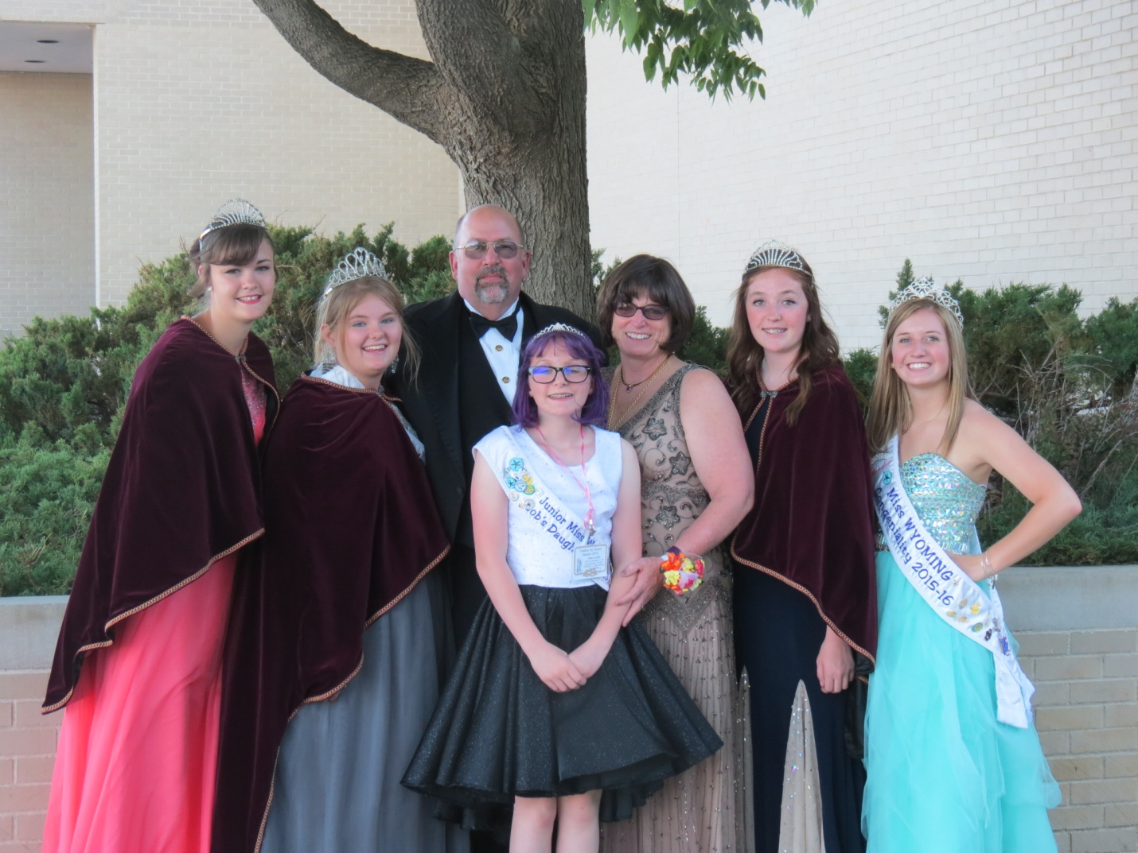
THE COWBOY UP GRAND FAMILY-2015-2016
Kayla Sweet, Miss Wyoming, Willow Waldock, GRHQ, Mike James, AGG, Indica Gallo, Junior Miss Wyoming, Kayleen Logan, Grand Guardian, Hannah Shenefelt, GBSP, Kendra Lewis, Miss Wyoming Congeniality

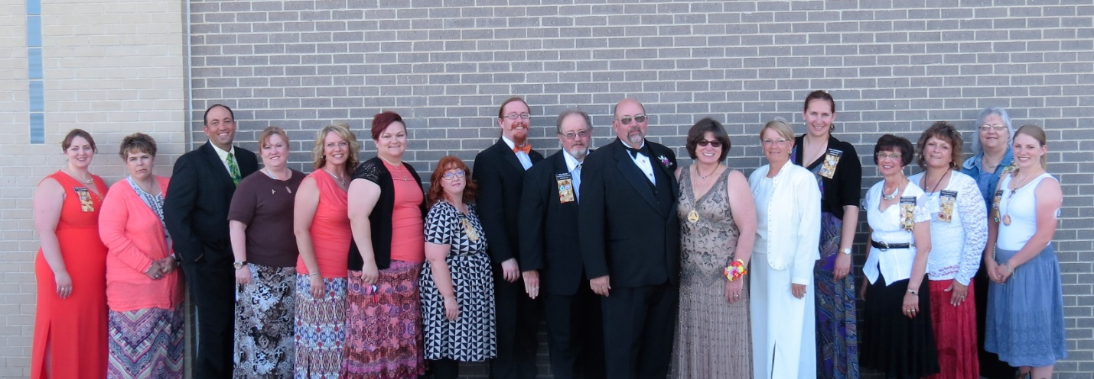
GRAND COUNCIL

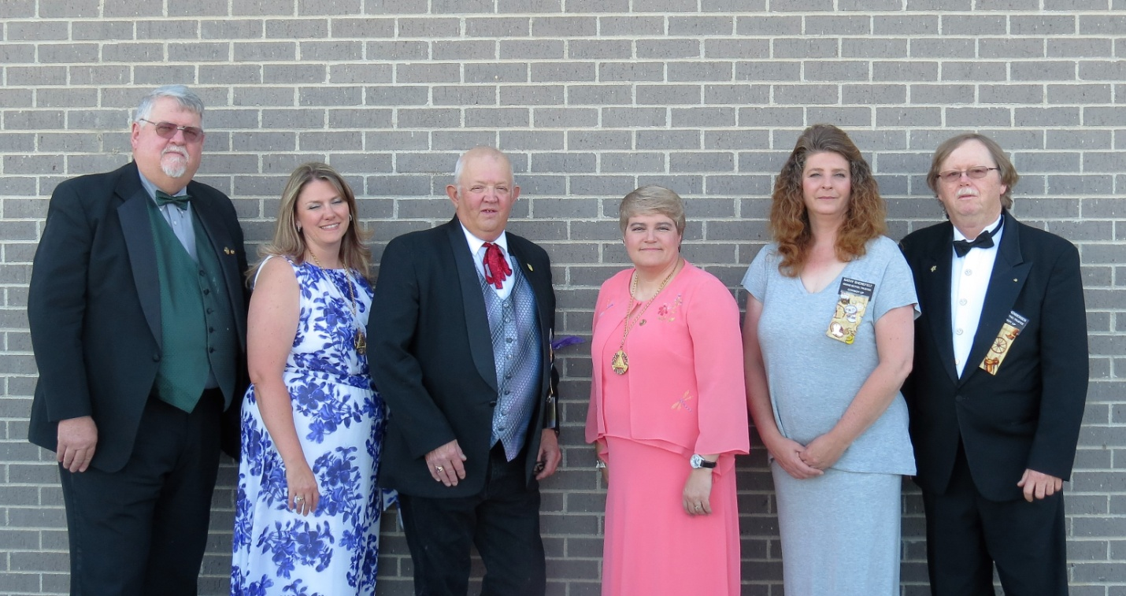

GRAND BETHEL TRUSTEES

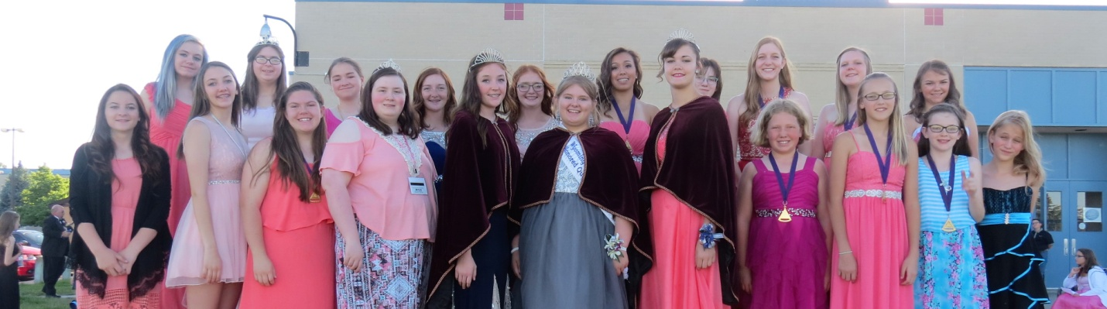

GRAND BETHEL OFFICERS
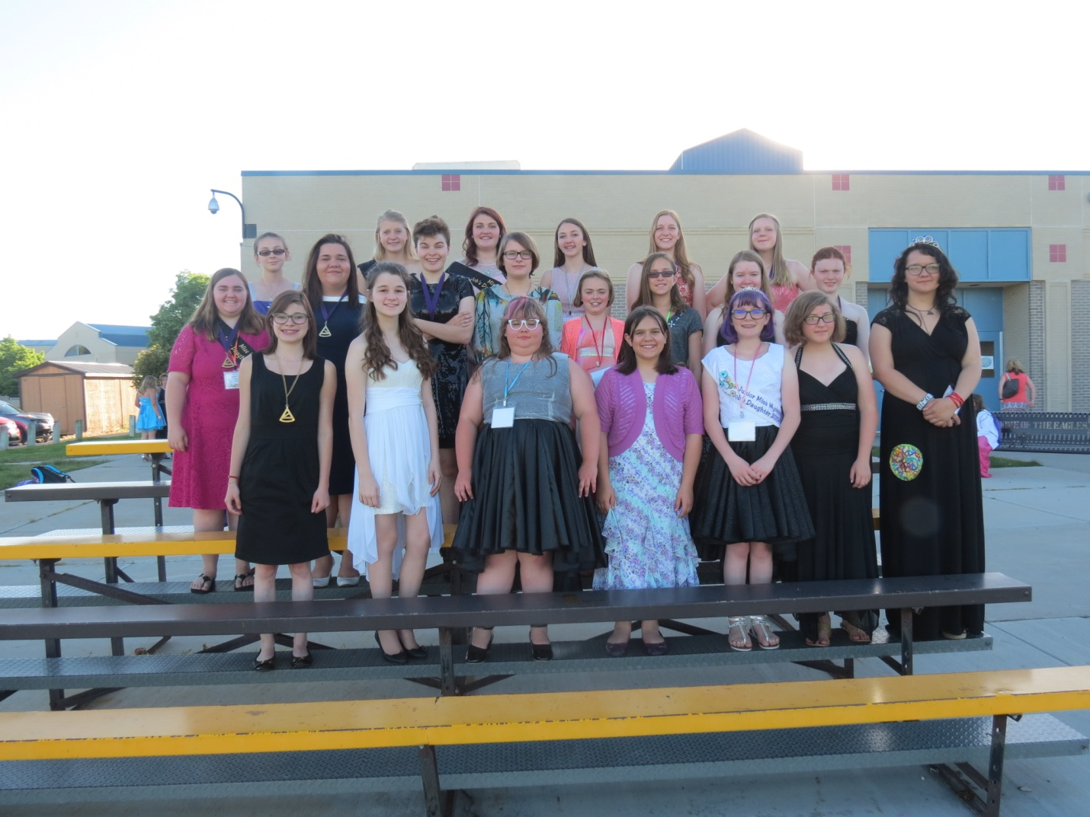

GRAND BETHEL REPRESENTATIVES

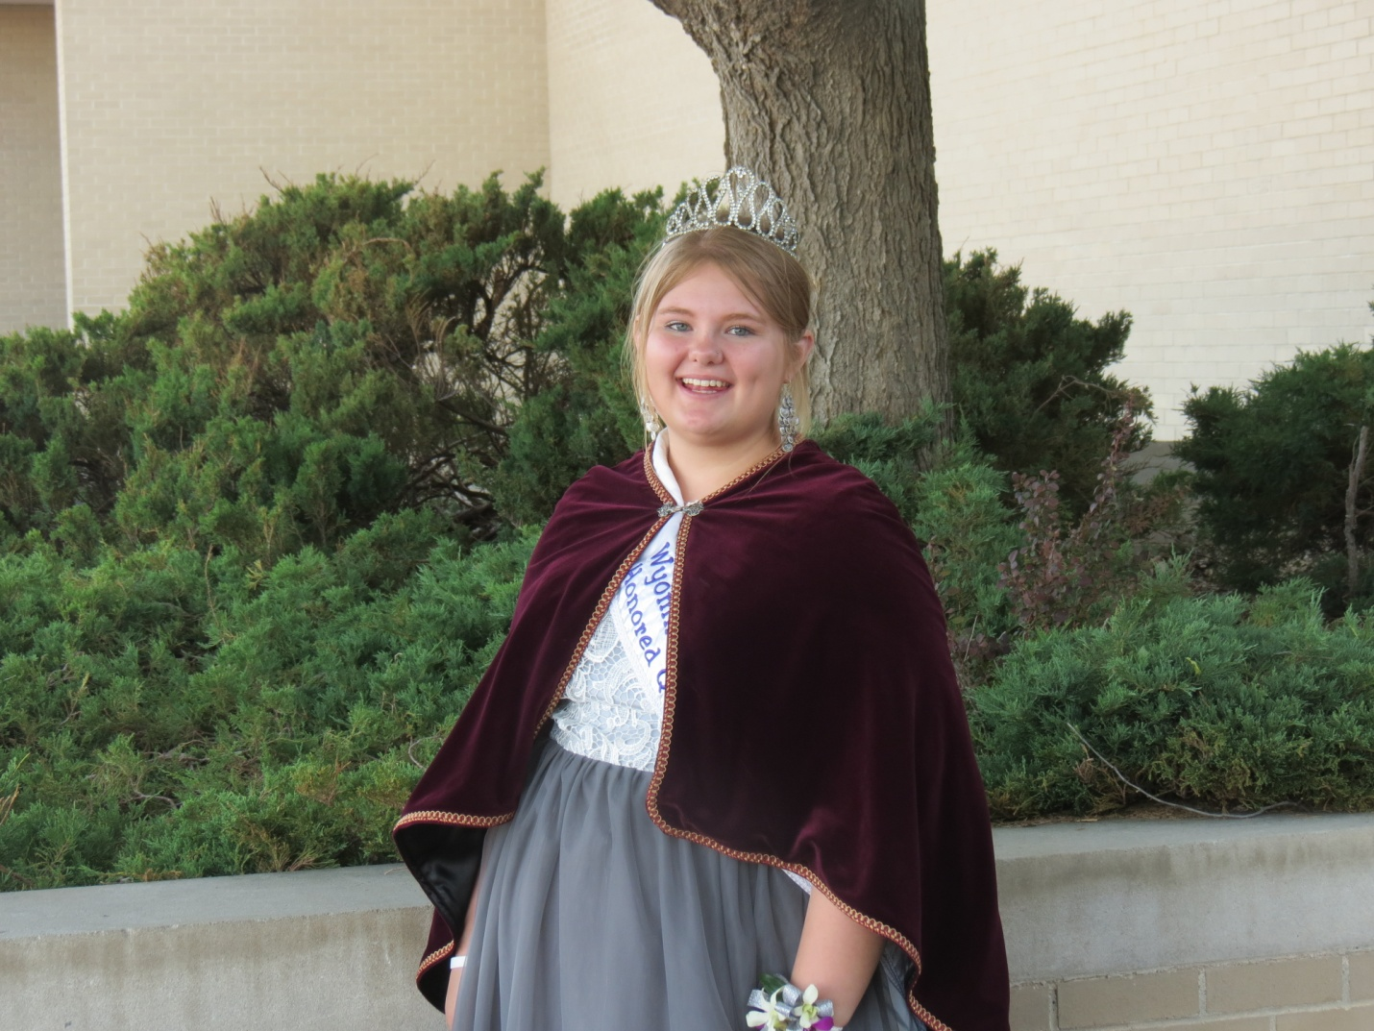

GRAND BETHEL HONORED QUEEN
Willow Waldock

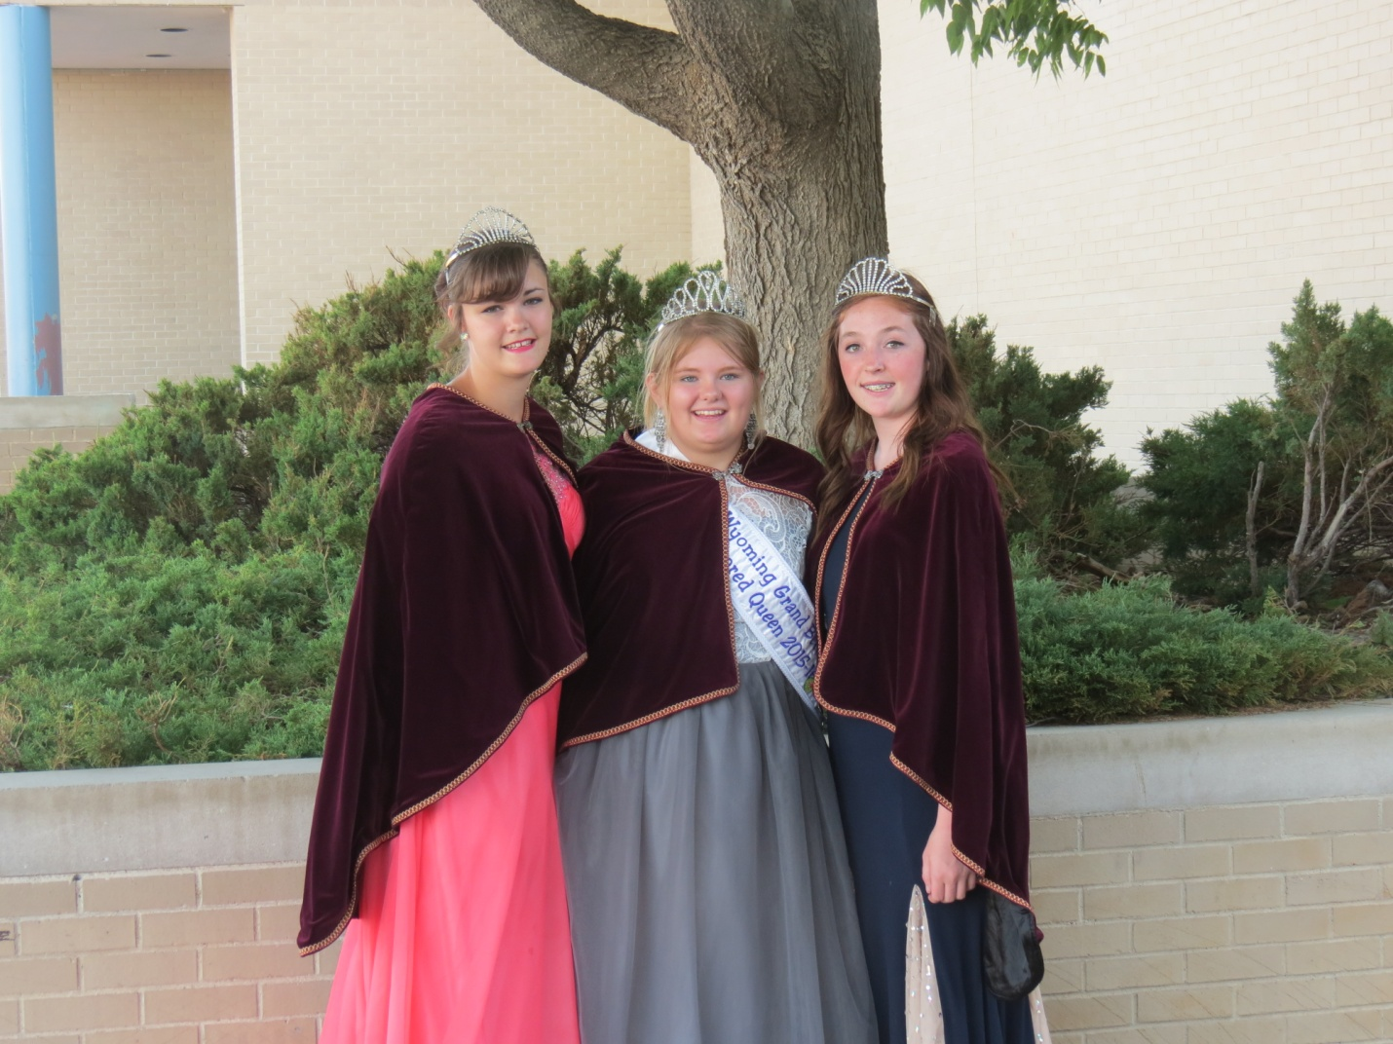
GRAND BETHEL ROYALTY
Kayla Swett, Junior Princess, Willow Waldock, Honored Queen, Hannah Shenefelt, Senior Princess
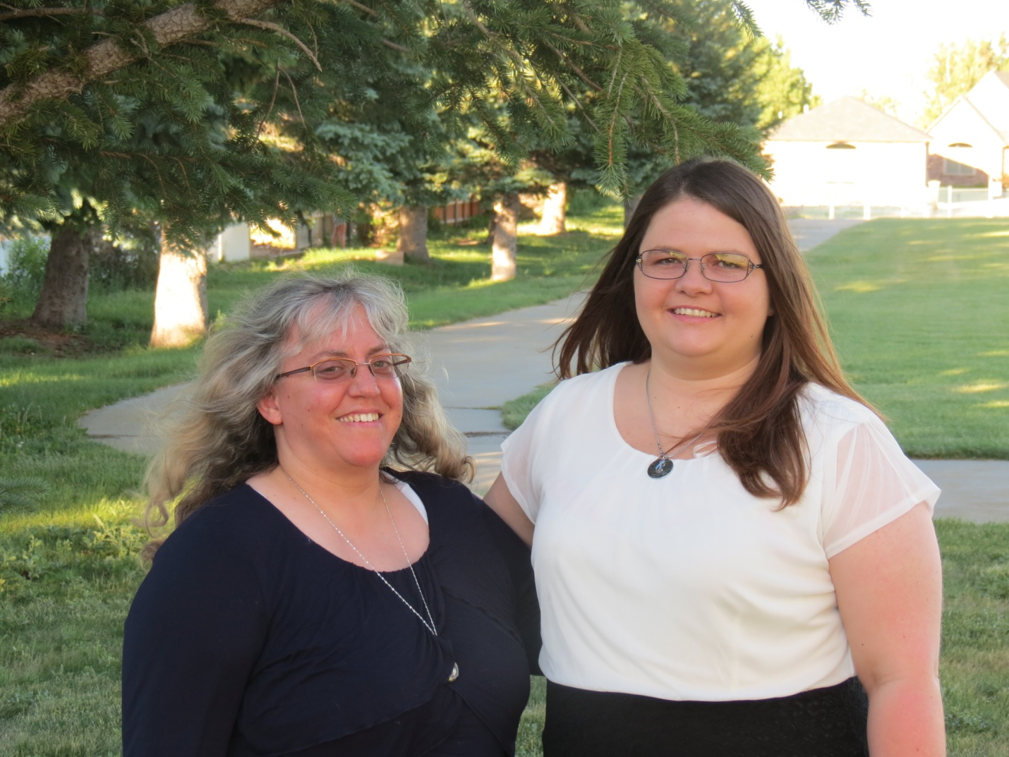

DORP RECIPIENTS
Becky Hoffman #20
Stacey Hays #50

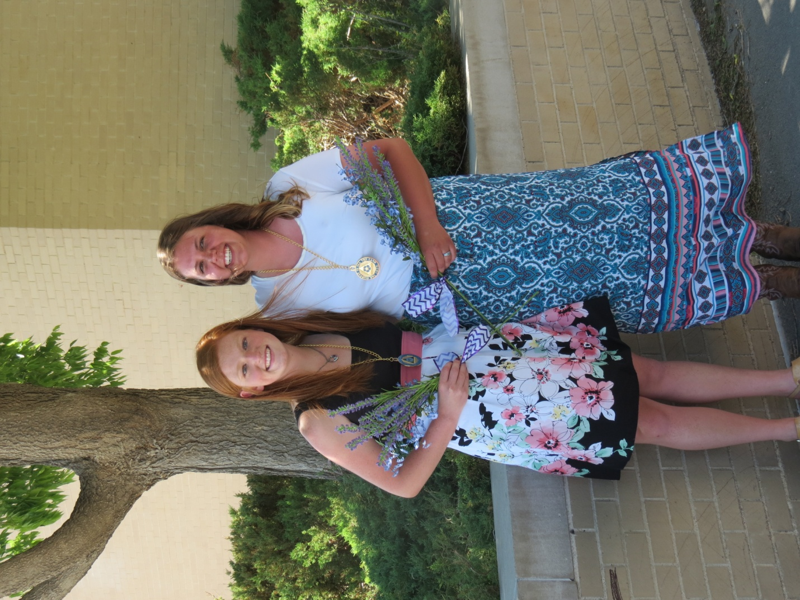

FORGET ME NOT RECIPIENTS
Shelby Porter #48
Bailey Crompton #19
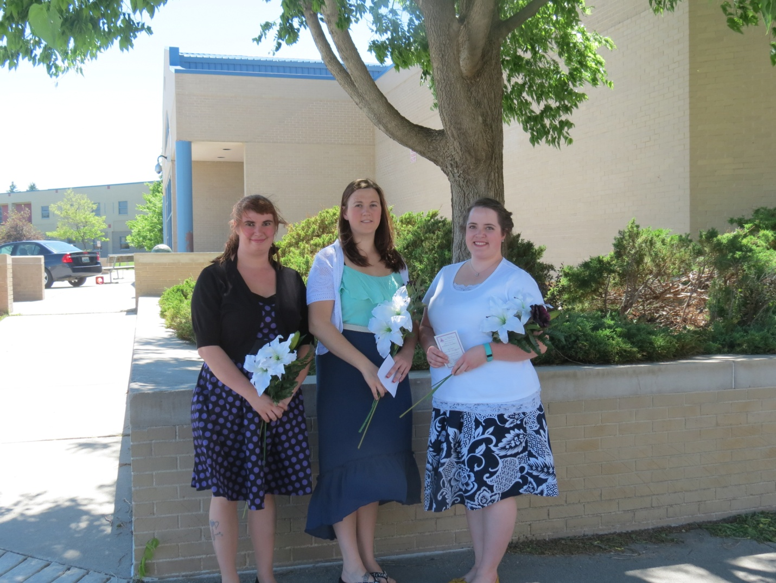
MAJORITY RECIPIENTS
Carlie Rae #33
Casey Miller #1
Johanna Swisher #20

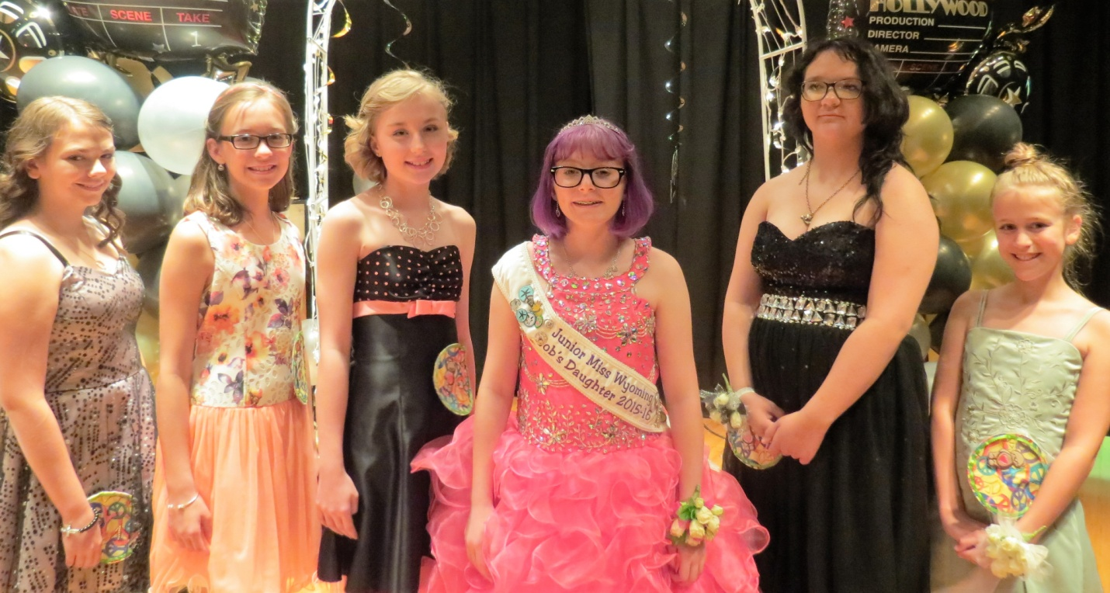
JUNIOR MISS WYOMING CONTESTANTS

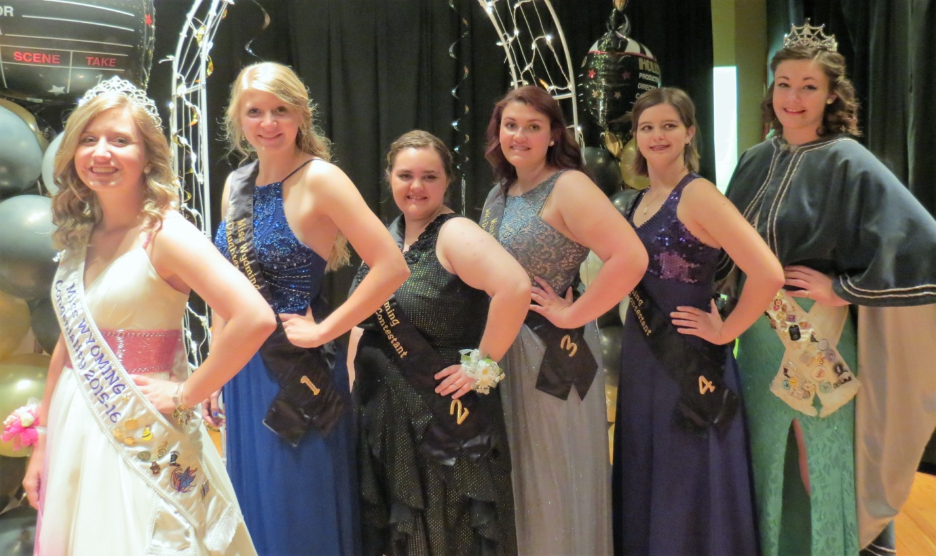
MISS WYOMING JOB’S DAUGHTER CONTESTANTS

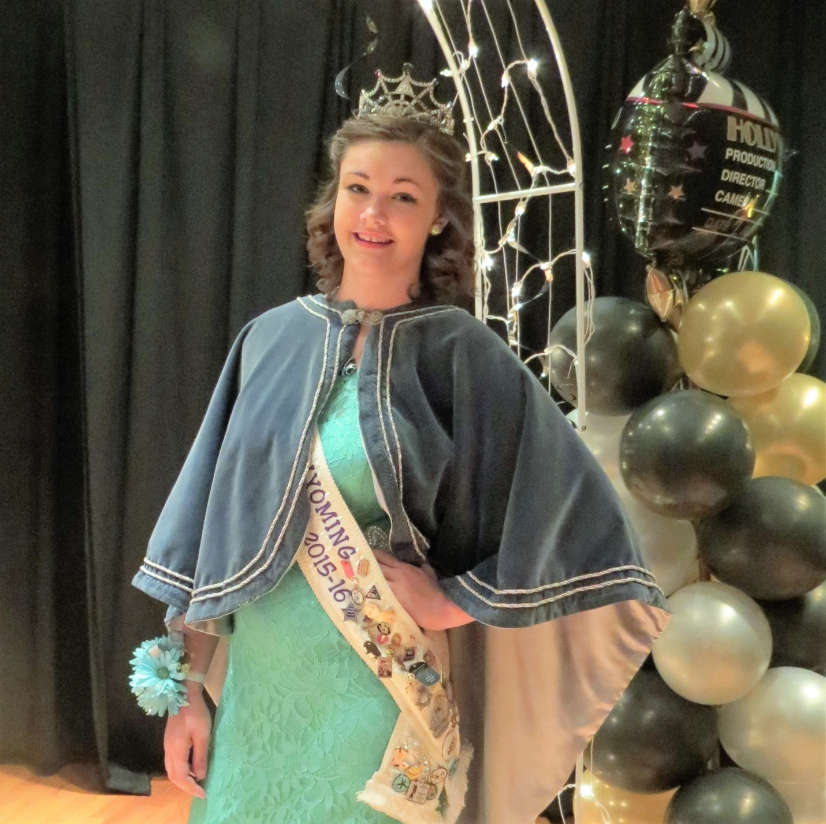
MISS WYOMING 2015-2016
Kayla Swett, #28

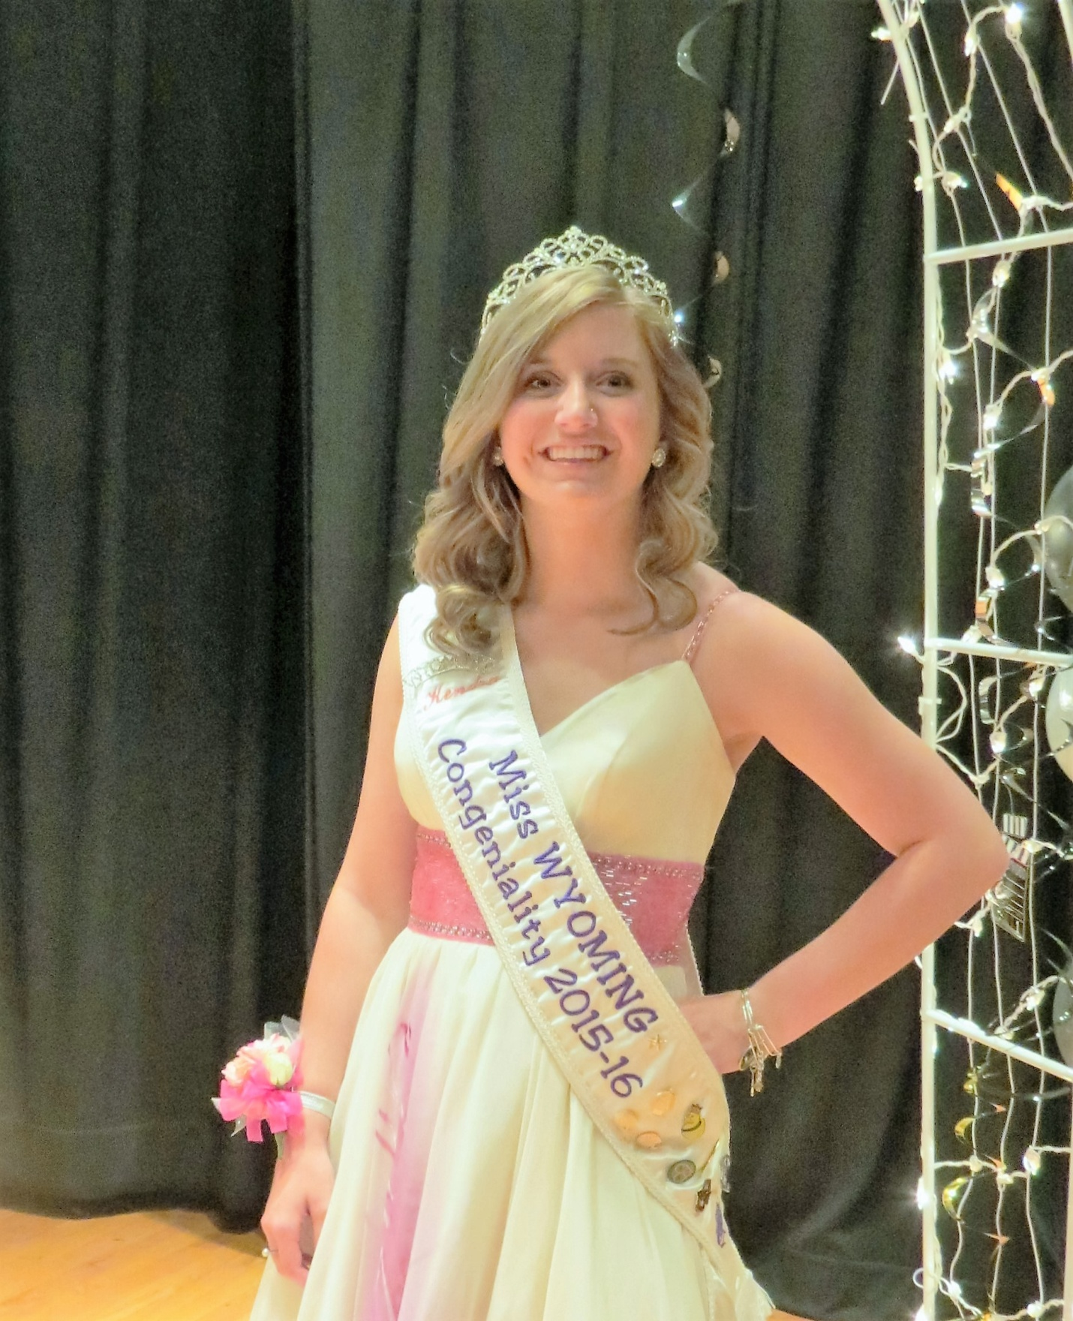
MISS CONGENIALITY 2015-2016
Kendra Lewis #48

