GRAND GUARDIAN COUNCIL

WYOMING

JOB'S DAUGHTERS INTERNATIONAL



PROCEEDINGS

83rd ANNUAL MEETING

2015

EVANSTON, WYOMING

GRAND GUARDIAN COUNCIL

OF WYOMING JOB'S DAUGHTERS

"CHOOSE TO MAKE A DIFFERENCE"

Develop, Decide and Achieve Session

83RD SESSION

AND

GRAND BETHEL

48TH ANNUAL SESSION

Evanston, Wyoming

June 16-20, 2015

Choose to Make a Difference

**MOTTO**

Life is like a camera. Focus on what’s important, capture the good times, develop from the negatives, and when things don’t work out, take another shot.

**SYMBOLS**

Anchor (Monica)

Windmills (Ron)

**MASCOTS**

Penguins (Monica)

Warthog (Ron)

**COLORS**

Cobalt Blue and Mint Green (Monica)

Dark Forest Green (Ron)

**FLOWER**

White Rose (Monica)

Marigold (Ron)

**SONGS**

Count on Me and Here comes the Sun (Monica)

Fruitcakes (Ron)

**SCRIPTURE**

If you have faith nothing shall be impossible for you

Matthew 17:20(Monica)

Make sure that nobody pays back wrong for wrong, but always strive to do what is good for each other and for everyone else. 1 Thessalonians 5:15 (Ron)

**PROJECT**

Suicide Prevention

**GRAND OFFICERS**

**2014-2015**

GRAND GUARDIAN…………………………………………………….Monica Ramirez (33)

ASSOCIATE GRAND GUARDIAN…………………………………Ron Siekert (33)

VICE GRAND GUARDIAN……………………………………………Kayleen Logan (13)

VICE ASSOCIATE GRAND GUARDIAN……………………… vacant

GRAND GUIDE……………………………………………………………Vickie Cooke (29)

GRAND INNER GUARD…………………………………………………vacant

GRAND MARSHAL……………………………………………………… Erin Jespersen (20)

GRAND OUTER GUARD……………………………………………… Regis Michelena (7)

GRAND SECRETARY…………………………………………………...Kathy Wiekhorst (48)

GRAND TREASURER………………………………………………………Joan Means (28)

GRAND CHAPLAIN…………………………………………………………JoDee Mendez (20)

GRAND DIRECTOR OF MUSIC………………………………………Nan James (1)

GRAND LIBRARIAN ...............................................Melanie Tibbitts (33)

GRAND FIRST MESSENGER…………………………………………Deidra Henderson (22)

GRAND SECOND MESSENGER …………………………………….Stephanie Ludwig (19)

GRAND THIRD MESSENGER …………………………………………Kya Gallo (3)

GRAND FOURTH MESSENGER ……………………………………..Kerri Lewis (48)

GRAND FIFTH MESSENGER ………………………………………….Kathy Shenefelt (33)

GRAND SENIOR CUSTODIAN………………………………………..Paul Lincoln (39)

**GRAND BETHEL TRUSTEES**

GRAND BETHEL GUARDIAN……………………………………Linda Walker (33)

GRAND BETHEL ASSOCIATE GUARDIAN………………Roger Means, II (28)

TRUSTEE………………………………………………………………..Cindy Selvey (28)

TRUSTEE………………………………………………………………..Jim Duncan (20)

TRUSTEE………………………………………………………………..Cara Mc Daniel (19)

TRUSTEE………………………………………………………………..Bill Zegley (33)

TRUSTEE (ex officio)……………………………………………Marge Christiansen,PGG (28)

TRUSTEE (ex officio)……………………………………………Craig Henderson, PAGG (22)

**GRAND BETHEL HONORED QUEEN**

**JOELENE RAMIREZ, PHQ #33**

**THEME**

It’s the Journey that matters

**MOTTO**

“You can accomplish anything you put your mind to.”

**SYMBOL**

Cowboy boots and Cowboy Hats

**FLOWER**

Fuchsia and purple carnations

**COLORS**

Light Pink, light blue and brown

**MASCOT**

Owls

**SCRIPTURE**

Do not worry about tomorrow for tomorrow will worry about itself. Matthew 6:34

**SONG**

“You’ll be in My Heart” Phil Collins

**PROJECT**

Great Plains Alzheimer’s Association

**GRAND BETHEL OFFICERS**

**2014-2015**

HONORED QUEEN Joelene Ramirez (50)

SENIOR PRINCESS Willow Waldock (1)

JUNIOR PRINCESS Annie Cook (5)

GUIDE Emily Bahmer (20)

MARSHAL Kendra Lewis (48)

CHAPLAIN Kiaya Johnson (28)

RECORDER Tonie Prego (50)

MUSICIAN open

TREASURER Makayla Waldock (1)

LIBRARIAN Hannah Zegley (50)

PARLIAMENTARIAN open

1ST MESSENGER Alexis Weekly (19)

2ND MESSENGER Gabrielle Young (7)

3RD MESSENGER Ashley Isenhauer (3)

4TH MESSENGER Punky St. John (28)

5TH MESSENGER Hannah Nichols (20)

INNER GUARD Hannah Shenefelt (50)

OUTER GUARD Indica Gallo (3)

SR. CUSTODIAN Morgan Crompton (19)

JR. CUSTODIAN Autumn Hime (2)

FLAG BEARER Alyssa Lenhardt (50)

**GRAND BETHEL REPRESENTATIVES**

ALASKA-OREGON Jessyka Smith (48)

ALBERTA Ariss Epps (50)

ARIZONA…………………………………………………………………………. Kayla Lenhardt (50)

AUSTRALIA Katalina Crain (7)

BRITISH COLUMBIA…………………………………………………………… GraceSteinbock (20)

CALIFORNIA I Jordan Brooks (48)

CALIFORNIA II Morgan O’Neill (50)

CALIFORNIA III Makaela Pohorelow (50)

CALIFORNIA IV Mikhela Scovil (2)

COLORADO……………………………………………………………………. BrendaRansom (20)

DELAWARE Kelli Johnson (20)

FLORIDA Autumn Mc Kinney (48)

IDAHO - WEST VIRGINIA Makayla Steinberg (28)

ILLINOIS Stephanie Nichols (20)

INDIANA -VIRGINIA Autumn Hoffman (20)

IOWA Shara Aaron (19)

KANSAS……………………………………………………………………………. Kennedi Millan (2)

KENTUCKY - SOUTH DAKOTA Cheyenne Mickle (20)

MARYLAND Elizabeth Nichols (20)

MICHIGAN -WASHINGTON Kate Dickinson (48)

MISSOURI…………………………………………………………………………… AbbeyAtkinson (48)

MONTANA Clancey Blume (48)

NEBRASKA I - StephanieRansom (20)

NEBRASKA II - ONTARIO Alissa McDaniel (19)

NEVADA - UTAH Sami Cole (1)

NEW MEXICO - MINNESOTA Natalee Ramirez (50)

NORTH CAROLINA………………………………………………………………… Jessica Miner (7)

OHIO -WISCONSIN Kylee Brooks (20)

OKLAHOMA………………………………………………………………………….. Brook Malone (2)

PENNSYLVANIA……………………………………………………………… Lacie Weinmeister (28)

PHILIPPINES-MANITOBA Cassi Cole (1)

SASKATCHEWAN……………………………………………………………… Alex Henderson (19)

**COMMITTEE CHAIRMEN**

**2014-2015**

**APPEALS & GRIEVANCES**

Levi Hime PAGG, Stephanie Means PGG, Marilyn Olson PGG,PSG

**ARTS & CRAFTS**

Kya Gallo, PHQ, Kerri Lewis PHQ,PGBG

**CAV ADMINISTRATOR**

Margie George, PGG

**CHOIR COMPETITION**

Nan James, PHQ

**COURTESY**

Kati Hime, PGG

**CREDENTIALS**

Margie George, PGG, Mike James, PGAG

**DEGREE OF ROYAL PURPLE**

Grand Bethel Trustees

**EDUCATIONAL LOANS**

Kayleen Logan, PHQ, VGG

**FINANCE**Sid Andersen, PAGG

**FORGET ME NOT**

Monica Ramirez, GG

**GRAND SESSION 2015**

Cara McDaniel, PHQ

**HIKE FUND**

Maria Criswell, PGG

**HONOR BETHEL**

Vickie Cooke, PBG

**JOBIE TO BE**

Stephanie Ludwig, PHQ

**JR. MISS WYOMING JOB'S DAUGHTER**

Chelsea Porter, PHQ, BG, Kathy Shenefelt PHQ, PBG, Beckie Arwood PGG

**JURISPRUDENCE**

Konne Rife, PHQ, PGG, Roger Means II, PAGG, Terry Wiekhorst, PAGG

**LIBRARIAN-SCRAPBOOK**

Melanie Tibbitts, PHQ, PBG, Kathy Shenefelt, PHQ, PBG

**LOCATIONS**

Vickie Cooke, PBG

**LONG RANGE PLANNING**

Grand Council

**MEMBERSHIP**

Stephanie Ludwig, PHQ, BG, Chelsea Porter, PHQ, BG, Joelene Ramirez, GBHQ

**MISS WYOMING JOB'S DAUGHTER**

Jessica Blackman, PHQ, PGBHQ, Kerri Lewis, PHQ, PGBG, Michele Blume, PHQ, PBG

**NECROLOGY**

JoDee Mendez, PHQ, BG, Jessica Blackman, PHQ, PGBHQ

**PARLIAMENTARIAN**

Mike James, PAGG

**PERFORMING ARTS**

Stacey Hays. PHQ, BG

**PUBLICATIONS**

Kathy Wiekhorst, PHQ, PGG, Marge Christiansen, PGG, Craig Henderson, PAGG

**RITUAL COMPETITION**

Erin Jespersen, PHQ, PBG, Regis Michelena, PABG

**SEWING**

Kya Gallo, PHQ, PBG, Kerri Lewis, PHQ, PGBG

**SUMMER CAMP 2015**

Vickie Cooke, PBG

**SUPREME TEAM 2014-2015 COACHES**

Chelsea Porter, PHQ, BG, Stephanie Ludwig, PHQ, BG

**SUPREME TRAVEL 2015**

Kayleen Logan, PHQ, PGG

**WEBSITE**

Marge Christiansen, PHQ, PGG

**WEDNESDAY - JUNE 17, 2015**

The 83rd Annual Session of the Grand Guardian Council and 48th Annual Session of the Grand Bethel of Wyoming was held on June 17, 18, 19, & 20th, 2015 at the Davis Middle School in Evanston, Wyoming.

Practice for Formal Opening was held in the afternoon at the Middle School. Formal Banquet was held at the Machine Shop.

**FORMAL OPENING**

Formal Opening was held at the Davis Middle School gym at 7:00 p.m. Past Grand and Supreme Guardian Marilyn Olson and Past Associate Grand Guardian Sid Anderson welcomed everyone to Formal Opening and Grand Session.

**ENTRANCE OF GRAND BETHEL REPRESENTATIVES, OFFICERS, GRAND BETHEL OFFICERS, HONOR BETHEL, GRAND GUARDIAN, ASSOCIATE GRAND GUARDIAN**

The Grand Bethel Guide and Grand Bethel Marshal escorted the Grand Bethel Representatives into the Bethel Room. The Grand Bethel Representatives placed their flags in the north and south. The Grand Bethel Officers and the Grand Council officers entered the Bethel room per the ritual. The Grand Bethel Guide Grand Guide, Grand Bethel Marshal and Grand Marshal retired and escorted the Grand Guardian, Associate Grand Guardian, Grand Bethel Honored Queen and the Honor Bethel Honored Queen to the altar and then they were escorted to the East and were introduced.

**PROCESSION OF DISTINGUISHED GUESTS**

Miss International Job’s Daughter: Caitlyn Washington

Miss Wyoming Job’s Daughter: Sami Cole

Miss Wyoming Congeniality: Tonie Prego

Junior Miss Wyoming Job’s Daughter: Shara Beth Aaron

Supreme Representative to Ohio: Natalee Ramirez

Past Grand Guardians and Past Associate Grand Guardians:

Joan Means

Mike James,

Kathy Wiekhorst

Terry Wiekhorst, Maria Criswell

Levi Hime, Evonne Rogers

Konne Rife

Roger Means

Craig Henderson, Marge Christiansen

Other Masonic Dignitaries:

Mark Mickelson: Right Worshipful Senior Grand Warden

WY Grand Lodge AF and AM

Terry Wiekhorst: Association Grand Patron

WY Order of the Eastern Star

Mike James: Personal Representative to John Farmer, SGIG

Scottish Rite Masons of Wyoming

Riley Cooke: Guide to Kalif Temple, Oriental Shrine

Todd Bennett: Chief of the Divan, Korein Temple

Oriental Shrine

James Porter: State Master Councilor Order of Demolay of WY

Craig Henderson: Cryptic Masons of WY

**PRESENTATION OF THE HOLY BIBLE**

The Holy Bible was brought into the Bethel room by the Grand Bethel Guide, Grand Guide, Grand Bethel Marshal, Grand Marshal, Grand Bethel Chaplain, and Grand Chaplain.

**PRESENTATION OF THE FLAGS**

The American Flag was displayed by the Grand Bethel Marshal and presented west of the altar. The National Anthem was sung and the Pledge of Allegiance given. The Bethel Flag Song was song.

The Grand Bethel Chaplain lead the body in the Lord's Prayer and Erin Jespersen, Grand Marshal made the Proclamation.

Grand Guardian Monica introduced Cara Mc Daniel who gave the following welcoming remarks to all attendees:

Good evening and welcome to Evanston. I hope that you all had a safe and uneventful trip down to the far west corner of our state. I Know, I know….it’s SOOOOOO far! Trust me I know! As we gather for our Grand Bethel Weekend, I’m looking forward to meeting new friends, sharing new ideas, and building our organization to the best of our abilities. Let’s capture some magical moments, let’s create some happy memories, let’s surround ourselves with laughter, friendship and love as we celebrate Job’s Daughters. Good luck to each and every one of you in your various challenges of the weekend, whether it’s Miss Wyoming Job’s Daughter, or new member ritual competition, Choir competition or with that special piece of art you submitted for judging. You will recite your parts, you will sit through meetings, and you will eat (we have lots of great food ready for you!) but most of all, you’re here to represent the fairest in all the land, the best of Wyoming Job’s Daughters. Please take a minute to sit and visit with each other, take fun pictures of yourselves in the photo booth, giggle a lot, stay up too late, eet a new friend. Bethel 19 is pleased to be your host, please make this weekend GREAT!

**COMMUNICATIONS**

There were no communications read.

**DEGREE OF ROYAL PURPLE**

The Honor Bethel Officers presented the Degree of Royal Purple to Chelsea Porter, PHQ#13, Cara McDaniel PHQ #19 and Bonita “Kathy” Shenefelt, PHQ #33.

**MAJORITY CEREMONY**

The Grand Bethel Officers presented the Majority Ceremony to Clancey Blume, PHQ #48.

**PRESENTATIONS**

Chelsea Porter and Stephanie Ludwig presented awards to Bethel #20 Torrington, and Bethel #3 Rawlins for most improved initiates. Bethel #3 got the traveling trophy award for the most new members per capita. Following daughters were called to the east to receive awards for signing petitions. For 2 petitions: Toni Prego, Kylee Brooks, Josie Emerson, Jessica Miner, Makaela Pohorelow, Madison Turney

For 1 petition: Makayka Scovil, Bailey Hamaker, Abbey Atkinson, Avey Jespersen, Autumn Hoffman, Katherine Mansfield Brooks Malone, Chelsea Davis.

The Spring Challenge was met by Bethel #7, congratulations to all!!

**REMARKS**

Remarks were given by Miss Job’s Daughter International, Mike James, Todd Bennett, James Porter, Riley Cooke, Craig Henderson, Terry Wiekhorst and Mark Mickelson on behalf of the Worshipful Grand Master Richard Lewis.

**GRAND GUARDIAN FAREWELL**

**Monica Ramirez**

Good evening daughters, adults and dignitaries,

I would like to welcome everyone to the Develop, Decide and Achieve Session of Wyoming Job’s Daughters. Thank you all for being here.

This year has been such an amazing experience for me and I could not do it without my family! Eric, thank you for being my rock, and wanting to share this experience with me. I cannot tell you enough how much I appreciate all you do for me. I love you! Coleton, thank you for always making sure I had Chills at all times and for keeping him safe. Son, you will never know how proud of you I am. I cannot imagine doing this without you! I love you son! Natalee, I am so thankful that you wanted to travel with Joelene and I this year and were always willing to protem when needed. I am very proud of you! Joelene, it has been such a blessing to have you as GBHQ this year. I am very proud of the young woman you have become and cannot wait to see what your future holds. When all else fails do yoga. I also have to thank my mom and dad. Mom, it has been so wonderful to have you with me not only as my guardian but also as my GL. I love you! And, to my grandpa you are the reason I started Jobies. You will always be my hero.

I had the pleasure to travel with an amazing Associate Grand Guardian. Ron I could not have asked for a better partner. Thank you for sharing three years with me as my associate guardian and now Associate GG. Thank you for bringing down from my rants and showing me a different side to all situations. We make a great team! Now if we can just keep our spouses healthy we’d be rocking it.

I also had the honor to travel with three beautiful examples of what a Job’s Daughter is. Sami, you have been so much fun to travel with! You have done a beautiful job as our Miss Wyoming. I am very proud of you accomplishments! And, yes I will be taking more pictures! Shara Beth, you are an amazing young lady and I am so thankful that I have gotten to know you. You are going to go far in this Order and in all you do. Joe and Tonie need more snacks. Tonie, I am so incredibly proud of you! You are a friend to everyone, you make sure that everyone is having fun and willing to help wherever it is needed. I can’t wait to see what your future holds. #Starbucksobsessed.

I also want to thank Bethel 50 for all of your support! I love each and every one of you. I’m excited to come back and help you beautiful girls and council. Kathy thank you for being an amazing friend! Your support means the world to me. Love ya sista!

Linda and Roger thank you so much for doing a wonderful job as Grand Bethel Guardian and Associate Grand Bethel Guardian. I loved working with both of you. Thank you, Marilyn for being my hostess. I am so blessed to have you in my life and for all of your encouragement and help through the years. I love you! You still spell your name wrong though. Oh and be sure to look above the doors when you walk outside. I know I am forgetting people and for that I am sorry.

Being Grand Guardian was a dream of mine when I met my first Grand Guardian. And here I stand tonight giving you my farewell speech. This year has been amazing and I could not have done it without everyone here. Daughters, whatever dream you have to go after it because dreams do come true.

Monica Ramirez, GG

**GRAND BETHEL HONORED QUEEN FAREWELL**

**Joelene Ramirez**

Farewell Speech

Ha-ha I have my speech this year! Thank the lord!

Thank you everyone who came this year! Thank you to our Miss International Caitlyn, I’m seriously so excited that you are here! Okay now I promise I will try and not cry but there are no guarantees...

There are so many people that I want to thank for helping to get to this point in Jobs Daughters, never in a million years did I ever think that I would be here standing in front of a ton of people giving a farewell speech. So on with my thank yous,

~ Bethel 50

Thank you, love them.

~Family MOM

HUGE thank you and you love them

~Tonie

#Shay, #orange, # pear, whisper challenge, bathtub in my room.

~Shara

My favorite, baby food snacks

~Sami

Sleepover in my room

Ron

Thanks for the endless support

~Aubree

I really have no clue what I would do without you.

~Linda

Thank you for everything you’ve done this year.

~Trustees

Thank you

~Kathy W

I appreciate you

~Means (Roger, Joan, Steph)

a HUGE thank you

~Marilyn

Thank you for calming me when I need it

~Britt

a HUGE thank you for putting up with me ‘

I am truly sorry if I forgot anyone, you all have impacted me in some kind of a way so thank you!

Respectfully

Joelene Ramirez, GBHQ

**ASSOCIATE GRAND GUARDIAN FAREWELL**

**Ron Siekert**

Daughters - Ladies and Gentlemen.

One of my favorite books is “A Christmas Carol” by Dickens -- and as I stand here, I feel a little like the Ghost of Christmas Present -- my time is rapidly drawing to a close. It has been a most rewarding year and I thank you for the opportunity to serve in this capacity. It has allowed me to become closer to many of you and, most especially, to enjoy meeting and working with Daughters all over the state. It has been a great experience.

I won’t stand here and tell you that this organization is hale and hearty with no clouds on our horizon. There are significant challenges facing us in gaining and retaining members but I want to remind all of us not to embrace despair with unnecessary enthusiasm. After seeing the young women of our organization and their advisors on their home turf and visiting with them I firmly believe that while there may not be a super one-size-fits-all type of solution to our difficulties -- there is in each Bethel a potential synergy of personalities, ideas and enthusiasm that will result in success. The trick is to find that combination and the key element in that is to not to allow ourselves to let gloominess stop us from trying.

We often say one of our difficulties in recruiting and retaining members is the plethora of other activities available to young women these days – especially sports. I agree and understand. In High School I was basketball nut; more enthusiastic than skilled I must admit but I was quite focused. Today, sports seem to require even more time and commitment than 30 years ago - conditioning, camps, practices - but let’s look at what that focus and investment ultimately returns. There are approximately 3.3 million young people graduating from High School this year. About 4% of the graduating seniors are young women who participate in Basketball – roughly 127,000. Some 3.7% of them will participate in NCAA sports and of that number about 9/10’s of 1 percent will go on to professional sports – that works out to about 41 young women who will apply their hard work and training directly to their adult life. Contrast that to the numbers who will need to develop the poise and confidence to speak in public, plan activities, run meetings, develop budgets and work with others in an effective manner not to mention the need in our society for moral leadership. Then ask yourself, where lays the greater relevance? What better reason for our continued efforts?

So – chin up. We still have work to do. We have fantastic young women in our Bethels and communities. We have dedicated and involved adults willing to invest time and energy and we have a program that is relevant and needed – a great foundation.

I want to thank Grand Guardian Monica; you‘ve been great to work with. Thanks to Jo, Sami, Toni and Shara. Ladies it has been great to travel with you and share this experience. Last but not least I want to thank the two ladies who got me into this in the first place. Cori: watching you grow – seeing what you have received from Jobs and what you have given in return convinced me how valuable this group is. Evonne: what can I say love. Your example of dedication and concern for the young women of Jobs has been my touchstone. Without the love and support of my family, I cannot imagine attempting this. Thanks to all.

**ANNOUNCEMENTS**

Grand Guardian Monica reminded everyone to bid on the silent auction items, and the GBSP Willow has her raffle tickets and bracelets for sale in the lobby.

**CLOSING**

The Grand Chaplain and Grand Bethel Chaplain gave the Closing Prayer and Grand Marshal Erin Jespersen gave the Proclamation. Grand Bethel Officers Honored Bethel Queen and Princesses formed the closing cross. The Grand Officers formed a line in the East to watch the closing cross.

**THURSDAY, JUNE 18, 2015**

A breakfast for the 2014-15 Honor Bethel Recipients started the day at the Masonic Temple. Registration continued throughout the day. Ritual Competition and Performing Arts Competition was held in the morning. Miss Wyoming competition was held at the Evanston Masonic Temple and the Jr. Miss Wyoming Job's Daughter competition was held at the Episcopal   
Church Hall.

**THURSDAY AFTERNOON**

The following luncheons were held: Miss Wyoming Job's Daughters, Jr. Miss Wyoming Job's Daughters, All Others and the Grand Secretary's, food was presented and participants went to their respective areas for their gathering. In the afternoon, the Necrology ceremony was performed in the afternoon at Depot Square. Names were read as a balloon was released in memory of our departed ones. Cheerleader tryouts were held following the ceremony. A wonderful picnic put on by the Evanston Masons was held.

**THURSDAY EVENING**

A wonderful picnic put on by the Evanston Masons was held at the Depot Square.

Choir Competition was held at the Davis Middle School Auditorium.

**FRIDAY MORNING - JUNE 19, 2015**

The Grand Bethel Officers and Reps breakfast was held at the Masonic Temple prior to the Grand Bethel Meeting.

**BUSINESS SESSION**

**FRIDAY MORNING, JUNE 19, 2015**

**Davis Middle School**

Joan Means, PGG, Grand Treasurer and Terry Wiekhorst, PAGG were opening host and hostess. They welcomed Grand Guardian Monica Ramirez and Associate Grand Guardian Ron Siekert to the East. Grand Guardian Monica welcomed all present and called the meeting to order at 9:00 a.m.

The American Flag was presented by the Grand Marshal followed by the singing of the National Anthem and the Pledge of Allegiance.

Grand Chaplain pro-tem Jessica Blackman gave the invocation and Grand Marshal Erin Jespersen made the proclamation to open the business meeting.

**INTRODUCTIONS**

GG Monica introduced:

PGG: Konne Rife, Maria Criswell, Kathy Wiekhorst

BG/ABG: Paul Lincoln. Chelsea Porter, Linda Cole, Susie Miner, Kya Gallo, Kathy Shenefelt, Stephanie Ludwig, Sharon Stadick, Regis Michelena

Council Members: Melanie Lincoln, Becky Hoffman, Michelle Brooks, Marilyn Giffin, LauraWaldock, KerriLewis, JessicaBlackman, SharAaron, Stacey Hayes, Tracey Malone.

Grand Secretary Kathy Wiekhorst moved that the minutes of the 2014 Annual Session be approved as printed in the Proceedings. Kayleen Logan moved to approve the minutes and Joan Means seconded the motion. Motion Passed.

Motion was made for the rules and regulations:

Proposed to set aside the WY rules and regulations and follow the Supreme Guidelines. Kayleen Logan moved and it was seconded by Jessica Blackman.

Rationale: as there are not enough bethels in Wyoming to conform with the bylaws of Wyoming.

Grand Secretary Kathy Wiekhorst moved that the minutes of the 2014 Annual Session be approved as sent by email in the Proceedings to all Bethels and Individuals. Kayleen Logan moved to approve the minutes and Joan Means seconded the motion. Motion Passed.

**GRAND GUARDIAN'S REPORT**

**Monica Ramirez**

We started our year out with an amazing installation with family, friends, laughs and of course some tears.

After Grand Session I installed the councils of Bethel’s 33 and 39 in Cheyenne. I also addressed some issues that 39 was having and we put a plan of action in place.

At the end of July we held summer camp at Skyline Camp outside of Encampment. Kayleen did an amazing job with summer! We had so much fun with the crafts, games, movies and rededication. And I must say Joelene, Sami, Shara and I look great with plastic bags, shaving cream and cheetos on our heads. The food was fabulous as well. It is sad that this is not a well-attended event. This is a time for the daughters and adults to build stronger bonds with each other. The girls also need practice on pranking the adults.

On Saturday, August 2 we left for Supreme in Spokane, WA. We traveled with eight daughters and four adults that flew out of Denver. Two of the daughters had never flown, but they had a blast. Three other adults drove to Spokane. Jessica Blackman did an amazing job with our Supreme team. The daughters worked very hard and did their best. I am very proud of all five of them. Sami represented Wyoming Job’s Daughters very well and even though she did not place she made a lasting impression on all she met. Stephanie Ransom, who was Supreme Bethel Marshal, did such a beautiful job on the flag ceremony. She had many of us in tears. Miranda Twomey is Supreme Rep to Alberta, Natalee Ramirez is Supreme Rep to Ohio and Sami Cole was Supreme Bethel Installing Recorder. We traveled home on Saturday, August 9 with a slight detour to Salt Lake City. What a wonderful experience this was and the memories I will always cherish.

The day after we got back from Supreme we traveled to Sheridan for Grand Lodge. After that we traveled to Casper for Grand Chapter. What an awesome experience for Joelene, Sami and myself. I love knowing that the Eastern Star and Masons are very supportive of our daughters.

In October we held JDU in Cheyenne. We enjoyed a movie Friday night. Saturday was filled with fun workshops for both daughters and adults. Saturday evening we help the Grand Bethel meeting. The food was awesome! Thank you to Oak Leaf Chapter 6 and Burns Chapter 41 for fixing our meals.

Winter Fest was so much fun! Bethel 7 in Gillette hosted it. Friday night Chills was penguin napped by two people that shall remain unnamed. The girls watched a movie that evening. Saturday Joelene and Sami gave a presentation on learning their parts and public speaking. Some of the girls memorized a part and were given a prize. Some of us adults even got in on it. That’s right we still have it. One of our Jobie to Bees was able to sneak away with Mr. Pig. No, I had nothing to do with it. That would be the person to my right’s doing. We then painted some neat pots. The girls and adults enjoyed this project. We all gathered in the Bethel room where Susie gave us the events for the afternoon. Now in this time our AGG Ron asked what I needed to do to get me sweet Chills back. And leave it to Hannah Shenefelt to say I had to participate in the talent show. Really! Anyone that knows me knows that I really have no talent, but I will do it. The girls played some fun relay races before ice-skating. That evening there was a talent show and we have some very talented daughters and adults. I finally got Chills back. What a great time and amazing food with wonderful friends. Thank you Bethel 7 for such a fun time.

Spring Fling was cancelled due to weather.

On June 7 we traveled to Green River where the cheerleaders practice and we enjoyed a bbq that to our chef Kerri. The next day we went to the Shrine Hospital. What an incredible experience this was. Watching the young men and our cheerleaders play with the patients there was life changing.

The following weekend we went to the Shrine Bowl banquet and our cheerleaders were recognized for the work they do. They all received a plaque. The following day they participated in the parade, helped sell raffle tickets and programs before the game, and then cheered both the South and North teams on. It was very hot, but that didn’t faze the girls in cheering. Thank you Cindy, Kerri and Cara for all of your hard work this year.

Our visits started in November with Evanston being our first visit. This is a strong Bethel with a group of daughters and council. They work very well together. They initiated one. We enjoyed the chili and goodies after the meeting. Joelene and Tonie spent the night at Shara Beth’s house and had a great time eating junk, laughing and staying up too late.

The next day we traveled to Green River. We had a wonderful brunch. I would love to see the pictures that were taken on the cameras. I’m sure that there were some of Coleton and Eric. This is also a strong Bethel with daughters and council working well together.

Our next visit took us to Laramie. What a fun and energetic group of daughters. They love being a Jobie and are always excited to learn. The council is strong and works well together. This is a young Bethel and is learning quickly. They initiated one. We had a wonderful lunch that Levi slaved over for hours.

That Sunday we had our visit in Cheyenne with 39. We had a very good brunch. They initiated one. It was great to see an almost full Bethel with the help from daughters from 33. After the meeting we met with the daughters and council from both Bethels. We started the girls out with a saying one thing they like about Jobies. Then we had the adults and daughters get in birth month order without talking. It was great to see them all working together. After that each daughter drew a card and had to finish the sentences. We then gathered the daughters and told them that both bethels would be merging. The reaction was very positive. There were a few tears, but it was not because of the merge. The daughters decided they would like to have a new Bethel number and become charter members. The councils have been working very well together and are preparing for the merge. I am very excited to see the daughters and council grow.

Our last visit for the Fall Term was with Rawlins on Saturday, December 13. These girls are very excited about Jobies. Their ritual work was amazing! They have a great council and PHQ that are very willing to help and protem when needed. There was one daughter that blew us away with her ritual work. Indica not only did her Senior Princess part, but she also did 3 and 4 Messenger and only missed one word! We had a wonderful dinner and a Christmas parade after.

On Saturday, January 3 Bethels 33 and 39 became one. They are now Bethel 50. The daughters signed a charter and were installed in their new offices. What a fun and special day for all of us. I believe that they will thrive and grow.

With a heavy heart we had to close Bethel 14 in Thermopolis. This was not an easy decision, but they have not grown. Ellen, Tammy and John we thank you for your untiring work and love for this Order and these daughters. We all know how hard you all have worked to try and make this Bethel grow.

Our first visit of the Spring Term was on Saturday, February 14 in Cheyenne. It was awesome to be back at home and to see a full floor. The girls and council are working vey well together. We enjoyed lunch after the meeting.

Sunday we traveled to Torrington. I must say this was the coldest bethel room we had been in. Yes, Rawlins even colder than yours. Chills and his friends did enjoy the room however. This is a quiet but fun group of girls. This was only their third meeting and for some only their second. They all had concerns about membership, but they have some new girls coming up.

On Saturday, March 14 we had Grand Visit in Douglas. They have three or four active girls. Two girls are in college and a few others don’t always show up. They did well with their ritual work. A couple of girls were very nervous. Mike makes the perfect initiate. It is awesome to have a musician. We had a wonderful baked potato bar after the meeting.

The next day we went to Bethel 7 in Gillette. We were served a wonderful lunch. They initiated one girl. Again it was great to have a musician. They had baskets that they raffled for HIKE, Ron and I’s project and their own Bethel. This was a lot of fun.

Our last two visits were Saturday, March 28 and Sunday, March 29. We started in Sheridan. We were served a wonderful lunch. The girls did a beautiful ceremony. Ron and I both appreciated the work that they put into their ritual work. There were no rituals used on the floor. The girls and council work very well together.

The next day we went to Casper. I felt very bad that it was Palm Sunday and they had to rush from church to make the meeting on time. Again I apologize. The girls seem to be working well together and are getting over some past obstacles. The council works very well together, but they are tired. The girls had a nice meeting. I was surprised that none of the ritual was memorized however.

I have had a lot of fun traveling to each of the bethels and spending time getting to know the girls. I love nothing more than having the girls give me a hug and ask where Chills is. Oh and I guess the councils are fun as well. Everyone was very welcoming.

On a more serious note I do believe that we as parents, chaperones and councils need to help these girls more with their ritual work. It was very hard to think about an Honor Bethel. In a few of the bethels they had majority members protem offices, which is awesome to see, and a great example for the girls. It seems as though we have lost the importance of the ritual work. Some of the smaller things like square corners, stopping at the honored queen after the cross, and voting are some of the items that I saw only a couple of bethels do properly. Our music is also an important part of this organization. For the most part all bethels know the music, however there are only a couple of bethels that know the new words to the songs that were changed.

This year Ron and I didn’t focus on membership, but retention. I love that we are getting new members, but what we are not doing is making sure they stay. I am not sure what the answer is, but this is an area that we need to work on. I know that all Bethels are struggling with finding adults to serve on councils as well. I know many parents don’t participate with their girls, but maybe try a dinner for the entire family, have a parents night where all of the parents come and have a night without their kids, have a girls vs. parents game day. These are just some suggestions. Maybe if we show the parents we are having fun they will want to help more. With the lodges in your city take refreshments after their meeting, offer to make them a meal, have a shadow meeting, or try secret pals.

Councils please make sure to check your email! Most communication is done through email. Many deadlines were missed. If your email address has changed please make sure that you have contacted Kathy Wiekhorst with the correct one.

Please remember this is a girl’s organization and they nee to do the work. We are here to help and guide them. It’s time we give it back to them. I have also noticed petty differences between adults. The girls do see this and react negatively to it. Problems will arise from these issues and will cause issues in the Bethel. Please leave your differences outside the Bethel doors.

Financial:

Beginning Balance $1000.00

                                     Supreme Team                                       250.00

                                    Supreme Expenses   341.28

                                     Honor Bethel  250.00

                                  Initiate gifts and other expenses               $300.00

**ASSOCIATE GRAND GUARDIAN'S REPORT**

**Ron Siekert**

After beginning the term by having to miss summer camp, my first “official” outing was our trip to Supreme in Spokane WA. Our contingent had a wonderful time and it was quite an educational experience. Upon our return to Wyoming, I made an immediate trip to Sheridan for Wyoming Grand Lodge and, sequentially, to Casper for Wyoming Grand Chapter. At both meetings our Grand Bethel Honored Queen and Miss Wyoming Jobs Daughter were introduced and acquitted themselves well.

After a month or so to gather ourselves up we began the rounds with JDU in Cheyenne. I believe the programs presented there were well received. My personal representative and travelling companion MR. PIG was kidnapped there but an immediate and thorough reaction on my part in gathering other mascots (for their own safety) brought about a negotiated return and raised some funds for our programs. I took the opportunity to present the new youth program for CAV and to try and evaluate its effectiveness with the girls. We began Bethel visits with #19 in Evanston is October and visited with 6 Bethels by the holiday break including Evanston, Green River, Laramie, Cheyenne #39 and Rawlins.

After the first of the year I was unable to be present at the chartering of Bethel 50 due to a previous family commitment. I was present at Winter Fest in Gillette and although the weather did not cooperate fully, we had a great time. This was the second snatch of my esteemed mascot and I had (to the regret of many) to sing for the return of THE PIG, much as the Grand Guardian had to sing for the return of Chills.

We began Bethel visits again in February with Cheyenne #50 and visited 6 Bethels in February and March including #50, Torrington, Douglas, Gillette, Sheridan and Casper. Unfortunate weather cancelled the Spring Fling in Laramie in April.

As is to be expected, we found a mix of conditions in the individual Bethels. Some are on an up-cycle with membership growth. Others are steady or in a down turning phase. I am encouraged that at each Bethel, there seems to be a determination at the local level that Jobs Daughters is of value and an accompanying commitment to maintaining it as a viable organization.

I have visited two Bethels during this term outside of our regular visits, trying to help them address council and/or Daughter issues. One arose around an issue regarding the correctness of a Daughter’s Masonic heritage and a subsequent breach between the council and a set of parents. Before the issue could be addressed, it expanded to include other adults with at least some Jobs Daughters background. The Grand Guardian and I, after seeking advice from Grand Jurisprudence and Supreme, concluded that the council was correct in their position. Unfortunately, the parents involved did not choose to attend a meeting attempting to achieve a positive outcome. The other visit was prompted by a letter to the Grand Guardian from a Daughter complaining about some actions taken by her Bethel that she perceived as violations of Jobs Daughters rules and policies and also questioning why the girls could not directly appoint their council. The questions of the “violations” stemmed from her misunderstanding of meeting and CAV requirements. At a meeting with the Council and the daughter, I presented an explanation of the areas where she did not fully understand requirements and also an explanation of the process and logic behind Council recommendations. It became apparent that the genesis of her issues stemmed from some Council member interactions and after the daughter left, I strongly advised them to insure that the girls be insulated from adult-adult issues.

It is my sincere belief that we have an issue that has been bumping along, causing concern but not necessarily stimulating a response and I believe it will need to be tackled for the ultimate good of Job’s Daughters in Wyoming. We need to work on beefing up and encouraging viable adult participation – especially men. The fact that I have served in my current position at this time is evidence of the existence of the issue. There is a level of weariness in some locales amongst adult advisors, both male and female – they’ve been “in the trenches” for quite some time and I think it may limit creative and flexible solutions to the girl’s membership efforts. **ADULTS** **cannot grow our membership** **but** effective and energetic adult support that fosters youth enthusiasm can. I had hoped to begin addressing this with some visits to local STAR chapters and Blue Lodges but family issues and some new responsibilities in other areas precluded a more extensive travel schedule. I would encourage, at minimum, a more active conversation and even some brain-storming on this issue.

It has been a true pleasure to serve in the capacity of Associate Grand Guardian for Wyoming and I appreciate the confidence shown by the Grand Council in allowing me to serve in this position. Due to Grand Guardian Monica’s excellent organizational skills, the term has gone quite smoothly and I have fully enjoyed the opportunity to interact with the Daughters and adults. I attempted to bring the Daughters a message about their individual power to choose how they would deal with the world and tried to encourage a sense of friendly mischief and fun overall; I hope to some success. It is privilege to work with these young ladies; with our dedicated adults; and to be a part of Job’s Daughters International in Wyoming.

Thank You.

Respectfully submitted,

Ronald E. Siekert

Associate Grand Guardian 2014-2015.

**GRAND SECRETARY’S REPORT**

**Kathy Wiekhorst, PGG**

Grand Guardian Monica, Associate Grand Guardian Ron and members of the Grand Guardian Council.

Wyoming started the year with 157 girls reported to Supreme council as of January 1, 2014. We reported an increase of members by 28; 27 initiated and 1 affiliated. 37 members were suspended or resigned and 17 took their majority. This is a sad note to think of all the wonderful girls who have given their teenage years to our order. But the great news is, so many of them have already taken their CAV’s and are contributing members to our councils. YEA!

My financial books for the Grand Guardian Council general fund, Grand Guardian Council Money Market Account, Grand Bethel General Fund and Grand Bethel Money Market account along with the Cheerleading and Summer Camp accounts have been turned over to the Chairman of the Finance Committee for audit. Special thanks to Sid Anderson, PAGG, for his expertise, experience and advise in this my first year as Grand Secretary.

Speaking of this new experience, I would like to applaud everyone for your understanding and patience as I crossed new “rivers” in my Jobie life. I am hopeful that the use of computerized reporting has been advantageous to all. The proposed amendment will hopefully, not only prove cost effective, but provide immediate accessibility to the directory, bylaws, and the proceedings. It has been great “conversing” with you across cyber space or by phone. You all have been very willing and responsive to anything I needed. I appreciate those of you who attended yesterday’s Grand Secretary’s luncheon. I hope the tips, concerns, and great ideas from everyone as we shared some of the “trials” of reporting, deadlines, etc.; will prove to be beneficial as the new year gets rolling. Good thing we really don’t have the “adversaries” Job had, right?

The packets will be available for each Bethel on Saturday morning for the Bethel Guardian’s to pick up. Council Certificates will be there for your Bethel Guardian Council installation. If you appointed someone to a position that is not yet a CAV (was so excited to give the CAV to two new prospective council members on May 30); you will not be able to be installed until the CAV clears. I will send your certificate as soon as I get the list from Supreme.

I would like to thank Mike James and Marilyn Olson for helping at the credentials table this year. It was great to have their expertise for me my maiden voyage. A special thank you to Kathy Winders for her great ability of addressing all of my questions, available at the click of a text! I have tried to fill her remarkable shoes this year! Once again thanks to everyone in this room, for your patience, understanding and assistance. As a little Job’s Daughter (49 years ago) I learned about patience, faith and reward; but also learned about how Job’s Daughters is one big family. Thank you brothers and sisters for your vote of confidence in placing me in this position!

Respectively submitted,

Kathleen Wiekhorst, PHQ, PGG, DORP

Grand Secretary

**GRAND SECRETARY'S FINANCIAL REPORT**

**Receipts:** June 1, 2014-May 31, 2015

|  |  |  |
| --- | --- | --- |
|  |  |  |
| **Balance Forward June 1, 2014** |  | $ 8,638.38 |
| 2014-2015 Council Dues | 1,500.00 |  |
| 2014-15 Dues | 725.00 |  |
| 2013-14 VGG Project | 750.00 |  |
| 2014 Grand Session Fees | 399.00 |  |
| 2014-2015 VGG Project | 3,924.67 |  |
| 2015-16 Council Dues | 1200.00 |  |
| Annual Report Income | 4788.18 |  |
| Bank Fees Income | 24.00 |  |
| CAV Training | 200.00 |  |
| Dispensation Income | 30.00 |  |
| Donations (Grand Lodge for GG) | 750.00 |  |
| Donations (Various organizations) | 493.55 |  |
| Educational Loan Income | 470.44 |  |
| Equipment Fund Income | 445.00 |  |
| GGC Project | 680.00 |  |
| Jewelry Income | 806.90 |  |
| Jr. Miss Pageant Income | 280.25 |  |
| Late Fee Income | 50.00 |  |
| MWJD Pageant Income | 500.00 |  |
| Postage Income | 36.58 |  |
| Proceedings Income | 95.00 |  |
| Promotional Fund | 470.45 |  |
| Supreme Inventory | 562.61 |  |
| Supreme Messenger Team | 500.00 |  |
| Supreme Session 2015- Nut Sales | -1.74 |  |
| Wyoming By-Laws | 330.00 |  |
|  |  |  |
|  |  |  |
| **Total Receipts** | 20,009.89 |  |
|  |  |  |

**Disbursements:**  June 1, 2014 - May 31, 2015

|  |  |
| --- | --- |
| 2014-15 VGG Nut sales | $ 1,891.08 |
| 2013-14 VGG Project | 406.40 |
| AGG Allowance  Craig Henderson –Mileage to Grand 140.00 | 140.00 |
| AGG Mileage  Craig Henderson 60.00 | 60.00 |
| Annual Report Expense | 3,754.80 |
| Bank Charges | 24.00 |
| Corporation Taxes | 25.00 |
| Donation  HIKE $ 50.00  Cindy Schonholtz- Vickie Cooke 25.00 | 75.00 |
| Equipment Fund | 1585.01 |
| G.G. Allowance  Monica Ramirez Airfare Supreme 270.00 | 270.00 |
| GG Fund | 1,210.00 |
| GG Mileage  M. Christiansen- mileage to Grand  M. Christiansen- | 120.00 |
| GG Per Diem  M. Christiansen $60.00 | 60.00 |
| GS Per Diem K. Winders per diem | 120.00 |
| GS Mileage K. Winders mileage | 60.00 |
| Insurance & Bonds | 556.00 |
| Internet, GO Daddy.. Levi Hime | 18.17 |
| Jewelry Expense | 493.07 |
| Miscellaneous Expense  Flowers –Hecox funeral $48.15 | 48.15 |
| Office Supplies | 96.10 |
| Payroll Taxes | 193.86 |
| Postage | 560.72 |
| Promotional Fund: rooms for SG, Merback Awards, ad for paper, Supreme Visit, Girls to Supreme | 717.26 |
| Salary, Grand Secretary | 2400.00 |
| Supreme Inventory | 728.49 |
| Supreme Team Expense 2014 | 500.00 |
| Telephone Expense | 154.00 |
| **Total Disbursements** | -16,267.11 |
|  |  |
|  |  |
| **Beginning Balance** | $8,638.38 |
| **Receipts** | $20,009.89 |
|  | $28,648.27 |
| **Disbursements** | *($16,267.11)* |
| **Total in Checking Account** | $12,381.16 |

**MEMBERSHIP REPORT**

**JANUARY 1, 2014 – December 31, 2014**

NUMBER OF ACTIVE MEMBERS JANUARY 1, 2014 157

ADDITIONS:

INITIATED 27

REINSTATED 0

AFFILIATED 1

TOTAL ADDITIONS 28

TOTAL ACTIVE MEMBERS 185

DEDUCTIONS:

SUSPENDED, RESIGNED, EXPELLED ..... 37

DEMITTED 0

MAJORITY 17

TOTAL DEDUCTIONS 54

TOTAL ACTIVE MEMBERS DECEMBER 31, 2014 131

NET LOSS 2014 26

**GRAND TREASURER'S REPORT**

**Joan Means, PGG**

Grand Guardian, Associate Grand Guardian, Members of Grand Guardian Council:

2014-2015 was a really good year for the GGC. The ending balance in our checking account was $12,381.16. All bills are current. That was so outstanding that I researched our records in Quickbooks to see what had been the highest ending balance. I was able to go back to 1999 when we began using QuickBooks. What I found was that in 2010 we had the lowest balance at $1,277 and the highest was, in fact, this year.

When I reviewed what our financial this year, I found that our total income had actually decreased from last year, but, so had our expenses by 21%. It all makes perfect sense since we have fewer bethels.

I compared last year's financials to this year's and there are a couple of accounts that I would like to point out.

VGG Project: The VGG Project this year was a huge success. Every time this has been the VGG Project, everyone seems to get behind the Nut Sales and this year was no different. The Income from the sales was $3,925. You may remember that that last few years we've had to have more than one project. Thank you for your support.

Equipment Expense: The next account I want to point out is Equipment Expense. As you can see on the Financial Spread Sheet and P & l, this was one of the largest expenses incurred this year at $1,585. Hopefully, we will not have to pay out this much for our equipment this year. From that account, we replenished the toner for the Grand Secretary's antique printer. But the largest expense was to repair the Grand Secretary's computer which broke down 2 months after she took this position and to update our Quickbooks program to a newer version since Intuit no longer supported the version we were using. Office Depot loved us!

We actually did quite well in holding down the expenses in the Per Diem and Mileage accounts because the Executive Council wasn't able to travel to hold its meetings due to weather. We met via a conference call and decided that we would continue using that method going forward. Also using email and texting helped to hold down our Postage Expense.

I believe there is also an amendment that will come before this body that will further reduce the Postage and Office Supplies accounts.

Before I close I would like the Council to know what a fantastic job Kathy Wiekhorst did during her first year as Grand Secretary. She took the job very seriously and worked very hard. I'm very proud of the job she accomplished. Grand Guardian Council is in very good hands.

Lastly, I want to inform you that, if re-elected on Saturday, I'd like this coming year to be my last year as Grand Treasurer. It's a big commitment so I wanted to give you plenty of time to think it over. I don't know where the time has gone. I've been Grand Treasurer for 8 years. I can see from what Kathy Wiekhorst brought to the position this year, that change is not always a bad thing.

Thank you for allowing me to be your Grand Treasurer.

Respectfully Submitted,

Joan Means

Grand Treasurer

**GRAND TREASURER'S FINANCIAL REPORT**

|  |  |  |  |  |  |
| --- | --- | --- | --- | --- | --- |
|  | Gen. Fund | Educ. Fund | Equip. Fund | Promotions | Total |
| Cash Bal. 6/1/14 | $ (988.57) | $ 6,988.43 | $ 284.56 | $ 2,353.96 | $ 8,638.38 |
| Receipts | 18,624.00 | 470.44 | 445.00 | 470.45 | 20,009.89 |
| Warrants | (13,964.84) | 0.00 | (1,585.01) | (717.26) | (16,267.11) |
| Cash Bal 5/31/15 | $ 3,670.59 | $ 7458.87 | $ (855.45) | $2,107.15 | $ 12,381.16 |
|  |  |  |  |  |  |
|  |  |  |  |  |  |
| BancWest Invest opened 3/10 | $ 26,834.41 |  |  |  | $ 26,834.41 |
| M.M. BOW opened 6/10 | $ 7,269.89 |  |  |  | $ 7,269.89 |
| CD/SAC 2004 Platte Valley opened 2011 | $ 25,000.00 |  |  |  | $ 25,000.00 |
| Total Year to Date  5/31/15 | $ 62,774.89 | $7,458.87 | $ (855.45) | $ 2,107.15 | $ 71,485.46 |

**CREDENTIALS REPORT**

**CREDENTIAL COMMITTEE PARTIAL REPORT**

|  |  |  |
| --- | --- | --- |
| Grand Guardian | 1 |  |
| Associate Grand Guardian | 1 |  |
| Other Grand Officers | 13 |  |
| Past Grand Guardians | 6 |  |
| Past Associate Grand Guardians | 6 |  |
| Bethel Guardians | 2 |  |
| Associate Bethel Guardians | 0 |  |
| Past Bethel Guardians | 13 |  |
| Past Associate Bethel Guardians | 0 |  |
| Guardian Secretaries | 2 |  |
| Guardian Treasurers | 1 |  |
| Guardian Directors of Music | 0 |  |
| Guardian Directors of Epochs | 1 |  |
|  |  |  |
| TOTAL VOTING DELEGATES | 46 |  |
| TOTAL NON VOTING DELEGATES | 3 |  |
|  |  |  |
| TOTAL BETHELS REPRESENTED | 10 |  |
|  |  |  |
| PARTIAL TOTAL REGISTERED AT THE 83RD GRAND SESSION - JUNE 2015 EVANSTON, WY |  |  |
|  | 51 |  |

CREDENTIAL COMMITTEE: Mike James, Kathy Wiekhorst

**JURISPRUDENCE**

Partial report approved by Terry Wiekhorst and seconded by Erin Jespersen

**NEW BUSINESS**

Erin Jespersen GM, discussed the idea of having everything we do at Grand   
Session take place in three days instead of 4. We need to decide to make our Job’s Daughters our priority. Reasons stated:

*1. Adults would not have to take 4 days off from their work week.

*2. Still do all the events with less downtime.

*3. We can have all the meals together, allowing more time to socialize.

*4. This would make a 3 day session with the lower amount of girls we have.

Discussion ensued:

Konne Rife: Would be less $ for girls and adults.

Laura Waldock: Girls like down time as a way to interact.

Terry Wiekhorst: Change to survive, change can be good. Keep your mind open.

Sharon Stadick: Travel across the state often times involves either leaving at 5:00 in morn or the night before.

Aubree Jones: As numbers decrease Grand is our BIG event, so cutting back on times together, could be not a good thing.

Konne Rife: Piloting is not a bad thing, but if we don’t try some things we become stagnant.

Marilyn Olson: Need to energize Job’s Daughters

Michelle Brooks: all the young 10 year old girls are away from their parents.

Susan Miner: Be careful to allow for down time.

Sharon Stadick: Ask the girls what they would like to do.

**LOCATIONS**

Vickie Cooke, Grand Guide

A bid was received from Sharon Stadick and Jenny Cooke, Bethel 5 to hold Grand Session 2017 in Sheridan. It was voted upon by the body and approved.

**CAV COORDINATORS REPORT**

**MARGIE GEORGE**

**2014-2015**

Four Certified Adult volunteer classes were held this year. The first class was held on December 30, 2014 in Green River with Kathy Wiekhorst leading. Seven people attended the class with six receiving their CAV certification. The second class was held in Laramie on February 10, 2015 and was led by Ron Siekert. There were seven participants with four receiving their CAV certification. The third class was held on March 21, 2015 in Sheridan with Ron Siekert leading. Five people participated in this class with all five receiving their CAV certification. Lastly a class was held in Torrington on May 30, 2015 with Kathy Wiekhorst as the leader. Nine people attended this class with six receiving the CAV certification. One person attending this class was just taking a refresher and already had their CAV.

We want the thank our three trainers in Wyoming who are Terry and Kathy Wiekhorst and Ron Siekert. We are very fortunate that they are so willing to travel all over the state to facilitate the training. We still are in need of other trainers so if you are at all interested please go to the website and download the application and get started!

Thank you once again to all of our CAV’s in Wyoming for working with our daughters and making Wyoming a wonderful Jurisdiction.

Respectfully submitted,

Margie George PGG

CAV Coordinator, Wyoming

**HIKE**

**Maria Criswell**

To Monica Ramirez, Grand Guardian, Ron Siekert, Associate Grand Guardian and Grand Guardian Council: This year’s donations to HIKE before Grand Session included donations from two Bethels, one ice bucket challenge and one individual. These donations came to a total of $474.80.

I was encouraged last summer when everyone was doing the ice bucket challenge for HIKE, but then only one family sent in their challenge money.

I had one inquiry about an application for a HIKE award. I believe they found funding elsewhere. No information was received for High Plains HIKE this year.

A silent auction was held at Grand Session again this year. Bethels 1, 3, 19 and 48, Monica Ramirez, GG and myself donated baskets and items for the silent auction. $660.00 was collected which included the silent auction, some sales from items leftover from previous supreme sales, ice bucket challenge money and donations. Thank you to those who donated and bid on the different items.

Next year will be the 30th Anniversary for HIKE and I hope that we can get some new ideas and give more support to HIKE.

Thank you Monica and Ron for the appointment as HIKE chair this year. It was an honor and privilege to be able to do this. If anyone knows of a child that is in need of help with hearing devices please let me know. Total funds sent to HIKE from Wyoming for this year after Grand Session was $1134.80 as of June, 21, 2015. Thank you everyone for your generous donations.

**MEMBERSHIP/PROMOTIONS-2014-2015**

**Chelsea Porter and Stephanie Ludwig**

Dear GG Monica, AGG Ron and GG Council,

It is no secret that membership has been dramatically on the decline for the past few years. Job’s Daughters is different than it was 94 years ago when it became an organization. Different than it was 65 years ago when my grandma was Honored Queen. Different than it was 35 years ago when my mom was Honored Queen. Different than it was 9 years ago when I was Honored Queen, Much different. But that is the beauty of being human, learning and growing. We adapt, we change, we grow, we learn. God is always throwing us a curve ball, always challenging us in unexpected ways. Yes, girls in general are less interested and involved, parents are more skeptical and in general everyone is too busy, and while we are not a religious organization, churches and activities involving God in general have seemed to have taken a backseat for many people. BUT, there are still plenty of girls that love Job’s Daughters. That NEED Job’s Daughters. And while we harbor negativity at the fact that “Jobies isn’t what it was when I was in it” in terms of membership, it is still so important for us to not give up and to preserve the one thing that does not change- the same beautiful organization for girls to feel safe to grow up in and become the fairest in all the land. Each and every girl matters and has value. Not to mention the fact that the girls in the organization today don’t even know what a Grand with hundreds of people even looks like, so it’s not “depressing” for them, but all the same depresses it when we reminisce on the sad point.

Since becoming a part of the Membership and Jobie to Bee Committees, I have wracked my brain trying to figure out what is missing in the puzzle that is declining membership. And so this year we tried something different-not having a challenge for the Fall term. I don’t feel that it affected membership at all. Instead, Chelsea and I taught a class at JDU this fall on membership. We racked the girls’ brains for ideas, their fears in talking to others about Jobies, made them practice approaching prospective members and compiled a list of Jobie to Bee activities for the girls that we sent out with the challenge we did do in the Spring.

We had a Spring Challenge where the Bethels got points for having Jobie to Bee events, points for each girl (not just Bees, as retention is also important in membership) that came to an event, and points for each new member for the term. Four out of ten Bethels competed in the challenge. Bethels #3, #7, #19 and #48. Again, I feel that this challenge did nothing for membership, the participating Bethels can correct me if I’m wrong. Bethel #7 had the most points and received an award at Formal Opening of a movie gift basket.

I wonder if this is part of our problem. If we, as adults, don’t motivate our girls and use the tools we are given, then who will? I am as guilty as everyone. Yes, we do a lot for the girls and the organization and yes, we are busy without adding yet another paper to fill out to the mix, but we can at least give the girls some energy and these challenges can greatly help in doing so.

26 girls were initiated into Jobies in Wyoming from Grand 2014-May/June 2015. Awards for membership this year were given in four different categories. The Bethel with the greatest per capita increase, the Bethel who initiated the most girls, girls who signed two petitions, and girls who signed one petition.

The awards were given as follows:

* Membership Award: Bethel #3 Rawlins with 120% increase
* There were two Bethels who initiated 6 girls each: Bethel #3 Rawlins and Bethel # 20 Torrington
* There were 7 girls who signed two petitions (Tonie Prego, Mikayla Pohorelow, Jessica Miner, Madison Turney, Indica Gallo, Josie Anderson, Kylie Brooks)
* There were 12 girls who signed one petition (Bayliegh Hammacker, Brook Malone, Mikayla Scovil, Bernadette Moore, Rian Hallman, Katherine Mansfield, Terissa McClure, Kelsie Davis, Autumn Hoffman, Avey Jespersen, Heidi Lietzau, Abbey Attkinson)

Awards were presented at Formal Opening on June 17, 2015. The traveling plaque will be presented to Rawlins’ at their Grand Visit. The two Bethels who initiated 6 girls received a gift card for further promotion. The girls who signed two petitions each received a gift of a JDI bag and the girls who signed one petition each received a Symphony candy bar. Each girl who contributed to membership was recognized.

The key to membership hit me this year as I worked with Monica and taught the class at JDU though-fun. Create a fun place for the girls and they’ll tell their friends, no pressure to “get them in” to Jobies. Create a fun activity for them and they will come. AND WE CANNOT GET DISCOURAGED WHEN THEY DON’T! Because if we get discouraged, the girls will also become discouraged and again will add pressure and “bad feelings” in terms of membership and promotion. We need to focus on creating fun and giving the girls positive energy and passion and the rest will follow. And if it doesn’t, there is nothing to regret, nothing to fear and nothing to worry about, because God will provide. We will keep riding this storm out because these girls need Jobies.

Plans for 2015-2016 include: I am attending Supreme this year where I intend to pick up as many ideas as I can in regards to membership. I will be working closely with the Membership and Promotion Committee- Willow Waldock and Aubree Jones. I also placed the poster boards at the registration desk for girls to share their thoughts and ideas about Membership and Jobies as well as sign a pact to share what we love about Jobies with others. After talking to Willow, our GBSP, who will be traveling to all the Bethels this year; she will be giving recognition to the girls who signed petitions last year in front of their Bethel sisters and encourage all the girls to sign petitions and to have fun. As always, I am open to suggestions and ideas.

Respectfully Submitted,

Stephanie Aaron Ludwig

Bethel #19 Guardian

Membership Chair and Jobie to Bee Chair

**NECROLOGY CEREMONY/ GRAND CHAPLAIN REPORT**

**JoDee Mendez**

Necrology was held on Thursday, June, 18 in Evanston.

**Chaplains**

Madison Clark #3

Rian Hallman #3

Keziah Davis #19

Erin Henderson #19

Autumn Hoffman #20

Makayla Dean #48

Tonie Prego #50

Kendra Lewis #48 Honor Bethel Chaplain

Kiaya Johnson #28 Grand Bethel Chaplain

**Program**

Opening

Special Reading and Balloon Launch “Miss me – but let me go”

Closing

**Departed Loved Ones**

Pat Bishop Husband of Darlene Bishop PGG

J. Earl Christiansen PAGG and Past Grand Master

Ella Olson Grandmother of Gina Olson PHQ #20, Mother-in-Law of Marilyn Olson,

PGG, PSG

Orlee Palmer Mother of Melanie Tibbitts PBG #33, Grandmother of Monica Ramirez GG, Great-Grandmother of Joelene Ramirez GBHQ and Natalee Ramirez PHQ #33

Gerry Thompson Grandmother of Zoe Thompson PHQ #19, Keziah Davis PHQ#19, Kelsie Davis PHQ#19 and Jessica Davis #19, Mother of Samantha Davis PHQ#19 and Audrey Thompson MM #19

Alice Westling Mother of Carol Fields PHQ #27, Grandmother of Christie Peterson McGill PHQ #5, Great-Grandmother of Hailey McGill #5

Terrell Wiekhorst Father of Terry Wiekhorst PAGG, Father-in-Law of Kathy Wiekhorst PGG, Grandfather of Heidi Finn PHQ, MM #48 and Jessica Rubidoux PHQ, MM #48

Mary Elizabeth McDonald Mother of Maria Criswell PGG, Grandmother of Sarah Dykes PMWJD, PHQ #13 and Grandmother of Madeline Dykes #48

Cora Waldock Great grandmother to Makayla Waldock PHQ #1 and Willow Waldock GBSP

George Waldhauser Father of Vickie Cooke Grand Guide, grandfather of Jenny Cooke PHQ and MM #29 and Annie Cooke GBJP

Edna Timmons Grandmother to Jessie Sketterberg PHQ and MM #14 and Jada Timmons

Bryant Jolley Uncle to Jessie Sketterberg PHQ and MM #14 and Jada Timmons

Mary & Steve Langley Uncle to Tammy Timmons PBG #14 and uncle to Jessie Sketterberg PHQ and MM #14 and Jada Timmons

Virginia Vanderpool Mother of Joanne Conroy PHQ and PBG #48 and grandmother to Laura Kofidza PHQ #48

Thank you to Monica and Ron for giving the Chaplains around the state and myself the opportunity to honor our loved ones. JoDee Mendez, Grand Chaplain

**Miss me – but let me go**

When I come to the end of the road

and the sun has set for me,

I want no rites in a gloom-filled room,

why cry for a soul set free?

Miss me a little, but not too long

and not with your head bowed low.

Remember the love we once shared-

miss me, but let me go.

For this is a journey we all must take

and each must go alone.

It’s all a part of the Master’s plan,

a step on the road to home.

When you are lonely and sick at heart

go to the friends we know.

And bury your sorrows in doing good deeds; **Miss me – but let me go.**

**Performing Arts**

**Stacey Hays**

Grand Guardian Council,

The Performing Arts competition for the 2015 Grand Session was held don June 18, 2015. There were a total of twelve entries received, two dropped, leaving ten girls to perform. There were five 10-13 year old entries, four 14-16 year olds, and one 17-19 year old entry. Of the 10-13 year old performers, three were vocal solos and two were instrumental. In the 14-16 year old division, two were vocal solos and two were instrumental. The single 17-19 year old was a vocal solo. I gave a total of eleven ribbons: seven first place (one being first overall for most points received) and four for second place. There was a tie for first in the 10-14 year old division for vocal solo. I was assisted in judging by Melanie Tibbits. Cindy Selvey also assisted accompanying two competitors. The young ladies that competed should be commended for their willingness to put themselves in front of judges to display their talent.

Respectfully Submitted,

Stacey Hays

Winners:

Division: 10-13 Year Olds

Vocal Solo: 1st Place –Jada Timmons and Mikhaela Scovil

2nd Place- Autumn Hime

Instrumental Solo: 1st Place- Avey Jespersen

2nd Place-Jada Timmons

Division: 14-16 Year Olds

Vocal Solo: 1st Place- Autumn Hoffman

2nd Place-Kinsey Hegy

Instrumental Solo: 1st Place- Cassidy Cole

2nd Place- Sierra Penrod

Division: 17-19 Year Olds

Vocal Solo: Rebecca Triplett

1st Place Overall- Rebecca Triplett

**RITUAL COMPETITION-2015**

**ERIN JESPERSEN AND REGIS MICHELENA**

Ritual competition was held on Thursday, June 18, 2015, at Davis Middle School in Evanston, WY.

39 daughters registered and 38 competed in 12 categories including: Senior Princess, Junior Princess, Guide, Marshal, Chaplain, the five Messengers, New Member, and Story of Job.

There were three divisions available in each category: Novice for girls who were attending their first Grand Session and had never competed, General for girls who had competed before but had not placed, and Purple for girls who had placed in prior competition. There were also three age groups available for each category and division, 10-13, 14-16, and 17-19. All Daughters were required to take an open book written test and have their robes judged.

There were a few changes made to Ritual Competition this year, which we hope will keep things running smoothly in the future. Changes included were:

1. There was no Librarian category this year. No one had entered the competition in a few years and we felt it did not need to be included.
2. Daughters competed on a schedule. This was an attempt to not waste judges’ time waiting for girls to show up for their competition. In addition, girls were required to check in to Regis and me and receive a card with the times for their competitions. If they scratched or added any category they were required to let us know at check-in.
3. While daughters took their written tests, we held the judges meeting. After girls finished their written tests, they went to the Robe Judging station to complete that part of competition before saying ritual parts. This allowed time for girls to run through their parts while in line. We started ritual recitation a little later in order to allow time for this. We did end up having robe judges available throughout the competition, since this did not go as quickly as anticipated.
4. Scoring was changed to reflect a greater importance on verbatim.
5. Each test was open ritual. The novice and general tests, while having different questions, had the page numbers on the tests where answers could be found in the ritual. The purple test did not include page numbers. Overall, girls did very well on the test and we hope this took some anxiety away from the girls.
6. Awards were restructured to include a minimum threshold for 1st, 2nd, and 3rd place. In order to be eligible for 3rd place, a daughter had to score at least 75% of her total points possible. 2nd place eligibility was at 85% of total points possible, and 1st place eligibility was at 92% of the total points possible. This did result in a few categories not having a girl place 1st or even 2nd. We felt this was an appropriate change due to the seemingly disproportionate number of girls in the purple category by sole virtue of lack of competition in the past. We recommend for next year and beyond that girls are only advanced to the purple category if they place first in novice or general categories, rather than simply placing 3rd or 2nd.
7. We also recommend for next year that the deadline for registration of ritual competition be June 1st, not May 1st. We expect this may cut down on the number of scratches and additions at Grand Session. It may be easier for the girls to know what they are capable of preparing a little closer to session and when school is winding down.

Awards were presented Friday evening, June 19th. Certificates were made for all Daughters competing and were included in each daughter’s envelope along with the Daughter’s score sheets and written tests. The Betty Smith Ritualist of the Year award had only one contestant but unfortunately she did not receive enough points to merit the award. Regis and I contacted Bill Smith to confer and since the award comes from him he felt strongly that a minimum score needed to be reached in order to receive the award. The list of awards by category, division and age group is attached to this report.

Thank you to all of the judges that volunteered their time to listen to the Daughters.

Thank you to the Grand Council for allowing us the opportunity to work with our Daughters through Ritual Competition.

Respectfully Submitted,

Erin Jespersen Regis Michelena

Grand Marshal Grand Outer Guard

|  |  |  |  |
| --- | --- | --- | --- |
| **Ritual Competition 2015 - Results** | |  |  |
|  | **Division** | **Name** | **Bethel** |
| **New Members** |  |  |  |
| **1st** | **Novice 10-13** | **Madison Turney** | **3** |
| **2nd** |  | **Avey Jespersen** | **20** |
| **3rd** |  | **Zia Brown** | **5** |
| **1st Messenger** |  |  |  |
| **1st** | **Novice 10-13** | **Devin O'Harra** | **19** |
| **2nd** | **General 10-13** | **Mikhela Scovil** | **2** |
| **2nd** | **Purple 10-13** | **Jada Timmons** | **5** |
| **2nd** | **Purple 14-16** | **Alyssa Lenhardt** | **50** |
| **1st** | **Purple 17-19** | **Annie Cooke** | **5** |
| **2nd** |  | **Audrey McIntosh** | **19** |
| **3rd** |  | **Alissa McDaniel** | **19** |
| **2nd Messenger** |  |  |  |
| **1st** | **Novice 10-13** | **Bernadette Moore** | **3** |
| **2nd** |  | **Alexis Tew** | **5** |
| **1st** | **Novice 14-16** | **Josie Andersen** | **20** |
| **2nd** | **General 10-13** | **Alex Henderson** | **19** |
| **1st** | **Purple 14-16** | **Hannah Shenefelt** | **50** |
| **2nd** |  | **Shara Aaron** | **19** |
| **3rd** |  | **Kelli Johnson** | **20** |
| **2nd** | **Purple 17-19** | **Audrey McIntosh** | **19** |
| **3rd Messsenger** |  |  |  |
| **2nd** | **Novice 14-16** | **Katharine Mansfield** | **5** |
| **1st** | **Purple 14-16** | **Morgan Crompton** | **19** |
| **2nd** | **Purple 17-19** | **Willow Waldock** | **1** |
| **4th Messenger** |  |  |  |
| **1st** | **Purple 14-16** | **Hannah Shenefelt** | **50** |
| **2nd** |  | **Kelli Johnson** | **20** |
| **5th Messenger** |  |  |  |
| **2nd** | **Novice 10-13** | **Rian Hallman** | **3** |
| **3rd** |  | **Haylie McGill** | **5** |
| **1st** | **Purple 14-16** | **Cassi Cole** | **1** |
| **2nd** |  | **Natalee Ramirez** | **50** |
| **2nd** | **Purple 17-19** | **Annie Cooke** | **5** |
| **3rd** |  | **Audrey McIntosh** | **19** |
| **Chaplain** |  |  |  |
| **1st** | **Novice 10-13** | **Maddison Clark** | **3** |
| **2nd** |  | **Rian Hallman** | **3** |
| **3rd** |  | **Erin Henderson** | **19** |
| **3rd** | **Purple 10-13** | **Jada Timmons** | **5** |
| **1st** | **Purple 17-19** | **Willow Waldock** | **1** |
| **Marshal** |  |  |  |
| **1st** | **Purple 14-16** | **Cassi Cole** | **1** |
| **Guide** |  |  |  |
| **2nd** | **Novice 10-13** | **Bernadette Moore** | **3** |
| **2nd** | **Purple 17-19** | **Willow Waldock** | **1** |
| **Junior Princess** |  |  |  |
| **1st** | **General 14-16** | **Kinsey Hegy** | **5** |
| **3rd** | **Purple 14-16** | **Autumn Hoffman** | **20** |
| **Senior Princess** |  |  |  |
| **2nd** | **Purple 14-16** | **Kelli Johnson** | **20** |
| **Honored Queen** |  |  |  |
| **Story Of Job** |  |  |  |
| **2nd** | **Purple 17-19** | **Savannah Jones** | **50** |
| **Messenger Team** |  |  |  |
| **Ritualist Of the Year** |  |  |  |

Grand Chaplain pro-tem Jessica Blackman gave the closing prayer and Grand Marshal Vickie Cooke made the proclamation. The meeting adjourned at 11:30 a.m.

**FRIDAY AFTERNOON**

The Awards Luncheon was held at the Middle School, pageant rehearsals were held in the auditorium and installation practice was in the gymnasium. VGG Kayleen held her School of Instruction

**FRIDAY NIGHT**

Ritual Awards were given during the dinner that was held at the Middle School. After dinner the Jr. Miss Wyoming Job's Daughter Pageant and the Miss Wyoming Job's Daughter Pageant was held in the auditorium of the Davis Middle School. An ice cream social was held after the pageants in the school commons.

**SATURDAY MORNING - JUNE 20, 2015**

A Grand Officer breakfast, hosted by GG Monica Ramirez and AGG Ron Siekert was held at the Legal Tender Restaurant prior to the business session.

**BUSINESS SESSION**

**SATURDAY MORNING - JUNE 20, 2015**

Past Grand Guardian Kathy Wiekhorst and Past Associate Grand Guardian Roger Means II called the business meeting to order at 8:00 a.m. at the Davis Middle School in Evanston, Wyoming. They introduced Grand Guardian Monica and Associate Grand Guardian Ron who welcomed everyone to the business meeting. Grand Chaplain, pro-tem Jessica Blackman gave the invocation and the Pledge of Allegiance was said and Grand Marshal Erin Jespersen gave the proclamation

**INTRODUCTIONS**

GG Monica Ramirez introduced six PGG/PAGG, two BG/ABG and one council member along with the Grand Bethel Trustees. Joelene Ramirez, Grand Bethel Honored Queen, MWJD 2014-15 Sami Cole, MWC Toni Prego, Jr., Miss WJD Shara Aaron and, Willow Waldock GBSP were introduced.

Grand Guardian Monica Ramirez called for the final report of the Credentials Committee. Mike James, PAGG Chairman of Credentials gave the following report:

**CREDENTIAL COMMITTEE REPORT**

Mike James, PAGG, Chairman

|  |  |  |
| --- | --- | --- |
| Grand Guardian | 1 |  |
| Associate Grand Guardian | 1 |  |
| Other Grand Officers | 13 |  |
| Past Grand Guardians | 6 |  |
| Past Associate Grand Guardians | 7 |  |
| Bethel Guardians | 2 |  |
| Associate Bethel Guardians | 0 |  |
| Past Bethel Guardians | 16 |  |
| Past Associate Bethel Guardians | 1 |  |
| Guardian Secretaries | 2 |  |
| Guardian Treasurers | 1 |  |
| Guardian Directors of Music | 0 |  |
| Guardian Directors of Epochs | 1 |  |
|  |  |  |
| TOTAL VOTING DELEGATES | 51 |  |
| TOTAL NON VOTING DELEGATES | 4 |  |
|  |  |  |
| TOTAL BETHELS REPRESENTED | 10 |  |
| TOTAL JOB'S DAUGHTERS | 72 |  |
|  |  |  |
| TOTAL REGISTERED AT THE 83RD GRAND SESSION - JUNE 2015 EVANSTON, WY | 127 |  |

Ron Siekert, Associate Grand Guardian, presided over the elections and appointed tellers. The following officers were elected:

Grand Guardian Kayleen Logan (13)

Associate Grand Guardian Mike James (1)

Vice Grand Guardian Vickie Cooke (29)

Vice Associate Grand Guardian Bill Biggs (28)

Grand Guide Erin Jespersen (20)

Grand Inner Guard Regis Michelina (5,7)

Grand Secretary Kathleen Wiekhorst, PGG (48)

Grand Treasurer Joan Means, PGG (28)

Grand Marshal Linda Cole (1)

Grand Outer Guard Paul Lincoln (50)

The following Grand Bethel Trustees were elected:

First Year Trustee Cindy Selvey (28)

First Year Trustee Jim Duncan, PAGG (20)

Second Year Trustee Cara McDaniel (19)

Second Year Trustee Craig Henderson (22)

Third Year Trustee Kathy Shenefelt (50)

Third Year Trustee Don York (1)

Reports were given by Sami Cole, MWJD 2014-15, Toni Prego, MC and Sharabeth Aaron JMWJD. Kayla Swett, MWYJD, Kendra Lewis, MC, and Indica Gallo, JMWYJD were introduced and given a hearty welcome.

**NEW BUSINESS**

Grand Guardian Monica Ramirez called upon Terry Wiekhorst, PAGG to give the Jurisprudence report.

**JURISPRUDENCE COMMITTEE REPORT**

Terry Wiekhorst, PAGG Chairman (Protem)

Roger Means II, PAGG

Konne Rife, PAGG

The following amendments were placed on the floor for discussion:

**PROPOSED AMENDMENT #1:**

**Page: WY-B-GGC Section 2.**

**Article: IV - Fees**

**Section: Duties**

**Subsection: (c)**

**NOW READS**: The newly elected first year trustee will be responsible for the Grand Bethel Cheerleaders event. The Second Year Trustees will assist as needed to provide continuity with the Shrine Bowl Committee.

**WILL READ:** The Second year Trustee will be responsible for the Grand Bethel Cheerleaders event. The First year trustees will assist as needed to orient to the Shrine Bowl Committee.

**REASON FOR CHANGE:** The First Year Trustees would be able to be mentored for the cheerleading responsibilities and switching roles would help with equal responsibilities of duties by the First and Second Year Trustees.

**PASSED**

**PROPOSED AMENDMENT #2:**

**Page: WY-B-GGC 6**

**Article: XIII**

**Section: Grand Bethel Trustees and their Duties- 1**

**Subsection: (c)**

**NOW READS**: The Past Bethel Guardian and Past Associate Bethel Guardian serving their final year on the GB Board of Trustees shall act as GB Guardian and GB Associate Guardian. The Past Bethel Guardian and Past Associate Bethel Guardian serving their Second year on the GB Board of Trustees shall act as the GB Guardian Treasurer and GB Guardian Secretary, respectively. Other GB Council Members, as needed shall be selected by the members of the GB Board of Trustees

**WILL READ:** The Past Bethel Guardian and Past Associate Bethel Guardian serving their final year on the GB Board of Trustees shall act as GB Guardian and GB Associate Guardian. The Past Bethel Guardian and Past Associate Bethel Guardian serving their First year on the GB Board of Trustees shall act as the GB Guardian Treasurer and GB Guardian Secretary, respectively. Other GB Council Members, as needed shall be selected by the members of the GB Board of Trustees.

**REASON FOR CHANGE:** The First Year Trustees would be able to be mentored for the cheerleading responsibilities and switching roles would help with equal responsibilities of duties by the First and Second Year Trustees.

**PASSED**

**PROPOSED AMENDMENT #3:**

**Page: WY-Grand Bethel 12**

**Article: XII- Committees**

**Section: 1- Finance Committee**

**Subsection: (e)**

**NOW READS**: The First Year Trustees may hold a separate checking account for the purpose of documenting fund raising and accounting for expenditures of the Grand Bethel Cheerleaders. The First Year Trustees will document all money received as well as bills paid with accompanying receipts. A report of activities will be prepared annually for the Finance committee, The Grand Secretary and Grand Treasurer for the Grand Bethel Trustees

**WILL READ:** The Second Year Trustees may hold a separate checking account for the purpose of documenting fund raising and accounting for expenditures of the Grand Bethel Cheerleaders. The Second Year Trustees will document all money received as well as bills paid with accompanying receipts. A report of activities will be prepared annually for the Finance committee, The Grand Secretary and Grand Treasurer for the Grand Bethel Trustees

**REASON FOR CHANGE:** The First Year Trustees would be able to be mentored for the cheerleading responsibilities and switching roles would help with equal responsibilities of duties by the First and Second Year Trustees.

**PASSED**

**PROPOSED AMENDMENT #4:**

**Page: WY-C-GGC 3a**

**Article: XII-Meeting**

**Section: 2**

**Subsection: (a) and (b)**

**NOW READS**: (a): A quorum for the transaction of business shall consist of the representatives of a least (12) BGC of Wyoming. See SI 14.26

(b): A quorum of the Executive GGC shall consist of five (5) members of the Executive GGC.

**WILL READ:** (a): A quorum for the transaction of business shall consist of the representative of a majority(50%) plus 1 BGC of Wyoming.

(b): A quorum of the Executive GGC shall consist of a majority(50%) plus 1 members of the Executive GGC.

**REASON FOR CHANGE:**

(a): Currently there are ten (10) active BGC in the state of Wyoming. Representation of twelve (12) BCG is not possible at this point without counting past members of prior Bethels that have been merged or closed. To stay a jurisdiction, the State of Wyoming will need to maintain at least seven (7) active Bethels and BGC, To have the rules and regulations read a majority plus 1 will allow for a quorum to be reached for transaction of business.

(b): At present two positions on the Executive Grand Guardian Council are not filled. The decline in available males to fill positions on the EGGC as well as the distances in the state of Wyoming has made it difficult to sustain a representation of 5 members present to hold a quorum. Therefore, it is proposed to change to a majority plus 1 of EGGC.

**PASSED**

**PROPOSED AMENDMENT #5:**

**Page: WY-C-GGC 1a**

**Article: V- Officers and the Board of Trustees**

**Section: 3- Appointive Officers**

**Subsection: (b)**

**NOW READS**: (b): The appointive officers shall be cleared from the floor annually, with the exception of the Grand Director of Music who may succeed herself or himself as Grand Director of Music only.

**WILL READ:** (b): The appointive officers shall be cleared from the floor annually whenever possible, with the exception of the Grand Director of Music who may succeed herself or himself as Grand Director of Music.

(c): Appointees shall be on the current list of CAV’s provided by the Executive Manager. C-GGC 3 Article VIII Appointments

**REASON FOR CHANGE:**

(b): Due to the decline of active bethels in the State of Wyoming and the limited number of CAV adults on Executive council it is difficult to have representation of appointive officers from each Bethel and annually clear the floor.

(c): To comply with Supreme Bylaws all appointed officers shall be on the current list of CAV’s.

**PASSED**

**PROPOSED AMENDMENT #6:**

**Page: WY-B-GGC 3b, 3c**

**Article:**

**Section: Publication Committee**

**Subsection: (a,1) (a,2) (a,3) (a,4) (a,5)**

**NOW READS**: (a): **Publication Committee** shall be composed of three (3) members: the Grand Secretary, Chairman; the Junior Past Grand Guardian, and the third to be appointed each year. The duty of this committee shall be:

(1): To publish the proceedings after the successful bidder on printing has been determined by the Finance committee.

(2): To have the proceedings printed and ready for distribution and mailing at the earliest possible date from the last day of the annual Session of the GGC.

(3): Each Bethel shall receive a copy of the annual proceedings of the GGC Session at the current cost each year. This shall be added to the assessment sheet for the January 31st report.

(4): Each adult, at the time of registration at Grand Council, may order Proceedings for the year at a cost of the printing of the same. Adults not present may order Proceedings from the Grand Secretary prior to September 1.

(5): All materials to be included in Proceedings must be submitted to the Publications Committee in an acceptable form for publication; i.e. typewritten, double spaced, and in good grammatical form. Duplicate copies of reports and ceremonies must be handed to the Grand Secretary at the time they are given at the Annual Session of the Grand Council.

**WILL READ:**

(a): **Publication Committee** shall be composed of three (3) members: the Grand Secretary, Chairman; the Junior Past Grand Guardian, and the third to be appointed each year. The duty of this committee shall be:

(1): To complete the proceedings after all reports are received, and send them out by email to all bethels and interested parties.

(2): The directory will be completed and sent out by email to all bethels and interested parties, and placed on the website, following CAV regulations.

(3): The bylaws will be reprinted after Supreme approval has been granted after Supreme Session, and sent out by email to all bethels and interested parties.

(4): Any individual requesting to receive a written or disc copy of any of the above, will be sent one after emails have been sent out.

**REASON FOR CHANGE:**

In today’s world of technology, it is a waste of time and postage to create discs for the proceedings, books for the directory, and postage for bylaws being sent out. This would make access readily available to all by being saved to individual computers as well as the website.

**PASSED**

The following reports were given between the dates of Friday June 19 and Saturday June 20, 2015:

**MISS WYOMING JOB’S DAUGHTER-2014-2015**

**SAMI COLE**

Report

6952 miles traveled throughout my term.

I made it to 9 of the 11 grand visits. The grand visits I attended were Laramie, Cheyenne twice, Torrington, Douglas, Gillette, Sheridan, Casper, and Rawlins. I also went to summer camp in Encampment, Grand Lodge, Grand Chapter, Supreme, grand bethel weekend in Cheyenne, Winter Fest in Gillette, Shrine Hospital Tour and Banquet, and Grand Session.

Traveling the state I was able to see the girls and how they worked in their own bethels. I also got to see how the adults work with the girls.

**MISS WYOMING JOB’S DAUGHTERS REPORT**

**2015**

The Miss Wyoming Job’s Daughters festivities began on Wednesday June 17, 2015 with a meet and greet at 1:00PM. The girls received their sashes and contestant numbers along with goodies from Contestant # 4 Kendra Lewis and me. During this time Sami drew the Messenger part that the girls would use for their competition the next morning. This year’s contestants were: Joelene Ramirez Bethel 50 Cheyenne; Alexis Weekley Bethel 19 Evenston; Allison Kent Bethel 28 Casper; Kendra Lewis Bethel 48 Green River; and Kayla Swett Bethel 28 Casper. The judging began at 9:00am on Thursday with the test first and then the Ritual, Robe, and Personal Interview judging. It was a good time for the girls to visit and be nervous together. Gifts were handed out on Thursday from Sami, Tonie, and Kayla.

Rehearsal for the pageant was held on Friday afternoon following the lunch and awards, and then Friday evening the main event. Awards were given to Kayla Swett Bethel 28 for the best score on the written test and to Joelene Ramirez for the best Oral Ritual work. These awards were acrylic trophies. After a wonderful pageant and a farewell to our 2014-2015 Miss Wyoming Congeniality Tonie Prago and our Miss Wyoming Job’s Daughter Sami Cole the follow daughter were selected to serve for the 2015-2016 year.

Miss Wyoming Congeniality – Kendra Lewis, Bethel 48

First runner up – Joelene Ramirez, Bethel 50

Miss Wyoming Job’s Daughter – Kayla Swett, Bethel 28

The runner up was given single roses and the Miss Wyoming Congeniality and Miss Wyoming were each given arm bouquets along with their sashes.

A big thank you goes out to our Master of Ceremonies Randy Hansen. Debbie Braithwaite for donating the programs and all of the wonderful judges. The judges were: Robe judge: Nan James; Ritual Judges: Mike James, Aubree Jones and Deb Sturdevant; Personal Interview judges: Deidra Henderson, Joyce Martines and Amber Martines; and Stage appearance judges Shelly Cole; Denise Elwood; and Terry Wiekhorst. A big thank you to Cindy Selvey for playing the piano for the pageants and her assistant Kathy Wiekhorst, also Paula Henderson for doing all the tallying of scores.

The additional members of the committee were very helpful and willing to run and get stuff for the pageant whenever something was needed. They were Kerri Lewis and Michele Blume.

Thank you, Grand Guardian Monica and Associate Grand Guardian Ron for trusting in me to be the chairman for the Miss Wyoming Pageant. I have had various jobs in Job’s Daughters but this one was a difficult one for me and I hope that I was able to make it a memorable pageant for Sami, Tonie, and the contestants.

Financial Statement:

Received $500.00 advance for the pageant.

Received 5 Contestant Entry Fee x 5: $175.00

Total: $675.00

Ritual and Test awards: $106.07

Flowers: $79.80

Sashes made by Maria Criswell $115.50

Goodies for the Girls: $68.06

Food for competition and night of the pageant: $25.04

Total amount paid: $394.47

Total Remaining: $ 280.53

Respectfully submitted;

Jessica Blackman – Pageant chairman – PHQ & MM; PGBHQ; PMWJD; DORP

**Junior Miss Wyoming Job’s Daughter Pageant**

**Chelsea Porter, 2015 Chairman**

Grand Guardian Monica, Associate Grand Guardian Ron, and Executive Grand Council,

Thank you for the opportunity to serve this Grand Bethel as chairman of the Jr. Miss Pageant. I was pleased to be able to serve on this committee. It was a learning experience and I hope that I met all of your expectations.

I received entries from six contestants:

Indica Gallo #3

Brook Malone #2

Katalina Crain #7

Kylee Brooks #20

Autumn McKinney #48

Morgan O’Neill #50

2014-2015 Junior Miss, Shara Beth Aaron selected the second messenger part for the girls to learn for the ritual test, and an email was sent to the contestants on June 8 with the expectations of judging and a rough schedule of events. The email was sent to the email address provided by the daughter on their registration form. All daughters received the e-mail. A second email was sent to the contestants on June 14th with the updated schedule of events and information.

We had a meet and greet at Davis Middle School on Wednesday afternoon (1:00 to 2:00) which gave the girls an opportunity to meet each other and for the committee and 2014-2015 Junior Miss to greet the contestants. Contestants were given their pageant numbers at this time as well as gifts from the current Junior Miss. Five of the six contestants were present at the meet and greet. The remaining contestant was given her number and gift at a later time by Junior Miss, Shara Beth.

Judging took place at St. Paul’s Episcopal Church from 9:00 to 12:00 on Thursday. The judges were: Beckie Arwood, Kathy Shenefelt, Jenny Rife, and myself. Konne Rife also assisted with scoring the written test. We shared judges for the stage appearance with the Miss Wyoming pageant, they were Terry Wiekhorst, Shelley Cole, Denise Elwood. Cindy Selvey played the piano for the stage appearance. Many thanks to all of them, for their contribution to the Junior Miss Pageant.

I received electronic copies of all of the judging sheets from the previous chairman and I was able to update and use these to print all of the judging forms. Kathy Shenefelt created the written test.

Friday at 2:30 we held a practice for the stage appearance. The girls and Jr. Miss talked about how they wanted to walk in and the girls practiced walking in while Shara read their biographical information.

Immediately following the awards dinner on Friday night the girls gathered on stage for the Grand Bethel photographer, Levi Hime to take individual pictures of each girl as well as a group photo. The girls were beautiful and ready for the pageant to begin.

The stage appearance took place at Davis Middle School at 6:30 prior to the Miss Wyoming Pageant. The 2015-2016 Junior Miss is Indica Gallo from Bethel 3. The first runner up was Morgan O’Neill from Bethel 50.

Indica was presented with her sash; crown; $100.00 and certificates for winning best ritualist, best written test, and Jr Miss Wyoming’s Job’s Daughters.

The other members of this committee are Kathy Shenefelt and Beckie Arwood. I would also like to thank Debbie Braithwaite for printing the programs for the pageant.

It was truly a pleasure to work with all of the contestants and I am glad to have had this opportunity.

Financial Report:

Income:

**Junior Miss Fund $250.00**

$20/contestant $120.00

Total: **$390.00**

Expenses:

Cash Prize $100.00

Sash $ 31.50

Pens/Activities for girls $ 22.90

Contestant Badges $ 11.08

Flowers for Jr. Miss & Runner up $ 41.86

Total: $207.34

Respectfully submitted,

Chelsea Porter, PHQ, MM #13, FMN, DORP, Bethel Guardian #48

2015 Junior Miss Chairman

**Finance Committee Report - 2015**

**Sid Anderson, Chairman**

**Marge Christiansen, Co-Chairman**

The Finance Committee examined the following organizations’ accounting records during the 2015 Grand Session of the Grand Guardian Council of Wyoming:

1. Wyoming Grand Guardian Council
2. Wyoming Grand Guardian Council Money Market
3. Wyoming Grand Bethel
4. Wyoming Grand Bethel Money Market
5. Wyoming Grand Guardian Council Summer Camp
6. Wyoming Grand Guardian Council Shrine Bowl Cheerleaders

The period from June 1, 2014 to May 31, 2015 was utilized as the auditing period for all organizations. This auditing period was employed to allow for a twelve month review of accounting records and provide for a closing date by the end of the month immediately preceding Grand Session. The Finance Committee requested and received “backup” “QuickBooks” files from the Grand Guardian Treasurer and the Grand Guardian Secretary for those accounts for which they utilize this accounting software. These files were then loaded onto a separate computer and reviewed using the latest edition of “QuickBooks”.

1. Wyoming Grand Guardian Council

Accounting records for the Grand Guardian Council are maintained separately by the Grand Guardian Treasurer and the Grand Guardian Secretary. Both of these offices utilize “QuickBooks” to record transactions, with the Grand Guardian Treasurer receiving and maintaining transaction statements from financial institutions.

Utilizing the “Profit & Loss” reporting feature of the software, the entries of the Grand Guardian Treasurer and the Grand Guardian Secretary in the various Income and Expense categories were examined and matched over the defined auditing period.

The Grand Guardian Treasurer’s account data and the account statements from Bank of the West were last reconciled by the Grand Guardian Treasurer for the month ending April 30, 2015. The reconciled figures for all cleared transactions agreed with the bank statement, showing an ending cleared balance of $13,102.14. Fourteen (14) checks/bank fees totaling $2,201.02 and one (1) deposit totaling $41.10 had not cleared the bank, resulting in a final balance of $10,942.22 for the month ending April 30, 2015.

It should be noted that seven (7) of the fourteen (14) outstanding checks/bank fees are dated prior to the beginning of the audit period date of June 1, 2014. The dates on these transactions range from 10/27/1997 to 10/31/2013 and total $622.70. The Finance Committee recommends that the Grand Guardian Treasurer and the Grand Guardian Secretary review the analysis of the Finance Committee and, upon their concurrence, reverse these seven (7) transactions from their accounts. An “adjusting entry” can then be made into their respective “QuickBooks” accounts to reconcile their files with the latest Bank of the West account statement. If these seven (7) transactions are reversed from the account, the resulting final balance for the month ending April 30, 2015 would be $11,564.92.

The Finance Committee further recommends that the Grand Guardian Treasurer and the Grand Guardian Secretary remove future “stale” checks and “stale” bank fees from their accounts when they become more than two (2) years old and prior to future yearly audits by the Finance Committee.

The Finance Committee noted that checks written by the Grand Guardian Council from the “QuickBooks” program utilize preprinted check sheets that print three (3) checks to a page. There is another format available for writing checks that print one check per page, providing a “check stub” that is retained by the individual writing the check as a permanent record. The Finance Committee suggests that the Grand Guardian Treasurer and the Grand Guardian Secretary review this format and determine if it would be better suited for their needs.

1. Wyoming Grand Guardian Council Money Market

Accounting records for the Grand Guardian Council Money Market are maintained separately by the Grand Guardian Treasurer and the Grand Guardian Secretary. Both of these offices utilize “QuickBooks” to record transactions, with the Grand Guardian Treasurer receiving and maintaining transaction statements from financial institutions. The financial records of the Grand Guardian Treasurer and the Grand Guardian Secretary match with the latest account statement (ending 4/30/2015) from Bank of the West and show a balance of $7,269.89.

1. Wyoming Grand Bethel

Accounting records for Grand Bethel are maintained separately by the Grand Guardian Treasurer and the Grand Guardian Secretary. Both of these offices utilize “QuickBooks” to record transactions, with the Grand Guardian Treasurer receiving and maintaining transaction statements from financial institutions. The financial records of the Grand Guardian Treasurer and the Grand Guardian Secretary match with a balance of $9,541.47. The latest account statement (ending 4/30/2015) from Bank of the West shows a balance of $9,825.91. Adjustments not reflected in the latest account statement include one recent charge of $495.45 and one recent deposit of $262.00, leaving a difference of $51.00 between the adjusted bank statement and the “QuickBooks” total. This $51.00 difference was due to two (2) “stale” checks numbered 1236 and 1238, both dated March 29, 2012 and totaling $51.00.

The Finance Committee recommends that the Grand Guardian Treasurer and the Grand Guardian Secretary review the analysis of the Finance Committee, remove these two (2) “stale” checks and make an adjusting entry into their respective “QuickBooks” accounts to reconcile their files with the latest Bank of the West account statement. The Finance Committee further recommends that the Grand Guardian Treasurer and the Grand Guardian Secretary remove future “stale” checks and “stale” bank fees when they become more than two (2) years old from their accounts and prior to future yearly audits by the Finance Committee.

1. Wyoming Grand Bethel Money Market

Accounting records for the Grand Guardian Council Money Market are maintained separately by the Grand Guardian Treasurer and the Grand Guardian Secretary. The Grand Guardian Treasurer utilizes “QuickBooks” to record transactions, and receives and maintains transaction statements from financial institutions. The Grand Guardian Secretary does not currently utilize “QuickBooks” to record transactions for this account. It may be beneficial for the Grand Guardian Secretary to secure a “backup” “QuickBooks” file from the Grand Guardian Treasurer and begin utilizing “QuickBooks” for this account. The financial records of the Grand Guardian Treasurer and the Grand Guardian Secretary match with the latest account statement (ending 4/30/2015) from Bank of the West and show a balance of $4,786.86. There were no checks written or deposits made during the reporting period, with the only changes due to monthly interest earnings.

1. Wyoming Grand Guardian Council Summer Camp

The beginning balance for this account on June 1, 2014 as reported to the Finance Committee was $201.45. Bank statements from Bank of the West for this account were examined for the period from August 1, 2014 to May 31, 2015 with an ending balance of $768.85. During the audit period, deposits of $2,500 were made and checks totaling $1,932.60 were written, leaving a balance in the checkbook of $768.85, which agrees with the ending balance reported by Bank of the West for this account.

1. Wyoming Grand Guardian Council Shrine Bowl Cheerleaders

Bank statements from Bank of the West for this account were examined for the period from July 1, 2014 to May 31, 2015. The beginning balance during this period was $391.29 with an ending balance of $391.29. During the month of April, one check in the amount of $1,560 was written and one deposit in the amount of $1,560 was made. Subsequent to the bank statement ending May 31st, five checks totaling $752.19 were written and one deposit of $1,525.00 was made, resulting in a net balance in the account of $1,164.10.

The Shrine Bowl Cheerleading account owes Cindy Selvey a total of $1,560.00 to repay her for the funds she advanced from her personal account for the purchase of chocolates as a fund raising event. Since the present balance of $1,164.10 is insufficient to repay Cindy, the Grand Bethel has agreed to lend the Cheerleading fund $1,560.00 to repay Cindy. Six cheerleaders owe the Cheerleading account a total of $943.00 and statements will be sent to these Daughters requesting payment by July 31, 2015. Once these funds have been received, the Cheerleading account will be in a position to repay the $1,560.00 Grand Bethel advanced to them and still leave a reasonable working sum in the Cheerleading account.

Grand Secretary Kathy Wiekhorst and Grand Treasurer Joan Means are to be commended for maintaining outstanding financial records on QuickBooks. The Summer Camp and Shrine Bowl Cheerleader records maintained by Kayleen Logan and Cindy Selvey were found to be in fine shape and they are also to be commended. The Finance Committee would like to note that having access to the QuickBooks files and analysis using QuickBooks software simplified the audit procedure for those accounts being maintained by this software. We recommend that future audits consider using QuickBooks during the audit procedure where applicable.

Respectively Submitted,

Sid Anderson, Chairman

Marge Christiansen, Co-Chairman

**Grand Bethel Report 2014-2015**

**Linda Walker**

I just want you all to know that I am in love…in love with an organization that has meant a great deal to me over the past nearly fifty years. Never in a million years would I have thought in the fall of 1966 that I would be Grand Bethel Guardian forty eight years later. But, here I am and at the end of the whirlwind year, I am struck with a couple of observations. Many of the adults I knew back then as a Jobie have become lifelong friends as an adult; and many of our Jobies now, I see as ones who will remain with this organization long after I am history. Continuity is a good thing.

Now let me move on to our fun and eventful year. Our fall meeting was held October 3rd and 4th 2014 in Cheyenne in conjunction with JDU at the Cheyenne Masonic Temple. JDU was planned and hosted by GBHQ Joelene Ramirez, GG Monica, AGG Ron and me. So we were able to keep costs to a minimum; our food was prepared and served by Oak Leaf #6 and Burns #47 who are my two Eastern Star chapter sisters and brothers. Those who arrived on Friday night were treated to Disney movies, old cartoons and snacks in the temple dining room before going to their hotels. It was funny to watch the girls, many of them lying on the floor, laughing at some of the same cartoons we all laughed at as children. Here’s a shout out and thank you to the Associate Grand Guardian Ron for those ‘Golden Oldies’. Saturday morning began with the GB Trustees and EGGC each having a meeting at the temple. GBHQ Joe, along with her GBSP Willow, and MWJD Sami , started everyone’s day out in workshops beginning with ‘Getting to know you’ and Jobie 101, and followed by Agent Metcalfe’s workshop on internet safety. Great thanks to him for sharing his expertise with all of us and certainly for opening many people’s eyes to the dangers of living in a techno-world. Lunch was a yummy make-your-own sandwich or cold cut plate table with some healthy and some not so healthy accompaniments. We thank Burns Chapter #47 OES for providing it as a free meal to the Grand Bethel. It was followed by a CAV refresher course for adults and a YPP class for the girls. While one group was sitting in their workshop with AGG Ron, the other was lounging and talking in the dining room. After these two serious ones, there were three fun time workshops for the girls, one on scrapbooking done by Gr. Librarian Melanie Tibbitts Thank you Melanie, one on emergency preparedness given by a member of the LCEP teamand the last was a Jobie Congress after which we took a breather to have a scrumpdillyious taco bar dinner which was also free to everyone and served by Oak Leaf #6. I want to thank them here as well. After dinner and a brief break, the Grand Officers and Representatives robed out and we began our Grand Bethel meeting. Some groups stayed in Cheyenne on Saturday night. We are happy that one and all had safe uneventful travels to and from the weekend. I do want to say that having the GBHQ, GG, AGG and GBG all from one town doesn’t happen very often, but it worked to our advantage for this weekend. In this case it was also good for the finances of Grand Bethel and Grand Council and hopefully allowed more to attend than might have otherwise. Grand Bethel made $1600.00 and Grand Council received $225.00 from the registrations. The hotel portion of travel is almost inevitable in Wyoming but it is nice when other Masonic bodies are able to help out with other items.

Bids were requested at the fall meeting for any group that wanted to host either Winterfest in January 2015 or the Spring Fling/GB meeting in April 2015. Two bids were initially received for Winterfest, although one was withdrawn prior to consideration by the trustees. Winterfest was held in Gillette hosted by Bethel 7, BG Susie Miner and ABG Regis Michelena and other adults. Friday night began with movies, popcorn and fun at the Gillette Masonic temple. Everyone was on their own for breakfast and we met for some fun and cocoa at the park which turned into a bit chillier time than most had bargained for but there was NO snow to do typical snowy activities with…YET! However, that would change later on. Lunch was done at the Gillette temple followed by a pottery activity where I learned just how creative some girls AND adults can be. After dabbling in the arts a bit, the GBHQ and her Hench women got us all into the bethel room to discuss and explore ways to make part memorization easier and participate in public speaking. MWJD Sami Cole and GBSP Willow did a presentation on their tactics for learning and everyone, girls and adults alike, shared their methods. Challenges to learn on the spot and deliver were issued and answered, quite well I might add. We went to the park for playtime, but since the weather was turning and it was getting pretty chilly for outside games, some opted to go to the indoor pool instead of skating or back to their hotels for a nap. After a great pasta dinner served at the masonic temple, there was a talent show with song and dance enjoyed by most. But, it sure was a challenging improvisation for some; am I right Monica and Ron? When we came out of the talent show, the snow was really flying and AGG Ron and I headed home. Wyoming’s wintery January set in with a vengeance and others ran into challenges trying to get back to home or at least a safe haven on Sunday; Wyoming weather showed us it’s the bomb once again.

The Spring Fling meeting was scheduled to take place in Laramie April 17th – 19th 2015, but was cancelled on Friday morning after conferral with the rest of the trustees and GG and after getting calls from almost half those who had registered to say they would not be there because of the weather. With a reluctant heart, I made the final decision to pull the plug and cancel for everyone’s safety. The original plans were for laser tag on Friday, meetings on Saturday morning, lunch and shopping expeditions to downtown Laramie. Then we were to have a tour of the Wyoming Territorial Prison, dinner and a white elephant/Pajama party. All in all, we’d have had a ball. We’d like to thank Bethel #2 for being willing to be our hosts for this event. But, even the best plans go awry and we certainly had our share of last minute issues that arose and the weather had done its best to hold everyone at bay. Of course, true to form here in Wyoming, Saturday’s weather changed back abruptly and many might have been able to come. I really missed seeing everyone and would have liked to have had the spring Grand bethel meeting. But, I don’t regret our decision. I spoke with the Laramie group and we discussed the return of registration checks or issuance of refunds to all registered bethels. Since I haven’t heard anything to the contrary, I think that was completed.

Because of unavoidable job conflicts, I was unable to attend any of the Shrine week events. GG Monica and our cheerleaders and other adults made the trip to the Shrine Hospital, stopping over in Green River at Kerri Lewis’ for practice and food. I understand that the visit to the Shrine hospital was a greatly motivational and emotional visit as those who’ve been there will attest. GG Monica and Cindy tell me that the girls and Shrine players are outstanding in their interactions with the children and staff and that the trip was worth the time. On Friday the 12th they went to Casper, once again, due to job duties, without me. The girls received appreciation plaques this year which was a kind of recognition that hasn’t happened for some time. They attended the breakfast; walked in the parade and cheered their hearts out at the game; all in all, they did us all proud.

Now we are here at this Grand session in Evanston being held June 17-20 and the end of my year as Grand Bethel Guardian is upon me. It has been insanity with the ups/downs and ins/outs of business as usual. Wednesday witnessed many practices and the formal banquet. Thursday was mostly competitions of one type or another. Our girls are so talented in many arenas and will excel in their future endeavors.

Degree of Royal Purple recipients were selected as per bethel recommendations and requirements. Honor Bethel handled the DORP ceremony at the Formal opening with remarkable aplomb and Honor Bethel HQ Hannah Shenefelt was so happy to have her mother Kathy Anderson Shenefelt as one of the recipients. The other two were Chelsea Porter and Cara Cue McDaniel. Majority ceremony was done by Grand Bethel Officers and Miss Clancey Blume received her majority certificate at the Formal opening ceremony as well.

Friday was the Grand Bethel of Wyoming meeting with lots of reports. We were assisted in our meeting by the wonderful Caitlyn Washington, PHQ-Missouri and Miss International Job's Daughter 2014-2015 who acted as our ‘Page’ Extraordinaire; she regaled the girls with fun facts about the states which added a great deal to the Grand Representatives’ section of the meeting. The topic of Future discussion for the award for adult men and women not eligible for either the DORP or Forget-me-not Awards was passed along to GBSP Willow to handle in her term; and a loan from the Grand Bethel to the Cheerleaders account was approved by the girls to pay Trustee Cindy Selvey for the fundraising candy which will be paid back as the candy gets sold off.

We did only have one girl apply to be GBSP; but Hannah Shenefelt is a very proficient young woman and she will, without a doubt, serve this group above and beyond what is ever asked of her. The excitement of the draws for offices was fun and went quickly. We were able to fill all the officers, all the representatives, had a girl volunteer to take Musician, AND added back three pages for next year with just a very few who declined for good reasons. Now we’ll like to see if we can have additional microphones next year; that will also make life go smoother in Grand Bethel. Attendance for the girls, counting Miss International was seventy two girls, so we do still have room for growth for sure. Installation will go on this Saturday afternoon and the cycle will begin anew; once again fluidity and continuity seem to be our mantra.

This has been a hectic, but strangely satisfying year of my life and I was grateful for the smiling demeanor and directness of PAGG/GBAG Roger Means. He has made some of my challenges feel much more manageable than at first blush and his knowledge was invaluable. I’d like to thank the Grand Council for our time of work and laughter and for the opportunity to live this ‘Grand’ Experience.

While the progress of our organization based on a level of excellence above and beyond the normal gives me a great feeling of peace; at the same time our dwindling numbers cause me a certain amount of ongoing anxiety. This fact forces me to ask you the difficult question – How DO we remain a force of good in these young women’s lives. The challenge being faced by our Grand Council in retention of interested and engaged members is one shared with many other Masonic organizations of our day. The way we meet that challenge will be how we define our future wellbeing. The answer to the challenge will soon be in future leaders’ hands. So, I ask you…Are YOU still willing to engage, love, care, and prepare future leaders of your world? If so, buckle down to work; but if not, or if you are ready to retire, help us find those who feel the same and uphold and inspire our girls, who are INDEED - the Fairest in all the Land.

Respectfully submitted,

Linda Walker, PBG, DORP

Grand Bethel

**2014-2015**

**Officers**

|  |  |
| --- | --- |
| Honored Queen | Joelene Ramirez 50 |
| Senior Princess | Willow Waldock 1 |
| Junior Princess | Annie Cooke 5 |
| Guide | Emily Bahmer 20 |
| Marshal | Kendra Lewis 48 |
| Chaplain | Kiaya Johnson 28 |
| Recorder | Tonie Prego 50 |
| Treasurer | Makayla Waldock 1 |
| Librarian | Hannah Zegley 50 |
| 1st Messenger | Alexis Weekly 19 |
| 2nd Messenger | Gabrielle Young 7 |
| 3rd Messenger | Ashley Isenhauer 3 |
| 4th Messenger | Punky St. John 28 |
| 5th Messenger | Hannah Nichols 20 |
| Inner Guard | Hannah Shenefelt 50 |
| Outer Guard | Indica Gallo 3 |
| Senior Custodian | Morgan Crompton 19 |
| Junior Custodian | Autumn Hime 2 |
| Flag Bearer | Alyssa Lenhardt 50 |

**Representatives**

|  |  |
| --- | --- |
| Montana | Clancey Blume 48 |
| Colorado | Brenda Ransom 20 |
| Alberta | Ariss Epps 50 |
| Arizona | Kayla Lenhardt 50 |
| Missouri | Abbey Atkinson 48 |
| Iowa | Shara Aaron 19 |
| Kansas | Kennedi Millan 2 |
| Florida | Autumn McKinney 48 |
| Pennsylvania | Lacie Weinmeister 28 |
| Delaware | Kelli Johnson 20 |
| Saskatchewan | Alex Henderson 19 |
| Maryland | Elizabeth Nichols 20 |
| S. Dak/Kentucky | Cheyenne Mickle 20 |
| Nevada/Utah | Sami Cole 1 |
| Minnesota/N. Mexico | Natalee Ramirez 50 |
| Michigan | Jessica Miner 7 |
| Nebraska I | Stephanie Ransom 20 |
| Australia | Katalina Crain 7 |
| Oklahoma | Brooke Malone 2 |
| Nebraska II/Ontario | Alissa McDaniel 19 |
| Philippines/Manitoba | Cassi Cole 1 |
| Idaho/W. Virginia | Makayla Steinberg 28 |
| Illinois | Stephanie Nichols 20 |
| California I | Jordan Brooks 48 |
| California II | Morgan O’Neill 50 |
| California III | Makaela Pohorelow 50 |
| California IV | Mikhela Scovil 2 |
| Indiana/Virginia | Autumn Hoffman 20 |
| Washington | Kate Dickinson 48 |
| Ohio/Wisconsin | Kylee Brooks 20 |
| Oregon/Alaska | Jessyka Smith 48 |
| British Columbia | Grace Steinbock 20 |
| Brazil I | Audrey McIntosh 18 |
| Brazil II | Miranda Twomey 48 |
| Brazil III | McAnna Sinner 20 |
| Brazil IV | Makayla Dean 48 |

**Grand Bethel Senior Princess Report**

**Willow Waldock**

Willow gave her remarks orally with no written report submitted.

**Honor Bethel Report 2014-2015  
Monica Ramirez, GG**

Honor Bethel Report

Honor Bethel this year was very difficult to chose. There was only one Bethel that didn’t use a ritual on the floor. Bethel 3 also did not use rituals with the exception of the girls who protemmed. I also need to recognize Indica Gallo for not only doing Senior Princess, but also 3 and 4 Messenger with only missing one word! She is an awesome ritualist.

I believe that Honor Bethel needs to be looked at and maybe another way to honor the girls that do exemplary work. In choosing the offices we took into consideration their total points and if they held a Grand Bethel Office or Representative.

Ron and I used the scoring sheets that Jessica Blackman made for Marge the year before. This is a great way to see how the girls are doing on their ritual work. Thank you, Jessica, for making this.

The following were chosen for Honor Bethel:

HQ: Hannah Shenefelt, Bethel 50

SP: Indica Gallo, Bethel 3

JP: Natalee Ramirez, Bethel 50

G: Audrey McIntosh, Bethel 19

M: Bernadette Moore, Bethel 3

CH: Kendra Lewis, Bethel 48

R: Shelby McIntosh, Bethel 19

T: Amber Tew, Bethel 5

L: Morgan Crompton, Bethel 19

Music: None

1M: Alissa McDaniel, Bethel 19

2M: Sierra Penrod, Bethel 2

3M: Katharine Mansfield, Bethel 5

4M: Kelli Johnson, Bethel 20

5M: Rian Hallman, Bethel 3

SC: Baileigh Hamaker, Bethel 2

JC: Sydney Grossmann, Bethel 50

IG: Becky Padget, Bethel 3

OG: Savannah Jones, Bethel 50

**EDUCATIONAL LOANS REPORT**

Kayleen Logan, Vice Grand Guardian

The Wyoming Job's Daughters Educational Loan fund has no outstanding loans. No new loans were applied for during this past year. I encourage all BGC's to remind all college students and graduating seniors that the loans are available. I did receive one person who expressed an interest in the Educational Loan.

**SUMMER CAMP REPORT-2014-2015**

Kayleen Logan, Vice Grand Guardian

Summer camp was held at the Presbyterian Camp by Encampment. What an adventure most of us had in trying to find the camp. We had Pizza Friday night, check in and started the Jobie plaques. Saturday morning we served breakfast. Then the activities started with a Scavenger hunt, finished the Jobie plaques, make washer necklaces, tied bracelets and games. Of course ice cream on a hot summer afternoon is always a great treat. We had underwear hanging from the flag pole, rooms were decorated and vehicles were shrink wrapped. That night we had the rededication ceremony with glow in the dark bubbles. We hung a sheet outside the cabin and watched a movie. It was Sid Anderson’s birthday that was celebrated with one of the best German Chocolate Cakes in the world. Made by Maria Criswell. Yummy. We had lots of food and no one went hungry! We had omelets in a bag which was a fun treat on Sunday Morning. Sunday morning we wake to more pranking in and outside the cabins. However everyone pitched in and cleaned the cabins and grounds. By the end of camp and clean up no one could tell all the fun had with shaving cream and other silly games. Everyone’s help was greatly appreciated.

Lots of memories, pictures, stories and relationships were formed. We had one visiting daughter from Montana and one Jobie to Bee attend. I appreciated all the help from adults and daughters. Everyone pitched in and helped in so many ways. Several majority members attended and helped with cooking, assisting with games and projects. We had a total of 26 Jobies and 13 adults attend.

Many of the young Jobies were very enthusiastic about the camp events and continued to ask for future camps even with the attendance being marginable. I think the best part of camp was seeing the older daughters helping with new members especially in developing camp traditions. Various options were discussed in terms of improving attendance which will be explored by Vickie Cook in planning Summer Camp 2015.

It is my hopes that Summer Camp will be a wonderful memory for those who attended as well as Monica. Unfortunately Ron was not able to attend, but memories were shared with him.

The beginning Balance $ 201.45  
Registration $ 2,500.00  
Total Income $ 2,636.45  
Expenses $ 1,932.60  
Balance in Check book $ 768.85

The financial records are attached and the books were audited by the Finance committee.

**GRAND BETHEL SHRINE CHEERLEADING REPORT**

**Cindy Selvey**

GRAND BETHEL CHEERLEADERS

2014-2015

Beginning Balance **$391.29**

24 May 15 Deposit from Cindy Selvey +1560.00

**$1951.29**

25 May 15 Check #144 World’s Finest Chocolate -1560.00

Fundraiser

**$391.29**

7 June 15 Check #145 Fairmont Supply -183.68

Jackets

**-$207.61**

14 June 15 Check #146 Kerri Lewis -212.01

1 jacket, embroidery, pizza, candy -**$4.40**

16 June 15 Deposit Hannah S., Kayla L., Kelli, Morgan, +1525.00

Kiaya, Kendra, Alexis, Shara, Brenda

Chocolate & t-shirt money **$1520.60**

17 June 15 Check # 147 Cindy Selvey -11.96

Carousel Check Registers

**$1508.64**

17 June 15 Check #148 Cindy Selvey -26.04

Postage to mail CD’s & ads

**$1482.60**

17 June 15 Check #149 Cindy Selvey -318.50

CustomInk t-shirts **$1164.10**

18 Jun 15 **FINAL BALANCE $1164.10**

Outstanding income to be billed - $943.00.

Chocolate still to be sold - $710.00.

Prepared by

Cindy Selvey

2nd Year Grand Bethel Trustee

**Grand Librarian’s Report-2014-2015**

**Mel Tibbitts**

Grand Librarian’s Report

June 20, 2015

Updated July 23, 2015

Dear Grand Guardian, Associate Grand Guardian and Grand Council,

Thanks so much for the opportunity to serve as Wyoming’s Grand Librarian.

There were a total of fourteen literary entries this year. Four of the entries were not turned in for judging. Entries submitted included poems, short stories and representative letters.

Each entry was judged by three judges. Examples of the judging score sheets are attached. Scores from each judge were totaled and averaged for the entries’ final score. Ribbons awarded were based on the total average percentage points. The final tally sheet is attached.

We had one scrapbook entry from the eastern side of Wyoming; but unfortunately, they did not submit the entry because the project was not completed.

Daughters’ entries were returned to them along with the judges’ score sheets and ribbon awarded during the awards lunch on Friday, June 19th.

Respectfully submitted,

Melanie Tibbitts

Wyoming Grand Librarian

**Miss Wyoming Farewell**

**Joelene Ramirez, 2014-2015**

Ha-ha I have my speech this year! Thank the lord!

Thank you everyone who came this year! Thank you to our Miss International Caitlyn, I’m seriously so excited that you are here! Okay now I promise I will try and not cry but there are no guarantees...

There are so many people that I want to thank for helping to get to this point in Jobs Daughters, never in a million years did I ever think that I would be here standing in front of a ton of people giving a farewell speech. So on with my thank yous.

~ Bethel

Thank and you love them.

~Family MOM

HUGE thank you and you love them

~Tonie

#Shay, #orange, # pear, whisper challenge, bathtub in my room.

~Shara

My favorite, baby food snacks

~Sami

Sleepover in my room

Ron

Thanks for the endless support

~Aubree

I really have no clue what I would do without you.

~Linda

Thank you for everything you’ve done this year.

~Trustees

Thank you

~Kathy W

I appreciate you

~Means (Roger, Joan, steph)

a HUGE thank you

~Marilyn

Thank you for calming me when I need it

~Britt

a HUGE thank you for putting up with me ‘

I am truly sorry if I forgot anyone, you all have impacted me in some kind of a way so thank you!

Respectfully

Joelene Ramirez, GBHQ

**Junior Miss Wyoming Farewell-2014-2015**

**Shara Beth Aaron**

Dear Grand Guardian Monica, Associate Grand Guardian Ron, Grand Guardian Council,

In my year as Jr Miss, I started the year by traveling to Summer Camp after Grand, where all the Grand Family had shaving cream on our heads with Cheetos thrown in. In the Fall I attended JDU where I helped Jolene and Sami with their classes about Membership. In January I went to Winterfest with Bethel #48, thank you for letting us tag along. I made it to Green River, Rawlins and Laramie’s Grand Visits, as well as my home Bethel #19 in Evanston, I became better at giving remarks and watched the girls do great ritual work. I witnessed 3 girls get initiated. I traveled a total of 2,956 miles this year at Jr Miss. I have learned a lot of leadership and speaking skills along the way. I’m so grateful for the opportunity to travel as much as I did and getting to see the girls’ beautiful faces.

Respectfully Submitted,

Shara Aaron

Jr Miss Wyoming Job’s Daughter 2014-2015

*The report above was given at the GGC meeting on Saturday, June 20.

Corrections below are as follows.

“I also traveled to the Shrine Bowl Cheerleader practice in Green River, Shriner’s Hospital Visit in Salt Lake City, and Shrine Bowl in Casper for a grand total of 3947 miles traveled. (as opposed to 2,956 miles as mentioned above)

**SCHOOL OF INSTRUCTION 2015-2016**

**KAYLEEN LOGAN AND MIKE JAMES**

**Cowboy Ethics - Honesty, Courage and Pride**

Cowboy Ethics is based on the character, principles, and values of the cowboy. It did not matter what a person looked like or what their past was. What mattered was measured by the deeds of the person, what they did when things were rough. Cowboys embrace values for they had to rely on the integrity and character of the cowhands that rode with them. Cowboys Ethics is based on a past time but I think has meaning for each of us today. Thus I am going to present the principles of the Cowboy Ethics!

**Live Each Day with Courage**

Be brave! Be a true-blue friend. Reach out to others. Know that others do and will feel the same as you in most situations. Courage is putting fear aside when there is work to be done. “Real courage is being scared to death and saddling up anyway!” Our culture and society has changed since the inception of Jobs Daughters. Let us be courageous and explore options to continue recruiting others! Real courage is being willing to speak up when things are not right even if that means going up against people in power, friends, or adults.

Inclement weather is often a challenge in Wyoming, however do not risk lives! A meeting, Grand Visit, Fun Event can be rescheduled. Our life is a onetime experience! Be courageous to understand our limits within nature.

**Take Pride in Your Work**

Do your best in every task you do. Follow through and work hard. Remember the saying, “Anything worth doing is worth doing well.” I encourage the daughters to memorize your ritual parts. Learning to memorize now is a life time asset. Adults please encourage the daughters to memorize, assist them in learning how to memorize. Honor Bethel will be filled with those who have memorized their parts and show exemplary ritual work. If we are unable to fill all positions then something else will be developed to honor those who have excelled. It is understandable however if individuals have learning disabilities and need other assistance.

**Always Finish What You Start**

A cowboy hated quitters, whining and complaining. This is where the term “Cowboy Up” is derived. Try, try and try again. Be determined and persistent. Learning from frustration and doing those tasks that often are not liked can teach valuable life lessons. See the job through then make a decision about signing up again.

**Do What Has to Be Done**

Stand up for what is right! Do the right thing when the odds are against you! It is not always easy to do the right things. Therefore, I am going to diverge.

**Be on time and within the deadlines! The deadlines are in place so that others can have their jobs completed within the deadline they have. Be considerate of others and how not fulfilling your obligations affects others.**

Most communication is and will be done through email, please check it several times a week. Hopefully the new change will occur that Kathy Wiekhorst, Grand Secretary, proposed so that we can email more and have information posted on the website. Supreme is proposing an e-reader verse of the Ritual. How technology is changing our lives to the better in many ways! I still like the feel of paper and turning pages though! Utilize technology to keep deadlines in place whenever possible. Remember that the mail seems to be taking longer and longer so please plan accordingly.

Forms are on the Wyoming JDI and Supreme JDI website, please make sure that each daughter has a Health Form filled out and it must be with a chaperone when at events. Media Release Form must be filled out and be on file with Grand Secretary, webmaster and the Guardian of the Bethel. Remember that you must have a two-thirds project.

**Be Tough, Be Fair**

Cowboys felt honor-bound to give those they encountered a “square deal.” Treat others as you would like to be treated. Extending open hospitality to anyone who was in need, was a given. Pay it forward is a modern saying. Look about and include everyone in activities and conversation. This is based on the principle of “do unto others what you would have them do unto you.” Whenever you start to question what is fair, just ask “How would I want to be treated?”

I continue to learn about our Masonic Heritage and encourage those attending meetings to wear their aprons. Encourage the Master Masons or Eastern Star to share a short piece of information. Time is valuable but so is education, so share knowledge in short messages. Jobies do fun things for the Masons and Eastern Star each term. Please thank them personally for coming to a meeting, acknowledge them with a smile, and speak to them when you see them mean a lot. A smile and caring thought or behavior means so much to people of all ages.

**When You Make a Promise, Keep It**

If you say you will do something do it! Commit and follow through. Most individuals who are involved in volunteer organizations are the busiest people one can meet. However when you commit to a position it is important to stay committed, show up, complete tasks on time, utilize organizational skills and know your limits. Morals can strengthen or weaken an organization easily and it is dependent upon a person’s commitment. A cowboy belief is, “A man is only as good as his word.”

**Ride for the Brand**

Be proud of our Brand – Jobs Daughters. A cowboy was intensely loyal to the outfit they worked for even to the point of fighting until death. They would follow the wagon boss through tough times without complaining. Their loyalty was demonstrated by hard work, cheerfulness and defense of the outfit. However the cowboy gave their loyalty and respect where they were deserved and respected.

Talk with friends about the strengths, positives, and how much fun we have as an order. I would like to encourage each of us to focus on strengthening, retaining, and building Jobs Daughters in Wyoming. It is vital to the survival of Job’s Daughters in Wyoming to strengthen membership and councils, retain members, and build membership through caring interactions and enjoyable opportunities.

**Talk Less and Say More**

Keep it simple, keep it true. Cowboys say what they mean. Listen to one another to both what is being said and unsaid. Listen with your heart and intuition will guide in making the good decisions. As leaders of Job’s Daughter please listen and guide versus tell, order, etc. Our youth have good ideas and are the pulse of the organization. They will guide us to keeping the organization alive and growing if we listen. Have fun, comfort one another, and demonstrating care touches lives! As leaders listen and encourage. Listen to how things are said including the tone of voice, for tone can make all the difference in the world to achieving goals.

**Remember that Some Things aren’t for Sale**

How smart can we be if we don’t value our reputations above all else? As stated in the Cowboy Ethics, “To the cowboy, the best things in life aren’t things.” Be careful what you say and do! I encourage each of us to be thoughtful regarding posts on social media. Also remember that cell phones and other electronic devices ***ARE NOT*** to be used in bethel meetings unless directly used for the meeting minutes. Hold tight to your morals, values, and beliefs. It takes courage to say no and patiently work towards your goal. Be honest and when making mistakes own them and take responsibility without blame or excuses.

**Know Where to Draw the Line**

Just because something isn’t illegal doesn’t meant it is right, is also a major principle of the Cowboy Ethics. There is right and wrong but nothing in between! The Constitution and Bylaws of Job’s Daughters International are in place for a reason. Please familiarize yourself with the current bylaws, which are updated and accessible to all through the Supreme Website. Hopefully, the Manual of Rules and Regulations of the Grand Guardian Council of the Wyoming of Job’s Daughters International will be published on the Website so that everyone will have up to date access. Check to make sure that you are following your Bethel’s Rules and Regulations as well. In the past Bethels were asked to see 5 copies of this material during Grand Visits, however due to the accessibility to websites I will not be asking for this at Grand Visits. As a Bethel Council please review the reference manual, you can access it the Wyoming Website. This manual is very helpful and will answer many questions you might have during the year. Please review your CAV information and if there is training in your area you are always welcome to attend at no charge.

Please remember to request Special Dispensations and allow time for the mail, however scanners can also be used. I learn more and more each day how to utilize technology as well as the down falls. I think it is great to utilize it and learn how we can meet deadlines in this technology driven world. We can always print the final form in the end for documentation.

If the Cowboy Ethics can change the US Industry, I believe that it can change our organization and possibly be the basis for strengthening Job’s Daughters in the state of Wyoming. I am very excited to begin my year with the Job’s Daughters and adult volunteers all over the state!!! I look forward to having lots of fun with each and every one of you!! Remember girls this is your order – your cattle drive. Once you sign on, ride for the brand! Who knows what this year’s drive will entail. Hardships do occur but I am sure we will prevail. Let us have fun, celebrate goals and achievements, encourage, and support each other. I am honored to have this opportunity to make memories with each of you.

**COWBOY UP!**

Kayleen Logan, GG 2015-2016

307-382-5872 (home)  
307-371-0377 (cell)  
kayleen50@msn.com

There being no further business to come before the Grand Council, Grand Guardian Monica Ramirez asked Grand Chaplain pro-tem, Jessica Blackman to give the closing prayer. Grand Marshal, Erin Jespersen gave the Proclamation. The meeting adjourned at noon.

**GRAND BETHEL AND GRAND COUNCIL**

**JOINT INSTALLATION**

Saturday Afternoon - June 20, 2015

Evanston, Wyoming

Installations of the Grand Bethel Officers, Representatives, Board of Trustees and Grand Council Officers were held jointly at 2:00 p.m. at the Davis Middle School in Evanston, Wyoming. Installing Grand Council Officers were: Hostess was Konne Rife, PGG and Host was Terry Wiekhorst, PAGG. Installing Officer Konne Rife, PGG; Installing Associate Officer Terry Wiekhorst; PAGG; Installing Guide Maria Criswell, PGG; Installing Marshal Marge Christiansen, PGG; Installing Chaplain Joan Means, PGG; Installing Musician Kathy Wiekhorst, PGG; Installing Secretary, Evonne Rogers, PGG; Installing Sr. Custodian, Don York, PAGG and Installing Junior Custodian Roger Means, II, PAGG. Installing Grand Bethel Officers were: Installing Grand Bethel Honored Queen Joelene Ramirez; Installing Grand Bethel Guide Jessica Timmons #14; Installing Marshal Jenny Cooke, PHQ #29; Installing Chaplain Makayla Waldock, PHQ #1; Installing Recorder Aubree Jones PHQ #20, PWYJD; Installing Senior Custodian Annie Cooke, PHQ #29; and Installing Junior Custodian Cori Siekert, PHQ #33.

The Bible was presented by Chelsea Porter, PHQ 13, BG 48 and Shelby Porter PHQ13, MM 48.

The flags were presented in the East. The American Flag was presented by Casi Cole, PHQ 1. The Job's Daughter Flag presented by Sami Cole PHQ 1, PMWYJD.

Linda Walker, Grand Bethel Guardian installed the following Trustees: Cindy Selvey, Grand Bethel Guardian; Jim Duncan, Grand Bethel Associate Guardian; Cara McDaniel, Craig Henderson, PAGG, Kathy Shenefelt and Don York, PAGG.

The Grand Bethel Officers, Representatives and Grand Council Officers were installed into their respective offices.

Grand Guardian Council Officers installed were: Kayleen Logan GG; Mike James AGG; Vickie Cooke, VGG; Erin Jespersen, Grand Guide; Linda Cole Grand Marshal ;Grand Inner Guard Regis Michelena; Grand Outer Guard Paul Lincoln; Kathy Wiekhorst, PGG Grand Secretary; Joan Means, PGG Grand Treasurer; Eric Ramirez, Grand Sr. Custodian; Jeri Crompton, Grand 1st Messenger;Tracey Malone, Grand 2nd Messenger; Jessica Blackman, Grand 3rd Messenger; Michelle Brooks, Grand 4th Messenger; Brooke Michelena, Grand 5th Messenger, Chelsea Laughlin, Grand Chaplain; Susie Miner, Grand Librarian; and Nan James, Grand Director of Music.

While Grand Guardian, Kayleen was at the altar her song- *Amazing Grace*, was played and everyone in attendance. She was then escorted to the east by her family.

While at the altar, the Associate Grand Guardian Mike James song, *The Rose* was played and he was escorted to the east by his wife Nan. While GBHQ Willow was at the altar, her song, *Unwritten* was played and she was escorted to the east by her family.

Introduction of families and special guests were done by the Grand Guardian, Associate Grand Guardian and Grand Bethel Honored Queen.

Remarks were given by Willow Waldock, Grand Bethel Honored Queen, Mike James, Associate Grand Guardian and Kayleen Logan, Grand Guardian.

Presentations were made to Past Grand Guardian Monica Ramirez and Past Associate Grand Guardian Mike James; Past Grand Guardian Monica Ramirez, Past Associate Grand Guardian Ron Siekert to GG Kayleen and AGG Mike and Past Grand Bethel Honored Queen Joelene to Grand Bethel Honored Queen Willow Waldock. Kayleen’s mom, Lois Shedden made a presentation of a gavel and sounding block to her. She was also given a quilt for her travels from Bethel 48. Her daughters presented her with flowers and a orange box. Gerda Dickinson gave her the second Cowboy Ethics Book. Bethel #1 presented Mike a picture frame and hugs.

**GRAND GUARDIAN'S ACCEPTANCE SPEECH**

**Kayleen Logan, GG**

As a young girl, who lived in small gas camps in the country, my Dad talked with me about family tradition, morals and values! It was during that time he talked of what it meant to him to be a Mason! Then at the age of 12 he said it was time for me to join Jobs Daughters! I was very troubled by this decision. I was afraid, did not understand even what it was or why I needed to do this! Then the teasing started about pushing pennies with my nose, riding a donkey or pig! I do not remember the ceremony, but I do remember being so amazed that individuals could tell the story of Job in such an impactful way! The beautiful songs and robes! I remember wondering if I would ever get to wear the crowns and capes or lead young girls around the room! I remember the people, relationships and fun events! Even money makers! Then the day came that we had to move! To a town without a job daughters bethel! I was devastated and bargained with my parents! I would move if we start a Bethel! I started recruiting the minute I walked through school doors! Mom sewed every robe for the new Bethel!

What a labor of love! A dream came true! Bethel 18 became a reality! I appreciate to this day my Dad s insistence for me to join Jobs Daughters! Who you will become will be directed by the lessons learned in Jobs Daughters! What truth and wisdom he shared!

As Senior Princess of Bethel 18 - the newest bethel in Utah! I was asked to give a welcome speech for Utah Supreme visit. As I sat at the head table with GG and SG, I remember how incredibly knowledgeable, friendly, but more importantly how they paid attention to each daughter in the room! They chatted, asked questions, encouraged those nervous or fearful installing faith and hope, and drew out the shy and dried tears! I sat and watched in awe! I wondered if one day I could ever resemble them in any way! I remember to this day how I felt sitting with those women! As I stand here today I have such emotions! Dreams become reality!

As I look out I see so many people who have impacted my life and decision to fulfill this dream! However there is a special group of Jobies that convinced me and my husband to Just say Yes! Grand session in Douglas will be always be very special to me! Shelby, Joelene, Bailey, Kendra, Chelsea, Ashlin, Kate, I had no choice but to listen! Joan and Roger thank you! We all have times when we need the encouragement to say yes!

My husband, Cleav has struggled for years with all the time his girls spend with Jobies. He called that day after talking with Shelby and said he would not stand in my way. Thank you for trying to understand the importance this journey has for me! Chelsea, Ashlin and Shelby thank you!

Grandpa you became a Mason because of the girls’ involvement in Jobies! You stepped up, supported us, other Jobies and are here today to encourage! I appreciate all you have done to be a part of our lives! Mom, you worked so hard to help start Bethel 18 in Vernal! I have appreciate your help throughout the years!

I want to thank the installing officers! Each of you have touched my life, provided guidance, support and encouragement in big and small ways! Each of you have a vital part of my journey! Thank you! I have learned that if I ask, people will step up, encourage me when apparent and do whatever needs to be done!

The power of this group is astounding! I hope I can follow in all of your footsteps! Monica and Ron, what fabulous mentors! I have learned from each of you! Thank you for assisting me!

Having the installation here in Evanston is extra special! Traveling is so much fun with members of bethel 48 and 19! I love Bethel 19 traditions! Daughters you have enriched my life! I have many special memories with so many of you! My wish is to see more bethel traditions and to learn from you! I am grateful for opportunities to make memories over the next year!

As we start this year following Cowboy Ethics I encourage all of us to take a look back to the times that our state of Wyoming was founded! The traditions and ethics of the cowboy developed in a different time however I believe if we incorporate the principals today, a time when many principles are lost we will become stronger personally and the organization will become healthier!

Live each day with courage

Take pride in your work

Always finish what you start

Do what has to be done

Be tough be fair

When you make a promise keep it

Ride for the brand

Talk less and say more

Remember that some things are not for sale

Know where to draw the line

Mike, I am honored to have you stand here with me and start this trail ride! You are a man who voices his opinions, is tough but fair and advocates for the daughters. I know where you draw the line! I appreciate you stepping up and volunteering for this journey! What better cowboy could I share this experience with! Grand Bethel Guardian, AGBG, Executive Council and GB Trustees let's start the trail ride. Daughters I am honor!

Cowboy up!

**ASSOCIATE GRAND GUARDIAN'S ACCEPTANCE SPEECH**

**Mike James, AGG, PGG**

Mike spoke from the heart and didn’t submit a written report.

Linda Cole, Grand Marshal made the proclamation to reconvene June 16, 2016 in Casper, Wyoming.

Casi Cole, PWYJD, played the Old Rugged Cross on the flute while the chairs were collected. The installation concluded with the Grand Bethel Officers forming the cross in the West and the Grand Council officers forming the triangle surrounding the cross. The living Cross ceremony was performed and the session concluded at 4:15.

**PAST GRAND GUARDIANS**

**\*indicated deceased**

1922-23 Viola Mechling (9) *

1946-47 Mamie Brown (6)*

1947-48 Agnes C. Taylor (10)*

1948-49 Mary Guenther (3,22)*

1949-50 Agnes Evans Brower (23)*

1950-51 Dorothy E. Clark (11)*

1951-52 Bertha Brown (20)*

1952-53 Marian F. Meyers (3)*

1953-54 Elsie F. Ryan (22)*

1954-55 Lillian R. Carver (1)*

1955-56 Isabell Huling (13)*

1956-57 Lois S. Dearinger (33)*

|  |  |  |
| --- | --- | --- |
| 1957-58 Genevieve Minter (15)* |  |  |
| 1958-59 Merlin Mills Milstead* |  |  |
| 1959-60 Barbara Baldwin (10,11) | 2408 Golden Blvd | Billings 59102 |
| 1960-61 Virginia Schrader * |  |  |
| 1961-62 Donna Beth Downer | P.O. Box 53 | Torrington 82240 |
| 1962-63 Mildred Wilson (3) | P.O. Box 518 | Saratoga 82331 |
| 1963-64 Dorothy Gilliland (25) | 3841 E. 15th #204 | Casper, 82609 |
| 1964-65 Iris Trosper (33) | 4009 Snyder Ave. | Cheyenne, 82001 |
| 1965-66 Ada Mary Melonuk (34)* |  |  |
| 1966-67 Dorothy Heller (16) | 2107 Shoshone Trail N | Cody 82414 |
| 1967-68 Lue Purcell (4)* |  |  |
| 1968-69 Mary V. Williams (8) | 4806 Butterfield TR | Albuquerque, NM 87120 |
| 1969-70 Louise K. Soward (22)* |  |  |
| 1970-71 Janet Minette (34)* |  |  |
| 1971-72 Mildred S. Hazeldine (43) | 1919 N. Main | Spearfish, SD 57783 |
| 1972-73 Margaret Mickelson (47) | P.O. Box 189 | Big Piney 83113 |
| 1973-74 Betty Good Anderson (1)* |  |  |
| 1974-75 Cathy Smith (41, 9)* |  |  |
| 1975-76 Jane Edwards (43) | P.O. Box 511 | Sundance 82729 |
| 1976-77 Mary Alice Nixson (22)* |  |  |
| 1977-78 Emma Lee Hecox (36)* |  |  |
| 1978-79 Juanita Angeli (13) | 1711 Collins | Rock Springs 82901 |
| 1979-80 Betty Beaver (21) | 716 Long Beach Dr | Hot Springs, AR 71913 |
| 1980-81 Dorothy Oberg (20) | Rt. 2, Box 188 | Henry, NE 69349 |
| 1981-82 Janet Shoop (22) | 39 Preuit Rd | Wheatland 82201 |
| 1982-83 Darlene Bishop (40) | 1323 E. 19th | Casper 82601 |
| 1983-84 Vera Darlington (1)* |  |  |
| 1984-85 Ethel C. Waddell (44)* |  |  |
| 1985-86 Maxine Lacey (21) | P.O. Box 1608 | Dubois 82513 |
| 1986-87 Karla Nicholls Davis (2)* |  |  |
| 1987-88 Lorraine Kramp (16) | 2025 Shoshone Tr. N | Cody 82414 |
| 1988-89 Pat Stevenson (39) | 10675 Bryant St. #29 | Yucaipa, CA 92399 |
| 1989-90 Sondra Somerville (40) | 4056 Bretton | Casper 82609 |
| 1990-91 Sheila Cooper (28) | 991 Waterford | Casper 82609 |
| 1991-92 Virginia Rice (21, 7) | 3408 Kinner Drive | Gillette 82716 |
| 1992-93 Marilyn Olson PSG (20) | P.O. Box 696 | Torrington 82240 |
| 1993-94 Shirley Bryngelson PSG (17) | 4115 High Cliff Court | Gillette 82718 |
| 1994-95 Mae Smith (1) | 119 N. 3rd Street | Douglas 82633 |
| 1995-96 Dolly Maxwell (25) | 505 S. 17th St | Worland 82401 |
| 1996-97 Karen Bard (2) | 1659 Diamond Head | Laramie 82070 |
| 1997-98 Kathy Winders (40) | 3630 Brookview Dr | Casper 82604 |
| 1998-99 Dolly Heyl (20) | 1505 Monterey | Broomfield, CO 80020 |
| 1999-00 Margie George (3) | 3819 Snyder Ave | Cheyenne 82001 |
| 2000-01 Joan Means (28) | 3542 E. 23rd | Casper 82609 |
| 2001-02 Lois Woodward (48) | P.O. Box 339 | Green River 82935 |
| 2002-03 Cindy Gruwell (10) | Box 46 -311 W. 5th | Lusk 82225 |
| 2003-04 Karen Robblee (33,39) | 805 Dogwood | Cheyenne 82009 |
| 2004-05 Kathy Wiekhorst (48) | 180 Cedar | Green River 82935 |
| 2005-06 Maria Criswell (13) | 4 North Fork Road | Lander 82520 |
| 2006-07 Liz Hepp (40) | 1725 Buck Creek Rd | Casper 82601 |
| 2007-08 Glenna Broadaway (39) | P.O. Box 1104 | Henderson, TX 75653 |
| 2008-09 Mary Hansen (3) | 306 LaPaloma | Rawlins 82301 |
| 2009-10 Stephanie Means (28) | 1240 Trojan | Casper 82609 |
| 2010-11 Evonne Rogers (8) | 907 E. 20th St. | Cheyenne 82001 |
| 2011-12 Konne Rife (20) | 5174 Road 72 | Torrington 82240 |
| 2012-13 Kati Hime (2) | 1957 N. 16th St. | Laramie 82072 |
| 2013-14 Marge Christiansen (28) | 734 W. 19th | Casper 82609 |
| 2014-2015 Monica Ramirez (33) | 6123 Kerry Ave. | Cheyenne, 82009 |
|  |  |  |

**PAST ASSOCIATE GRAND GUARDIANS**

1928-29 Charles Townsend (9)*

1929-30 Marion Line (8)*

1931-32 Joseph M. Lowndes (9)*

1933-34 T. M. Guenin (6)*

1934-35 W. W. Tipton (2)*

1935-36 Estlin J. Brewitt (11)*

1936-37 F. W. Pallis (15)*

1937-38 Frank Hepner (2)*

1938-39 E. M. McMaken (5)*

1939-40 Bert Christ (8)*

1940-41 John Priborsky (19)*

1941-42 H. D. McCoun (17)*

1942-43 C. N. Bell (8)*

1943-44 Oliver J. Colyer (20)*

1944-45 Rufus J. Copps (4)*

1945-46 John H. Brown (17)*

1946-47 Alva L. Henderson (6)*

1947-48 Richard G. Topham (2)*

1948-49 Walter Gallaher (8)*

1949-50 Howard Bundy (17)*

1950-51 L. M. Kayner (9)*

1951-52 James Crew Reynolds, PASG (27)*

1952-53 L. Ben Martin (19)*

1953-54 George Jones (14)*

1954-55 Cecil H. Beck (23)*

1955-56 Glen E. Jenks (5)*

1956-57 Harvey C. Coleman (22)*

1957-58 Marcus R. Nichols (9)*

1958-59 C. S. Gilliland (25)*

1959-60 Thomas A. Freeman (8)*

1960-61 Mike Melonuk (34)*

1961-62 Paul J. Cook (4)*

1962-63 Russell Sandercock (6,25)*

1963-64 David A. Weisse (19)*

1964-65 Howard Downer, PASG (40)*

1965-66 Ora J. Epler (39)*

1966-67 Gene Bass, PASG (34)*

1967-68 Allan Edwards (43) P.O. Box 511 Sundance, WY

1968-69 Harry Stephenson (9)*

1969-70 Richard McMillan (22)*

1970-71 Carl S. Gilbert (44)*

1971-72 Ernest Burgon (5)*

1972-73 Frank Allen (33)*

|  |  |  |
| --- | --- | --- |
| 1973-74 Frank Angeli (13) | 1711 Collins | Rock Springs 82901 |
| 1974-75 Earl Christensen (15)* |  |  |
| 1975-76 Robert Ward (28) | 1544 S. David | Casper 82601 |
| 1976-77 George Oberg (20)* |  |  |
| 1977-78 Axel Stockhouse (11) * |  |  |
| 1978-79 Fred Sellin (39)* |  |  |
| 1979-80 Chester Hejde (43) | 189 Hwy 111 | Alladin 82710 |
| 1980-81 Ed Collins (7) |  |  |
| 1981-82 William Kramp (16)* |  |  |
| 1982-83 Gabe Mehalow (33)* |  |  |
| 198 3-84 Joe Toth (13)* |  |  |
| 1984-85 Loren Willford (30) | P.O. Box 103 | Saratoga 82331 |
| 1985-86 Richard Cooper (28,40,9)* |  |  |
| 1986-87 Dean Makie (48) | P.O. Box 655 | Green River 82935 |
| 1987-88 Bob Youngblood (8) | 5118 Hoy Road | Cheyenne 82009 |
| 1988-89 Jim Mickelson (47) | P.O. Box 128 | Big Piney 83113 |
| 1989-90 Don Harris, PASG (2) | 7596 Walnut Drive | Citrus Heights CA 95610 |
| 1990-91 Ted Purvis (40) | 3645 Navarre | Casper 82604 |
| 1991-92 William Smith (33) | 1415 W. 4th Ave | Cheyenne 82001 |
| 1992-93 Sidney V. Anderson (40) | 4351 S. Ash | Casper 82601 |
| 1993-94 Robert Paul (39) | 4717 Sullivan | Cheyenne 82009 |
| 1994-95 Robert Smith (3, 33) | 705 Rifle Pit. Rd | Beulah 82729 |
| 1995-96 John Riesland (15) | 114 W. Darlington | Newcastle 82701 |
| 1996-97 Roger L. Means (40)* |  |  |
| 1997-98 David Robblee (33) | 805 Dogwood Ave | Cheyenne 82009 |
| 1998-99 Leroy Milner (20) | 123 Arrowhead Rd | Torrington 82440 |
| 1999-00 Bill Jones (2) | 1757 Apache | Laramie 82070 |
| 2000-01 Ben Smith (40) | 1235 Stafford Ct. | Casper 82609 |
| 2001-02 Pat Ghormley (13) | P.O. Box 1822 | Rock Springs 82902 |
| 2002-03 Mike James (1) | 919 Leal St | Douglas 82633 |
| 2003-04 Richard Lewis (22) | P.O. Box 38 | Wheatland 82201 |
| 2004-05 Jim Sturdevant (5) | 200 Rice Avenue | Sheridan 82801 |
| 2005-06 Terry Wiekhorst (48) | 180 Cedar | Green River 82935 |
| 2006-07 John Brooks (14) | 712 Amoretti | Thermopolis 82443 |
| 2007-08 Cal Van Zee (44) | 1108 East Shields | Laramie 82070 |
| 2008-09 Don York (1) | 739 E. Antelope | Douglas 82633 |
| 2009-10 Cliff Spoonemore (33) | 4311 Ocean Ave | Cheyenne 82001 |
| 2010-11 Levi Hime (2) | 1957 N. 16th St. | Laramie 82071 |
| 2011-12 Jim Duncan (20) | 7847 Road 37 | Lingle 82223 |
| 2012-13 Roger Means II (28) | 4422 E. 22nd | Casper 82609 |
| 2013-14 Craig Henderson (22) | 57 14th Street | Wheatland 82201 |
| 2014-2015 Ron Siekert (33) | 5099 Hwy 216 | Albin WY 82050 |
|  |  |  |



**Grand Guardian Monica Ramirez**

**Associate Grand Guardian Ron Siekert**

**2015**

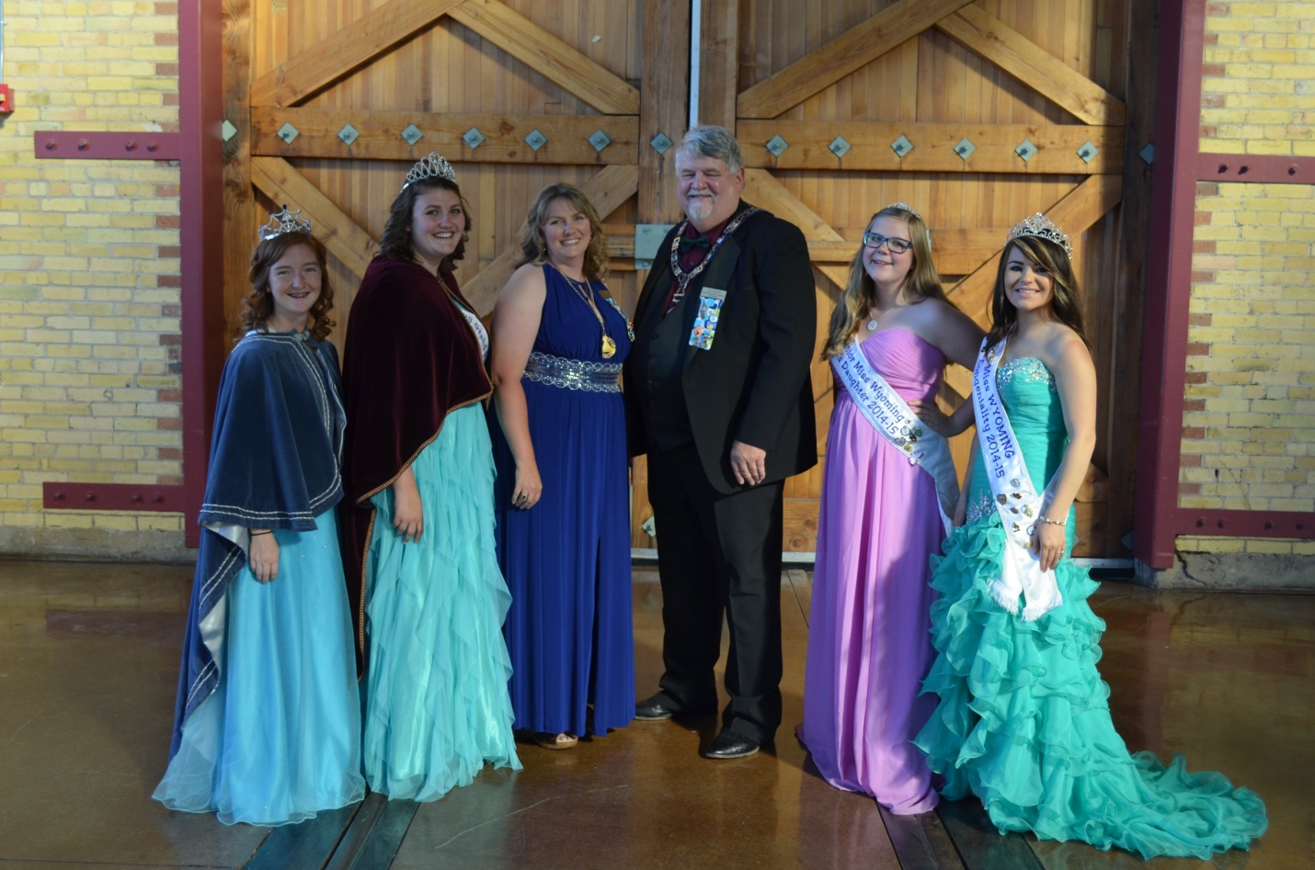

**OUR DIGNITARIES**

**SAMI COLE-MISS WYOMING**

**JOELENE RAMIREZ- GRAND BETHTEL HONORED QUEEN**

**MONICA RAMIREZ, RON SIEKERT,**

**SHARA BETH AARON-JR.MISS WYOMING**

**TONI PREGO-MISS CONGENIALITY**

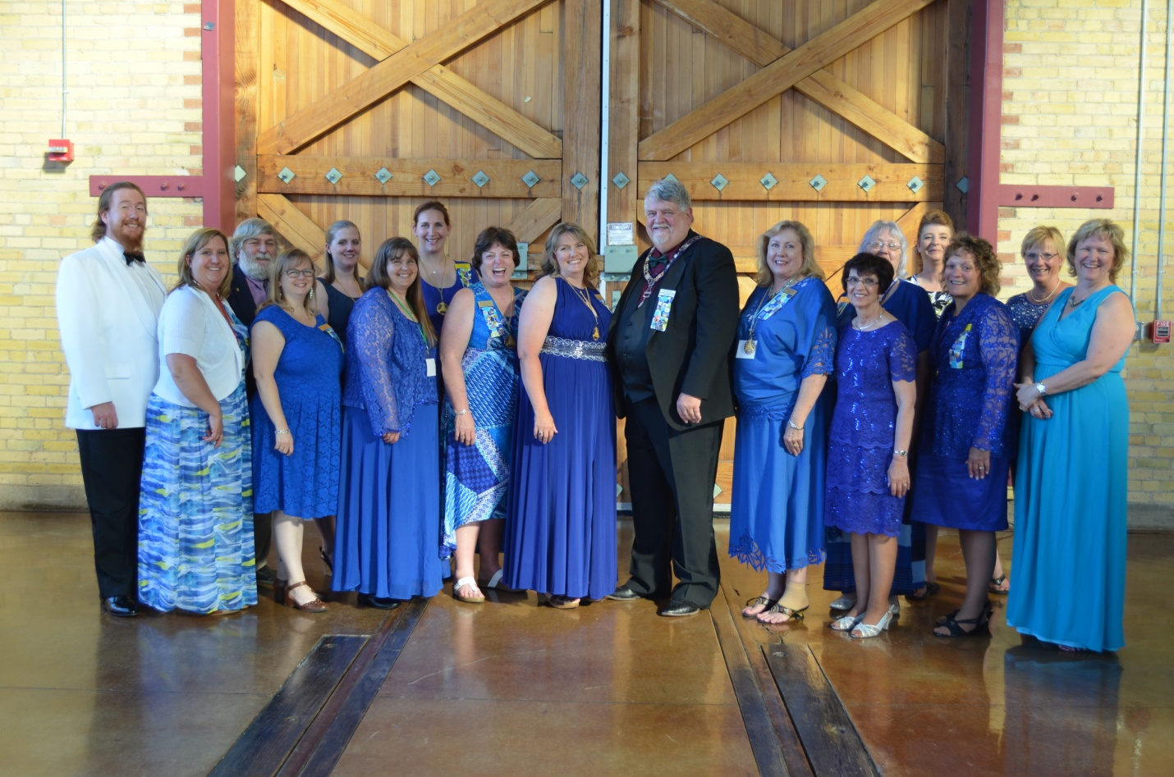

**GRAND COUNCIL**

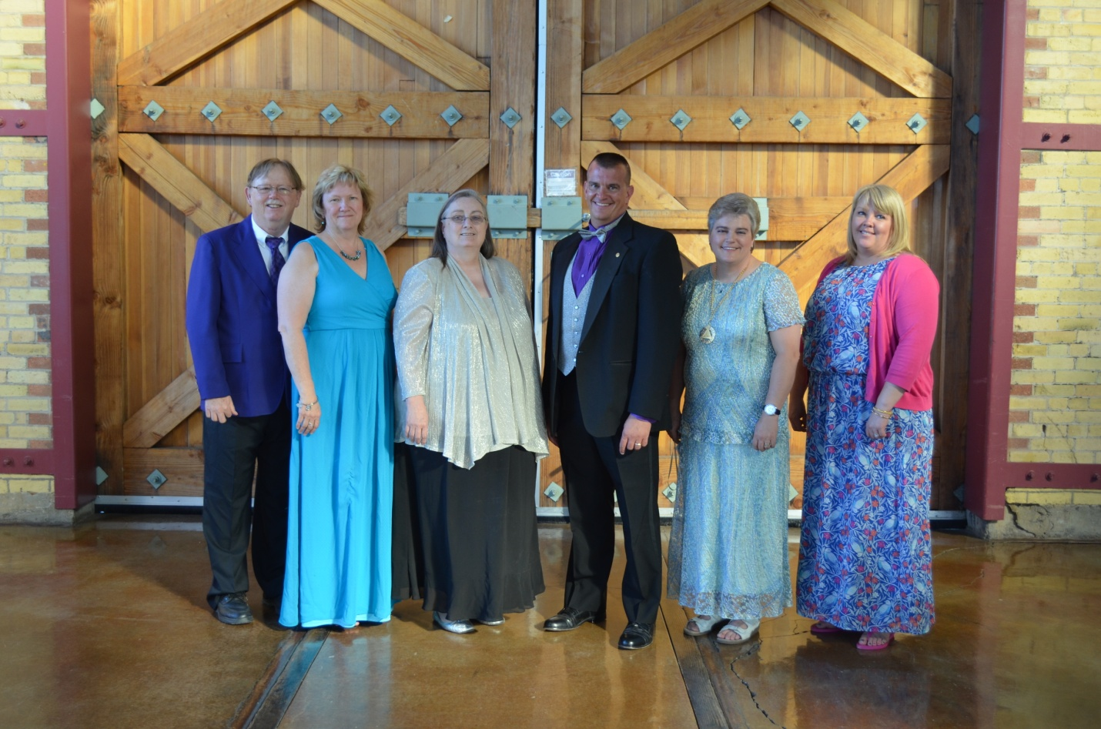

**GRAND BETHEL TRUSTEES**

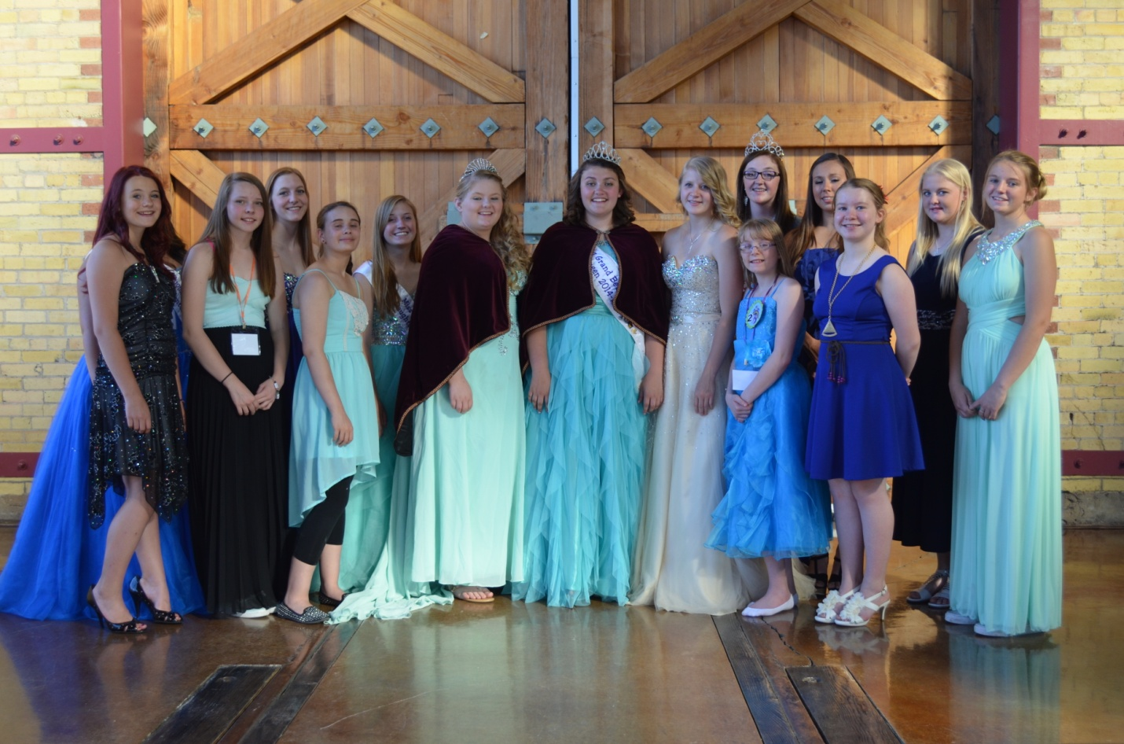

**GRAND BETHEL OFFICERS**

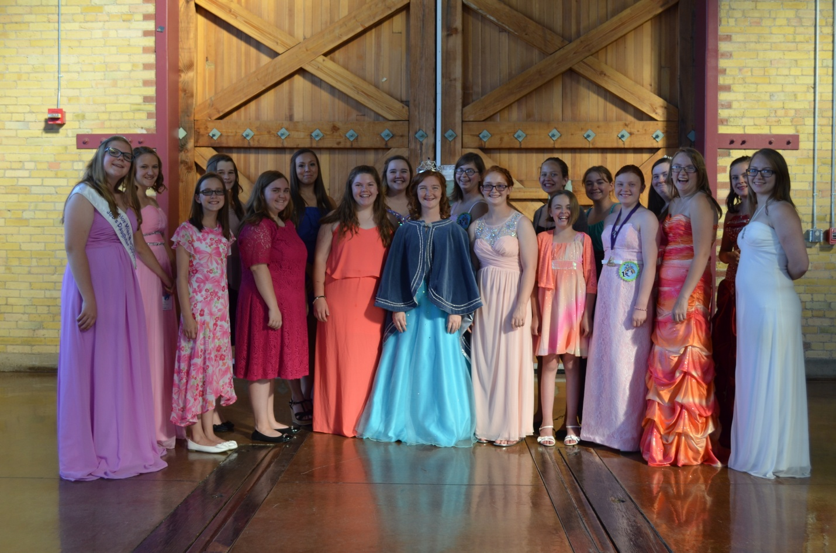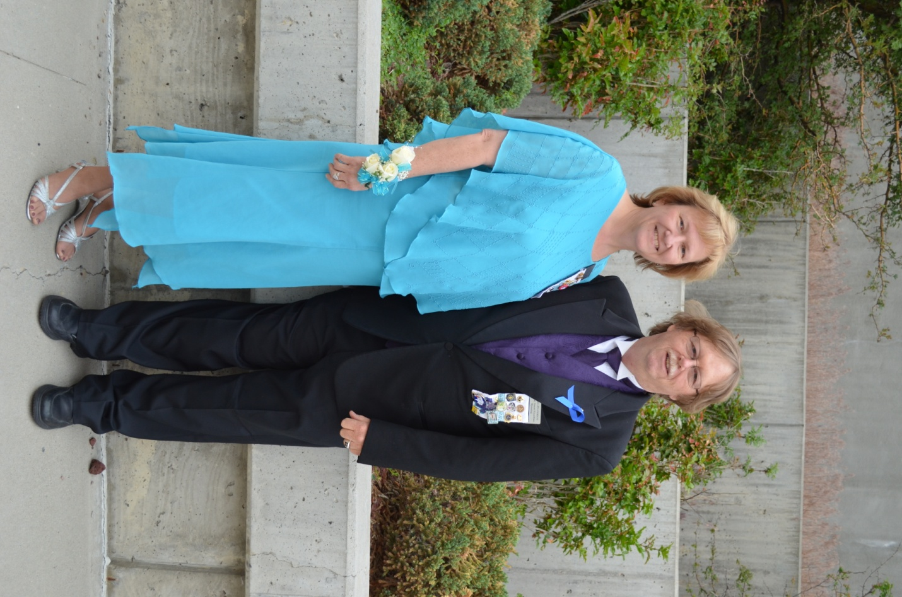

**GRAND BETHEL REPRESENTATIVES**

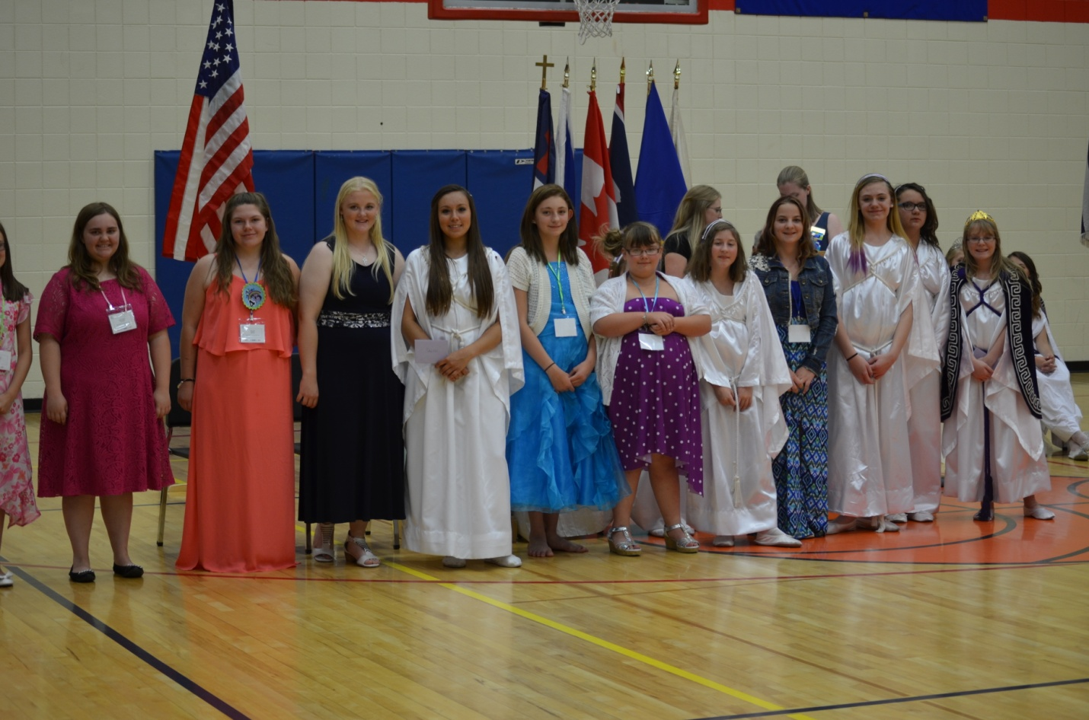

**MEMBERSHIP WINNERS**

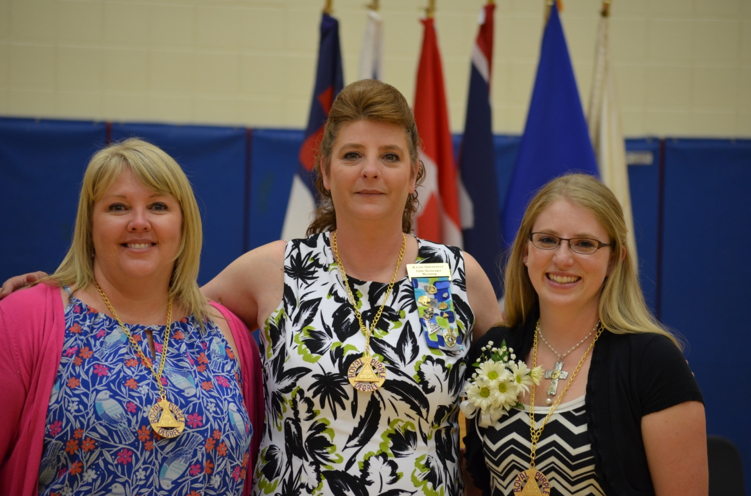

**DORP RECIPIENTS**

**CARA MC DANIEL**

**KATHY SHENEFELT**

**CHELSEA PORTER**

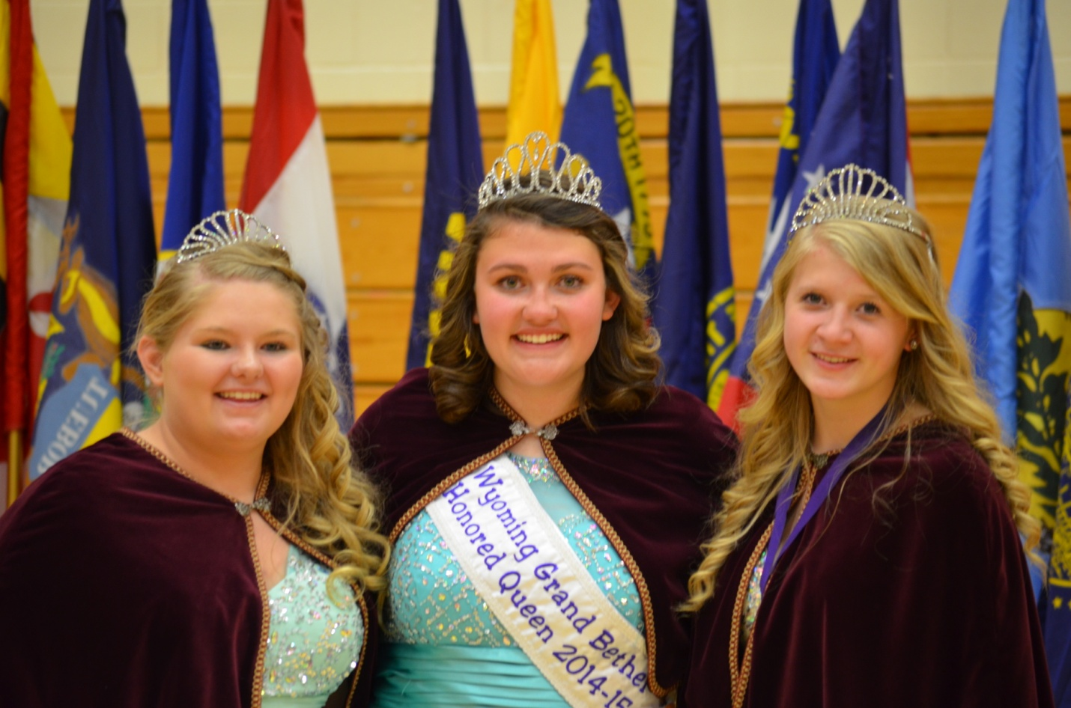

**GRAND BETHEL OFFICERS**

**WILLOW WALDOCK, SENIOR PRINCESS**

**JOELENE RAMIREZ, HONORED QUEEN**

**ANNIE COOKE, JUNIOR PRINCESS**



**JUNIOR MISS WYOMING CONTESTANTS**

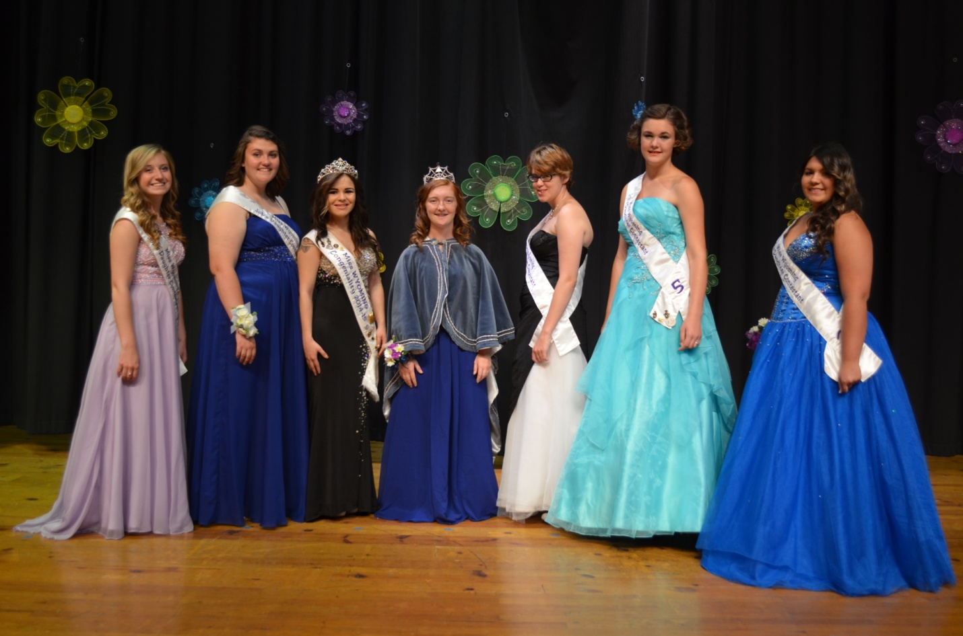

**MISS WYOMING JOB’S DAUGHTER CONTESTANTS**



**SUPREME MESSENGER TEAM-2015**