GRAND GUARDIAN COUNCIL

WYOMING

JOB'S DAUGHTERS INTERNATIONAL



PROCEEDINGS

87th ANNUAL MEETING

2019

CHEYENNE, WYOMING

GRAND GUARDIAN COUNCIL

OF WYOMING JOB'S DAUGHTERS

"Be Brave and Be Kind”

87th SESSION

AND

GRAND BETHEL

52nd ANNUAL SESSION

Cheyenne, Wyoming

June 12-15, 2019

**Casi Cole, Grand Bethel Honored Queen**

**Grand Guardian, Linda Cole**

**Associate Grand Guardian, Paul Lincoln**

**MOTTOS**

Cassi: Don’t let the world take away your roar!

Linda: Like a Butterfly, you are growing, and changing, and finding the true colors in life. You are finding your wings so you can fly, and soon be on your way.

Paul: Giving

**MASCOTS**

Cassi- Lion

Linda- Butterfly

Paul-Santa Claus

**COLORS**

Teal/purple, rainbow, red/white

**FLOWERS**

Cassi-Poppy

Linda-Peony

Paul: Lily of the Valley

**SONGS**

‘I Hope You Dance’ Lee Ann Womack

‘I Believe in You’ Amanda Marshall

‘Life’s a Happy Song’-from the movie ‘The Muppets’

**SCRIPTURE**

“Don’t be afraid, for I am iwith you. Don’t be discouraged, for I am your god.” Isaiah 41:10

**PROJECT**

VFW Foundation

HIKE

**GRAND OFFICERS**

**2018-2019**

GRAND GUARDIAN Linda Cole (1)

ASSOCIATE GRAND GUARDIAN Paul Lincoln (50)

VICE GRAND GUARDIAN Marge Christiansen (28)

VICE ASSOCIATE GRAND GUARDIAN Terry Wiekhorst (48)

GRAND GUIDE Susan Miner (7)

GRAND INNER GUARD Craig Henderson (22)

GRAND MARSHAL……………………………………………………………………Stacey Hays (50)

GRAND OUTER GUARD VAACANT

GRAND SECRETARY Kathy Wiekhorst (48)

GRAND TREASURER Joan Means (28)

GRAND CHAPLAIN Stephanie Aaron Ludwig(19)

GRAND DIRECTOR OF MUSIC………………………………………………..Cindy Selvey(28)

GRAND LIBRARIAN…………………………………………………………..Karen Stapleton (48)

GRAND FIRST MESSENGER……………………………………………..Tammy Timmons (5)

GRAND SECOND MESSENGER………………………………………………………………VACANT

GRAND THIRD MESSENGER ………………………………………….Dorthy Neumiller (28)

GRAND FOURTH MESSENGER …………………………………………….Deidra Wilson (22)

GRAND FIFTH MESSENGER ………………………………………..…Paula Henderson (22)

GRAND SENIORCUSTODIAN………………………………………………................VACANT

GRAND JUNIOR CUSTODIAN…………………………………………………..Steve Juhala (7)

**GRAND BETHEL TRUSTEES**

GRAND BETHEL GUARDIAN…………………………………………………….. Kya Gallo (3)

GRAND BETHEL ASSOCIATE GUARDIAN……………… Sid Anderson, PAGG (28)

TRUSTEE………………….………………………………………………….. Jessica Blackman (3)

TRUSTEE…………………………………………………………….. Regis Michelena, PAGG (7)

TRUSTEE……………………………………………………………….Monica Ramirez, PGG (50)

TRUSTEE………………..……………………………………………………………….. Ray Miner (7)

TRUSTEE (ex officio)…………………………………………….. Erin Jespersen, PGG (20)

TRUSTEE (ex officio)…………………………………………… Regis Michelena, PAGG (7)

**GRAND BETHEL OFFICERS**

**2018-2019**

HONORED QUEEN Casi Cole (1)

SENIOR PRINCESS Indica Gallo (3)

JUNIOR PRINCESS Jessyka Smith (48)

GUIDE Madalyn Burks (20)

MARSHAL Shara Aaron (19)

CHAPLAIN Aris Shank (50)

RECORDER Heidi Juhala (5)

TREASURER Dolores Neumiller (28)

LIBRARIAN Hailey Matevier (3)

MUSICIAN…………………………………………………………………………………Katelyn Ott (20)

PARLIAMENTARIAN open

1ST MESSENGER Alex Henderson (19)

2ND MESSENGER Tillie Merchant (28)

3RD MESSENGER Cassidy Kellum (48)

4TH MESSENGER Morgan O’Neill (50)

5TH MESSENGER Hannah Fike (50)

INNER GUARD Taeryn Hallman (3)

OUTER GUARD Shelby Luttrell (20)

SR. CUSTODIAN Erin Darlington (48)

JR. CUSTODIAN Avey Jespersen (20)

FLAG BEARER Marissa Grice (50)

1stPAGE Karlee Fisher (3)

2ndPAGE Rian Hallman (3)

**GRAND BETHEL REPRESENTATIVES**

**2018-2019**

ALBERTA/WISCONSIN………………………………………………………….Katalina Crain (7)

ARIZONA/MICHIGAN…………………..…………………………………………..Holly Lake (48)

BRAZIL #1……………………………………………………………………..Madison Sutphin (28)

BRAZIL #2………………………………………………………………………..Erin Henderson (19)

BRITISH COLUMBIA…………………………..…………………………………….Lola Armajo (3)

CALIFORNIA 1……………..………………………………………………Hailey Moorehouse (20)

CALIFORNIA 2…………………………………………………….……………Natalee Ramirez (50)

COLORADO/VIRGINIA…………………………………………………………….Shelby Pavey (1)

DELAWARE/PENNSYLVANIA…………………………………………………Charlie Smith (48)

FLORIDA/KANSAS Kylynn Derringer (50)

IDAHO/OKLAHOMA Alexis Bone (28)

ILLINOIS/QUEENSLAND Ashley Anderson (48)

INDIANA Alyssa Wondercheck (20)

IOWA/MISSOURI………………………………………………………………………..Lucy Pavey (1)

KENTUCKY - SOUTH DAKOTA……………………………………………….Iona Beasley (50)

MARYLAND/SASKATCHEWAN……………………………………………….Kylee Brooks (20)

MINNESOTA/NEW MEXICO Mari Anderson (28)

MANITOBA/PHILLIPINES Allison Ott (20)

MONTANA/ONTARIO…………………………………………………………….Ada Rose Lee (28)

NEBRASKA Taylor Morgan (50)

NEVADA/UTAH Kendzy McIntosh (20)

OHIO/WASHINGTON Lainey Sekerka (20)

OREGON…………………………………………………………………………….Josie Anderson (20)

**COMMITTEE CHAIRMEN**

**2018-2019**

**APPEALS & GRIEVANCES**

Marge Christiansen, PGG, Erin Jespersen, PGG, Don York PAGG

**ARTS & CRAFTS**

Paula Henderson, PBG, Grand 5th Messenger

**CAV ADMINISTRATOR**

Margie George, PGG

**CHOIR COMPETITION**

Cindy Selvey, PBG, Grand Director of Music

**COURTESY**

Paula Henderson, PBG

**CREDENTIALS**

Margie George, PGG, Mike James, PGAG

**DEGREE OF ROYAL PURPLE**

Grand Bethel Trustees

**EDUCATIONAL SCHOLARSHIP**

Linda Cole, GG

Paul Lincoln, AGG

Marge Christiansen, VGG

Terry Wiekhorst, VAGG

**FINANCE**Linda Cole, GG, Marge Christiansen, PGG, Mike James, PAGG, Margie George, PGG

**FORGET ME NOT**

Linda Cole, GG

Paul Lincoln, AGG

**GRAND SESSION ARRANGEMENTS 2019**

Monica Ramirez, PHQ, PGG

Stacey Hays, PHQ, PG

**HIKE FUND**

Maria Criswell, PGG

**HONOR BETHEL**

Susan Miner, PHQ, PG

Craig Henderson, PAGG

**JOBIE TO BE, PROMOTIONS AND MEMBERSHIP**

Joelene Ramirez, PHQ,

Casi Cole, PHQ, GBHQ, Shara Beth Aaron, PHQ, Miss Congeniality

**JR. MISS WYOMING JOB'S DAUGHTER**

Stephanie Ludwig, PHQ, PBG, Heidi Finn, PHQ, Sami Cole, PHQ, PMWJD

**JURISPRUDENCE**

Monica Ramirez, PHQ, PGG, Roger Means II, PAGG, Regis Michelena, PAGG

**LIBRARIAN-SCRAPBOOK**

April Ott, Grand 2nd Messenger

**LOCATIONS**

Susan Miner, PHQ, PBG, Grand Guide   
Craig Henderson, Grand Inner Guard, PAGG

**MISS WYOMING JOB'S DAUGHTER**

Stacey Hays PHQ. BG, DORP

Kylee Lewis, PHQ, PMWJD, Deidra Wilson, PHQ

**NECROLOGY**

Stephanie Ludwig, PHQ, PBG, Ggrand Chaplain

**PARLIAMENTARIAN**

Sid Anderson, PAGG

**PERFORMING ARTS**

Dorthy Neumiller, PBG

**PUBLICATIONS**

Kathy Wiekhorst, PHQ, PGG

**RITUAL COMPETITION**

Stacey Hays, PHQ, PBG, Grand Marshal

**SEWING**

Marilyn Giffin, PHQ, PBG, DORP

**SUMMER CAMP 2019**

Susan Miner, VGG and Craig Henderson, VAGG, PABG, PAGG

**WEBSITE**

Marge Christiansen, PBG, PGG

**WEDNESDAY - JUNE 12, 2019**

The 87th Annual Session of the Grand Guardian Council and 51st Annual Session of the Grand Bethel of Wyoming was held on June 12, 13, 14, & 15th, 2019 at the Red Lion Hotel and the Masonic Temple in Cheyenne, Wyoming.

The Formal Opening was held following a delicious Christmas dinner for the Formal Banquet, in honor of our AGG Paul Lincoln.

**FORMAL OPENING**

Formal Opening was held at the Cheyenne Masonic Temple at 7:00 p.m. Past Grand Guardian Erin George, PGG and Past Associate Grand Guardian Mike James, welcomed everyone to Formal Opening and Grand Session.

**ENTRANCE OF GRAND BETHEL REPRESENTATIVES, OFFICERS, GRAND BETHEL OFFICERS, HONOR BETHEL, GRAND GUARDIAN, ASSOCIATE GRAND GUARDIAN**

The Grand Bethel Guide and Grand Bethel Marshal escorted the Grand Bethel Representatives into the Bethel Room. The Grand Bethel Officers and the Grand Council officers entered the Bethel room per the ritual. The Grand Bethel Guide, Grand Guide, Grand Bethel Marshal and Grand Marshal retired and escorted the Grand Guardian, Associate Grand Guardian, Grand Bethel Honored Queen Miss Wyoming and Miss congeniality and Jr. Miss Wyoming to the altar and then they were escorted to the East and were introduced.

**INTRODUCTION AND PARADE OF HONORED QUEENS FOR THE YEAR 2018-2019:**

Bethel #1: Cassi Cole

Bethel #3: Madison Turney

Rian Hallman

Bethel #5: Jada Timmons

Bethel #7: Jade Weaver

Bethel #19: Alex Henderson

Erin Henderson

Bethel #20: Avey Jespersen

Katelyn Ott

Bethel #28: Dolores Neumiller

Bethel #48: Jessyka Smith

Bethel #50: Natalee Ramirez

**PROCESSION OF DISTINGUISHED GUESTS**

As GBHQ Casi read the names of the Distinguished Guests they approached the east and then took their seats.

Miss Wyoming Job’s Daughter: Morgan O’Neill

Miss Congeniality: Shara Aaron

Jr. Misd Wyoming Job’s Daughter: Lola Armijo

Supreme Bethel Officers and Representatives:

Natale Ramirez: Supreme Bethel Sr. Princess

Past Grand Guardians and Past Associate Grand Guardians:

Sid Anderson, 1992-93

Margie George, 1999-2000

Joan Means,2000-2001

Mike James, 2002-2003, 2015-2016

Kathy Wiekhorst-2004-05

Maria Criswell-Terry Wiekhorst. 2005-06

Marge Christiansen- Craig Henderson, 2013-14

Erin Jespersen- Regis Michelena 2017-2018

Other Masonic Dignitaries:

Barb Boster: Worthy Grand Matron WY Order of the Eastern Star

Thomas Hamm II: Right Worshipful Deputy of the Grand Lodge of Wyoming, AF and AM

Wayne Long: Most Illustrious Grand Master of Cryptic Masons of WY

Harry Furry, Right Excellent Deputy Grand High Priest

**PRESENTATION OF THE HOLY BIBLE**

The Holy Bible was brought into the Bethel room by the Grand Bethel Guide, Grand Bethel Marshal, and Grand Bethel Chaplain.

**PRESENTATION OF THE FLAGS**

All flags were previously placed in the East.

The Grand Bethel Chaplain, Aris Shank, lead the body in the Lord's Prayer and Stacey Hays, Grand Marshal made the Proclamation.

**WELCOMES**

Justice Kari Grey welcomed us to Cheyenne. She is a PHQ of Bethel #10 in Lusk, and shared her experience in Job’s Daughters. “The story of Job has always been an important part of my life. Service is an important part of Job’s in the community. It makes you a better person. In Job’s Daughters you have a role to play, a very important part to do. Public speaking will serve you well throughout your lives. Everyone’s well being is important to you. As the newest Justice of the Wyoming Supreme Court, I have learned to be dedicated to doing things well and right.”

**COMMUNICATIONS**

There were no communications read.

**DEGREE OF ROYAL PURPLE**

The Grand Bethel Officers presented the Degree of Royal Purple to Patti Kiernan, Bethel #48.

**Forget Me Not Ceremony**

The Forget Me Not Ceremony was performed by Honor Bethel for Joelene Ramirez, #50 and Sami Cole, #1

**NECROLOGY CEREMONY**

Stephanie Ludwig, Grand Chaplain led the ceremony assisted by the following chaplains, Ashley Anderson #48, Lucy Pavey #1, Hailey Metevier #3, Shara Aaron #19, Kylynn Derringer #50, Morgan O’Neill #50, Adarose Lee #28, Avey Jespersen #20 Erin Henderson #19 Aris Shank, Grand Bethel Chaplain.

**PRESENTATION**

Sami Cole presented wooden carved photo albums to her mother, Linda Cole, GG and her sister, Casi, GBHQ.

Flowers were received from the Grand Master of Masons AF and AM.

**REMARKS**

Remarks were given by the following distinguished guests: Wayne Long, Illustrious Grand Master, Council of Cryptic Masons, Barbara Boster, Worthy Grand matron of OES, Harry Furry, Right Excellent Deputy Grand High Priest. Letter was read from William Neumiller, State Master Councilor, Natalee Ramirez, Supreme Senior Princess, Indica Gallo, GBSP, Thomas Hamm II, Right Worshipful Deputy Grand Master of te Grand Lodge A.F. & A.M. of Wyoming.

**FAREWELL SPEECHES**

**ASSOCIATE GRAND GUARDIAN**

**PAUL LINCOLN**

Girls, it’s been a wonderful year! Young ladies you have made me proud. You, young ladies and your council are those doing all the work. This is the start of your life. Thank you so much for giving me the honor of representing you this year and tonight!

**GRAND BETHEL HONORED QUEEN**

**CASI COLE**

Crazy year, over 6,000 miles. I wouldn’t be here tonight without the support of so many people. Bethel#1, I am so proud of the bethel we are building. Mike and Nan you have been like a second set of parents to me. Kya and Indica, and Bethel #3 for letting me share you.

Zack you are my rock.

To the state of Wyoming and the Grand Bethel Officers. It has been an amazing honor to work with you all.

Monica, Joelene and Natalee; thanks for all you have done for me. It has been an amazing time to watch you do your work.

**GRAND GUARDIAN**

**Linda Cole**

Welcome everyone to Grand! Please give Monica Ramirez and Stacy Hayes a big round of applause for all the work they have done! Thank you, Bethel 50 for being our hosts for this year’s event. You girls are awesome!

Thank you to our distinguished guests. Your being here shows our daughters that they are part of the Masonic family and the other parts of that family do care about them and want them to succeed.

How many of you have ever volunteered for something and didn’t really know what it was that you were volunteering for? That was me a few years ago when I raised my hand in a meeting thinking, yeah, I can do that for a year. I was not part of the Jobi world until Sami was initiated at the tender age of 10, and at the time I was in or just getting ready to start nursing school, so I didn’t get very involved. It wasn’t until Bethel 1 was getting very limited on parental help that I it was time to step up and help, but I still didn’t really understand all the lingo, the processes, the lines…

So when I was elected to Grand Marshall, and then informed I was now in the line to become Grand Guardian, I squeaked and nearly hyperventilated. I secretly hoped I would get voted out of the line before I made it to that point. Alas, here we are. Finishing my time as Grand Guardian of Wyoming Jobs Daughters. I have enjoyed 99% of my time as I went up the line. I enjoyed all the time I got to spend on the road traveling and doing all the activities and events that we have gotten to do. From camp to scavenger hunts, sleep overs and even meetings, I enjoyed them all.

Wyoming Job’s Daughters is alive and well. We have a couple bethels really growing, we have some that are at a stand still, but all the girls here today love this organization and all that goes with it. You have friends across the state, you have friends for life.

Our theme or motto this year was Be Humble and Kind. Santa Clause is the most kind person any child or person can imagine, and ours is no exception. Mr. Paul Lincoln enjoys visiting with, teasing, doing most any activity with the people involved with anything Masonic. He and his travel partner Melanie were at almost every event and always smiling. The bells, however, were another story. I think we are all glad that the bells will be going into hibernation after this weekend! Thank you Paul for going up the line with me, and thank you Mel for being my friend and always having a smile and hug for me.

Cassidy, Morgan, Shara, and Lola, It takes a lot of bravery and confidence to shoot for the positions you girls held this year. You all put in a lot of time and effort to learn parts, look the part of the Jobie, be able to talk in front of crowds and be friends to all. Thank you, girls for being part of my Grand Family. You all have bright futures ahead of you and I can’t wait to see how you all blossom and spread your wings.

Thank you to my Grand Officers, my deputies, our executive council. You helped keep my going the right direction and looking like I might have an idea of what I was doing. But we all know that the one who really runs the show, and keeps us all in line and doing what we are supposed to is Mrs. Kathy Wiekhorst. She has worked many long hours getting reports, lining up conference calls, suggesting to me what I should be doing next, what I need to think about, and the biggest project that is finally complete was getting our bylaws rewritten and approved by Supreme. With the help of Terry they tackled that project head on, did every redo, that was requested and are both still smiling.

My family knows that I don’t do numbers well. I have a difficult time remembering numbers and try not to work with them too much. Joan Means, you are one of the people I most admire. You take care of our financials and I wouldn’t do that job for all the money in the world. Thank you for working so well with Kathy, to make it all look streamlined and as efficient as it can be. You two are our Dynamic Duo! I hope you enjoy the gifts I have for you.

Bethel 1! Thanks for sharing me with the rest of the state. Love you girls! Mike James promised to help me through this process from the time I put my hand in the air and said I would be Marshall. He has done that, and remained my friend. Nan is also someone I trust to steer me right, as she was a Jobie and has been part of the Jobies as an adult a lot longer than she probably cares the say. Thank you both for being the cornerstones of Bethel 1 for so long, and being wonderful examples to our kids.

This year would not have been possible without my own daughters. Since I didn’t know Grand Bethel from Honor bethel for a long time, I obviously needed some serious assistance. Sami was my right-hand girl. She tried her best to keep my on track, focused, correct, hopefully not looking like a fool. Sometimes I just happened. She was a great taxi driver for me. She hauled my stuff and helped me get it into and back out of meetings. Not sure how I’m going to be able to function with out my right arm since she is going back to school.

We all know the title “Hot Mess.” Cassi and I decided early on that we were the Hot Mess Express. Behind the scenes we were crazy, frazzled, nervous. But when we arrived, we mostly had our poop in a group and could function as intended. A little later I saw a meme on Facebook and decided I was pretty much a spicy disaster waiting to happen. So, we had a Hot Mess with a Spicy Disaster driving around the state. Yikes! We had some very good talks, that is one thing about traveling the way we do. Lots of windshield time can mean lots of time to either really get to know the people in the car with you, or it can become a cocoon of comfort where you can start talking, venting, crying, arguing, planning, getting out all the anxiety, fear, nerves that you have just waiting for the right time to surface. Oh, yeah, also that is wonderful time to be practicing your parts, getting things memorized!

It has been a fast and good year. I chose the butterfly as my mascot because of the changes it goes through. We all begin life small, crawling around, eating, like a caterpillar. Then we grow and change. The caterpillar goes into a dark, quiet place where it is protected. Then it breaks free, spreads it wings and flies. All of us are like that. We grow, change, and have opportunities to fly and live. Job’s Daughters give you a place to learn skills, learn to communicate, how to plan an event or project, how to build relationships and support each other. It helps prepare you to spread your wings and fly. All the people here want you girls to be happy, healthy, productive members of the world. We want you to be you. Love each other, have faith that never fails. Be brave enough to speak up, find your voice, don’t let the world keep you quiet, spread your wings, have a little fun a long the way. Be humble, don’t boast about your own successes, but praise others to success. And be kind.

Grand Marshal Stacey Hays made the proclamation and we adjorned until tomorrow.

**THURSDAY, JUNE 13, 2019**

Registration continued throughout the day. Ritual competition and performing arts competitions, arts and crafts, sewing and scrapbook judging took place, as well as formal opening practice. took place took place at the Red Lion. Miss Wyoming competition and the Jr. Miss Wyoming Job's Daughter meet and greet and competition began at 11 at the Cheyenne Masonic Temple. A delicious BBQ was prepared on the grounds of the Lions Park by the Cheyenne Shrine Club in Cheyenne. Cheer leading tryouts took place at the park during the picnic.

After the picnic, we returned to the Red Lion for choir competition. Regis told his tractor jokes and many girls enjoyed getting up after the competitions and singing. It was a wonderful evening!

**FRIDAY MORNING - JUNE 14, 2019**

The Grand Bethel Meeting was held at the Red Lion Hotel in Cheyenne. The Grand Council Meeting was held in an adjacent ballroom.

**BUSINESS SESSION**

**FRIDAY MORNING, JUNE 14, 2019**

**Cheyenne- Red Lion Hotel**

Grand Guardian Linda Cole and Associate Grand Guardian Paul Lincoln welcomed all present and called the meeting to order at 9:00 a.m.

The American Flag was presented by Grand Marshal, Stacey Hays followed by the singing of the National Anthem and the Pledge of Allegiance.

Grand Chaplain, Stephanie Ludwig gave the invocation and Grand Marshal Stacey Hays made the proclamation to open the business meeting.

**INTRODUCTIONS**

GG Linda introduced:

PGG: Roger Means, Terry Wiekhorst, Joan Means, Kathy Wiekhorst, Marge Christiansen and Maria Criswell, and Craig Henderson

BG AND ABG: Artha Smith, Sami Cole, Tammy Rowland, Dorthy Neumiller, Steve Juhala, and Cindy Selvey.

PBG/PABG: Paula Henderson, Becki Arwood, and Jane Zuluaf

COUNCIL MEMBERS: Janel Couture, Mindy Grice, Shannon Beasley, Stephanie Aaron Ludwig, Jan Poppe, Marilyn Giffin, Kyle Polidora, April Ott, Karen Stapleton,Ashley Kiernan and Patti Kiernan.

SPECIAL GUEST: Morgan Crompton, PMWJD

Grand Secretary Kathy Wiekhorst moved that the minutes of the 2018 Annual Session be approved as sent by email in the Proceedings to all Bethels and Individuals. Joan Means seconded the motion. Motion Passed.

**CREDENTIAL COMMITTEE PARTIAL REPORT**

**Margie George, PGG**

|  |  |  |
| --- | --- | --- |
| Grand Guardian | 1 |  |
| Associate Grand Guardian | 1 |  |
| Other Grand Officers | 9 |  |
| Past Grand Guardians | 4 |  |
| Past Associate Grand Guardians | 5 |  |
| Bethel Guardians | 5 |  |
| Associate Bethel Guardians | 1 |  |
| Past Bethel Guardians | 11 |  |
| Past Associate Bethel Guardians | 0 |  |
| Guardian Secretaries | 1 |  |
| Guardian Treasurers | 3 |  |
| Guardian Directors of Music | 1 |  |
| Guardian Directors of Epochs | 1 |  |
|  |  |  |
| TOTAL VOTING DELEGATES | 43 |  |
| TOTAL NON-VOTING DELEGATES | 3 |  |
|  |  |  |
| TOTAL BETHELS REPRESENTED | 10 |  |
| TOTAL JOB’S DAUGHTERS | 59 |  |
| PARTIAL TOTAL REGISTERED AT THE 87th GRAND SESSION - JUNE 2019 CHEYENNE, WY 105 |  |  |
|  |  |  |

CREDENTIAL COMMITTEE: Margie George, PGG

**GRAND GUARDIAN FAREWELL**

June 14, 2019

Linda Cole, GG 2018-2019

Thank you for the opportunity to serve in such an integral position in Job’s Daughters of Wyoming. A few years ago, I put my hand in the air at a grand council meeting to volunteer for a position I thought would be a one and done thing. My daughters had been in Jobs for several years, but I had only helped a little and didn’t understand how it worked. After I volunteered and was voted to be the Grand Marshall, Laura Waldock, who was sitting next to me was looking at me, with a dumb founded look on her face. I said “What?” She said, “do you realize what you just did?” Then giggled and said I had just put myself in the line to be Grand Guardian. I squeaked and asked why she didn’t slap me, she said she was too stunned. While I was processing that information, here comes Sami, who had been in the daughter’s meeting. She was also stunned, and it looked a little panicked. Mike James was also giggling at me. I had hoped through the last few years that you would all vote me out of the line. Obviously, not and now I have completed my run up the line.

I had a wonderful example to follow, thank you Erin Jespersen for being so organized, excited and purposeful during your year as Guardian. You made it easier for me to follow and learn from you.

I was also lucky enough to travel with Cassi all year and share this experience with her. Between her and Sami, I had 20+ years of Jobie experience in my ear; trying to keep my doing the right thing at the right time. They very much follow rules and tradition, not much room for creativity and variation. Whenever I tried to think out of the box, one of them would pull me back. Sami was our driver for several of the visits and events. If Sam couldn’t make it the Hot Mess Express was running off the rails, kinda. I traveled 6,424 miles this year. This included most recent trip to the Shrine Hospital. I had never been there before and did enjoy it. Thank you to Kathy for hosting dinner the night before!

We started our year off with summer camp that Monica and Terry had planned for us. The Jobie Olympics was really fun, as were the pranks and I loved the butterfly sand art! Camp Story is a wonderful place to get away from our normal stuff, unplug from the main world and relax. However, after talking to a couple people, our attendance may be down due to the fact is has been the month right after Grand and if families have to pay some for grand then pay for summer camp when we are supposed to be not doing anything, may be causing either a financial choice or family time choice.

Supreme was in Layton, UT in late July last year. We had a Supreme team, a majority team and several girls compete in individual ritual and performing arts competitions. I had never been to a supreme before, so this was also new for me. It was a little crazy, but fun seeing the girls compete on a much larger stage. Our own Stephanie Ludwig was asked to do service before breakfast one of the days and did a fabulous job. We are so proud of her and where she is being called to serve and touch young Jobies.

Fallapalooza was in Evanston and was at the same time as a community celebration so there was extra stuff to do and learn about that part of the state. The meeting was good, and more fun was had. Winterfest was in Casper in February and we hosted the Supreme Guardian, Supreme Bethel Honored Queen and Supreme Miss Congeniality. We had a sleepover, ice skating, a fun craft; fun was had by all. Spring Fling was in Rawlins in March. Again, there were crafts, a sleep over, a meeting.

In April I, Marge Christiansen, and Bethel 5 held a paint event in hopes of attracting more girls to learn about Jobs. Sadly, only one non-Jobie showed up and she wanted to do the picture we were doing and had a free card, as she was a frequent patron of the business. We will need to do more work in that area to get them growing again.

We still have 10 Bethels. Three are under reorganization. Douglas, Laramie, and Sheridan are in Reorg. Douglas grew by three girls this year and have three that will come in the fall. Sheridan presently has a couple of adults and possibly a couple girls. Laramie had little desire to continue after this honor queen finished her term. They had decided to help each other get their honored queen pin and then be done. They want to focus on other activities in their lives. The lone girls from Laramie to be active is Isabel. She has traveled to many state events, riding with other bethels, riding to Supreme and back with me, and if her dad was available, he would bring her. We have not seen the treasurer’s book from that bethel in years and when Kati Hime and Kyle Polidora went to the bank to see what exactly was in the accounts there were some without either of their names on them. In light of the lack of support for that bethel in that town, we have decided to close that bethel. The girls are going to get their past honored Queen pins and do a closing ceremony in the coming months. The other bethels are holding their own or growing.

On a positive note, Sarah Dike, in Lander, held an informational event and has seven petitions out. I hope we are able to put some focus in that area and maybe open a new bethel.

This year we re-implemented deputies to the bethels. This was a great thing for me, as the deputies were a resource for the bethels and were past grands who could advise and hopefully guide them, where I may not have been the best choice to guide. I want to thank those of you who were my deputies. You took a lot of stress out of my life and made me feel much better about my year.

Financially we started off in not as good a place as in a year’s past. My chosen fund raiser and doing it late in the year were not good choices. Marge and Terry did an awesome nut fund raiser and we are looking better. Thank you Joan Means for continuing to be our Treasurer. You are a gem that is treasured by all of us in the family of Jobs Daughters Wyoming.

We are kept on track and organized by the Ever-Awesome Kathy Wiekhorst. I would not have been able to do anything without her. She is the glue that keeps us all together and running as smoothly as she can. She can only work with what she is dealt, so sometimes her hands are full of jokers and jacks. Sorry for that Kathy. But at least we are a fun bunch! She and Terry deserve a special thank you because they did all the reformatting of he bylaws so that they would be acceptable to Supreme leadership. There was another job I’m pretty sure no one wanted to do and they did it with only a mild amount of complaining. It was totally deserved to be able to rant and rave about the process. And a HUGE THANK YOU to both of you!

I think we all can call Kathy and Joan the Dynamic Duo of Job’s Daughters. Pretty sure none of us wants to try to take on either of those jobs yet.

I also want to thank Paul for going up the line with me. The bells just about got you strung up by your toenails, but Santa Clause is always a welcome person at any party, any time of year. It reminds all of us to be happy and generous. Melanie is a trooper for going all the miles that you and she have gone this year.

I’m looking forward to just being responsible for Bethel one. I am honored to have been given this opportunity and look forward to working with all of you in the future.

Respectfully Submitted

Linda N Cole

Grand Guardian of Wyoming Job’s Daughters

2018-2019

**GRAND BETHEL HONORED QUEEN FAREWELL**

**Cassi Cole, PHQ**

This year has flown by and I have had a blast traveling to each bethel and all of the state events. I have traveled approximately 6,650 miles and was able to attend all of the grand visits, along with all of the state events. I started out the year by traveling to summer camp in Story. This was such an amazing time participating in the “Amazing Race” and getting to spend time with a lot of the girls to start the year. After summer camp, I traveled to Supreme in Salt Lake City. Supreme was an amazing experience and I met tons of new friends and as always it was a blast. After Supreme, I got the chance to attend Grand Chapter of Eastern Star in Casper and watched their opening and speak on behalf of the daughters of Wyoming. Next was Grand Lodge and this was an awesome and very eye-opening experience for me and one that I will never forget. This was the end of my summer travels and the first part of the year. Next was Fallopalooza in Evanston, where we got to take a scavenger hunt around downtown and learn more about their bethel and town. Then we kicked off the grand visits with Bethel 20 and 50, even though the weather delayed them a little bit they were still very enjoyable. Next was Winter Fest, in Casper, where the Supreme Guardian, Pam Henderson, SBHQ Casey Bowles, and MIJD Kayleigh Pierson joined us. I was able to room and spend some time with both Casey and Kayleigh; it was fun to share stories and hear of their travels. Then we finished off the Grand Visits with Bethels, 28, 48,19, 1, 7, 5,2, and 3. All of the bethels did a wonderful job during their grand visits and it was awesome to see the differences in each one. Finally, we finished up the Grand Bethel state events with Spring Fling in Rawlins where we had our spring Grand Bethel meeting and enjoyed swimming and some fun arts and crafts. My final travel adventure for the year was to the Shrine Hospital in Salt Lake City. This was an amazing experience that I will absolutely never forget. Throughout this year, I did a fundraiser of selling crosses and the money will be donated to the Guernsey VFFW post #4471 after Grand is completed. As of today, I have made $105.00, but have a few left to sell until after installation. Thank you for the amazing two years, I couldn’t have imagined them any differently.

Respectfully submitted,

Cassi Cole GBHQ 2018-2019

**ASSOCIATE GRAND GUARDIAN FAREWELL**

**Paul Lincoln, PABG, AGG**

To the Grand Guardian council, trustees and all others who are present, it has been a pleasure to serve in this position as Associate Grand Guardian of Wyoming. As most of you were present to remember, in June I got installed in Torrington Wyoming.

July 13-15 Jobie camp at camp story. 16 girls from bethels: 1, 3, 7, 20, 28, and 50. 15 adults were present at camp. Some of the girls played in the creek and chased a frog. They were unable to kiss him so he did not turn into a prince. The adults were spoofed by the girls who took their belongings and texted adults some riddles to find their clothes. The adults retaliated by saran wrapping their cabin intensely. In response to this, overnight the girls decorated the adult’s cars with saran wrap and crepe paper.

The girls and adults all had a great time. We escaped with three injuries, Delores broke her arm Iona twisted her ankle and Nora got a scratch from a door spring. Of the 16 girls three were Jobie to bee's. the girls had a good time at the campfire telling scary stories as they made them up.

(620 miles total travel for this event)

June 24 thru 27 Melanie and I traveled to Supreme in Layton Utah. WE drove 430 miles there and 430 miles back with approximately 100 miles of back and forth travel while in Utah. Melanie and I missed first day and last day. We went to all supreme council meetings passed many amendments. Jobies to bee program was present and beekeeper made official council member. They tried to make promoter of growing bethel. (???) part of mandatory council if under restructure. There was an amendment for changing jurisdiction girls only being eligible for scholarships because we were told they were only contributors to fund passed first day, second day it was brought out that every girl pays dues and part of dues went to scholarship fund. As a whole, we withdrew the vote on the amendment so it failed second attempt. Wyoming represented very well. Natalie was selected supreme bethel Sr. Princess. Linda, Sammy, Cassy Kathy, Natalie, Mindy, Marissa, Stacey, Morgan, girl from Laramie???? Erin, and her daughter Avery, Kathy W. Terri W, and one other council member, myself and Melanie all present.

Brazil, Philippine, Australia, and others present. It was very, very, hot the whole supreme session. Cheyenne had downpours and major hail each day we were gone. Our girls had many opportunities to enjoy Salt Lake City area. The supreme bethel opening was very beautiful. Melanie and I missed council installation and supreme bethel installation. Kyleigh Pierson from Oregon was elected miss international. I was not able to make time for me to visit shrine hospital as I had hoped to do during my visit to Utah.

In August we drove to Gillette to attend grand lodge open session. Linda, Cassie, Morgan, and one other daughter were present with myself and Melanie. The young ladies made a very good representation for Jobs Daughters of Wyoming and were presented with a check from Grand Lodge of Wyoming. We traveled 250 miles there and 250 miles back, for a total of 500 miles.

On Sept 11 we had our first EGG conference call. We discussed that Laramie was slow on turning in their council recommendations. One of the Bethels up north losing two daughters leaving bethel that only has 7 girls.

At our September meeting, Burn’s eastern star meeting, burns eastern star donated $500.00 to my travels.

On Sept 29 Morgan attended Cheyenne lodge #1’s 150 year birthday celebration, I went to support her.

On November 9,10,11 We travelled to Evanston for Fallopalloza Friday there were: pizza, games and tie dye shirts. Saturday there was a grand Bethel meeting. We went on a hike and find in old town with a train/hay ride. We went back to the temple for subway sandwiches for supper. Sunday morning we had church at the temple and a highly respected lawyer talked to our girls about ladies helping ladies succeed in life, girl power. There were some worries about driving in the snow due to weather warnings so most left early o beat storm. For this trip I added 650 total miles.

On November 17, our scheduled Torrington visit was postponed due to weather. It was rescheduled for 28 November. Due to conflicting schedules I was unable to make this visit.

On November 18 we had our Bethel 50 Cheyenne visit scheduled. The Grand Guardian postponed this visit due to weather, roads too slick to drive. Bethel 50 went ahead and had meeting with lunch before meeting. There was an initiation of a new girl that went on as planned. Cassie, Melanie, and I. were all in Cheyenne and attended their meeting. The preparation showed as the girls did a wonderful job in their initiation. This bethel was young girls, some even pro-tem but work was wonderful. grand visit rescheduled to Dec 3.

December 3 Bethel 50 grand visit went wonderful although young, the girls did a great job again. Bethel 50 scheduled kidnap masons breakfast but got cancelled due to lack of masons willing to participate and Bethel guardians husband in hospital.

I played Santa for Scottish rite language clinic Christmas party. There was great representation of Wyoming Job’s Daughters as Bethel 50 girls assisted passing presents to Santa for 92 children of language clinic scheduled. My Santa bells got stolen while I was giving presents and letting the children sit on my lap for pictures. There was nobody claiming responsibility.

We drove to Casper for winterfest.186 miles each direction February 2 thru February 3. painted pottery sock snowball fight. We had an impromptu GGC meeting. This also was a supreme visit. Afterwards, we had a go to church at Bethel Baptist church, 3030 poplar.

I tried to visit Bethel 50 to try to get my bells back day after Winterfest. I was not able to get my bells back. The next Tuesday I was given another chance at my regular lodge. Yahoo, I got them back in time for Casper grand visit.

Feb 10th grand visit Casper Wyoming, we drove to Casper and was given brunch before meeting. 183 miles each direction for a total of 366 miles. The girls initiated 2 new members. (1 was step/adopted sister of one of the older girls) the girls did a great job with pro-tems. The young ladies talked about doing things with DeMolay.

Charlie Moore passed away. Services were Sunday while I was gone to grand visit in Evanston. This was a great loss for all the youth in Wyoming as Charlie was a great supporter of the youth groups for a long time.

On February 16, 2019 I drove to Green River for grand visit. 271 miles one way. great carry in brunch after the meeting. The girls initiated two girls. The Jobies shuffle was performed fabulously. The girls and pro-tems did a wonderful job with meeting and installation. Kathy and Terri Wiekhorst mentioned two boys wanting to join DeMolay, after done in Green River, drove on to Evanston to spend night in motel provided by Evanston bethel.

Green River to Evanston 86 miles.

Evanston young ladies wanted to go without pro-tems. One pro-tem helped, but the ladies did a fabulous job and initiated 1 new girl. This new girl brought 6 family members to see her get initiated. There was lunch and cake after meeting. I mentioned DeMolay to council and was told that a Mason that was trying to start a chapter. He had at least 3 boys and 3 council. I suggested Green River and Evanston work together with Skype or something to make it more convenient. I discussed this again with Terry and he said he would talk to Green River Mason. Nothing will be done until after chemo treatments. we drove home to Cheyenne. Total miles this weekend 745 miles

Sheridan changed from next Saturday to next Sunday.

At the recommendation of GGC, Stacy went to Laramie for visit. 3 girls and one council no dressing out just informal meeting.

I traveled to Sheridan the night of February 23rd and stayed at the Dunmar hotel at Bethel #5s expense. We had lunch and then a meeting. There were only three girls and 2 council. The girls and council are worried about low numbers. There was no initiation, we talked to girls about newspaper add and doing a paint party for a fun activity with anyone able to attend. The three girls wanted to do the meeting without help except one grand girl did one of the princesses. They did a good job. The books needed a lot of work. The two council ladies bad been given some confusing information about how to do books. Cindy Selvey made reservation for us at a Best Western. Our total travel for this visit was 660 miles.

March 2nd we travelled in horrible ice roads to Douglas. Indica turned back to Cheyenne because of the miserable roads leaving Cheyenne. We got to Douglas after stopping to help one pickup load get out of their rolled over truck (no injuries) and then continued on. Two girls (10 and 14 year old sisters) were initiated. The Bethel girls were smiling and positive throughout initiation. This was a very good meeting. After the meeting we drove to Gillette and spent the night at Days Inn in Gillette at Douglas expense. In the morning it was so cold that my truck barely started, it was well below zero degrees. Our total driving was 497 miles and several hours waiting for fatal accident.

On March 10th we drove to Laramie Bethel 2 grand visit. There were 4 girls, 2 were ready to be done. Guardian Kati Hime was not happy with Linda and I after we talked to girls. We planted idea of making an attempt to save Bethel. There were no masons that showed up for grand visit and we were told that they do not show up. They did not have an Association Guardian due to none available. The 4 girls did meeting without pro-tems. There was no initiation. They installed their senior princess. Linda offered the girls a mother daughter granddaughter tea as a prospect party. The girls voted to accept it. My total travel for this visit was 100 miles. This meeting was very controversial, we had an emergency EGGC meeting to discuss what to do. it was decided to continue with plans to have mother daughter granddaughter tea on May 5th. Trying to find new girls to save Bethel. Stacey helped with activity.

March 16 sit with Jobies and DeMolay at a Jobie’s overnighter at temple. Played Jobies jeopardy. The night ended with o e of my boys being asked to leave.

May 17 bunco with Bethel 50

May 18 spaghetti dinner with Bethel 50

May 19 Bethel 50 meeting Colorado grand Bethel honored queen and two other Colorado representatives from Florence, and Denver. The initiation was cancelled due to stomachs flu.

I drove a total of 5244 miles in my travels and had all kinds of good times.

This brings me to the end of my term. Thank you so much for giving me the honor and pleasure of being a representative of the greatest youth leadership organization in Wyoming.

Thank you

Paul J. Lincoln

Associate Grand Guardian

Wyoming Job’s Daughters

**GRAND SECRETARY’S REPORT-2019**

**KATHY WIEKHORST, PHQ, PGG**

Grand Guardian Linda, Associate Grand Guardian Paul and members of Wyoming’s Grand Guardian Council:

This has been a good year for Wyoming’s Job’s Daughters! We have initiated many and people have “cleaned up” their rosters. The Membership report shows that we are down in membership, as a result of not carrying girls (who are now 26) on your annual report. The annual reports are a necessary “evil”, as that is how Supreme keeps track of majority, initiates, etc. So, please try to keep with the deadlines on everything; especially state events. The bethels putting on these events are dealing with caterers, and facilities and need a proper count. By the way, just for your information a jurisdiction has to be down to below 70 members before it loses its status as a Grand Guardian Council; so we are way far away from that and will continue to flourish.

My financial books for the Grand Guardian Council General Fund, Grand guardian Council Money Market Account, Grand Bethel General Fund and Grand Bethel Money Market Account along with the Cheerleading and Summer Camp account have been audited by Margie George, PGG, who has been Finance chairman during this term.

The packets will be available for each Bethel on Saturday to be picked up by your Bethel Guardian. Council certificates will be there for your Bethel’s Guardian Council Installation. Please remember to pay your bethel back for your council dues, if you are serving on the Executive council. The girls should NOT be paying your way. Please keep a copy of your annual reports, Bethel Guardian Reports and council Recommendations in a file. This is a great point of reference, assisting you with Masonic heritage, CAV numbers, etc. This will also save me from scanning your last year’s copy to you. Also please realize that the Council Recommendation form has two pages: one for the VGG and one for the Grand Secretary. I do not have these forms still from two bethels. Please make sure you list the correct address and email address. If you change either please let everyone know so that you will not miss out on important information.

The 2/3 project seems to be a source of confusion for many. This is not an option. This is part of the bylaws! IT MUST BE SENT IN EACH TERM!! A fine of $10.00 should be assessed if not turned in by May 31, and Dec. 31. This will happen this year This should be part of the Honored queen’s term plan to plan an event to be used for this purpose. This is divided in half and distributed to the promotional fund and educational fund. Both of these benefits everyone in the state. We give scholarships out from the educational fund. Three $500.00 Scholarships were given out this year, to three past Honored Queens in varying spots in their educational career! The promotional fund is in place provide advertisement, events, and/or food at events which are being used to encourage Jobie’s to Be to join our wonderful order.

We have received extra donations this year from different sources. Amazon Smile is an automatic easy give when you are shopping on line. Speaking of shopping on line, Wyoming Job’s Daughters received $203.13 was the rebate we received from our jewelry provider Doc Morgan this month. The Mickelson family have a special place in our Masonic heart; from two Past Grands, Miss Congeniality, Past Grand Masters to Past potentates, they have touched our lives. This year they gave over $2,000.00 to a fund to help Wyoming Job’s Daughters go to Supreme. We will be receiving $2000.00 from a Masonic group in Cody, known as Wyoming Widows Sons Grand Chapter, who do a motorcycle run each year. The proceeds usually going to a widow, orphan or child needing a hearing appliance. This year they have chosen to give it to HIKE. This check will be sent to Maria Criswell, to be added to our giving.

As I put on my other hat of CAV trainer:

* I would like to remind you that Margie George does a wonderful job reminding us three times before our due date of renewal. It really is an easy thing to remind yourself by putting it in your own calendar 2-3 months ahead of time. If you do change email addresses, please notify her and myself as well.
* Our bylaws continue to state that in order for an Honored Queen to receive her Past Honored Queens pin, charm, or crown, and receive that title she must: have an initiation, installation, a fund raiser, and an official worship service. The official worship per bylaws is held in an appropriate place of worship chosen by the honored queen and approved by the Executive Members of the BGC. So, a sharing of favorite inspirational poems, or attending a service at a rodeo know as Cowboy church, this can be a worship service if your council approves it. (SOP-Bethel- 9, and SOP 16)

Thanks to you for allowing me to continue to do this job!! I do truly love working with you and our wonderful girls! Even 53 years later, Jobie’s will be in my heart forever. Special thanks to Margie George and Mike James for their help at the Credentials table! Joan, I cannot adequately express to you, how much your love and support means to me! We make a great team!!!

Respectively submitted,

Kathy Wiekhorst, PHQ, PGG

Grand Secretary, Wyoming

Wyoming started this year with 123 girls reported to Supreme as of January 1, 2018. As you can see from this membership report, we gained 25 girls!! However, we have lost 35 members. Which brings us to a loss of only 10 members. We need to try and keep those members that become dissatisfied with our bethels, by finding new and exciting ways to keep them interested.

MEMBERSHIP REPORT

JANUARY 1, 2018 – December 31, 2018

NUMBER OF ACTIVE MEMBERS JANUARY 1, 2018 123

ADDITIONS:

INITIATED 25

REINSTATED………………………………………………………….0

AFFILIATED……………………………….0

TOTAL ADDITIONS………………………………………………………………………………………..25

TOTAL ACTIVE MEMBERS…………………………………………………………………………….148

DEDUCTIONS:

SUSPENDED, RESIGNED, EXPELLED ..... 21

DEMITTED………………………………………3

MAJORITY………………………………………11

MERGED………………………………………..0

TOTAL DEDUCTIONS…………………………… 35

TOTAL ACTIVE MEMBERS DECEMBER 31, 2018 113

NET LOSS 2018 10

**GRAND TREASURER'S REPORT-2018-2019**

**Joan Means, PGG**

Grand Guardian Linda, Associate Grand Guardian Paul, and Members of the Grand Guardian Council:

As of May 31, 2019, all outstanding bills have been paid and the Grand Treasurer’s books balance with the Grand Secretary’s books. The books have been audited by Margie George, Chairman of the Finance Committee.

The ending balance in the Grand Guardian Council Checking Account was $11,044.33 as of May 31st. This is an increase of $2,067.40 over the previous year. I am pleased to report that for the first time since 2015, the General Fund has a positive balance of $1,403.29.

Several things including two one-time events accounted for this increase. Among those was the income from the Vice Grand Guardian’s Fundraiser, the Nut Sales. This year’s gross income was $2,472 as compared to $896 in 2017. A big thank you goes to Marge Christiansen and Terry Wiekhorst for spearheading this successful project. Thanks to all of you who participated in this project. We look forward to your continued support.

Another contributing factor is that we have seen an increase in non-council members who paid their individual dues. It’s great to see past grands and past bethel guardians and past associate bethel guardians renew their interest in Wyoming Job’s Daughters. We have already collected $300 in dues from these individuals and anticipate more to come.

There were also two one-time events that contributed to the increase. The first event was the garage sale which Grand Council held to sell excess items and items from closed bethels which had been stored for quite some time in Casper. The garage sale grossed $325. Selling these items at a reduced price benefited both the bethels and the Grand Guardian Council.

The second event that took place was a donation made to Wyoming Job’s Daughters in the amount of $2,000 in honor of Margaret Mickelson, Past Grand Guardian, and Jim Mickelson, Past Associate Grand Guardian, who passed away this year. We set up an account entitled Wyoming Supreme Travel Fund as requested by the family for the purpose of helping the daughters attend Supreme Session. It has not been determined yet exactly how the funds will be disbursed.

Now, I’d want to draw your attention to the column on the Financial Spreadsheet entitled Educational Fund (Educ Fund). You will see that this year we made a disbursement of $1,500. We were able to award scholarships to three daughters in the amount of $500 each. We have received thank you notes from the daughters expressing their gratitude for the help they received in financing their college education. It is exciting to be able to assist our daughters in furthering their education and hope to be able to continue providing this opportunity for a long time to come.

As a reminder, the funds allocated to both the Educational Fund and the Promotion Fund are the direct result of the Bethels two-thirds projects. As evidenced by the scholarship awards, this project directly benefits the daughters. As you know, the two-thirds projects are required by Supreme during each Honored Queen’s term. Now that you can see the results of these projects, we hope that each bethel and its members will get behind this project to support the scholarship program. Also, please be sure to remind the daughters to apply for the scholarships.

One last thing I’d like to discuss. If you shop online at Amazon, as many of us do, you can sign up for AmazonSmile whereby a portion of your purchases are rebated to a charity of your choice. If you have not done so, sign up and designate Wyoming Job’s Daughters. We have received small quarterly payments this year. Just imagine what we would realize if many more signed up.

As you can see, we had a solid financial year. However, we do need your help and support to keep on tract for the upcoming year.

In closing, I would want to thank Linda Cole, Paul Lincoln, Kathy Wiekhorst, the Executive Council, and Margie George and the Finance Committee, for all the support and assistance you have given me. Thank you for this wonderful opportunity to serve as your Grand Treasurer.

Respectfully Submitted,

Joan L. Means, Past Grand Guardian

Wyoming’s Grand Treasurer

**CAV COORDINATORS REPORT**

**MARGIE GEORGE, PGG**

**2018-2019**

Five Certified Adult volunteer classes were held this year including the class on Thursday at Grand Session. The first class was held on September 23, 2018 in Cheyenne with Ron Siekert as Trainer and Erin Jespersen as a Trainer in Training. Six people attended the class of which 3 received their certification. The second class was held in Rawlins on October 6, 2019 with six participants. Kathy and Terry Wiekhorst were the Trainers and four received their certification. May 4, 2019 a class was held in Sheridan with Kathy and Terry Wiekhorst as Trainers. That class had 5 participants with 2 receiving their certification to date. The fourth class was held in Casper on June 1, 2019 with Kathy and Terry Wiekhorst as Trainers. Six people participated in the class and hopefully have applied for their certification. A fifth class was held during session with one participant to receive certification and several to refresh.

As you can see classes were held around the state this year giving adults the opportunity to be trained somewhat close to their home Bethels. Our goal was for three classes in different locations and that was more than supplied. Also, all of our classes had a good number of people so it was a very successful CAV year. Again, I want to thank our faithful Trainers Terry and Kathy Wiekhorst and Ron Siekert. They are always willing to travel and receive no compensation for their efforts except your thanks. I am pleased to report that following Supreme Session this year we will have one more trainer available. Erin Jespersen needs to complete her training at a final class held at Supreme Session and she will be able to join the ranks.

The notification method will remain the same this year. You will receive at least two email notifications from me. However, I can’t send you a renewal notification if I don’t have your correct email address. If you change your email number sometime during the year you must notify me or you may not receive your notice. Remember if you change your email and don’t remove the old address and that’s what I have, that is where the notice will go. It won’t come back to me, it will just sit there unread and neither of us will know that you didn’t receive it.

If you have questions about your CAV status you have to contact the Supreme Office yourself. They will not give me information on anyone’s account except my own. I can give you your CAV number if you misplace your card, I can’t however fix it if you forget or let your certification go even by just one day. As the year progresses you will no longer be able to receive your CAV card by mail. It will have to be done electronically. I don’t know at what point this year they will implement that requirement so you may as well try the electronic version. Most people who have done it say it is a breeze. There are step by step directions on the JDI website.

Finally, I have decided that this will be my last year as CAV Coordinator. I have been the coordinator since the inception of the CAV program and it is time for me to bow out. I have appreciated all the adult cooperation as we began the program and as it has progressed. It has become a necessary part of our Job’s Daughters world and I hope it has made adults and girls alike feel more comfortable together. I am giving you a year to have someone step forward and take this job. I will be happy to visit with anyone about the responsibilities. Thank you for another successful CAV year.

Respectfully submitted,

Margie George PGG

CAV Coordinator for Wyoming

**FORGET ME NOT-2019**

There were two recipients of the Forget-Me-Not Award this year; Sami Cole and Joelene Ramirez.

Respectively Submitted,

Linda Cole, GG

Paul Lincoln, AGG

**LOCATIONS**

**Susan Miner, VGG and Craig Henderson, PAGG**

One proposal was received for the 2020 Grand session from Bethel 7 in Gillette. Motion was made by Stephanie Ludwig to accept the proposal. Motion carried. Grand will be in Gillette in June 2022.

**COURTESY-2019**

**Paula Henderson, PBG**

Grand Guardian Linda, Associate Grand Guardian Paul, and Guardians on Wyoming Job’s Daughters;

As Courtesy Chairman this year, I was able to greet the distinguished guests on Wednesday June 12, 2019. Those in attendance included:

Barbara Boster, Worthy Grand Matron of the Grand Chapter of Wyoming Order of Easter Star

Wayne Long, most Illustrious Grand Master of the Grand Council of Royal and Selects Masons of Wyoming

Harry Furrey, Right Excellent Deputy Grand High Priest of the Royal Arch Masons of Wyoming

And the most important,Thomas F. Hamm II, Deputy Grand Master of the Grand Lodge AF and AM of Wyoming.

There are many organizations that did not attend this year and we probably need to add to our list of organizations that membership is based on the Masonic Fraternity. There are several for women that allow our daughters to continue service to others.

Thank you goes to Grand Guardian Linda and Associate Grand Guardian Paul for the appointment as Courtesy Committee Chairman for the 2019 Grand Session.

Respectfully Submitted,

Paula Henderson, MM, PBG, DORP

**SCHOLARSHIPS**

**Linda Cole, GG**

$500.00 Job’s Daughters Scholarships were awarded to one very qualified applicant. Jessica Blackman will receive financial support after she turns in her first semesters grades.

**VGG and VAGG Project**

**Marge Christiansen, PGG and Terry Wiekhorst, PAGG**

A very successful nut sale from Western Nut in Salt Lake City really helped to boost our income

**FINANCE COMMITTEE REPORT-2019**

**MARGIE GEORGE, PGG**

The financial books of the Grand Secretary and Grand Treasurer were audited and found to be in order. The financial books of the Grand Bethel were also audited and found to be in order. The Finance Committee would like to thank the Grand Secretary and Grand Treasurer for their diligent stewardship of our money.

Respectfully submitted,

Margie George PGG

Finance Chairman

**Summer Camp 2018**

**Marge Christiansen, PGG and Terry Wiekhorst, PAGG**

Marge and Terry shared in the Grand Council meeting about all the fun times at summer camp in Story. No written report was given.

**Supreme Session 2018**

**Logan, UT**

Supreme Session 2018 was held July 23-27 in Logan, Utah. We were well represented by a strong Messenger Team, a Majority Messenger Team and several others who competed in ritual competition and performing arts. A few of us went to Lagoon to play around, some went on a tour of the East High campus where the movie High School Musical was made. Some attended a performance of the Mormon Tabernacle Choir.

We all drove over. Rooms were located in hotels either connected to or very close to the convention center. It was nice having it so close.

We had eleven daughters and anywhere from 12-15 adults there, depending on the day. Our own Stephanie Ludwig was asked to a church service one morning and did a fabulous job! Erin Jespersen served on the Miss International committee.

We had three daughters chosen for supreme positions. Avey Jespersen is Supreme Representative to Sao Paulo, Isabel Polidora is Supreme Representative to Ohio and Natalie Ramirez was chosen as Supreme Bethel Sr. Princess.

Later in the year I was notified the two of our adults had accepted positions for this year. Erin Jespersen is the Supreme Librarian and Vicky Cook is the Supreme First Messenger.

In closing, we were well represented at Supreme 2018 and I have no doubt that we will be again.

Submitted,

Linda Cole GG

**HONOR BETHEL-2019**

Honor Bethel performed the Forget Me Not Ceremony on Wednesday, June 12 during formal opening. Recipient were Sami Cole, #1, PHQ, PMWYJD, and Joelene Ramirez, #50, PHQ, PGBHQ.

**HONOR BETHEL 2018-2019**

Honored Queen: Casi Cole, #1

Senior Princess: Natalee Ramirez, #50

Junior Princess: Indica Gallo, #3

Guide: Shilia Hallman, #3

Marshal: Erin Henderson, #19

Chaplain: Kylynn Derringer, #50

Recorder: Alex Henderson, #19

Treasurer: Ada Rose Lee, #28

Librarian: Marrisa Grice, #50

1st Messenger: Aly Wondercheck, #20

2nd Messenger: Hannah Fike, #50

3rd Messenger: Haley Metevier, #3

4th Messenger: Madison Sipp, #50

5th Messenger: Sylvia McClure, #7

Senior Custodian: Kyla Beasley, #50

Junior Custodian: Luna Revis, #50

Inner Guard: Lola Armajo, #3

**Alternates:**

Honored Queen: Shara Aaron, #19

Senior Princess: Shelby McIntosh, #19

Junior Princess: Erin Darlington, #48

Guide: Kenzie McIntosh, #20

Marshal: Madison Turney, #3

Chaplain: Ashley Anderson, #48

Recorder: Haley Moorehouse, #20

Librarian: Michaela Russell, #20

1st Messenger: Marissa Grice, #50 and Lola Armajo, #3

2nd Messenger: Kenzie McIntosh, #20, and Taeryn Hallman, #3

3rd Messenger: Tracy Sipp, #50

4th Messenger: Karlee Fisher, #3

5th Messenger: Taylor Morgan, #50

Senior Custodian: Allison Ott, #20

Junior Custodian: Alexa Johnson, #7

Honor Bethel Council

Grand Guardian: Linda Cole

Associate Grand Guardian: Paul Lincoln

Honor Bethel Guardian: Susan Miner, Grand Guide

Honor Bethel Associate Guardian: Craig Henderson, Grand Inner Guard

**HONOR BETHEL REPORT-2019**

**Sami Cole**

This year was fun watching all the bethels do their meetings. At each meeting, the girls did very well. Cassi, Morgan and Shara helped in all of the meetings as protems, except Cheyenne and Evanston. Indica helped Evanston and any bethel that needed it. When tabulating the results, I ran into some issues while figuring out who received it. Some bethels gave me a list with the officers on it. That is very helpful with getting the names for me to have the correct names. Thank you, Monica for helping me get the correct names, and correct spellings. Thank you to Stacy, Kya and Jessica for helping me with notes during the visits, and doing what I called my “big book”; when I was not there. Several offices I struggled to have a daughter who did not already have an honor bethel position or someone who was part of the Grand family. I struggled to keep each office straight as many girls did several offices. We did not have many other girls traveling around this year. Please continue to work with your girls on everything; as we looked at robes, how they were sitting and if they cared about their part.

Respectfully submitted,

Sami Cole

**HIKE Report**

**2019**

**Maria Criswell, PGG**

To: Linda Cole, Grand Guardian, Paul Lincoln, Associate Grand Guardian and Grand Guardian Council

Last year, 2018-2019, was an exciting year for HIKE in Wyoming. We gave two awards and raised over $7500. At Supreme last August they changed the name of HIKE to Hearing Improvement Kids Endowment. They did not raise as much money as the previous year and decided that each jurisdiction should set their goals at 10 plus 10, making Wyoming’s goal for this year $9290.40. I knew this was a very large amount for our small state and was somewhat discouraged.

This year’s donations to HIKE, before Grand Session, were $1169.34, compared to last year’s at $3880.13

A silent auction was held at Grand Session again this year. Bethel No’s. 1, 3, 5, 7,19, 28 and 48, Sarah Dike, PMWJD, Beckie Arwood, PGBG and I donated baskets and items for the silent auction. Formals were again offered for sale. The girls have so much fun trying them on and wearing them to the events. I love watching them look through the formals and deciding which ones might work for them. Thank you to Bethel No. 3and everyone that donated. Kya, GBG, even advertised on different Facebook sites for formal donations. What a great idea. We continued the wishing wall from last year. If we could fill all 200 envelopes the wishing wall would bring in over $20,000. $1653.00 was collected at Grand which included the silent auction, formals, some sales from miscellaneous items, wishing wall envelopes and other donations. Thank you to those who donated, bid on the different items and bought formals and filled envelopes.

Thank you, Linda and Paul for the appointment as HIKE chairman this year. It was an honor and privilege to be able to do this again. Indica, our soon to be GBHQ, is going to use HIKE for her charity next year. I have high hopes that we will make our goal. Thank you, Marge and Terry for asking me to be HIKE Chairman again next year. It will be the 35th anniversary for HIKE and the 100th anniversary of Job’s Daughters, a very exciting year.

If anyone knows of a child that is in need of help with hearing devices; please let me know. Total funds sent to HIKE from Wyoming for this year, after Grand Session, was $2822.34 as of June, 30, 2019.Thank you everyone for your generous donations.

**FRIDAY AFTERNOON**

VGG Marge, PGG and VAGG Terry, held their School of Instruction during the luncheon at the Red Lion in Cheyenne.

**2019-2020**

**School of Instructions**

**Marge Christiansen, PGG, GG Terry Wiekhorst, PGG, AGG**

**Love, Joy, Happiness**

**Each step leads to a new adventure.**



GENERAL INFORMATION FOR EVERYONE

Terry and I are excited about the opportunity to travel to each Bethel this year. We want to get to know each of you better and are excited to help each Bethel grow and prosper in the coming year. We are going to focus on membership and the Jobie to be program. It is vital to the survival of Job’s Daughters in Wyoming to not only increase but retain members in this wonderful organization.

I am available by calling 307-267-5938, please leave a message and I will get back to you as soon as I can. My email, margebc59@gmail.com. Terry’s number is 307-871-4826, Terry’s email, [wiekhorstkt@wyoming.com](mailto:wiekhorstkt@wyoming.com) There are Deputies this year, please notify them if you need some advice or help with any problems.

They are as follows:

Bethel #1 Regis Michelena

Bethel #3 Kathy Wiekhorst

Bethel #5 Regis Michelena

Bethel #7 Linda Cole

Bethel #19 Kathy Wiekhorst

Bethel #20 Margie George

Bethel #28 Joan Means

Bethel #48 Kayleen Logan

Bethel #50 Erin Jesperson

Safety of the Daughters and adults is extremely important, so please do not drive the daughters late at night or inclement weather. If hotel accommodation is a problem please call me for a solution.

When each of us became council members, we took an obligation to “endeavor to live in accordance with the teachings of the Ritual of Job’s Daughters International in hope that I may be found worthy of being a Guardian of the fairest in all the Land”… “You are given the privilege of guiding and advising these fair Daughters…. You should be alert and watchful that your conduct will be an example of patience and virtue which will be an inspiration for the Daughters to emulate”. Please always think about this obligation and be respectful to others. As adults we are to set the example for the daughters. The daughters look up to the adults and if there are conflicts between adults then these actions could be detrimental to the bethel. Be careful what you say on social media, the daughters read and know what is said among the adults. That includes discussing or showing pictures of you drinking alcohol and events that may not show the best behavior of the adults. Also remember that cell phones and other electronic devices are not to be used in bethel meetings unless directly used for the meeting minutes.

Most communication is done through email, please check it several times a week and also pay attention to the deadlines. Remember that the mail seems to be taking longer and longer so please plan accordingly. Remember that each term you must have a two thirds project. Please send the check to the Grand Secretary by the deadline so that there are no late charges. These funds are used to promote Job’s Daughters and are available for any activities to help with promoting this great organization. The other one third is used for the Education Fund. Please remember to let your older daughters knew about scholarships, they are available through the website.

Forms are on the Supreme JDI website, please make sure that each daughter has a Health Form filled out and it must be with a chaperone when at events. Media Release Form must be filled out and be on file with Grand Secretary, webmaster and the Guardian of the Bethel. Please review your CAV information especially with reference to chaperones. If there is training in your area you are always welcome to attend at no charge. Make sure that the Supreme office and Grand Secretary has any email changes to ensure no lapse in your CAV renewal. Daughters need to review the Safety Awareness Slides each year.

Please remember to request Special Dispensations and allow time for the mail. Bethels must request a dispensation for installation, if not done on a regular meeting time per Bethel Constitution Article X and Supplemental Instruction (S16). A Dispensation must be given to change a regular meeting date, time, place, or to hold a special meeting. Bethels requesting a dispensation for a day and time change, to see if attendance would be better, before making a By-law change; will need a dispensation and pay $2.00 for each meeting. There are no blanket dispensations given. This should be decided within six months then request a bylaw change. No fee is charged for a Special Dispensation for the official visits of Grand Guardian, or when your meeting time falls on a legal holiday.

We are being the role models for our girls who know to call for this order of business, and they are often thrown for a loop when they are not available for them. We really need to concentrate on the fact that this is the daughter’s order; we are merely the advisors acting on their wishes. Therefore, it is imperative that the **Guardian and the Honored Queen sit down before each meeting to set their agenda.** This helps everyone, making the meeting go smoothly and rapidly so there will be more time for fun after the meeting. The parents of our young girls do not want their 5th and 6th grade daughter out on a school night until 10:00 p.m.

We are hoping to continue the tradition this year of all Masons wearing their aprons to all Jobie meetings.

Please make sure your girls have practiced their parts. Directors of Epochs, **PLEASE DO NOT** automatically offer your open ritual to the daughters. This becomes a crutch and the girls never truly learn their parts. The initiatory work is the first introduction to our wonderful order, and as we all know….first impressions are permanent. Let’s make all first impressions be positive for everyone involved. We need to set up everyone in the bethel, adults and daughters alike, to **BE SUCCESSFUL!!!!**  Another reminder is to work on getting daughters proficient as soon as possible after they are initiated.

We hope that all girls will be encouraged to remain active in your bethels, regardless of age. We have bethels in our state that have girls who were Honored Queens at 15; stay active and be role models for younger girls until they reach the age of majority at twenty. The “tradition” that as soon as you are queen, you “can” quit, should be discontinued. This is counterproductive for your bethels. Especially for those of you who are having declining membership. Past queens/older girls have a wealth of experience and are positive role models for the younger girls both with ritual work and life in general. Let’s do what we can to keep them active.

It is always special for the Grand Guardian and Associate Grand Guardian to be given Honorary Memberships to your Bethel. These are the most treasured gifts your Bethel can bestow upon them. Be sure to have your Bethel Members vote on issuing the Honorary Membership at a meeting prior to the Grand Visit. It is at the discretion of the Daughters to confer this honor.

In preparing for your Grand Visit, please send invitations by email to the Grand Officers, Grand Bethel Honored Queen, Miss Wyoming Job's Daughter, Miss Wyoming Congeniality, Jr. Miss Wyoming Job's Daughter, and the Bethels in your surrounding area. A mailing should be made about a month in advance of your meeting to allow enough time for invitations to be read at Bethel meetings and travel arrangements to be made. The e-mail addresses for all of the Bethel Guardians are available from the Grand Secretary.

All Grand Visits are scheduled for Saturdays and Sundays. If your visit is on a Saturday, please schedule your meeting for late morning or early afternoon. Sunday visits should be scheduled as early in the day as possible. If you would like to prepare a meal to coincide with your visit, please plan on the meal to take place before the meeting. Light refreshments may be provided after the meeting, if you so choose. (Please note that both GG Marge is a diabetic, so please plan accordingly). In addition, GG Marge & AGG Terry would like to meet with the girls prior to the meeting and the council after the meeting, unless the weather is bad, then they will meet with everyone before the meeting. It is very important that the meeting begins on time.

We will continue to encourage increasing membership and they would like to see Initiation Ceremony for Grand Visits. Please note that the 2019-20 Honor Bethel will be selected based on each Daughter's performance at the Grand Visit, which includes both her speaking parts and her Jobie poise. Protems will also be considered.

Once the date of your Grand Visit is set, you are asked to make every effort to ensure the meeting happens on that date. Changes will be made only in extremely limited circumstances as the Grand Guardian and the Associate Grand Guardian schedules are tight with their personal, professional, and Job's Daughters obligations. Please stress this to both Daughters and Council Members so they can plan their schedules accordingly.

The Grand Guardian and Associate Grand Guardian would appreciate hotel accommodations when they come to your town. If that is not possible, please let them know as soon as possible so that they may make their own reservations. In addition, the GBHQ, MWJD, JMWJD, and MWC would love to stay with one of your Bethel Members in order to be able to get to know them better and to ease their travel expenses for the year. Marge has also been known to sleep on the floor of a Temple on occasion or would love to stay with adults and get to know them better.

At the close of your meeting, please invite any honored guests (i.e. new members, parents, Majority Members, Grand Guardian, Associate Grand Guardian, etc.) to the East to view the closing formation. It is also an honor for the Grand Guardian to close your Bethel Meeting should you choose to ask her. Picture takers need to try to move to their position before the Closing Ceremony begins.

During the closing cross, it is a tradition in some Bethels for the Daughters to raise their heads when singing the second verse of “Nearer My God to Thee.” The Ritual states they assume the Attitude of Prayer, which to us means their heads remain bowed. If you would like to continue raising your head during the second verse, please do so. This is very impressive and meaningful to visitors, new members. Be sure that everyone in your Bethel does it the same way.

We wish you all a fun and exciting year and a most successful Grand Visit. Remember to relax and have fun! We are looking forward to seeing all of you and hope that the Grand Visits are enjoyable for everyone! We have some fun adventures planned for the coming year and would love to see as many daughters and adults attend from around the state.

We are very excited to begin our year with the Job’s Daughters all over the state!!! We look forward to having lots of fun with each and every one of you!! Remember girls this is your order, and we are merely sharing a very small part of your Jobie life with you!!!! Remember that each step leads to a new adventure.

Jobie Love,

Marge Christiansen, PGG, GG Terry Wiekhorst, PAGG, AGG

734W. 19th St 180 Cedar St

Casper, WY, 82601 Green River, WY 82935

(307)267-5938 [margebc59@gmail.com](mailto:margebc59@gmail.com) 307-871-4826 [wiekhorstkt@wyoming.com](mailto:wiekhorstkt@wyoming.com)

**FRIDAY NIGHT-AWARDS DINNER AND PAGEANT**

Ritual, performing arts, and other awards were presented dafter a delicious dinner. The Jr. Miss Wyoming Job's Daughter Pageant and the Miss Wyoming Job's Daughter Pageant was held in the Bethel room at the Masonic Temple in Cheyenne. Natalee Ramirez was crowned Miss Wyoming! Jessyka Smith was crowned Miss Congeniality! Avey Jespersen was crowned Wyoming’s Jr. Miss! Kathy Wiekhorst was very surprised to receive a very nice monetary appreciation of her work on the reformatting of our Constitution and Bylaws; Steve Juhala presented her with a ocean scene lantern.

**BUSINESS SESSION**

**SATURDAY MORNING - JUNE 15, 2019**

Grand Guardian Linda Cole and Past Associate Grand Guardian Paul Lincoln called the business meeting to order at 8:30 a.m. at the Yellowstone room in the Red Lion, Cheyenne, Wyoming. Grand Chaplain, Stephanie Aaron Ludwig gave the invocation and the Pledge of Allegiance was said and Grand Marshal Stacey Hayes gave the proclamation.

**INTRODUCTIONS**

GG Linda Cole introduced:

PGG/PAGG: Mike James, Kathy Winders, Sid Anderson, Regis Michelena and Don York.

GRAND BETHEL COUNCIL: Kya Gallo, Jessica Blackman, Monica

Ramirez, Ray Miner

Special Girls:

Morgan O’Neill, Miss Wyoming-2018-2019, Shara Aaron, Miss Congeniality 2018-2019, Casi Cole, GBHQ 2018-2019 Natalee Ramirez, Miss Wyoming, 2019-2020, Jessyka Smith, Miss Congeniality 2019-2020, Avey Jespersen, Jr. Miss Wyoming 2019-2020.

Grand Guardian Linda called for the final report of the Credentials Committee. Margie George, PGG. Chairman of Credentials gave the following report:

**CREDENTIAL COMMITTEE FINAL REPORT**

Margie George, PGG, Chairman

|  |  |  |
| --- | --- | --- |
| Grand Guardian | 1 |  |
| Associate Grand Guardian | 1 |  |
| Other Grand Officers | 9 |  |
| Past Grand Guardians | 4 |  |
| Past Associate Grand Guardians | 5 |  |
| Bethel Guardians | 6 |  |
| Associate Bethel Guardians | 1 |  |
| Past Bethel Guardians | 11 |  |
| Past Associate Bethel Guardians | 0 |  |
| Guardian Secretaries | 1 |  |
| Guardian Treasurers | 3 |  |
| Guardian Directors of Music | 1 |  |
| Guardian Directors of Epochs | 1 |  |
|  |  |  |
| TOTAL VOTING DELEGATES | 44 |  |
| TOTAL NON VOTING DELEGATES | 3 |  |
|  |  |  |
| TOTAL BETHELS REPRESENTED | 10 |  |
| TOTAL JOB'S DAUGHTERS | 59 |  |
|  |  |  |
| TOTAL REGISTERED AT THE 87th GRAND SESSION – JUNE 15, 2019 CHEYENNE, WY | 106 |  |

Paul Lincoln, Associate Grand Guardian, presided over the elections and appointed tellers. The following officers were elected:

Grand Guardian Marge Christiansen, PGG (28)

Associate Grand Guardian Terry Wiekhorst, PAGG (48)

Vice Grand Guardian Susan Miner (7)

Vice Associate Grand Guardian Craig Henderson, PAGG (22)

Grand Guide Stacey Hays (50)

Grand Inner Guard Steve Juhala (7)

Grand Secretary Kathleen Wiekhorst, PGG (48)

Grand Treasurer Joan Means, PGG (28)

Grand Marshal Artha Smith (48)

Grand Outer Guard vacant

The following Grand Bethel Trustees were elected:

First Year Trustee Jessica Blackman (3)

First Year Trustee…………………………………………………….Regis Michelena, PAGG (7)

Second Year Trustee Monica Ramirez, PGG (50)

Second Year Trustee Ray Miner (7)

Third Year Trustee Stephanie Aaron Ludwig (19)

Third Year Trustee VACANT

**JURISPRUDENCE-2019**

**Monica Ramirez, PGG, Chairman**

**Roger Means II, PAGG**

**Regis Michelena, PAGG**

The following amendment was presented and discussed before being voted upon!

ARTICLE X CHEERLEADING

Section 1. Eligibility and Selection

(a) To be eligible to serve as a Grand Bethel Cheerleader to cheer at the Annual Shrine Bowl, a member must be at least fourteen (14) years old by the day of the try-outs.

(b) Daughters may try-out and/or be selected more than once.

(c) Try-outs will be held during Annual Grand Guardian Council Session. There will be no more than fourteen (14) cheerleaders selected as well as two (2) co-captains, who will be chosen by the newly elected first year trustee. Priority will be shown to Daughters trying out for the first-time.

(d) If there are not enough members who try out at Grand Session or members resign or are removed, the Grand Bethel Board of Trustees may hold an additional tryout to complete the numbers on the cheerleading squad at a later date. The member must be at least fourteen (14) years old by the prior Grand Guardian Council Session date and will be a member for the remaining year.

Section 2. Duties

(a) The cheerleaders should tour the Shrine Children’s Hospital in Salt Lake City, Utah, and attend the Shrine Bowl Banquet, Parade and Game.

(b) Cheerleaders need to raise sufficient funds to pay their expenses. Cheerleaders who do not raise sufficient funds or choose not to fund raise will be responsible to pay their own expenses.

(c) The duties of the Grand Bethel Cheerleaders are to sell ads for the Shrine Bowl program, attend practices and meeting(s) as required.

(d) The second year Grand Bethel Board of Trustees will be responsible for the Grand Bethel Cheerleaders event. The newly elected first year Grand Bethel Board of Trustees member will assist as needed to provide continuity with the Shrine Bowl Committee.

Changes-

ARTICLE X CHEERLEADING

Section 1. Eligibility and Selection

(a) To be eligible to serve as a Shrine Bowl Cheerleader to cheer at the Annual Shrine Bowl, a member must be at least fourteen (14) years old by the day Shrine hospital visit. Shrine Bowl Cheerleaders must attend at a minimum five (5) Job’s Daughters events during the year. The Daughter’s dues must also be current with a Wyoming Bethel at the time of the Shrine Bowl.

(b) Daughters may try-out and/or be selected more than once.

(c) Try-outs will be held during Annual Grand Guardian Council Session. There will be no more than fourteen (14) cheerleaders selected as well as two (2) co-captains, who will be chosen by the newly elected first year trustee. Priority will be shown to Daughters trying out for the first-time.

(d) If there are not enough members who try out at Grand Session or members resign or are removed, the Grand Bethel Board of Trustees may hold an additional tryout to complete the numbers on the cheerleading squad at a later date. The member must be at least fourteen (14) years old by the date of the Shrine Hospital Visit and will be a member for the remaining year.

Section 2. Duties

(a) The cheerleaders should tour the Shrine Children’s Hospital in Salt Lake City, Utah, and attend the Shrine Bowl Banquet, Parade and Game.

(b) Cheerleaders need to raise sufficient funds to pay their expenses. Cheerleaders who do not raise sufficient funds or choose not to fund raise will be responsible to pay their own expenses.

(c) The duties of the Shrine Bowl Cheerleaders are to sell ads for the Shrine Bowl program, attend practices and meeting(s) as required.

(d) The second year Grand Bethel Board of Trustees will be responsible for the Shrine Bowl Cheerleaders event. The newly elected first year Grand Bethel Board of Trustees member will assist as needed to provide continuity with the Shrine Bowl Committee. It will be up to the Board or Trustees to determine eligibility of a Shrine Bowl Cheerleader.

The amendment was presented and discussed before being voted upon! It was then approved and sent to Supreme for approval.

**MISS WYOMING JOB’S DAUGHTER-2018-2019**

**Morgan O’Neil, PHQ, #50**

Dear Grand Guardian Council,  
  
Good evening everyone, friends, family, guests and people who just come to these things. Wow, I never thought in my entire life would I ever be standing where I am today. About 7 ish years ago I entered this organization because me and my mom had a very lengthy conversation about it our dinner table, this is, I think, about after the Girl Scouts didn’t call me back, which I’m still a little bitter about. So, I thought why not. And for the years I’ve been in the organization, I’ve been through so much with so many people and I’m just so grateful for everyone that has touched my life in any way. So I’d just like to start by thanking some very special people that helped me this year.  
  
To my grand family. Lola, you’re the cutest thing and i was always so happy to see you and you’re going to go do great things when you’re older. Paul, You don’t hear this enough, you have a heart of gold and the things you’ve done for this organization are amazing, I’m so glad I got to see you do that for us and I’m excited to see us and Demolay grow. Linda, you are just a bundle of joy and your love for this organization definitely showed this year and you got to be a shorter mom for me, I really appreciated everything you’ve done for me. Cassi, you did an amazing job with these girls and have grown so much. You’re an absolute angel and I’m so, so, so immensely proud of everything you have done. Shara, we’ve only now just started really bonding over weird things like how we are both obsessed with food, and how we thought horseradish was ranch and how you dumped it all over your salad, we’ve started giving each other looks and just saying words without saying them, it’s actually kinda weird. I know these are small things but it makes me happy to know someone is just as weird as me, you’re an absolute joy to be around, you are honestly one of the funniest people I’ve ever met and I always love spending time with you. Your love for jobs daughters Is so big and I hope we can continue what we’ve got going on into the future.  
  
Kathy and Terry, you are literally the best people in the whole world. You’ve always been like family to me and I’m so glad you would always be willing to take me in. You would always give me really big hugs and always put a smile on my face when I needed it. Your kindness is abundant. I don’t know what I’d do without gansta grandma or you, Terry. And I’m so appreciative for everything you guys do.  
  
Arin and Morgan and Regis, I felt like I needed to mention you both just because you guys are three pees in a pod. Arin thank you for all your help with everything, you’ve been so amazing, whether it’s prep for supreme or getting ready for this pageant, anything I needed. Morgan, thank you for being you. I appreciate it. And I appreciate all the guidance you’ve given me. You’re also just an absolute joy to be around and I always look forward to seeing your cute face. Regis, your sense of humor, your kind words, and all of your “funny” jokes have helped me keep my head up. Especially when you cheered with us at shrine bowl. That was amazing. So thank you three for being a support.  
  
To my bethel, you have been nothing but supportive every single day of my life. We have grown not only in size but we’ve grown as jobs daughters and as people. And I’m so so so proud of each and every one of you and I love you all so much.  
  
Natalee and Monica. The people I spill tea with all the time. I would say the people that keep my head on straight but we all know none of us really do. Natalee your drive, motivation and passion for this organization has pushed me to be a better leader even in the worst of times. Monica you’re always there to lend an ear even when it’s about something really stupid. Your sarcastic remarks are hysterical and I love traveling with you. Or when it’s just about something like this. I love you both so much very much. I really appreciate you both and I’m glad to have you in my life.  
  
To my family, whoever’s here, I love you all so much and I don’t know what I’d do without you. Grandpa and grandma your endless support and love is amazing. I appreciate the big hugs when I do things I’m not too sure about, or the reassurance for a performance I wasn’t feeling good about, or when I was not feeling to good about anything at all. Anything I did or every move I made, you were always there to just be there for me and make me feel so much better. So thank you.  
  
To my mom. Oh mom, while writing this speech, I wasn’t really sure what to say. And even here now I don’t know exactly what to say. It’s been a ride this year, after getting miss Wyoming, then came miss international, and all of the grand visits and everything in between. You’re my rock. You are my absolute favorite and it’s been you and me for about 17 years we’ve been through everything together. Even if we fight about really silly things about how much I say “here’s the thing” or how my time management and my listening skills aren’t really the best. I cherish everything I hear from you. I’ll call you every day in college cuz I’ll be a hot mess. I love you so immensely and I love and appreciate your support for every single day of my life.  
  
And to everyone that I did not mention, you are all the most amazing people I’ve ever met and I’m so thankful for every one of you. Thank you. Thank you. Thank you.  
  
To the next Miss. Your year is going to be wonderful. And to whoever gets to have this pleasure, I will always be here to help and I’m so excited to you to experience what I have. Make it your own and don’t be afraid to show who you are. You’ll have a wonderful time.  
  
So last night at the choir competition, so many of my girls and many other girls went up and sang, or played the piano, or did monologues. I enjoyed it so much. Everyone did amazing. And it warmed my heart to hear the support behind each and every one of those girls. I have been able to do what I’m doing with the support of all of you girls and I am so incredibly thankful for every single one of you. I have really learned that without support these girls may not be able to blossom. Even my shy girls have come out of their shell and I’m so proud of them. Practice love. Be kind. And give everyone in your bethel, state, and organization your absolute undying support, because without it, people like me wouldn’t be here. My motto this year was “find your voice and encourage others to find theirs.” I’m so proud of each and every one of you for practicing that. We should always strive to make everyone feel at their absolute best and you guys have done that for me. I’ve had such a good time, and I couldn’t have done it without you. So thank you. Thank you. Thank you. Thank you. I love you all.  
  
Respectfully submitted, Morgan O’Neill Miss Wyoming 2018-2019

**JUNIOR MISS WYOMING JOB’S DAUGHTER**

**2018-2019**

**Lola Armajo, #3**

No report given.

**GRAND BETHEL SENIOR PRINCESS REPORT-2019**

**Indica Gallo, PHQ, GBSP**

This year as GBSP, I traveled to Bethel 50, 28, 48 and 19 for their grand visits, Jobie Camp, Fallapalooza in Evanston, hosted Spring Fling with my bethel and finally traveled here for Grand Session. This year, I traveled 1,504 miles as Grand Bethel senior princess. For my fundraiser this year, my aunt embroidered two Job’s Daughters pillow cases and I sold raffle tickets all year as I traveled around the state. Tickets were sold for 1 for $1 and 6 for $5. I will be pulling the raffle at Grand Bethel installation. With my fundraiser, I have raised $104.00.

For every Grand Visit I went to. I was able to protem a part for their bethel. This year, I protemed Recorder, First messenger, Jr. Princess and Sr. Princess.

This year, I was able to watch six beautiful girls be initiated into this wonderful organization. Which was pretty amazing. Next year is going to be so amazing and exciting and I can’t wait.

Respectfully submitted,

Indica Gallo, GBSP 2018-2019

**GRAND BETHEL HONORED QUEEN REPORT-2019**

**Cassi Cole #1, PHQ, GBHQ**

This year has flown by and I have had a blast traveling to each bethel and all of the state events. I have traveled approximately 6,650 miles and was able to attend all of the grand visits, along with all of the state events. I started out the year by traveling to summer camp in Story. This was such an amazing time participating in the “Amazing Race” and getting to spend time with a lot of the girls to start the year. After summer camp, I traveled to Supreme in Salt Lake City. Supreme was an amazing experience and I met tons of new friends and as always it was a blast. After Supreme, I got the chance to attend Grand Chapter of Eastern Star in Casper and watched their opening and speak on behalf of the daughters of Wyoming. Next was Grand Lodge and this was an awesome and very eye-opening experience for me and one that I will never forget. This was the end of my summer travels and the first part of the year. Next was Fallopalooza in Evanston, where we got to take a scavenger hunt around downtown and learn more about their bethel and town. Then we kicked off the grand visits with Bethel 20 and 50, even though the weather delayed them a little bit they were still very enjoyable. Next was Winter Fest, in Casper, where the Supreme Guardian, Pam Henderson, SBHQ Casey Bowles, and MIJD Kayleigh Pierson joined us. I was able to room and spend some time with both Casey and Kayleigh; it was fun to share stories and hear of their travels. Then we finished off the Grand Visits with Bethels, 28, 48,19, 1, 7, 5,2, and 3. All of the bethels did a wonderful job during their grand visits and it was awesome to see the differences in each one. Finally, we finished up the Grand Bethel state events with Spring Fling in Rawlins where we had our spring Grand Bethel meeting and enjoyed swimming and some fun arts and crafts. My final travel adventure for the year was to the Shrine Hospital in Salt Lake City. This was an amazing experience that I will absolutely never forget. Throughout this year, I did a fundraiser of selling crosses and the money will be donated to the Guernsey VFFW post #4471 after Grand is completed. As of today, I have made $105.00, but have a few left to sell until after installation. Thank you for the amazing two years, I couldn’t have imagined them any differently.

Respectfully submitted,

Cassi Cole GBHQ 2018-2019

**MISS WYOMING PAGEANT REPORT-2019**

**ERIN JESPERSEN, PHQ, PMIJDI, PGG**

The 2019 Miss Wyoming Job’s Daughter Pageant took place on Friday, June 14th at the Cheyenne Masonic Temple. There were four contestants: Isabel Polidora from Bethel #2, Natalee Ramirez from Bethel #50, Jessyka Smith from Bethel #48, and Dolores Neumiller from Bethel #28. The contestants took a written test, completed a personal interview, and gave the 3rd Messenger’s opening and initiation ritual recitation. The Miss International Pageant has required the opening part in addition to initiation the past few years so I decided to add that in to the Miss Wyoming pageant in order to better prepare our future MWJD for Supreme.

The contestants met on Wednesday afternoon with Morgan O’Neill, MWJD 18-19 and Shara Aaron, MWC 18-19 for an informal meet and greet. They were given contestant sashes that evening to wear throughout Grand Session. The judges were shared between the Miss and Jr. Miss pageants and I would like to take this opportunity to thank all of the Judges for the pageants. Ritual judges were Nan James, Mike James, and Sami Cole. Personal Interview and Stage Appearance judges were Joan Means, Jan Poppe, and Regis Michelena. Robe judges were Nicole McIntosh and Jane Zulauf. Doing double duty with two sets of contestants was a huge task and I truly appreciate all of the work they put in for the daughters. I hope you enjoyed seeing all of these young ladies working hard.

Steve Juhala was our Master of Ceremonies this year and did a wonderful job entertaining the crowd. He reminded me a bit of our dear Charlie Moore on his entrance by showing off his pink cummerbund. I hope you noticed that there were many of Charlie’s jackets and vests on display last night. This was a fitting tribute to the man who gave so much to the spirit of the pageant. Thanks to Monica Ramirez for setting up that display.

Morgan and Shara were great to work with and I loved hearing their ideas for pageant and seeing the way they made the contestants feel at ease. They are terrific young women and I really can’t wait to see what happens in their next chapter of life.

The results of the 2019 pageant were:

Highest written test: Natalee Ramirez

Highest ritual recitation: Jessyka Smith

1st Runner Up: Jessyka Smith

Miss Congeniality 2019-2020: Jessyka Smith

Miss Wyoming Job’s Daughter 2019-2020: Natalee Ramirez

I would like to thank Maria for once again making our beautiful sashes. We are so lucky to have her in Wyoming and our sashes always get complimented when we are at Supreme Sessions. A huge thank you to Margie and Walt George for printing up the programs. Thank you to Stephanie Ludwig for writing the test for both pageants. I was not able to write the test because of my position on the MIJD committee and Stephanie took the reins on a difficult job. She was so much fun to work with and I’m so glad we partnered on the two pageants. Thank you to Linda and Paul for asking me to chair the pageant this year. It is so much fun working with these young ladies and I enjoyed helping them plan. The financial part of this report is on the next page.

Respectfully Submitted,

Erin Jespersen, PGG, MWJD Chair

**JUNIOR MISS WYOMING JOB’S DAUGHTER PAGEANT-2019**

**STEPHANIE AARON LUDWIG**

Dear Grand Guardian, Linda, Associate Grand Guardian, Paul, and Members of the Grand Guardian Council,

Thank you so much for allowing me to be a part of the Junior Miss Wyoming Job's Daughter Pageant.  This pageant has been near to my heart since Shara, my sister, won the title a few years back.

Prior to Grand Session, the contestants received information and an application form regarding the pageant in the Grand Packet sent out by the Grand Secretary, Kathy Wiekhorst, to each Bethel Guardian.

I received 8 applications from 5 Bethels.

The Junior Miss activities began at 1 pm Wednesday afternoon with a “Meet and Greet” hour-long event at the Masonic Temple.  Each contestant was given a gift bag and contestant sash.

The rest of the competitions (written test, oral messenger part, personal interviews and regalia judging) took place from 8-11 am on Thursday during regular Grand Session competitions at the Red Lion Hotel. The written test consisted of a multiple choice, true/false, fill in the blank and short answer questions that were designed to test the contestants' knowledge of the ritual.  The test covered only that information which is in the ritual.  For the oral ritual competition, each contestant was instructed to recite one of two Messenger's initiation parts, chosen by Lola- 3rd or 5th Messenger, and each drew to see which part they would recite. While in her official regalia, each contestant was instructed to have her regalia judged according to the guidelines set forth in the Bylaws. Finally, each Daughter participated in a personal interview with three judges.  The judges were instructed to ask each contestant the same questions to allow for continuity in the scoring.  At the conclusion of these events, the judging sheets were submitted for tabulation.

On Friday, beginning at 3 pm for about an hour, we had pageant practice. The final event for the Daughters was the stage appearance competition that took place Friday evening at the Masonic Temple.  Each contestant was introduced by Lola Armijo, Junior Miss Wyoming Job’s Daughter 2018-2019, (who arrived to session shortly before the pageant began and left shortly after the new Jr. Miss was crowned) with a short biography that was compiled from a resume submitted with their Jr. Miss application prior to Grand Session. During the introductions and a known question, our three judges awarded points based on the contestants' poise, appearance and speaking skill.

Next, the awards were made.  The highest written Ritual test award was awarded to Avey Jespersen. The highest oral ritual part was also given to Avey Jespersen. After all the points were tabulated, it came time to announce the second runner up, first runner up and winner of the 2019 Junior Miss Wyoming Job's Daughter pageant. Second runner up was Erin Darlington and first runner up was Iona Beasley. Miss Wyoming Job’s Daughter 2018-2019- Avey Jespersen. She received a bouquet, a sash, and $50 cash.

At the close of the pageant, each contestant was given their test and judging sheets from each competition.  Most of them seemed to have a positive experience in competing for Jr. Miss and a few even shared how excited they were to run again next year.

There are several people I would like to thank for their help with the pageant:  Maria Criswell for making the sash.  Judges included Jan Poppe, Regis Michelena and Joan Means. Our Tabulator was Cindy Henderson. Alex Henderson, although a daughter, was quite helpful in being a runner for me and provided emotional support for the contestants, helping them with their parts, etc., which was quite endearing and fun to observe. Erin, Shelby and Shara from Bethel #19 were also very helpful in behind-the-scenes things for me! I would also like to thank Erin Jespersen, for her efforts in coordinating the two pageants and being my emotional support at times.

I was given a binder of information (mostly from 2016) as well as electronic copies from the 2012 pageant and a jump drive to start compiling this information from year to year. What I ended up using and was VERY helpful and organized- Erin Estes (2018 Jr. Miss Chair) sent me a Google Drive folder of all the documents she had compiled and used the previous year. It made the process incredibly smooth in comparison to having used the previously mentioned things. (Thank you Erin!)

For next year, I strongly recommend working with the Miss Wyoming Pageant closely – that was a valuable asset.  I found that allowing contestants to compete in more than just the pageant was helpful if that was their wish but stressful for them at times to balance both ritual competition and Jr Miss competition.

Again, thank you for this opportunity.  It was a wonderful experience to both connect and bond with these beautiful contestants and also see the passion they have for Job’s Daughters.

Respectfully Submitted,

Stephanie Aaron Ludwig, PHQ, PBG, DORP

Jr. Miss Wyoming Job’s Daughter Chairperson 2019

**GRAND BETHEL 2nd YEAR TRUSTEE**

**Jessica Blackman, Regis Michelena**

On Sunday June 2, 2019, the cheerleaders assembled at Terry and Kathy Wiekhorst’s house in Green River for a barbeque and practice. The following cheerleaders were present: Morgan O’Neill (Captain), Tillie Biggs, Alex Henderson, Erin Henderson, Dolores Neumiller, Kateyln Ott, and Natalee Ramirez, along with coaches Jessica Blackman and Regis Michelena. The cheerleaders practiced cheers and received their cheer squad t-shirts. They also received their Shrine Bowl t-shirts and sweatshirts and signed thank you cards. Marge Christiansen, Linda Cole, Cassi Cole, April Ott, Cindy Henderson, Monica Ramirez, Joelene Ramirez, and Kathy Wiekhorst were also in attendance. Terry Wiekhorst wasn’t there so Tommy Wiekhorst came and grilled our hamburgers and hot dogs for us. That night some of us helped Kathy make dinner favors for Eastern Star.

The next day, June 3, 2019, we caravanned to the Shriners Hospital for Children in Salt Lake City, Utah. We broke into groups to visit stations with different patient ambassadors outside and ate lunch. It was great to get to interact with the kids and learn more about the services that the Shriners Hospital provides. Once lunch and stations were complete, we took pictures with the football players and coaches, after which we received a special tour just for the cheerleaders. Although the tour was not up to the standard of previous years, we were grateful to be able to see more of the hospital and all that it has to offer. Once our tour was over we all headed our own ways.

On Friday June 7, 2019 the cheerleaders met at Marge Christiansen’s house in Casper to receive their uniforms. Then we all met at the Fairgrounds at 5:00 pm in business casual attire where the daughters helped sell programs and took tickets at the door when the doors opened at 5:30 pm.

The banquet started at 6:30 pm with a different entrance than in years past. The girls formed a tunnel for the football players and coaches to go through on their way in, and then the girls, Regis, and I followed them to the front. We all stood in front of the stage for the Pledge of Allegiance, after which an invocation was given. The dinner was very good, having prime rib, scalloped potatoes, green beans with bacon, rolls, salad, and dessert. After dinner, the cheerleaders and football players were all introduced and gave their names, where they are from and their plans for next year. We then listened a Shriners Hospital Patient Ambassador and a Shriners Hospital representative speak about the benefits of Wyoming Shrine Bowl.

On Saturday June 8, 2019 the following cheerleaders met at City Park for a pancake breakfast at 8:00 am: Morgan O’Neill, Shara Aaron, Tillie Biggs, Alex Henderson, Erin Henderson, Adarose Lee, Dolores Neumiller, Katelyn Ott, and Natalee Ramirez. After breakfast they practiced cheers until the daughters needed to line up for the parade at 9:45. The parade started at 10:00 am. The girls, along with Regis and myself, walked in the parade while the girls cheered. This year I opted to not have the girls throw candy and let the football players throw candy instead. The girls then took pictures and then went back into the park and continued to practice their cheers. The girls had a short break and we met at the game at noon. The girls were invited to the tailgate party and the Shriners bought them all lunch. The daughters were introduced with their escorts starting at 1:15 pm and the game kicked off at 2:00 pm.

The girls cheered their heart out for both the North and the South teams. The North beat the South 29-19. After the game, I received the uniforms back and put those of returning cheerleaders into bags so that they can have them again next year. The pom-poms and coolers are stored at the Casper Temple. I provided water and snacks for the daughters and Bill Biggs provided a cooler of ice and Gatorade. It was a very weird day for weather. We experienced a couple different seasons culminating in a downpour of rain in the end of the fourth quarter. There was some behavior by some of the cheerleaders that resulted in some upset daughters but there is no reason for the daughters to act inappropriate to the adults or people in attendance at the game.

I found the best way to communicate with the daughters was through text messages, though I found sometimes they answered and sometimes they did not. I sent out packets to the daughters through snail mail at the beginning of March with a letter explaining everything that was going to take place and when, along with ad sales and an ad example. Ten ads were sold by four girls, with Erin Henderson and Katelyn Ott selling three each and Alex Henderson and Shara Aaron selling two each.

I sent out a sponsorship letter to the Grand Secretaries of Wyoming Order of Eastern Star and Grand Lodge AF&AM of Wyoming. Participation was wonderful - four Eastern Star chapters, four Masonic lodges, three Shrine clubs, one Knights Templar commandery, and two personal couples donated sponsorship money totaling $1053.10. This year we only had three daughters who didn’t have jackets so 10 or 11 jackets can be sponsored next year as I have all the information laid out for Monica to be able to use them. This year I decided to have the girls sell jerky. I personally paid for the jerky and each girl was given one or two cases to sell with some girls not selling much. We will continue to sell jerky through Grand and I will be reimbursed $676.00 of which $276.00 I have already been paid. Jerky sale proceeds of $712.00 have been deposited into the cheerleaders account and another $212.00 will be deposited for a total balance of $924.00.

I spent $14.30 on postage to send out packets and ads to the program designer, $153.06 for the BBQ with some food brought to the game, and $261.08 to Kathy Wiekhorst for three jackets with embroidery and t-shirts. I made five hotel reservations at the Ramkota in Casper, Wyoming for those that needed it for the Shrine Bowl, though we only needed four rooms so one was cancelled. I personally paid for three of the rooms as the fourth was used by grandparents. Instead of writing multiple checks to all the parents one check was written to me from the cheer account for $277.95 for the three hotel rooms.

As with everything we do there are always going to be some ups and downs. In years past it has been difficult for the cheer trustees to communicate with the Shriners but this year that was not a difficult process for me. I adhered to the deadlines and had them the information they need well before their deadlines which I think helped build a better rapport with the executive director and the board of trustees. We as adults of this order need to work on our daughters adhering to rules and regulations that are set forth. I was informed by the executive director that we are toeing the line of participation in the Shrine Bowl with the way we are allowing or girls to dress. I communicated with the executive director that we need to continue to move forward for the benefit of the children. I had a very candid conversation with him about the Masonic bodies coming together as one and that we as Job’s Daughters wouldn’t be where we are without the Masons because we have to be related to one or be sponsored by one. I also informed him that without Job’s Daughters, some of these girls could be in youth homes, jail, or even dead. I apologized for the dress attire of the two daughters he had issues with and that we would move forward next year and make sure all, in attendance were in appropriate attire. We have existing bylaws that detail different dress codes, and we as the adults of this organization need to ensure that our daughters are adhering to them.

I would personally like to thank Kathy Wiekhorst for the continued support to the Shrine bowl cheerleaders especially with the shirts and jackets and allowing us to stay at your house and have a barbeque the night before we head to the Shrine hospital.

Respectfully submitted,

Jessica Blackman and Regis Michelena 2nd year trustee

**Ritual Competition-2019**

**STACEY HAYS, GRAND MARSHAL**

Competition was held June 13th 2019 during the grand session of Wyoming jobs daughters. there were 40 three daughters that entered in several categories. This year, there were a limited amount of judges so I had to double up some of the categories to have two judges per category. Before competing in the ritual competition, the girls took a test. Testing category one, is the novice test this was for girls who have never been in ritual competition before. The second testing category, is general this is for the girls who have competed in ritual competition before but did not place. The last testing category, is the purple division this is for the girls who have done ritual competition before and have also placed. in order to place and this year's competition the girls had to score in a certain bracket.

I did not have runners this year because most of our girls were competing. So how I organized this year’s competition, was I put everything in color coordinated folders. I had two judges per category and some judges had to judge two totally separate parts. One judge did verbatim the other did performance. They had all their paperwork in the folder, and instead of having a runner they just stuck the finish paperwork back in the folder an I collected it at the end. Since I was by myself and didn't have a partner in running the ritual competition; I felt that the folders really helped me out.

I was really excited this year because we had royalty team and we had Messenger teams and we even had four girls that competed for ritualist of the year. Ritualists of the year is incredibly difficult, but all four girls did such an outstanding job. Natalee Ramirez did win first place in ritualist of the year. I did reach out to bill Smith left him a voicemail and asked him to come to the awards ceremony so that he could see Natalee win the award. Unfortunately, Bill did not return my phone call and he was unable to come to the award ceremony.

I did bend the rules a little bit because there were girls from the same Bethel that wanted to do more than one Messenger team, I believe if the girls want to participate in ritual competition; we need to make it as easy as possible for them. I also left the deadline as June 1st so that the girls could decide what part they wanted to do and polish it up before Grand Session. We have some of the best ritualists in the entire world and I'm so proud of each and every one of them that decided to participate this year.

**Ritual competition 2019 winners**

Honored Queen purple division age 10 to 13: 2nd place Jade Weaver

Honored Queen purple division 14 to 16: 1st place Kaitlyn Ott

Honored Queen purple division 17 and 19: 1st place Indica Gallo; 2nd place Natalie Ramirez

Senior Princess purple division 14 to 16: 1st place Shelby Macintosh; 2nd place Katie Cottrell

Senior Princess purple division 17 to 19: 1st place Shara Aaron 2nd place Natalie Ramirez 3rd place Morgan O'Neill

Senior Princess general division 14 to 16: 1st place Shaya Holman

Senior Princess novice 14 to 16: 3rd place Taya Finch

Junior Princess purple division 10 to 13: 1st place Kenzie Macintosh; 2nd place Jade Weaver

Junior Princess purple television 14 to 16: 2nd place Erin Darlington

Junior Princess purple division 17 to 19: 1st place Shara Aaron

Junior Princess general division 17 to 19: 3rd place Madison Sutphen

Guide purple division 10 to 13: 1st place Kenzie Macintosh

Guide purple division 17 to 19: 1stplace Morgan O'Neill

Guide general division 14 to 16: 3rd place Tilly Biggs

Guide novice 10 to 13: 1st place Sophia Gonzales

Marshall purple division 14 to 16: 1st place Kaitlyn Ott; 2nd place Haley Morehouse

Marshall general division 14 to 16: 2nd place Tilly Biggs

Chaplain purple division 14 to 16: 1st place Avey Jespersen

Chaplain general division 10 to 13: 2nd place Ashley Anderson

Chaplain general division 14 to 16: 1st place Ada Rose Lee

First Messenger purple division 10 to 13: 1st place Kylynn Derringer; 2nd place Allison Ott

First Messenger purple division 14 to 16: 1st place Madison Turney; 2nd place Marissa Grice

First Messenger general division: 3rd place Holly Lake

First Messenger novice division 14 to 16: 1st place Charle Jackson

Second Messenger purple division 10 to 13: 1st place Allison Ott; 2nd place Aris Shank; 3rd place Allison Wondercheck

Second Messenger purple division 14 to 16: 1st place Ryan Hallman

Second Messenger purple division 17 to 19: 1st place Shara Beth Aaron

Second Messenger general division 10 to 13: 1st place Hannah Fike; 2nd place Taryn Hallman

Second Messenger novice division 10 to 13: 1st place Imogen Bolden

Third Messenger purple division 10 to 13: 1st place Kenzie Macintosh; 2nd place Taylor Morgan

Third Messenger purple division 17 to 19: 1st place Indica Gallo

Third Messenger general division 14 to 16: 1st place Hailey Metevier

Fourth Messenger purple division 10 to 13: 1st place Allisa Wondercheck

Fourth Messenger purple division 14 to 16: 1st place Erin Henderson

Fourth Messenger purple division 17 to 19: 1st place Natalie Ramirez; 2nd place Morgan O'Neill; 3rd place Indica Gallo

Fourth Messenger general division 10 to 13: 1st place Carly Fisher

Fifth Messenger purple division 10 to 13: 1st place Kylynn Derringer 2nd place Taylor Morgan

Fifth Messenger purple division 14 to 16: 1st place Jada Timmins; 2nd place Ryan Hallman

Fifth Messenger novice division 10 to 13: 1st place Luna Revis

Story of Job purple division 17 to 19: 1st place Natalie Ramirez; 2nd place Morgan O'Neill; 3rd place Shara Aaron

Story of Job purple division 10 to 13: Kenzie Macintosh

New member 10 to 13: 1st place Nora Jespersen; 2nd place Mary Garcia; 3rd place Luna Revis

Royalty team: 1st place Bethel 19; 2nd place Bethel 3

Messenger team age 15 to 19: 1stplace Bethel 3; 2nd place also Bethel 3

Messenger team age 10 to 14: 1st place Bethel 50; 2nd place Bethel 20

Ritualist of the year: 1st place Natalie Ramirez; 2nd place Morgan O'Neill; 3rd place Kenzie Macintosh; 4th place Shara Beth Aaron

**CHOIR COMPETION-2019**

**Cindy Selvey, PHQ, PBG**

It was my honor to host choir competition this year. The event was held Thursday night at 6:30 pm. after the picnic at the Red Lion.

We had 4 Bethels fill out the form to compete: #3, #20. #48, and #50. Bethel #3 withdrew before Grand and after we started Bethel #19 was planning on competing. They said they mailed it, but I did not receive it. (It may be in my mail when I get home. I will look!) They were worried that I wouldn’t let them compete, but it was not problem! We want all the participation we can get! Terry Wiekhorst was kind enough to hurry to the hotel office and make more copies of the judge’s form. I asked three adults at the last minute to be my judges. Thank you very much to Missey Turney from Bethel #3, Marge Christiansen from Bethel #28, and Regis Michelena PAG from Bethel #7.

I had the Bethels draw numbers to determine order. Bethel #48 was first. Bethel #50 was second. Bethel #20 was third. Bethel #19 was fourth. The ritual song was “The Bethel Flag Song.” For the Fun Song”:

* Bethel #50 from Cheyenne did “All About that Job”
* Bethel #48 from Green River did “Iyob Filae” to the tune of “Hakuna Matata”
* Bethel #19 from Evanston did “She Could Be the Onel”
* Bethel #20 from Torrington did “Grand Session Count Down”

I awarded trophies this year. One for Bethel Song. One for Fun Song. One for Best in Show. Monica Ramirez helped me find them. They were neat looking. I felt that would be enough, but in retrospect I feel I should have done ribbons also. With ribbons, every Bethel gets something. Maybe next year it can be both?

Ritual

Bethel #20

Fun

Bethel #50

Overall

Bethel #20

Thank you for allowing me this privilege. I enjoyed hosting it.

Respectfully Submitted,

Cindy Selvey – Grand Director of Music

**PERFORMING ARTS COMPETITION-2019**

**Dorthy Neumiller**

It was my pleasure and honor this year to be in charge of the performing arts competition. We had 21 young ladies enter this year and 19 compete. Some of the young ladies competed in more than one category. 3 young ladies competed in piano, 3 in theater, 10 in vocal, 3 in instrumental not piano, and 2 in dance.

The competition was held on Thursday morning from 9 to 12:30. We ran over our scheduled time by an hour. I did not assign individual times to the girls. We did try to get the Miss Wyoming and Junior Miss contestants in first so they would have time to do their other duties.

Monica was instrumental to making the whole process of running this competition go smoothly. She helped secure judges, a dance floor, and contacted people for me so I could have judging sheets and anything else we needed to run the competition. I would suggest a check list of some sort be given to the next person who takes over this duty so they know what they are supposed to do. While this competition I felt ran fairly smoothly once we got it going, I do not feel I can take credit for much of it. Monica set everything up and Cindy provided the judging sheets.

The following are the categories, divisions, contestants, songs they performed, and place awarded.

Category 1 = Instrument Solo (piano sub-category)

Division A –1st place = Nora Jesperson English Rose Garden

2nd Place = Ashley Anderson The Harmonic Player

Division B –1st place = Jillian Ewing Concert Etude in A Minor

Category 1 = Instrument solo (not piano)

Division A – 1st Place = Imogen Bolden Cello Bach Minuet #2

2nd place = Lexie Morton Viola Star Spangled Banner

Division B – 1st Place = Hailey Metevier Guitar Desert Song

Category 3 = Vocal Solo

Division A – 1st place = Aris Shank The Sound of Silence

2nd place = Alyson The Climb

3rd place = Taeryn Hallman Bohemian Rhapsody

Division B- 1st place = Marissa Grice Lovely

2nd place = Rian Hallman Hallelujah

3rd place = Quyana (Kiki) Patton Dream to Dream

4th Place = Indica Gallo Waving Through a Window

5th place = Shila Hallman Little Toy Guns

Division C- 1st place = Morgan O’Neil Stone Cold

Category 5 = Dance Solo

Division A – 1st Place = Imogen Balden Taekwando

Division B – 1st Place = Avey Jesperson Insinuation

2nd Place = Avey Jesperson Invincible

Category 7 = Speech & Theater Solo

Division A – 1st Place = Iona Beasley Signing How does a moment last forever

2nd Place = Luna Revis monologue Mr. Swimmy

Division B – 1st Place = Jayla Rogan Moana Medley

Respectfully Submitted,

Dorthy Neumiller, Bethel #28

**NECROLOGY REPORT-2019**

**STEPHANIE AARON LUDWIG**

Dear Grand Guardian, Linda, Associate Grand Guardian, Paul, and Members of the Grand Guardian Council,

Thank you so much for allowing me to be your Grand Chaplain. I truly cannot think of a better honor.

Prior to Grand Session, a form requesting the report of any known related deaths in the past year and another requesting the Chaplains who served in their Bethel for the past year, were included in the Grand Packet sent out by the Grand Secretary, Kathy Wiekhorst, to each Bethel Guardian.

I wanted the ceremony to represent light in the darkness, hope in sadness and pain. This year’s ceremony was also particularly near to my heart as my Father-in-Law was listed, as was Charlie Moore.

I complied several prayers sayings, quotes, bible verses, etc., that Natalee and I read throughout the program and narration, along with the names of the deceased. During the ceremony the Chaplains stood in a circle facing outward. The lights in the room were turned off. As each name was read, one Chaplain would turn on their handheld battery-operated candle. At the end of the ceremony, all the candles had been turned on by all the Chaplains. Please see attached program for list of girls who participated as Chaplains, the names the deceased read and so on.

Each Chaplain was given a small gift at the end of the ceremony.

Thank you to Jan, Cindy, Alex, Erin, Shelby and Shara from Bethel #19 were so very helpful in helping me plan and orchestrate this. And helping with all the behind-the-scenes things for me! All four of the girls from #19 also volunteered to participate in the ceremony. Also thank you Natalee Ramirez who agreed to assist me in narrating.

I was given a file box of odds and ends for my year as Grand Chaplain and it included several past Necrology programs which were helpful.

Again, thank you for this opportunity.  It was a wonderful experience to both connect and bond with these beautiful Chaplains and give due remembrance to all our loved ones now deceased.

Respectfully Submitted,

Stephanie Aaron Ludwig, PHQ, PBG, DORP

**SESSION COMMITTEE REPORT-2019**

**MONICA RAMIREZ, PHQ, PGG AND**

**STACEY HAYS, PHQ, GM**

Grand Session Committee 2019 Bethel 50 We started planning Grand after the EGGC approved our proposal. The Red Lion Inn was booked for those days and the meal planning with them began. We started meals and were originally told that we would have the facility for free as long as we spent $2500 in food and that was the only cost that would be charged. After finalizing the meals we were told that we would pay for all of the meals plus gratuity. It was decided that we would look at catering the dinners and a lunch. The Red Lion provided breakfasts and two lunches of which they all were not what was in our contracts. We were fortunate that we had a dad that was willing to prepare our formal dinner for the cost of the food. The Awards Dinner was provided by Girls Gone Gourmet Catering, which was very affordable. There were 122 registered for the session and was a total amount of $9,616.72. Of those registered we had 118 in attendance that paid for the full session. Of those 62 were Daughters and 56 were adults. We loved that we had more Daughters than adults! We purchased teeshirts from Custom Ink and ordered extras for those that would like to purchase one. The cost per person was $12.00 and an extra $2.00 for larger sizes. Shirts cost the session committee $1021.70 Formal Banquet was a cost of $831.14. We charged $20.00 per person Thursday morning breakfast was priced at $9.25 per person of which we did not charge those registered. Thursday lunch was priced at $18.55 per person of which we charged $8.00 Thursday picnic was provided by the Shriners and Bethel 50 and was free for guests. We did pay for the meat and some other items. Friday breakfast was priced at $9.25 per person of which we did not charge those registered. Friday lunch was priced at $18.55 per person of which we charged $8.00 Friday awards dinner was $2340.00 and we charged $12.00 per person. Saturday breakfast was priced at $9.25 per person of which we did not charge those registered. Saturday lunch was free for those registered and cost the Bethel $74.20 Over all we spent $9,629.15 on food, meal supplies, decorations, refund to Bethel 3, other supplies, and location costs. Based on bylaw requirements we also paid $500.00 to the MWJD Pageant, $250.00 to the Jr. Miss Pageant, $500.00 to the Supreme Messenger Team, and $1,210.00 to the Grand Guardian Council for fees collected from registration. Our expenses for Grand planning came to $9,629.15 plus the bylaw required fees of $2,460.00 bringing our overall total to $12,089.15. We had 2,023.22 left in our Grand Session Account and used $2,486.60 from the Bethel account to pay the account at the Red Lion. Fortunately, the Bethel had been given money from Charlie Moore’s estate and the girls voted to use the $2480.60 from that money. We had a separate account for Grand Session and highly recommend that any Bethel holding Grand would do the same. We had several issues with the Red Lion from the breakfasts that were served, lunch on Friday, dirty rooms, rooms not set up according to layouts, and staff issues. The council met with the Red Lion to have some of these issues worked out. Those that had dirty rooms were credited a night stay. They gave us some breaks on the food issues. The final bill came to the Bethel in December or 2019. We ended up paying the Red Lion $4509.82. We also had a parent agree to take pictures for the session, however he did not take the pictures that we wanted. The committee gave him a schedule of events to cover and what pictures needed to be taken at each. We also asked that he take several candid pictures throughout the session. Thank you to Sid Anderson who helped take pictures. I know that this has been an ongoing issue in the state, but deadlines are still an issue. It is extremely hard to plan and give final numbers to those who are preparing meals, ordering shirts and hotel numbers. There were several changes that were made after the due dates, which is fine, but it is also hard to change numbers with those who are preparing food. I suggest to future committees to not deviate from their deadlines. With the issues and hiccups I believe that we had a successful session. It was very special that Charlie Moore’s niece gave us his sport coats to display for the Jr. Miss and Miss pageants. Bethel 50 is very fortunate in having the Daughters, council and parents we have. Coming together and working as a group was a lot of fun and something the Daughters look forward to doing again, however the parents and council would like to wait at least another 8 years to hold session again. Thank you for the opportunity to host Grand Session!

Respectfully submitted, Co-Chairmen, Monica Ramirez and Stacey Hays, Bethel #50

**ARTS AND CRAFTS/ SCRAPBOOKING-2019**

**Paula Henderson, PBG**

**Arts and Crafts Competition**

**Grand Bethel June 2019**

Grand Guardian Linda, Associate Grand Guardian Paul, and Guardians on Wyoming Job’s Daughters;

I received 77 entries by the deadline for the Arts and Crafts competition at this Grand Session. Sixty-six entries were judged at an 86% participation rate. The breakdown of the 66 entries are as follows: ten in photography, 18 in painting, 18 drawing, one computer Generated Art, one other art, three Job’s Daughters related items and 14 handicrafts.

I had some entries arrive that had one entry in the category. These items were judged as a group. I did not limit the number of entries in each category per daughter. If the daughters have more than one item, please have them indicate how many items they plan on bringing. Our daughters have worked hard on many projects and need to share talents with us. We should not turn anything away. Please have the daughters make a copy of the entry so they can remember what was pre-entered We need to encourage the daughter’s creativity.

Judging sheets were developed from the judging criteria used for Supreme Session Arts and Crafts competition It would be wonderful if our daughters entered their items for judging at Supreme Session.

One category that could be changed is the needlework entry and the daughters can enter their needlework items in the sewing competition. There are seven other handicraft categories in Category 7 Handicrafts.

Ribbons will be given to the top three in each category, all three age groups vying for the ribbons. The top three of each age group will receive a special gift. Certificates will be available for each daughter who participated.

Thank-you Craig Henderson, Grand Outer Guard for serving as judge. A big thank you goes to Grand Guardian Linda and Associate Grand Guardian Paul for the appointment as Arts and Craft Chairman for the 2019 Grand Session.

Results:

**Category 1: Photography**

Total Entries: 17

Entries Turned In: 10 -- 58% of total entries

|  |  |  |  |
| --- | --- | --- | --- |
|  | Age Division A 10-13 | Age Division B 14-16 | Age Division 17-20 |
| First | Jade Weaver- Bethel 7 | Erin Darlington- Bethel 48 | Morgan O’Neill- Bethel 50 |
| Second | Imogen Bolden- Bethel 50 | Adarose Lee- Bethel 28 |  |
| Third | Karlee Fisher- Bethel 3 | Shelby McIntosh- Bethel 19 |  |

Ribbons Awarded to:

Blue- Jade Weaver

Red- Morgan O’Neill

White- Erin Darlington

**Category 2: Painting**

Total Entries: 21

Entries Turned In: 18 -- 86% of total entries

|  |  |  |  |
| --- | --- | --- | --- |
|  | Age Division A 10-13 | Age Division B 14-16 | Age Division 17-20 |
| First | Aspendelle De Lon Reyes- Bethel 28 | Kayla Beasley- Bethel 50 | Teja Finch- Bethel 3 |
| Second | Aspendelle De Lon Reyes- Bethel 28 | Erin Darlington- Bethel 48 | Teja Finch- Bethel 3 |
| Third | Allison Ott- Bethel 20 | Jayla Regan- Bethel 50 | Shara Aaron- Bethel 19 |

Ribbons Awarded to:

Blue- Aspenelle De Leon Reyes

Red- Kyla Beasley

White- Aspenelle De Leon Reyes

**Category 3: Drawing**

Total Entries: 20

Entries Turned In: 18 -- 90% of total entries

|  |  |  |  |
| --- | --- | --- | --- |
|  | Age Division A 10-13 | Age Division B 14-16 | Age Division 17-20 |
| First | Ashley Anderson- Bethel 48 | Haley Metevier- Bethel 3 | Teja Finch- Bethel 3 |
| Second | Ashley Anderson- Bethel 48 | Erin Darlington- Bethel 48 |  |
| Third | Mary Garcia- Bethel 5 | Marissa Grice- Bethel 50 |  |

Ribbons Awarded to:

Blue- Haley Metevier

Red- Ashley Anderson

White- Ashley Anderson

**Category 4: Computer Generated Art**

Total Entries: 1

Entries Turned In: 1 – 100% % of total entries

|  |  |  |  |
| --- | --- | --- | --- |
|  | Age Division A 10-13 | Age Division B 14-16 | Age Division 17-20 |
| First |  | Erin Darlington- Bethel 48 |  |

Ribbons Awarded to:

Blue- Erin Darlington

**Category 5: Other** **Art**

Total Entries: 1

Entries Turned In: 1 -- 100 % of total entries

|  |  |  |  |
| --- | --- | --- | --- |
|  | Age Division A 10-13 | Age Division B 14-16 | Age Division 17-20 |
| First |  | Katelyn Ott- Bethel 20 |  |

Ribbons Awarded to:

Blue- Katelyn Ott

**Category 6: Job’s Daughters Related Items**

Total Entries: 3

Entries Turned In: 3 -- 100 % of total entries

|  |  |  |  |
| --- | --- | --- | --- |
|  | Age Division A 10-13 | Age Division B 14-16 | Age Division 17-20 |
| First | Allison Ott- Bethel 20 | Katelyn Ott- Bethel 20 |  |
| Second | Allison Ott- Bethel 20 |  |  |

Ribbons Awarded to:

Blue- Katelyn Ott

Red- Allison Ott

White- Allison Ott

**Category 7: Handicrafts**

Total Entries: 17

Entries Turned In: 15 -- 88% of total entries

|  |  |  |  |
| --- | --- | --- | --- |
|  | Age Division A 10-13 | Age Division B 14-16 | Age Division 17-20 |
| First | Lexie Morton- Bethel 50 | Katelyn Ott- Bethel 20 | Caitlyn Pike- Bethel 1 |
| Second | Iona Beasly- Bethel 50 | Erin Darlington- Bethel 48 | Katalina Crain- Bethel 7 |
| Third | Luna Revis- Bethel 50  Aris Shank- Bethel 50  Jade Weaver- Bethel 7 | Erin Darlington- Bethel 48 |  |

Ribbons Awarded to:

Blue- Lexie Morton

Red- Katelyn Ott and Iona Beasley

White- Luna Revis, Erin Darlington, Aris Shank, and Jade Weaver

Respectfully Submitted,

Paula Henderson, MM, PBG, DORP

**Scrapbook Competition**

**Grand Session 2019**

Grand Guardian Linda, Associate Grand Guardian Paul, and Guardians on Wyoming Job’s Daughters;

Entries for this competition were received on June 12, 2019 and placed in the room with the Arts and Crafts entries. The entries were judged on Thursday June 13, 2019.

Pre-entered scrapbooks- 8

Entries received- 4 50% of the scrapbooks entered made it to Grand Bethel

Spring Honored Queen – 1

Personal Job’s Daughters – 3

Our daughters completed some awesome scrapbooks this year. The other daughters need to study these scrapbooks to get ideas, so they too can enter their own scrapbooks at future sessions.

Certificates will be given to each participant and ribbons given to the top three in each category,

Thank-you Craig Henderson, Grand Outer Guard for serving at the judge for this competition.

Thank you goes to Grand Guardian Linda and Associate Grand Guardian Paul for the appointment as Scrapbook Committee Chairman for the 2019 Grand Session.

Results:

**Spring Term Honored Queen**

Blue- Jade Weaver, Bethel 7

**Personal Job’s Daughters**

Blue- Cassie Cole, Bethel 1

Red- Natalee Ramirez, Bethel 50

White- Marissa Grise, Bethel 50

Respectfully Submitted,

Paula Henderson, MM, PBG, DORP

**Sewing**

**Marilyn Giffin, PHQ, PBG**

Thank you for allowing me to be the sewing competition chairperson this year. We had entries from 5 bethels and only one didn’t bring their entry to Grand in Cheyenne. I was assisted by two ladies as judges from our bethel and want to thank them – Janel Couture and Candy Davis.

I had 9 entries from 6 girls. Winners are listed below. It was fun to see their projects and it encourages me to see this skill being developed in these young ladies. I hope they will continue to sew as they mature.

**In Division A (Ages 10-13)**

Beginning Level – Category Needlework

1st place Gracie Davis, Bethel 7

2nd place Imogen Bolden, Bethel 50

3rd place Holly Lake, Bethel 48

Beginning clothing, Category Junior Dress

1st place Imogen Bolden, Bethel 50

Beginning level, Quilting

Tie for 1st place Gracie Davis, Bethel 7 and Hannah Fike, Bethel 50

Beginning level – Category Pillows

1st place Allison Ott Bethel 20

2nd place Holly Lake Bethel 48

**Division C (Ages 17-20)**

Intermediate level – Category Quilt

1st place Caitlyn Pike Bethel 1

Thank you to the bethels that helped encourage these young girls to enter the competition and share their talents with us.

Jobie love,

Marilyn Giffin, PBG #15, MM, Council Member of Bethel #7

**Website report 2019**

**Marge Christiansen, PBG, PGG**

Thank you for giving me the opportunity to manage the Job’s Daughters Website. Last year we made the decision to recreate the website which has been a wonderful decision. It is easy to manage and hopefully people are utilizing it more than in the past. Please let me know what can be added to it for the daughters and adults. The new site has some of the same clipart as the new JDI website. For your reference the new website name is: wyojdi.org

It is important to get Media releases to Kathy Wiekhorst so that all daughters’ pictures and names can be on the website. This continues to be a problem and urge each Bethel Guardian to please get media releases from all of your members at the beginning of the year if they do not have them sent in and when there is a new member initiated. I do not put last names of daughters on the website according to statue. At this time there is information on the website including the GB Ritual, the directory, and Grand Council Proceedings. This is very helpful and saves on postage. Please send any information to me to post on the site.

Respectfully submitted,

Marge Christiansen PGG

**LIBRARIAN’S COMPETITION-2019**

**April Ott, PBG**

Very new technique of online librarian’s competition. Explained orally at Grand session, no written report received.

**Closing**

Grand Chaplain Stephanie Aaron Ludwig offered closing prayer. Susan Miner (in place of Stacey Hays who had to leave for Europe) proclaimed this business session closed.

**GRAND BETHEL AND GRAND COUNCIL**

**JOINT INSTALLATION**

Saturday Afternoon - June 15, 2019

Cheyenne, Wyoming

Installations of the Grand Bethel Officers, Representatives, Board of Trustees and Grand Council Officers were held jointly at 1:30 p.m. at the Red lion Hotel, in the Big Horn Room, in Cheyenne, Wyoming. Installing Grand Council Officers were: Hostess was Margie George, PGG from WY; Host was Regis Michelena, PAGG. Installing Officer: Kathy Wiekhorst, PGG, Installing Associate Installing Officer: Mike James; Installing Guide Maria Criswell, PGG; Installing Marshal, Karen Bard; Installing Chaplain, Joan Means, PGG; Installing Musician, Kathy Winders, PGG; Installing Recorder: Sheila Cooper, PGG; Installing Sr. Custodian, Roger Means, PAGG;

Installing Grand Bethel Officers were: Installing Grand Bethel Honored Queen Cassi Cole, PHQ, GBHQ #1; Installing Grand Bethel Guide , Joelene Ramirez, PHQ, PGBHQ #50, PHQ,PGBHQ; Installing Grand Bethel Marshal Kayla Goetz #28, PHQ, PMWJD; Installing Grand Bethel Chaplain, Rian Hallman, PHQ; Installing Grand Bethel Recorder Natalee Ramirez, PHQ#50, PGBHQ; Installing Grand Bethel Senior Custodian, Sami Cole, #1 PHQ, PMWJD; Installing Grand Bethel Junior Custodian, Shilia Hallman, #3.

The flags were presented in the East. The American Flag was presented by Jessica Robidoux, PHQ #48, FMN. The Job's Daughter Flag presented by Alyson Robidoux, #48. The bible was presented by Vincent Robidoux, grandson of

The following Trustees were installed by PGBG Kya Gallo, PHQ, PGBG, and PAGBG, PAGG Sid Anderson:

Jessica Blackman, PHQ, BG, PMWJD as Grand Bethel Guardian; Regis Michelena, PAGG, Grand Bethel Associate Guardian;

Monica Ramirez, PHQ, PGG and Ray Miner, as 2nd year trustees

Stephanie Aaron Ludwig, PHQ, BG and, 1st year trustee.

The presentation of the GBQ and AGBG pins were passed at this time.

The Grand Bethel Officers, Representatives and Grand Council Officers were installed into their respective offices.

Grand Guardian Council Officers installed were: Marge Christiansen, PGG, GG, Terry Wiekhorst, PAGG: Grand AGG, Susan Miner, PHQ, PBG, VGG, Craig Henderson: PAGG: VAGG, Steve Juhala: Grand Outer Guard, Artha Smith, GM; Kathy Wiekhorst PGG: Grand Secretary, Joan Means PGG: Grand Treasurer,

Jan Poppe, PBG: Grand 1st Messenger; Shannon Weaver, PBG: Grand Second Messenger; Ashley Kiernan, PHQ, Grand 3rd Messenger; Joelene Ramirez, PHQ: Grand 4th Messenger; Mindy Grice, PHQ: Grand 5th Messenger; Kya Gallo, PHQ, PGBG: Grand Chaplain; Jesi Skretteberg: Grand Librarian, and Nan James, PHQ, PBG: Grand Director of Music.

While GBHQ Indica Gallo was at the altar, her song, *Hakuna Matata* was played and she was escorted to the east by her family.

The Following Past Grand deputies were installed;

Regis Michelena #1, Kathy Wiekhorst #3, Regis Michelena #5, Linda Cole #7, Kathy Wiekhorst #19, Margie George #20, Joan Means #28, Kayleen Logan #48, Erin Jespersen#50.

The proclamations were read by both installing recorders.

Presentations: The Grand Guardian pin was passed from Linda to Marge. The Associate Grand Guardians’ collar was passed from Paul to Terry. The PGBHQ’s pin was passed to Cassi.

Introduction of families and special guests were done by the Grand Guardian, Associate Grand Guardian and Grand Bethel Honored Queen.

Miss Wyoming-Natalee Ramirez, Miss Congeniality Jessyka Smith and family and Jr. Miss Wyoming, Avey Jespersen were introduced.

Presentations:

*PGG Linda, and PGBHQ Cassi, presented Paul with his PAGG pin.

*Linda was presented her PGG jewel by daughters Sami and Cassi Cole.

* Jessica Blackman and Russ Christiansen presented Marge with her Bible.

* Cole family, Sami PMWJD and Linda PGG presented Cassi with her pin and charm

* Presentation of the “BOX” from Linda to Marge.

* Cassi gave to Indica the Grand Bethel ritual, etc.

**Grand Guardian Acceptance 2019**

**Marge Christiansen**

Acceptance Speech

Marge Christiansen, GG

I would like to thank the Grand Guardian Council for entrusting me with the welfare of Wyoming Job’s Daughters for the next year. I also would like to thank my husband Russ for always supporting me and Jessica for keeping me on track. Thanks for keeping me grounded. Thank you to my installing officers, you all have touched my life in different ways and I am delighted that you are sharing this day with me. To all the “Past Grands” your guidance, support and friendship mean the world to me. To the George family, our friendship started through church and then Job’s Daughters, thanks for convincing me to let my daughter join now it has come full circle as Avey is now our Junior Miss. To the Wiekhorst family, we bonded when you becoming Jessica’s second family and now we are the best of friends. It is a bit crazy that Terry and I are going to try this all again for another year. I know we will have a great adventure. To Indica, Natalee, Jessyka and Avey, I am excited to start our journey together and for each of you to share your talents and enthusiasm with the other daughters of the state.

Six years ago, I became Grand Guardian never dreaming that I would take this journey again but due to Kerri Lewis’s passing I am honored to have this opportunity to support our daughters this year, Kerri will be our Guardian Angel for the year. Angels and the forget me not flower are in her honor. Each daughter has a special place in my heart and I love when each of you start as a new Jobie and then become young successful women that will be the leaders of tomorrow. There are many friendships formed from daughters to adults and as we travel this year we will make many new memories.

This year’s symbol is stepping stones; our motto is “Each step leads to new adventures. Our priority this year is to not only increase membership but retain member. Keeping Job’s Daughters in Wyoming is worth the fight.

When I was elected into the Grand Line my husband asked me why I wanted to do this, our own daughters were majority members and he did not understand my desire to commit my time and energy to each of you daughter. Thanks, Russ for letting me fulfilling that dream. I feel very strongly that our Jobies need adults to support and mentor them as positive role models; I feel that I am up for that challenge. But it is much more than that; it is what the daughters give back to me. As my career as a emergency nurse I have witnessed many devastating situations with young adults, when I am with the daughters, they are the bright spot in my day with their many stories, enthusiasm, and contagious smiles. I love listening to the hopes and dreams for their futures. I want to be part of that and support, guide, and have fun with the wonderful daughters of Wyoming. Our watchwords are **Love, Joy, Happiness.** Love and Joy are the meaning of hummingbirds which is Indica and my mascot, Happiness is the meaning of turtles which is another mascot of mine. From my book of Lesson of a turtle… lost is just another word for exploring so ladies let’s start this adventure this year and see where it takes us. Thank you all of giving this opportunity again to share adventures with the Job’s Daughters of Wyoming. Thank you

**Grand Bethel Honored Queen**

**Acceptance Speech**

**Indica Gallo, PHQ**

It’s so unreal how fast this year went, and I can’t believe that this moment is actually here. This year went by in a blink of an eye, and it seems like I was just being crowned as grand bethel senior princess.  I can’t wait for what the next year holds. Traveling as Grand Bethel Sr. Princess this year was so much fun, and now I have the privilege to travel as Wyoming Grand Bethel Honored Queen and I am super excited for the year ahead.

This year, my mascot is a hummingbird. Hummingbirds are always humming around and buzzing around happily, which is why it fits my motto perfectly. My motto is “Hummm with Happiness”. My main focus this year is positivity and happiness. Whenever you’re feeling down or having a bad day, stay positive or Hummm with Happiness, and everything will be better.  My colors for this year are dark blue and hot pink.

I wouldn’t have been able to do this without the support of everyone in my life. I wanted to say thank you to everyone who have helped me through this journey and have helped me get to this spot.

Linda, Paul, Lola, Morgan and Shara, thank you so much for letting me travel with you this past year and thank you for adopting me into your Grand family. It meant a lot to get to travel with you this past year.

Cassi, thank you for being a great travel buddy, and thank you for everything for this year. Thank you for all of your help. It has been a great year full of long--lasting memories, silly photos and stealing of the mascot. I have a big spot to fill, because you did an amazing job this year. I can't wait for what your adult future holds for this organization.

Natalee, thank you so much for all of your support and all of your help. You are one of my biggest role models in this organization and it meant the world to me that you helped me get to this spot. Thank you for everything.

To my bethel, thank you all so, so much for all the support you all have given me in the past year. Having your support meant so much to me. I love you all to death.

And finally, mom. This is the part where I get all emotional so bear with me please. Mom. You are my biggest supporter. You have helped me with so much and have been through so much with me. Without you, I wouldn't be in this spot. Without you, all of my jobie dreams wouldn't have come true, and I can't thank you enough for everything you do for me. I know I can be a pain, but you love me anyways. And I love you so much. Thank you for everything.

I still can't believe that this moment has come. It's finally here and I cannot wait for what the year brings. Thank you everyone for all of your support and love. Marge, Terry, Regis, Jessica, Nataalee, Jessyka and Avey this year is going to be so much fun. Let's hummm with happiness this year and make this year the best year yet!!

Respectfully submitted,

Indica Gallo, GBHQ 2019-20

**ASSOCIATE GRAND GUARDIAN-2019**

**Terry Wiekhorst, PAGG**

No written report given.

**CLOSING**

Grand Marshal Artha Smith made the proclamation, concluding the session to reconvene in Green River, Wyoming June 17-20, 2020.

Closing: the retiring march was performed as per ritual.   
Grand Officers formed a line in the East to observe the closing cross

**PAST GRAND GUARDIANS**

**\*indicated deceased**

1922-23 Viola Mechling (9) *

1946-47 Mamie Brown (6)*

1947-48 Agnes C. Taylor (10)*

1948-49 Mary Guenther (3,22)*

1949-50 Agnes Evans Brower (23)*

1950-51 Dorothy E. Clark (11)*

1951-52 Bertha Brown (20)*

1952-53 Marian F. Meyers (3)*

1953-54 Elsie F. Ryan (22)*

1954-55 Lillian R. Carver (1)*

1955-56 Isabell Huling (13)*

1956-57 Lois S. Dearinger (33)*

|  |  |  |
| --- | --- | --- |
| 1957-58 Genevieve Minter (15)* |  |  |
| 1958-59 Merlin Mills Milstead* |  |  |
| 1959-60 Barbara Baldwin (10,11) | 2408 Golden Blvd | Billings 59102 |
| 1960-61 Virginia Schrader * |  |  |
| 1961-62 Donna Beth Downer | P.O. Box 53 | Torrington 82240 |
| 1962-63 Mildred Wilson (3) | P.O. Box 518 | Saratoga 82331 |
| 1963-64 Dorothy Gilliland (25) | 3841 E. 15th #204 | Casper, 82609 |
| 1964-65 Iris Trosper (33)* |  |  |
| 1965-66 Ada Mary Melonuk (34)* |  |  |
| 1966-67 Dorothy Heller (16)* |  |  |
| 1967-68 Lue Purcell (4)* |  |  |
| 1968-69 Mary V. Williams (8) | 4806 Butterfield TR | Albuquerque, NM 87120 |
| 1969-70 Louise K. Soward (22)* |  |  |
| 1970-71 Janet Minette (34)* |  |  |
| 1971-72 Mildred S. Hazeldine (43) | 1919 N. Main | Spearfish, SD 57783 |
| 1972-73 Margaret Mickelson (47)* |  |  |
| 1973-74 Betty Good Anderson (1)* |  |  |
| 1974-75 Cathy Smith (41, 9)* |  |  |
| 1975-76 Jane Edwards (43) | P.O. Box 511 | Sundance 82729 |
| 1976-77 Mary Alice Nixson (22)* |  |  |
| 1977-78 Emma Lee Hecox (36)* |  |  |
| 1978-79 Juanita Angeli (13) | 1711 Collins | Rock Springs 82901 |
| 1979-80 Betty Beaver (21) | 716 Long Beach Dr | Hot Springs, AR 71913 |
| 1980-81 Dorothy Oberg (20) | Rt. 2, Box 188 | Henry, NE 69349 |
| 1981-82 Janet Shoop (22) | 39 Preuit Rd | Wheatland 82201 |
| 1982-83 Darlene Bishop (40) | 1323 E. 19th | Casper 82601 |
| 1983-84 Vera Darlington (1)* |  |  |
| 1984-85 Ethel C. Waddell (44)* |  |  |
| 1985-86 Maxine Lacey (21)* |  |  |
| 1986-87 Karla Nicholls Davis (2)* |  |  |
| 1987-88 Lorraine Kramp (16)* |  |  |
| 1988-89 Pat Stevenson (39) | 10675 Bryant St. #29 | Yucaipa, CA 92399 |
| 1989-90 Sondra Somerville (40) | 4056 Bretton | Casper 82609 |
| 1990-91 Sheila Cooper (28) | 991 Waterford | Casper 82609 |
| 1991-92 Virginia Rice (21, 7) | 3408 Kinner Drive | Gillette 82716 |
| 1992-93 Marilyn Olson PSG (20) | P.O. Box 696 | Torrington 82240 |
| 1993-94 Shirley Bryngelson PSG (17) | 4115 High Cliff Court | Gillette 82718 |
| 1994-95 Mae Smith (1) | 119 N. 3rd Street | Douglas 82633 |
| 1995-96 Dolly Maxwell (25) | 505 S. 17th St | Worland 82401 |
| 1996-97 Karen Bard (2) | 1659 Diamond Head | Laramie 82070 |
| 1997-98 Kathy Winders (40) | 3630 Brookview Dr | Casper 82604 |
| 1998-99 Dolly Heyl (20) | 1505 Monterey | Broomfield, CO 80020 |
| 1999-00 Margie George (3) | 3819 Snyder Ave | Cheyenne 82001 |
| 2000-01 Joan Means (28) | 3542 E. 23rd | Casper 82609 |
| 2001-02 Lois Woodward (48) | P.O. Box 339 | Green River 82935 |
| 2002-03 Cindy Gruwell (10) | Box 46 -311 W. 5th | Lusk 82225 |
| 2003-04 Karen Robblee (33,39) | 518 Chadwick Shores | Sneads Ferry, NC 28460 |
| 2004-05 Kathy Wiekhorst (48) | 180 Cedar | Green River 82935 |
| 2005-06 Maria Criswell (13) | 4 North Fork Road | Lander 82520 |
| 2006-07 Liz Hepp (40) | 1725 Buck Creek Rd | Casper 82601 |
| 2007-08 Glenna Broadaway (39) | P.O. Box 1104 | Henderson, TX 75653 |
| 2008-09 Mary Hill (3) | P.O. Box 101 | Rawlins 82301 |
| 2009-10 Stephanie Means (28) | 1240 Trojan | Casper 82609 |
| 2010-11 Evonne Rogers (8) | 907 E. 20th St. | Cheyenne 82001 |
| 2011-12 Konne Rife (20) | 5174 Road 72 | Torrington 82240 |
| 2012-13 Kati Hime (2) | 1957 N. 16th St. | Laramie 82072 |
| 2013-14 Marge Christiansen (28) | 734 W. 19th | Casper 82609 |
| 2014-15 Monica Ramirez (33) | 6123 Kerry Ave. | Cheyenne, 82009 |
| 2015-16 Kayleen Logan (13,48) | 3513 Santa Ana Dr. | Rock Springs, 82901 |
| 2016-17 Vickie Cooke (29, 5) | 29 N. Teesdale | Bridger, MT 59014 |
| 2017-18 Erin Jespersen (20) | 323 Loma Vista | Torrington, WY 82240 |

**PAST ASSOCIATE GRAND GUARDIANS**

1928-29 Charles Townsend (9)*

1929-30 Marion Line (8)*

1931-32 Joseph M. Lowndes (9)*

1933-34 T. M. Guenin (6)*

1934-35 W. W. Tipton (2)*

1935-36 Estlin J. Brewitt (11)*

1936-37 F. W. Pallis (15)*

1937-38 Frank Hepner (2)*

1938-39 E. M. McMaken (5)*

1939-40 Bert Christ (8)*

1940-41 John Priborsky (19)*

1941-42 H. D. McCoun (17)*

1942-43 C. N. Bell (8)*

1943-44 Oliver J. Colyer (20)*

1944-45 Rufus J. Copps (4)*

1945-46 John H. Brown (17)*

1946-47 Alva L. Henderson (6)*

1947-48 Richard G. Topham (2)*

1948-49 Walter Gallaher (8)*

1949-50 Howard Bundy (17)*

1950-51 L. M. Kayner (9)*

1951-52 James Crew Reynolds, PASG (27)*

1952-53 L. Ben Martin (19)*

1953-54 George Jones (14)*

1954-55 Cecil H. Beck (23)*

1955-56 Glen E. Jenks (5)*

1956-57 Harvey C. Coleman (22)*

1957-58 Marcus R. Nichols (9)*

1958-59 C. S. Gilliland (25)*

1959-60 Thomas A. Freeman (8)*

1960-61 Mike Melonuk (34)*

1961-62 Paul J. Cook (4)*

1962-63 Russell Sandercock (6,25)*

1963-64 David A. Weisse (19)*

1964-65 Howard Downer, PASG (40)*

1965-66 Ora J. Epler (39)*

1966-67 Gene Bass, PASG (34)*

1967-68 Allan Edwards (43) P.O. Box 511 Sundance, WY

1968-69 Harry Stephenson (9)*

1969-70 Richard McMillan (22)*

1970-71 Carl S. Gilbert (44)*

1971-72 Ernest Burgon (5)*

1972-73 Frank Allen (33)*

|  |  |  |
| --- | --- | --- |
| 1973-74 Frank Angeli (13) | 1711 Collins | Rock Springs 82901 |
| 1974-75 Earl Christensen (15)* |  |  |
| 1975-76 Robert Ward (28) | 1544 S. David | Casper 82601 |
| 1976-77 George Oberg (20)* |  |  |
| 1977-78 Axel Stockhouse (11) * |  |  |
| 1978-79 Fred Sellin (39)* |  |  |
| 1979-80 Chester Hejde (43) | 189 Hwy 111 | Alladin 82710 |
| 1980-81 Ed Collins (7) |  |  |
| 1981-82 William Kramp (16)* |  |  |
| 1982-83 Gabe Mehalow (33)* |  |  |
| 198 3-84 Joe Toth (13)* |  |  |
| 1984-85 Loren Willford (30) | P.O. Box 103 | Saratoga 82331 |
| 1985-86 Richard Cooper (28,40,9)* |  |  |
| 1986-87 Dean Makie (48) | P.O. Box 655 | Green River 82935 |
| 1987-88 Bob Youngblood (8) | 5118 Hoy Road | Cheyenne 82009 |
| 1988-89 Jim Mickelson (47)* |  |  |
| 1989-90 Don Harris, PASG (2) | 7596 Walnut Drive | Citrus Heights CA 95610 |
| 1990-91 Ted Purvis (40) | 3645 Navarre | Casper 82604 |
| 1991-92 William Smith (33)* |  |  |
| 1992-93 Sidney V. Anderson (40) | 4351 S. Ash | Casper 82601 |
| 1993-94 Robert Paul (39) | 4717 Sullivan | Cheyenne 82009 |
| 1994-95 Robert Smith (3, 33) | 705 Rifle Pit. Rd | Beulah 82729 |
| 1995-96 John Riesland (15) | 114 W. Darlington | Newcastle 82701 |
| 1996-97 Roger L. Means (40)* |  |  |
| 1997-98 David Robblee (33) | 518 Chadwick Shores | Sneads Ferry, NC 28460 |
| 1998-99 Leroy Milner (20) | 123 Arrowhead Rd | Torrington 82440 |
| 1999-00 Bill Jones (2)* |  |  |
| 2000-01 Ben Smith (40) | 1235 Stafford Ct. | Casper 82609 |
| 2001-02 Pat Ghormley (13) | P.O. Box 1822 | Rock Springs 82902 |
| 2002-03 Mike James (1) | 919 Leal St | Douglas 82633 |
| 2003-04 Richard Lewis (22) | P.O. Box 38 | Wheatland 82201 |
| 2004-05 Jim Sturdevant (5) | 200 Rice Avenue | Sheridan 82801 |
| 2005-06 Terry Wiekhorst (48) | 180 Cedar | Green River 82935 |
| 2006-07 John Brooks (14) | 712 Amoretti | Thermopolis 82443 |
| 2007-08 Cal Van Zee (44) | 1108 East Shields | Laramie 82070 |
| 2008-09 Don York (1) | 739 E. Antelope | Douglas 82633 |
| 2009-10 Cliff Spoonemore (33) | 4311 Ocean Ave | Cheyenne 82001 |
| 2010-11 Levi Hime (2) | 1957 N. 16th St. | Laramie 82071 |
| 2011-12 Jim Duncan (20)* |  |  |
| 2012-13 Roger Means II (28) | 4422 E. 22nd | Casper 82609 |
| 2013-14 Craig Henderson (22) | 57 14th Street | Wheatland 82201 |
| 2014-2015 Ron Siekert (33) | 5099 Hwy 216 | Albin 82050 |
| 2015-2016 Mike James (1) | 919 Leal St. | Douglas 82633 |
| 2016-2017 William Biggs (28) | 2705 E. 5th | Casper 82609 |
| 2017-2018 Regis Michelena (7) | 530 S. Forest Drive | Casper 82609 |
|  |  |  |

**GRAND GUARDIAN LINDA COLE, PBG**

**ASSOCIATE GRAND GUARDIAN, PAUL LINCOLN, PABG**

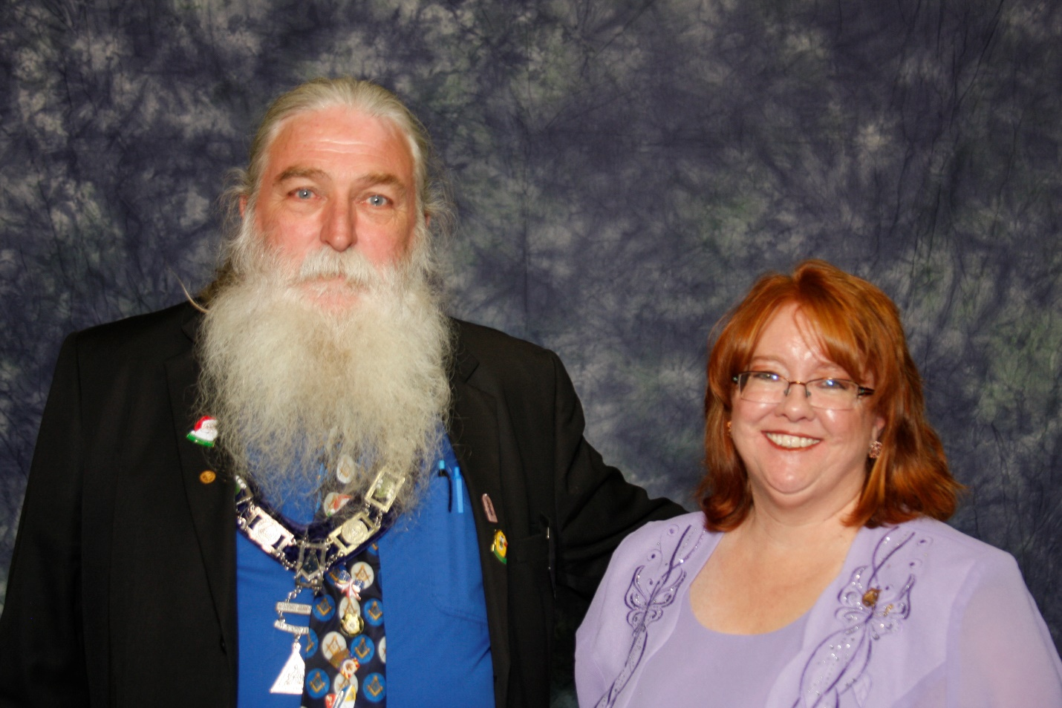

**2018-2019 GRAND FAMILY**

**MORGAN O’NEILL, PHQ, MWJD; CASI COLE, PHQ, GBHQ, SHARA BETH AARON, MISS CONGENIALITY, LOLA ARMAJO, JR MISS WYOMING, LINDA COLE, PBG, GG, PAUL LINCOLN, PABG, AGG**

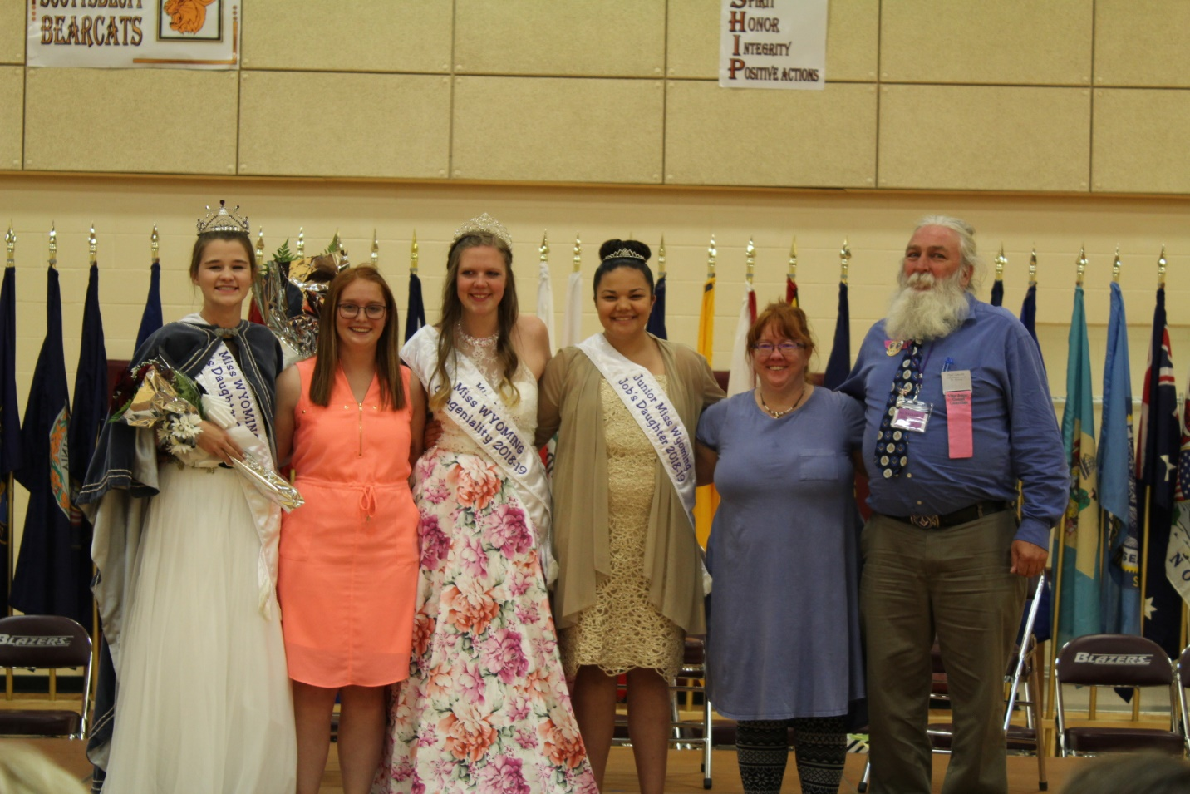

**Grand Guardian Council 2018-2019**

**Front row: Kathy Wiekhorst, Stacey Hays, Craig Henderson, Susan Miner, Paul Lincoln, Linda Cole, Marge Christiansen, Terry Wiekhorst, Joan Means**

**Back row: Steve Juhala, Nan James, Cindy Selvey, Karen Stapleton, Stephanie Ludwig, Dorthy Neumiller, Tammy Timmons, Paula Henderson, Deidra Wilson**

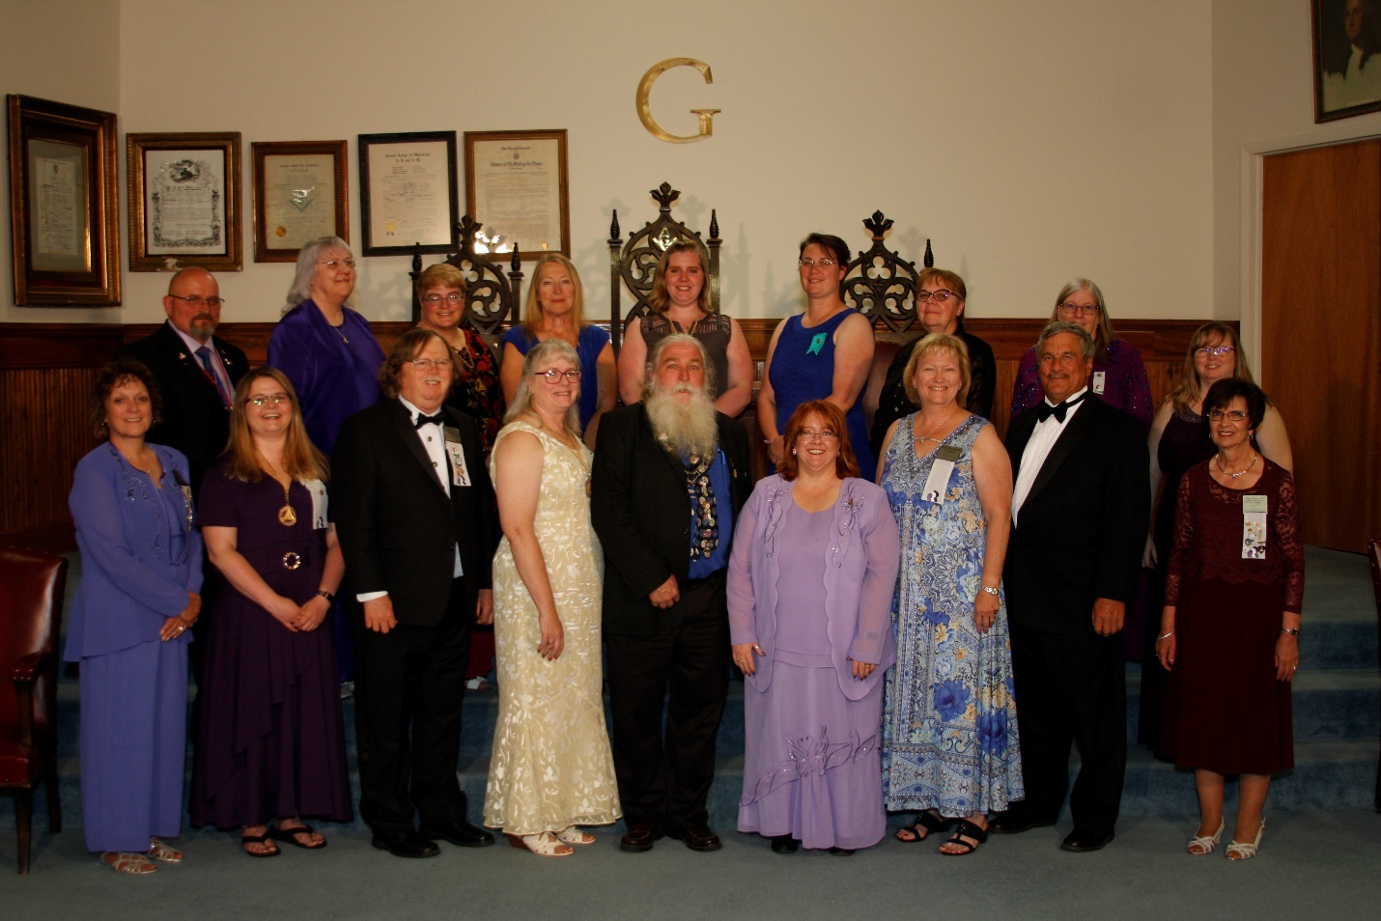

**GRAND BETHEL TRUSTEES**

**Regis Michelena, Jessica Blackman, Sid Anderson, Kya Gallo, Monica Ramirez and Ray Miner**

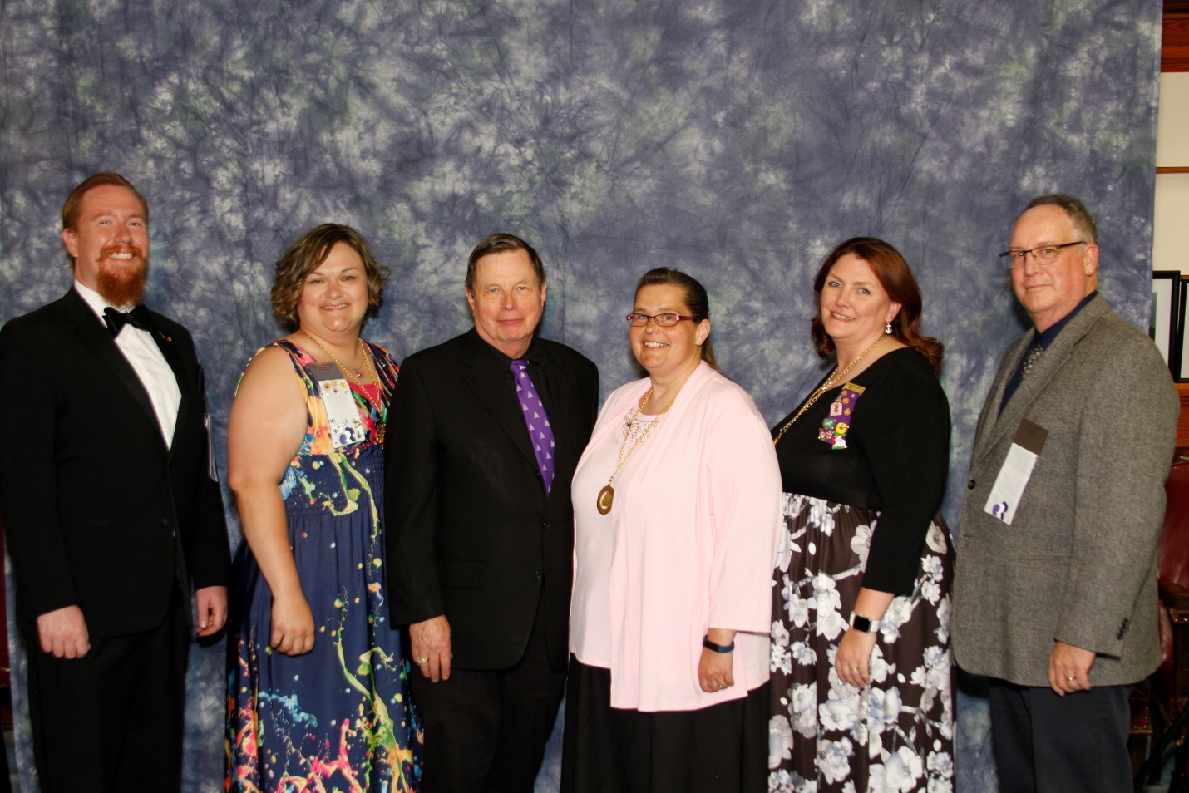

**DORP RECEIPIENT**

**Patti Kiernan, #48**

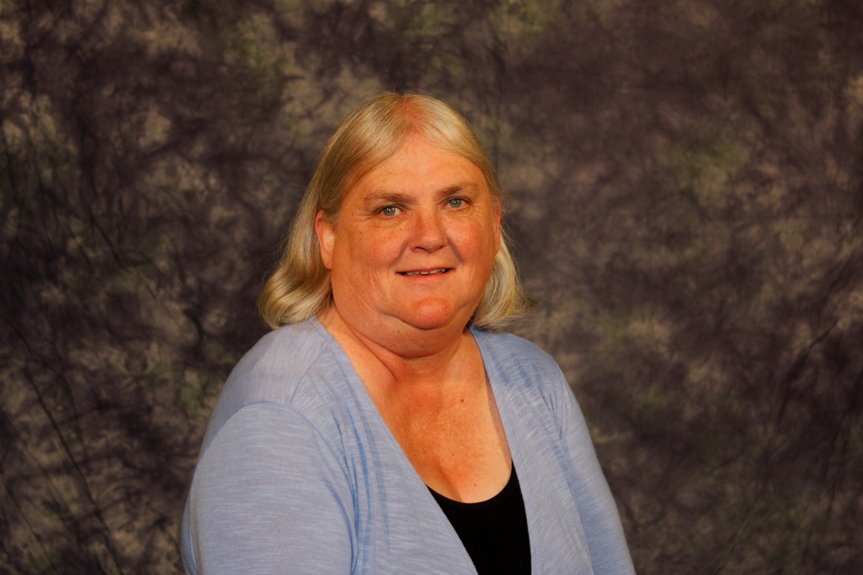

**FORGET ME NOT RECIPIENTS- 2018-2019**

**Joelene Ramirez, PHQ, #39, PGBHQ**

**Sami Cole, PHQ, PHQ #1, PGBHQ, PMWJD**

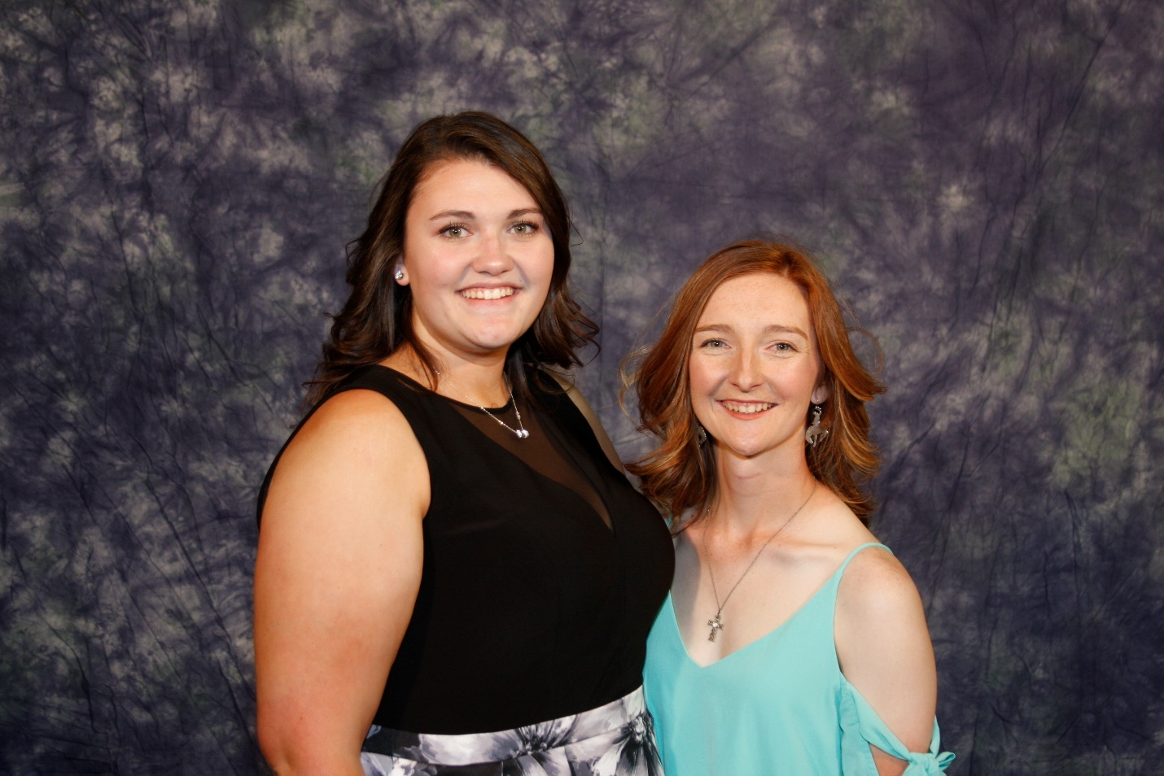

**HONOR BETHEL OFFICERS-2018-2019**

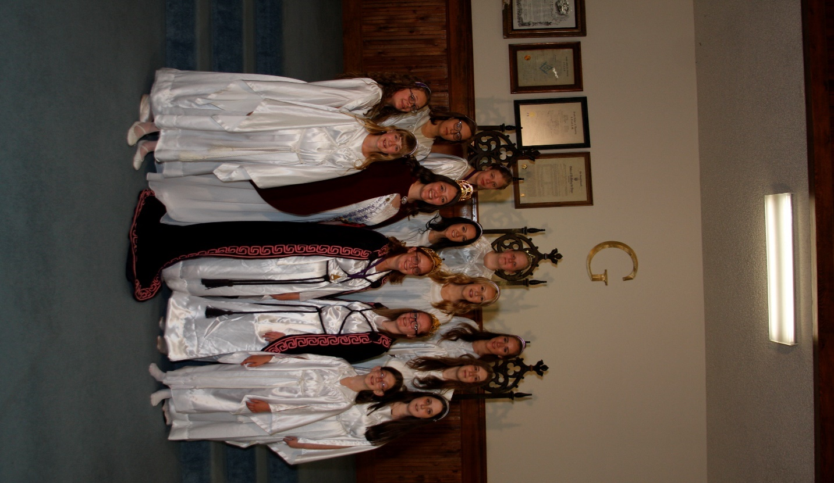

**GRAND BETHEL OFFICERS-2018-2019**

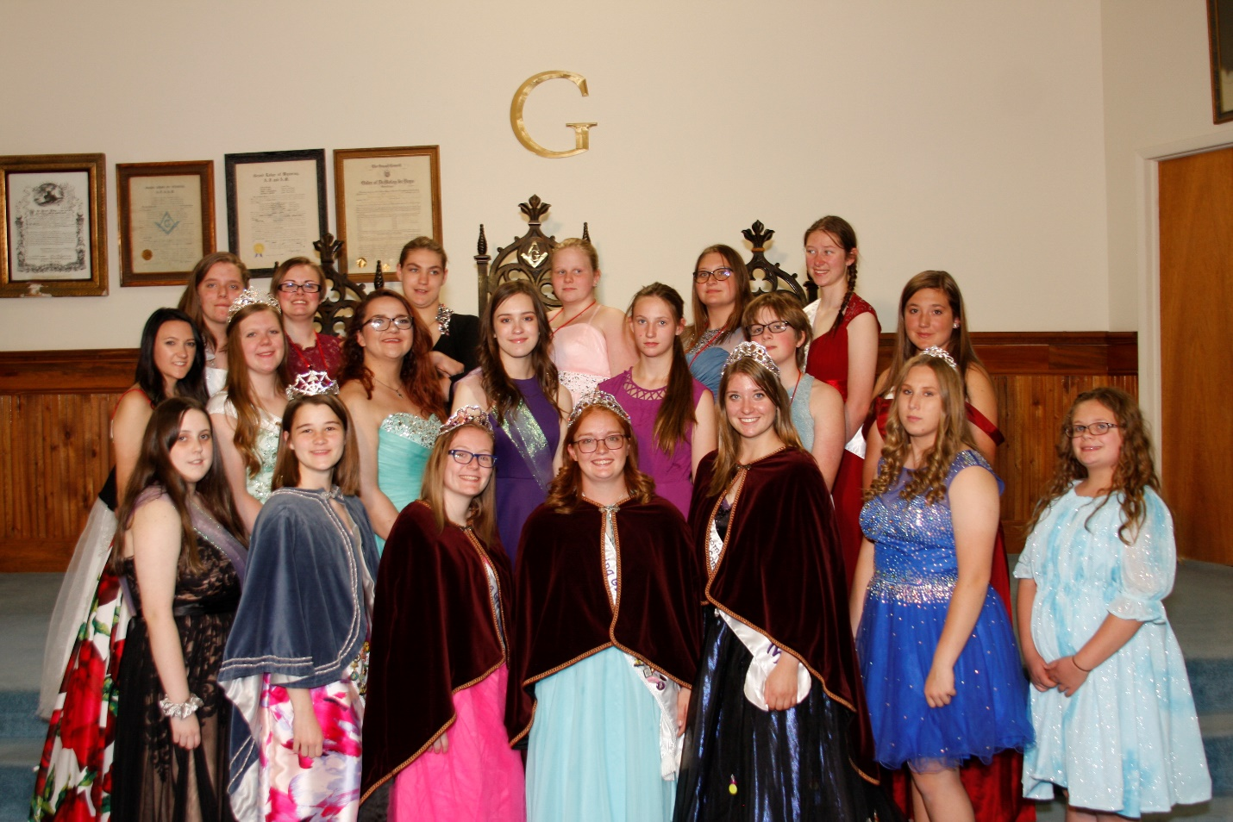

**GRAND BETHEL REPRESENTATIVES**

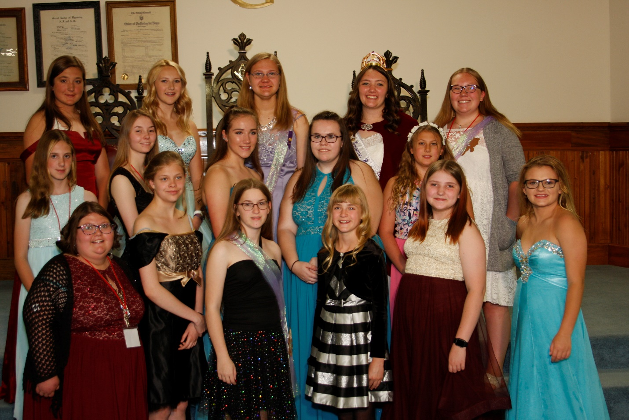

**MISS WYOMING CANDIDATES**

**Isabel Polidora, #2, Natalee Ramirez #50, Jessyka Smith #48, Dolores Neumiller #28**

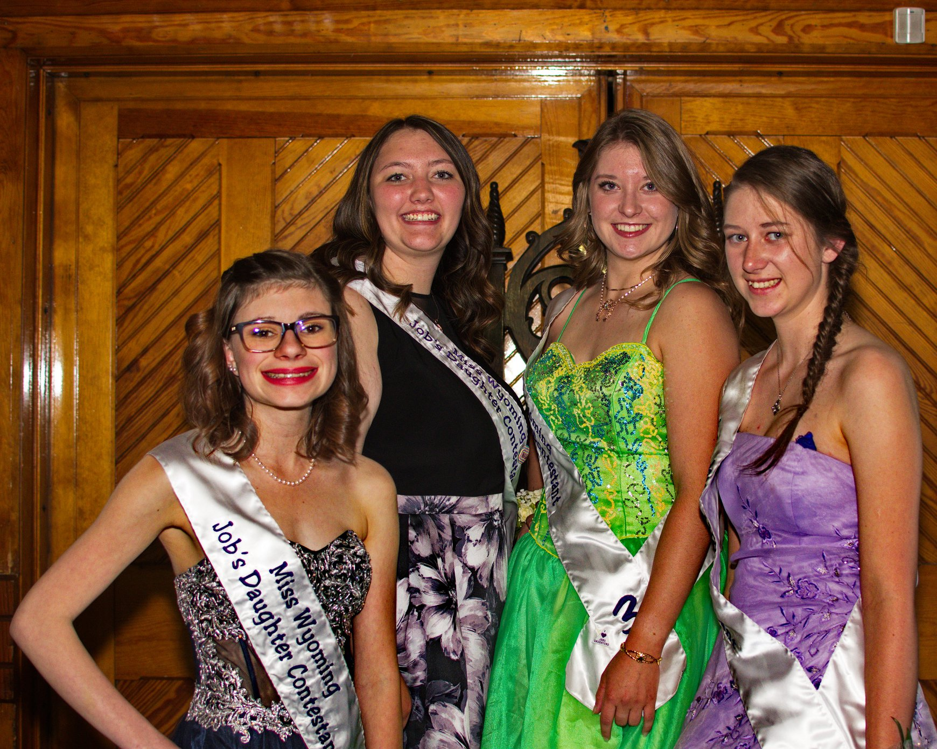

**Jr. Miss Wyoming Job’s Daughter Contestants-2018-2019**

